**Software Engineering Tools Lab**

**Assignment No-9**

**Name:Vishal Chauhan**

**PRN:2020BTECS00090**

**Batch-T8**

Installation process and the creation of test cases using Selenium.

1. Prerequisites for installing Selenium:

* Java Development Kit (JDK)
* Selenium WebDriver Java bindings
* A web driver for the browser you want to automate
* An Integrated Development Environment (IDE) such as Eclipse or IntelliJ IDEA

Installation of Selenium:

1. To install Selenium on your machine, follow these steps:

* Install Java Development Kit (JDK) if not already installed. You can download it from Oracle's website.
* Download the latest version of Selenium WebDriver Java bindings from the official Selenium website.
* 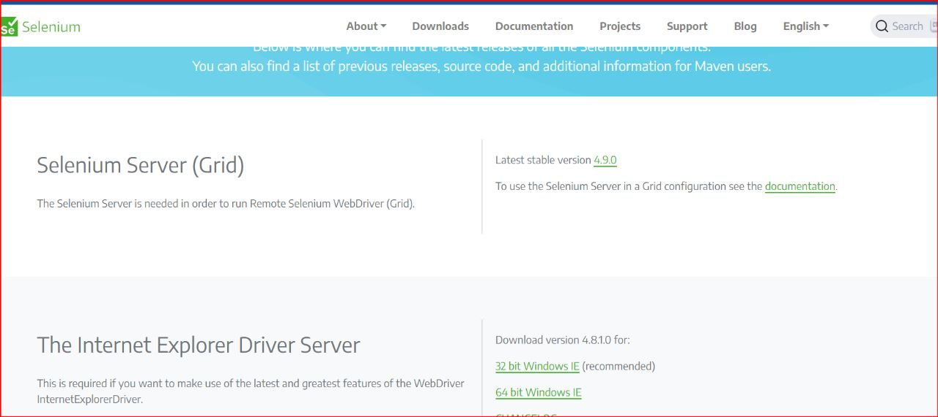
* 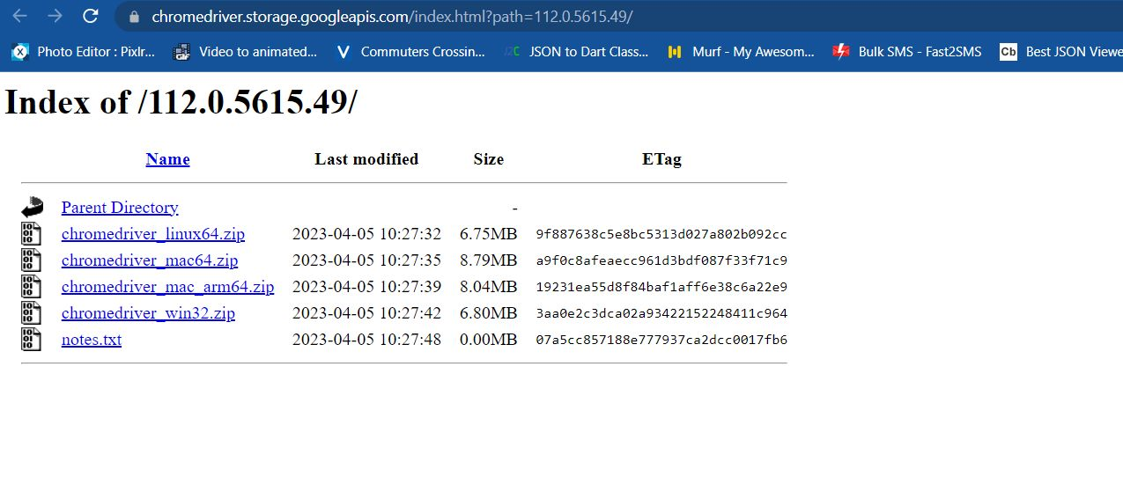
* 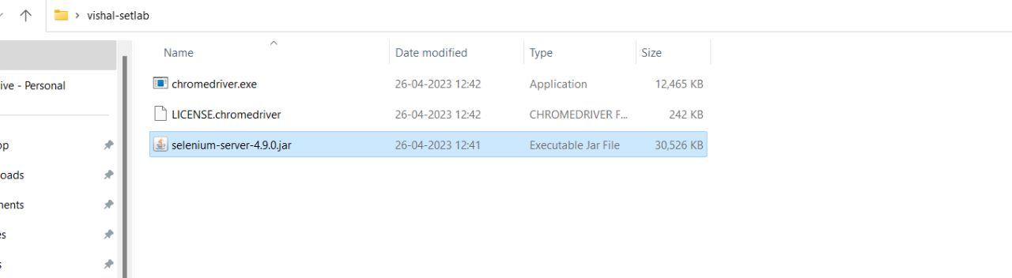

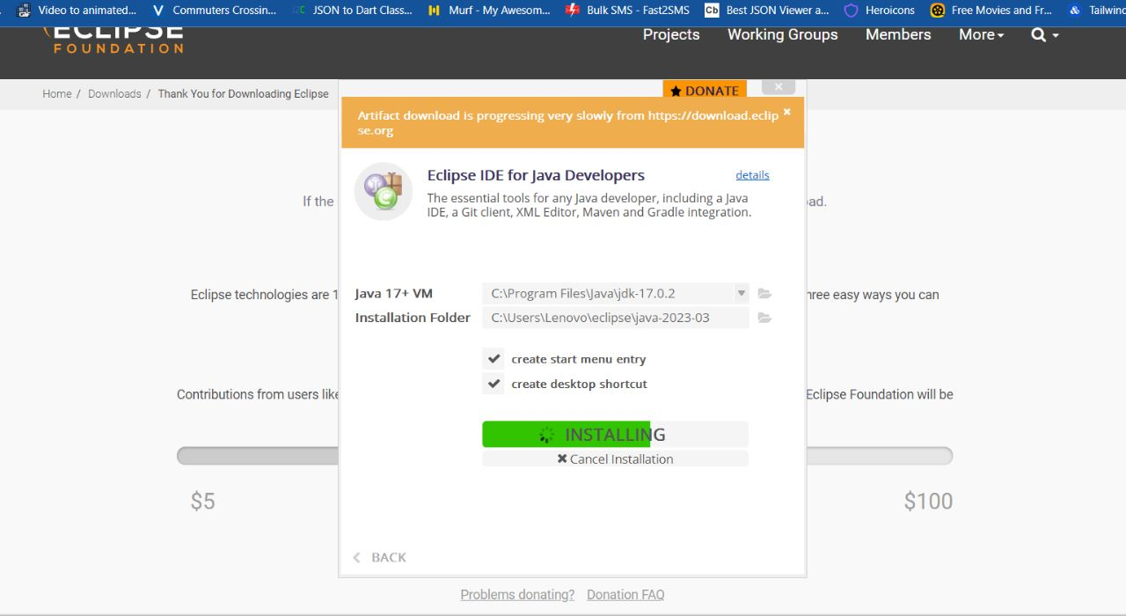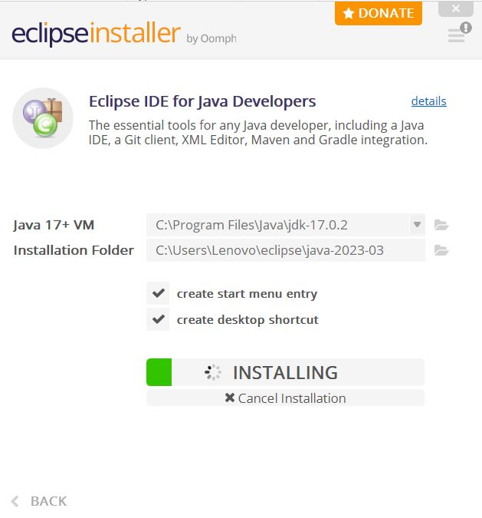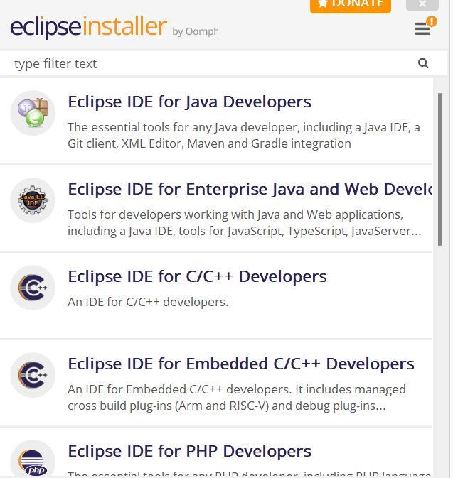

* Extract the downloaded zip file to a desired location on your machine.
* Open your IDE and create a new Java project.
* Right-click on the project and select "Properties."
* Select "Java Build Path" and click on "Add External JARs."
* Navigate to the location where you extracted the Selenium WebDriver Java bindings and select all the JAR files.
* Click "Apply" and "OK" to save the changes.

Creation of Test Cases:

To create test cases using Selenium, follow these steps:

a. Create a new test project in your IDE and name it SETProject.

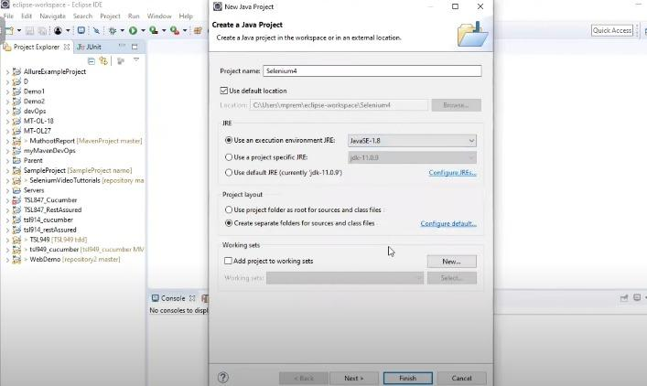

b. Create a new test plan in your IDE and name it SETProjectTestPlan.

c. Create a new build in your IDE and name it SETProjectBuild.

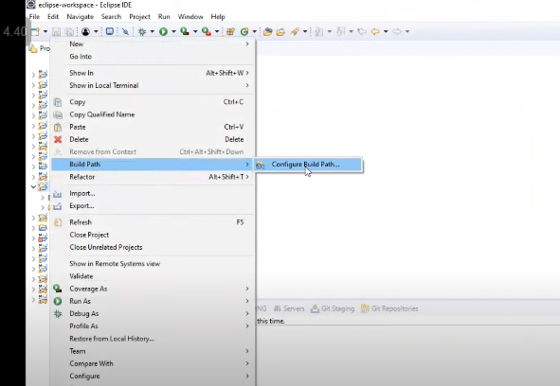

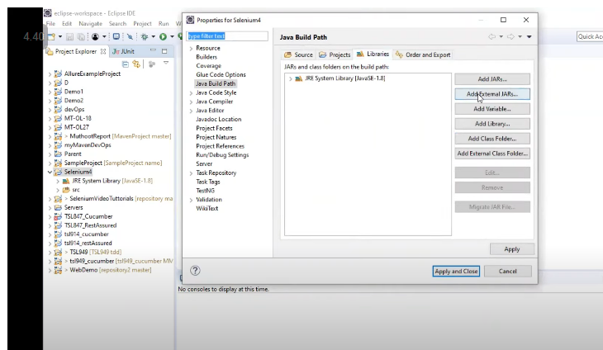

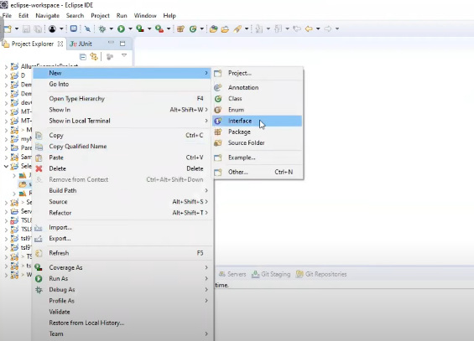

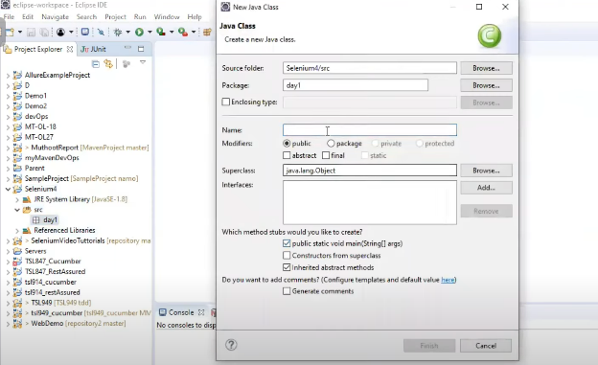

d. Create a new test suite in your IDE and name it Test Suite 1 under SETProject.

1. e. Create test cases using the Selenium tool. You can create at least 10 test cases to cover different scenarios and functionality of your application/project.

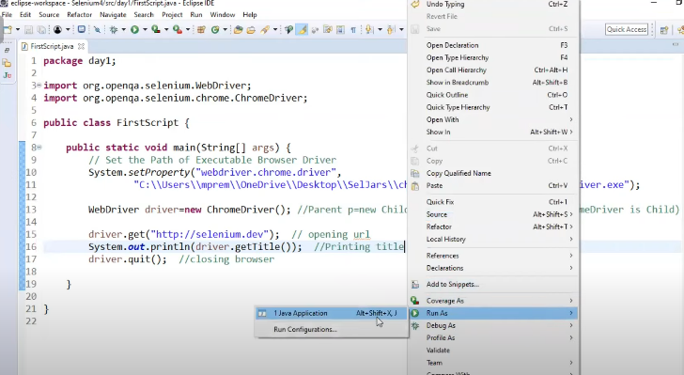

Here is a sample code to help you get started with creating a test case using Selenium WebDriver: