Name:Vishal Chauhan

PRN:2020BTECS00090

Sub:DAA

Assignment no:6

Topic:Greedy Method

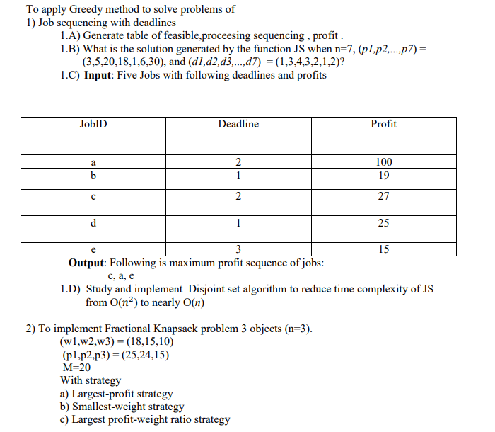

Solution:

*// C++ Program to find the maximum profit job sequence*

*// from a given array of jobs with deadlines and profits*

#include<bits/stdc++.h> using namespace std;

*// A structure to represent various attributes of a Job*

struct Job

{

*// Each job has id, deadline and profit*

char id;

int deadLine, profit;

};

*// A Simple Disjoint Set Data Structure*

struct DisjointSet

{

int *parent;

*// Constructor*

DisjointSet(int n)

{

parent = new int[n+1];

*// Every node is a parent of itself*

for (int i = 0; i <= n; i++) parent[i] = i;

}

*// Path Compression*

int find(int s)

{

*/* Make the parent of the nodes in the path from u--> parent[u] point to parent[u] */* if (s == parent[s])

return s;

return parent[s] = find(parent[s]);

}

*// Makes u as parent of v.*

void merge(int u, int v)

{

*//update the greatest available*

*//free slot to u*

parent[v] = u;

}

};

*// Used to sort in descending order on the basis*

*// of profit for each job*

bool cmp(Job a, Job b)

{

return (a.profit > b.profit);

}

*// Functions returns the maximum deadline from the set*

*// of jobs*

int findMaxDeadline(struct Job arr[], int n)

{

int ans = INT_MIN;

for (int i = 0; i < n; i++)

ans = max(ans, arr[i].deadLine); return ans;

}

int printJobScheduling(Job arr[], int n)

{

*// Sort Jobs in descending order on the basis*

*// of their profit*

sort(arr, arr + n, cmp);

*// Find the maximum deadline among all jobs and*

*// create a disjoint set data structure with*

*// maxDeadline disjoint sets initially.* int maxDeadline = findMaxDeadline(arr, n); DisjointSet ds(maxDeadline);

*// Traverse through all the jobs*

for (int i = 0; i < n; i++)

{

*// Find the maximum available free slot for*

*// this job (corresponding to its deadline)*

int availableSlot = ds.find(arr[i].deadLine);

*// If maximum available free slot is greater*

*// than 0, then free slot available*

if (availableSlot > 0)

{

*// This slot is taken by this job 'i'*

*// so we need to update the greatest*

*// free slot. Note that, in merge, we*

*// make first parameter as parent of*

*// second parameter. So future queries*

*// for availableSlot will return maximum*

*// available slot in set of*

*// "availableSlot - 1"*

ds.merge(ds.find(availableSlot - 1),

availableSlot);

cout << arr[i].id << " ";

}

}

}

*// Driver code*

int main()

{

Job arr[] = { { '1', 1, 3 }, { '2', 3, 5 },

{ '3', 4, 20 }, { '4', 3, 18 },

{ '5', 2, 1 },{ '6', 1, 6 },{ '7', 2, 30 } };

int n = sizeof(arr) / sizeof(arr[0]); cout << "Following jobs need to be "

<< "executed for maximum profit\n"; printJobScheduling(arr, n);

return 0;

}

OUTPUT:

Following jobs need to be executed for maximum profit

7 3 4 6

------------------------------------------------------------------------------

* 1. **Input**: Five Jobs with following deadlines and profits

|  |  |  |
| --- | --- | --- |
| JobID | Deadline | Profit |
| a | 2 | 100 |
| b | 1 | 19 |
| c | 2 | 27 |
| d | 1 | 25 |
| e | 3 | 15 |

**Output**: Following is maximum profit sequence of jobs: c, a, e

OUTPUT:

Following jobs need to be executed for maximum profit

a c e

* 1. Study and implement Disjoint set algorithm to reduce time complexity of JS from O(𝑛2) to nearly O(*n*)

*// C++ Program to find the maximum profit job sequence*

*// from a given array of jobs with deadlines and profits*

#include<bits/stdc++.h> using namespace std;

*// A structure to represent various attributes of a Job*

struct Job

{

*// Each job has id, deadline and profit*

char id;

int deadLine, profit;

};

*// A Simple Disjoint Set Data Structure*

struct DisjointSet

{

int *parent;

*// Constructor*

DisjointSet(int n)

{

parent = new int[n+1];

*// Every node is a parent of itself*

for (int i = 0; i <= n; i++) parent[i] = i;

}

*// Path Compression*

int find(int s)

{

*/* Make the parent of the nodes in the path from u--> parent[u] point to parent[u] */* if (s == parent[s])

return s;

return parent[s] = find(parent[s]);

}

*// Makes u as parent of v.*

void merge(int u, int v)

{

*//update the greatest available*

*//free slot to u*

parent[v] = u;

}

};

*// Used to sort in descending order on the basis*

*// of profit for each job*

bool cmp(Job a, Job b)

{

return (a.profit > b.profit);

}

*// Functions returns the maximum deadline from the set*

*// of jobs*

int findMaxDeadline(struct Job arr[], int n)

{

int ans = INT_MIN;

for (int i = 0; i < n; i++)

ans = max(ans, arr[i].deadLine); return ans;

}

int printJobScheduling(Job arr[], int n)

{

*// Sort Jobs in descending order on the basis*

*// of their profit*

sort(arr, arr + n, cmp);

*// Find the maximum deadline among all jobs and*

*// create a disjoint set data structure with*

*// maxDeadline disjoint sets initially.* int maxDeadline = findMaxDeadline(arr, n); DisjointSet ds(maxDeadline);

*// Traverse through all the jobs*

for (int i = 0; i < n; i++)

{

*// Find the maximum available free slot for*

*// this job (corresponding to its deadline)*

int availableSlot = ds.find(arr[i].deadLine);

*// If maximum available free slot is greater*

*// than 0, then free slot available*

if (availableSlot > 0)

{

*// This slot is taken by this job 'i'*

*// so we need to update the greatest*

*// free slot. Note that, in merge, we*

*// make first parameter as parent of*

*// second parameter. So future queries*

*// for availableSlot will return maximum*

*// available slot in set of*

*// "availableSlot - 1"*

ds.merge(ds.find(availableSlot - 1),

availableSlot);

cout << arr[i].id << " ";

}

}

}

*// Driver code*

int main()

{

Job arr[] = { { '1', 1, 3 }, { '2', 3, 5 },

{ '3', 4, 20 }, { '4', 3, 18 },

{ '5', 2, 1 },{ '6', 1, 6 },{ '7', 2, 30 } };

int n = sizeof(arr) / sizeof(arr[0]); cout << "Following jobs need to be "

<< "executed for maximum profit\n"; printJobScheduling(arr, n);

return 0;

}

1. To implement Fractional Knapsack problem 3 objects (n=3). (w1,w2,w3) = (18,15,10)

(p1,p2,p3) = (25,24,15) M=20

With strategy

1. Largest-profit strategy
2. Smallest-weight strategy
3. Largest profit-weight ratio strategy

#include<bits/stdc++.h> using namespace std;

float greedybyprofit(int weights[3],int profit[3],int M,int N){ vector<pair<int,int>> vp;

for(int i=0;i<N;i++){ vp.push_back({profit[i],weights[i]});

}

sort(vp.begin(),vp.end(),greater<pair<int,int>>()); float ans = 0;

for(auto x:vp){ if(M>x.second){

ans+=x.first; M-=x.second;

}

else{

ans+=(float)(((float)M/x.second)*x.first); break;

}

}

return ans;

}

float greedybyweight(int weights[3],int profit[3],int M,int N){ vector<pair<int,int>> vp;

for(int i=0;i<N;i++){ vp.push_back({weights[i],profit[i]});

}

sort(vp.begin(),vp.end()); float ans = 0.0;

for(auto x:vp){ if(M>x.first){

ans+=x.second; M-=x.first;

}

else{

ans+=(float)(((float)M/x.first)*x.second); break;

}

}

return ans;

}

float greedybyratio(int weights[3],int profit[3],int M,int N){ vector<pair<float,int>> vp;

for(int i=0;i<N;i++){ vp.push_back({((float)profit[i]/weights[i]),i});

}

sort(vp.begin(),vp.end(),greater<pair<float,int>>()); float ans = 0.0;

float sum=0; for(auto x:vp){

if(M>sum+weights[x.second]){ ans+=profit[x.second];

M-=weights[x.second]; sum+=weights[x.second];

}

else{

ans+=(float)(((float)M/weights[x.second])*profit[x.second]); break;

}

}

return ans;

}

int main(){

int weights[3] = {18,15,10}; int profit[3] = {25,24,15}; int M = 20;

cout<<endl;

cout<<"Answers using various starategies\n"<<endl; cout<<"Largest profit strategy :

"<<greedybyprofit(weights,profit,M,3)<<endl; cout<<"Smallest weight strategy :

"<<greedybyweight(weights,profit,M,3)<<endl; cout<<"Largest profit-weight ratio strategy :

"<<greedybyratio(weights,profit,M,3)<<endl; cout<<"\n"<<endl;

return 0;

}

OUTPUT:🡪

Answers using various starategies

Largest profit strategy :28.2

Smallest weight strategy :31

Largest profit-weight ratio strategy :31.5