Fiji NFMS ER Calculations Summary

David Chambers, Carly Green, Michael Green

May 2021

Table of Contents

# 1. Introduction

## 1.1 Purpose of Document

This document describes the methodology used to calculate the emissions, removals and emissions reductions using R language for the for the Fijian Ministry of Forestry Forest Carbon Partnership Fund (FCPF) Monitoring Report.

The document will:

* Outline the parameters and outputs for the functions used to calculate the emissions and removals from REDD+ Activities,
* Reference the functions used to calculate the outputs required for the FCPF monitoring report,
* Discuss the outputs from the R calculations with reference to their values, associated uncertainty and sensitivity analysis,
* Provide guidance on modification of the code for a change in methodology or adoption to a new data set (e.g a new country),
* Provide information/code for the packages used to complete the calculations.

## 1.2 Audience

There are three main audiences for this document. Each group is listed below with the intended outcomes for that audience.

The Ministry of Forestry Staff:

* Be able to make changes to the calculations based on methodology changes
* Find the code that implements calculations for review and auditing of processes
* Communicate to third parties to allow improvements

Consultants

Auditors and Reviewers

## 1.3 Terminology

### Code Naming Convention

The names used in identifiers (functions, objects, values, …) are based on the following style:

Scope::Usage::Type::Name

|  |  |  |  |
| --- | --- | --- | --- |
| Scope | Usage | Type | Name |
| Calc | Est | Em | e.g Defor |
| Mp | Net | Rem |  |
| Rp | Gross | EmRems |  |
| Erpa | Current | ERs |  |
|  | Previous | FRL |  |
|  | Transferred |  |  |
|  | Adj |  |  |
|  | Contested |  |  |
|  | Sold |  |  |

Each field (Scope, Usage, Type) can have the following:

Scope: - **Calc**: A calculation function returning a result. This generally will be in CO2e. - **Mp**: Monitoring Period. These values and data are for the whole Monitoring period. - **Rp**: Reporting Period. These values and data are pro rata values of the equivalent Mp data. Based on the ratio of the Reporting Period to the Monitoring Period - **Erpa**: ERPA value which relates to the whole program period.

Usage: - **Est**: An estimate of the data - **Net**: A sum of estimates which have a -ve and +ve range - **Gross**: A estimate which has not been adjuested or reduced by the opposite estimates. For example all the Enhancements without considering Removals. - **Previous**: A running total of the value across all reports but does not include this reports estimates. - **Current**: The running total value which takes in to consideration all previous report values as well as the current report estimates. - **Transferred**: The Emissions Reductions which have been transferred prior to this reporting period. - **Adj**: Values which have been adjusted for buffers and constative factors have been applied. - **Contested**: Contested Emissions Reductions - **Sold**: The Emissions Reductions which have been sold prior to this reporting period.

Type: - **Em**: A value representing an emission of CO2e, always positive. - **Rem**: A value representing an removal of CO2e, always positive. - **EmRem**: A value that represents a -ve (removal) or +ve (emission) of CO2e. - **ERs**: A value that represents a +ve (reduction) or -ve (reversal) as compared to the ERPA reference level. - **FRL**: A value that represents the Forest Reference Level or a sub activity of the Forest Reference Level

The following are examples of Names and abbreviations used.

* EstEmRemsDefor: is an Estimate (Est) of Emission Removals (EmRems) for deforestation (Defor)
* MpEstFRL: is the specific Monitoring Period (Mp) Estimate (Est) of the Forest reference level (FRL)
* ErpaPreviousERs: is the ERPA (Erpa) running total not including the monitoring period of the report (Previous) of the Emission Reductions (ERs)

Other shortened words used are:

* Enh: Enhancements, i.e. sinks.
* FDeg: Forest Degradation.

### Acronyms

|  |  |
| --- | --- |
| Acronym | Meaning |
| AD | Activity Data |
| AGB | Above Ground Biomass |
| AR | Afforestation/Reforestation |
| Args | Arguments |
| BCEF | Biomass Conversion and Expansion Factor |
| BGB | Below Ground Biomass |
| Conv | Conversion |
| DF | Deforestation |
| Defor | Deforestation |
| EF | Emissions Factor |
| ER | Emission Reduction |
| ERPA | Emission Reductions Program Agreement |
| Em | Emissions |
| Est | estimate |
| FD | Forest Degradation |
| FDeg | Forest Degradation |
| FP | Forest Plantation |
| FRL | Forest Reference Level |
| Fell | Felling |
| ForPlant | Forest Plantation |
| GHGS | Greenhouse Gases |
| HW | Hardwood |
| Harv | Harvested |
| Inc | Increment |
| LCI | Lower Confidence Interval |
| MAIAGB | Mean Annual Increment of Above Ground Biomass |
| MAIB | Mean Annual Increment of Biomass |
| MAIC | Mean Annual Increment of Carbon |
| MAIV | Mean Annual Increment of Volume |
| MC | Monte Carlo |
| Plant | Planted |
| Rem | Removals |
| SD | Standard Deviation |
| SW | Softwood |
| Stock | Stocked |
| TEF | Total Emissions Factor |
| Trop | Tropical |
| UCI | Upper Confidence Interval |
| Vol | Volume |
| err | Error |
| ha | hectare |
| m3 | cubic metre |
| tCO2e | Tonne of Carbon dioxide equivalent |
| yr | year |
| yrs | years |

## Preliminaries

Ask MG

Download library? Packages? Versions?

# 2. R Script Calculations

This section describes the calculations carried out by the R Script to produce the required values from the FCPF Monitoring Report.

## 2.1. REDD+ Activities Annual Estimations

The REDD+ Activities note the contribution of emissions and removals from Deforestation, Forest Degradation and Enhancements.

### 2.1.1. Deforestation

**Scope** Estimates emissions from deforestation from lowland and upland natural forest, excluding areas subject to logging, in Fiji.

**Reference**

Package - FijiNFMSCalculations Function Script - Deforestation.R

**Prior Requirements**

TBC Data: Hectares of Area Deforested in lowland an upland natural forest.

**Output**

This emission source provides a contribution to the overall emissions from Forest and Forestry related activities in Fiji in tCO2e. This value is required for reporting and further calculation of values in the FCPF Monitoring Report.

**TEST** Include this? test-CalcEMDF.R

### 2.1.2. Forest Degradation

Emissions from degradation are estimated as the combination of the net emissions/removals from logging in Natural Forests and the emissions from Fire in Pine Plantations.

#### Felling

**Scope** Emissions related to logging practices in natural forests.

**Reference**

Package - FijiNFMSCalculations Function Script - Felling.R

**Prior Requirements**

Data?

**Output**

This emissions source provides a contribution to the overall emissions from Forest and Forestry related activities in Fiji. This value is required for reporting and further calculation of values in the FCPF Monitoring Report.

#### Emissions from Fire

**Scope** Emissions from fire in Softwood Plantations (Pine)

**Reference**

Package - FijiNFMSCalculations Function Script - Burning.R

**Prior Requirements**

Data?

**Output**

This emissions source provides a contribution to the overall emissions from Forest and Forestry related activities in Fiji. This value is required for reporting and further calculation of values in the FCPF Monitoring Report.

### 2.1.3. Enhancements

Enhancements are the removals in tCO2e related to afforestation and forest plantations in Fiji.

#### Afforestation

**Scope** Removals in tCO2e from Afforestation/Reforestation activities - defined as the conversion of land in the land-use sub category Non-Forest to land in the sub-category Natural Forest(Low-or Upland) and Plantations (Softwood and Hardwood).

**Reference**

Package - FijiNFMSCalculations Function Script - Afforestation.R

**Prior Requirements**

Data?

**Output**

This removals source provides a contribution to the overall emissions/removals from Forest and Forestry related activities in Fiji. This value is required for reporting and further calculation of values in the FCPF Monitoring Report.

#### Forest Plantations

**Scope** Emissions and Removals in tCO2e from Forest Plantation Management. This includes the growth and harvesting of Softwood and Hardwood plantation stocks.

**Reference**

Package - FijiNFMSCalculations Function Script - ForestPlantations.R

**Prior Requirements**

Data?

**Output**

This emissions/removals source provides a contribution to the overall emissions/removals from Forest and Forestry related activities in Fiji. This value is required for reporting and further calculation of values in the FCPF Monitoring Report.

### 2.1.4. Annual Net Emissions/Removals from REDD+ Activities

**Scope** The summation of the annual net emissions or removals from the REDD+ activities: Deforestation, Forest Degradation and Enhancements.

**Reference**

Package - Function Script - TBC Fiji_ER_Estimates.R

**Prior Requirements**

Calculation of all REDD+ activities (Deforestation, Forest Degradation, Enhancements)

**Output**

The values of net emissions and removals are reported in the FCPF Monitoring Report and are used to calculate Emissions Reductions against the Forest Reference Level (FRL)

## 2.2. Emission Reductions

**Scope** The Emissions Reductions are calculated by subtracting the annual net emissions from the Forest Reference Level (FRL)

**Reference**

Package - FijiNFMSCalculations Function Script - ForestPlantations.R

**Prior Requirements**

Forest Reference Level (FRL) from Fiji Ministry of Forestry Net Emissions/Removals value for the monitoring period.

**Output**

The value of Emission Reductions is reported in the FCPF Monitoring Report.

## 2.3. Outputs for FCPF Monitoring Report

**Scope** The outputs from the R script calculation are used to populate the FCPF Monitoring report for the reporting period for Fiji. In particular tables 4.2, 4.3, 5.2.2, 7.2 and 8.

**Reference**

TableCreationFunction.R

**Prior Requirements**

Calculation of all REDD+ activities (Deforestation, Forest Degradation, Enhancements), Emissions Reductions and net emissions/removal values.

**Output**

Values to be reported in the FCPF monitoring report including Tables 4.2, 4.3, 5.2.2, 7.2 and 8.

# 3. Discussion

## 3.1. Drivers

-Purpose - Load files, Run drivers, see outputs.

* Three different drivers Values Values_with_UC [check naming] Sensitivity [check naming]

-Output - Console - Environment (variables and parameters defined from the code)

* See individual driver sections for specific purpose and outputs.

### Guidance: Opening and Running a Driver

* Open R Studio
  + 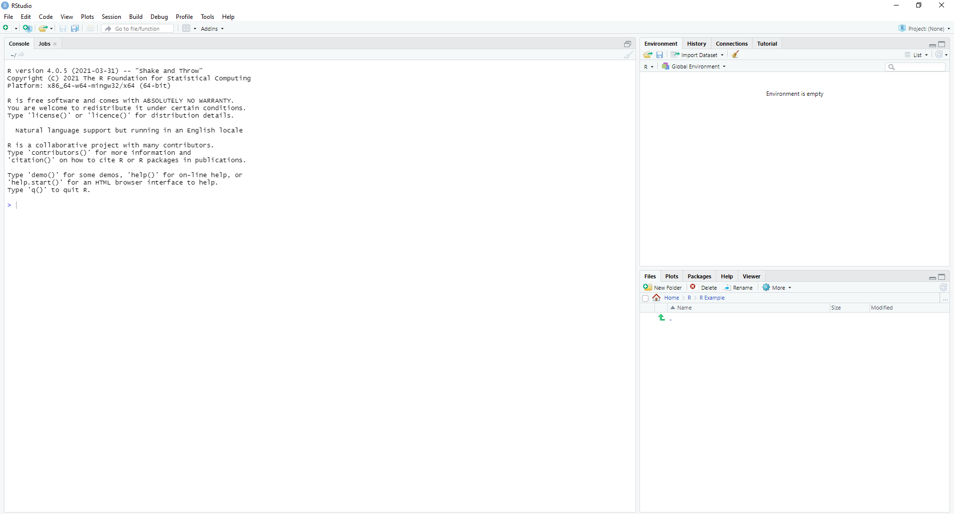{width=200px}
* Set working directory to file directory
  + 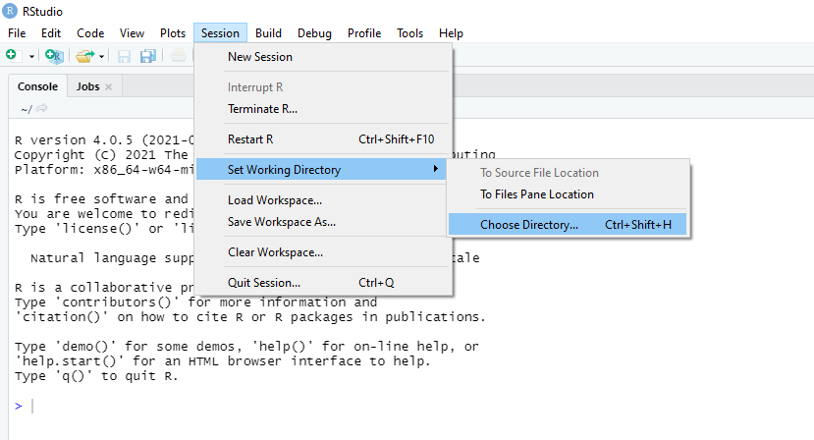
  + Step2
* Open Driver file
  + 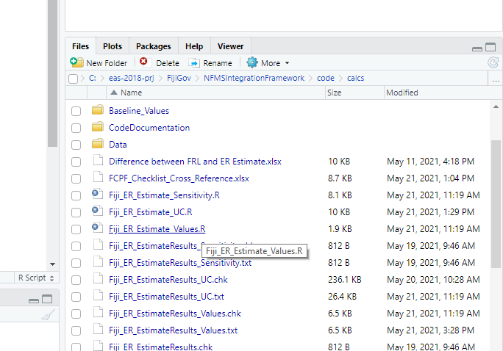
  + Step3
* Run file (Ctrl+alt+r, through code menu or on console source(“./driverfilename.R”))
  + 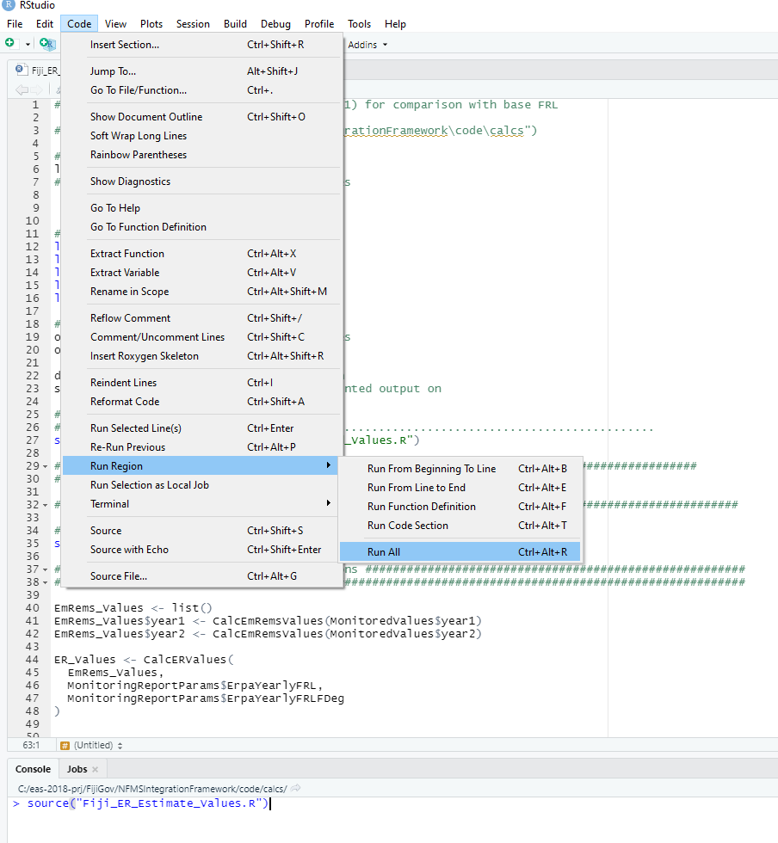
  + Step4
* Check the outputs in the environment window and console.
  + [Step5][CheckOutputs]

For more guidance on using RStudio please refer to the RStudio website [RStudio Support](https://support.rstudio.com/hc/en-us)

### 3.1.1. Values

**Purpose** - The Values drive produces estimates without uncertainty that are quick to run: - Yearly EmRems - Monitoring Period Gross ERs - Reporting period Emission Reduction Program Agreement (ERPA) balance of ERs.

* Produce Tables 4.2, 4.3 and 7.2 for the FCPF Monitoring Report.

**Output**

EmRems_values : 2 Yeas/Monitoring Period data ER_Values : Potential ER’s before deductions or Buffering

#(2 lists to be added)

### 3.1.2. Values with Uncertainty

**Purpose**

* The Values with uncertainty driver provides estimates with uncertainty for the monitoring period data and the Emission Reductions available for transfer to the carbon fund.
* Produce Tables 5.2.2 and 8 for the FCPF Monitoring Report.

**Output**

Table 5.2.2 and 8 for the FCPF Monitoring Report.

### 3.1.3. Sensitivity Analysis

**Purpose**

* The Sensitivity Analysis produces a report which assesses the total effect index of parameters which have uncertainty included which are used in the calculation.

*(To do) Reference (Word document with value with uncertainty defined) either in CG document (link) or coding table with parameter and code name……..*

*(MG - TE index document notes to be added here)*

**Output**

TBC

Table of 2 cols - name of value, TEI

## 3.2. Modification of Code

-number of use cases for modification of the code 1. Fiji methodological changes requires code to be updated/reviewed 2. Another country adopts the calculation code 3. Monitoring Period Report Tasks for new FCPF Report

Note placeholder for diagram showing drivers code structure . . . . . .

### 3.2.1. Resulting from changes to Methodology

* If a default parameter is changed, the relevant params file will need to be updated.
* If a calculation equation is changed, the relevant calc file will need to be updated.
  + Associated Test documents will need to be updated
* New calculations or activities will need to be added to the FIJI_NFMS_Calculations package and the drivers files.

### 3.2.2 Adoption of code for a new country context

* Country specific default parameters will need to be updated,
* Calculations in FIJINFMSCalculations Package to be reviewed and updated for the new countries activities and saved as a new package.
  + New calculations package should be referenced in the the drivers files in EmRem, ER and data list sections.

### 3.2.3 Monitoring Period Report Tasks for new FCPF Report

(Baseline Values files need to be updated for each new FCPF monitoring report. This can be done in two ways: - directly in the code files - via FIMS

Each updating method depends on the updating party. Updating directly in the code is useful in the case where the code can be sent to an external party who does not have access to the FIMS.

See FIMS manual for editing in the FIMS. **Link to manual- which will be saved in the FIMS.pdf**

## 3.3. Testing & Unit Testing

Unit testing is written into all code packages to test functions. Each test set includes test data from Fiji data

Other tests are general examples and use cases of using the code.

Code changes should be reflected in associated tests.

**Running the Tests** devtools::test() See ?testthat for more information

Note: Some of the tests use a set.seed(#) with an arbitrary number to ensure that the tests are repeatable when using random number generation. The seed is not required in the normal operation of the code. # 4. Packages {.tabset}

## Fiji NFMS Calculations

<https://cran.r-project.org/web/packages/roxygen2md/roxygen2md.pdf>

* Afforestation.R
* Burning.R
* CarbonConversion.R
* Constants.R
* Default_Parameters.R
* Deforestation.R
* EmissionReductions.R
* ER_Calculated_Values.R
* Felling.R
* Fiji_Constants_from_Reference_Level.R
* Fiji_Specific_Parameters.R
* ForestPlantations.R
* FRL_Calculated_Values.R
* ReportTotals.R
* utils-pipe.R

## Value with Uncertainty

* gen_sample.R
* init.R
* ops.R
* summary.R
* types.R
* utils.R
* utils-pipe.R
* ValuesWithUncertainty.R

## Monte Carlo Utils

* ASCBRMonteCarloSamples.R
* GenMonteCarloSamples.R
* PlotMonteCarloSamples.R
* StableMonteCarloSamples.R
* utils-pipe.R

## FCPF Monitoring Report Tables

* TableCreationFunctions.R