R Setup

Tim Graham, Carly Green, Michael Green

November 2021

Table of Contents

1. Introduction 1

1.1 Purpose of Document 1

1.2 Systems to be Installed 1

2. Pre-requisites 2

3. Installing R 2

4. Installing RStudio 3

5. Installing Rtools 3

5.1 Installation 3

5.2 System Settings 4

6. Installing Github Desktop 6

6.1 Instillation 6

6.2 Login 7

# 1. Introduction

## 1.1 Purpose of Document

This document will guide you on how to install and setup R, RStudio and Rtools on your machine, so that the Fiji FNMS project can be run on your machine.

## 1.2 Systems to be Installed

* **R** is the programming language that this project is written in, this must be installed for the project to run on your machine.
* **RStudio** is an integrated development environment (IDE) which is commonly used by R developers, this will be used to navigate the project’s code base.
* **Rtools** is a set of programs that is required on Windows to build R packages from source.

# 2. Pre-requisites

* Windows 64-bit machine
* Admin privileges on your user account
* R and Rstudio not currently installed on your machine

# 3. Installing R

To start with, you must download the appropriate distribution of R. To do this visit [Comprehensive R Archive Network](https://cran.rstudio.com/) and click on **Download R for the first time** and then click on **Download R 4.1.2 for Windows** an exe file will then download to your machine. **Note R version may have changed since time of writing**

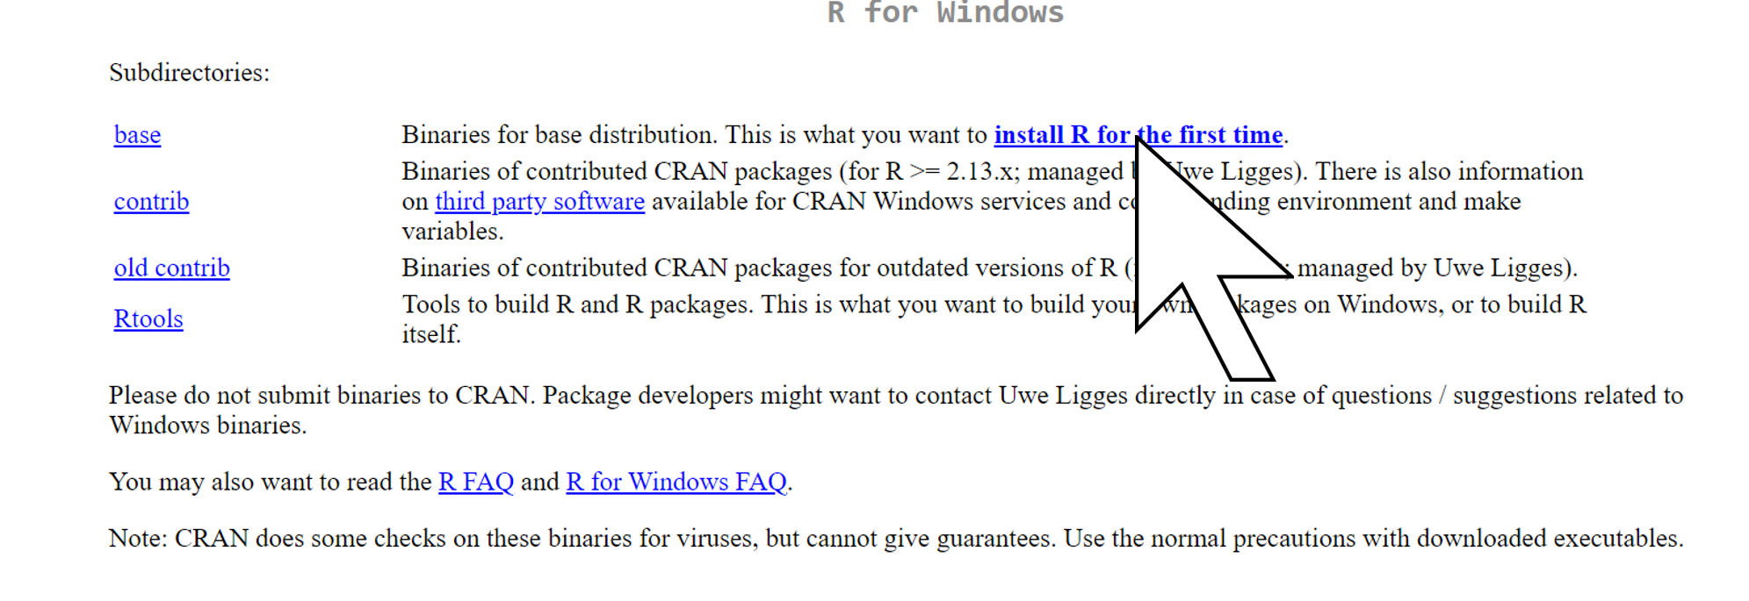

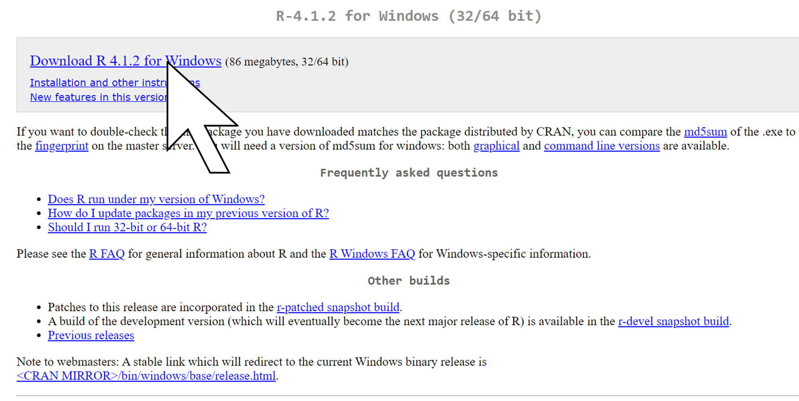

Run the .exe file that has downloaded to your machine. Ensuring that your user account has administrator privileges.

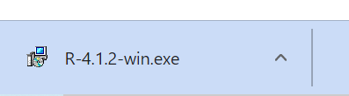

Proceed through the installation wizard, accepting all default settings. Once you have done this, R is installed and you can proceed to the installation of RStudio.

# 4. Installing RStudio

Start by downloading the latest version of Rstudio from the [RStudio website](https://www.rstudio.com/products/rstudio/download/#download). This will download a .exe file to your machine.

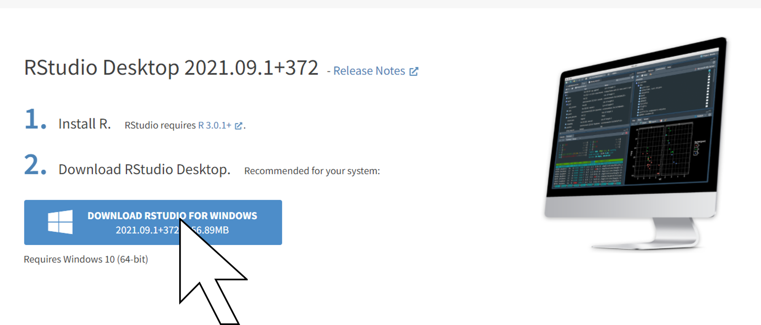

Open the .exe file, this will launch the RStudio installation wizard, proceed through the installation wizard, accepting all default settings.

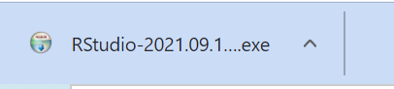

# 5. Installing Rtools

## 5.1 Installation

To install Rtools please visit the [R for Windows Build Tools Archive](https://cran.r-project.org/bin/windows/Rtools/history.html) and download the version which corresponds to the version of R that you installed in section 3 of this manual. This will download a .exe file to your machine.

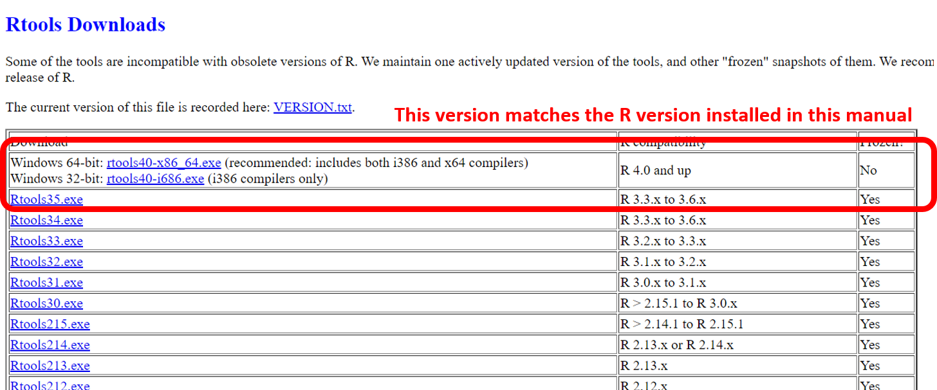

Open the .exe file, this will launch the Rtools installation wizard, proceed through the installation wizard, accepting all default settings.

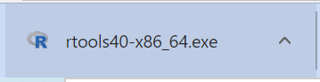

## 5.2 System Settings

In order for Rtools to work on your machine you must update your Windows System Variables. To do this:

1. Go to Windows settings
2. System
3. About
4. Advanced system settings
5. Environment variables

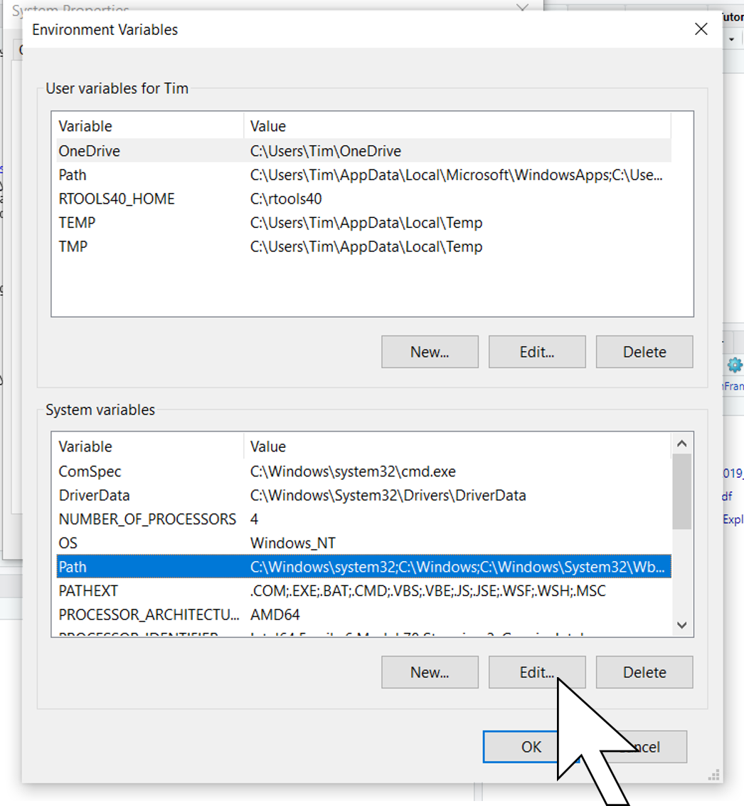

1. Select **Path** under System Variables and click edit
2. Click **New** and paste the following **C:\rtools40\usr\bin**
3. Click **OK** and you are finished

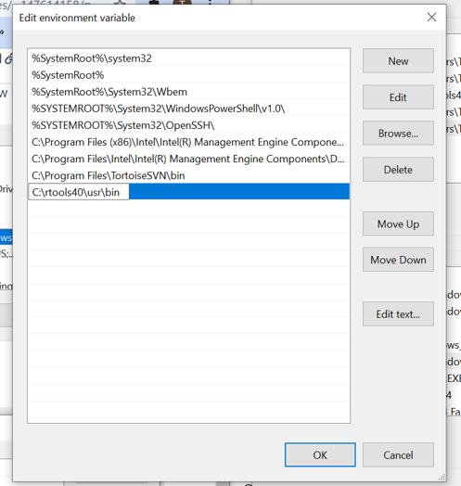

# 6. Installing Github Desktop

## 6.1 Instillation

To install Github Desktop please go to [GitHub Desktop](https://desktop.github.com), pressing the purple button will start the download of a .exe file.

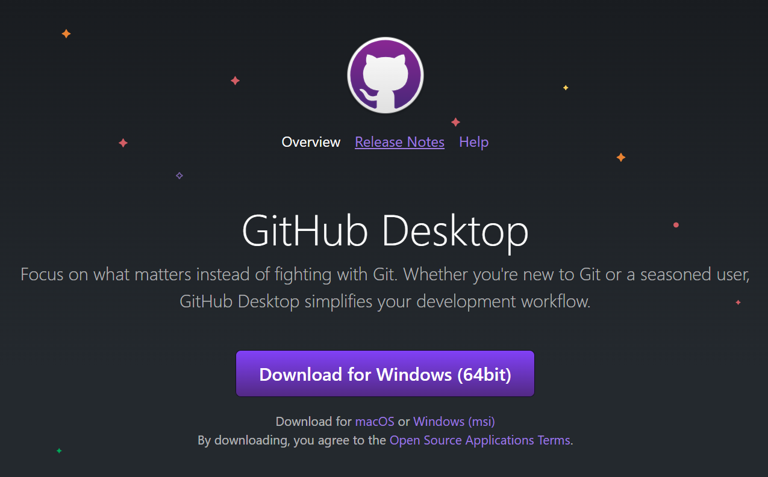

This needs to be executed when the download is completed.

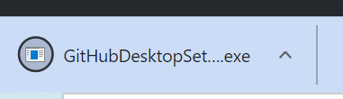

## 6.2 Login

Once the program has been executed the user will be prompted to login or create an account.

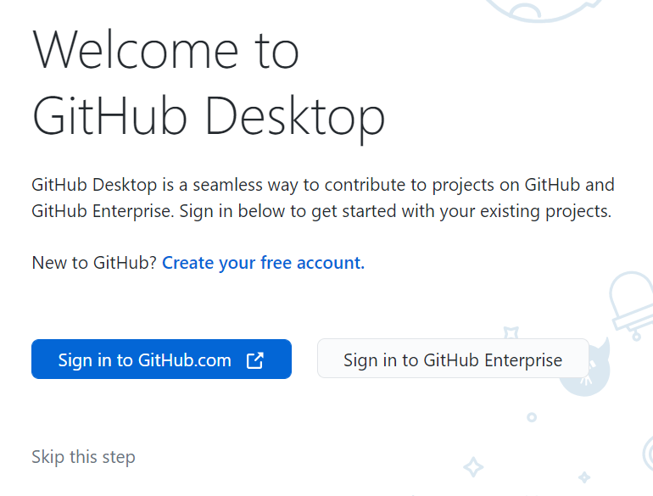

Do what is valid for you; - Already have an account: Login - Dont have an account: Create account