Fiji NFMS R Script Manual

David Chambers, Carly Green, Michael Green

May 2021

Table of Contents

# 1. Purpose of Document

This document details the process of running the Fiji NFMS R Script for generating the FCPF monitoring report.

# 2. Pre-requisites

* RStudio installed
* Rtools installed
* Github account
* GitHub Desktop installed

# 3. Request Access

The source code for this script is stored on Github so in order to access it, a Github account is required (free)

3.1. Those who require access need to send their GitHub login to the project administrator.

3.2. The Github project administrator will then invite you to collaborate with two repositories, (the invites will be sent to the email address linked to your GitHub Account):

* FijiNFMSCalculations
* FijiNFMSIntegration

# 4. Clone Repositories

First, let’s consider the FIJI NFMS Calculations Repository:

4.1. Open your email invite and click on the green View Invitation button. This will automatically open a the Github website

4.2. Log in to GitHub and accept the invitation. This will open the repository

4.3. Select the green code button and select **Open with GitHubDesktop**

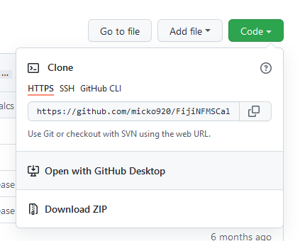

4.4. GitHub Desktop desktop will open.

* You may have to accept a browser request to use Github desktop for these actions. To do so, select GitHubDesktop.exe and then ‘Open Link’

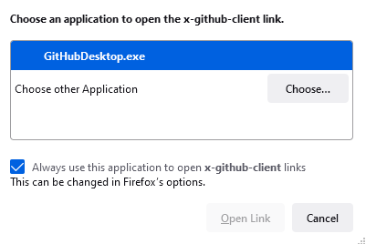

4.5. You will be prompted to clone the [Fiji NFMS Calculations repository](https://github.com/micko920/FijiNFMSCalculations)

* You will need to choose a local path. Select ‘Choose’, then navigate to your local Documents directory and create a new a folder ‘FijiNFMSRCode’ and click select to choose this as the path.
* Finally, select ‘Clone’.

4.6. Now repeat steps 1-5 for the [FIJI NFMS Integration repository](https://github.com/micko920/FijiNFMSIntegration)

* **Ensure you choose the same folder path at step 5.**

# 5. Running the script

5.1. Open R Studio

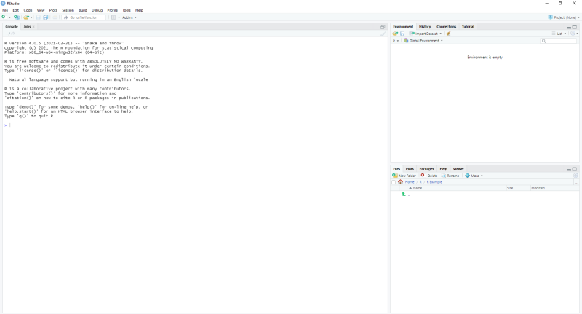

5.2. Set working directory to the new ./FIJINFMSRCode/FijiNFMSIntegration directory

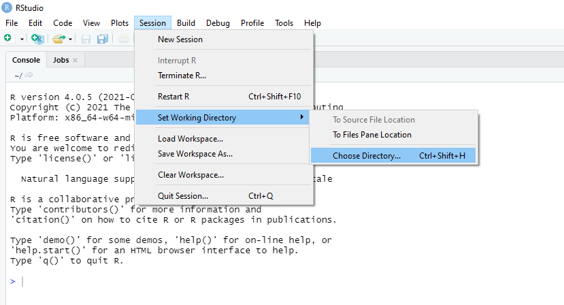

5.3 Open and run **requirements.R** (Accept Packages Update if notified. You only need to do this once. You can click ‘No’ the second time.) You may also have to Accept using compiled code as well as binaries.

5.4. Open and run **Fiji_ER_Estimate_Values.R**

5.5. This must be completed first before you can start to generate reports.

5.6. To generate the report you must run the following command in the console:

rmarkdown::render('./reports/Fiji_ER_Estimate_Values.Rmd')

5.7 You can now open the generated .html file which will be saved in the ./reports directory.

# 6. Using the Shiny App

**Example: ER Estimate Values**

6.1. Copy and paste the following code into the console

library('shinyjs')

6.2. To run the app, copy the following into the console:

shiny::runApp('./appER_Estimate_Values.R')

6.3. Enter data into the text boxes and file input files on the Data Upload tab.

All the required data is located in: ./FijiNFMSIntegration/Data/MonitoringReport2021

| Inputs | Source |
| --- | --- |
| AdjustedAreas From Accuracy Assessment | Fiji_ER_Estimate_AccuracyAssessment.Rdata |
| Monitored Values - year 1 and 2 | 2020ERMonitoredValuesSummary.xls, Sheet 1 |
| Monitored Values - burn data for year 1 | Burn2019.txt |
| Monitored Values - burn data for year 2 | Burn2020.txt |
| Monitoring Report Params | 2020ERMonitoredValuesSummary.xls, Sheet 2 |

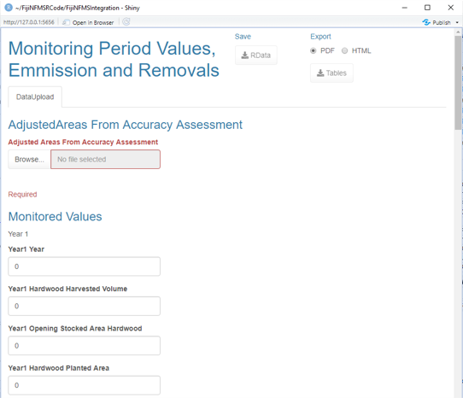

6.4. Once all data is loaded select ‘Proceed to Run Calculations’

6.5. Click ‘Run’ to start calculations. When completed the results tables will appear on screen under the Results heading.

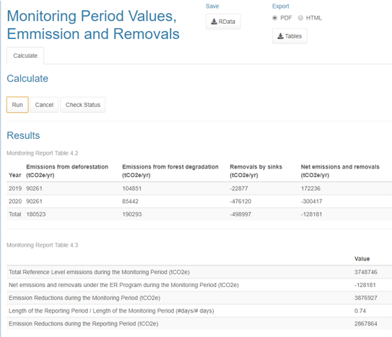

6.6. You can now save the R Data file and Export the Report Tables in both html and pdf format.

**Please refer to SOP 415 (Located on FIMS) for the procedure for using these tools for FCPF monitoring report generation.**