1. (a)
(b)
(c)
X Y | Z
X Y | 0 | 1
0 0 | 1 | 0
1 0 | 0 | 0
0 1 | 1 | 0
1 1 | 1 | 0

2. (a) (b)
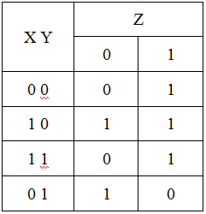
(c)

3. (a) (b)
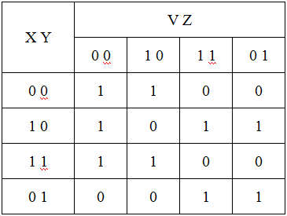
(c)

4. (a) (b)
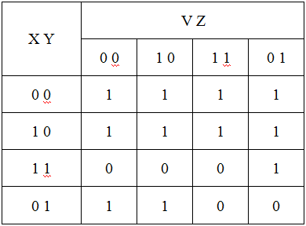
(c)

5. (a) (b)
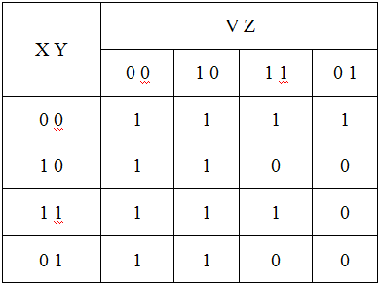
(c)

