**Instructions for connecting to DMM with connection to client’s API via VPN**

1. First, you need to connect to the VPN in my office, as follows:
   * Create a new **PPTP** VPN connection in Windows, using the following information:

**Host:** funemahn.gotdns.com

**Login:** Milos

**Password:** [will send separately]

1. Once connected, you should have IP, but no DNS network connectivity to the RPI host which has a DHCP reserved IP of 192.168.2.113, so it will always stay the same. ICMP is open so after successful VPN connection, you should be able to ping it. The current hostname is: WP-WW123
2. You will now be able to open direct connections to the RPI from your local workstations including VNC, SSH, WinSCP, etc… etc…
3. Credentials for RPI= l/p: pi/solution
4. There’s no need to login as pi and sudo or su because I modified sshd.conf to allow for direct root login to SSH. You can now SSH to the RPI directly as root using: l/p: root/solution
5. Now, you must connect the RPI to the client’s Fortinet IPSEC VPN appliance. You can do so by executing the following commands as root:
   * To start the VPN tunnel: root@WP-WW123:~# **service ipsec start**
   * 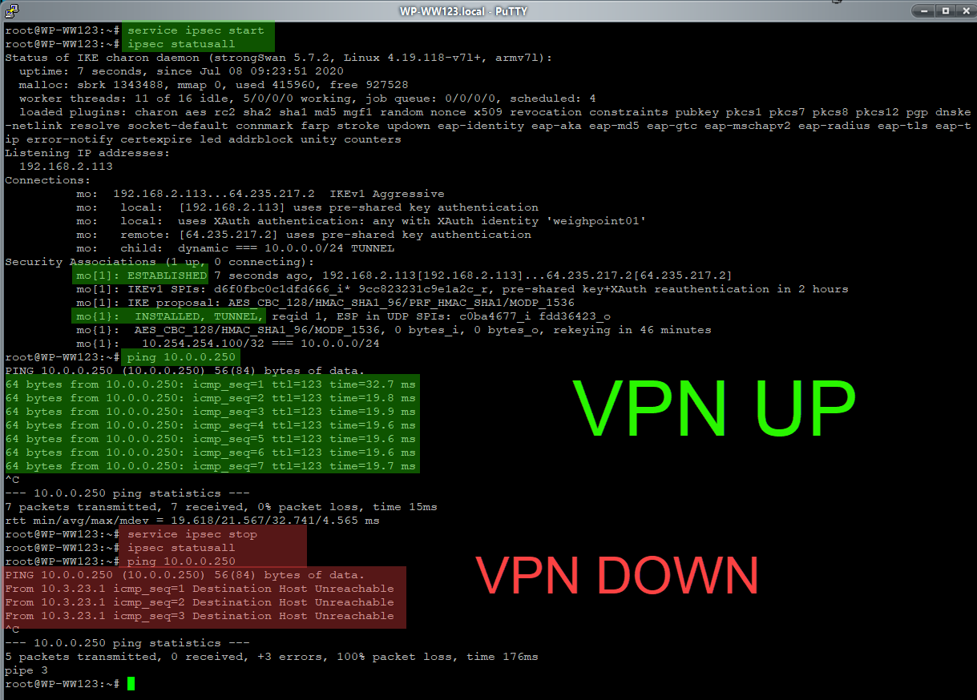To view VPN tunnel status: root@WP-WW123:~# **ipsec status all**
   * **To close VPN tunnel:**  root@WP-WW123:~# service ipsec stop
   * **IP of Client’s API endpoint:** 10.0.0.5 : 80 (may turn to 443 shortly)
   * Periodically, the VPN tunnel may drop, in which case you will not see “INSTALLED, TUNNEL”, and only “ESTABLISHED”. In this case you’ll have to just stop and start the tunnel again. Not to worry, this doesn’t happen very often and usually on happens if it idles for too long; it’s probably a built-in timeout on the client’s side.
6. I will leave the setup on and available 24/7 for you to access anytime you like.
7. I will leave the scale simulator connected via RS232 and set at 1501lbs.
8. You can emulate the client’s FreightBill and Item Level barcodes by just using numerical ASCII inputs (ie.. 168342-001, 168342-002, 168342-003, etc….)