COUSERA CAPSTONE PROJECT

BATTLE OF THE NEIGHBOURHOODS

Report submitted in partial fulfilment for completion of the Applied Data Science Capstone Course on IBM for Data Science Coursera

By

MICHAEL SEKYERE

# **DECLARATION**

I hereby declare that this report is my submission as the original work done through research. I also declare that it has not been previously and concurrently submitted for this course.

# **ACKNOWLEDGMENT**

I would like to express my sincere gratitude to the instructors who have taught me throughout the beginning of this course.

A very big thank you to IBM Cousera for providing me with the opportunity to learn about Data Science and to work on this Capstone project. I am deeply grateful for their help and valuable guidance throughout.

I would also like to express my gratitude to all persons who in one way or the other assisted me in this course. I say a very big thanks to you all

Contents

**DECLARATION** 2

**ACKNOWLEDGMENT** 3

**INTRODUCTION** 4

Description of the problem and background 4

**DATA** 5

Data Sources 5

Sample queries that can be answered by the data 5

**METHODOLOGY** 6

**RESULTS** 7

**DISCUSSION** 10

**CONCLUSION** 10

# **INTRODUCTION**

## Description of the problem and background

The population of New York City has grown considerably over the last decades. New York is very diverse. It consist of a large and ethnically diverse group of people. New York City is home to over 18 million people. With its diverse culture, comes diverse way of living for the people of New York. Notably, the different kinds of lifestyles, music genres, dressing, movies, foods, languages, etc.

There are many restaurants in New York City, each belonging to different categories like Chinese, Indian, and French etc. The idea of this project is to help my client who is planning to open an Italian restaurant in New York chose the right location by providing data about the different types restaurant already existing in each neighborhood as well as the competitors already present in the same regions. Since the New York demography is so big, my client needs deeper insight from available data in other to decide where best to establish the restaurant in order to receive the maximum clientele. Therefore, as part of this project, we will list and visualize all major parts of New York City that has great Italian restaurants. I will also compare neighborhoods where customer gives the best tips and ratings about Italian restaurant.

# **DATA**

## Data Sources

New York City data contains many of list Boroughs, Neighborhoods along with their latitude and longitude.

Data source: https://cocl.us/new_york_dataset. It was obtained from the from the Applied Data science Capstone course for IBM.

Description: This data set contains the required information. Moreover, we will use this data set to explore various neighborhoods of New York City and available Chinese restaurants in each of the neighborhoods.

Data source: Foursquare API Description.

Description: By using this API, we will get all the venues in each neighborhood. We can filter these venues to get only Chinese restaurants.

GeoSpace data source: https://data.cityofnewyork.us/City-Government/Borough-Boundaries/tqmj-j8zm

Description: By using this geo, space data we will get the New York Borough boundaries that will help us visualize choropleth map.

## Sample queries that can be answered by the data

1. What is best location in New York City for Chinese Cuisine?

2. Which areas have already existing Chinese Restaurant Market?

3. Which areas lack Chinese Restaurants?

4. Which is the best place to site a Chinese restaurant?

# **METHODOLOGY**

1. Collect the New York City data from https://cocl.us/new_york_dataset

2. Using Foursquare API we will find all venues for each neighborhood.

3. Filter out all venues that are Italian Restaurants.

4. Find rating, tips and like count for each Italian Restaurants using Foursquare API.

5. Using rating for each restaurant, we will sort that data.

6. Visualize the Ranking of neighborhoods using folium library

# **RESULTS**

Upon extraction the neighborhoods from our data, I realized that there are a total of 5 borough and 306 neighborhoods in New York with the majority of it in the Queens area. The bar charts representation is shown in the picture below;

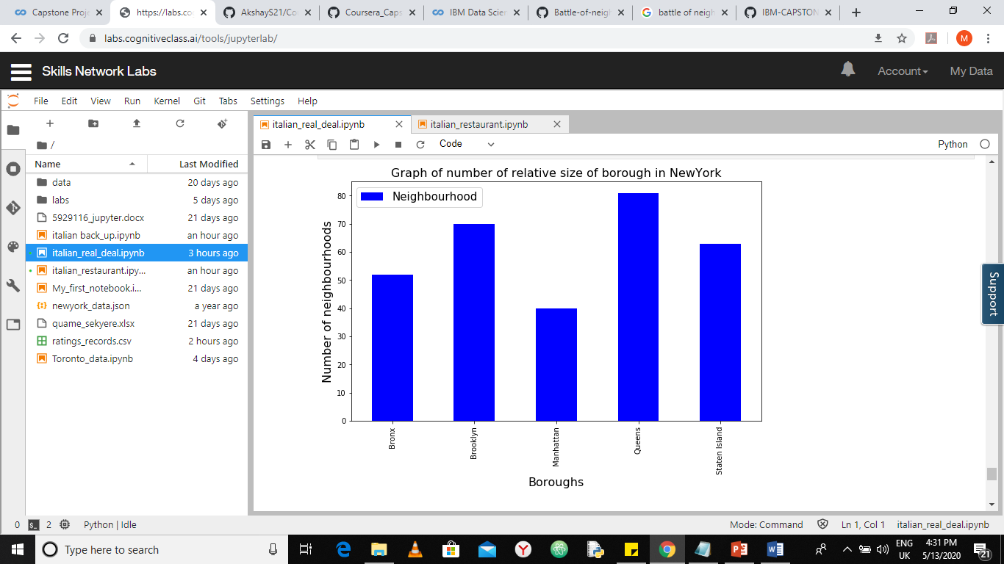

*Figure1: bar chart representation of the number of neighborhoods present in each borough of NY*

From the available data, we were also able to locate 457 Italian restaurants around New York using the Foursquare API. The majority of which are spread across the Brooklyn and Manhattan

That information is also represented in the figure below.

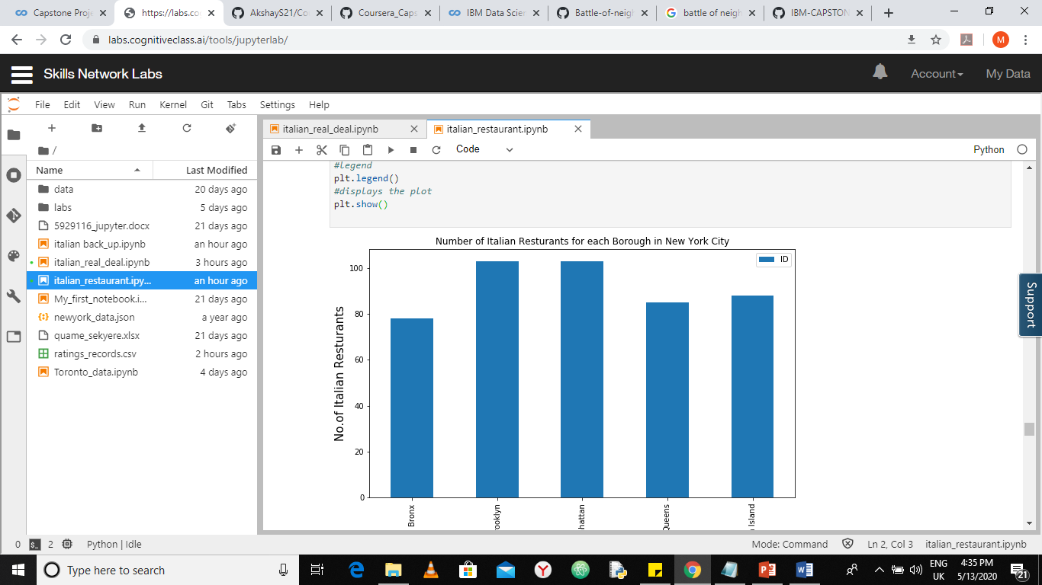

*Figure2: bar chart representation of the number of Italian Restaurants present in each borough of NY*

I then gathered information about each of the Italian restaurants. Information about their likes, tips and ratings.

From the information I gathered, Tino’s Delicatessen in Belmont rated highest in both likes and ratings making it arguably the best Italian restaurant in all of New York.

I also gathered information about the average likes and ratings of the neighborhoods in the data and realized that restaurants in Belmont has the highest rating which makes that neighborhood very good place to site up an Italian restaurant.

The top 15 rated neighborhoods in New York in terms of Italian restaurants are in the picture below

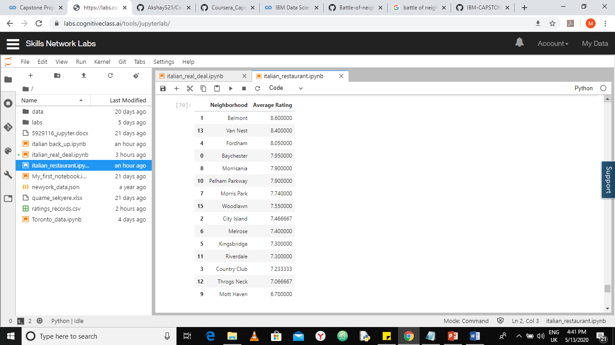

*Figure3: Top 15 rated Italian restaurants in New York*

# **DISCUSSION**

* Tino’s Delicatessen in Belmont is the best Italian restaurant in New York
* Belmont rates highest in both likes and ratings making it arguably the best neighborhood to site an Italian restaurant in all of New York.
* The Bronx area has best places for italian restaurants while Queens ranks last for Italian restaurants

# **CONCLUSION**

# 

1. The Bronx contains venue for some of the best Italian dishes in New York

2. Brooklyn and Manhattan have potential Italian Restaurant Market

3. The Bronx is the best place to stay if you prefer Italian Cuisine.

4. The ranking is purely on basis of rating of restaurants

5. The accuracy of data depends purely depends on the data provided by Foursquare

NB: Due to insufficient API calls, the steps outlined in this project may not be accurate but nonetheless it laid down a procedure that can be used to solve the problem