For design

You need to add design for following.

For request box:

Original: You can see this in current project

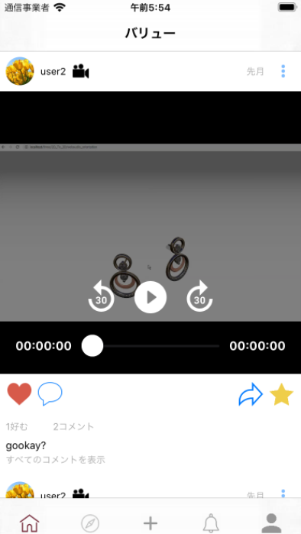

Latest design for adding:

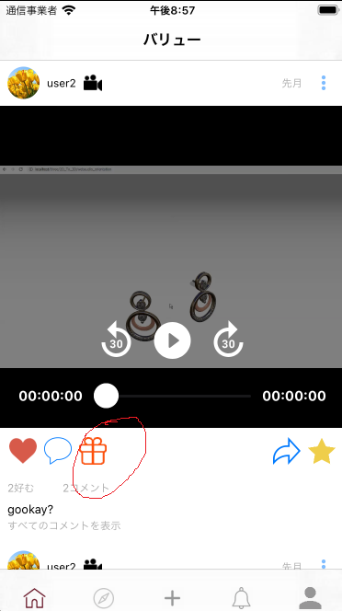

When user click request box, user can send text like comment

After that user have to see following screen that have multiple button

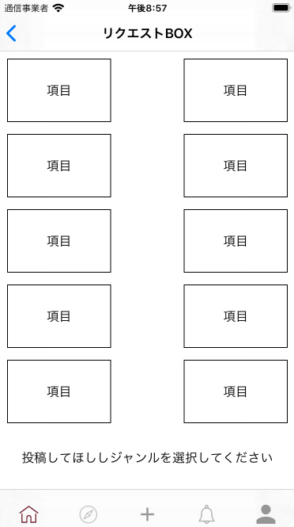

Every item mean category(for example: Art,Food and Drink and so on)

So user should be able to send question about category by clicking each button.

After clicking it, user can see following like this

Also the category button would be modern design.

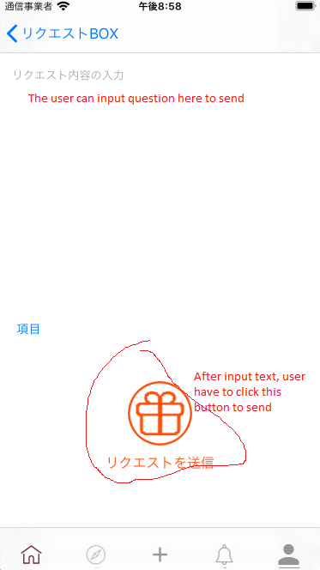

Figure 1

If you have any question about request box, let me know

Next original design:

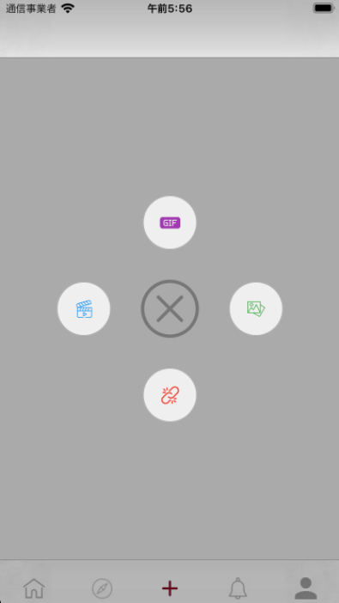

Latest design for deleting gif button:

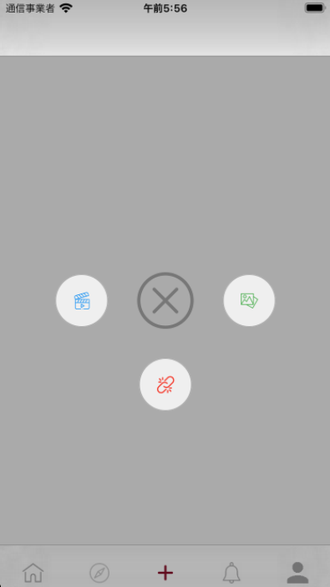

Latest design for user profile:

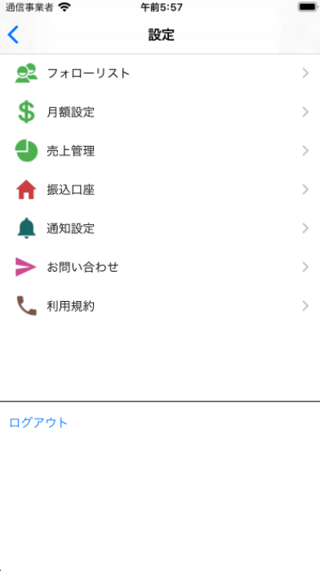

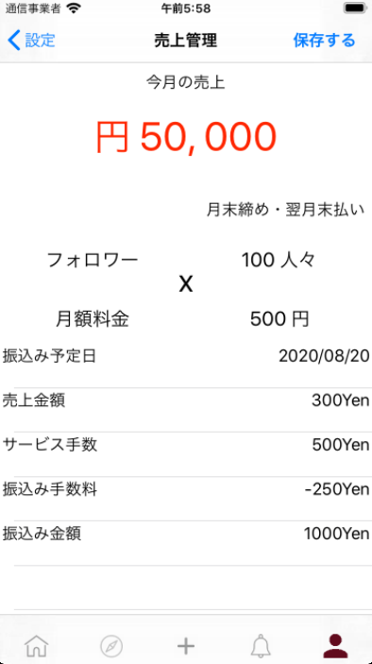

This is about payment status design.

In this app when the user follow favorite user, the user have to pay for following.

So every user can see payment status in their user profile like above

This design mean 100 users followed you each 500 yen for payment.

If you have any question about payment status, let me know

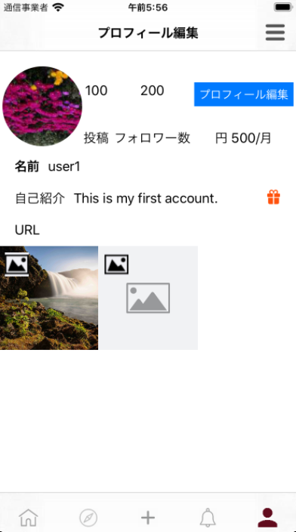

After clicking request box:

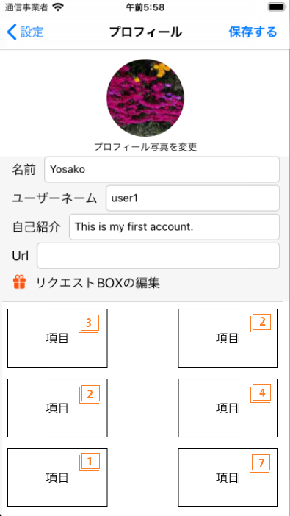

This is about design for when user send question in request box, received user can see like this in their user profile.

If the user sent 3 question , the number 3 have to be displayed in one category button like above.

Also the user that received question can send answer by clicking the category button.

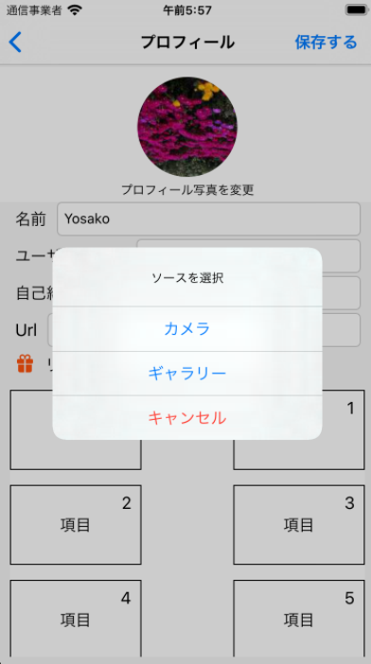

Latest design for setting following price:

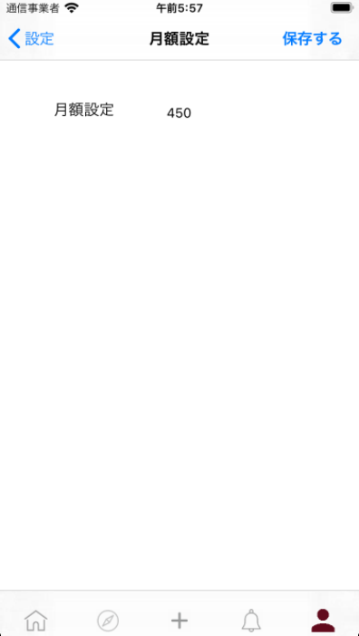

The user should be able to set the following price in user setting like above.

If the user set following price for 500 yen, other user will pay 500 yen for following .

Latest design for sending email:

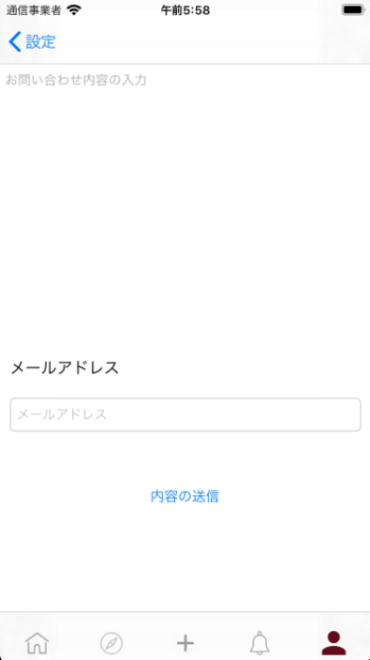

Terms of sevices:

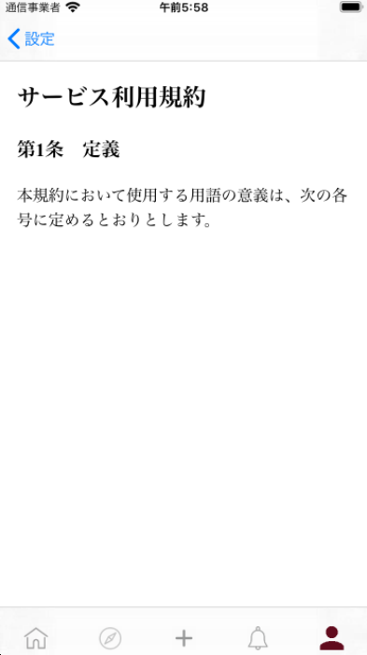

Existing (original) design:

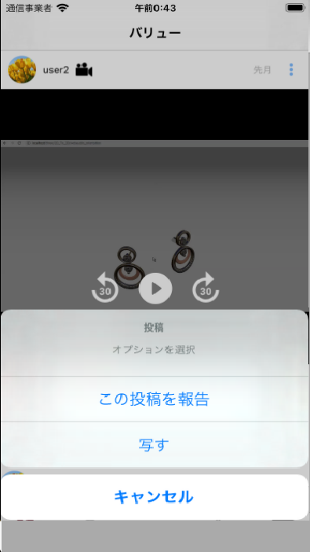

Latest Design:

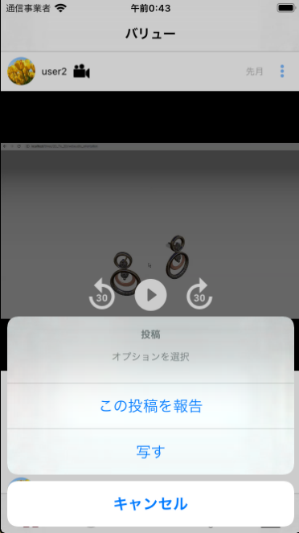

IF you have any question, please feel free to contact me