ABSTRACT TEMPLATE
Theme: HEIs at the Forefront of Transformative Extension: Advancing Evidence-Based, Inclusive, Sustainable, and Resilient Community Development
Instructions: Complete all sections. Select only one paper category and one thematic area. Use clear, evidence-based statements and avoid unsupported outcome or impact claims.

A. Paper Information
1. Title of the Extension Project Paper | PaG-ULIKID Katawhayan Peacekeepers for Security and Safety
2. Author/s and Institutional Affiliation/s Note: Use an asterisk (*) after the name of the project leader. If the presenter is not the project leader, write “paper presenter” after the name | Vanessa T. Cayacay PhD.  Director ESO  State University of Northern Negros
3. Name and Email Address of Corresponding Author
3. Paper Category | [ /] Completed Extension Project Paper  [ ] Ongoing Extension Project Paper
4. Thematic Area (choose 1 only) | [ ] Food Production, Agriculture, Fisheries, and Natural Resource Systems  [ ] Health, Nutrition, Wellness, and Community Care  [ /] Education, Literacy, Skills Development, and Lifelong Learning  [ ] Livelihood, Entrepreneurship, Cooperatives, MSMEs, and Local Economic Development  [ ] Environment, Climate Action, Disaster Risk Reduction, and Community Resilience

B. Extended Abstract Narrative
Guide: Write concise paragraphs under each required component.
5. Community or Sectoral Need Addressed
Briefly describe in not more than 150 words the validated community, institutional, or sectoral need addressed by the project.
The PaG-ULIKID KATAWHAYAN (Peacekeepers for Security and Safety) project addresses the validated need for strengthened community safety, peace, and social structure in Barangay Old Sagay, Sagay City, Negros Occidental. Community needs assessment identified concerns related to peace and order, community security, conflict prevention, and the need to strengthen residents’ awareness and participation in maintaining a peaceful and safe community. The project responds by enhancing the knowledge, skills, and capabilities of Barangay Tanod and community members and local peacekeepers in peace education, conflict resolution, disaster and safety preparedness, and community-based security initiatives. It also promotes active collaboration among residents, barangay officials, and partner institutions in addressing emerging community concerns. Through these interventions, the project seeks to build a more informed, resilient, peaceful, and responsive community capable of sustaining security and safety through collective action.
6. Project Objectives
State the main objective/s of the extension project.
1. To help build a peaceful and safe community;
2. To provide the Barangay Tanod and fathers in Saint James Ville the necessary trainings and seminars to promote security and safety in the community;
3. To organize volunteer empowered, functional and sustainable Peacekeepers in St. Jamesville among the Barangay Tanod and fathers of the community;
4.Work hand in hand with the Barangay Old Sagay officers in promoting security and safety at St. James Ville; and;
5.Establish linkages with other organizations in supporting peaceful and safety community at St. James Ville.

7. Extension Methods, Strategies, or Activities Implemented
Describe in not more than 300 words the major extension approaches, methods, strategies, or activities implemented.
1.Capability Building
2.Seminar on awareness of Barangay Ordinances, and Gender-related laws which promote social protection
3.Seminar on duties and function of Barangay Tanod
4.Seminar on causes of crime and crime victimization
5.Self-defense Training
6.Arrest Technique
7. First Aid Training
8. Key Outputs, Emerging Results, and Evidence of Outcomes, Adoption, or Utilization
Briefly present in not more than 300 words the documented outputs and emerging results of the project. Include available evidence of outcomes, adoption, utilization, capability-building, institutional change, or public value, if applicable. Claims must be supported by verifiable evidence.
a. Major Outputs or Emerging Results
1. Champion on the Tanods Olympics 2025 the competitions focused on three main areas of assessment: basic life support, firefighting, and arrest techniques
2. In the barangay category, Old Sagay emerged as champion received cash prizes of P20,000 also received one handheld walkie-talkie radio to support communication during operations.
3. Organized volunteer empowered, functional and sustainable Peacekeepers in St. Jamesville.
4.Linkage with PNP, DSWD in supporting peaceful and safety community at St. James Ville.
b. Evidence of Outcomes, Adoption, or Utilization
[Type response here. If not yet available, write: “Not yet available.”]
Achieved Champion in the Tanods Olympics 2025, demonstrating enhanced competencies in basic life support, firefighting, and arrest techniques.
c. Supporting Documents/Evidence Available
[Examples: attendance sheets, monitoring reports, photos, testimonials, adoption records, partnership agreements, policy issuances, utilization reports, or other proof.]
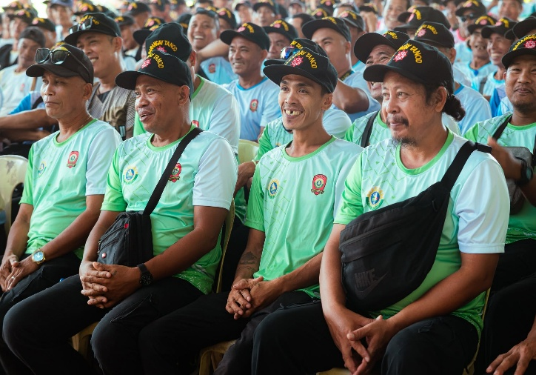
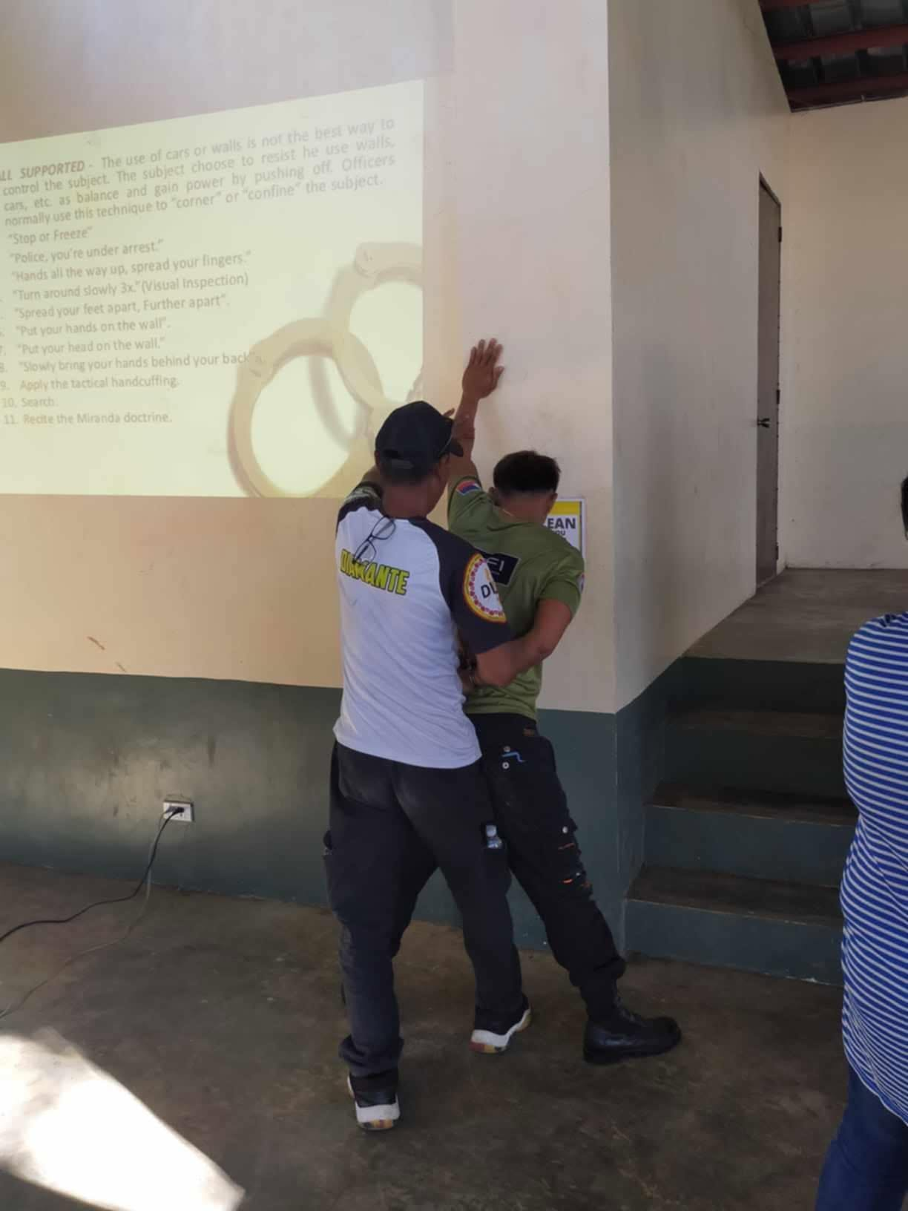
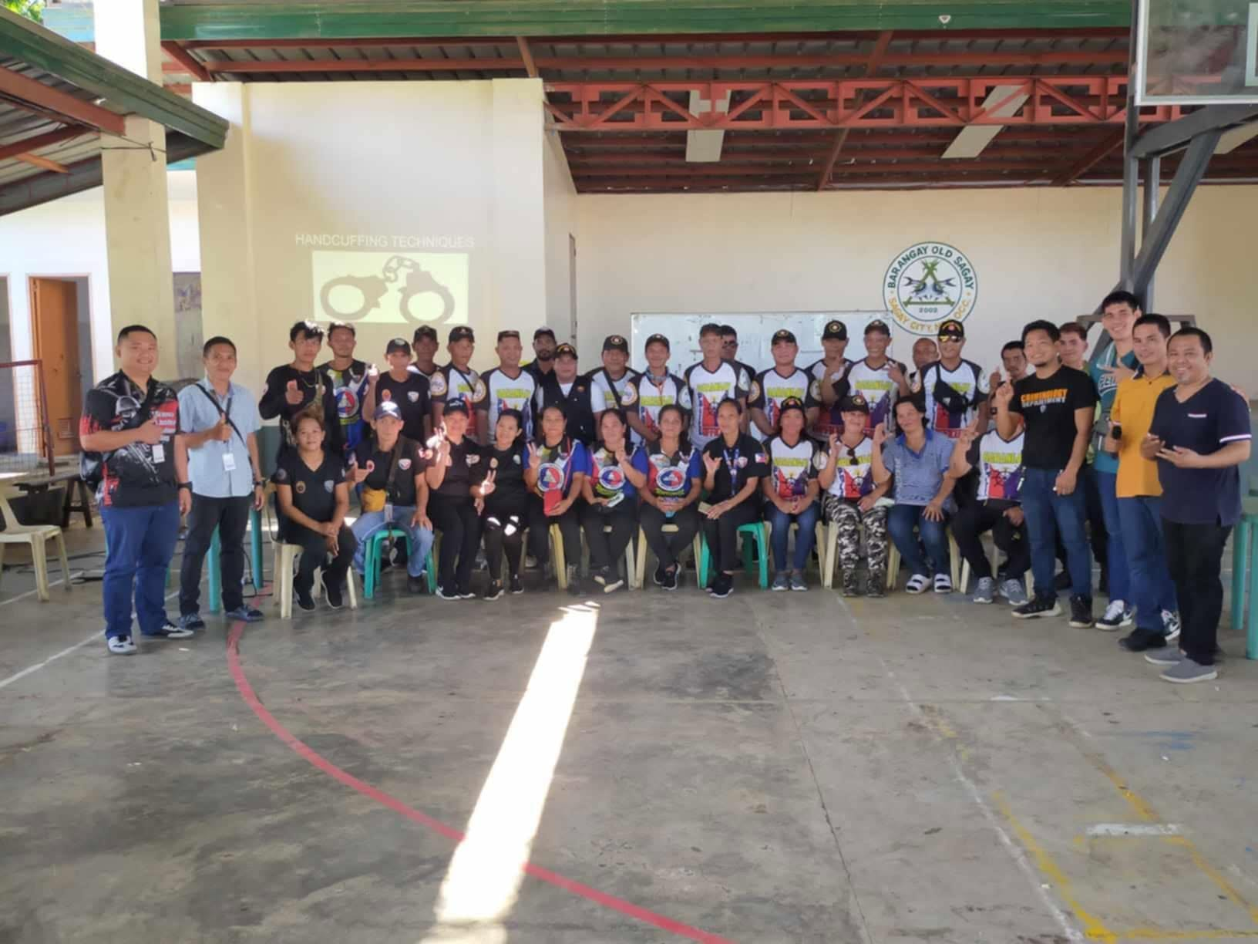
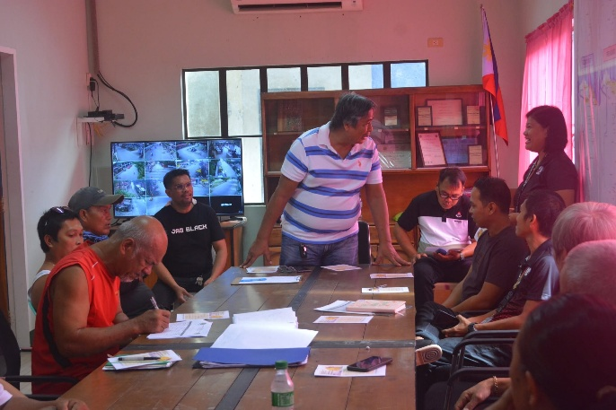
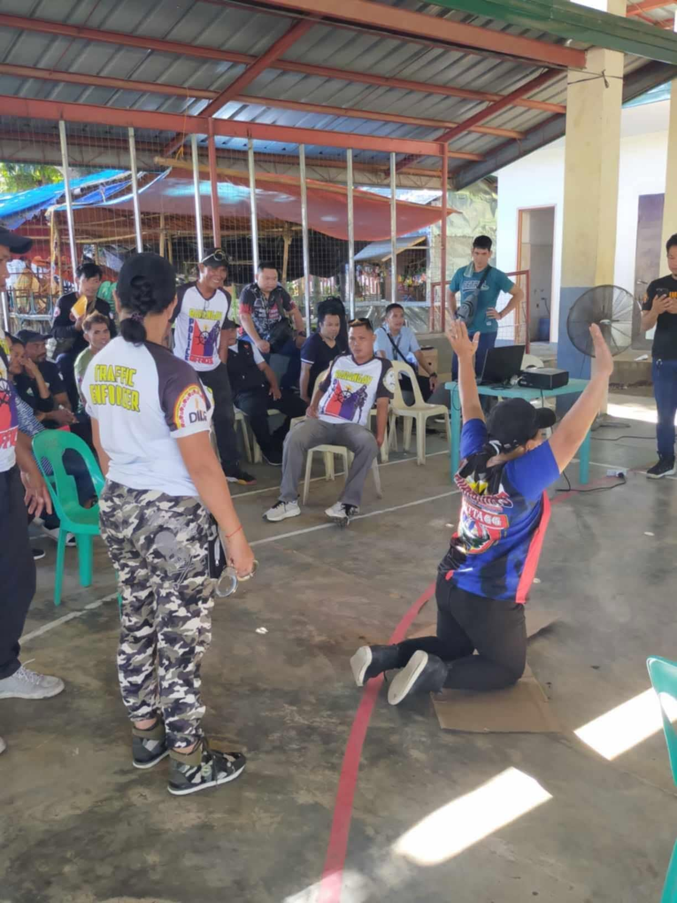
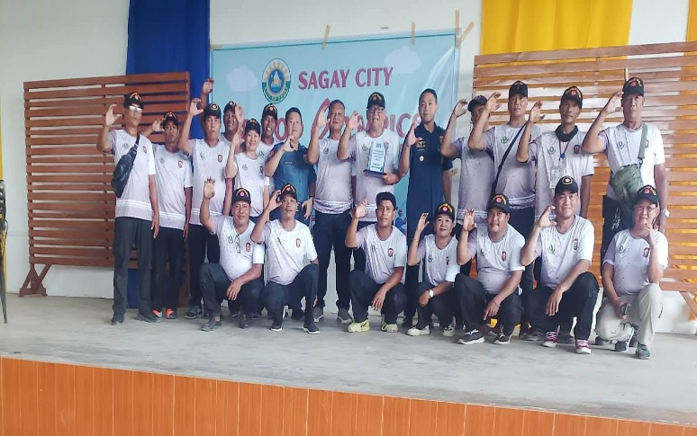
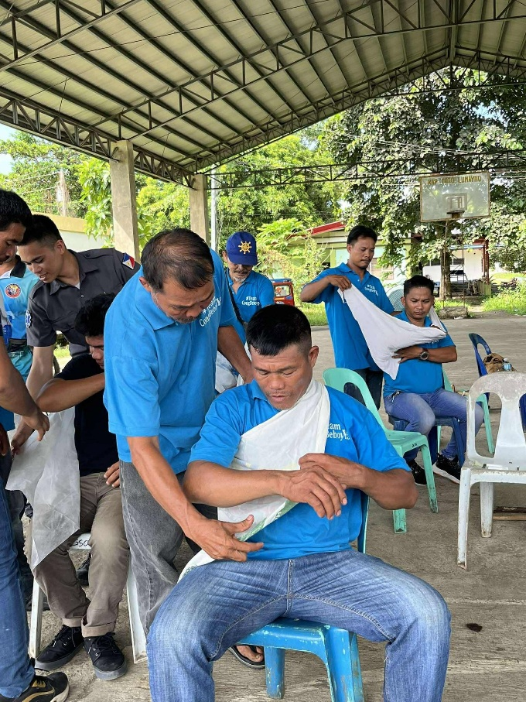
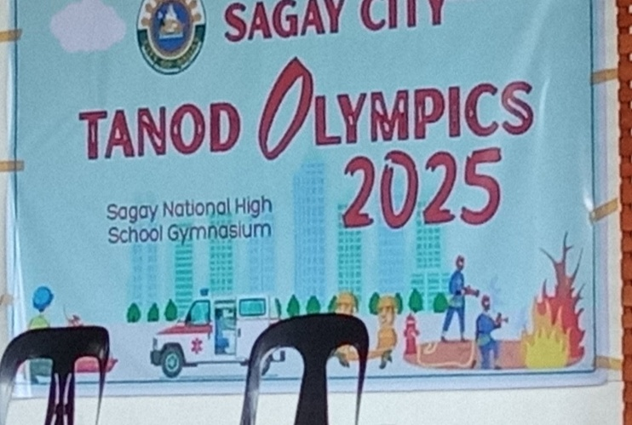

TERMINAL REPORT
Academic Year 2024-2025
Project: PaG-ULIKID Katawhayan(Peacekeepers for Security and Safety)
Location: Brgy Old Sagay, Sagay City Negros Occidental
Proponent: Vanessa T. Cayacay Ph.D
General Description of the Project: Pag ULIKID KATAWHAYAN Peacekeepers for security and safety is a project spearheaded by the College of Criminal Justice Education through its extension program. The main goal of the project is to organize volunteer empowered and sustainable peacekeepers among Barangay Tanod and fathers of Saint James Ville Barangay Old Sagay Sagay City Negros Occidental
Date Started: June 1, 2020
Expected Completion: June 1, 2025
Activities Previously Undertaken:
- Consultation Meeting
- MOA Signing
- Seminar on Awareness of Barangay Ordinances and Gender Related Laws which promotes social protection
- Seminar on causes of crime and crime victimization,
- Self defense Training
- Arrest Technique
- First Aid Training

Persons Involved:
Name Involvement
Vanessa Cayacay Proponent/ Project Lead
Ryan Cayacay Facilitator/Resource Person
Sherwin Baynosa Facilitator
Angelo Layson Facilitator
Joleo Magandan Resource Person
Iver Montano Facilitator
Freddie Maguad Resource Person

Activities Undertaken During the Period:
1.Conducted a consultation meeting with concerned personnel and stakeholders to discuss relevant concerns, plans, and activities. The meeting provided an opportunity to clarify objectives, identify issues and needs, exchange recommendations, and establish appropriate actions to ensure the effective implementation of planned programs and activities. Key points raised during the consultation were documented and considered in the preparation of succeeding activities and necessary interventions.
2.Facilitated and participated in the signing of the Memorandum of Agreement (MOA) between the Barangay Old Sagay and SUNN to formalize their partnership and establish clear roles, responsibilities, and commitments. The activity strengthened institutional collaboration and provided a framework for the effective implementation, monitoring, and sustainability of the agreed programs and activities.
3.Conducted a seminar to increase participants’ awareness and understanding of relevant barangay ordinances and gender-related laws that promote social protection, equality, safety, and the protection of individual rights. The activity provided participants with practical information on their rights and responsibilities, available protection mechanisms, and the importance of community participation in preventing discrimination, violence, and other social concerns. The seminar also encouraged active cooperation among community members and local stakeholders in promoting a safe, inclusive, and supportive community.
4.Conducted a seminar on crime and crime victimization to enhance participants’ awareness and understanding of the causes, nature, and effects of criminal activities and their impact on individuals, families, and communities. The activity discussed common forms of victimization, risk factors, prevention strategies, and appropriate responses to criminal incidents.
5.Conducted a self-defense training activity designed to enhance the Barangay Tanod and the Father’s knowledge, skills, confidence, and preparedness in responding to potential threats and dangerous situations. The training included basic self-defense techniques, situational awareness, risk avoidance, proper defensive posture, and appropriate responses during emergencies. The activity emphasized personal safety, responsible use of defensive techniques, and the importance of avoiding unnecessary confrontation while promoting confidence and preparedness among participants.
6.Conducted a training activity on proper arrest techniques to enhance Barangay Tanod and Fathers’ knowledge and understanding of lawful, safe, and appropriate procedures in handling arrest situations. The activity covered basic principles of arrest, proper approach and communication, safety precautions, appropriate restraint procedures, and respect for the rights and dignity of persons being arrested. Emphasis was placed on professionalism, accountability, minimum necessary force, and compliance with applicable laws and established procedures.
7.Conducted a First Aid Training activity to enhance Tanod and Fathers’ knowledge and skills in providing immediate and appropriate assistance to individuals who may experience injuries, accidents, or medical emergencies. The activity covered basic first aid procedures, emergency response, wound care, bleeding control, and proper handling of injured persons while awaiting professional medical assistance. The training emphasized preparedness, safety, and prompt response to help prevent further injury and promote the well-being of individuals in emergency situations.
Expenditure:
: P378,000.00(5 years) (SUNN EXTENSION OFFICE)

Submitted By:


VANESSA T. CAYACAY Ph.D.
Project Lead

Note: Report must be supported with pictorials.
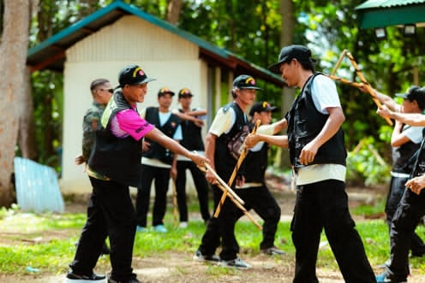

The activity involved a practical self-defense training session focused on developing participants’ awareness, confidence, coordination, and basic defensive techniques. Participants were guided through proper handling and use of training sticks, appropriate defensive movements, and safe techniques for responding to potential threats.
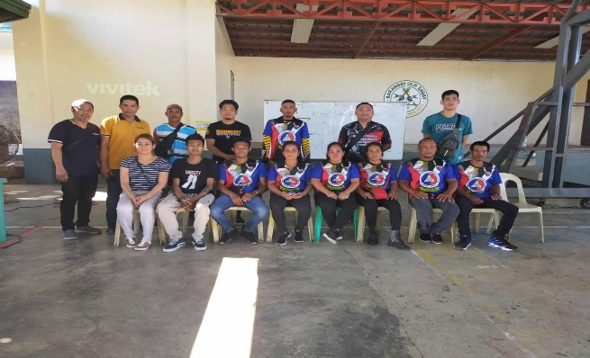
Mr. Fredie Maguad Faculty of CCJE conduct lecture and actual demonstration on practical self-defense

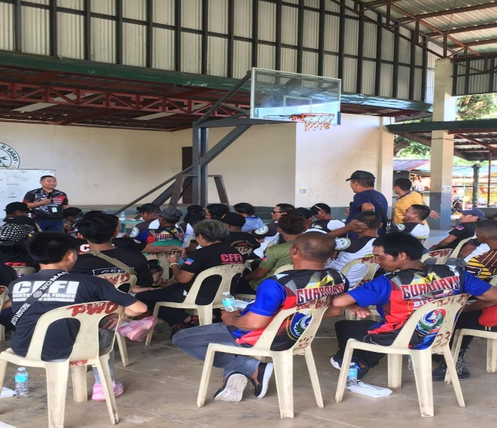
A lecture on barangay ordinances and gender-related laws was conducted to enhance the participants’ knowledge and understanding of the principles, roles, and responsibilities of peacekeepers. The discussion covered conflict prevention, maintaining peace and order, protection of civilians, respect for human rights, and effective communication in conflict situations.

Mr. Joleo Magandan Faculty CCJE talk about the role of Barangy Tanod and Ms. Vanessa Cayacay Extension Director of SUNN talk about RA. 9262 and Gender and Development
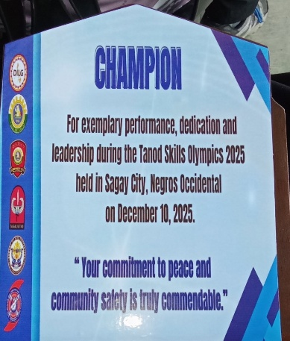
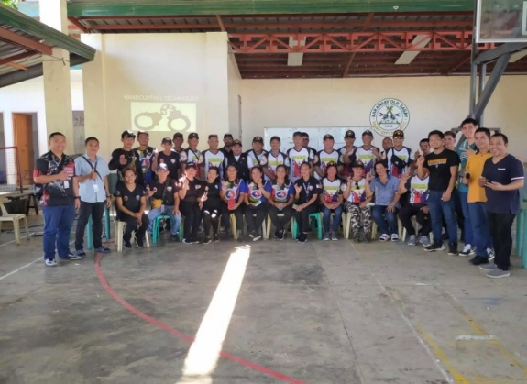
The Barangay Tanods of Barangay Old Sagay for being the CHAMPION of the Tanods Olympics 2025 held this day at the OSNH Gym.

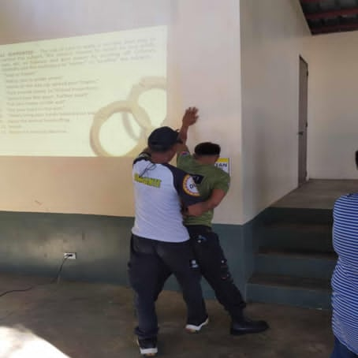

A lecture on Arrest was conducted to enhance the participants’ understanding of the legal principles, procedures, and proper techniques in making an arrest. The discussion focused on lawful arrest, the rights of arrested persons, the responsibilities of arresting officers, and the importance of observing due process and human rights. The activity strengthened the participants’ knowledge and awareness of proper arrest procedures, emphasizing lawfulness, professionalism, restraint, and respect for human rights during the performance of peacekeeping duties.

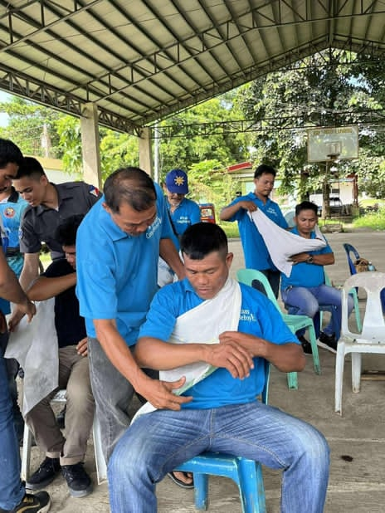
A lecture on First Aid was conducted by Director of Risk Reduction and Management of SUNN to provide participants with basic knowledge and skills in responding to emergencies and injuries. The discussion covered initial assessment, basic life support, wound care, bleeding control, and proper emergency response.
The activity enhanced the Barangay Tanod and the fathers in Saint James Ville Brgy. Old Sagay preparedness and confidence in providing immediate assistance to injured or ill persons while awaiting professional medical help.
Submitted By:


VANESSA T. CAYACAY Ph.D.
Project Lead

9. Sustainability Direction or Next Steps
Explain in not more than 150 words how the project will be sustained, institutionalized, scaled, or improved, or state the next steps for ongoing projects.
The PaG-ULIKID KATAWHAYAN (Peacekeepers for Security and Safety) extension project will be sustained through continuous collaboration and partnership with barangay officials, community stakeholders, and government agencies involved in peace, safety, disaster preparedness, and community development. The project will be replicated and expanded to other barangays with similar needs, using the lessons learned, strategies, and best practices from its implementation in Barangay Old Sagay. Capacity-building activities, community awareness programs, and skills training will be conducted regularly to strengthen the knowledge and preparedness of community members. The University will continue to establish and strengthen partnerships with relevant agencies and organizations to provide technical assistance, resources, and support. Monitoring and evaluation will also be conducted to assess the project's effectiveness and identify areas for improvement, ensuring its sustainability, institutionalization, and wider community impact.
C. Keywords
10. Keywords, three to five keywords: [Keyword 1; Keyword 2; Keyword 3; Keyword 4; Keyword 5]
Peacekeepers, Security, Safety, Barangay Tanod, Extension program,

For PEMNet Abstract Review Committee Use Only:
[ ] Recommended for Acceptance
[ ] Not Recommended for Acceptance

Reviewed by: ___________________________________________________
Chair, PEMNet Scientific / Abstract Review Committee

