**Mini-MIPS 8-bit Processor**

**OVERVIEW**

An 8-bit MIPS-like single-cycle CPU.

**ISA**

This is the Instruction set for the simple 8-bit processor. There is only two 8-bit registers (**$r0** and **$r1**). There is an 8-bit **PC**.

***Mini-MIPS*** has separate instruction memory and data memory. Each has maximum capacity of **256 bytes**.



**INSTRUCTION FORMATS**



**immediate** field

All immediate fields are treated as unsigned numbers and they are zero extended(Upper 3 bits will be all zeroes)

**R-TYPE** **INSTRUCTIONS**



**I-TYPE** **INSTRUCTIONS**

**lui** (load upper immediate):

Loads an **immediate** value into the upper bits of a register.

**sw** (store word):

Stores the value from a register into **memory** at an address **offset**.

**lw** (load word):

Loads a value from memory into a register using an **immediate** offset.

**ori** (bitwise OR immediate):

Performs a **bitwise OR** between a register and an immediate value.

**disp** (display):

See the section on the 7-segment display, below.

**J-TYPE INSTRUCTIONS**

**jump** instruction

jump instruction has 5-bit address. The address(5-bit) will be concatenated with the upper 3 bits of current value of PC.



**beq** instruction



The offset is a **signed number**, therefore the branch address is calculated as follows. The registers are implied and do not appear in the instruction itself.

if $r0 == $r1

PC = (PC + 1) + offset(sign extended)

else

PC = PC + 1

**ROM & RAM** MODULES

Instruction memory uses the ROM module to load your program. Data memory uses the RAM module..

Note: The ROM & RAM appear to be organized in 32-bit words but they are still “byte-addressable memory”. Also, remember that our word size is only one byte.

**INPUT & OUTPUT**

**Input**

Input will be a program that you will write and assemble(by hand) and load into the Instruction memory module. Use a ROM module to store instructions.

**Output**

Output will be displayed on an array(4 of them) of 7-segment display module.

**7-Segment Display**

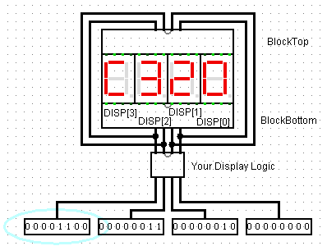

The Disp instruction displays the content of a register to the *imm***th** 7-segment display unit. In the above picture, there are four 7-segment display units.

For example, DISP $r1 [2] # $r1’s content will be displayed on 3rd unit—in this case, the imm= 2 (decimal) 00010 which points to the 3rd unit from right.

If the value of a register $r1 is 00000011(0x03), the display unit will display “3” as above.

**TESTING**

Here is a sample program that you can run as a basic test. The program loads 15(in decimal=F in hex) into register $r0 and display. We do the same for $r1. Then we branch by *beq -1* (it goes back to itself! In other words, “halt”). The result is to display FF on the 7-segment display and stops the program. It is a Display-and-Halt program.

lui $r0, 0 # load upper 4 bits with all zeroes

ori $r0, 15 # or with 15(F in hex)

disp $r0, 0 # display the content of $r0 on **0th** display unit

lui $r1, 0 # load upper 4 bits with all zeroes

ori $r1, 15 # or with 15(F in hex)

disp $r1, 1 # display the content of $r1 on **1th** display unit

beq -1 # Halt