You are provided with four different code html template files. Using the html tags that you already know, modify the html content so each individual file looks similar to their respective image

* Syntax: syntax_template.html

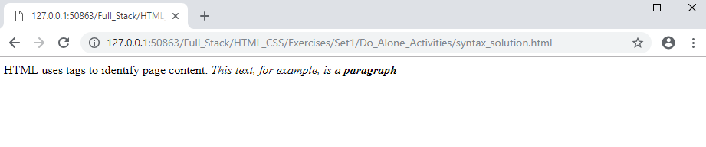

* Body: body_template.html

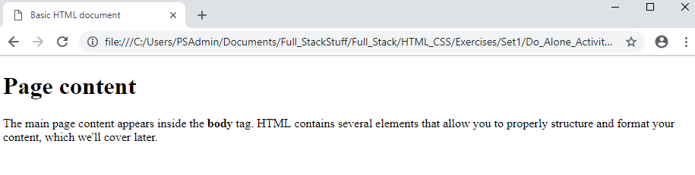

* Models: models _template.html.
  1. For the link, have it redirect to a page that talks about html
  2. Research – how to redirect on a new tab when the link is clicked on. Then implement it.

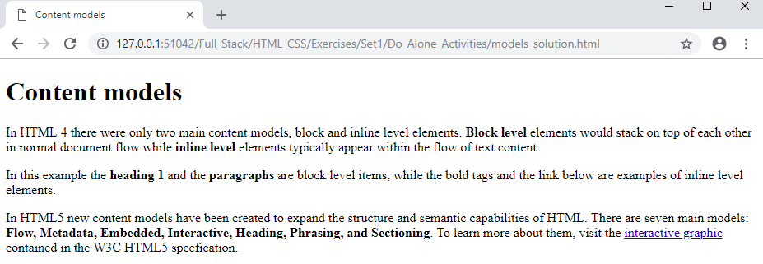

* Headings: headings _template.html

