DOC MICMAC GRAPHICAL USER INTERFACE

Contents

1 – General introduction to the MicMac Graphical User Interface
a – Top Menu
b – ToolBar
c – Top Dock
d – Bottom dock
e – Console
f – File Reader
g – Photos Tab
h – Visu Tab

2 – The workflows
a – Classic
1. Tapioca
2. Tapas
3. Malt
4. C3DC
b – Satellite
1. Tapioca
2. Convert2GenBundle
3. Campari
4. Malt

3 – Visualization tools

4 – 1st example : classic image processing (taken with a classic camera)

5 – 2nd example : satellite image processing (taken with the pleiades satellite)

6 – Warnings
1 – General introduction to the MicMac Graphical User Interface

The MicMac Graphical User Interface is developped in C++, with the help of the qt5 Famework in its 5.0 version. Those choices can be explain by the fact that MicMac has been entirely developped in C++, so the integration of the MicMac Interface code has been facilitated. Qt5 is easy to integrate on every current operating system and is relatively easy to use.
This interface has been developped in order to make MicMac easier to use, without having to type all the command lines in a console. But fundamentally, the commands launched by the console and by the interface are the same : the interface is just another way to create those commands.

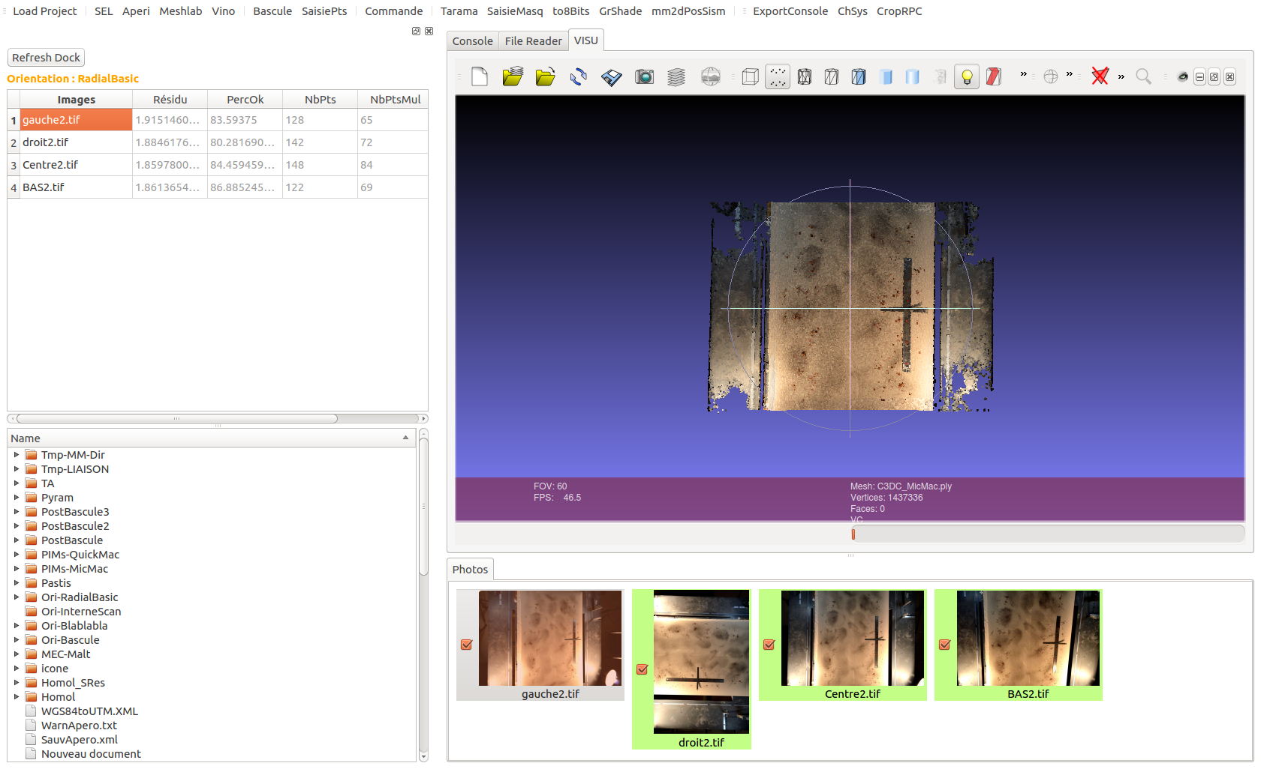

Top menu

Top dock

Bottom dock

Console, File Reader and VISU tabs

Photos Tabs
a – Top menu

This top Menu holds the « File » tab that allows you to create a new project, or to load another existing project. To create a new project : Click on File, then « New Project ». A new window is opened. You have to choose the folder where the images you want to study are placed. Then, click the « Choose » button.

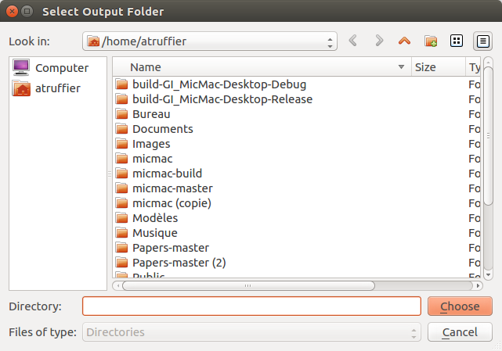

Another little window will ask you if you are really sure that the folder you chose is the right one.

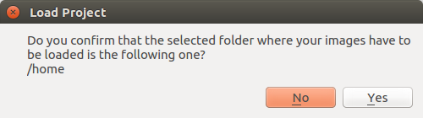

When the project is opened for the first time, the interface freezes. It is because of the images conversion : in order to have a previsualization in the « Photos » tab, the interface converts all the images in .JPEG, and changes their contrast to see clearly all kind of images. The delay is variable in fuction of the size and type of images loaded. Then, when the same project is opened a second time, the images are already converted in the « icone» folder of the project. The interface needs to load the images only. Those images are not the ones which are processed : their function is just to give a previsualisation and to give the user the possibility to make a selection.
To load an existing project, click on the «File» drop down menu, then place your cursor on “Recent project”: a list of other projects which have already been opened appears. Click on one of them. Then, the “Load Project” window is opened and asks you to confirm your choice. The interface will load automatically the entire informations already know about the project.

Next to the « File » drop menu, two workflows : the « Satellite Workflow », containing all the functions you have to launch in a satellite image processing (Convert2GenBundle (cf.), Tapioca (cf.), Campari (cf.) and Malt (cf.)) and a « Classic Workflow » (Tapioca (cf.), Tapas (cf.), Malt (cf.) and C3DC (cf.)) used in case of a project using a classic camera.
Those funtions have to be used in this order ! For example, creating an orientation with Tapas without having computed tie points with Tapioca before will not work.

And, finally, the visualization tool is a drop menu with three buttons : SEL (cf. ), Meshlab (cf. ) and AperiCloud (cf. ).

b – Toolbar

This Menu is made of 16 buttons :

Load project has exactly the same function as New File, described previously in the Top drop menu.

SEL is a tool that produces a visualiztion of the tie points computed with Tapioca.

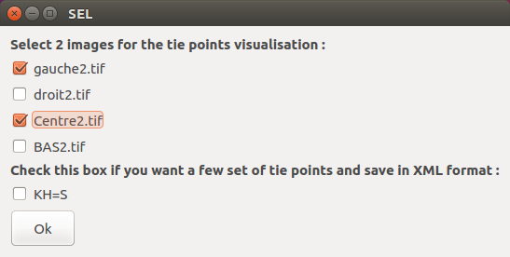
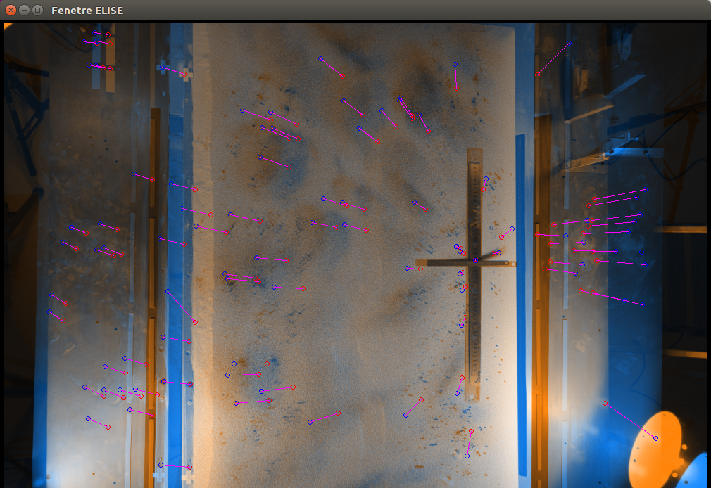

Aperi produces a point cloud based on a created Orientation.

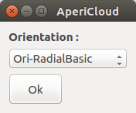

Meshlab opens files with a .ply extension in the meshlab software (like point cloud files) :

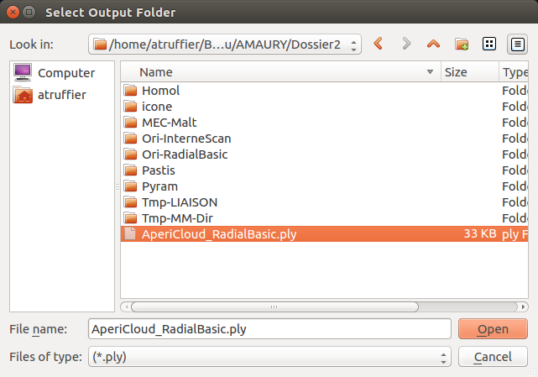

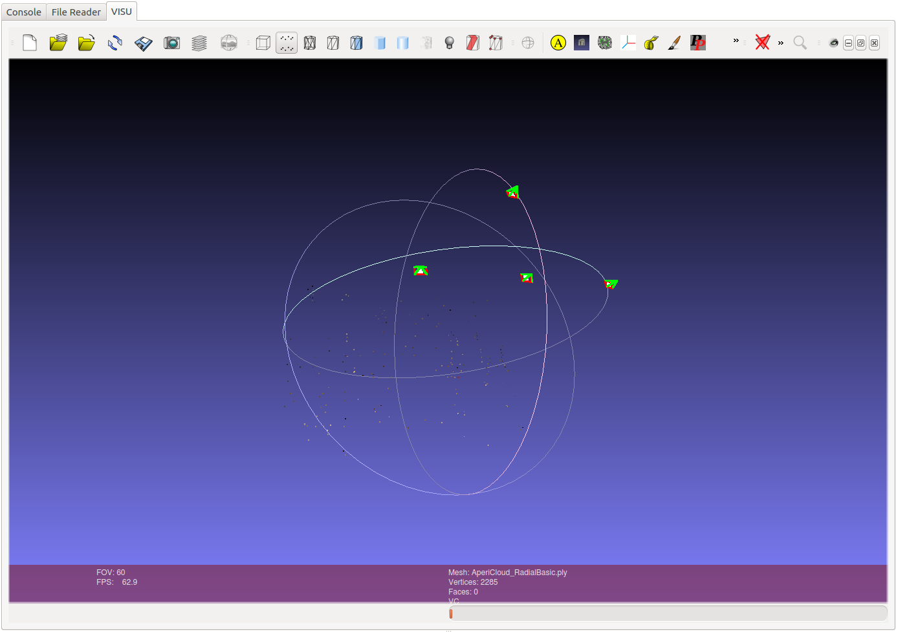

Vino is a tool that allows the user to pre-visualize the images.

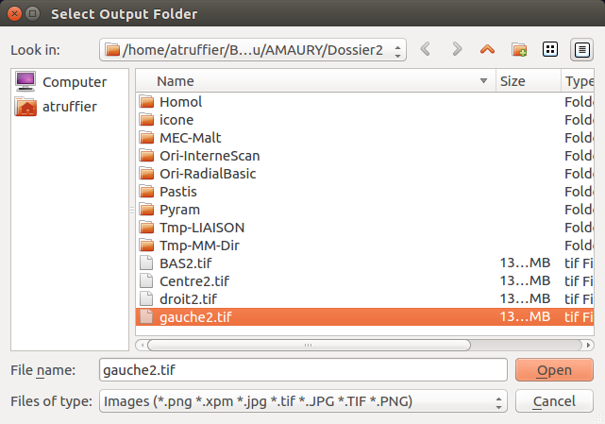

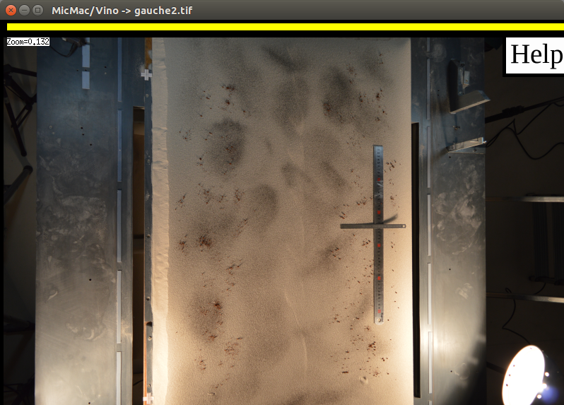

Bascule is used when a global transformation of your orientation is required

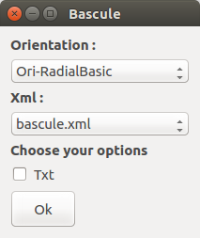

SaisiePts is a tool that allows you to grab a georeferenced point on an image (cf.)

Commande will open a new little window where you can type your own MicMac command
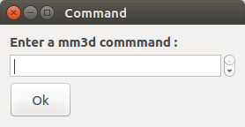

Tarama is an easy way to indicate which part of the scene you want to use, by creating a mask on a rectified mosaic : the tool Tarama allows the user to create such a mosaic.

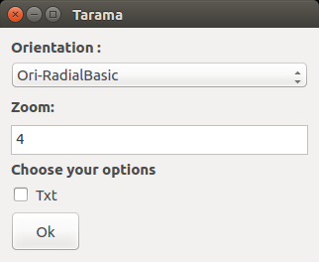

SaisieMasq is the tool that opens a window where you can select a zone (a masq) that you want to process.

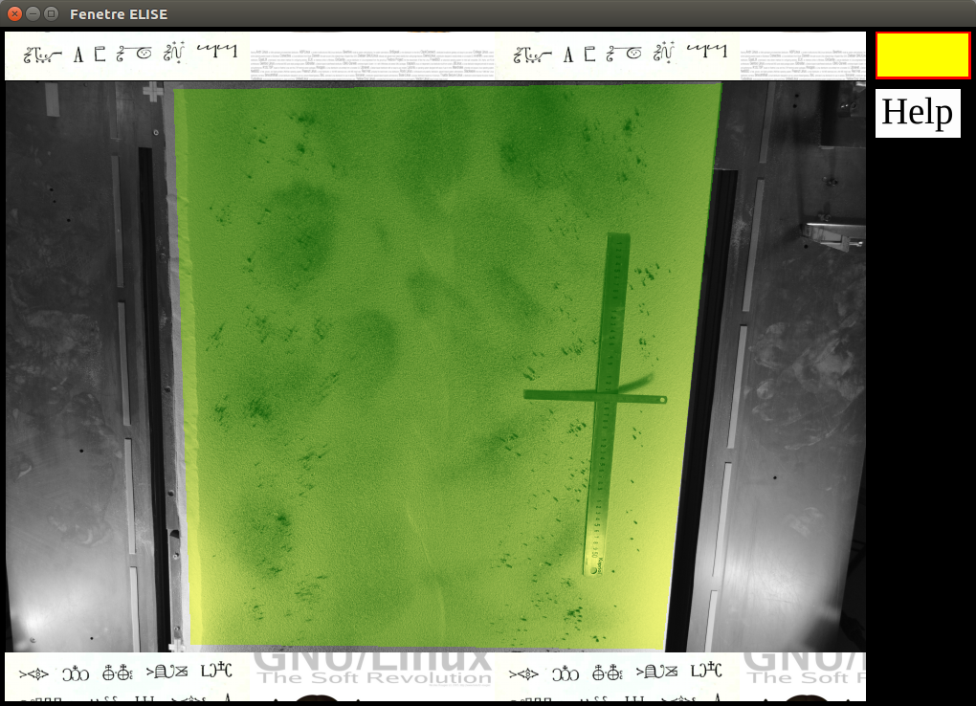

to8Bits is a tool that converts the 16 or 32 bit images into 8 bit images

GrShade computes shading from depth image

mm2dPosSism is a 2D correlator used for earth deformation studies. To use it, select an ortho-image before, and an ortho-image after the earthquake you are studying in your project. Then, choose the name of the folder that will hold the results of this correlation tool.

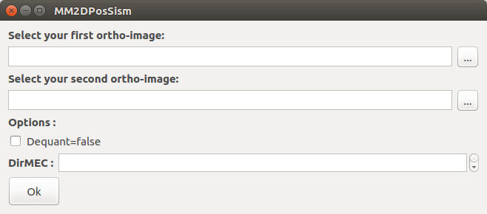

ExportConsole exports the console content

ChSys allows you to convert your coordinates from WGS84 to UTM : to do so, you just have to know the images UTM zone.

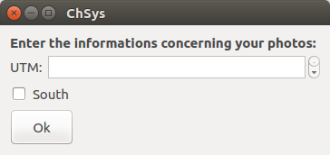

CropRPC is a tool that you can use to crop satellite images, in order to study only the areas of interest. To do so : you should select the orientation file of the image defining the crop extent first. Then, copy/paste this orientation file in the upper case named « Pattern of orientation files to be cropped accordingly... », delete the variable part of this string and create a pattern with this (cf.). Then choose a name of output directory, an origin and a window size (in pixel).

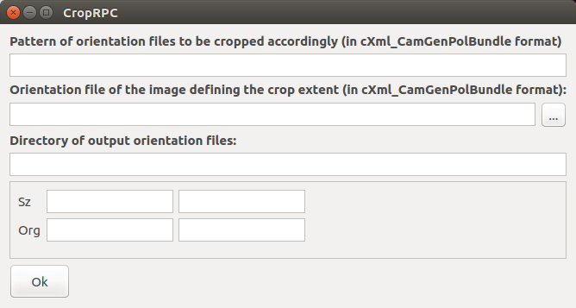
c – Top Dock

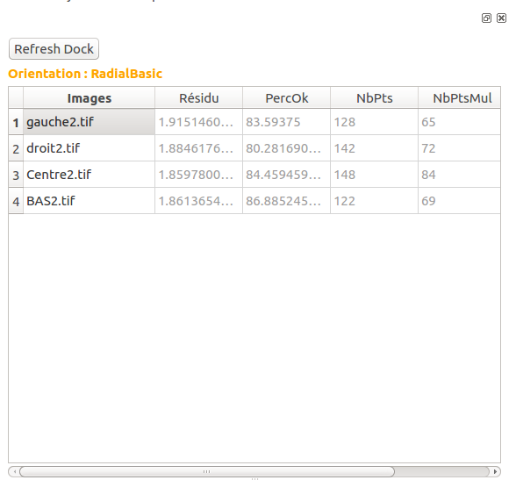

The « Refresh Dock » button refreshes the Dock in order to see files or folders added in the project folder. Indeed, the interface doesn’t detect the adding of files in the project folder, the user has to manually refresh the interface with this button.

The orange title shows the orentation chosen : to change it (if you processed your project with different orientations), just click on the Ori-file in the bottom part of the dock, it will refresh all the informations concerning the orientation clicked.

The tab lists all the images of the project, and gives the informations concerning the Résidu, the PercOk, the NbPts and the NbPtsMul, if they have already been created during the processing. Clicking on the name of the images highlights the concerned photos in the « Photos » tab.

If the interface doesn’t find any information concerning the images, this part shows only the names of the images (withtout résidu, PercOk...).

d – Bottom dock

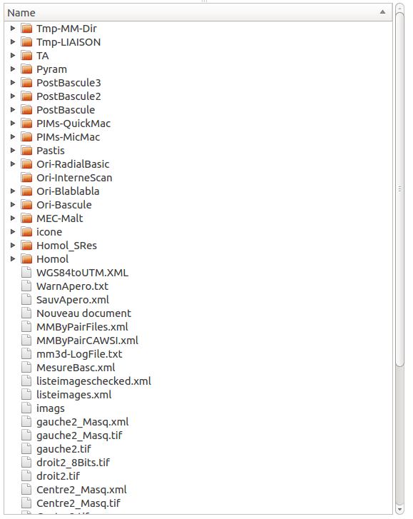

This dock shows the project « tree » : at the end of every commands, the interface refreshes this section and allows the user to know which folders and files have been created during the process. If the file created is a .xml or a .txt, a click on it will set it in the « File Reader » tab. The use of this section is classic : a click on the triangles at the left of the folders will open them and show what they contain.

If you added a file or a folder in this project, click the « Refresh Dock » button to add it in the project tree of the interface. It will refresh this section and let you see the changes.

This dock is just a way to see what kind of process has already been launched, which folders have been created, etc. But it allows only reading, not writing : you cannot delete or add any element from there. So, if you want to add or delete any element in your project folder (like deleting an image, adding a RPC file...), you have to open this folder with a classic folder explorer, paste/delete the elements concerned, and press the refresh button to see it in this Graphical User Interface.

But it is recommanded to make as little as possible changes in the project folder. If you want to make a new image process with the same images, copy/paste thtem in another folder and load this new folder with the GUI.
e – Console
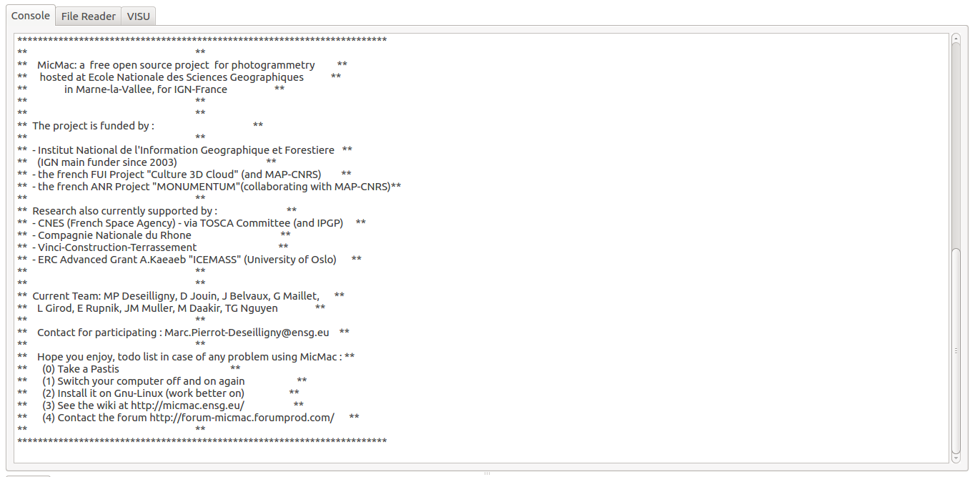
The console tab is filled at the end of each command. It is the same content as the little loading window filled in live during the processes. You can visualize the results of the process, and it is actually the best way to get informations directly after the end of a function processed.
The button « Export Console » at the top of the Interface exports the content of this tab in a text file. You can choose the place where you want to save this file.

f – File Reader
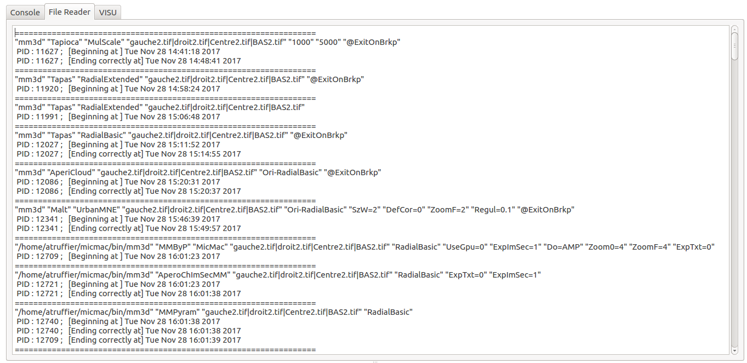
The « file reader » tab is filled with the .txt and .xml files clicked in the dock section. It allows you to consult the contents of the files created during the process (like mm3d-logfile.txt containing all the commands launched, or the residu.xml files...)
g – Photos tab

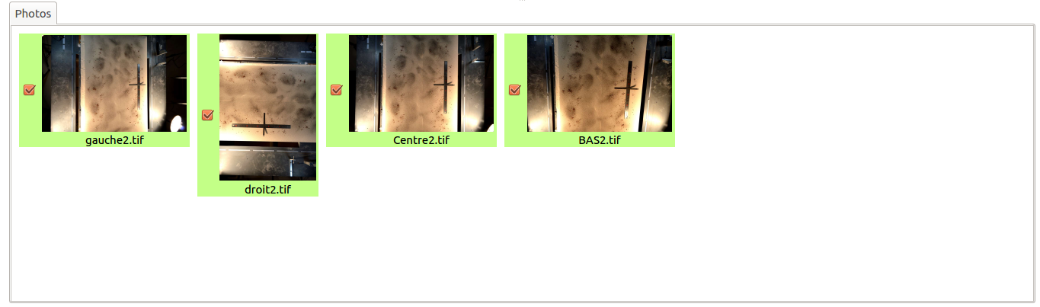
This tab shows the images included in the project. To select/deselect an image, click on it. A green image is an image that is selected to be processed. A red one is a none selected image. A double click on those icones will open a new Vino window, which is a tool allowing you to have a look on the image.
The selected images are stocked in the listcheckedimages.xml : when a project already created is opened for the second time, it loads the same selected images list as you lived it the last time you closed your project.

h –Visu tab

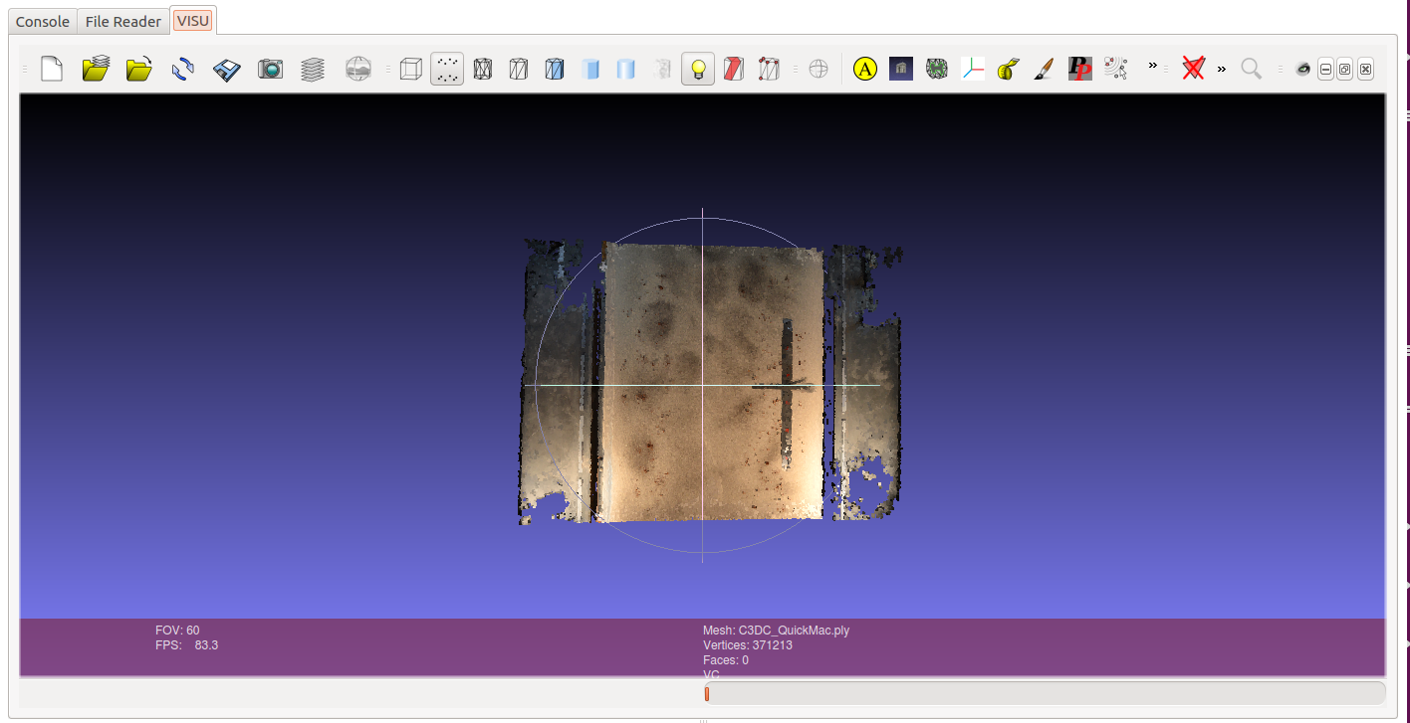
This tab is a space where .ply files can be opened. To use it, double click on a .ply file in the dock section, or select a file with the help oh the meshlab button. It will automatically open it. The goal of this section is to have a fast visualization of a point cloud created with the Apericloud or C3DC functions.
2 – Les workflow

a – Drone
1. Tapioca
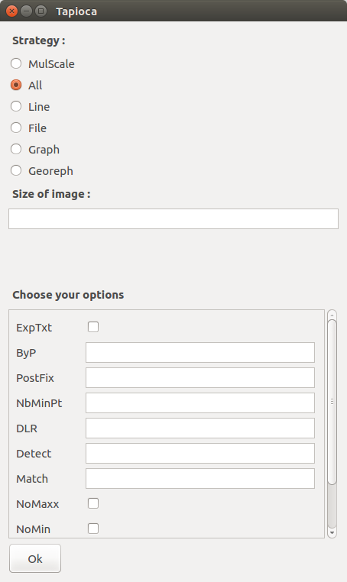

Pushing the Tapioca Button will open the little Tapioca window. This function is used to compute the tie points of the images.
The windows have the same structure : The top part of those windows are the mandatory args. The square at the end of the window allows you to add some options to your process.
Once you filled the window accordingly to your wishes, you can click Ok. A pop-up window will be opened and let you see the « command line » created with the parameters and options you chose.

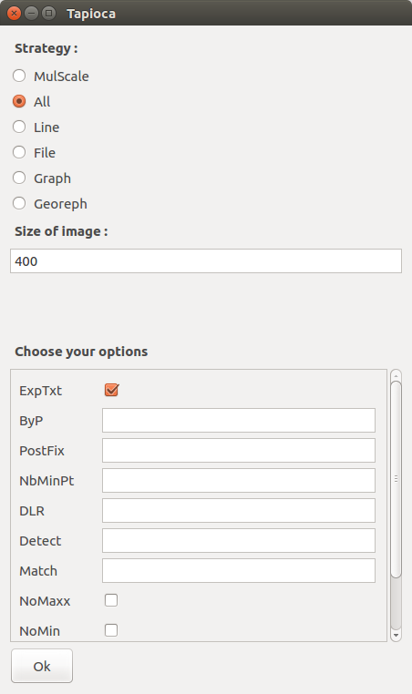
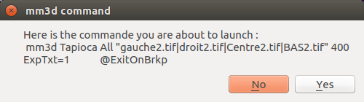

Then, a new window is opened and plays the role of a loading bar. You can follow in live the process of the images, and the errors.

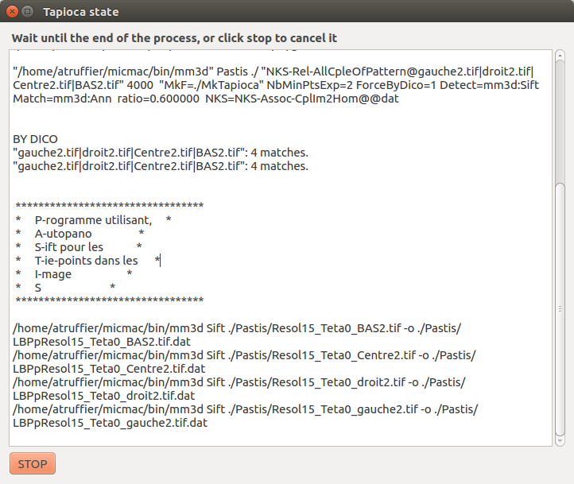

Once the process is finished, this previous window is closed automatically. If the process you launched were’nt exactly what you wanted, you can click the STOP button which will stop the process. In both cases, the « console » tab is filled with the content of the text space of the loading bar.
You can export the content of this console with the button ExportConsole as it was explained before.

2. Tapas

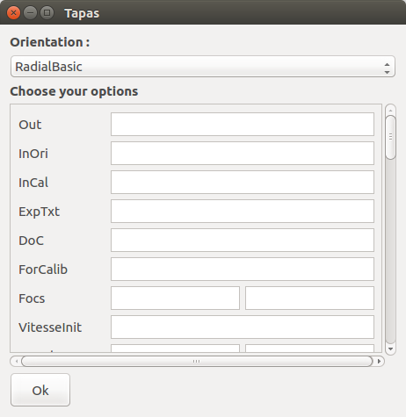

Pushing the Tapas button will open the little Tapas window. This function is used to create a relative orientation and calibration.

The only mandatory argument is the Orientation you want to use in your process.

3. Malt

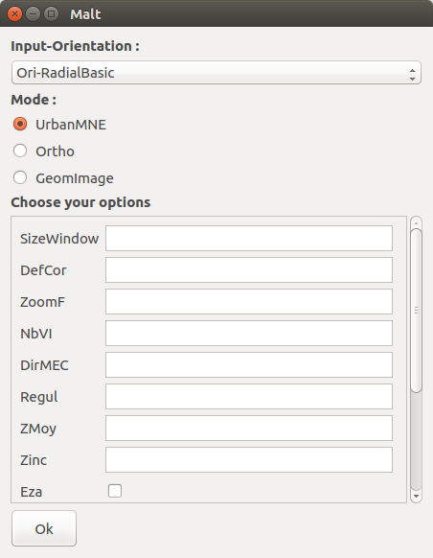

Malt is a simplified interface to MicMac. Currently it can handle matching in ground geometry (see 5.4.1) and ground-image geometry.

4. C3DC

The C3CD command is the command that compute automatically a point cloud from a set of oriented images. You just have to give a mode and to select a created orientation.

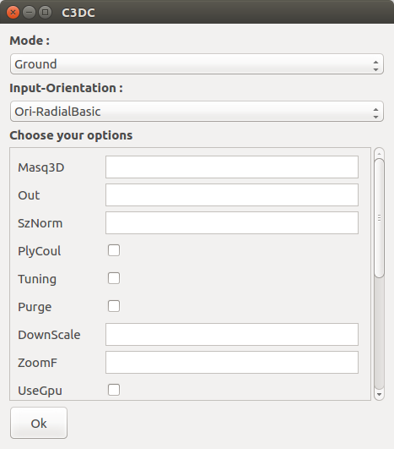
b – Satellite

Here, we do not explain how do Tapioca and Malt are used, because their function are exactly the same in the satellite image processing.

1. Convert2GenBundle

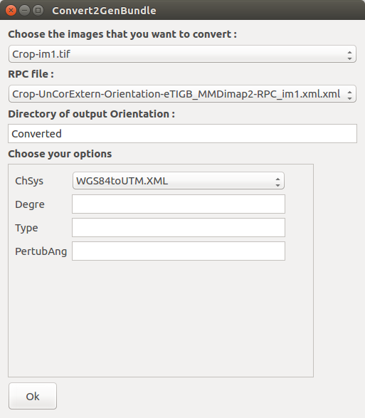

The RPC orientation parameters provided by different vendors have different file formats. So, to process satellite images, you will have to convert the RPC files in a format that MicMac will be able to understand. This conversion is possible with Convert2GenBundle. You should just place those RPC files in the same project folder as the images before.
Then the conversion can be made with an image at a time : select the name of the image you want to convert, then its RPC file, then type the directory of output orientation name that will hold your converted RPC files.

2. Campari

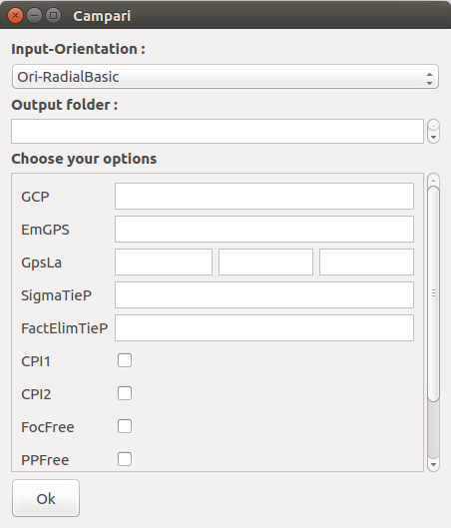

Campari is the function that will create a relative orientation with your satellite images.

The mandatory arguments in input are the orientation that you get from the Convert2GenBundle conversion, and the name that you want to give to the output folder of the Campari process.

4. An example of a process with classic images (taken with a classic camera)

Here is a simple example of a classic image processing. The chosen images have been taken with a classic camera. They are in the Fold1 folder. The aim of this processing is to get a DEM and a point cloud.

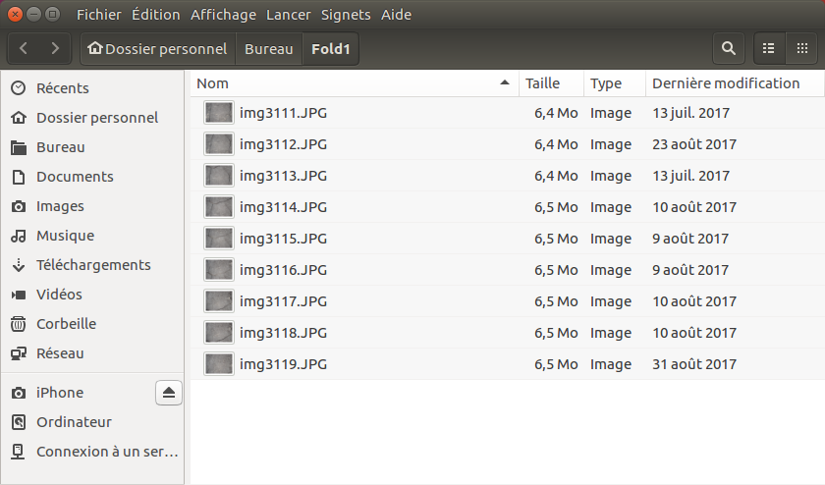

The first step is to open this project. To do so click on the top Menu « File » and select « New Project ».

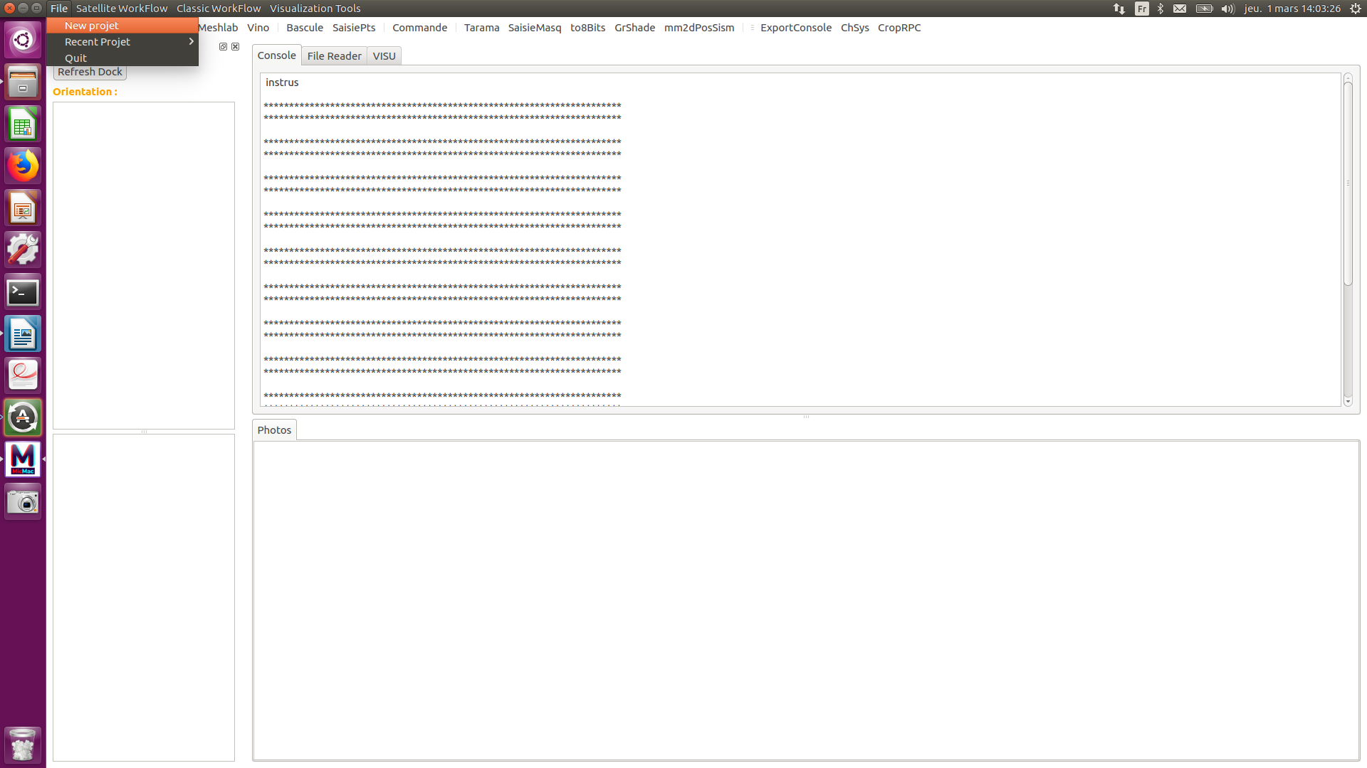

A new window is opened. Now you just have to select the folder where your images are placed, and click on the Choose Button.

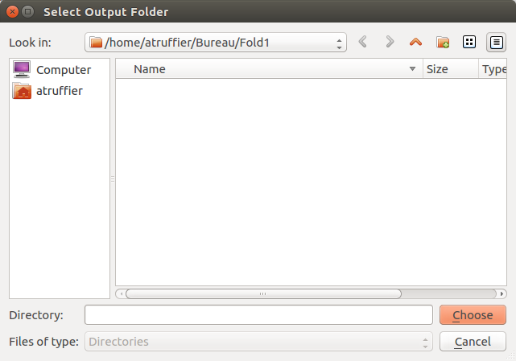

The interface is automatically refreshed. Normally, depending on the images sizes, the interface freezes : it is because of the creation of the image icones. The next time the project will be opened, it will not freeze anymore : the interface will find automatically the converted images placed in the icone folder. You can take a look at your images by double clicking on them, or select the ones you want to process, by simple clicking on the icones.

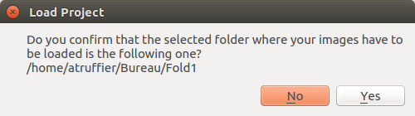
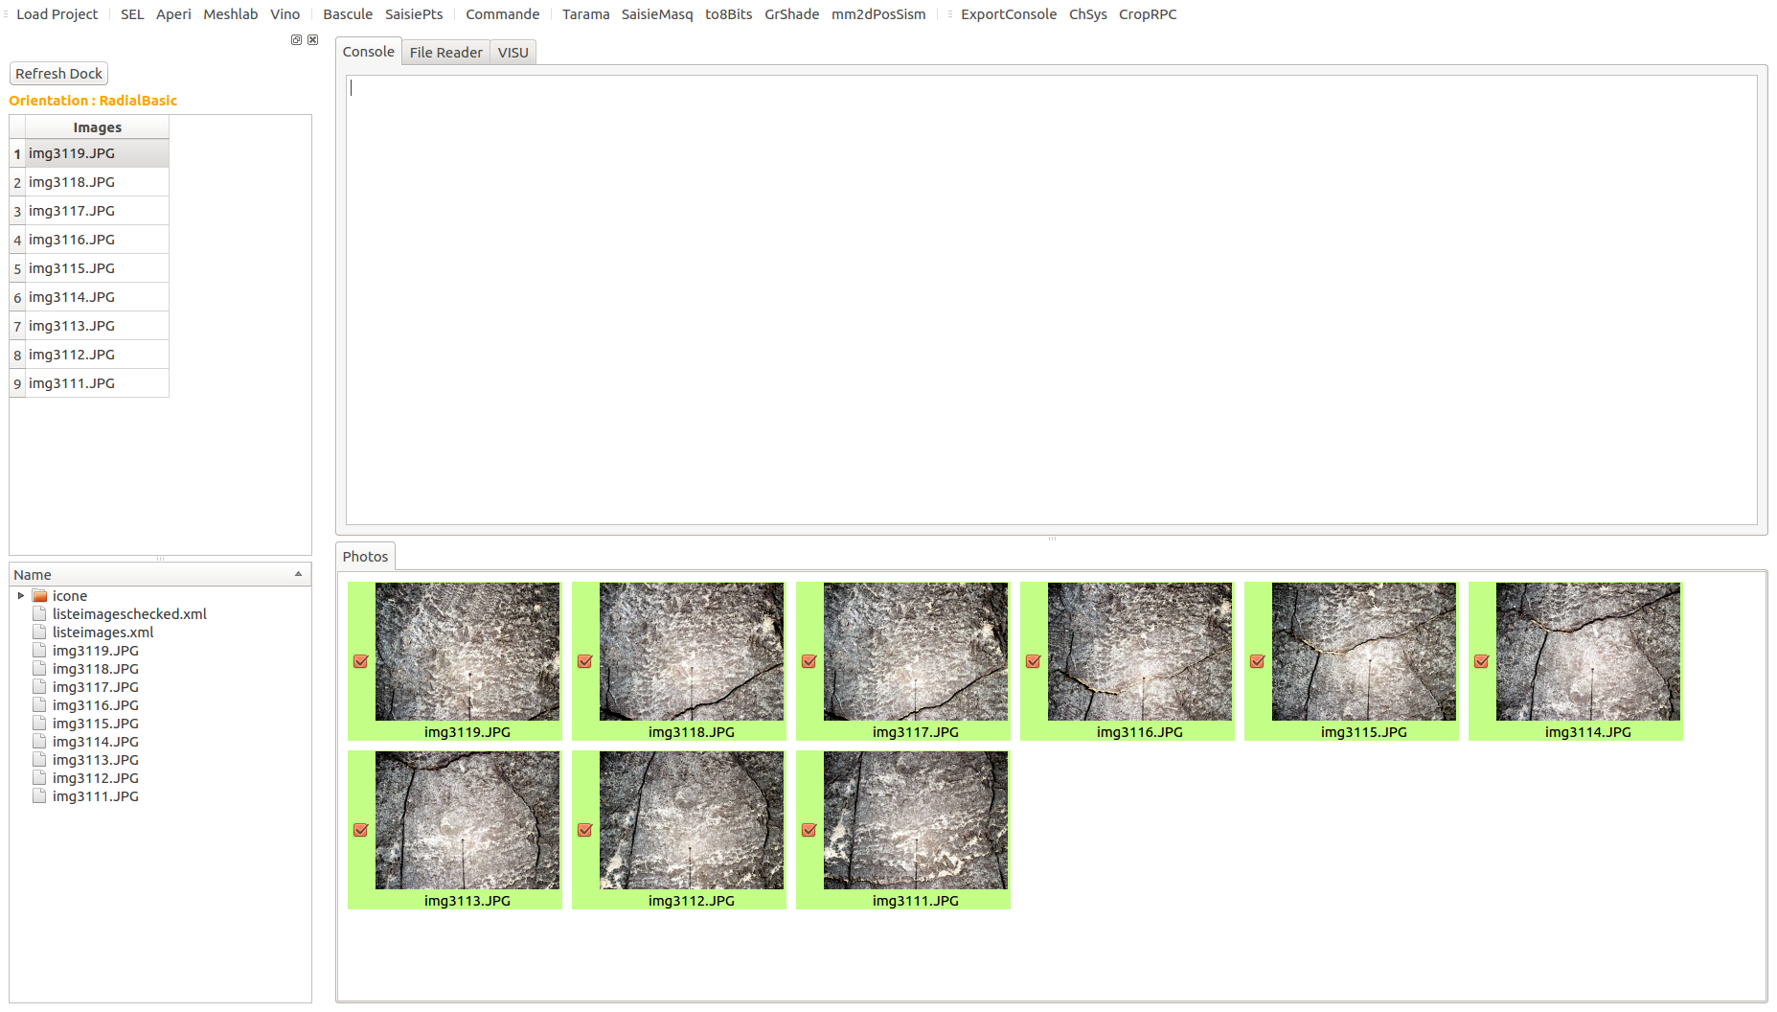
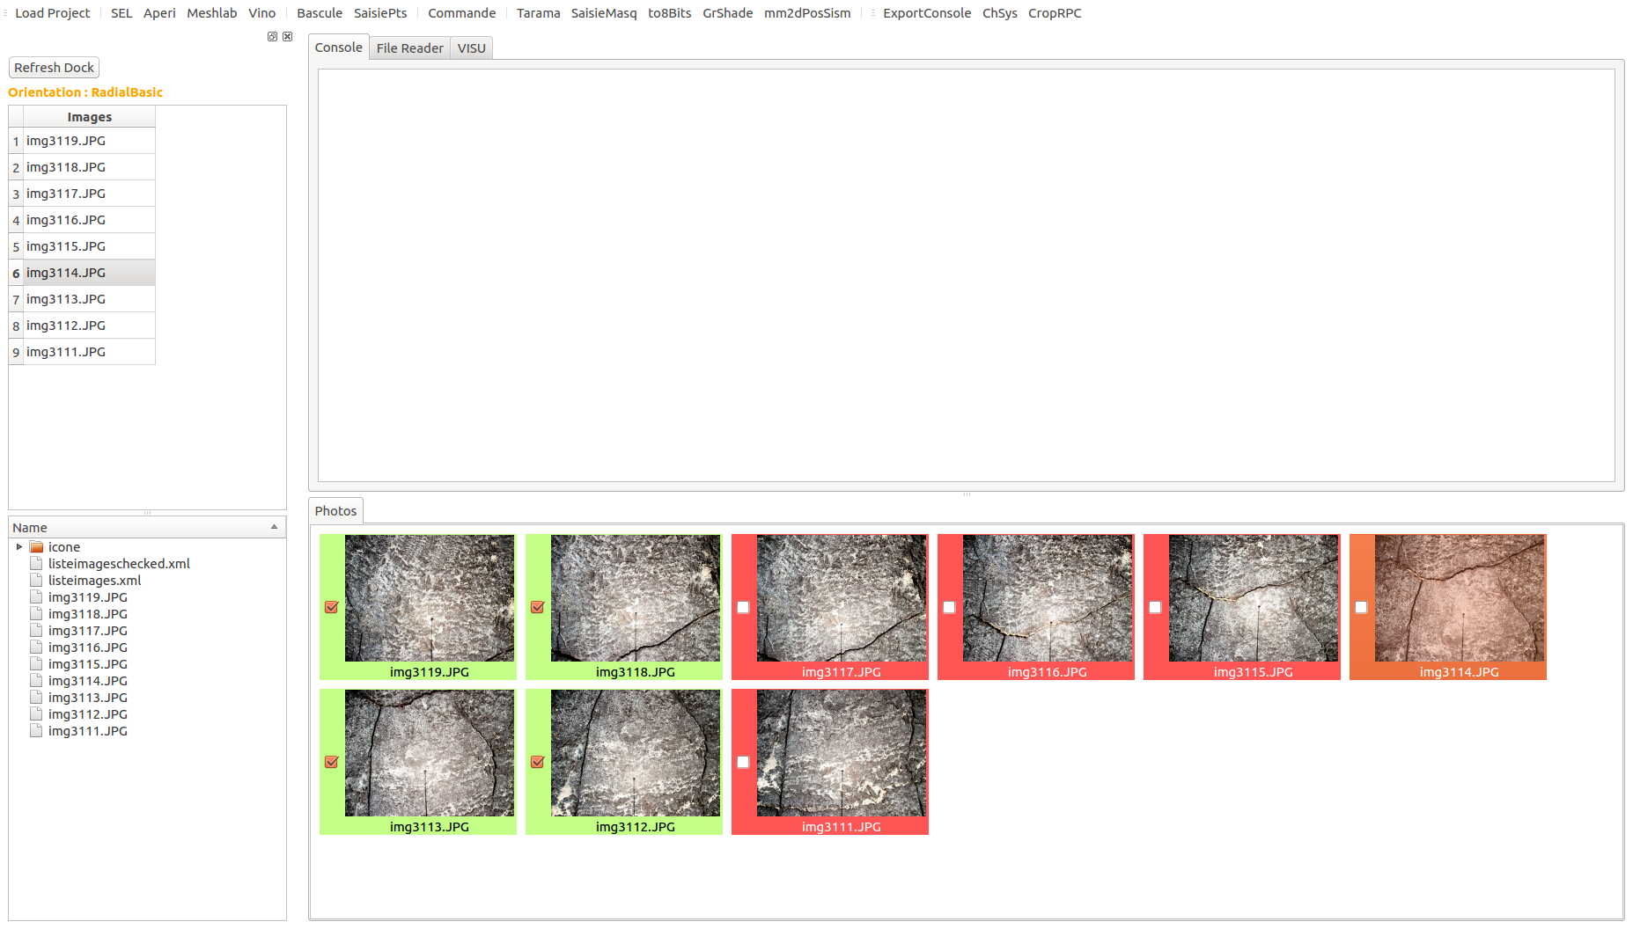

The icones are a little bit different from the original images : their contrasts have been modified to enable the user to see without any difficulty any kind of image (ex : satellite).
Once you selected your images, open the « Classic Workflow » top menu. Now click on Tapioca, the tie points computation tool.

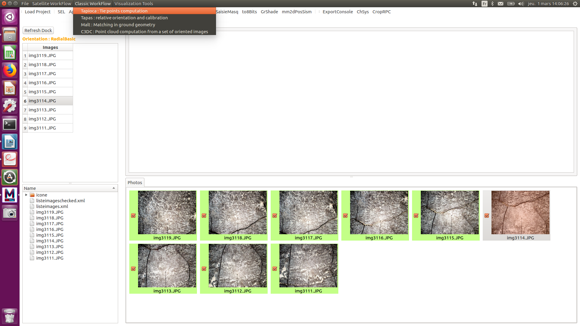

We chose to launch Tapioca with the MulScale option. After having entered the desired size of low and high resolution images, click on the « Ok » button.

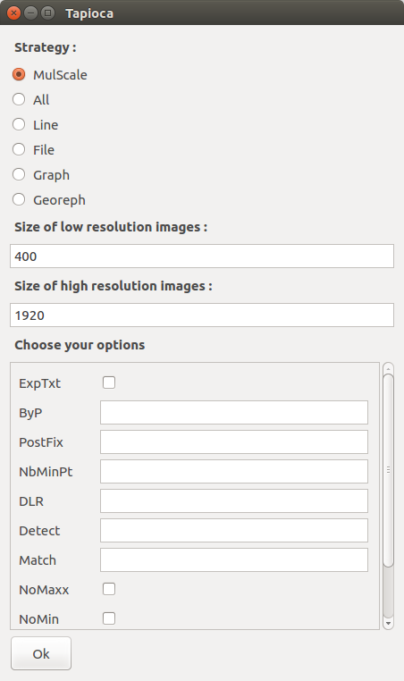
A new little window asks you to confirm the command you’re about to launch : check that all the informations and arguments you wanted to use are listed before clicking on Yes.

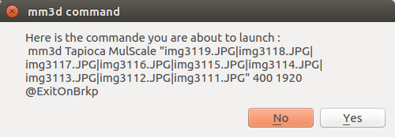

Then, the « Tapioca state » window is opened. You can follow the image processing in live. Click STOP if you want to stop the process, or wait for the window to be automatically closed.

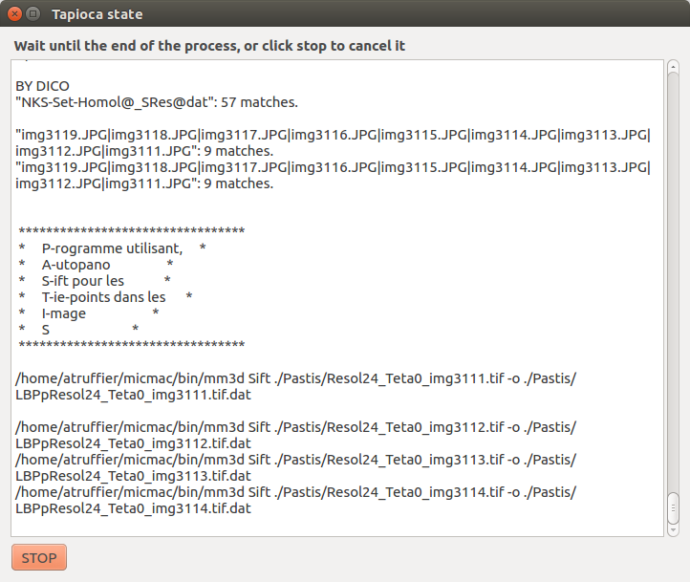

Once the Tapioca process is finished, the Tapioca state content is put in the console tab of the interface. You can see that new folders have been added in the dock.

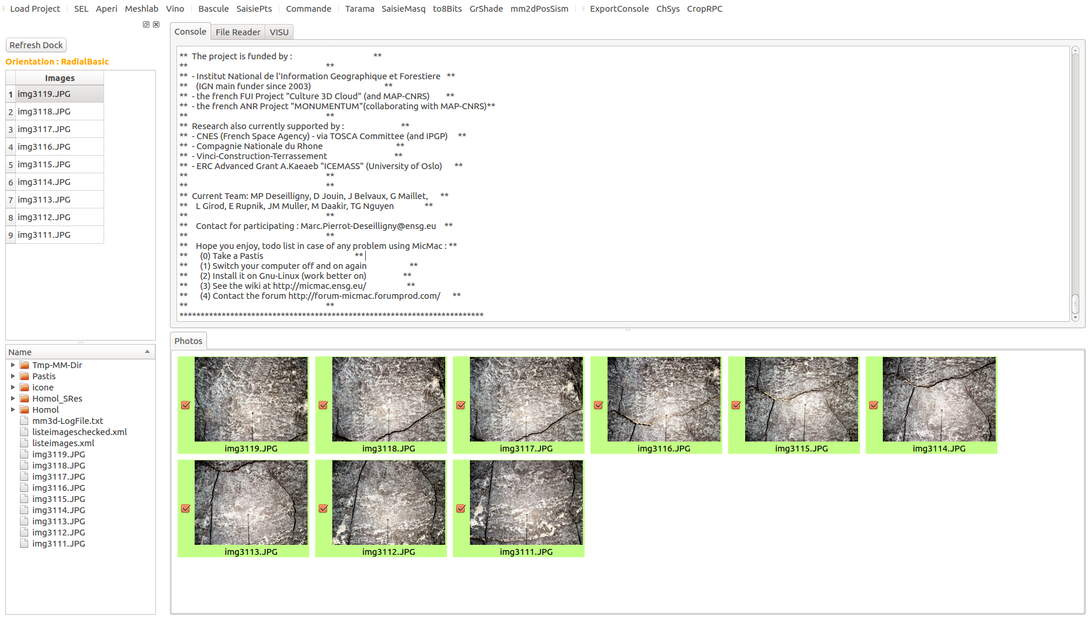

If you want to have a look at the tie points computed, select the SEL option, and select two images.

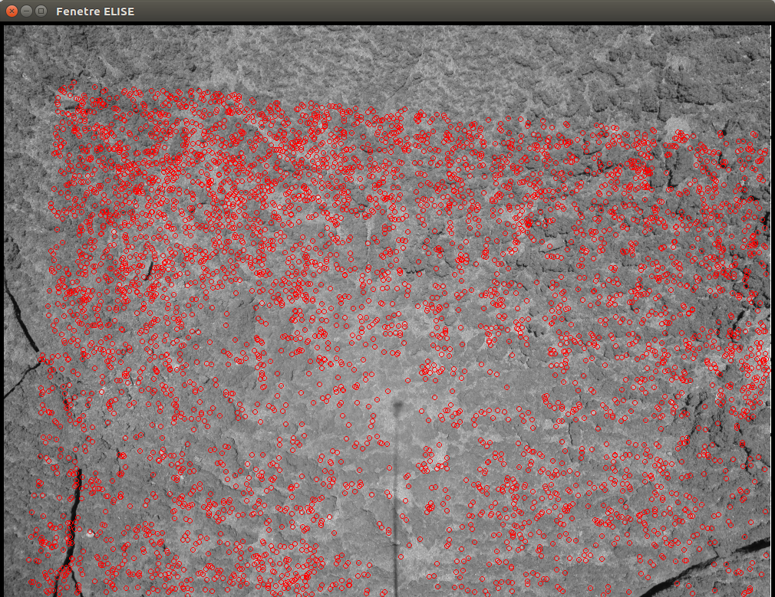
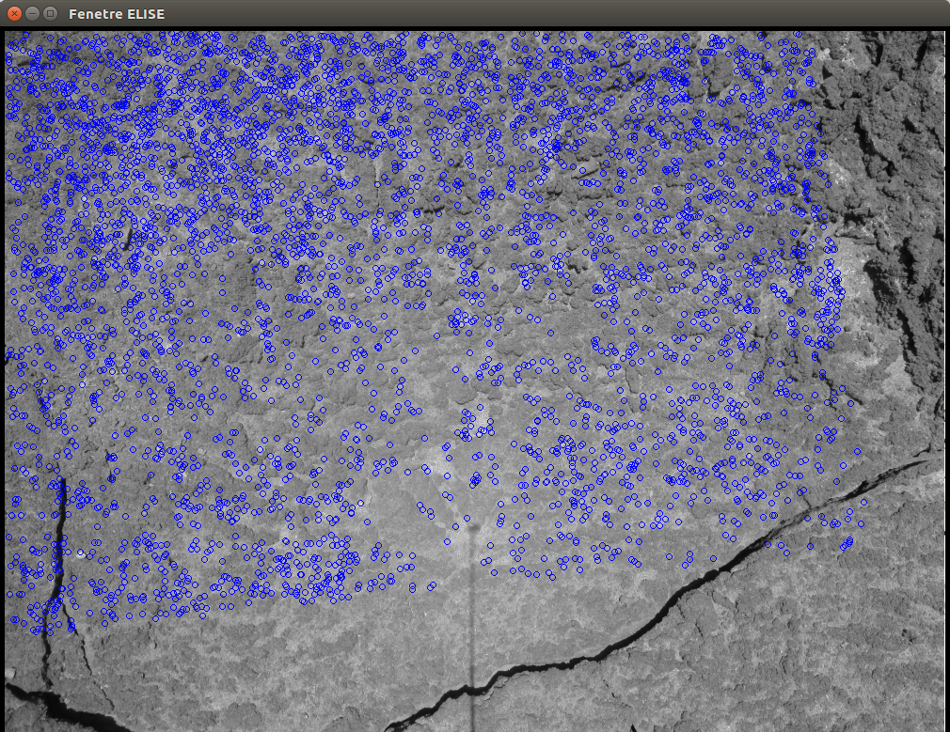
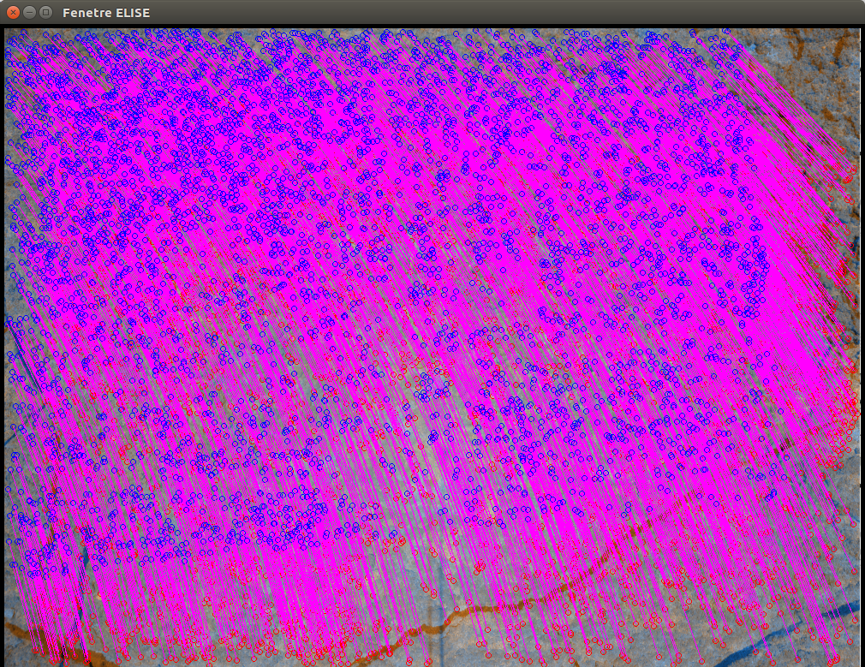
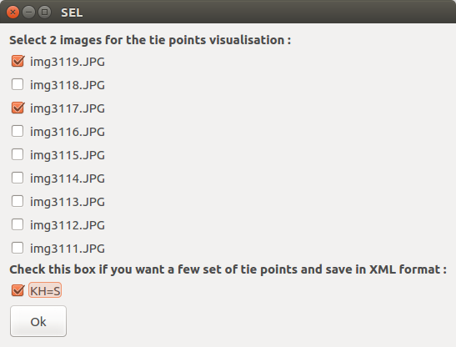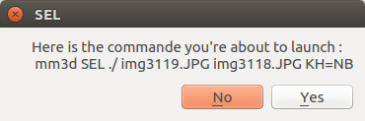

While holding the right click button on the images opened with SEL, you’ll see the options allowing you to select the image or the two images you want to check.

Then, open the Classic Workflow and select Tapas.

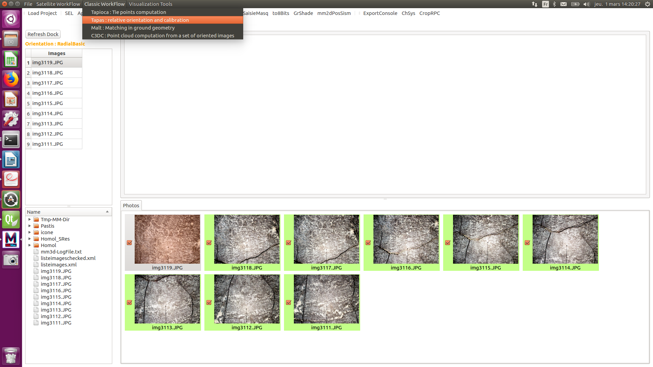
Tapas is the tool that creates a relative orientation and calibration.

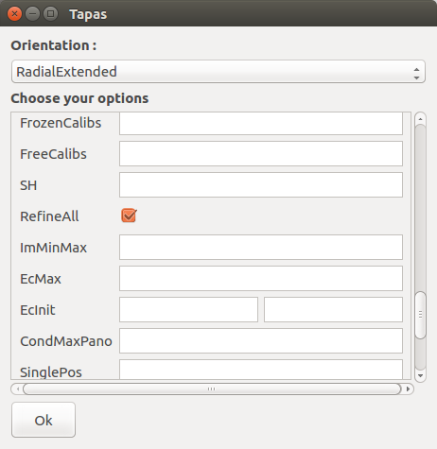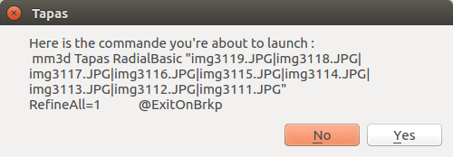

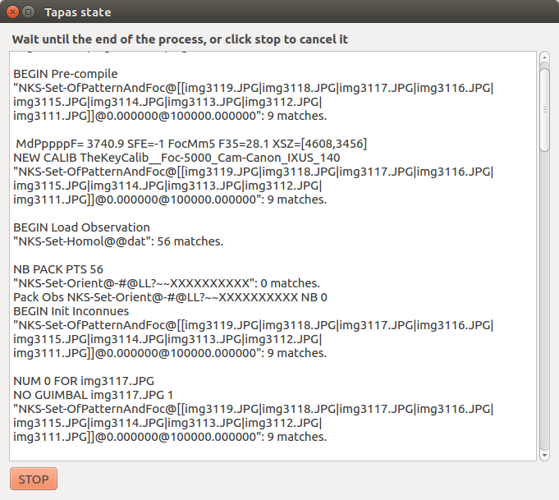

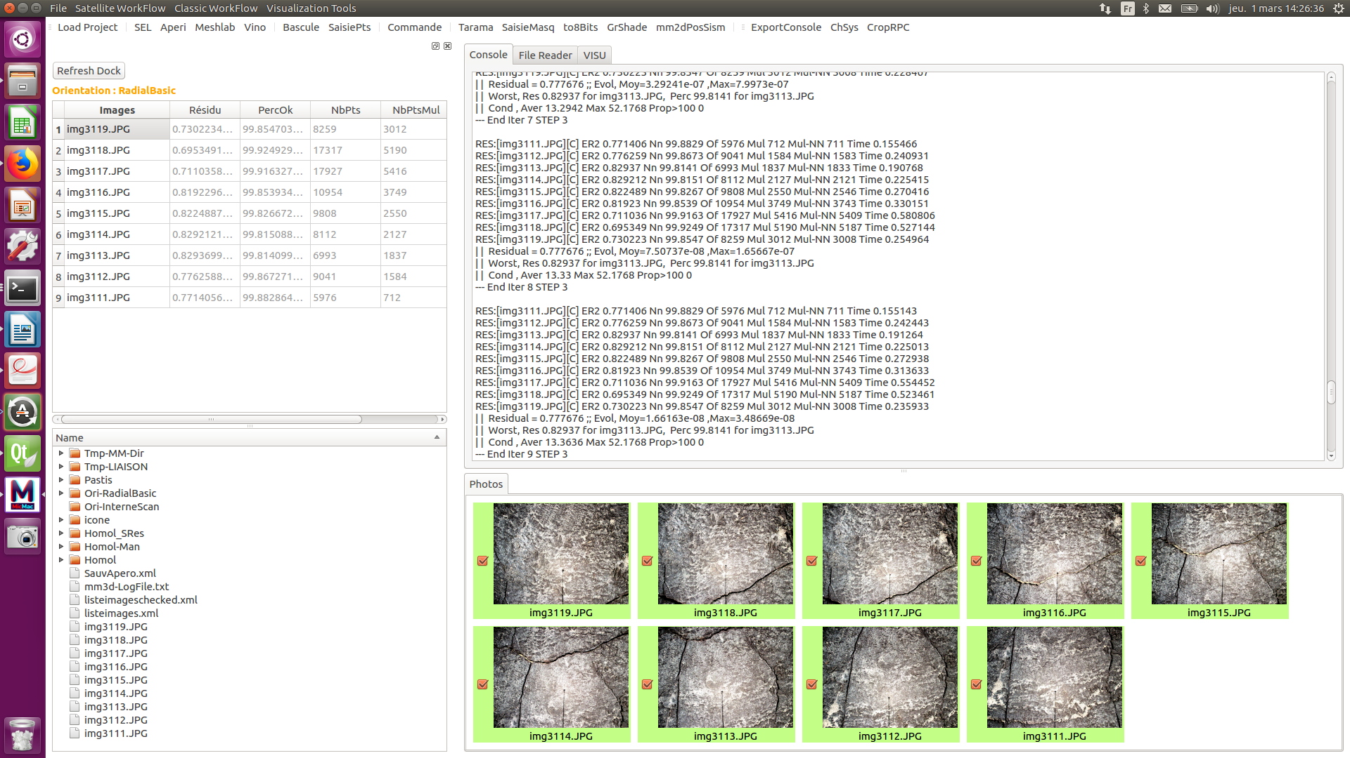

If you want to check the quality of your orientation, you can compute a point cloud with AperiCloud. To do so, choose the Orientation you created in the drop menu of the little AperiCloud window. Then click Ok.

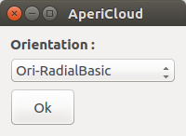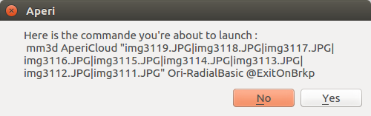

A .ply file will be created. To visualize it, open it with the Meshlab button, or double click on the .ply file in the dock section.

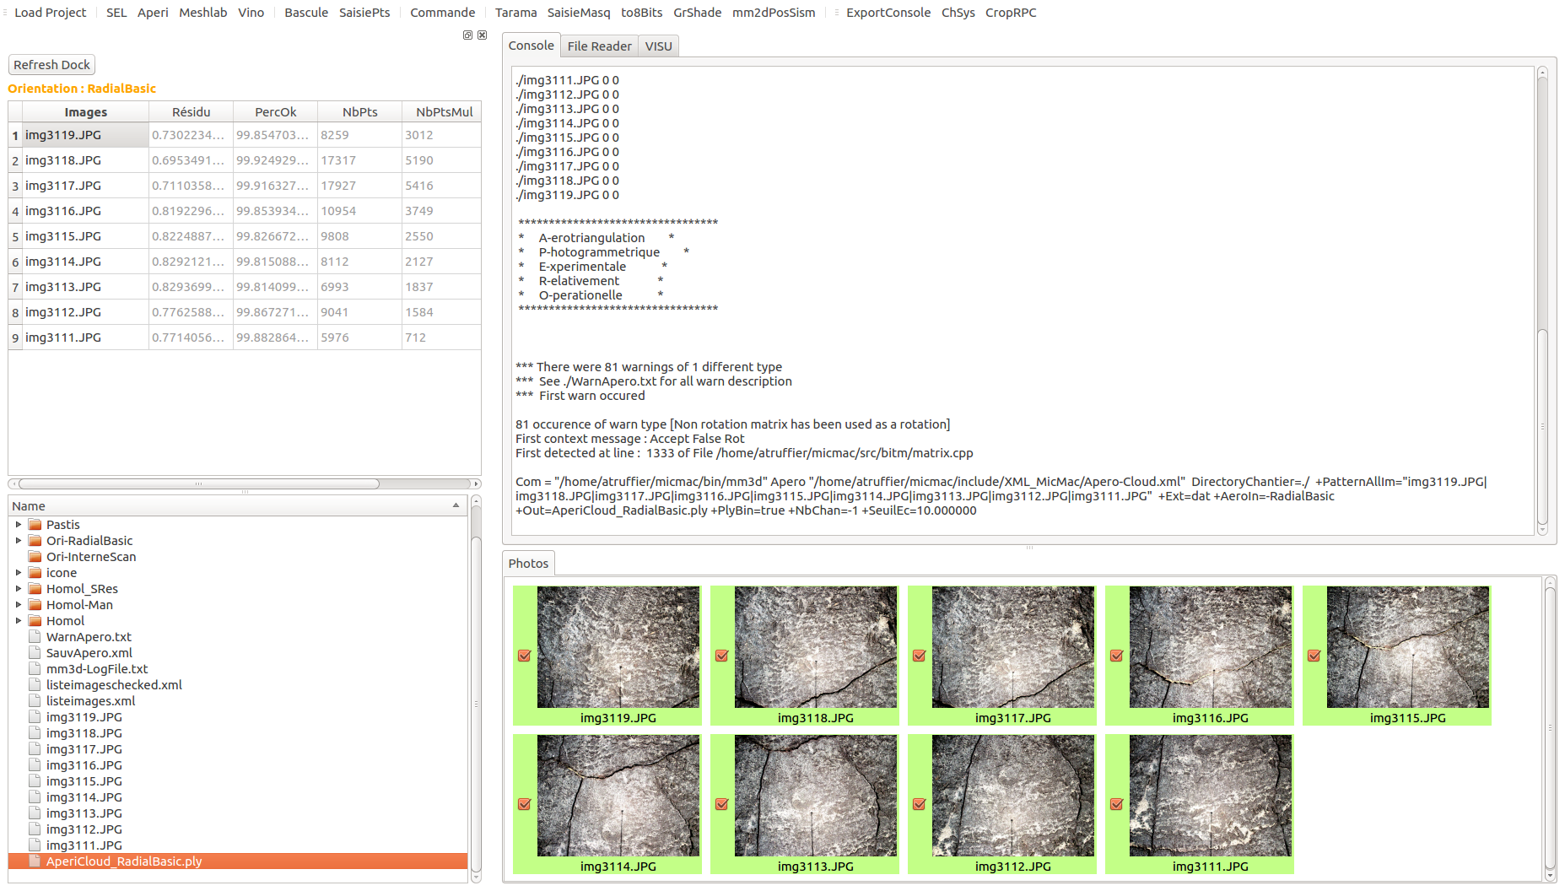

The VISU tab will be set at the foreground. You can now check your orientation.

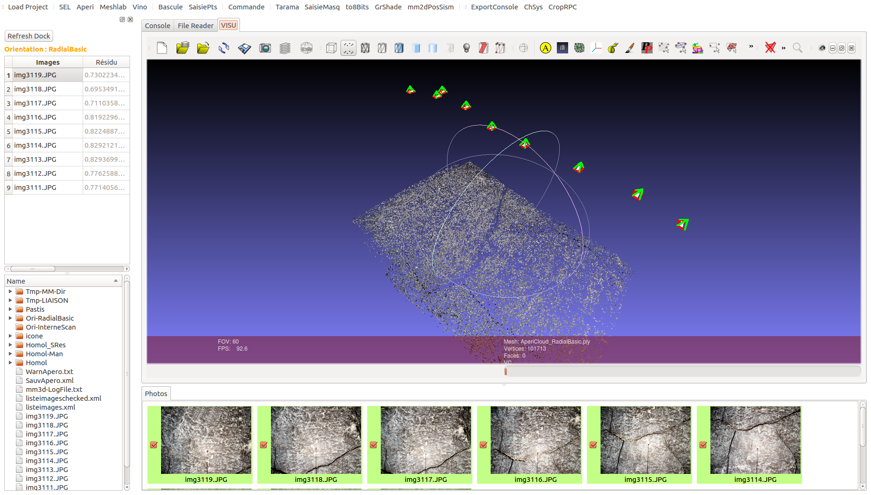

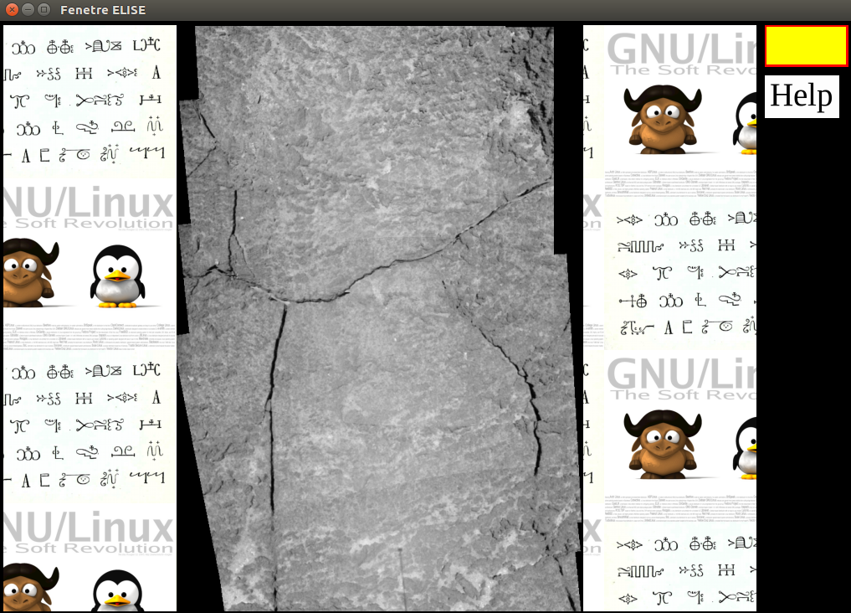
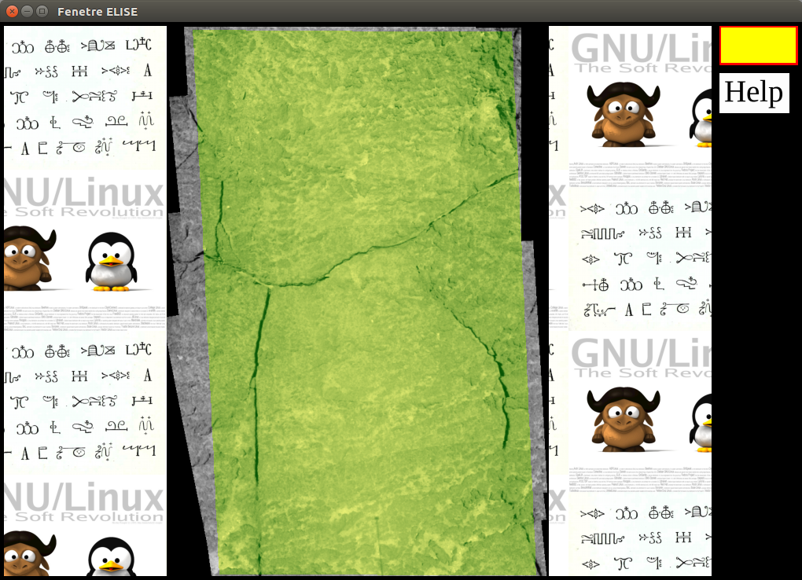
Before running dense matching, sometimes it is convenient to make a mask of the area of interest. First, you have to generate a an ortho-image with the Taram Tool.

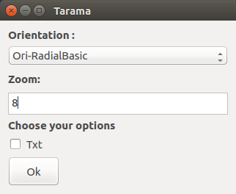

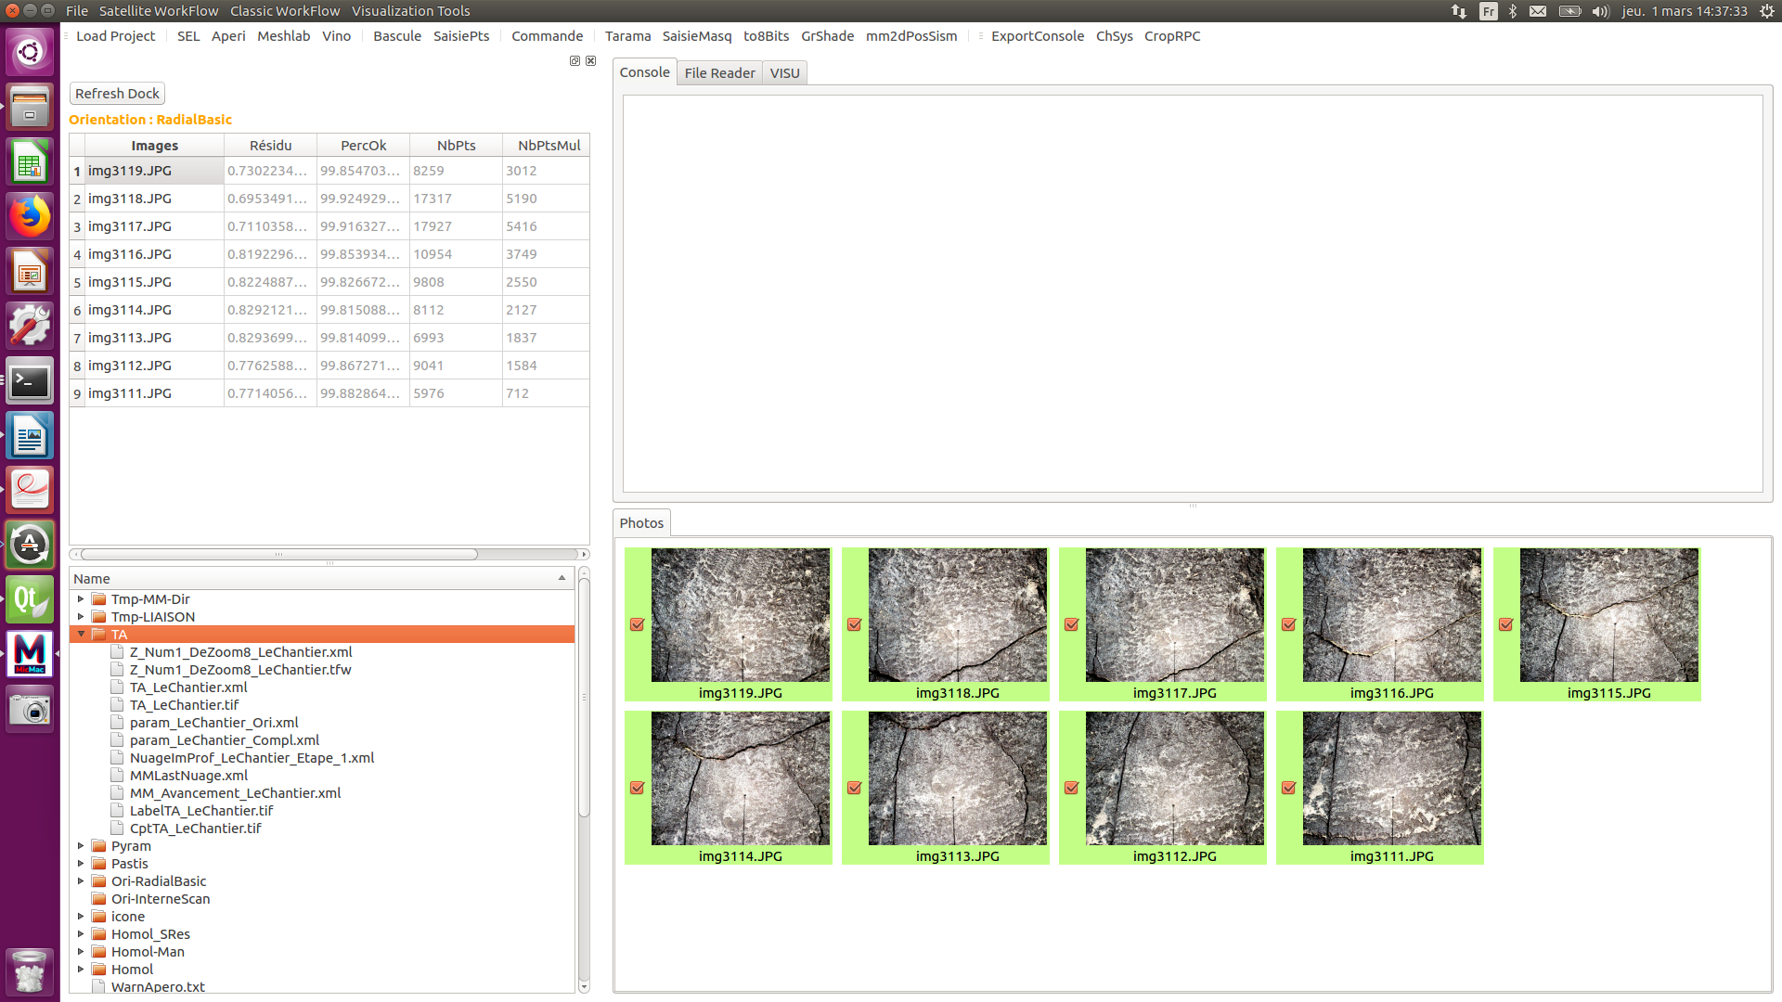

The TA folder is created : it contains the Mask you just created. Its name is TA_LeChantier.tif.

Now open the SaisieMasq tool, and select this file. A new window will be opened and let you select the area you want to process.

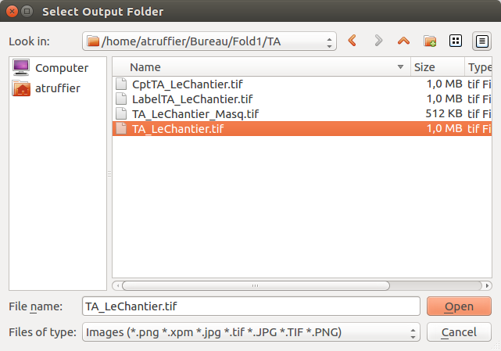

Now that you selected your area of interest, you can launch the dense matching function Malt. Open the « Classic Workflow » drop Menu, and click on Malt.

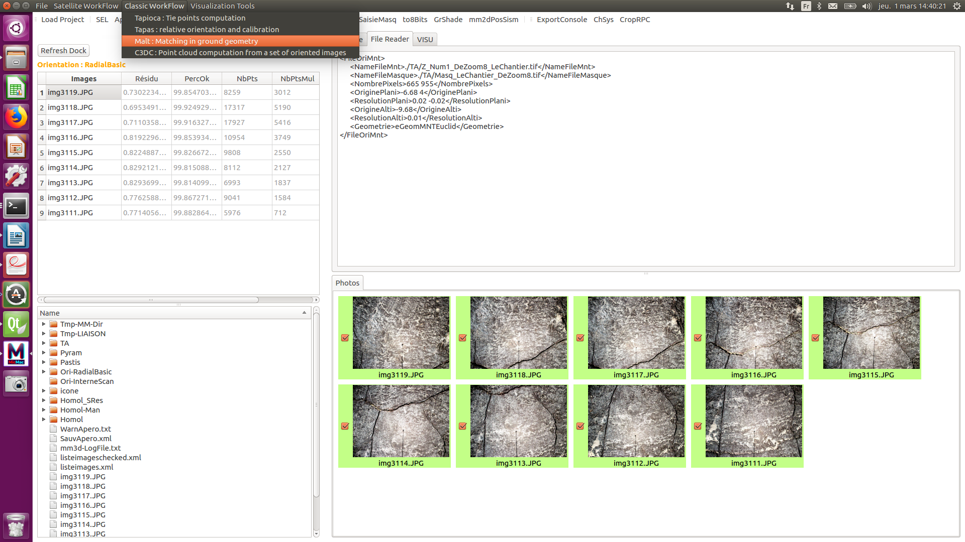

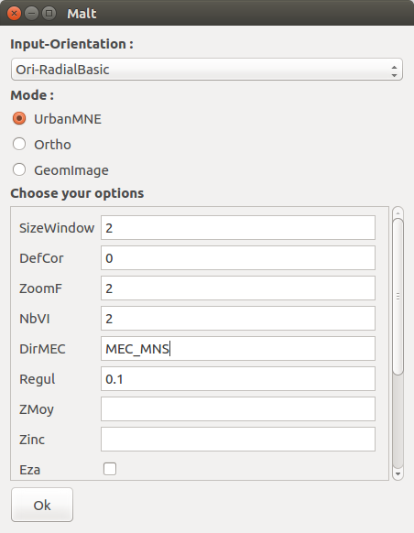
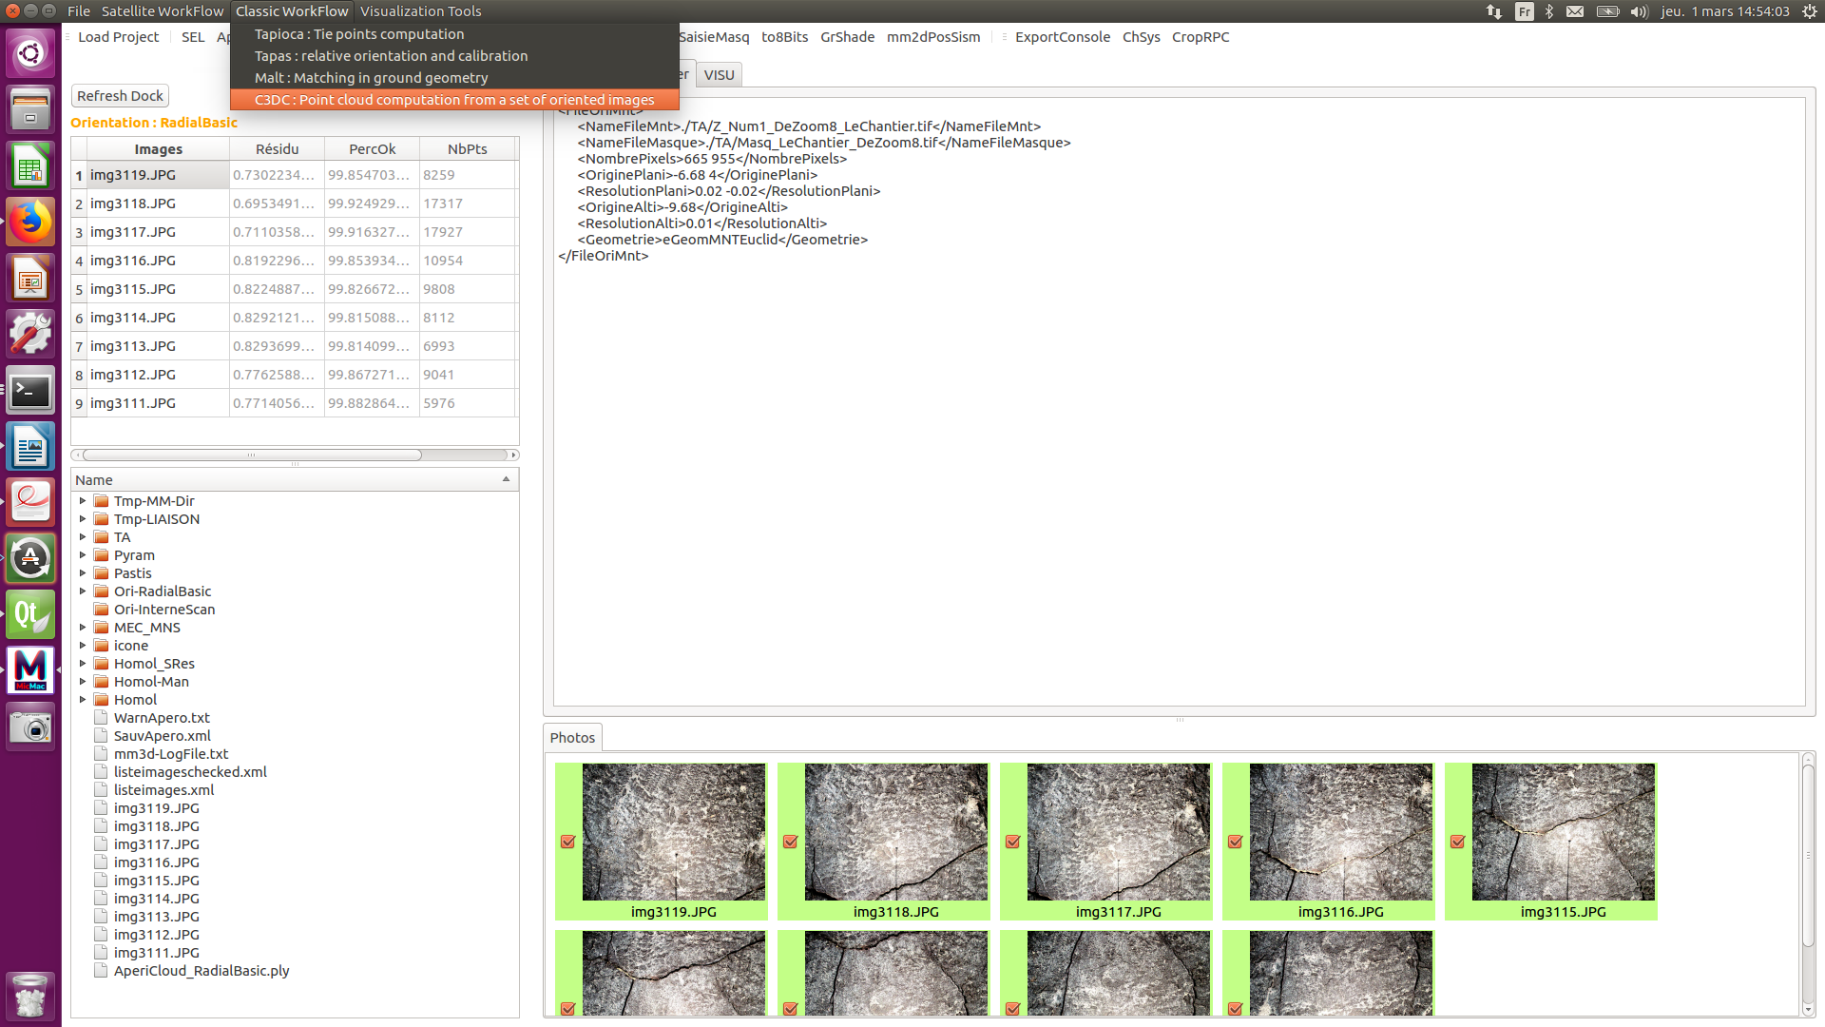
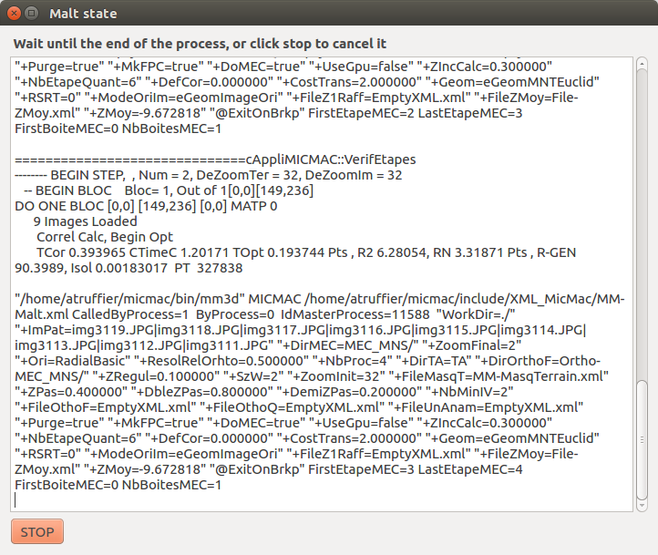

A new folder has been created, with the name « MEC_MNS ». You can now take a look at your DEM.

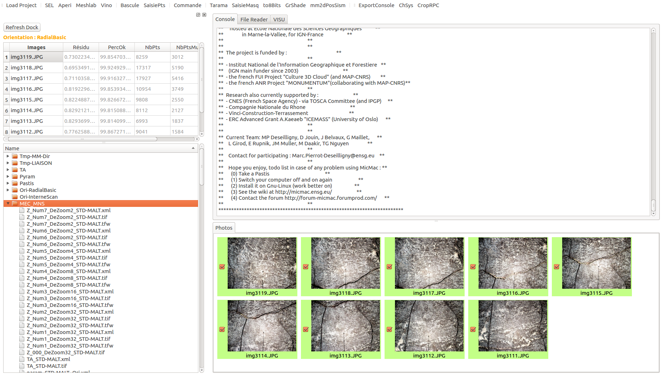

To do so : open the Vino tool, and select « Z_Num7_DeZoom2_STD-MALT.tif ». You can also create shaded DEM with GrShade. You just have to open the GrShade tool, and select your DEM.

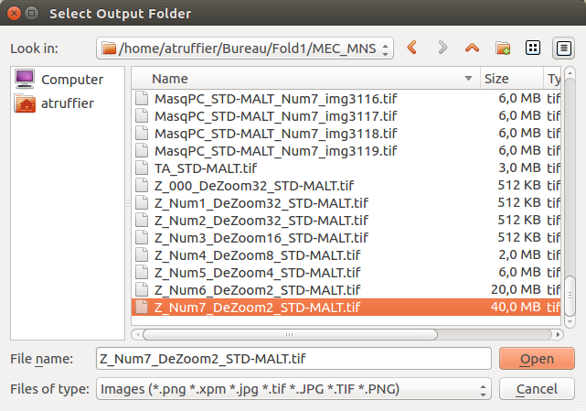

A new file called « Z_Num7_DeZoom2_STD-MALT_SHADED.tif » is created in the « MEC_MNS » folder. You can vizualise it the Vino.

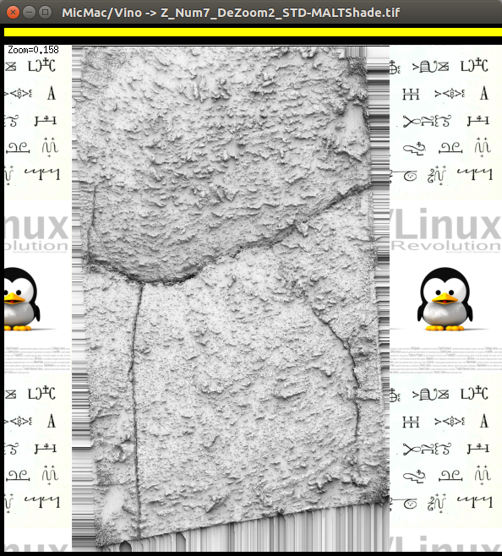

Now, we want to create a point cloud. We will have to use C3DC

To have a look on your point cloud, double click on the C3DC_QuickMac.ply file, or select meshlab then C3DC_QuickMac.ply.

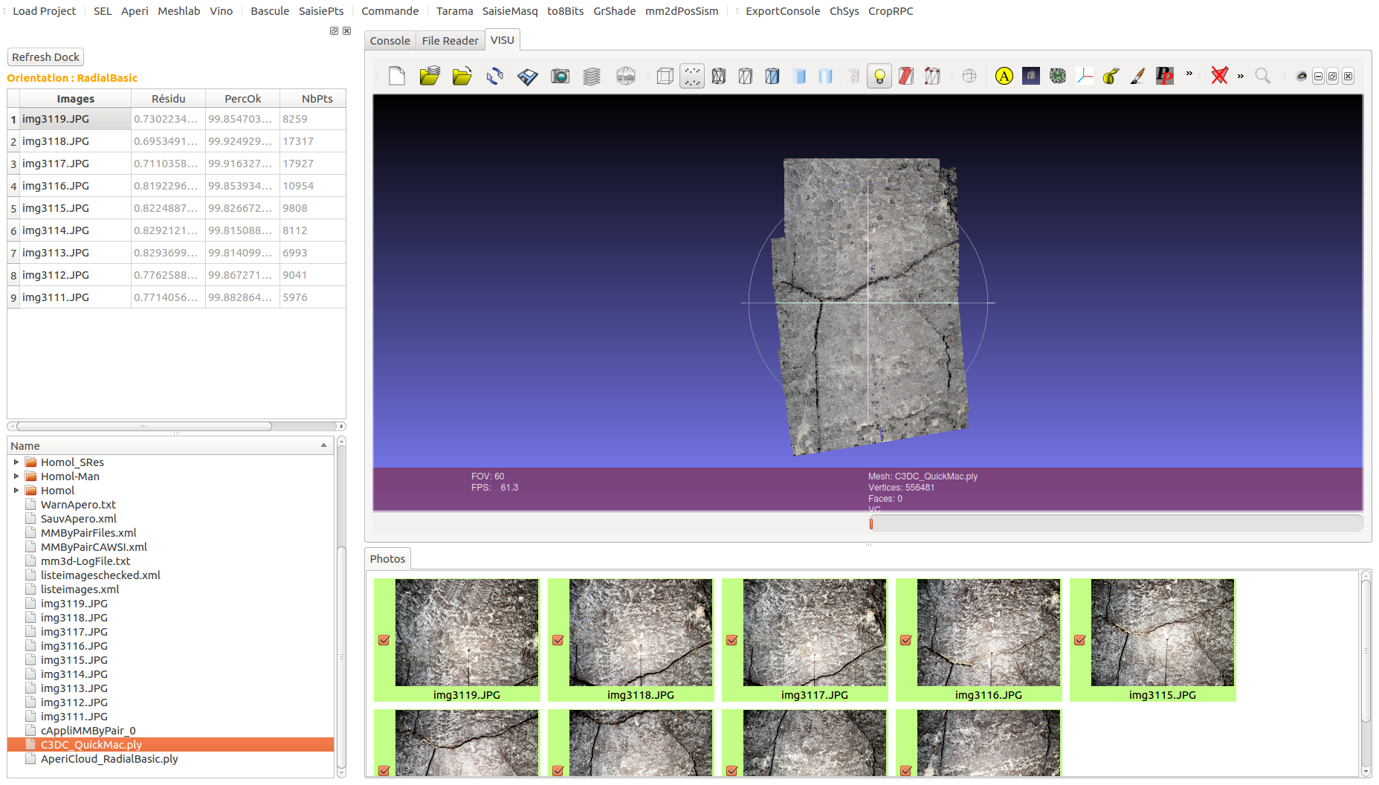

5 – 2nd example : satellite image processing (taken with the pleiades satellite)

Here is an example of a satellite image processing with two pleiade images : im1.tif and im2.tif. Before loading the project folder in your graphical interface, put the images and their RPC files in the same folder (here, the folder is DocSat).

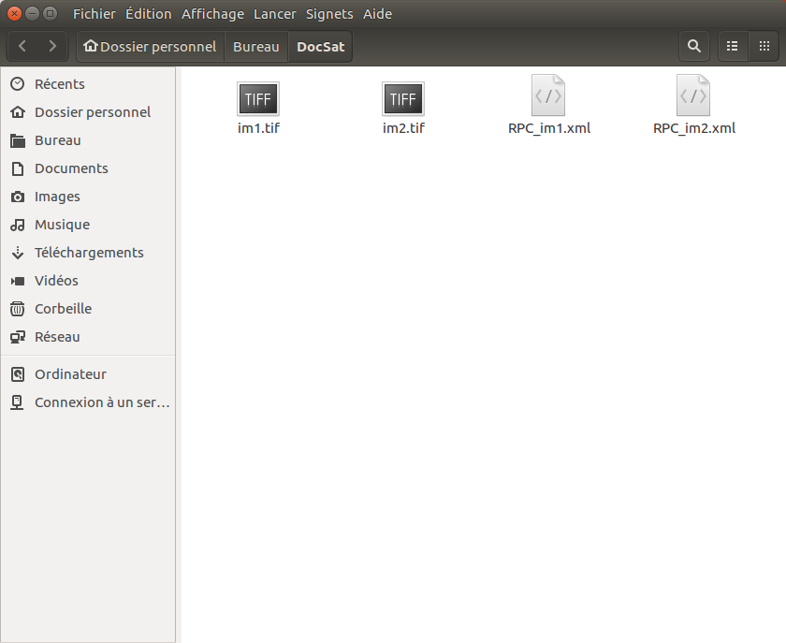

Then open the graphical user interface, and load the project folder.

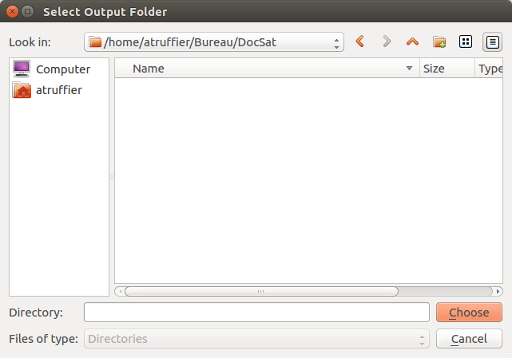

After a relatively short delay, the interface is refreshed, and you’ll be able to see your images in the photos tab.
The first step is the RPC conversion : the RPC files given with the satellite images are not readable by MicMac. We have to convert those RPC files in an understandable format for MicMac. The tool that we have to use is Convert2GenBundle. This tool requires :
- the name of the image you want to convert
- its RPC file
- the name you want to give to the folder that will receive the converted files
- in the case of a pleiade image processing, the ChSys option has to be used in order to load a file allowing the user to change the global referential to a local referential.

This last requirement needs to use the ChSys button . In our case, the area of interest is in the 27 UTM zone :
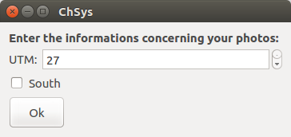

You can click on the new file that has just been created (« WGS84toUTM.xml »), and check that its format and informations is what you expected.
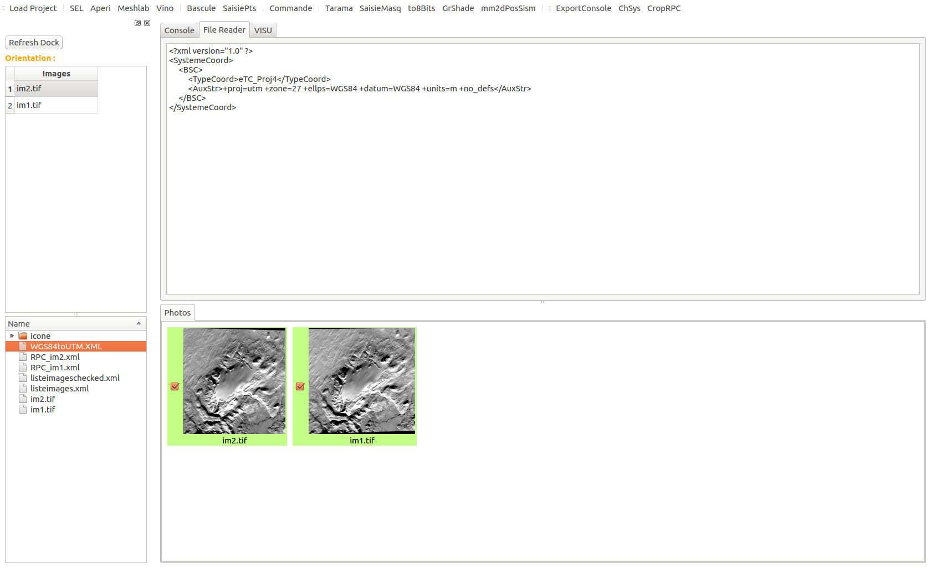
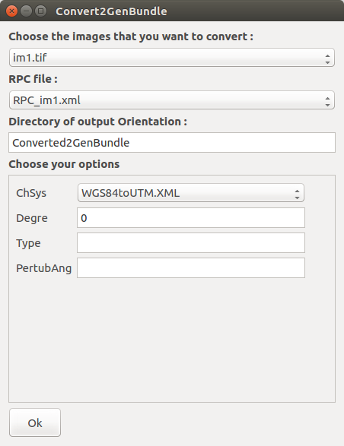
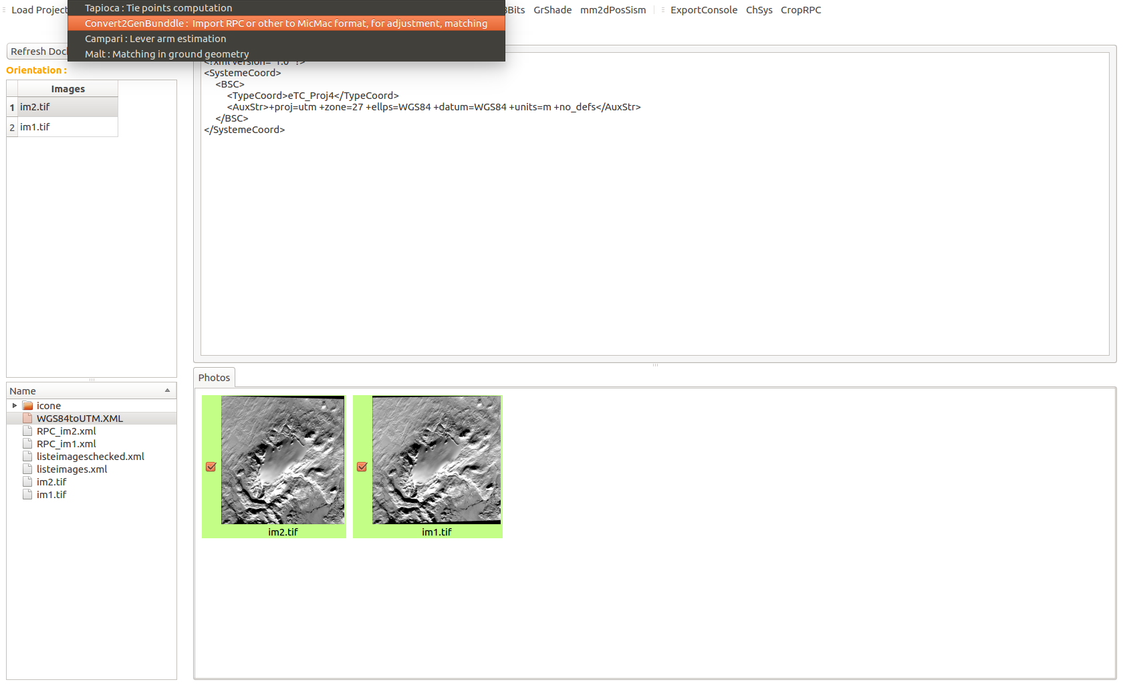
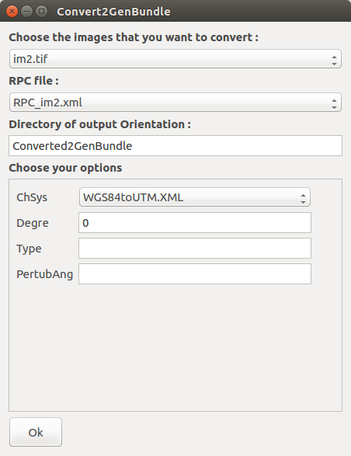
We can now launch Convert2GenBundle, and use it with the paramteres listed previously. We choose to call the Output folder « Converted2GenBundle ». Do it twice with the other image (or as much as it is required depending on the number of images you have to process) and be sure to define the same output folder for each image.
Once your conversions are completed, a new folder is created in the « bottom dock ». Its name is « Ori-Converted2GenBundle » (and it will allways be « Ori-+the_name_that_you_enterred_as_output_in_the_Convert2GenBundle_function »). In this folder, you’ll find the new orientation files that have been converted.

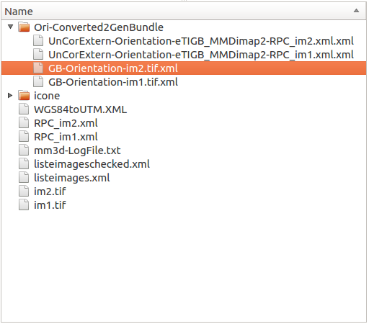

Then, as the images are too big and the region of interest is just a part of the two images, we will win some time with the CropRPC, enabling us to crop the satellite images accordingly.

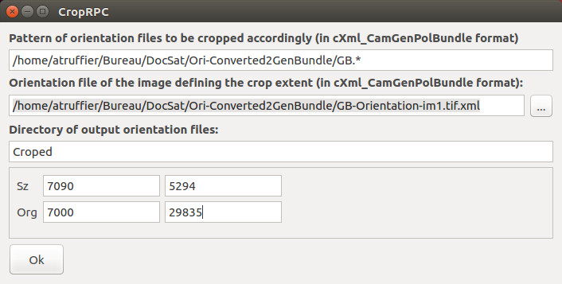
Enter the pattern of orientation files to be cropped that have normally been putted in the Ori-Converted2GenBundle folder (this pattern will select all the orientation of the images that have been converte. In our project they are GB-Orientation-im1.tif.xml and GB-Orientation-im2tif.xml). Then select the orientation file of the image that will be used as model for the crop, and enter a name for the new orientation folder that will be created with CropRPC (here, it is « Croped ») . Finally, add the size and the origin (in pixel) of the Crops you want to create
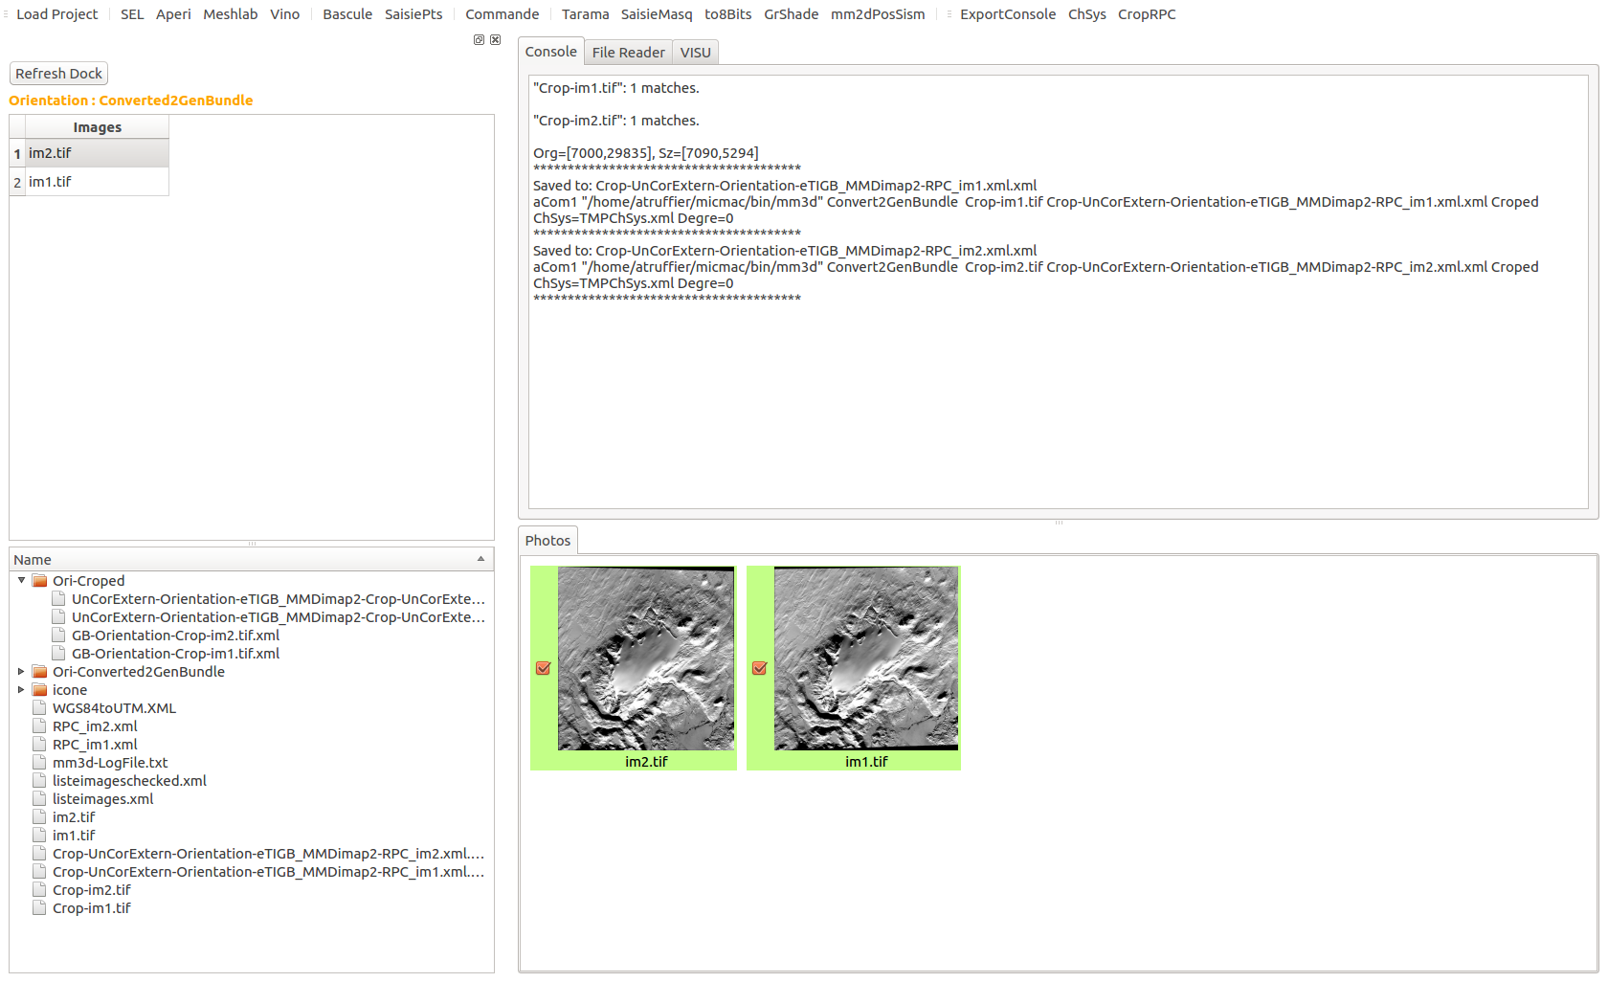
A new folder is created : « Ori-Croped ». It contains the new orientation files of your croped images. Those croped images are put in the same folder as the other two images, and have been automatically named (« Crop-im1.tif and Crop-im2.tif)

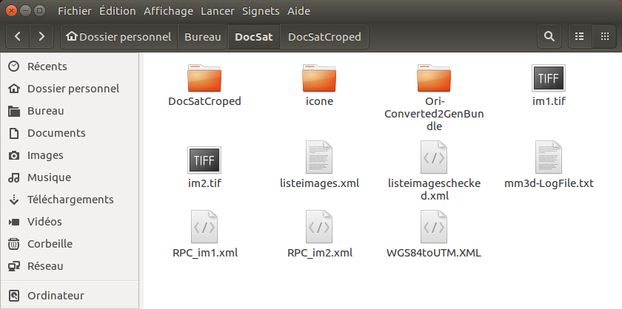
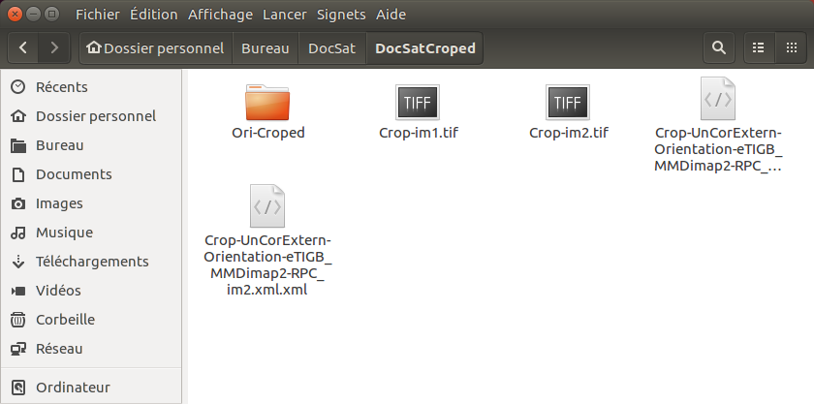
Now, to be sure to not mix all the images (croped and non-croped) we have to go back in the project folder and create a new folder (that we have called « DocSatCroped), where we will put all our stuff concerning the cropped images :
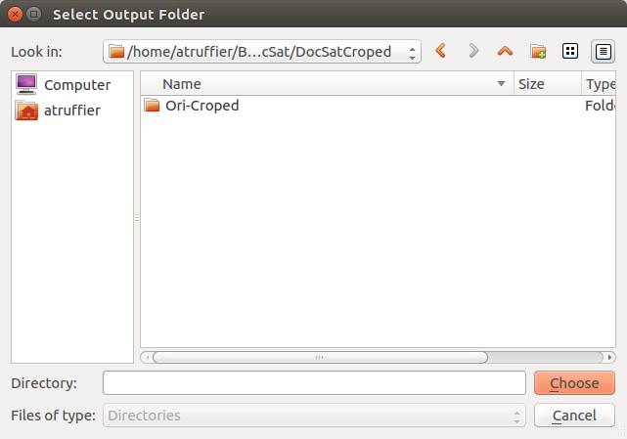
Then, create a new project in the graphical interface in this new folder :

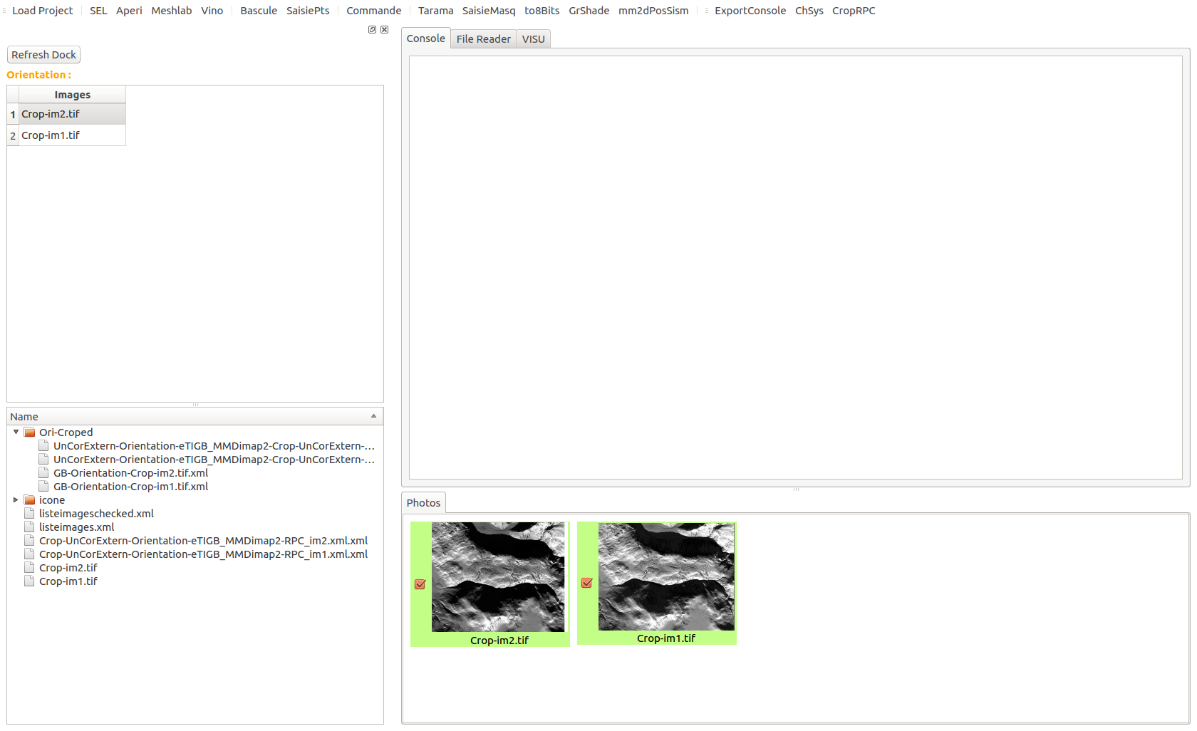
The interface is refreshed with the cropped images.
We can now work on the cropped-images. First, we have to find the tie points. The tool that will help you to do so is Tapioca :

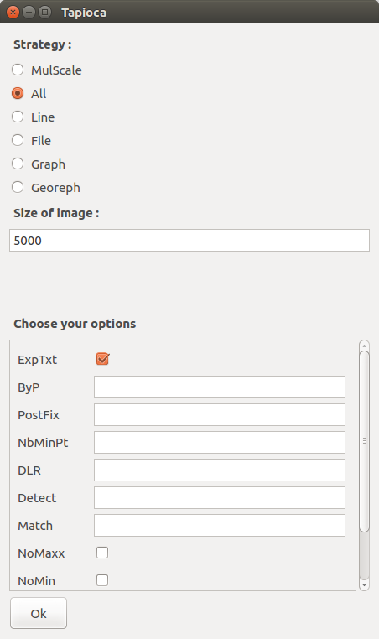

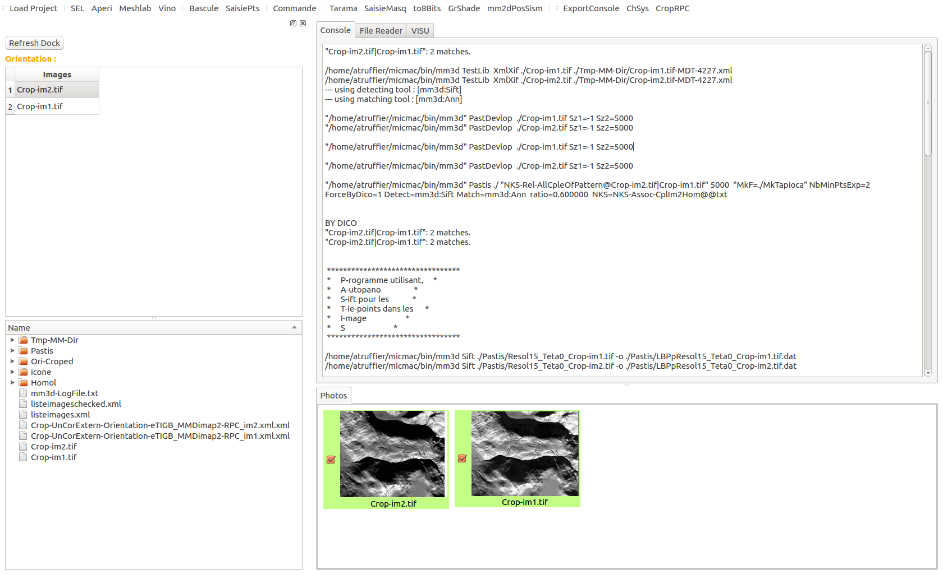
We decide to work on the half of the full resolution : 5000 px.
After Tapioca, if the number of Tie Points found seems to be good enough to continue your image processing, you can launch Campari.

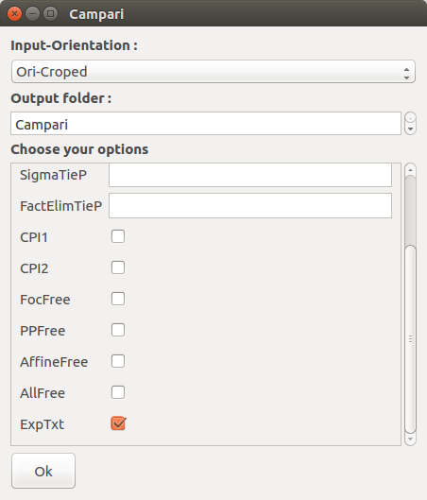

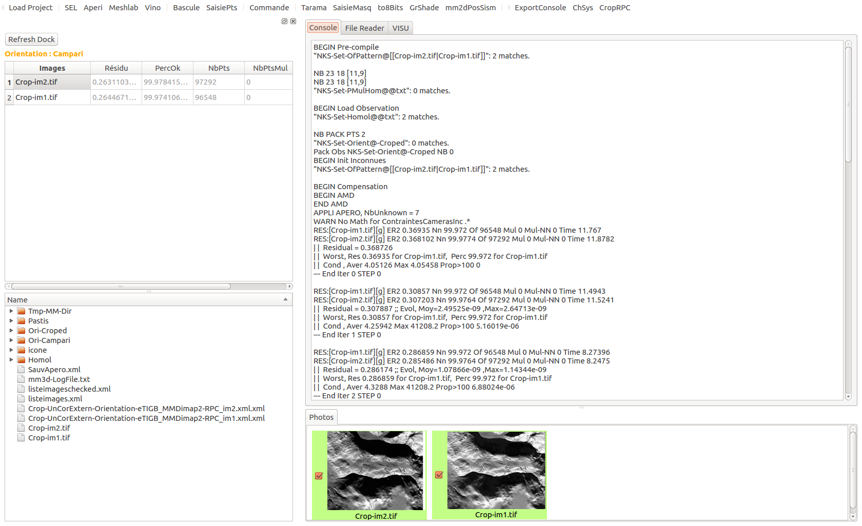
You have to select an input orientation : in our case, this folder is the one that has been created with CropRPC. Select an output folder name for the new orientation that will be created with the tool Campari. In our case, it is « Campari ».
You can check the quality of your orientation in the top Dock : It lists the names of the images and their residues. In our case, the residues are around 0.26 px, which is good enough to continue our process.
The next step is Malt : it is the step that will produce your DEM, or Ortho-images accordingly to your wishes (If you want to get ortho-images, cross the checkbox option « DoOrtho »). Here, we will just create a DEM.
The arguments required are
- The orientation created after the Campari step
- A mode that corresponds to your work (here, we choose UrbanMNE which is the tool that enables us to create a DEM)

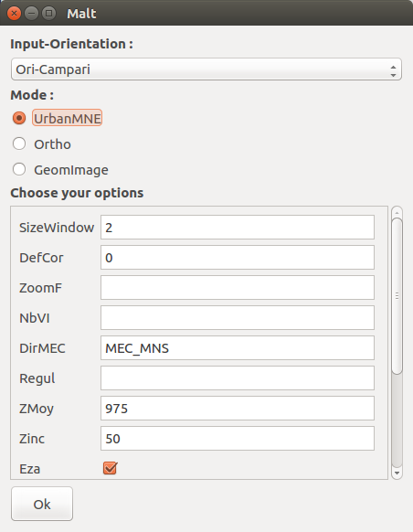
You can add some options : as the SizeWindow used for the DEM computation, the name of the output folder that will hold the DEM (DirMEC), or the elevation average of the scene (Zmoy).
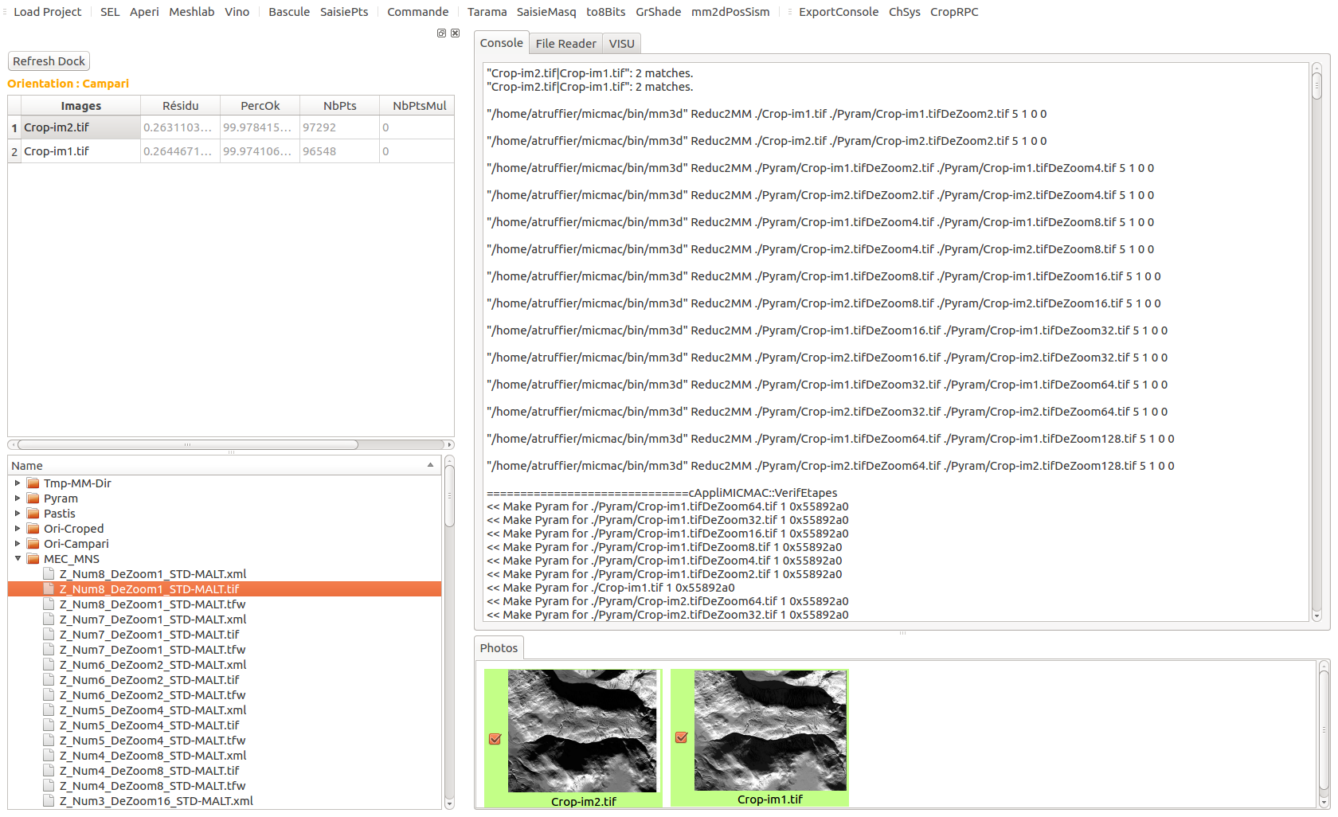
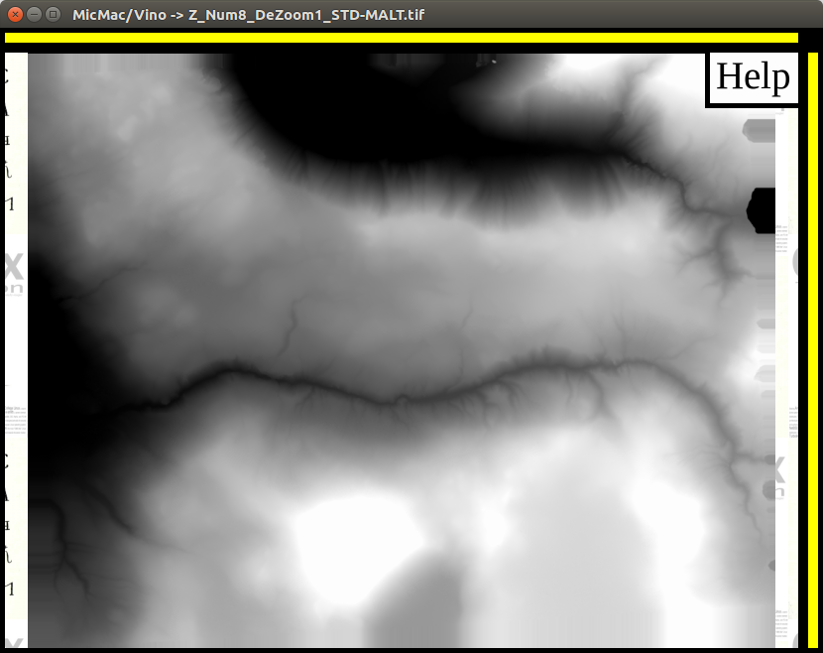
Your « MEC_MNS » folder is created after the end of the function. To visualize your DEM, open it with Vino : the name of your DEM is « Z_Num8_DeZoom1_STD-MALT.tif ».
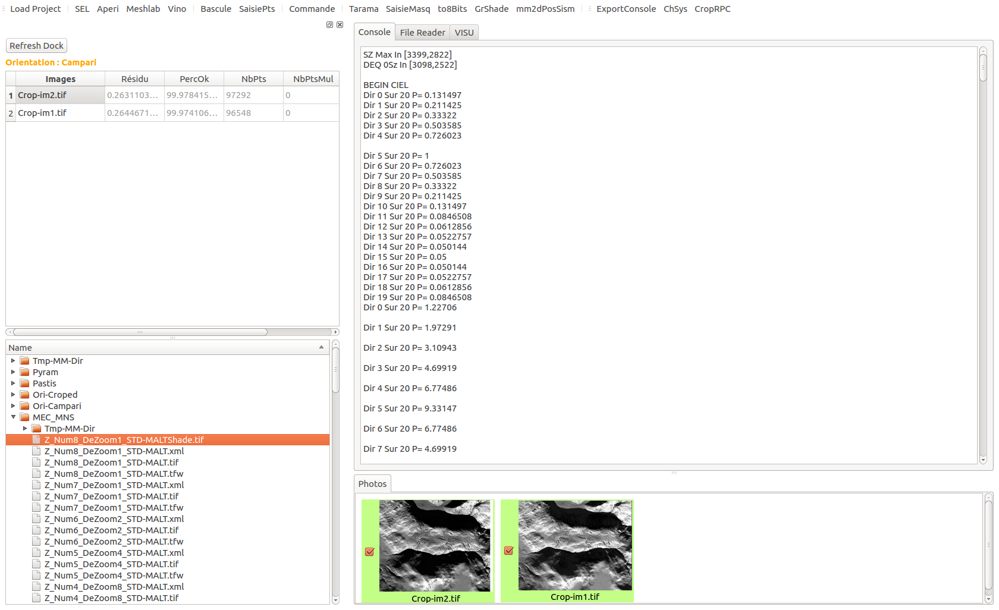
You can created a shaded version of your DEM with the tool GrShade.

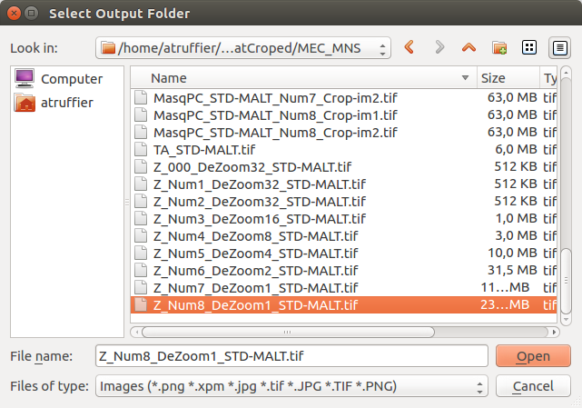

The shaded version of your DEM will be created in the same folder as the original DEM, with the extension « Shade ».
Finally, you can use Vino again to visualize it.
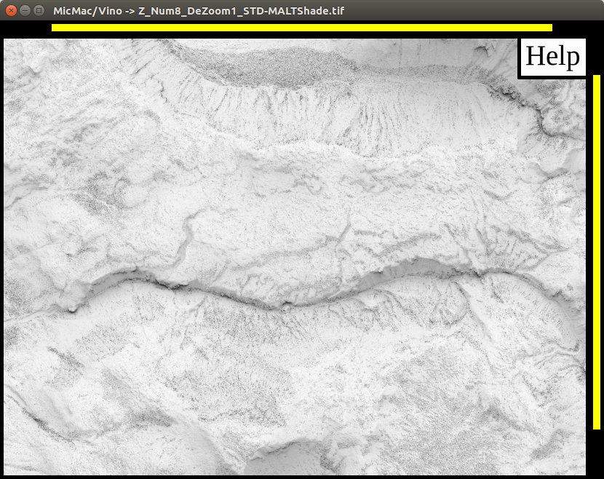
6. Warnings

The interface is still in developpment. You’ll find erros if you :

- delete an image from a folder which has alredy been loaded by the interface
- if a special function is not included in the interface, you can launch your command by typing it directly with the help of the Commande button
- the interface has been tested on Linux, not on windows or MacOS
-

