DOC MICMAC GRAPHICAL USER INTERFACE
CODE
The code architecture is made with a principal file « main.cpp » which opens a window « MainWindow.cpp ». From this MainWindow, we execute all the « functions » created in the other cpp files, which are all linked to a « header » (.h) where all the variables and inner functions (that can be used only with the associated .cpp) are initialized.
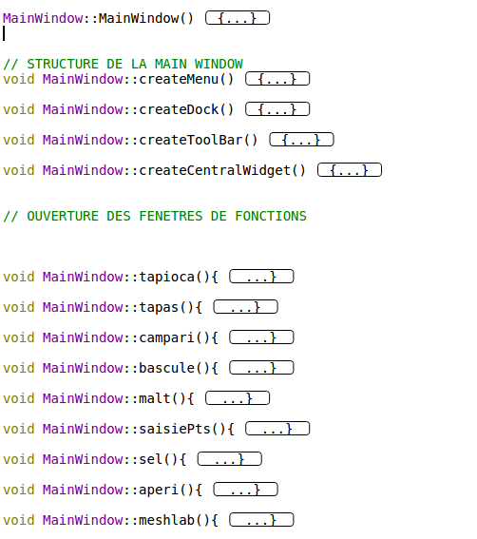
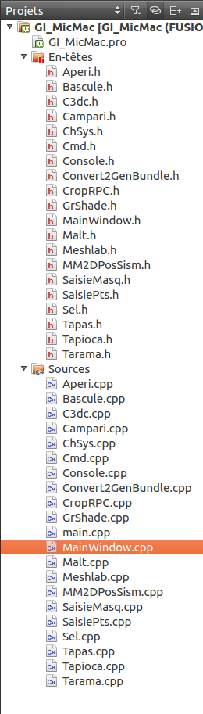

First, we have to talk about the MainWindow.cpp file, which contains and builds all the different sections of the main window. The forst line is the main method MainWindow which will build all the element of the GUI.
It calls all the functions that holds the Qt elements which build the interface :
- MainWindow is launched
- It calls the createMenu() method
- createMenu() holds all the Qt elements and put them on the interface.
It is the same for the other methods createToolBar(), createDock(), createCentralWidget.
It means that if you want to change an element, to delete it, or to add a Qwidget, it has to be done here.
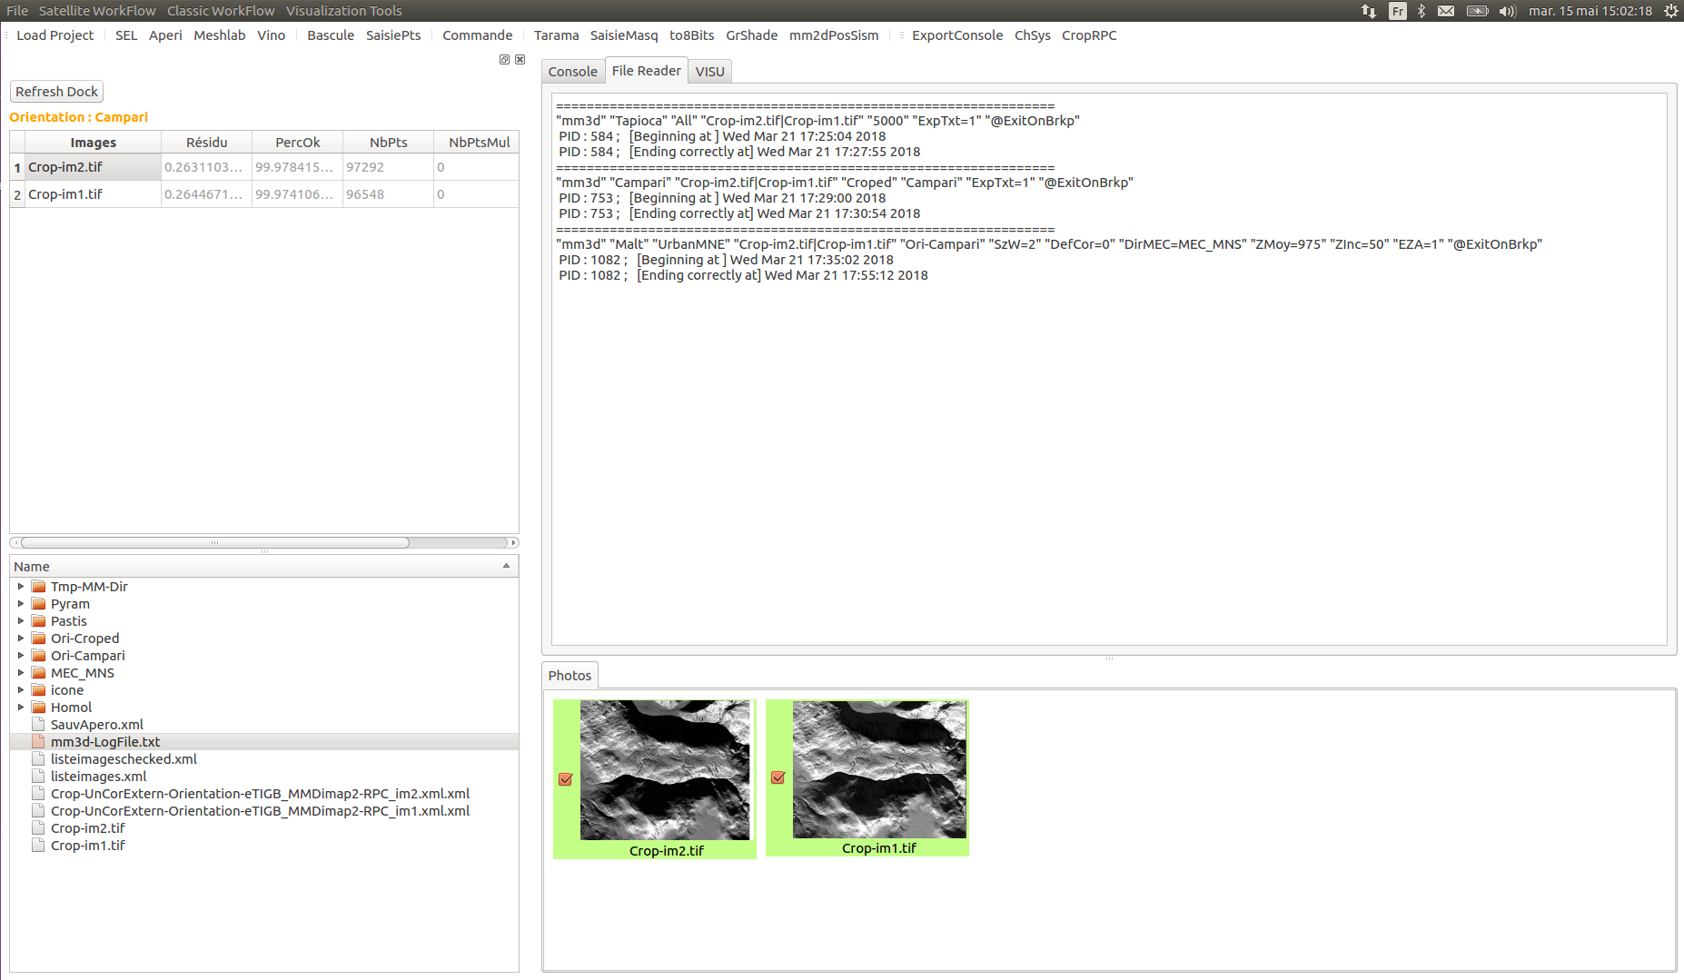
void MainWindow::createMenu()
This part is made of « QMenus » . Each « QMenu » is filed with « QActions », that are linked to « Qobjects » that make the connection with the concerned methods developped.
For example :
The « QMenu » Satellite Workflow holds the « QAction » actionTapioca that is connected with a « QObject » to the tapioca() method.
void MainWindow::createDock()
Here are created the QdockWidget that holds the QTreeView and the QtableView. The QtableView lists all the images and their datas « résidu », « PercOk »… To do so, we just pick the names of the images in the « listimages.xml ». Then, with the findResidu() method, we look for the corresponding residus stocked in the Ori-Residus.xml created.
This section is refreshed after every launched command.
void MainWindow::createToolBar()
This toolbar is made of QActions linked to the corredponding methods. For example, the actionAperiTB is linked to the Aperi method and opens its window.
void MainWindow::createCentralWidget()
This section is made of two QtabWidgets (onglets, that holds the QWidgets Console, File Reader and VISU, and onglets1, which gives the user the possibility to select the images that he wants to process) included in a global Qwidget ZoneCentral.
The photos of the onglets1 are connected to methods like doSomething2 with the help of signals like itemDoubleClicked : it gives some interactions to the users.
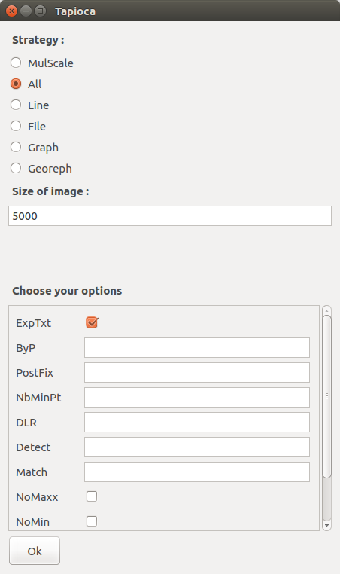
Function name
Options
Additional args

For the micmac functions, it is quite easy to understand : what we do is just creating a window, with clickable options or text spaces to enter specific values, and launching the command that has been created this way.
To do so, we created, for example the tapioca method.
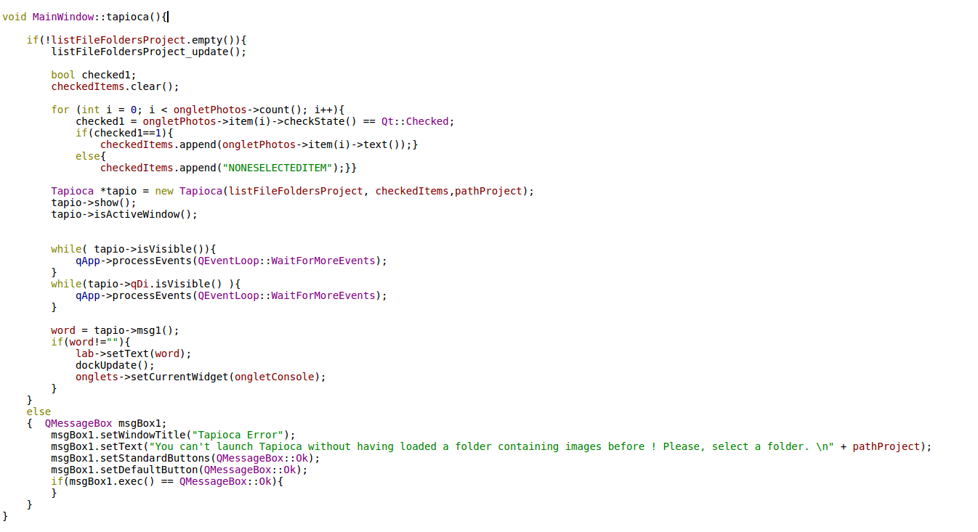
1 The Tapioca function description :
2 We check if the listFileFoldersProject is empty or not. It is a Qlist which is first filled with all the files that are placed in the project folder, then when a function is called, the listFileFoldersProject_update function is called to update this list and to fill it with the images of the project only.
3 To know what photos have been selected, we check it with the help of a boolean, and we add the selected images in the Qlist checkedItems, by checking the ongletPhotos.
4 Now we can call the Tapioca function. We have to give the good parameters : the Qlist with the name of all the images, the Qlist with the name of the selected images, and the path of the project. 5 Then, we set the Tapioca window as the main window, and wait for the Tapioca windows to finish their process.
6 Once the processes are done, we can get the Tapioca message, which is the report of the Tapioca ending. It will be placed in the onglet « Console » of the interface.
7 If the Qlist listFileFoldersProject was empty, it ended without doing all those steps.
It is the same process for all the functions.
1
2

3

4

5

6

7
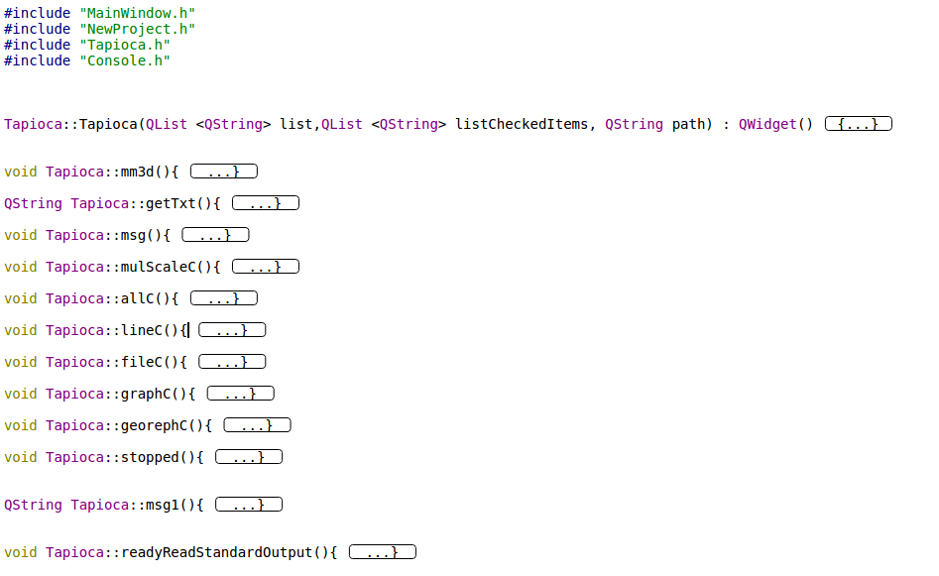
The Tapioca function is simple : it is a window that contains buttons and text spaces : the parameters. Clicking on the button « ok » will just create a command line, and launch it. So what we do is just creating a string containing all the parameters.
We can read in live the results of the command with the readyReadStandardOutput function.
cmd = " mm3d Tapioca "
+ mode +" \""
+ images +"\" "
+ resom_str +" "
+ resoM_str +" "
+ ExpTxtVar.c_str()+"
+ ByPVar.c_str()+" "+
+ PostFixVar.c_str()+" "+
+ NbMinPtVar.c_str()+" "+
+ DLRVar.c_str()+" "+
+ DetectVar.c_str()+" "+
+ MatchVar.c_str()+" "+
+ NoMaxVar.c_str()+" "+
+ NoMinVar.c_str()+" "+
+ NoUnknownVar.c_str()+" "+
+ RatioVar.c_str()+" "+
+" @ExitOnBrkp" ;
This is the string « cmd » that is used to create the command : if a paramter is doesn’t exist, then it will not appear in the command line. For example, if resom_str (which is the minimum resolution) is equal to 500 in the Tapioca window, the command line will contain « 500 » at the good place in the command line. The " @ExitOnBrkp" allows the function to quit automatically at the end of a process.
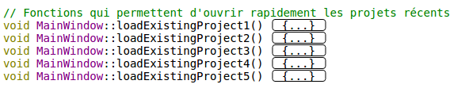
This one allows the program to load the 5 last programs that have been opened fastly with the help of a drop menu. Each function is a classic « loadProject » function, that just go into the paths.txt file and get the lines. We write in paths.txt with the function writePaths(QString) and we read it with readPaths().
So, those lines are the the project paths that have been put here after their first creation. We put their names in a Tab (pathsActions)
The « xport » function allows the user to export the console in a .txt file. It uses anitger method « confirm » to create and write in a .txt file.
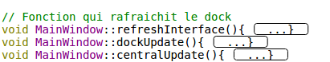
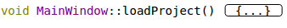
Thos functions have been created to refresh the interface, by deleting, and recreating the Qelements with the new datas that have been obtained ? The refreshInterface method is a method that takes all the widths and heights of all the Qwidgets, then call dockUpdate and centralUpdate to delete the dock section and the central widget, to recreate it, and to apply the widths and heights.
This function is the one that enables the user to select a folder where are the images you want to process. It lists all the element of this folder, extract all the photos (by filtering with their extension .jpg, .tif, …). Then it creates a /icone folder, where mini images of the original ones are put. It uses the imToJpg function to do so.
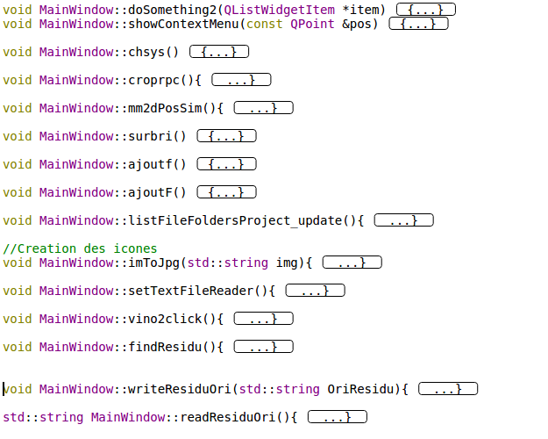
The 3 functions ajoutf, ajoutF and surbri have been created to respectively add a file (an image for example), add a folder, and delete a file or a folder. So, the functions exist but I canceled the link with the interface because it became a little bit hard to manage a project where an image has been deleted during the process for example.
Chsys creates a chsys file with all the georeferences that you want to give to micmac.
listFileFoldersProject_update is a method that was used by ajoutF, ajoutf and surbri to refresh the dock with all the files actualized.
SetTextFileReader is the method that put the text files contents in the File Reader onglet (in the central widget)
meshlab is a method that has to open meshlab and to show the .ply files (point cloud files). I tried to include this window in the VISU onglet but it is not really stable. What I do is launching a command line meshlab with the name of the .ply. Then I look through the xwininfo tree to know the id of the meshlab window. Then I put this window in a widget, and then in the VISU onglet.
findResidu, writeResiduOri and readResiduOri are the methods that will find the residus in the Ori folders, after a Tapas or a Campari. FindResidu will find the residu in the Ori-…/Residus.xml that Tapas or Campari created. Then, writeResiduOri write thos residus in a new file, residu.txt. And finally, readResiduOri read those residus in residu.txt and
doSomething2 is the method that opens a preview of an image with a double click. It basically launch a « vino » command when a double click is litened on an image of the photo onglet.
doSomething is the method that manages the selection of the image with a simple click.
showContextMenu is the method that can be used to interact with the right button of your mouse.

