DOC MICMAC GRAPHICAL USER INTERFACE
CODE
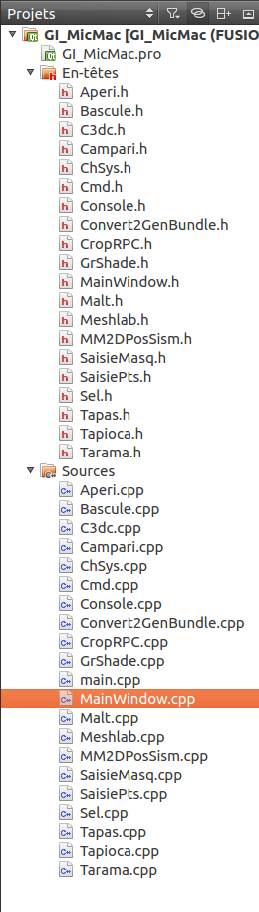
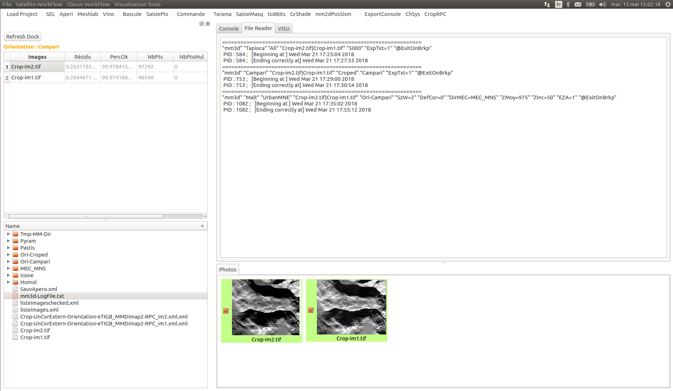
The graphical user interface is made of 4 sections created with the help of those methods:
void MainWindow::createMenu()
This one creates the top menu allowing the user to open a new project, select a project that has already be opened once, or select a function for an image processing.
For the projects already listed, the interface just opens a .txt file called « paths.txt » where the project paths are written once they are opened.
The functions are linked to methods, as it is explained below.
void MainWindow::createDock()
The left section is a dock which lists all the folder and files that have been created with this project, and the images with their informations. The widgets used are a QtreeView (treeViewFloders) for the bottom part and a QtableView (treeViewImages) for the top part. The names of the images come from the xml file listeimages.xml, and all the folders and files are directly selected from the folder of the project.
void MainWindow::createToolBar()
This toolbar is made of Buttons only, that will automatically open
void MainWindow::createCentralWidget()

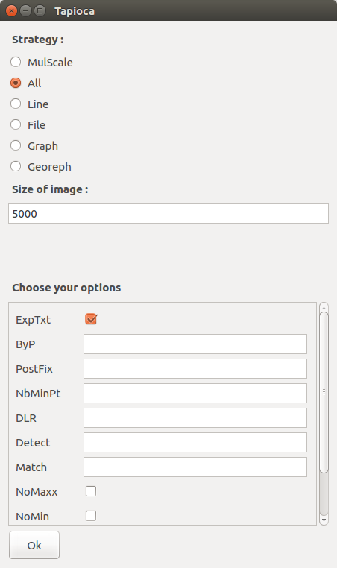

cmd = " mm3d Tapioca " + mode +" \""
+ images +"\" "
+ resom_str +" "
+ resoM_str +" "
+ ExpTxtVar.c_str()+" "+
+ ByPVar.c_str()+" "+
+ PostFixVar.c_str()+" "+
+ NbMinPtVar.c_str()+" "+
+ DLRVar.c_str()+" "+
+ DetectVar.c_str()+" "+
+ MatchVar.c_str()+" "+
+ NoMaxVar.c_str()+" "+
+ NoMinVar.c_str()+" "+
+ NoUnknownVar.c_str()+" "+
+ RatioVar.c_str()+" "+
+" @ExitOnBrkp";
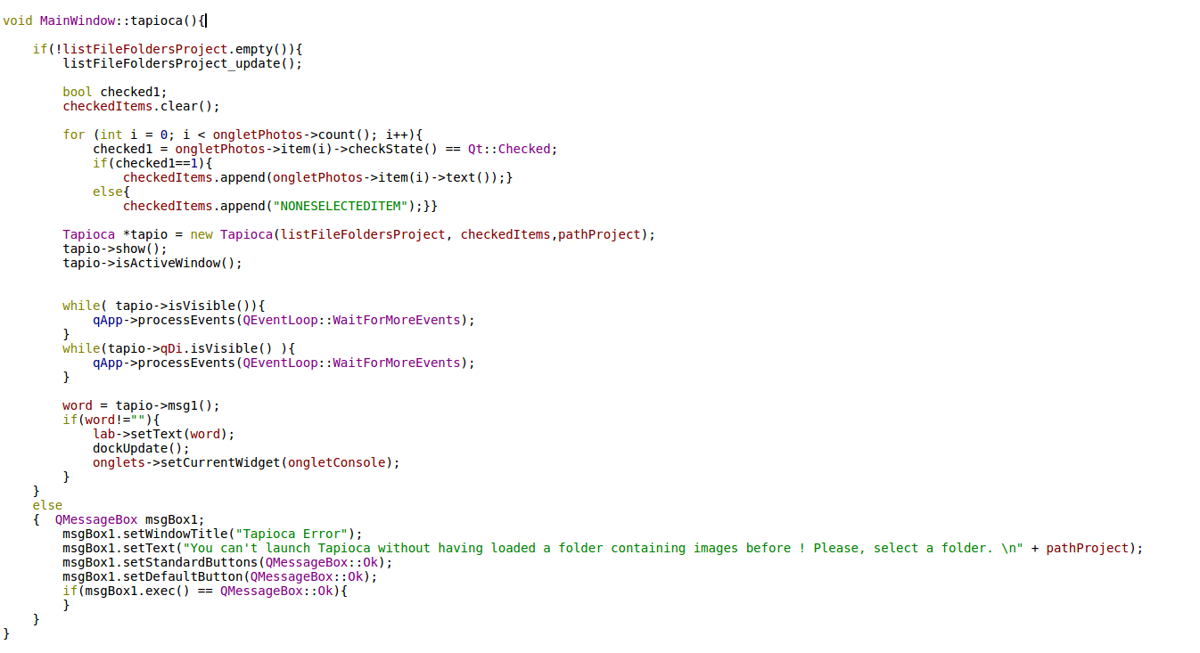
Tapioca *tapio = new Tapioca(listFileFoldersProject, checkedItems,pathProject);

