Relative geometric calibration of a thermal camera using a calibrated RGB camera.

M. Pierrot Deseilligny ^{a,} *, S. Labbé ª,

ª CEMAGREF, UMR Tetis, 500 Avenue Jean-François Breton

Commission I, WG I/4

KEY WORDS: Thermal, Calibration, Photogrammetry, Environment, Algorithm, Geometric

ABSTRACT:
This paper presents a method for geometric calibration of thermal cameras relatively to an already calibrated camera. Cost effective thermal camera are of increasing interest in remote sensing application especially when they can be superposed to other images (RGB, infrared …). A prerequisite for this superposition is the geometric calibration of the two cameras. As traditional methods cannot be used easily with thermal camera, due to poor image quality and low contrast of target, we have developed a method using only homologous point between a reference RGB image and the thermal image. Our relative method use a conical object to assure that we take picture of the two camera with almost identical projection centre; assuming this condition, the calibration problem is restrained to 2D mapping between two images. Different evaluation show that the proposed method is at least as precise as the traditional one with this kind of camera and it has the benefit of being time and cost effective.

Introduction
The use of thermal cameras in aerial remote sensing application should grown drastically in the next years due to the availability of low-cost (<15K$) bolometric instruments and to their potential for environmental survey applications (# Jacob, 2002) as hydric stress measurement of crops (#Begué, 2007). However, to take benefit of the full potential of such thermal data, these images must be analysed in combination with visible (and for vegetation near infrared) images, generally acquired during the same flight.
Thus we have to superpose thermal images to more classical imagery; in visible and near infra red spectrum, A prerequisite to the automatic superposition of thermal and RGB image is the geometric calibration of both pinhole cameras.
The geometric calibration of pin-hole camera, is a well known field, that has led to many fruitful methods in both photogrammetric and computer vision community; however, the calibration of a pin-hole thermal camera generate specific problems due to the difficulty of identifying precise ground truth target in a calibration scene. In this paper we describe a method for the geometric calibration of a thermal camera relatively to an already calibrated RGB camera. Typically, in our applications, the resolution of RGB camera are around 10 Thus we have to superpose thermal images to more classical imagery; in visible and near infra red spectrum, A prerequisite to the automatic superposition of thermal and RGB image is the geometric calibration of both pinhole cameras.
The geometric calibration of pin-hole camera, is a well known field, that has led to many fruitful methods in both photogrammetric and computer vision community; however, the calibration of a pin-hole thermal camera generate specific problems due to the difficulty of identifying precise ground truth target in a calibration scene. In this paper we describe a method for the geometric calibration of a thermal camera relatively to an already calibrated RGB camera. Typically, in our applications, the resolution of RGB camera are around 10
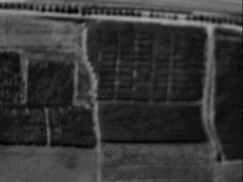
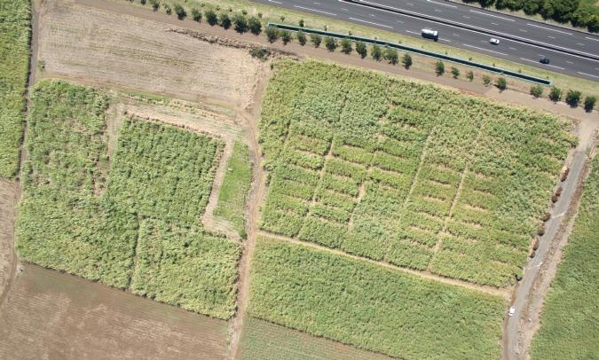

Figure 1. Thermal (320*240 pixels) and RGB (3500*2500 pixels) aerial images of a parcel acquired during the same flight.

time better than the resolution of thermal camera which make the RGB camera a high precision reference.
The basic idea is to take picture in particular conditions that give images from both cameras of the same calibration scene with the same projection center.
The paper in divided in three main part : the description of the traditional method used for calibration, the description of our method for relative calibration and some elements of evaluation.

Traditionnal calibration method

Notations
We note (O,R) the extrinsic parameters characterizing a camera pose, where O is the centre of projection and R the rotation matrix defining camera orientation. If w is a point in word coordinates, and q are the coordinates of w in camera system:
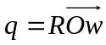 (1)
We note the “canonical” projection defined by:
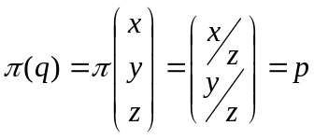 (2)
We note 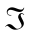 the intrinsic parameters that transform a projective point p into an image point i. Classically is characterized by a focal length F, a focal point PP, and a distortion D:

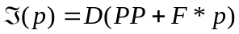 (3)
There have been many different model proposed for D. In this paper we use the polynomial radial model where D is characterized by a distortion centre and, for example, 2 or 3 coefficients:
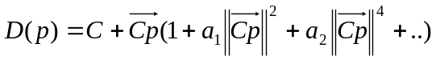 (4)
Intrinsic calibration is the task of computing the parameter defining. The correspondence between a point w in world coordinates and it projection in a image is thus given by:
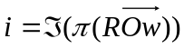 (5)
It is important to note that is defined up to a rotation.

Description
Many work have been devoted to camera calibration both in photogrammetry and computer vision (# Brown 197,1 Faugeras 1993, Weng 1992 Zhang 2000). We describe here the traditional photogrammetric method we use.

A classical method, for geometric calibration of a pinhole camera, uses a scene with a set of ground truth points (wk). The coordinate of these points have been measured by traditional topographic methods. A sufficient number of images of the scene are taken and the positions of the ground points in these images are measured (either manually or, preferably, automatically). For each image l and each ground point 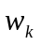measured at position , we have the equation:

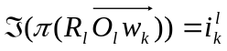 (6)

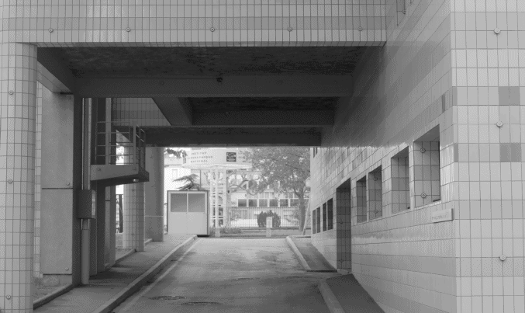
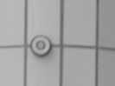 | 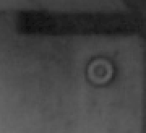
Figure 2. A calibration scene with zoom on two ground truth targets.
Let N be the number of image, and M be the total number of target seen in the images, we have a system of equations where:
- There are 6N unknowns due to extrinsic parameters;
- The are 8 unknown due to intrinsic parameters (assuming a polynomial radial model of degree 7);
- There are 2M observations.
To assure robustness, typically, in our scene we have at least “M>15N” and we have an over determined non linear system of equations. We use a classical Gauss-Newton method to solve this system. For the initial “guess” we set:
- 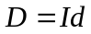
- PP is set at the centre of image;
- F is given by camera constructor instruction (focal length in mm of the lens and size of receptors);
- Initial value of 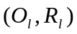 computed by space resection (# Zheng, 1992) assuming the previous initial values for .
Then one alternates iteratively linearization of equations and resolution of over determined system by least mean square.

Usability with thermal camera
The previous method has been used for many years by photogrammeters and gives satisfying results with classical images as long as the scene has a 3D structure (high variation of deepness) and the focal is not too high.
However we cannot use directly the same method and scene for calibration of thermal camera because the “black and white” target, chosen for being well contrasted in visible spectre, are indiscernible in the thermal spectre.
A possible alternative is to use metallic target, which are generally well separated from background on thermal image. Figure @3 presents a calibration scene we have tested, using metallic nail as target.

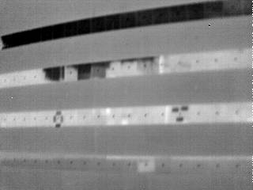 | 
Figure 3. A calibration scene tested for thermal camera with zoom on thermal targets.
Although the metallic nails are discernible, as can be seen on the zoom of figure @3, there remains some drawbacks for using these methods with thermal images :

- due to low resolution of thermal image (320*240 with our camera) the target are only few pixels, making difficult a reliable automatic detection;
- even with manual interaction, the position of the target in image are very imprecise, which would require a lot of image and target to overcome statistically this imprecision;
- the conception, fabrication and measurement of a second set of target dedicated to calibration of thermal camera is a very consuming task.

Relative calibration method

Basic idea of relative calibration
Taking two images of the same scene with two camera, by identifying homologous points and using equation (5), leads to the classical couple of equation (6) for relying intrinsic and extrinsic parameters with tie points.
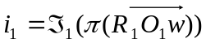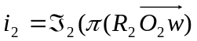 (6)
This equation is currently used by introducing w as a temporary unknown.
In the particular condition where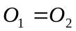, or where the scene has an infinite depth (mathematically this is equivalent) the relation (6) is simplified drastically. When this condition is achieved, the correspondence between two images becomes a mapping independent of the depth and we have:
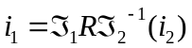 (7)
Where 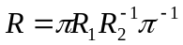is a rotation on the projective sphere. If one calibration is known (say 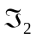), equation @7 gives a direct 2D constraint on 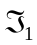. So if we can create these particular conditions and found a sufficient number of homologous point, we can compute with only one pair of image.

Protocol for alignment of projection centres.
Practically, it is difficult to have rigorously or an infinite depth, but by approaching simultaneously these two conditions we can be very close to equation (7).
Setting the depth the closet as possible to infinite is not complicated, we select a scene with a far background.
Setting can not be achieved directly because these points have no material existence. To achieve this part we use the following remarks:
- We use a truncated conical object, mathematically a conical surface is generated by a submit and a curve (for example a circle) and contains all the lines joining the curve to the submit; practically, the truncated cone can be materialized by a simple lampshade as shown on figure @4;
- It is easy to see that the image of the truncated cone by a pinhole camera vanishes to the generating curve when and only when the projection centre of the camera coincide with the submit of the cone;
- By manually moving the camera in front of the cone until the image vanish to a circle we can assure that we set the camera in a position where its projection centre coincide with the submit of the cone: bottom of figure @4 represent such an image.

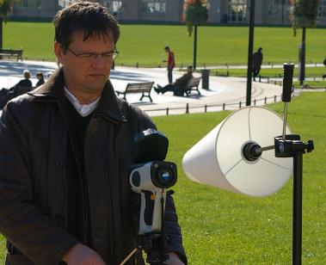
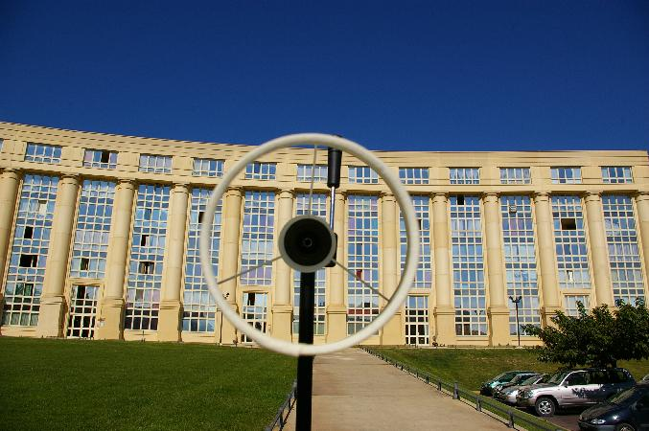
Figure 4. Up : a (intensively focused) photgrammeter at work, adjusting the position of a thermal camera. Bottom : a image obtained, with RGB camera, when the submit of the cone coincide with the centre projection of the camera.

So taking several image of the same scene with different camera, and achieving the vanishing condition on the image of the cone, we can assure that all the image will be taken with approximately the same projection center. Figure @6 represents two image of the same scene taken with a thermal and a RGB camera.
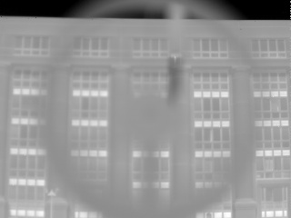

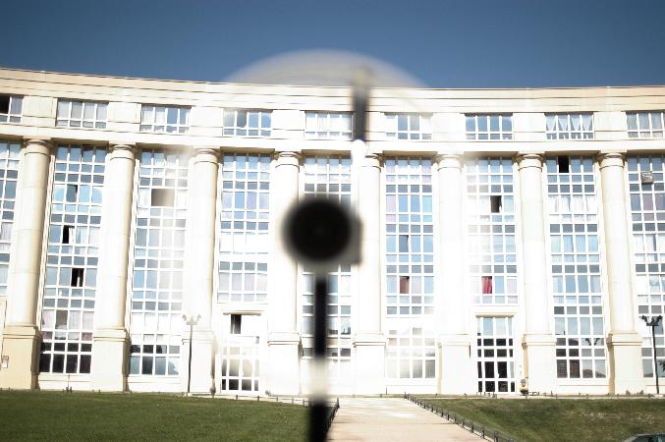
Figure 6 : A thermal (Up) and RGB(bottom) image of the same scene with our alignment protocol.

With pictures such as those presented on figure @6, the conical object in foreground perturbs the research of homologous points. To avoid these artefact we use the following protocol :
- Take an image of the background with the RGB camera without the conical object;
- Put the conical object in front of the RGB camera and adjust the position of the conical object until its image vanishes to the generating curve;
- Replace the RGB camera by a thermal camera and adjust it position until the image of the conical object vanishes to the generating curve;
- Take an image of the background with the thermal camera without the conical object
Figure @7 represents the image obtained with such protocol. The images have been set to, approximately, the same scale using the a priori focal lengths. We use gradient image who are easier to match than original images (because of frequent contrast inversion between original images).

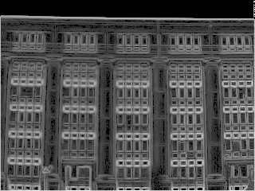
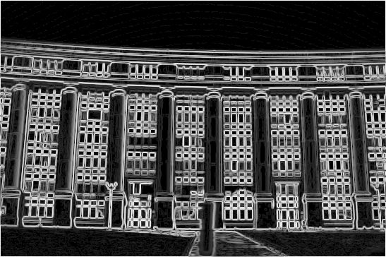
Figure 7 : Gradient of thermal (Up) and RGB (bottom) images, without the cone in foreground.

Equations and resolution
Practically we use the followings steps for calibration of a pair of camera including a thermal and a RGB camera:
- Calibrate the RGB camera by the traditional process describe in section 2, so we know the intrinsic parameters ;
- Take a pair of RGB/thermal images with projection centres almost identical, using the protocol describe in section 3.2;
- Get a set of homologous points between two images.
Using equation @7, each pair of homologous points gives a pair of constraint; in this equation , and are know; we use again a classical Gauss-Newton method where the unknown are :
- The intrinsic parameters ;
- A pure rotation defined (for example) by three unknown angles;
Due to the low resolution of thermal images, we select a model on with fewer parameters than usual (see next section) ; around twenty pairs of points are necessary to reach stability, the homologous points are captured manually (automation should be feasible but of low interest).

Evaluation

Choice of a parametric model
The problem of selecting the adequate parametric model for the is confronted to the usual alternative :
- if we have too few parameters, we cannot adjust the potential complexity of the real camera;
- if we had too much degrees of freedom we have a calibration that match perfectly the training set but is poorly extrapolated to other data:

Table @1 present the quantitative experiment we have made to test different models. We have tested the following options corresponding to the different columns of table @1:
- constrain the distortion centre and the principal point be equal or let them independent;
- fix the degree the polynomial radial mode to be 1, 2 or 3;
For each tested configuration, the first line of table@1 present the residual of equation @7, the result are in pixel. As obviously expected, the residuals decrease with degree of freedom. The second line, named evaluation, presents a more interesting measure obtained by the classical procedure:
- parse all pair of homologous point;
- for each pair, subtract this pair of the system, solve the system with this subset and measure the error for this pair;
- take the average of the error obtained for all pairs.
It appears from this evaluation that the best results are obtained with a principal point independent of distortion centre and a low degree of polynomial. The best results obtained by low degree can be seen a natural consequence of the poor resolution of thermal images and noisiness of matching point between thermal and RGB images : in such condition, rough models are more robust. It is more difficult to explain why the independence of principal point and central distortion gives better results.

 | CDist=PP |  |  | CDist and PP independant
 | D1 | D2 | D3 | D1 | D2 | D3
Residual | 0.34 | 0.33 | 0.31 | 0.34 | 0.31 | 0.31
Evaluation | 0.44 | 0.45 | 0.45 | 0.40 | 0.44 | 0.45
Table 1. Residual and evaluation in pixel of different parametric models.

Stability and comparison with traditional method
In this section we compare three different calibrations of the same thermal camera:
- a “traditional” calibration obtained by method of section 2, with the scene of section 2.3
- two calibrations (Rel1 and Rel2) obtained by the relative method of section 3, on different scenes.
All these calibration have been computed with a degree 3 radial polynomial and a principal point independent of distortion centre.
 | Focal | A0 | PPx | PPy
Traditional | 678.2 | -8.63e-7 | 148 | 114
Rel1 | 662.7 | -9.06e-7 | 140 | 134
Rel2 | 663.2 | -10.05e-7 | 148 | 138
Table 2. Value of parameters with different calibration. Parameters : focal length, first coefficient of radial polynomial distortion and principal point. Calibration : traditional with ground truth and two different relative calibration.

The first test is to compare directly the obtained parameters. Table @2 presents such a comparison. We have the following remarks:
- the focal length of the two last line are closed to each other and not far from the constructor specifications (ie 666); the focal length obtained by traditional method is quite different from those values, we think that this value is unstable due to the flatness of our thermal calibration scene;
- the term A0 (coefficient of degree 3 of radial polynomial) is rather stable, the difference between the calibration correspond to less than a pixel in the corners;
- the principal point is quite unstable, which is very usual due to its correlation with distortion centre and the unknown rotation of equation of equation @7.
Generally, the direct comparison of coefficient is not a pertinent method due to possible correlation between these coefficients (almost identical calibration can be coded by highly different parameters). Interpreting a calibration as a mapping from projective plane to image space, let and 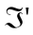be two calibration of the same camera, a better measure is to take:
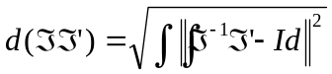 (8)
Where the integral of equation @8 is computed on all the image space. However we must take into account that and are defined up to a rotation, and the “good” distance is the quotient distance:
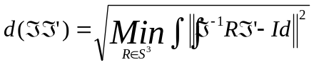 (9)

In equation (9) 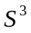 is the group of rotation of 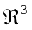and the min is computed by a (easy) Gauss-Newton minimization. Table 3 presents the distance (in pixel) obtained between these calibrations. We can see that the two relative calibrations are in fact very closed to each others (the difference between principal points has been almost absorbed by a rotation). The traditional calibration remains not so closed, due to the difference of focal length.

 | Traditional | Rel1 | Rel2
Traditional | 0 | 2.71 | 2.54
Rel1 | 2.71 | 0 | 0.15
Rel2 | 2.54 | 0.15 | 0
Table 3. Distance in pixel between different calibrations.

As a final test, we have used the different calibrations for computing a (small) aero-triangulation of some aerial thermal images. Figure @8 presents some used images and tables @4 present the residual obtained. The results are very similar according to this comparison, this is not surprising because the main difference between traditional and relative is the focal length which cannot be characterized due to the flatness of the ground on this test.

 | Traditional | Rel1 | Rel2
residual | 0.195 | 0.193 | 0.194

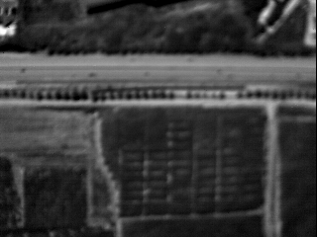 | 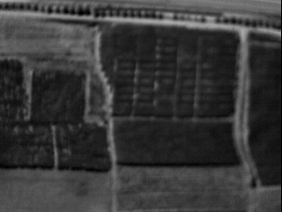
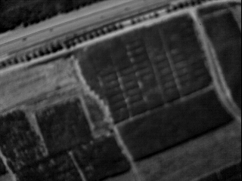 | 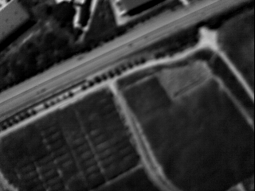
Figure 8: A subset of the images used for the test aero triangulation.
These evaluations should be extended with more extensive test. As a temporary conclusion for these elements of evaluation, the relative calibration seems sufficiently stable : a the distance of 0.15 pixel (measured with equation @9) seems reasonable taking into account the quality of thermal image.
For the comparison with traditional methods, the main difference between to methods is focal length; we think that the result of the relative method are more precise than the traditional for the following reason : they are stable, they are closed to constructor specification and the scene used for traditional calibration of thermal camera was relatively flat. However this cannot be proved formally and would require more investigations.
The main source of error in the focal estimation by the relative methods is probably the movement of the projection centre. In our test, the background is at 60 metres from the image, so assuming a pessimistic movement of 3 centimetres on the center, we still have a relative precision of 1/2000 which is quite coherent with a FOV of 1/600.

Conclusion
In this paper we have described a method for geometric calibration of a thermal camera. The method use an already calibrated camera RGB camera and a pair image taken in particular conditions that give images from both cameras of the same scene with the same projection centre. An originality of our method is the use of conical object to allow a sufficiently precise alignment of both projection centres.
Two kinds of evaluation have been made: comparison with traditional method and stability. In the comparison with traditional method, the results are significantly different due essentially to difference in focal length estimation. The focal estimated by relative method is probably more reliable but this has not been proved rigorously. The stability estimation gives satisfying results according to the low quality of images and potential imprecision of homologous point.
The proposed method appears to produce results at least as precise as traditional method for this particular kind of camera. Its main advantage is its cost and time effective aspect: it does not require a special calibration scene with ground trust target discernible in thermal image and it works with only one pair of images requiring little human interaction for capture of homologous points.
Obviously, the method is theoretically not limited to geometric calibration of thermal camera and it could be used, for example, to calibrate a RGB camera with another RGB camera. However, the precision on the focal length estimation would probably not be adapted with high resolution image.

Bégué A., Labbé S., Lebourgeois V., Roux B., Mallavan B.. 2007. Radiometric normalization of multi-temporal visible and near infrared images acquired with light ariborne systems. In : ISPRS. Workshop : Airborne Digital Photogrammetric Sensor Systems, 11-14 September 2007, Newcastle (UK) .

Brown, D.C., (1971), Close-Range Camera Calibration, Photogrammetric Engineering. 38( 8), pp. . 855-866.

Faugeras.O. 1993. Three-Dimensional Computer Vision: a Geometric Viewpoint. MIT Press, 1993.

Jacob F. Olisob A., Gu X.F., Su Z., Seguin B. 2002. Mapping surface fluxes using airborne visible, near infrared, thermal infrared remote sensing data and a spatialized surface energy balance model. Agronomie 22, pp 669-680.

Weng J., Cohen P, Herniou M. 1992. Camera Calibration with Distortion Models and Accuracy Evaluation. IEEE Transactions on Pattern Analysis and Machine Intelligence. 14(10)

Zeng, Z., Wang,X., 1992. General solution of a closed-form space resection. Photogrammetric Engineering & Remote Sensing . 58( 3), pp. 326-338.

Zhang Z., 2000. A Flexible New Technique for Camera Calibration. IEEE Transactions on Pattern Analysis and Machine Intelligence 22(11) pp 1330-1334.

* Corresponding author. This is useful to know for communication with the appropriate person in cases with more than one author.

