INTERFACEMICMAC

USER DOCUMENTATION

Isabelle CLÉRY
Institut Géographique National, laboratoire MATIS,
73, avenue de Paris, 94165 Saint Mandé, France
Université Paris-Est
isabelle.clery@ign.fr

Contents
I GUI OVERVIEW 3
1. Important 3
2. Principle 3
II SET UP 3
1. GUI 4
2. Associated binaries 4
3. Libraries and other required binaries 5
III USE OF GUI 5
1. Beginning 5
a. GUI menus 5
b. Main window and launching GUI 6
c. GUI general settings 7
2. Load images 7
3.Tie-point search 8
a. Adding initial calibrations of the camera 8
b. Selecting the shoot type 11
c. Selecting image pairs 11
d. Setting up other parameters 13
e. Running the process 13
f. Results 14
g. Frequent error messages 14
4. Computing poses 14
a. Selecting images to be oriented 15
b. Selecting master image 16
c. Absolute orientation 17
d. Initial orientation 22
e. Previous auto-calibration 23
f. Multi-scale computing 24
g. Calibration dissociation 25
h. Tie-point parameters 26
i. Process running 26
j. Results 27
k. What to do if processing fails... 27
5. Depth map computation 28
a. Depth map list 29
b. Images for correlation 29
c. Correlation frame 32
d. Masking 33
e. Orthoimages 34
f. Depth parameters 36
g. Parameter validation 36
h. Process running 37
e. Results 37
6. Using the masking drawing window 38
a. Automatic masking 39
b. Manual mask 40
7. Saving project – Opening and restarting previous project 41
8. Result display 42
a. Tie-point view 42
b. Survey view 43
c. Point cloud view 47
9. Depth map conversion to 8 bit tif format 48
10. Depth map conversion in 3D models (point clouds) 50
11. Mosaics of orthoimage computation 52
IV CONTACT 52
DATA ACQUISITION ANNEX 53
1 Camera setting 53
2 Shooting protocol 53
a. Converging shoot 54
A Shooting protocol for one depth map 54
B Shooting protocol to link depth maps 55
b. Parallel shoot 56
c. Auto-calibration 57

I GUI OVERVIEW

1. Important
The GUI is fully open source.
For questions regarding data acquisition, set up and use of the GUI, or the obtained results, you can write an email to isabelle.clery@ign.fr.
For any use (in the testing phase or in production), please write an e-mail to the same address to give me an overview of the uses, to help me to focus on devlopments in the desired features or in actual applications, as well as to report on bugs.
In any publication using the GUI, please cite the MATIS laboratory (Université Paris-Est, IGN, Laboratoire MATIS, 73, avenue de Paris, 94165 Saint Mandé, http://recherche.ign.fr/labos/matis/accueilMATIS. php).

2. Principle
InterfaceMicmac is a graphical user interface for a set of tools developed by the MATIS laboratory for processing photogrammetric projects.
It allows entire processing of a project in a simplified and fully graphical way, including:
- extracting tie- points from image pairs (tool Pastis)
- estimating camera poses (tool Apero)
- creating depth maps and orthoimages (MicMac tool) that can be converted to 3D point clouds, textured mosaics of orthoimages and shaded depth maps.
Please note that some projects cannot be processed through the GUI due to the need to simplify parameters.
In such a case, different tools are available at http://www.micmac.ign.fr/svn/micmac/ (the documentation is in Documentation/DocMicMac/DocMicMac.pdf).
The GUI is a free, open-source software that works on Linux and Mac OS, that does not require any Internet connection during its use and it can be downloaded either as a zip file or with svn software.

II SET UP
To install the GUI, just download the zip file for your OS from the folder http://www.micmac.ign.fr/svn/micmac_data/trunk/DocInterface/ - choose between Linux32bits.zip, Linux64bits.zip and Mac.zip.
The contents of the downloaded folder is detailed below.
The GUI should always be run via a terminal that displays the errors. In addition, the user must have access rights to the parent folder of the current terminal directory.
To start the GUI, double-click on the launcher lanceurInterfaceMicmac and select "run in terminal". To access it from another folder, copy the launcher, open it in a text editor, change the line "cd ./" with "cd GUIFolder", and type in the terminal "chmod + x newFolder /lanceurInterfaceMicmac."
Spaces and special characters should be avoided ("-" and "_" are not a problem) in the folder names (full paths), even if spaces and special characters (usually) run.

1. GUI
It includes:
- the executable file interfaceMicmac,
- documentation doc.pdf,
- databases (BDCamera.xml, xml directory)
- online help files (help.qhc and help.qch, directory help) and the program assistant for reading them (help/assistant)
- program tiff2rgba (lib /).
- program convert (lib /).

2. Associated binaries
The GUI uses a set of tools that must be installed in a directory called micmac/bin/ which the user has access.
Used binaries are:
- MyRename
- Devlop
- tiff_info
- MapCmd
- ElDcraw
- MpDcraw
- Pastis
- test_ISA0
- Bascule
- Tarama
- Apero
- MICMAC
- GrShade
- Nuage2Ply
- ScaleIm
- Porto.
And two other programs placed in the folder micmac/binaire-aux:
- siftpp_tgi.LINUX (or siftpp_tgi.OSX for Mac)
- ann_mec_filtre.LINUX (or ann_samplekey200filtre.OSX for Mac)

3. Libraries and other required binaries
Tools mv, sh, and make (already installed by default in Linux). On Mac OS the Apple Devloper has to be installed.
There is no need to install the Qt libraries, however, depending on the version of Linux, there may be a problem with the library version of libc. In that case you need to install Qt and use the executable file with dynamic links (see the READ ME file).

III USE OF GUI

1. Beginning
The GUI do not require an Internet connection. However, before surveying, do not forget to search for the sensor size or the pixel size of the camera (c.f. part Tie-point search), to check out if Qt libraries are needed, and in general to test the entire GUI (including data acquisition protocol). Do not hesitate to use the “hotline” for any question or if a bug occurs.
To get the English version, see part GUI general settings.
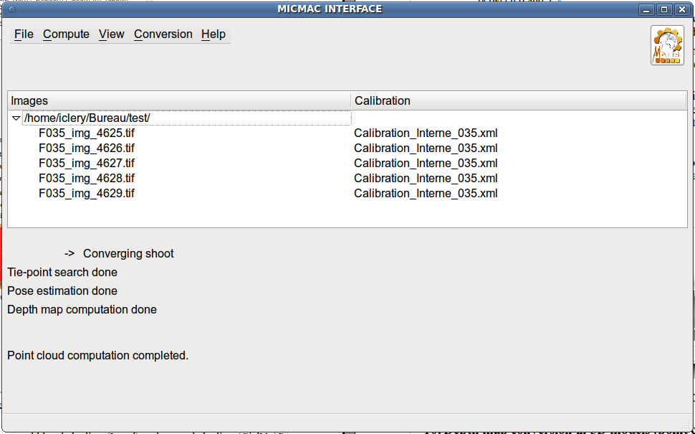

a. GUI menus
The GUI opens with the above main window. The following menus are available :
Project management :
- File → Open a project file - loads the parameters of a project whose processing began in a former session and which was saved
- File → Load images - loads all the images of the project ; start with this menu
- File → Save and File → Save as - saves all the parameters of the project and the progress of processing, which allows to go back later to the exact calculation
- File → Quit
Processing :
- Compute ->Tie-point search - converts images to TIF format, creates or imports initial calibrations and searches for tie-points between images ; this is the first step of processing
- Compute → Pose estimation - computes aerotriangulation and re-estimates calibrations ; this is the second step of processing
- Compute → Depth map computing - computes depth maps (they are images in which the third dimension is known for each pixel) ; this is the third step of processing
- Compute → Continue - continue interrupted processing
Result display at each step :
- View → Tie-point view - shows the computed tie-points in pairs of images
- View → Survey view - displays dynamically in 3D the oriented cameras and the obtained tie-points
- View → Point cloud view - displays in 3D the computed depth maps as point clouds
Depth map export :
- Conversion → 8 bit depth maps - converts each depth map into an 8 bit tif image that represents the model with shading and hypsometric colors
- Conversion → Orthoimage - converts each depth map into a mosaic of orthoimages with hidden part management
- Conversion → 3D models - converts each depth map into a point cloud in *. ply format
Help and GUI general settings :
- About - GUI presentation
- Help - on-line help
- Options - GUI settings (see below)
- Computing checkout - only accessible during depth map computation ; this window allows the user to check that the calculation is going well and to stop it if it is not
- Folder clean up - removes from the data directory all useless files ; it is useful especially after depth map computation to save free memory.

b. Main window and launching GUI
The main window shows progress at each stage of processing.
The different steps of the calculation must be processed sequentially to ensure data coherence.
In each window, the button provides access to the correspoonding online help section.
Most of the required parameters are pre-filled with a default value.
On Linux, the executable file must be run from a directory to which the user has access as well as those of the parent directory, otherwise an error message appears. Using the launcher lanceurInterfaceMicmac solves this problem.
If the prompt indicates that the user cannot launch the software, select the executable file interfaceMicmac, right click, Properties, Permissions and check "Allow executing file as program". Check as well that the other binaries have the required permission.
Note about the data directory:
- All data should be in the same directory.
- The results will be recorded in that directory. Don't forget to put all your data in a new folder before running the GUI if you want to keep your directories tidy.
- Avoided as much as possible spaces and special characters in folder names (full paths) and files (even though the spaces in the files and some special characters are handled).

c. GUI general settings
Some general parameters of the GUI can be set up with Help → Options :
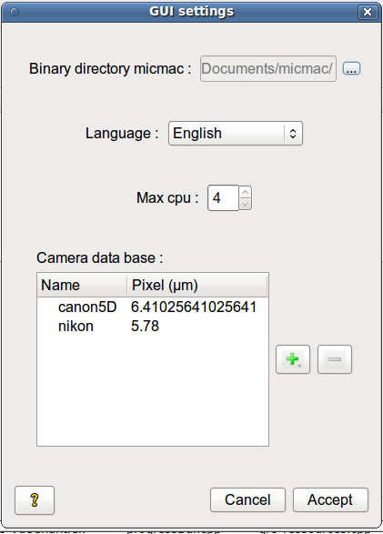
- Micmac directory, where associated binaries are located, will be searched in the whole system when you start the GUI for the first time (the nearest to the GUI directory is selected) ; then the path is stored in the GUI internal parameters in order not to look for it each time you launch. The GUI also warns the user if any binaries are missing in the micmac folder. If the found directory is not correct (the path is written in the command prompt at startup), this window lets you specify the right directory.
- The GUI can be in English or French, the default language is the one used by the system (or French if the system is in another language).
- Processing is mainly performed in parallel using multiple computer processors. The number of used processors is by default the number of recognized computer processors, but it may be useful to reserve one or two not to freeze the screen or to launch other applications.
- An editable database stores the pixel sizes of used cameras (see part Tie-point search). It is written in the xml/BDCamera.xml (also editable).

2. Load images
From the main window, select File -> Load images.
Images must be in raw, jpg or tif format, or a mixture of these, and can be imported at multiple times as long as no calculation has been made.
Accepted raw formats are 3FR, arw, crw, dng, kdc, mrw, nef, orf, pef, ptx, raf, x3f and RW2.
Some compressed jpg images cannot be read. In this case the error "Fail to convert the images to tif format" will appear (see also in the terminal which image it is). In this case, you have to convert images to TIF format using another software (eg. convert) and then import these tif images.
Tif images are then renamed with the focal length read from the meta-data. If the focal length is not indicated in the meta-data and multiple calibrations are possible (see Tie-point search), you should rename the images by including the name of the lens.
It is not possible to compute 2 different calibrations with the same focal length (except for focus modifications with a single lens). This is because the calibration files are automatically associated with the images in comparison with their focal length. If your images come from 2 different cameras, make sure that different focal lengths have been used.
Finally, automatic execution requires all images to have a different name (without extensions).
The list of images is displayed in the main window and updated at each stage of the calculation.

3.Tie-point search
From the main window, after importing images, Compute -> Tie-point search
opens a secondary window to enter the parameters of the survey.
If tie-points have already been calculated before, they will be deleted.

a. Adding initial calibrations of the camera
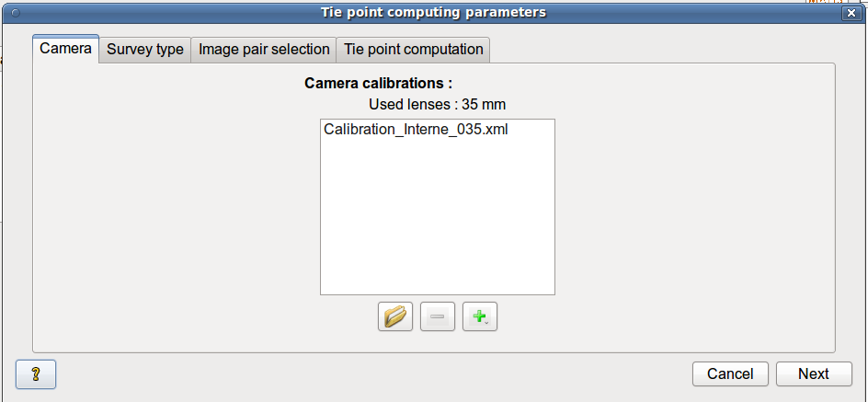
An initial calibration is required for every lens used ; as a reminder, the list of the used lenses is displayed above the frame (these focal lengths are extracted from images meta-data).
If the initial calibrations are already defined in xml files, load them by clicking on button .
The recognized format is the following :
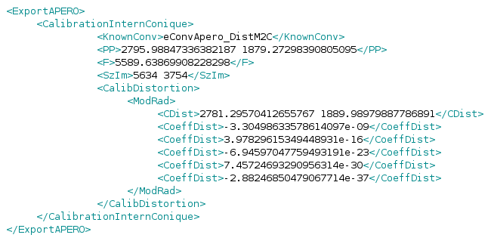
where :
PP is the principal point,
F is the focal length in pixels,
SzIm is the images size (width height),
CDist is the distortion centre,
CoeffDist are the coefficients of the distortion polynomial (r3, r5, r7 et r9).
To automatically process the data, calibration files must be in the data directory and they must end with the focal length in mm ; if it is not the case, they will be copied in this directory.
If a calibration is not defined, create it with button 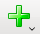.
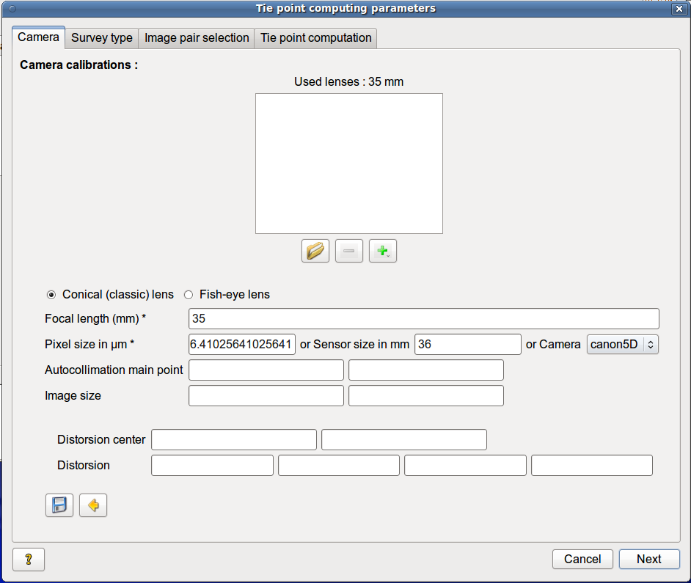
The user can create a calibration for a fish-eye or for a “classic” lens (conical).
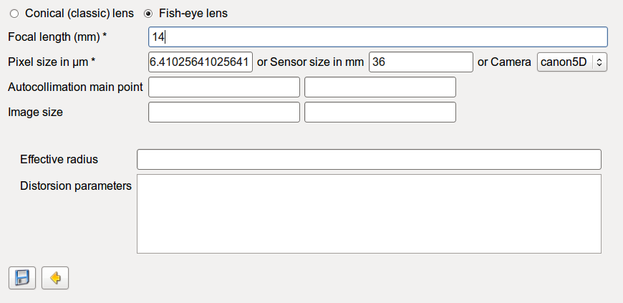
Focal length and pixel size (or sensor size) are the only required values.
The sensor size can be found in the manual of the camera or on the website www.dpreview.com/ which lists most cameras (topic specifications, select the manufacturer and the camera, the requested size is the longest one given by the line "sensor size"). The GUI then automatically calculates the pixel size from the size of the sensor.
If the camera is stored in the database of cameras (see Options), just select the camera to get the pixel size.
These two parameters are used to obtain on the one hand, the focal length in mm in order to automatically associate the images to the proper calibration, and on the other, a calculated focal length in pixels to initialize the calibration ; the entered pixel size can be computed so that the GUI determines an equivalent focal length.
By default, the distortion is set to zero, the main points are the center of the image and the radius is set to half of the image diagonal. The GUI accepts most formats of distortion coefficients.
Calibration parameters are in any case (re)calculated during the pose estimation. However, it is advisable to provide a fine enough initial calibration for the fish-eye lenses to avoid calculation diverging.
Then confirm the new internal calibration with button  (or cancel with button ).
The internal calibrations imported or created are listed above the form.
The internal calibrations are automatically associated with corresponding images, it is important to define a calibration for each lens used.
Note - The GUI does not include images taken with two different devices of the same focal length. One method may be to define two calibrations of different focal lengths of 1 mm (so as not to diverge the calculation) and rename the images with the focal length of the correct calibration (in order to associate the images with their calibrations).
It is possible to delete a calibration of the list with button .
Click on button ..
Next

b. Selecting the shoot type
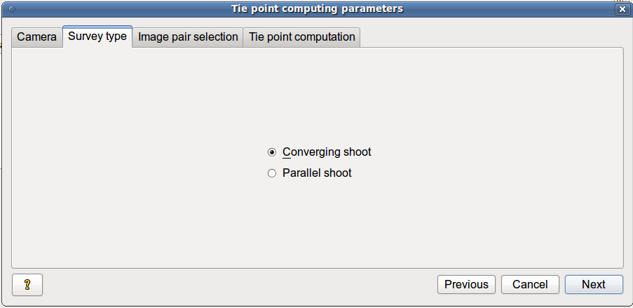
Select the shoot type :
- converging - all the shots converge to the same point ;
- parallel - all shots are oriented in the same direction.
This choice simplifies the entry of the following parameters.
After selecting the shoot type, click on .
Next

c. Selecting image pairs
This tab appears in the case of a converging shoot. In the case of a parallel shoot, it is difficult to list pairs of images that partially overlap due to an intra-band overlap ; that is why all the image pairs are selected.
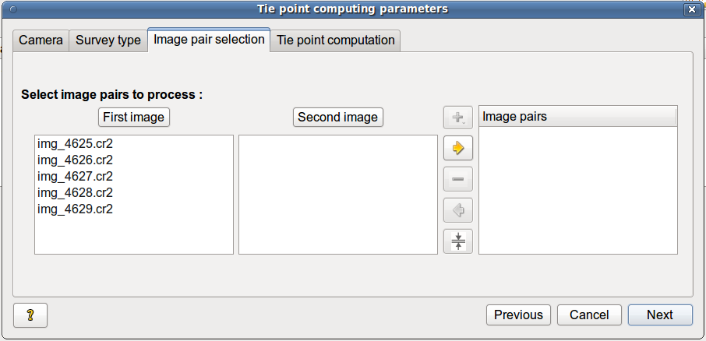
Select the image pairs in which tie-points are searched.
To select all the couples, click on button , then choose "Select all couples." If the survey includes many images, do not select all the pairs, the calculation could be long and the computer can run out of RAM.
To select all adjacent pairs of images (including cases of full rotation around an object), click on button , then select "Select the k closest pairs" :
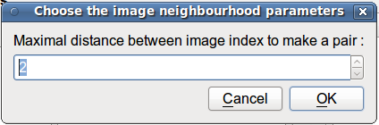
Choose how many successive images will be matched with each image and click on “ok”.
Depending on the configuration of the survey, it may be preferable to select the couples one by one:
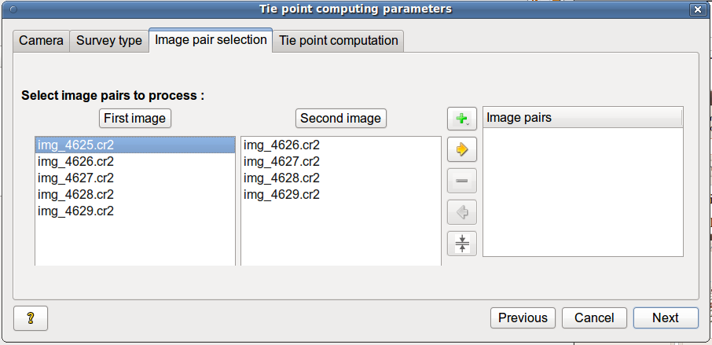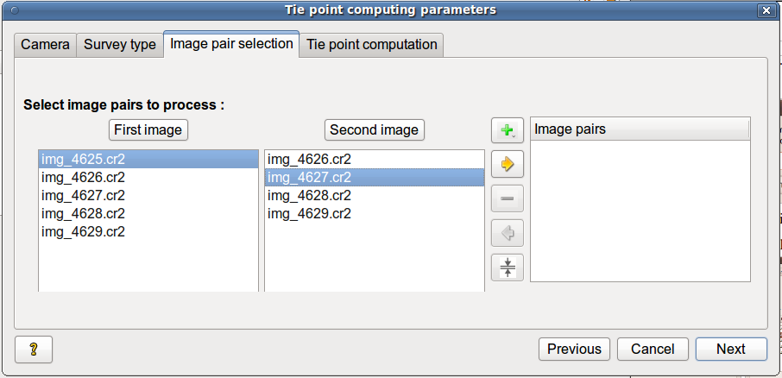
- select the first image of the couple in the list on the left,
- select the second image of the couple in the list of the right (only the images that are not already paired with the left one are displayed)
- click on button to add this couple.
To add all the possible couples associated with an image, select it from the list on the left and click on .
The list of selected pairs is displayed in the tree on the right.
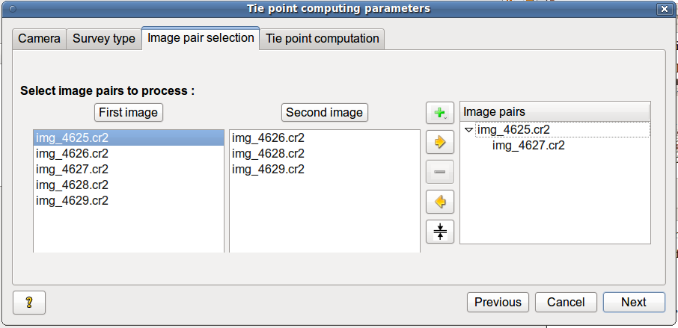
To delete a couple, select the second image in the tree and click on button (to remove all the couples associated with an image, select it as the first image in the tree).
To remove all couples click on .
After selection of image pairs, click on ..
Next

d. Setting up other parameters
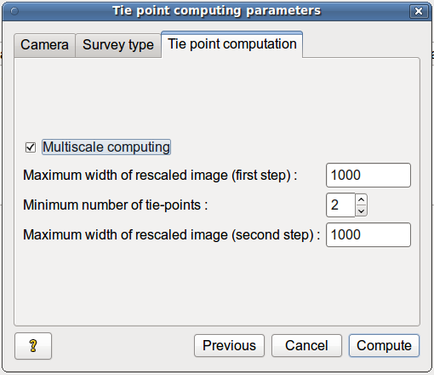
The size of the rescaled image corresponds to the maximum width of the subsampled image in which the tie-points will be searched ; this speeds up the calculation and reduces the number of tie-points. It must be a non-zero integer.
If many couples have been selected, it is possible to perform this calculation in two steps (select "Multi-scale"):
- Tie-points are searched for the first time in all pairs of images that are rescaled at a low resolution
- Then tie-points are searched only on couples in which enough tie-points were found during the first step (the selection criterion is determined by the "Minimum number of tie-points") and using a higher resolution.
This allows to keep only overlapping couples and thus eliminate some wrong tie-points.

e. Running the process
If all parameters have been filled, click on .
Compute
The calculation includes:
- raw and jpg images conversion to tif format,
- created calibration writing and initialization,
- tie-point computation for selected pairs of images.
If the calculation is too long, you can stop it by clicking on button in the progress window. The parameter values and the calculation progress are then saved to allow to start again the process at the same point.
Stop computation

f. Results
Images converted to tif format are listed in the main window with their associated calibration file.
The results are in directories Homol and Pastis:
- computed tie-points are ranked by pair of images in the *. dat and the *. result files,
- used rescaled images in *. tif format.
Jpg and raw images have been moved to the directory Images_brutes.
Other created files contain the provided settings:
- created calibrations files,
- the list of tif images Liste_images.xml,
- the list of couples Liste_couples.xml
- the list of calibration files to use Liste_calibrations_internes.xml
- the default settings depending on the shoot type MicMac-LocalChantierDescripteur.xml
You can graphically display the tie-points found (see Tie-point view) ; this is especially useful if the pose estimation does not converge to check if the images are connected together with tie-points.

g. Frequent error messages
You have to start the GUI with a terminal to see which image causes an error and if there were problems before the fatal error.
“An image has no associated calibration.” - Check that there is a calibration file for every used lens, otherwise you have to create one. To do that, just look for images with no associated calibration file in the main window. If it is a tif or jpg image, the metadata may not be readable ; in this case the image should be renamed by adding the correct focal length at the beginning of the name (for example, img_4625.tif becomes F035_img_4625.tif with a 35mm focal length).
“Fail to convert an image to tif format” - it is a compressed jpg image, it may not be readable by the used libraries ; in this case it is better to convert it to tif by another program (convert or gimp for example) and to load the converted image in the GUI.

4. Computing poses
From the main window, after getting tie-points, Compute -> Poses opens a second window to enter the parameters of the poses.
If the poses have already been calculated, they will be deleted for the saving file (the results are kept until new pose calculation).
The calculation includes the relative orientation (the images relative to each other), the absolute orientation (the whole scene) and the re-estimation of calibrations for each lens.
To start computation quickly, keep all default parameters and change them back if a problem occurs.

a. Selecting images to be oriented
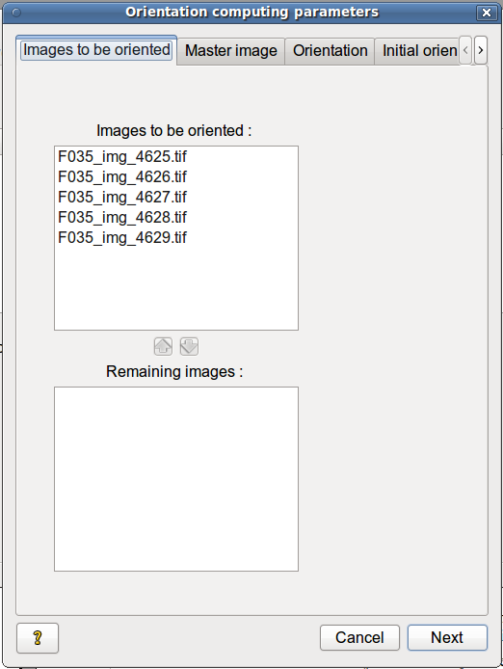
Images to orientate must be put on the list on the top, the others on list on the bottom.
By default all are selected, but if the calculation fails once due to a problem of sequencing (too few tie-points between two image blocks), it may be useful to divide the scene into several blocks of images and to run the process on one block at once.
To add images to be oriented, select them on list on the bottom and click on .
Not to orientate images, select them on the list on the top and click on .

b. Selecting master image
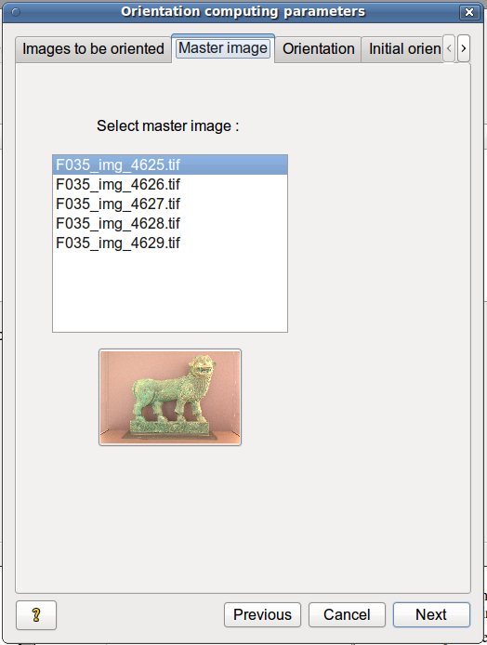
If no absolute orientation is defined in the next tab, the master image is the image according to which all other images will be oriented (its position is the origin of the frame and the rotation of the camera is the identity). Its choice simply allows to set an overall direction of the scene which will facilitate visualization.
In addition, the image orientation is done in two steps:
- First, the images are oriented one by one in relation to the master image, the priority is determined by the number and distribution of the tie-points,
- Then all initial orientations are adjusted iteratively at the same time.
To ensure the convergence in processing, the master image must be part of a block of images that are linked with a lot of tie-points (usually the image that is the closest to the center of the scene is chosen).
An overview of the selected image is displayed below the list.

c. Absolute orientation
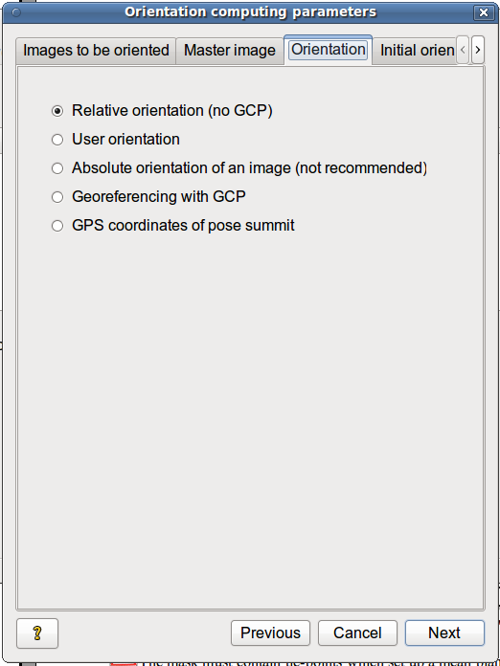
Absolute orientation can be defined in five ways:
- “Relative orientation” - the master image pose defines the orientation and the origin of the frame ; the base (distance between the tops of the shoots) between the master image and the next image (found using a tree built from the tie-points) defines the scale (base = 1) ;
- “User orientation” - a plan, a abscissa axis and/or a scale, that must be drawn on the images to define a general orientation ;
- “Absolute orientation of an image” - an image, whose orientation is already known from an independent calculation, and a scale define the general orientation ; this allows to link this project with an other project ;
- “Georeferencing with GCP” - a set of ground control points (points whose images and terrain coordinates are both known) define a precise georeferencing.
- “GPS coordinates of pose summits” - summits and possible orientation of the camera poses are known and give an approximate initial georeferencing.

User orientation :
You have to define a general rotation or scale or both. To do that, select the type of parameters to be fixed ; unselected parameters are by default those of the relative orientation (orientation according to the master image pose and scale computed from the base).
The rotation is itself defined by a horizontal plane (which gives the vertical axis) and a direction in this plan.

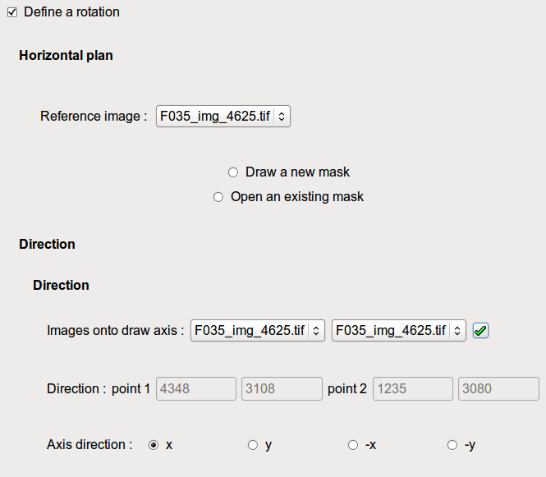
To set the horizontal plane, you should draw a mask of this plan on an image. To do this, it is possible to create one:
- select the image in which the mask will be sketched and click on ,
- select "create a new mask,"
- sketch the mask (see part Using the mask drawing window)
- validate the mask by clicking on in the drawing window, the mask is saved as "image" + _MasqPlan.tif.
It is also possible to import an existing one:
- select the image in which the mask has been sketched and click on ,
- select "open an existing mask,"
- import the mask (in *. tif format) by clicking on button next to "Mask".
...
It is possible to modify the mask by clicking on "Modify Mask".
The mask must contain tie-points which set up a mean plane defining the horizontal plane ; otherwise an error occurs during the calculation.

To set the direction of the frame, you should enter two points of this axis in the images :
- select the two images in which these points will be drawn (this can be the same twice)
- click on and select 2 points in the images (one in each image if there are two), the tools are the same as in the last window,
- validate the segment by clicking on in the drawing window, the coordinates of the points clicked are shown below,
- define which direction is pointed out by the drawn segment ; by default the drawn direction is the x axis.
To set a scale :
- you should have photographed a leveling staff or a tape measurement with at least two images of the scene,
- or you should know the size of an object seen in at least two images,
- otherwise, in the case of two image blocks of the same survey, that are calculated independently but which should be adjusted to the same scale, you should identify an object that is common to both blocks and assign the same size to it.
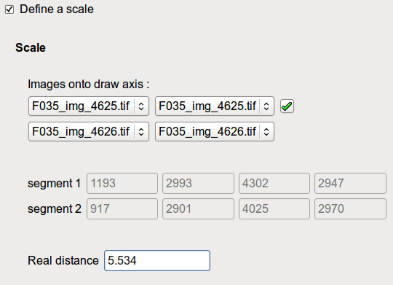
To set the frame scale, you should enter a segment in 3D, that means two segments drawn in two images or pairs of different images :
- select the four images in which these points will be entered (each segment can be selected from one or two images, depending on its length), as follows:
image segment 1 point A image segment 1 point B (this may be the same)
image segment 2 point A image segment 2 point B (this may be the same)
- click on and draw 4 points in the images (two in each frame if there are two), the tools are the same as in the previous window,
- validate the segment by clicking on in each drawing window, the coordinates of the clicked segments are displayed below.
- enter the actual distance of the segment.
The user orientation accuracy depends on the accuracy of the different segments drawing, and it cannot be as precise as georeferencement with a set of GCP but may be useful to consider the accuracy of the final result (including noise) .

Absolute orientation of an image :
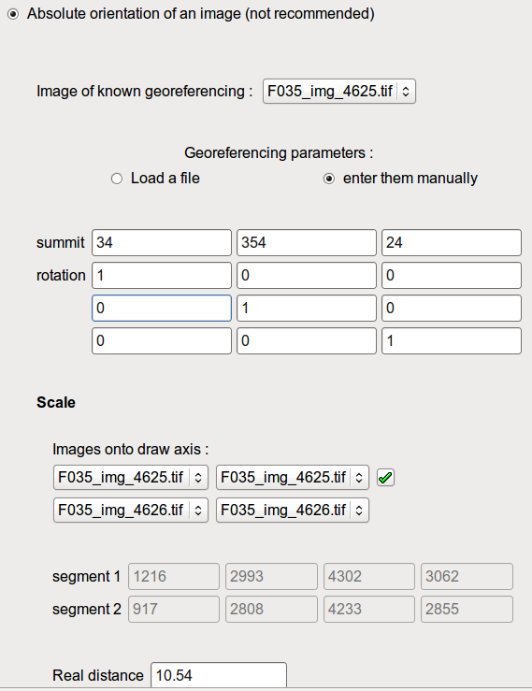
This choice allows to connect two blocks of images processed separately but that are shots of the same scene and share an image.
- select the shared image
- enter the parameters of the corresponding camera position:
- if the pose was calculated during former processing, select "Load a File" and select the image referencing file by clicking on button next to "Georeferencing file"
...
- if the parameters are not in the Apero format, check "Enter them manually" and enter pose summit and rotation parameters.
- Set the scale parameters (see User orientation).
This type of absolute orientation only switches the calculated relative orientation in the known pose frame. In case of a survey divided into two blocks, you should recalculate all the poses in a single block, because then there are tie-points between blocks that allow for a more robust triangulation. Moreover, if the pose estimation of the shared image is not very robust in one of the two blocks (regardless of tie-points with the rest of the block), the relative orientation between the two blocks will not be accurate, that is why this option is not recommended in this case.

Georeferencing with GCP :
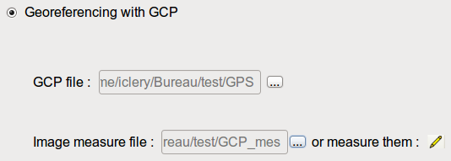
The GCP are points of known coordinates that are seen on the images.
The GCP file contains the terrain coordinates of the GCP and their measurement accuracy. It can be in Apero xml format or in text format (you can use a spreadsheet program such as Excel or OpenOffice and save the file in csv format, separating the columns with a space (no tabs or commas). The points are written by line, and the data written in this order :
groundPointName X Y Z dx dy dz
where dx and dy are the planimetric accuracy and dz the vertical accuracy of the point.
The image measurements file includes the image GCP coordinates. The possible formats are the same as for the GCP file (Apero xml format and text format). The data for each point should be written in this order :
ImageName column line groundPointName
where column and row are the image coordinates of the point in pixels.
It is also possible to create new image measurements by clicking on button 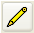. If a file has already been imported, the new measurements are added to the imported measurements, otherwise a new file is created. This opens a graphic input window ; for its use see part Using the mask drawing window.
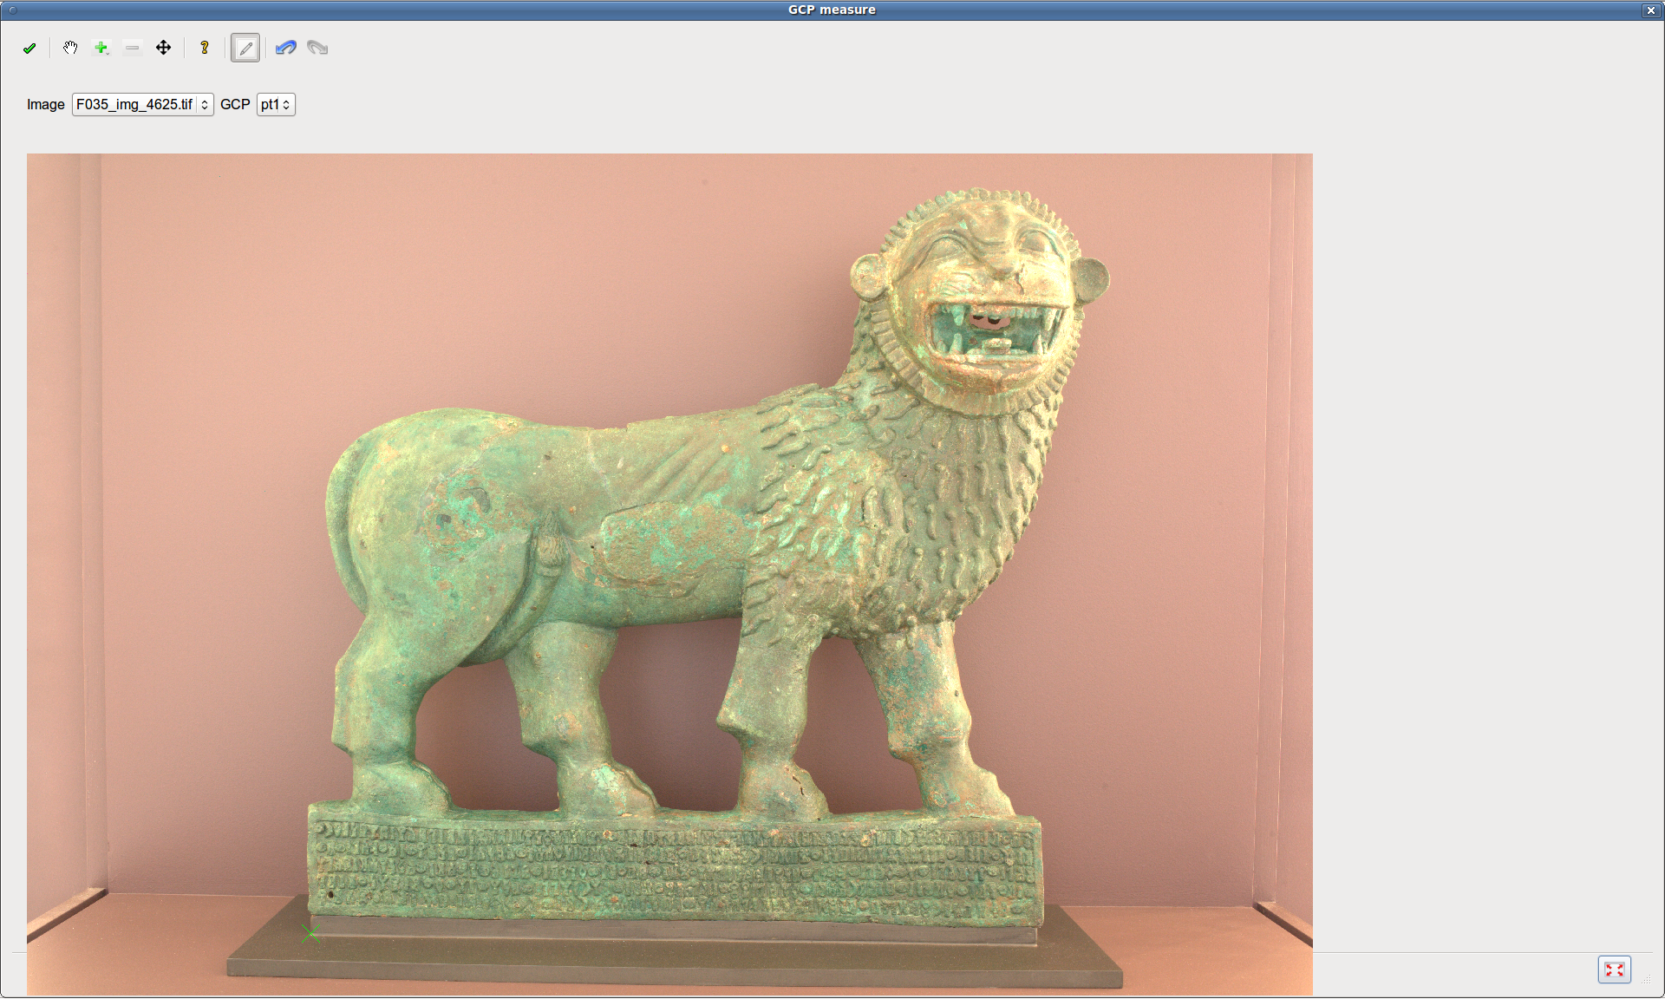
To enter a measurement, select the image and the ground point to be measured and then click on the point in the image. To measurement another point, select another image or another point and repeat it.
If a measurement is already made (when a GCP file was loaded for example), remove it first with button  before clicking on a new measurement.
When all points were measured, validate them by clicking on and save the file. If many points must be measured, it is to validate and save them regularly.

Gps coordinates of poses summits :
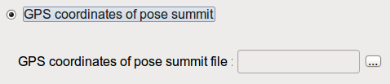
As for georeferencing by GCP, it is possible to load data either directly in Apero xml format (select "All directories (*)") or in text format (select "All Files (*)"). The poses are written per line, and the data written in this order :
ImageName X Y Z
so that the file can be converted to Apero format in folder Ori-BDDC.

d. Initial orientation
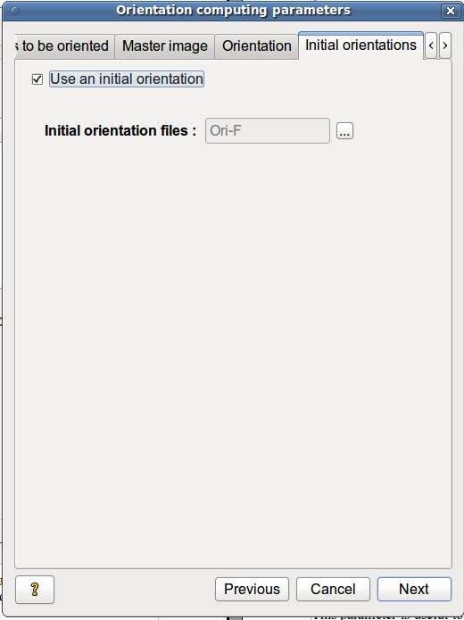
This tab allows you to load relative orientations of some images to initialize the calculation, independently of absolute orientation constraints (they can be added onto initial GPS coordinates of the summits for example).
This parameter is useful to compute the poses iteratively by subset images if the computation for all images fails. The method consists in finding a subset of images that can be processed successfully, then adding the other images one by one in the process while loading the last obtained result in this tab. Successive orientations are kept in directories Ori_InitialeX. This tab can be use to get a more accurate result too by doubling the number of least square iterations of the computation
To load an initial orientation, check the box and choose the right folder (choose. Ori-F to obtain the final result).

e. Previous auto-calibration
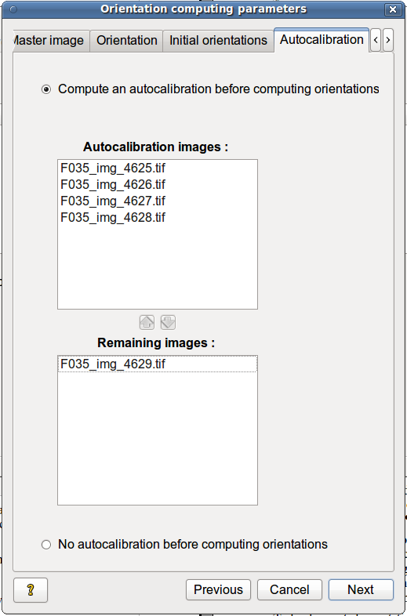
This tab allows you to improve the accuracy of the calibrations provided in the first step (Tie-point search) to ensure the convergence of pose computing and improve its accuracy.
To do this, select a group of images (same system as to select the images to be oriented) ; the pose computation is run the first time on the selected images to re-estimate the calibration once, then the computation is run the second time on all images to be oriented using these new calibrations. Even if no auto-calibration step is set up by the user, Apero re-estimates the calibrations anyway while poses are being computed but all are done in a single step.
The images that are used for auto-calibration should be closely linked with many tie-points to ensure the convergence and accuracy of auto-calibration, that is why it is better to consider this step during the shot (for example, add images to the survey specifically for auto-calibration, by photographing a part of the scene that is well-textured and with different depths).
These images are not necessarily the same as the images used for orientation in the second step ; indeed, the two calculations are independent.

f. Multi-scale computing
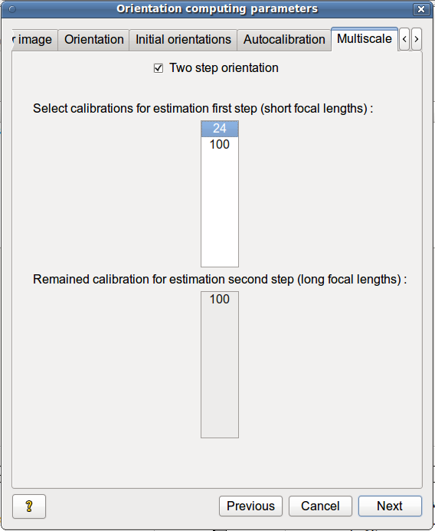
This tab appears only if several different lenses are used.
By default, the calculation is done in one step (all poses and calibrations are estimated at the same time, except if an auto-calibration is set up).
In the case where the images are taken with several lenses of different focal lengths (multi-scale) and pose estimation does not converge in one step, it is possible to do it in two steps:
- Only a part of the poses is estimated (usually images taken with a short focal length lens)
- The remaining poses are estimated by fixing the previously computed poses to get an initial orientation for all the images, and finally, all the poses are re-estimated from the initial orientations to share the errors between the two blocks.
To do this, check “Two steps orientation” and then select the image blocks to orientate first (the blocks are separated by calibration and defined by the focal length used).
NB - The master image must belong to the blocks estimated in first step.

g. Calibration dissociation
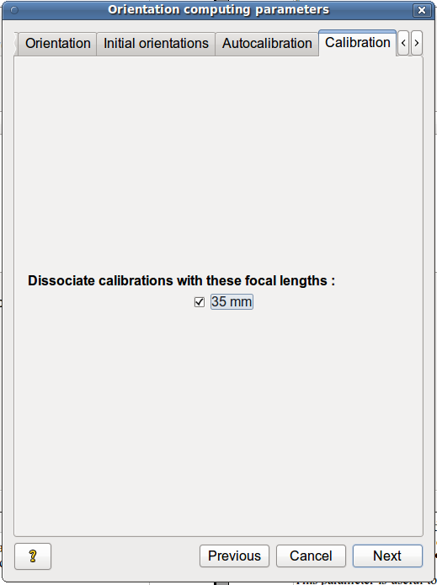
If the final model is noisy even on well correlated parts and (especially) if the calibration (including focus) has been changed between two images taken with the same lens (the same provided initial calibration), it is possible to dissociate calibrations for the corresponding images, that is to say to estimate a different calibration for each image.
To do this, check the corresponding calibrations.

h. Tie-point parameters
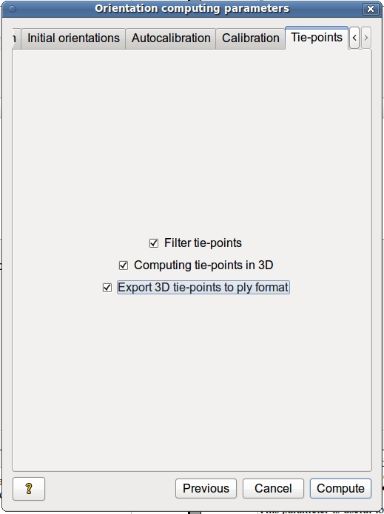
“Filtering tie-points” reduces the number of corresponding points while keeping their distribution ; this accelerates the following calculations (pose estimation, tie-point calculation in 3D and survey view). If there are no image cohesion problems (a lot of tie-points were found), it is advisable to check this box, otherwise it is better to keep all the found tie-points (NB - the survey view takes into account tie-point filtering). The initial points are preserved, so it is possible to restart the pose estimation after having unchecked this box to use them all.
After pose estimation, the terrain points corresponding to the obtained tie-points are computed and can be displayed in the GUI ; if there are many images, this calculation can take long. You can skip this computation by unchecking the box “Computing tie-points in 3D”.
It is also possible to ask Apero to directly export the tie-points and camera poses in a ply file format, regardless of the previous option by checking the box “Export 3D tie-points to ply file”.

i. Process running
Click on ..
Compute
If the computation is too long, you can stop it by clicking on button in the progress window. The parameter values and the calculation progress are then saved to allow the process to restart at the same point.
Stop computation

j. Results
The results are in the directory Ori-F (the intermediate results are in Orient and Ori-Interm directories) :
- computed poses in files OrFinale*.xml,
- reestimated calibrations in files * _AutoCalFinale.xml.
Other created files contain provided settings :
- the list of images to be oriented Images_a_orienter.xml,
- the master image Image_Maitresse.xml
- the default settings depending on the shoot type and the process step Apero.xml
You can view the results in 3D - position and orientation of the cameras, position of tie-points and image bounding box ; see Survey view.

k. What to do if processing fails...
- If absolute orientation parameters were set, compute only relative orientation first, in order not to add new sources of problems.
You should look for the origin of the error in file apero_outstream.txt.
- Images are not connected to the rest of the survey (" UNCONNECTED " or "Nn" = 0) :
- restart the pose computation without filtering tie-points;
- check the tie-points (see Tie-point view), especially those connecting the disconnected image to the block containing the master image and already oriented images ("Father", "Mother" images);
- restart computation with a subset of images and try different configurations until you obtain a result, then add iteratively each remaining image to the calculation while loading the last result as initial orientation ;
- if some correct tie-points were found and if more may be found (large overlap, textured images), restart the tie-point search using a larger length of subsampled image ; usually Apero requires two pairs of images that link each image to the block of already oriented images and that are linked by at least 8 correct tie-points ;
- otherwise divide the scene into two or more blocks that must be processed separately (keep tif images not to convert them again).
- The calculation does not converge ("RESIDU LIAISON MOYENS :" increases or "=nan "):
- quickly check the tie-points found, it is possible that there are many more incorrect than correct tie-points ;
- restart the pose computation without filtering tie-points;
- check the focal length of used lenses ; if it is a fish-eye or a very long focal length lens, use a more accurate initial calibration or with all parameters set up,
- or try to add an auto-calibration step to get a better initial calibration ;
- if the shoot is multi-focal, perform a two step calculation (multi-scale computation).
- restart computation with a subset of images and try different configurations until you obtain a result, then add iteratively each remaining image to the calculation while loading the last result as initial orientation ;
- if there are important groups of mismatches in some couples of images (for example when the scene contains moving objects or similar objects...) or if there are very few tie-points with some mismatches in some couples of images, remove them manually with the mismatches removal tool (see part Tie-point view) ;
- if absolute orientation parameters were set, check them out (GCP coordinates, summits coordinates, etc.)
- There is an ambiguity and a parameter cannot be calculated ("ImProfAndL2App"):
- If an absolute orientation has been defined (by plane, scale and direction), the mask of the plan may contain too few tie-points and thus may not be defined. In this case, you should sketch another mask or define no absolute orientation;
- if absolute orientation parameters were set, check out their coherence
- it is possible that the tie-points are aligned, too concentrated in an image or there are too few of them, then, see each case above.
Even if the result converges, it is important to check that the solution is correct in the 3D view of the survey before processing to the next step. Considering the required accuracy, check out the residual value in apero_outstream file too (the value after « RESIDU LIAISON MOYENS : »).

5. Depth map computation
From the main window, after getting the camera poses, Compute -> Depth maps opens a secondary window to enter the parameters of the depth maps.
A depth map is a georeferenced image (it means that the 3D position of the camera is known) whose each pixel describes the depth of the corresponding 3D point measured from the perspective summit. In this case, the depth map is said to be computed in image geometry or frame.
Then a DTM (digital terrain model) can be computed like a depth map using an orthoimage ; the depth described is the altitude from the ground. In this case, the depth map is said to be computed in ground or Euclidean frame.
Using the GUI, depth maps can be computed :
- either in the geometry of an image called reference image (calculation of the depth of each pixel of this image), the reference image corresponds to the point of view a laser scanner would have, so there must be as many depth maps as needed to model the entire scene. This calculation is suitable for converging shoot because the entire scene is represented in a small number of images and each part of the scene is seen in many pictures, which avoids hidden parts and provides good redundancy of information to extract the information of relief.
- either in ground geometry, that is to say, in the geometry of a mosaic (an assembling) of quick orthoimages ; so that there will be a depth map for each block of images and the depth map bounding box will be larger than the one of any reference image. This calculation is suitable for relatively planar and extended scenes (walls, cliffs, aerial shoot...) - as the shoot is rather stripped or parallel, it can limit the number of depth maps that are needed to model the entire scene. It is also suitable for converging shoot of relatively planar surfaces because it allows the calculation of orthoimages.

a. Depth map list
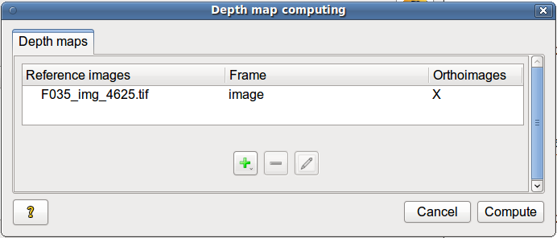
The first tab lists all the already parametrized depth maps or DTM that will be computed.
To add a depth map, click on .
It is also possible not to run the calculation of a parametrized depth map. In this case, select the depth map, right click and select "Do not compute again". This is useful when you run the calculation on a single depth map as a test and then on the remaining ones.
To delete a depth map, select the depth map and click on .
If a depth map is removed, all associated data and results are erased from the GUI memory.
To modify a depth map parameters, click on .

b. Images for correlation
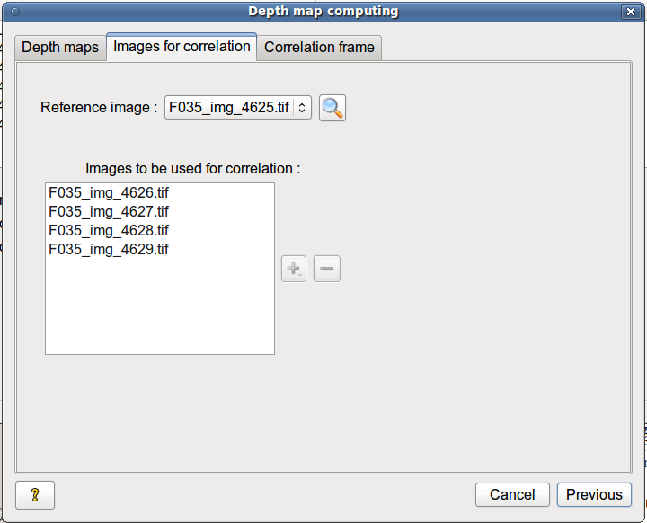
Firstly select the reference image, that is to say, the image from which either the depth map (in image geometry) or the orthoimage (ground geometry) will be calculated ; it must be the central image of a block of images that overlaps it and that either converges towards the same point (in image geometry) or represents the same relatively planar surface (in ground geometry).
The button  enables you to select the reference image in the 3D view (see Survey view) :
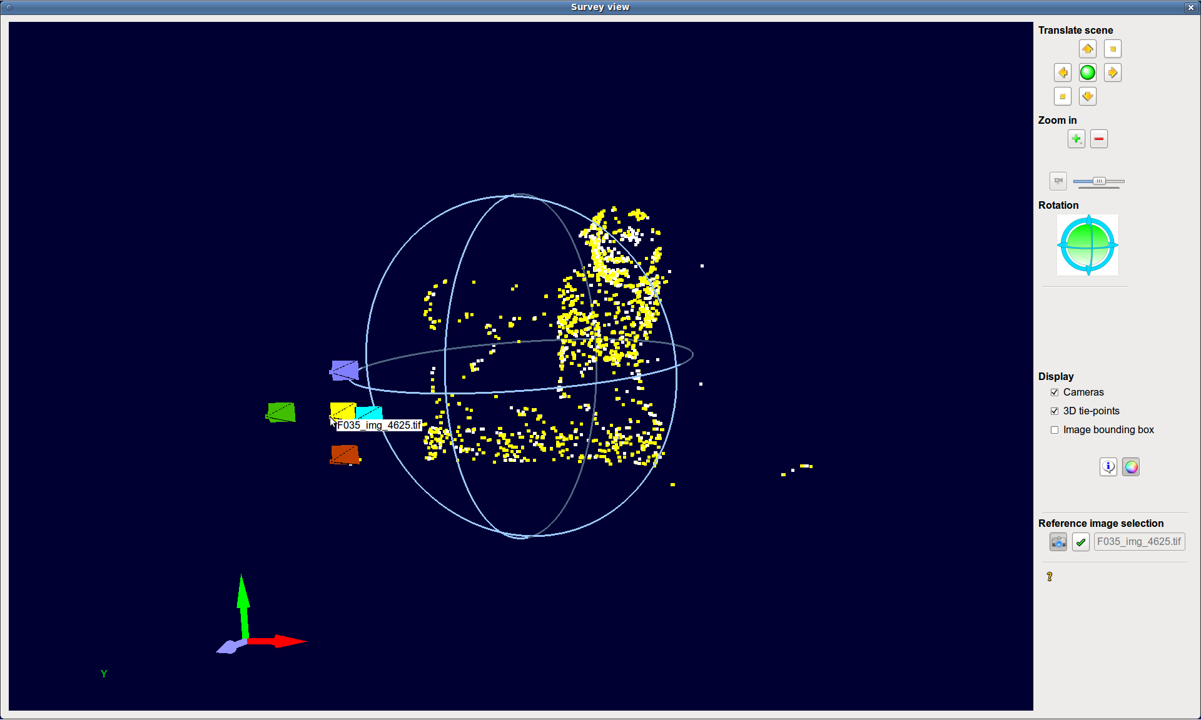
To select the reference image, select the tool , then click on the desired camera (it should be yellow and its name must be written below), right click in the view and click on "Select this camera", so that its name is put in the tool bar. Finally validate this image with button , otherwise it will not be taken into account.
Secondly select the images that will be used for correlation.
- In the case of a depth map in image geometry, they are all the images that represent the same part of the scene as the reference image. They must surround the reference image so that each pixel of the reference image has an homologous point in one of these images.
- For a depth map in ground geometry, they are all the images that make up the orthoimage and thus the depth map (with some redundancy).
It is advisable to use images of the same resolution as the reference image in order to keep the accuracy of the depth map.
It is also advisable not to add too many images for the correlation in image geometry (3-4 images are usually sufficient), because each pixel of each image must be correlated with a pixel from each other image, so that it increases the computing time very quickly ; it may be better to calculate more cards.
To add images, click on button and select one of the three possibilities.
To remove images, select them and click on button .

select a camera from list
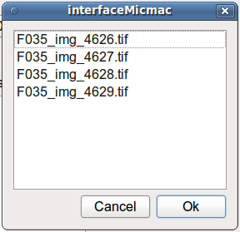
Select one or several images in the list list and click on .
Ok

Select camera from 3d view
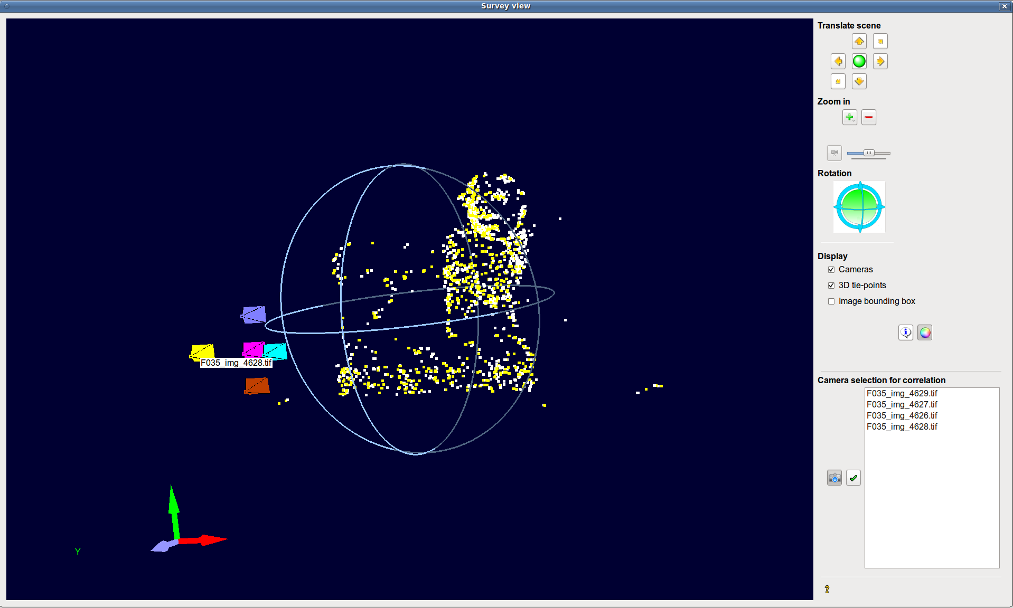
Select the tool , then click on the desired camera (it should be yellow and its name should be written below), right click in the view and click on "Select this camera" - its name is added to the list in the tool bar.
To remove a camera, select it in the tool bar, right click, choose "Delete".
Finally validate this list of images with button , otherwise it will not be taken into account.

add the best cameras
The four images that overlap and surround reference image at best are added to the list (it is advisable to check the configuration of the cameras in 3D view).

c. Correlation frame
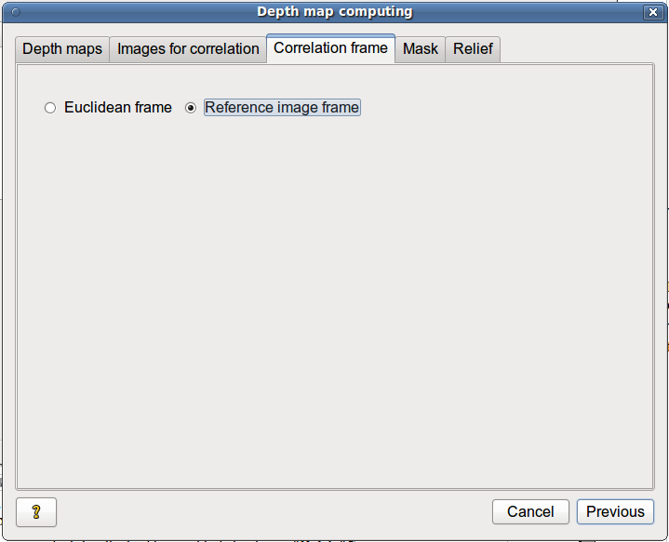
This tab allows you to select the correlation frame :
- either the frame of the reference image (depth map in image geometry)
- or a Euclidean frame (DTM)
In the case of a Euclidean frame, the DTM is computed by default in the frame defined by absolute orientation.
To compute DTM in another frame, check the box “Other frame than the absolute orientation frame” (this is useful for depth maps of vertical objects like walls, cliffs...).
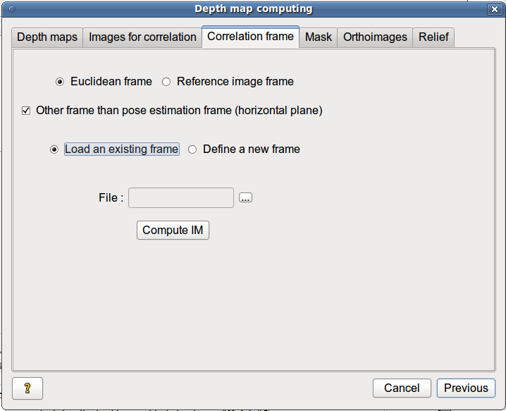
This specific frame can already be defined in an xml file. In that case, select “Load existing frame parameters” then click on next “File”. The format be must be as followings
...
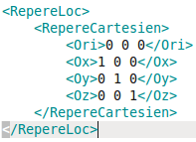
where Ori is the translation and Ox, Oy, Oz the rotation from the original frame.
Otherwise, the specific frame can be parametrized with GUI. Then select “Define a new frame”.
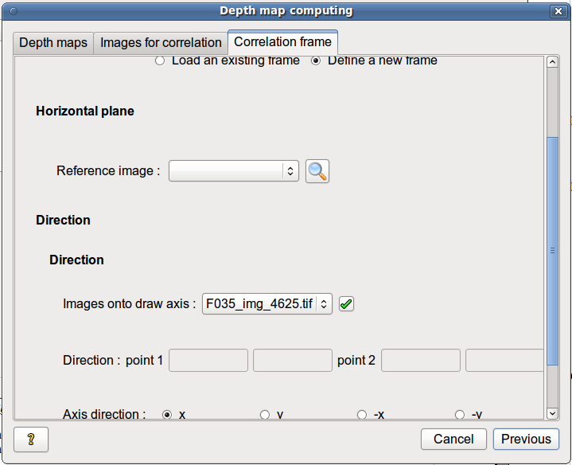
The required parameters are a mask of the horizontal plane, an axis in this plane and the direction of this axis (for more details, see part User orientation in Pose estimation chapter).
Whatever Euclidean frame is chosen, an index map (IM) must be computed using the images for correlation. This IM is a mosaic of quickly rectified images that puts together these images after having projected on a horizontal plane of the frame at the mean altitude of the tie-points (this should be the approximate position of the scene).
To save the parameters of the frame and to start the computation of the IM, click on "Compute IM".
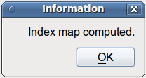

d. Masking
The calculation requires a mask of a particular part of the scene to avoid mapping the background for example (the correlation is generally difficult there, so it takes a long time and creates artifacts).
In the case of a depth map computed in image geometry, the mask is drawn over the reference image, otherwise on the IM which corresponds to the DTM orientation and approximately to its bounding box.
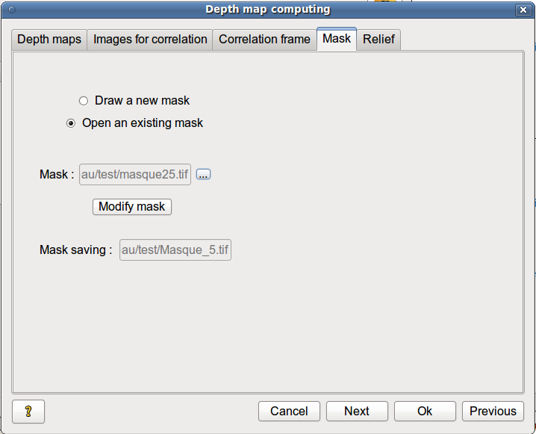
If a mask already exists :
- select "Open an existing mask" ;
- import the mask (tif format) by clicking on button next to "Mask".
...
If the mask requires modifications,
- click on button ;
Modify mask
- a drawing window opens to allow you to sketch the mask ; for its use, see part Using the mask drawing window ;
- check out that the mask is rightly saved in the file written in "Save the mask" line.
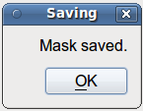
Otherwise, you can create a mask:
- select "Create a new mask";
- a drawing window opens to allow you to sketch the mask ; for its use, see part Using the mask drawing window ;
- once the mask is created, save it ; it is also possible to modify it as is the case in opening an existing mask.
If the scene has depth discontinuities (this is when two objects in the scene are disconnected in reality but are seen side by side in the reference image), the model will present artefacts due to the smoothing algorithm used by MicMac. It may help to cut these discontinuities in the mask at this step.

e. Orthoimages
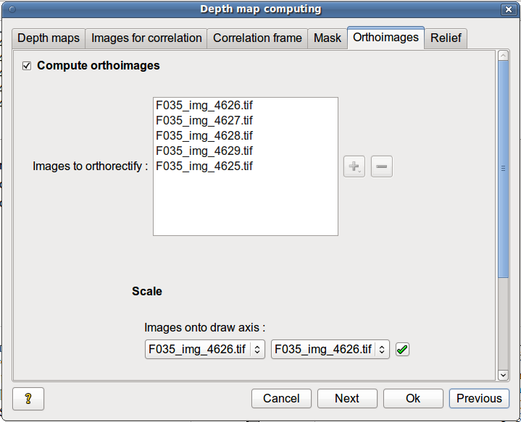
If the depth map is computed in Euclidean frame, real orthoimages can be computed (they take into account the ground relief described by the DTM and the hidden parts of the scene).
Then check “Compute orthoimages” and list above the images to orthorectify (in the same way as images for correlation list). These images are not necessarily the same as the images for correlating, the only constraint is that these images have to be in the DTM bounding box.
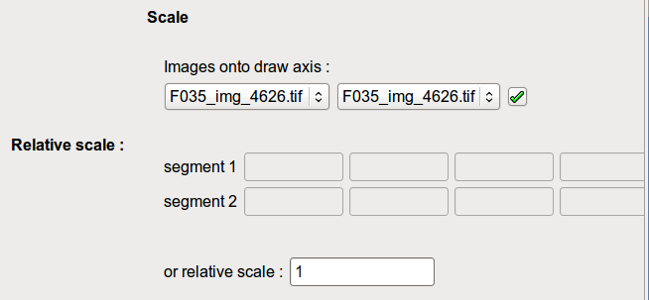
By default, the orthoimages are computed at the same scale as the DTM (relative scale=1). A different relative scale can be defined. Then fill the box “or relative scale” or draw manually the same object on an image to be orthorectified (left list) and on an image for correlation (right list). For more details, see part user orientation of the pose estimation.
Computing orthoimages and DTM at different scales can be useful for almost all planar scenes. Indeed the DTM requires redundancy, so, to limit the number of images, their resolution can be quite low (a very precise DTM of an almost planar scene is usually not useful, except for micro-relief studies like engravings). Then to get a very detailed orthoimage mosaic, specific images can be taken at a very high resolution without considering the redundancy.

f. Depth parameters
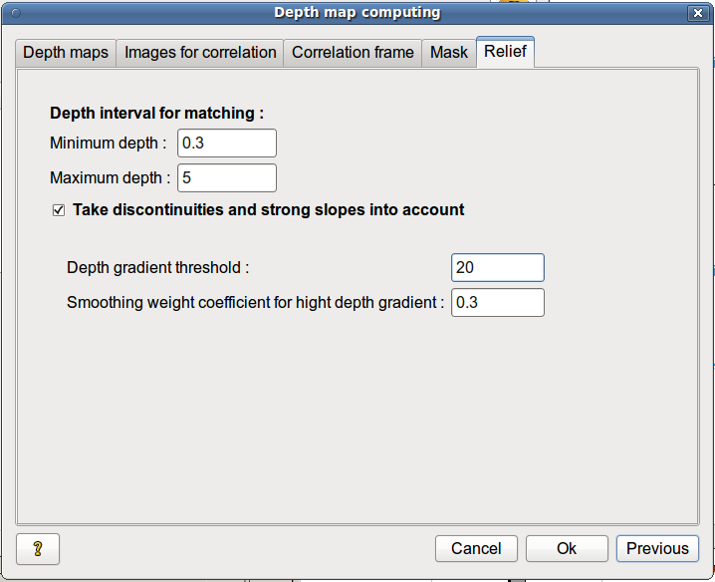
To reduce the computation time, the algorithm does not attempt to calculate the correlation coefficients for all possible depths but only in an interval corresponding to the depths where the scene is most likely to occur. This depth interval is expressed relatively to the mean depth of the tie-points of the reference image (by default depths are searched between 1/3 and 5 times that distance). For a landscape or a scene with large differences in depth, it may be useful to modify this parameter.
If the scene has discontinuities (objects that are overlapped from the perspective of the camera but that are separated in reality) or has steep slopes (object sides that are very slanted from the camera point of view), the pixels are hardly matched and smoothing done by the algorithm will create artifacts along the discontinuities. To reduce the impact of smoothing in areas with high depth differences, set the depth differences threshold over which smoothing weight will be changed (this value is in ground units, the scene should have been scaled during pose estimation).
The next parameter is the weight associated to distance variation between two points, it must be set between 0 to 1 (1 is the default value where there are no discontinuities). For a distance variation that is higher than the threshold (discontinuity), the weight will increase more slowly. When calculating the best surface to model the scene (it is the area incorporating both the highest correlation coefficients and the smallest changes in distance), for large distance variations, the values ​​of correlation coefficients will be privileged and depth gaps will be less constrained.

g. Parameter validation
To validate all set parameters for the current depth map, click on .. They can still be modified later in the first tab. If the button remains hidden, a parameter is missing or is not saved.
Ok
Otherwise click on .
Cancel

h. Process running
Once all parameters are set up, click on ..
Compute
The calculation corresponds to the process of each depth map at different resolutions and at different scales.
If the computation is too long, you can stop it by clicking on button in the progress window. The parameter values and the calculation progress are then saved to allow the process to restart at the same point.
Stop computation
Normally the calculation for one depth map takes about 10-15 min (indicative value for 5 images of 21M pixels and a computer with 4 processors). If the calculation time becomes much longer (especially if the progress bar has not moved for 10 min), it is possible that the process cannot converge and may take long time. This can come from a not accurate enough aerotriangulation or correlation problems (not enough textured scene, too steep a surface ...). You can watch the partial result of the calculation of the current map without interrupting it by clicking on Help → Computing check-out.
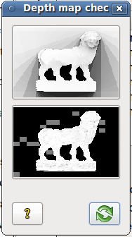
This window is only accessible when the depth map computation is running.
It displays the shaded model of the depth map that is currently calculated and its correlation map (the whiter the pixels in the mask, the more the correlation is correct). The depth map displayed is at he smallest scale (reduced 32 times) so as not to slow down the calculation ; but it gives a good idea of ​​the overall relief.
To update the view, click on (not too often ...). If an image does not display properly, regularly update the window until the images are calculated by MicMac and can be displayed (usually not until the progress bar has reached 3%).

e. Results
The results are in directories Geo* :
- computed depth maps in 16 bit *. tif format (Z_NumX_DeZoomY_Geom+referenceImageName) - they are computed at several levels of accuracy, they are not directly readable (see part Depth map conversion).
Index map and georeferencing files are in the folder TA*.
Ortho and hidden parts files are in the folder ORTHO*.
The other created files contains the entered parameters:
- masks *.tif and their referencing files *. xml,
- the list of images that are used for correlation Carte_ *. xml,
- the default settings depending on the frame param-Geo*.xml
The results are not yet usable format. You can:
- display point clouds in the GUI
- convert the depth maps into shaded and color images in 8-bit tif format
- convert them into textured point clouds in ply format,
- compute mosaics of the orthoimages that can be used to texture the point clouds.

6. Using the masking drawing window
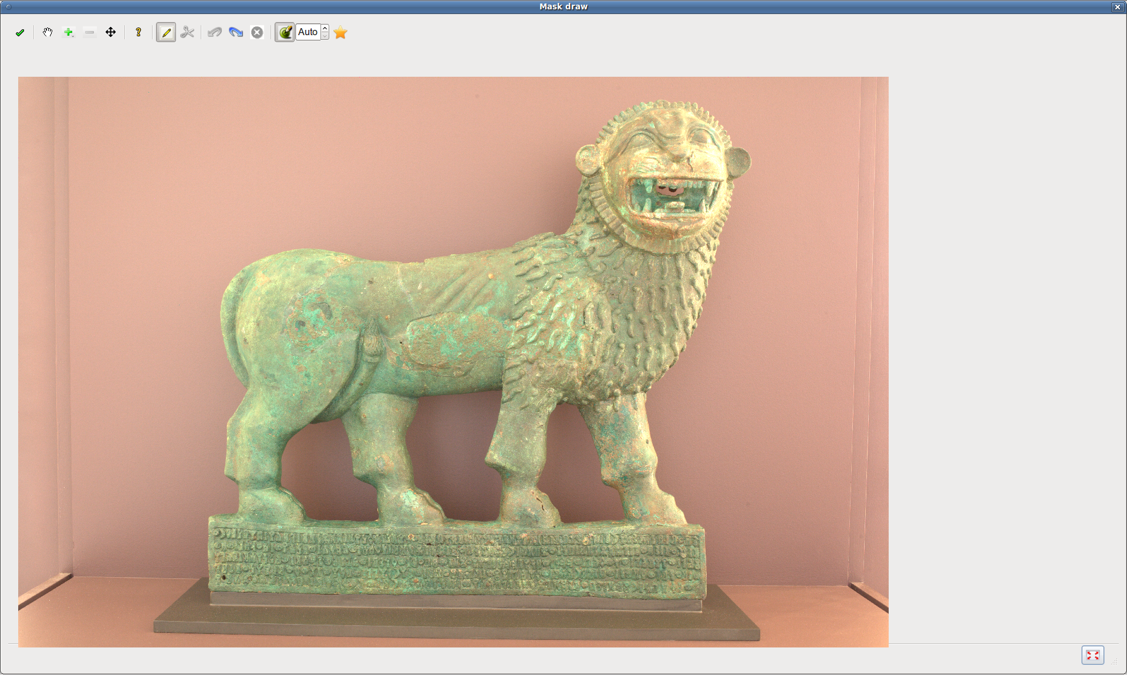
This window lets you display and/or graphically draw parameters directly over the images :
- segments for scaling (absolute orientation)
- segments to define the x-axis (absolute orientation)
- mask of the horizontal plane (absolute orientation)
- GCP (absolute orientation)
- tie-points
- mask of depth maps

Navigation tools :
- +clic to enlarge the image and center it around the mouse click ;
- +clic to reduce the image and center it around the mouse click ;
- +drag to move the image ;
- to return to the initial size of the image.
- The tool 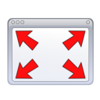 at the bottom right of the window allows you to enlarge and quickly reduce the size of the window..
- The image can be enlarged or reduced by changing the size of the drawing window too.

Sketching tools :
- to draw a point, a segment or a polygon ;
-  to draw an extrusion polygon (to cut the mask) ;
- to undo the last drawn point (with or ) ;
-  to remove all drawn points over the current image ;
-  to redo the last drawn point (with or , even those removed with ) ;
- to validate all sketches (necessary otherwise nothing is recorded).
Masks are drawn as combination of polygons over the reference image or index map.
The following two paragraphs concern only mask drawing (horizontal plane for absolute orientation or depth map computation).

a. Automatic masking
To automatically obtain a mask on the scene, click on button .
- If the mask contains holes, choose "Manage the holes in mask"
- otherwise choose "Create a full mask"
The mask is created by finding the bounding box containing the previously found tie-points of the image. The holes are extracted from the triangulation and correspond to large sets of oversized large triangles. The mask limits are then refined using the gradient of the image weighted with the distance to the tie-points.
The mask of a textured object in front of a plain background is more suitable to automatic drawing than a slightly textured object in front of a textured background as its tie-points are concentrated on the object and not on the background.
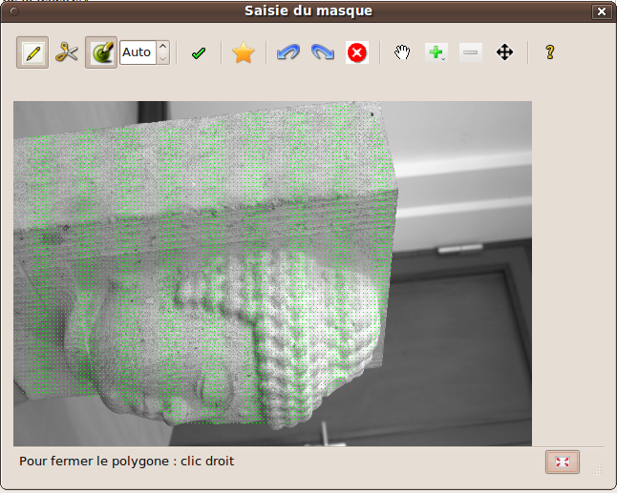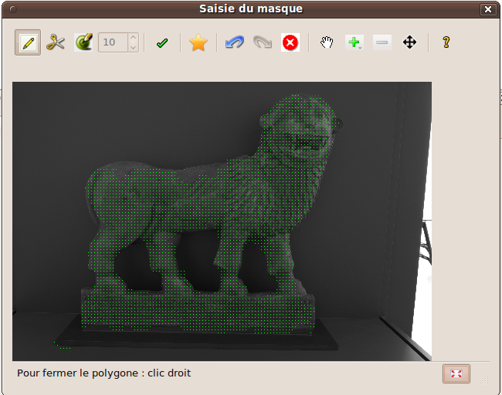

b. Manual mask
To sketch a polygon :
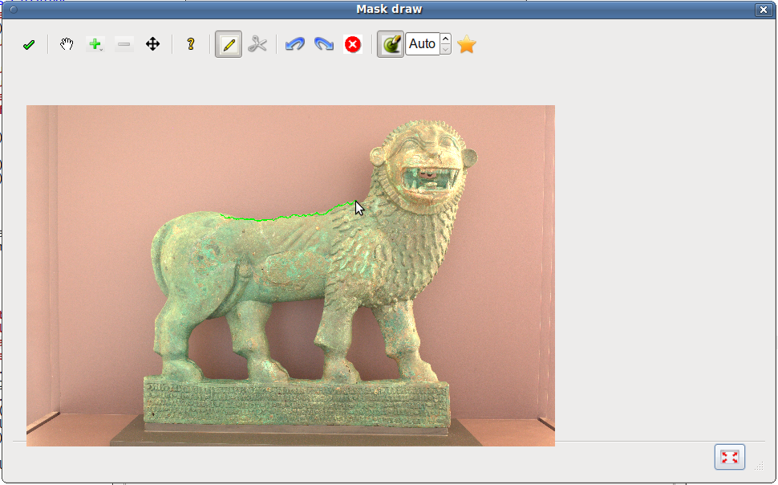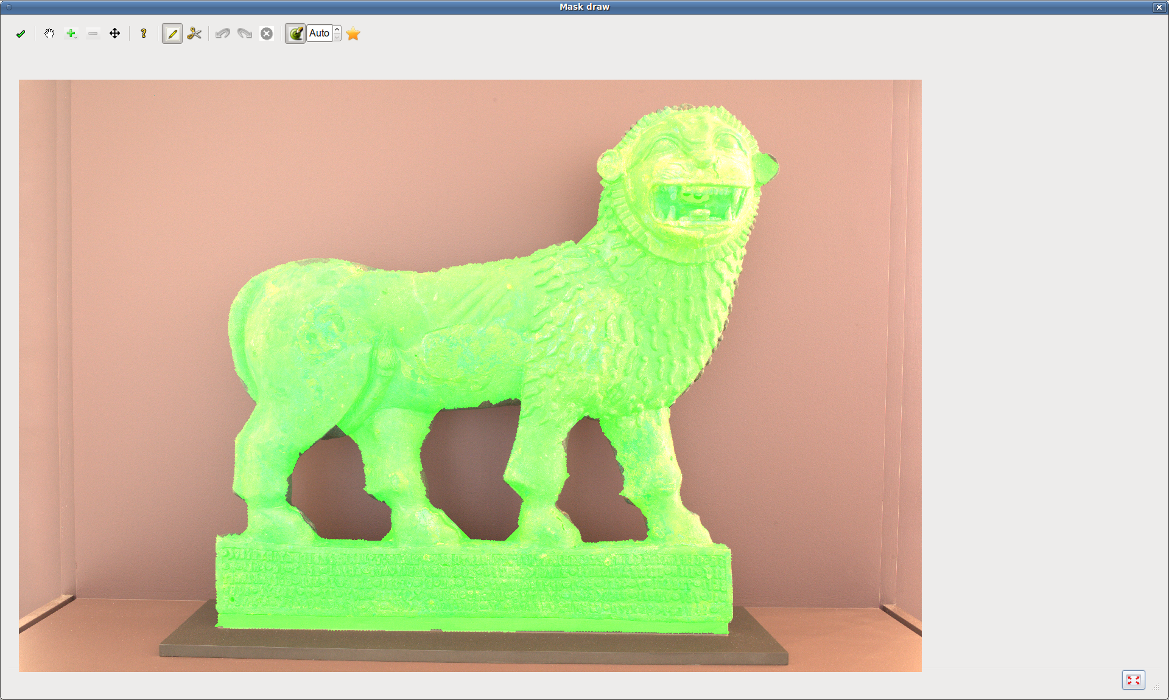
- select tool ;
- plot the polygon vertices with the mouse left click (the polygon is displayed in green) ;
- close the polygon with the mouse right click (or double-click).
You can draw several polygon ; the mask then consists in combining these polygons.
To cut part of the polygon, draw an other polygon using tool (the polygon is displayed in red) :
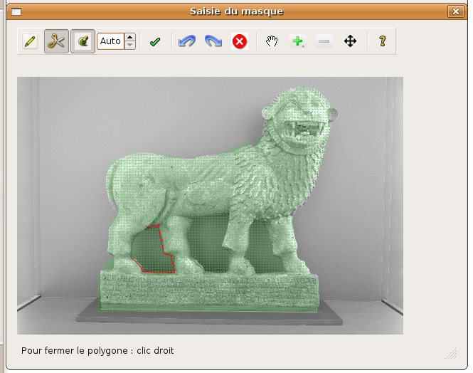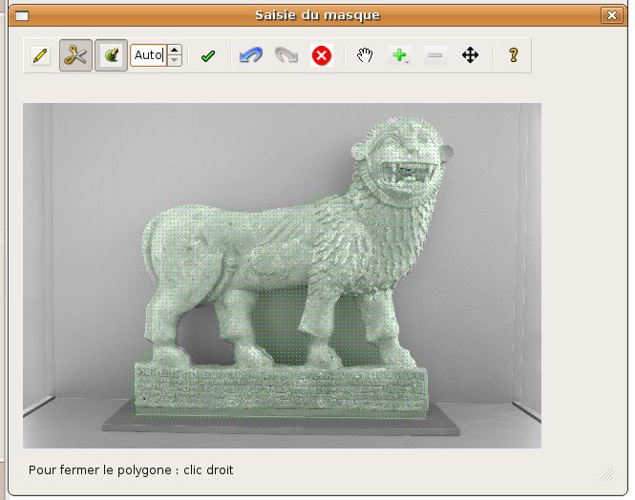
To capture the contours of objects more accurately, select both the tool  and the tool or depending on the type of polygon you want to draw.
This tool extracts the shortest path between the last drawn point of the polygon path and the new clicked point, this path is weighted by both the gradient of the image and the distance of each point of the path to the segment connecting the extremities of the path. Number to the right of the tool increases the relative weighting of a image gradient compared to the distance to the segment - the higher the number, the closer the path to the segment connecting its extremities. This tool works well only if the object to delimit has a different light from the background.
When the mask is finished, do not forget to click on to store it.
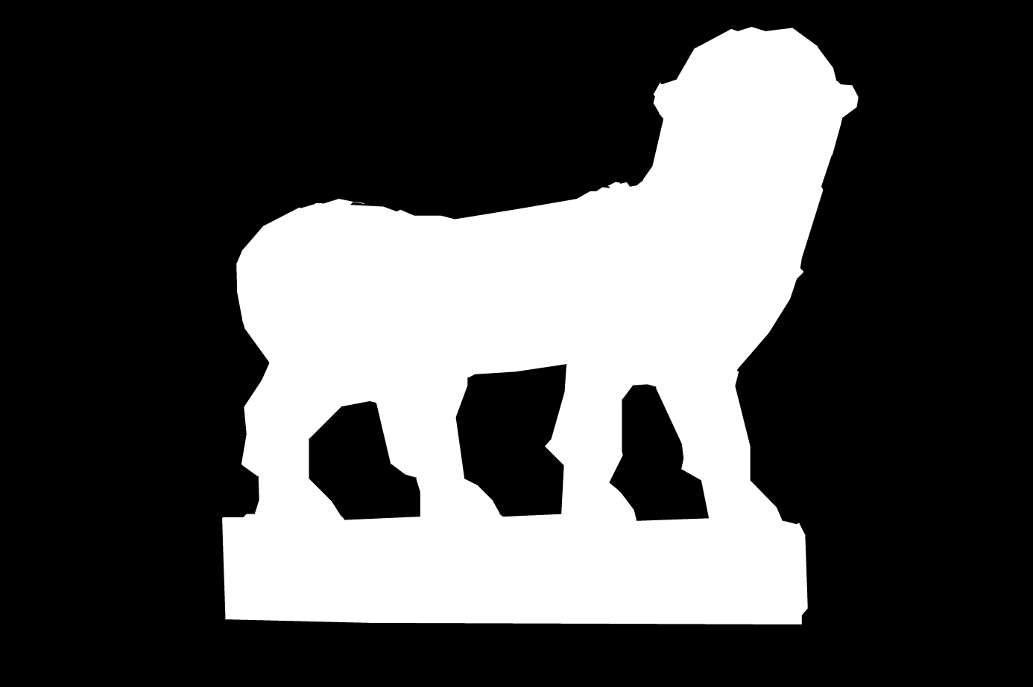

7. Saving project – Opening and restarting previous project
When a processing step is completed (tie-points are found, poses are estimated or depth maps are calculated), the parameters, current progress and results are automatically saved in the file sauvegarde.xml.
To save the calculation (even when stopped while running) in another file, select in the main window File -> Save or File -> Save As.
A project *. xml file is created, indicating the progress of the calculation, the results and the set parameters.
To open a previously saved project, select File -> Open a computation.
Opening another project file erases current processing data.
If the calculation was interrupted, you can start it again at the same stage (depending on type of processing in progress) by selecting Compute -> Restart. Otherwise you can go to the next step from the recorded data.
It is possible to integrate external data in the GUI (in the same format as requested by the GUI) by integrating them into a project file, which allows to bypass steps.
All the files that are created during processing stage depend on each other ; if any of them have been changed or renamed, make sure that they all remain coherent.

8. Result display

a. Tie-point view
This window lets you view the tie-points (see part Tie-point search). To open it, select View → Tie-point view.

1. Image pair selection
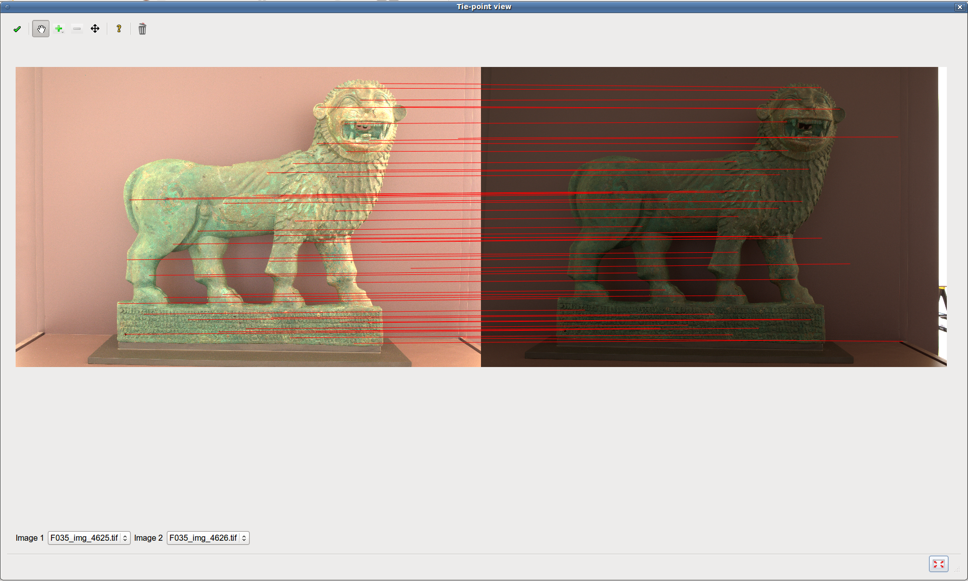
To select a pair of images for display, choose an image in the left drop-down list below the images, then select the second image in the right drop-down list. The associated tie-points are displayed as red segments.
Only the image pairs that are used in pose estimation (those for which at least eight tie-points are found) are available.

2. naviagation tools
To enlarge an image, select tool and click on one of the images.
To enlarge an image, select tool and click on one of the images.

3. Mismatch removal
If computed tie-points are mismatches and if the poses orientation fails, mismatches can be filtered manually.
Firstly click on  to display the required tool bar (click again to hide it).
To remove a tie-point, select tool and click near it (on either image of the couple).
To remove several tie-points, select too and draw a frame around them.
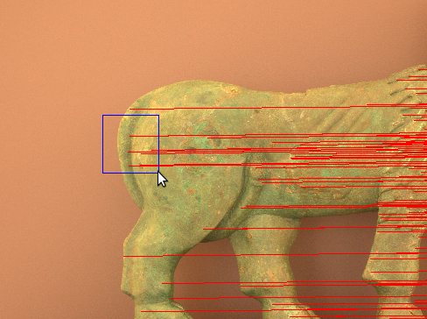
To cancel the last removal, click on (to restore it, click on ).
To save all the removals in the files, click on , otherwise they will not be taken into account in further computations.
Once the removals are saved, removed tie-points cannot be restored (then restart tie-point computation).
Removals are saved only in current files, which means that :
- if tie-points have previously been filtered during pose calculation, initial tie-point files are not modified ;
- reciprocally if tie-points have previously been filtered during pose calculation and if the current files are initial tie-point files (when the pose estimation was started again without filtering), filtered files are not modified ;
- if, after mismatch removal, tie-points are filtered for the first time during pose calculation, filtered files are modified too.

b. Survey view
This window allows you to view in 3D the parameters of the survey (position and orientation of the cameras, calculated tie-points and images bounding box) after pose estimation. To open it, select View -> Survey view in the main window.

1. survey view window overview
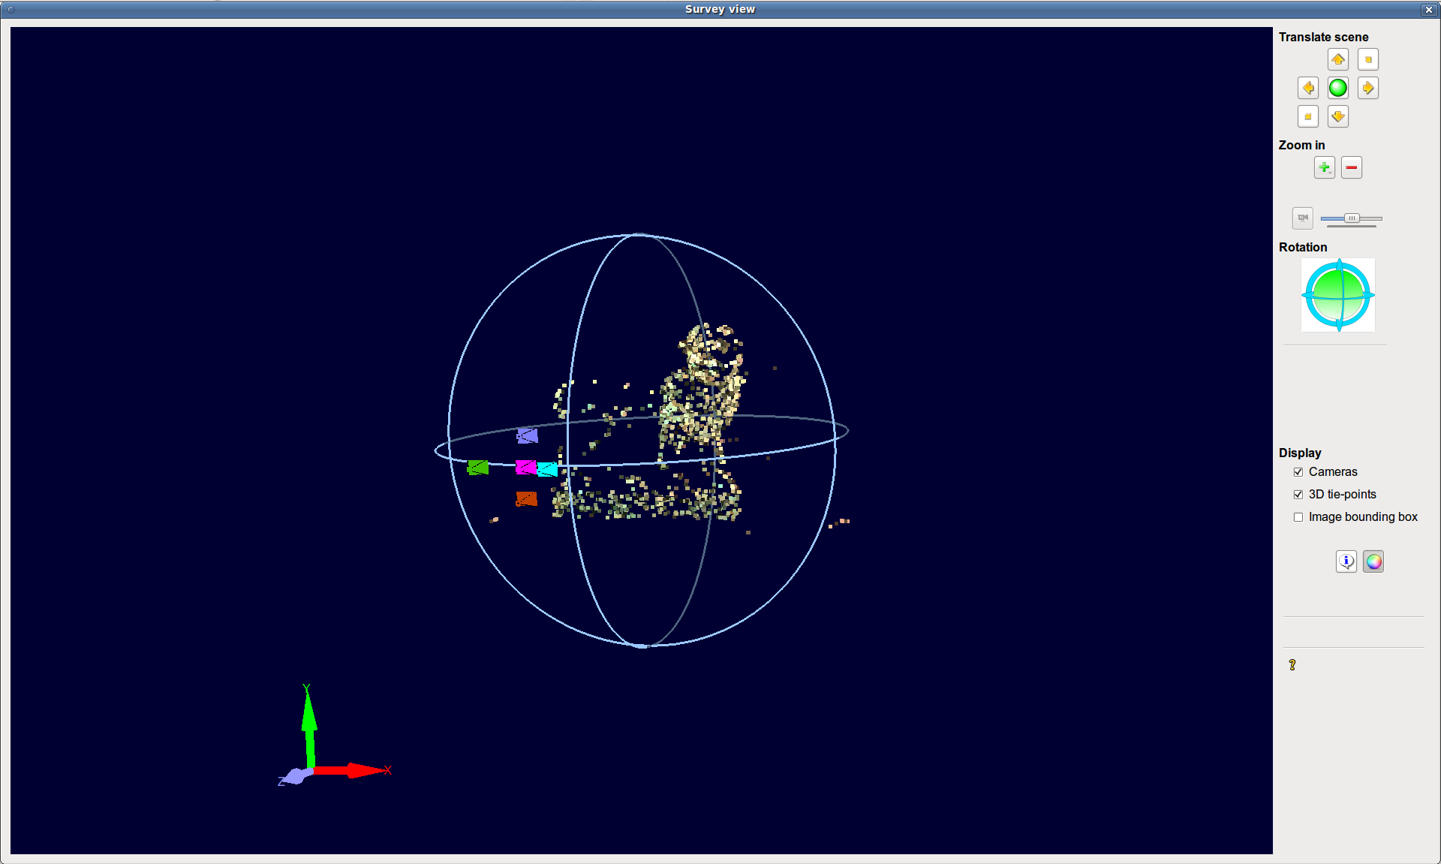
The left side of the window represents graphically and in 3D the elements of the survey based on the parameters that are calculated during pose estimation.
- The cameras are symbolized by a pyramid whose the top is a shoot summit and whose length corresponds to the camera focal length. While loading the cameras are directed towards the bottom.
- The tie-points are represented in 3D and textured with the image to which they belong.
- The bounding box of the image (projection of the camera on the mean plane of its tie-points) is represented by a rectangle.
- The axes in the lower left corner of the view show the view rotations.

2. tool bar use
The tools set in the right of the window let you modify the display parameters.

Translations
- To move in the view, use tools , , and .
- To initialize the view, use tool .
NB - If components of the survey are moved beyond the scope of view perspective (especially beyond the depth interval), they will be hidden.

Zoom
To zoom in or out the view, use tools 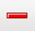 and .
You can enlarge and reduce the view by changing the window size too.
NB - If the survey components are moved beyond the scope of view perspective (especially beyond the depth interval), they will be hidden.
To modify the view opening angle, use tool 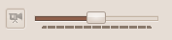 (especially useful to see inside models).

Rotation
To rotate the view, use tool 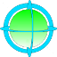
- either by clicking on the side of the circle that corresponds to the rotation of your choice,
- either by clicking on the circle that corresponds to the desired rotation and then by dragging the mouse until the desired angle ; if you click in the middle of the icon, both circles are selected.
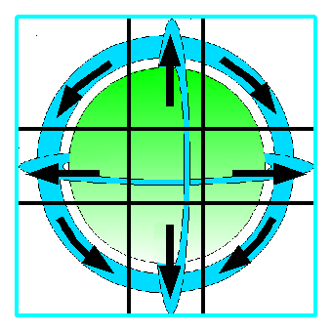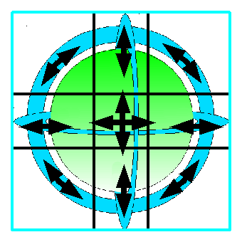
rotations of a fixed angle (click) rotation depending on mouse-dragging

Show/Hide elements
It is possible to show/hide the components of the view (cameras, tie-points or bounding boxes) by checking/unchecking them in the Display part of the tool bar.
To display the image name, select the tool  and click on a camera - the name appears under the mouse and the camera, its tie-points and its bounding box are red.
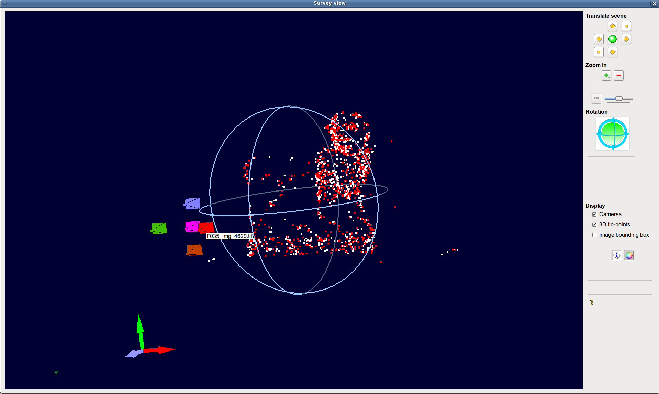
NB - When the tool is activated, it is not possible to navigate in the view with the mouse (but the tools and keyboard short-cuts are still active) ; to allow navigation with the mouse, turn the tool off.
To change the color of the tie-points, use the tool  (monochrome, with hypsometric colors or textured with the corresponding image).

3. navigation in the view with the mouse
- The main button of the mouse rotates the view – to do this, click on the blue circle that corresponds to the desired rotation (the light side is the part in the foreground of the scene), maintain the click and drag the mouse in the desired direction.
- The wheel of the mouse zooms.
- The secondary mouse button translates the view in both directions that are parallel to the screen.

4. keyboard shortcuts

Translations and zoom with the keypad
8 | Move to the top
2 | Move to the bottom
4 | Move to the left
6 | Move to the right
+ | Zoom in
- | Zoom out
7 or 9 | Move to the front
1 or 3 | Move to the back
0 | Initialize

Translations et zoom with the default keyboard
h | Move to the top
b | Move to the bottom
g | Move to the left
d | Move to the right
+ | Zoom in
- | Zoom out
p | Move to the front
l | Move to the back
o | Initialize

Rotations
↑ and ↓ | Rotate about view x-axis
←and ↑ | Rotate about view y-axis
Space and Alt (or Alt Gr) | Rotate about view z-axis

c. Point cloud view
This window is opened when you select View -> Point cloud view in the main window.
It is the same window as the survey view ; only point clouds are added. It is possible to show/hide each cloud or display it in hypsometric colors, textured or monochrome.
If there are many clouds, the loading can take some time.
The resolution of the clouds depends on their display distance to the user.
Point clouds are by default textured with either their reference image if the corresponding depth map was computed in an image frame, or by use of the index map if the depth map was computed in ground frame. To texture a point cloud with the mosaic of orthoimages (ground frame only), this must be computed before point cloud view loading. Otherwise restart the GUI to take it into account.
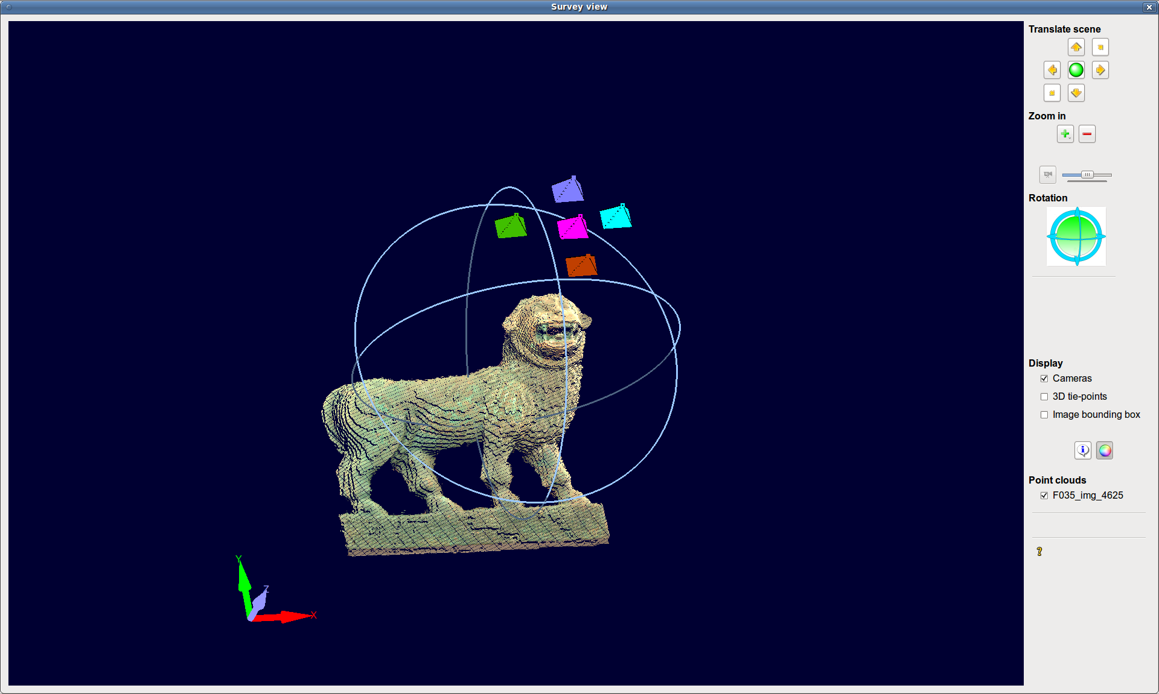

9. Depth map conversion to 8 bit tif format
The previously calculated depth maps are encoded into 16 bits and are therefore not usable. It is possible to convert them to 8 bit tif images by selecting Conversion → 8-bit depth maps.
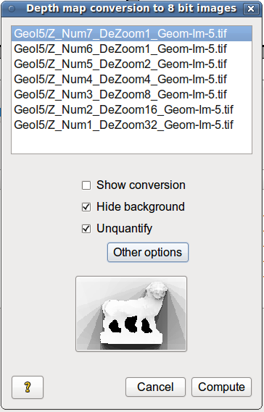
The depth maps are computed at different levels of accuracy (this is indicated by the particle "DeZoom+x" in their name).
- Select on the list the depth maps to convert;
- Select the conversion options:
- Show conversion displays the result at each stage of calculation;
- Hide background uses the mask at the same level of accuracy (previously calculated) in order to ignore the background during conversion and to give it a value of zero (the background was not taken into account when calculating the depth map, so any value was assigned to it);
- Unquantify smooths the depth levels of the depth map;
- To set additional options, click on ”More options” :
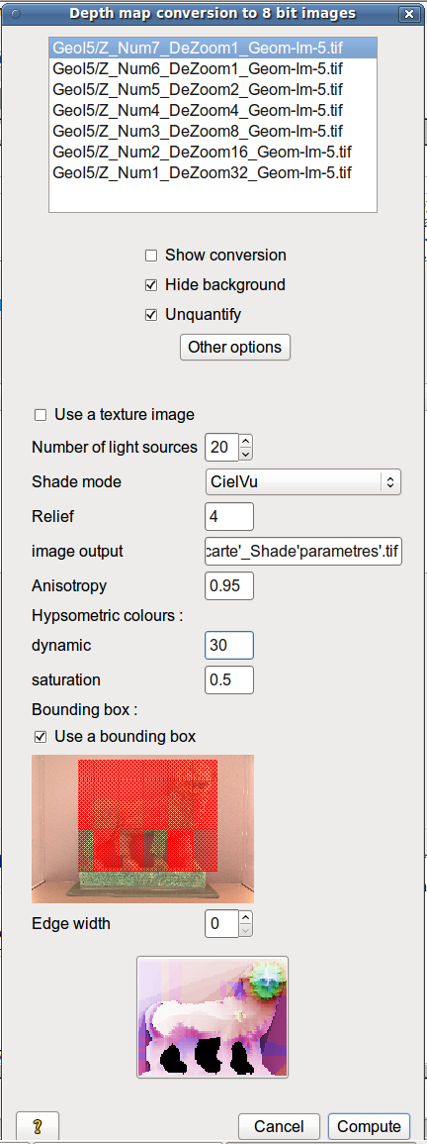
- Source number set the number of sources of light ; they are spread uniformly throughout the image
- Shade mode allows you to add local shading (Local) and general shading (CielVu)
- Relief exaggerates the relief ; it is multiplied by a coefficient to make it more visible after shading and coloring;
- Image output specifies the names of the 8-bit images (full path) to keep it generic (if more than one image is converted) ; use the keywords (do not forget the '):
- 'carte' - number of the reference image,
- 'repertoire' - data file,
- 'dezoom' - the image scale,
- 'etape' - step number in the depth map calculation ; step 6 and 7 have the same scale
- 'parametres' - parameters entered in this window
- Anisotropy changes the direction of the main light - if it is zero, the shading is isotropic (all directions are equivalent), the closer it is to 1, the more important the role of the directions that are close to the "north" of the image ; it must be set between 0 and 1;
- Hypsometric colors changes the color dynamic (the number of colors) and the color saturation of the hypsometric colors of the shaded image;
- Bounding box restricts the calculation to a frame that must be drawn in the image below ; to do this, click on a corner of the red rectangle and drag it to the desired size;
- Often the values ​​on the edges of images are noisy (or even meaningless) ; if they are high values​​, they have a strong influence on the shading ; “Border width” applies the minimum value of the image to the parameter value edge width, so that it does not affect the shade.
The shaded depth map at lower scale is shown at the bottom of the window ; remember to check in the terminal if there is no error messages about the validity of the parameters before running the calculation ;
Click on .
Compute
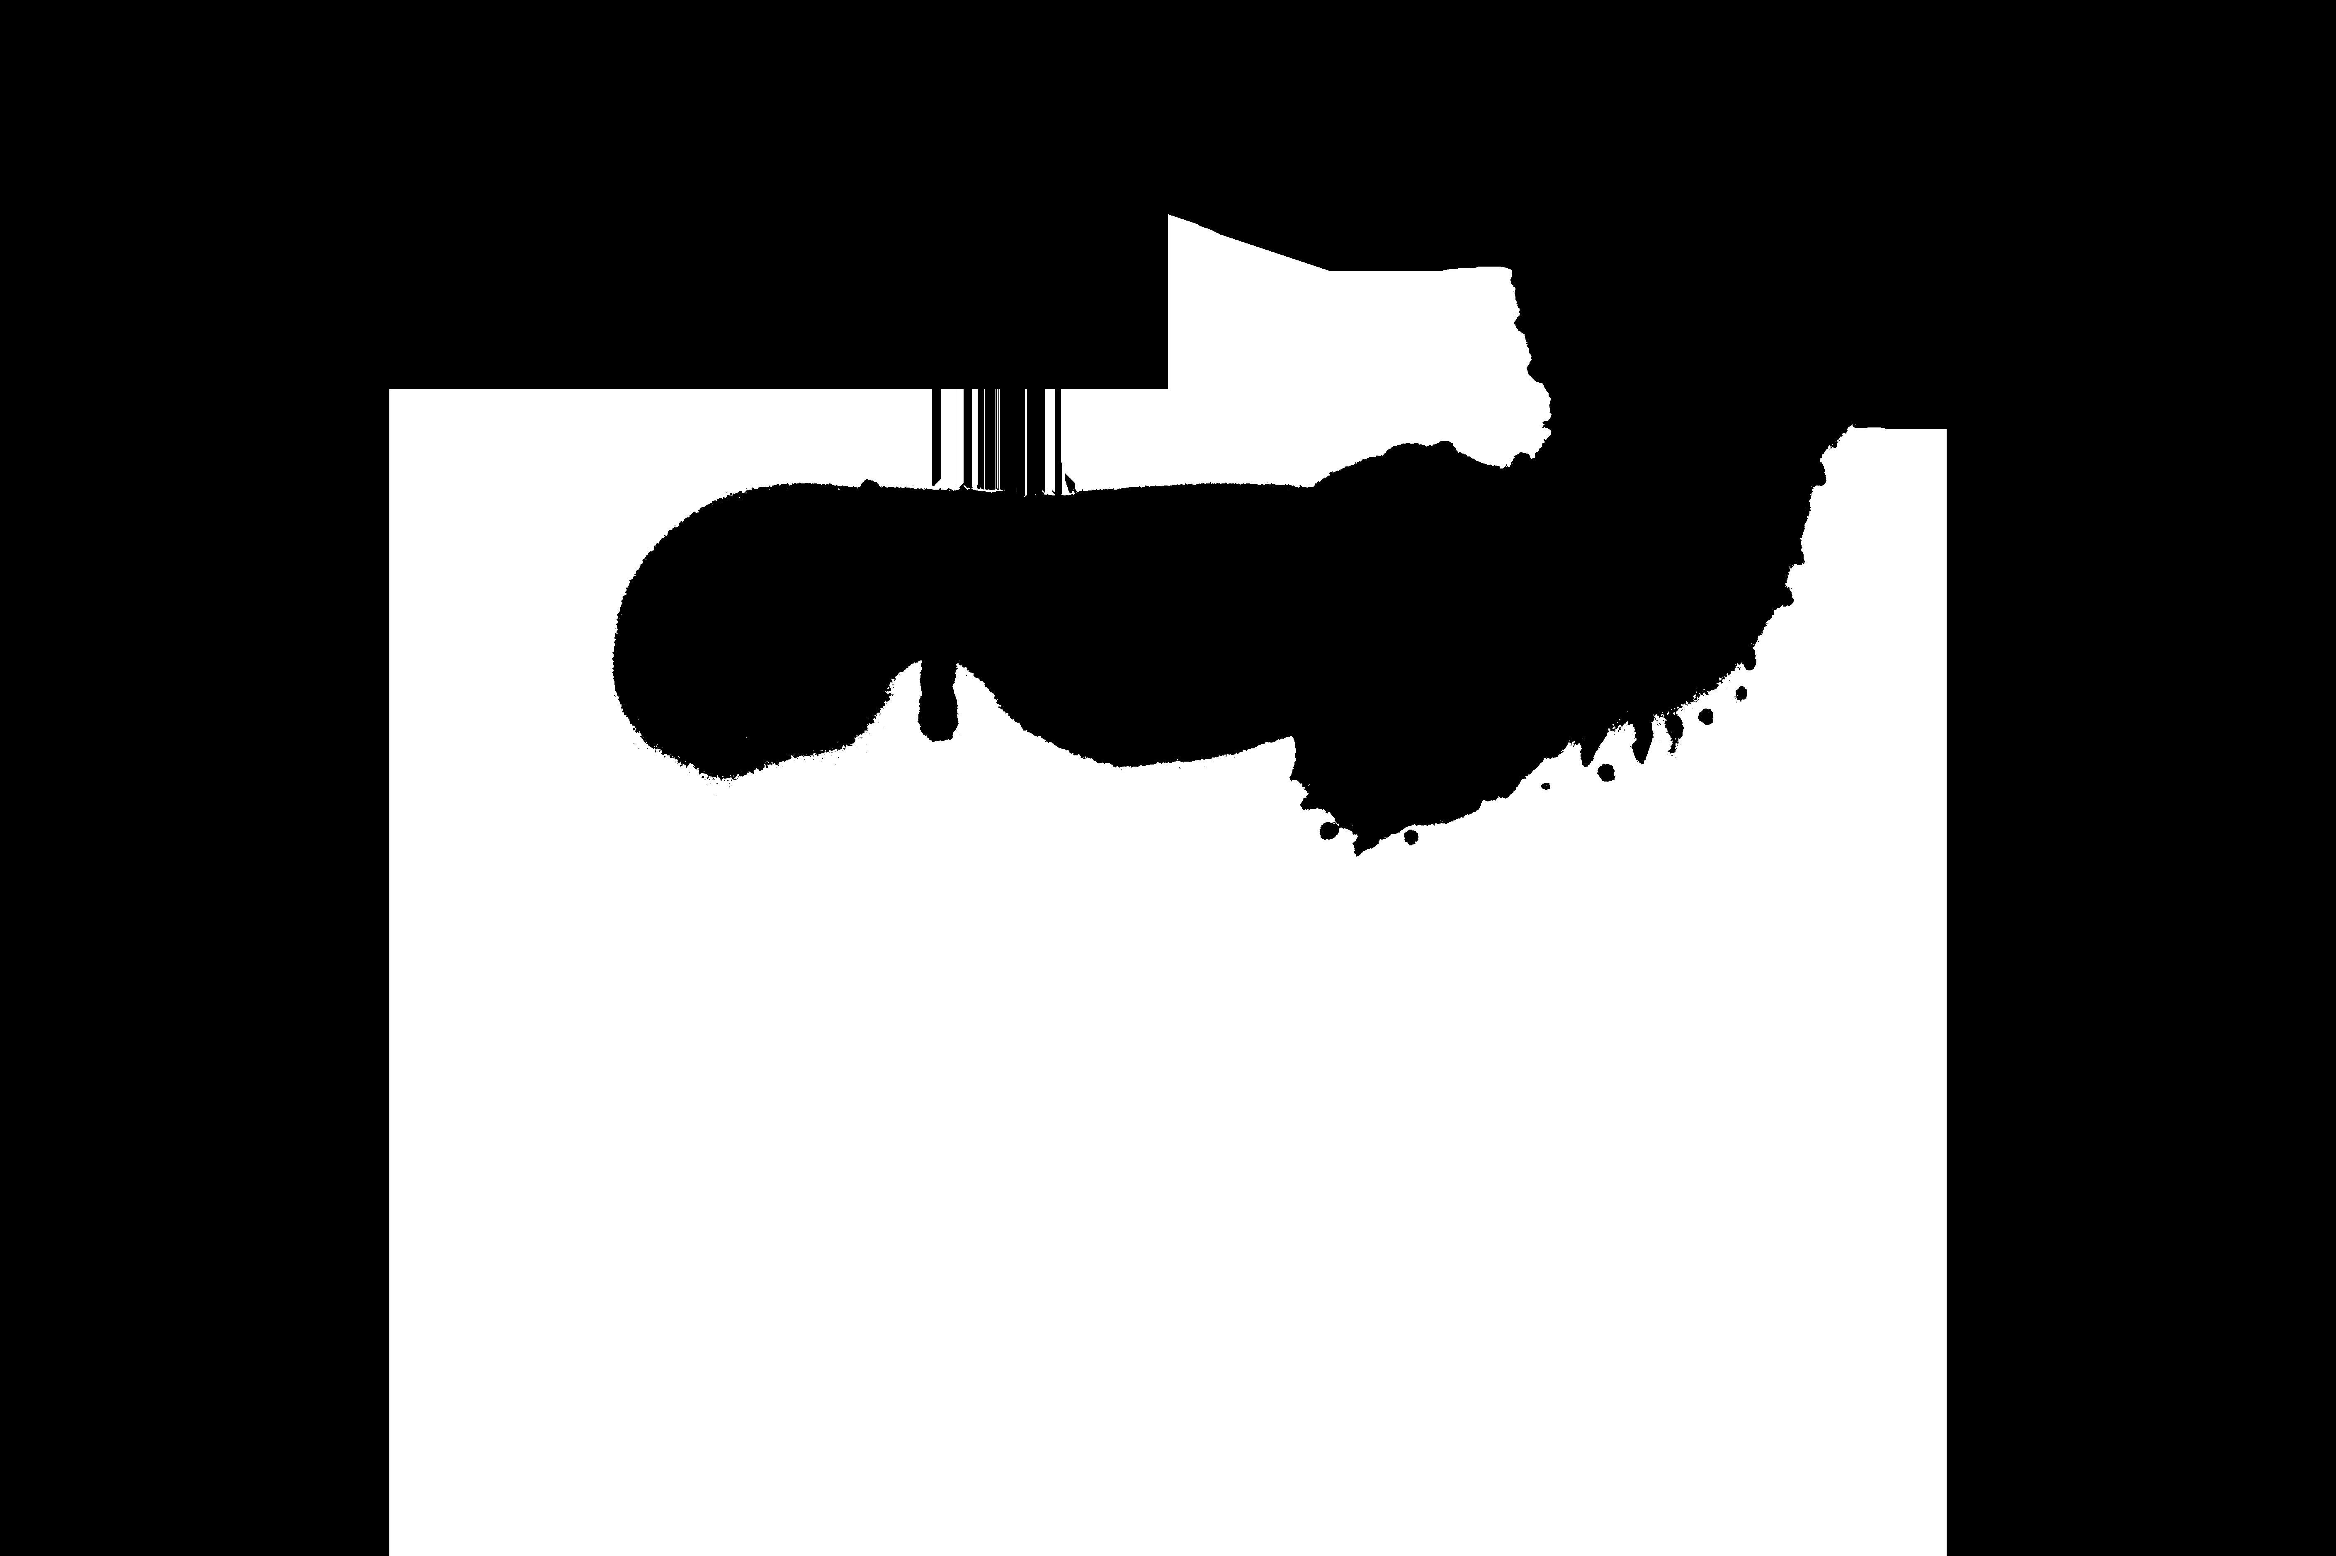 → 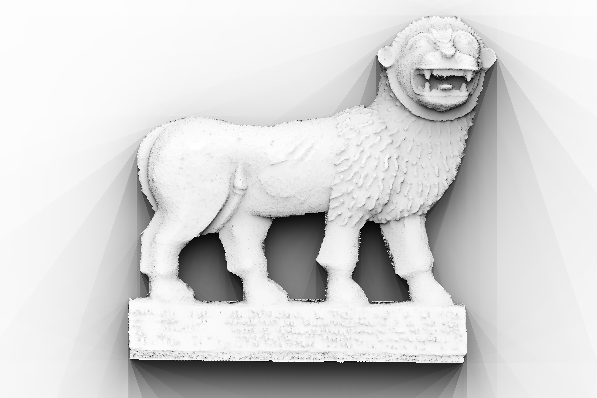
The converted depth maps are put by default in the directory Geo*/Conversion.

10. Depth map conversion in 3D models (point clouds)
To convert depth maps in 3D point clouds in ply format, select Conversion → 3D models in the main window.
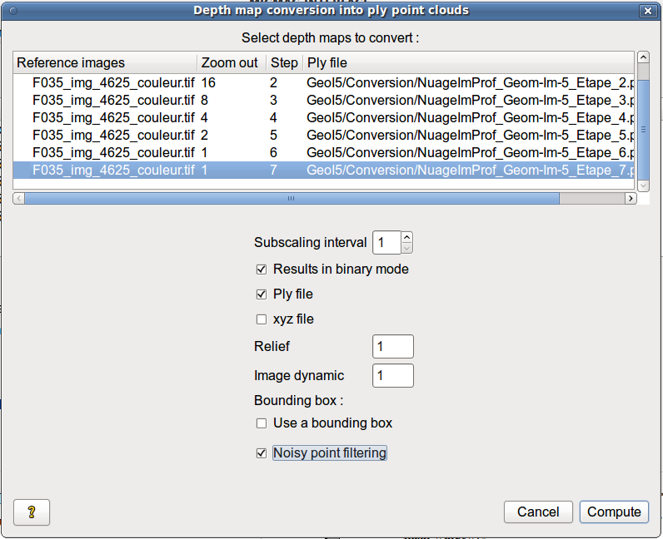
This window displays all depth maps at all calculated scales. To convert a set of depth maps, simply select them and click on .
Compute
Available options are :
- Subscaling interval is used to calculate only one point per interval without changing the scale of the cloud.
- Output file format depends on the application used to read them ; to read them with MeshLab on Windows, check Binary file and uncheck Xyz file, to read them with MeshLab on Linux, uncheck Binary file and uncheck Xyz file.
- Relief exaggerates the relief ; it is multiplied by a coefficient to make it more visible
- Image dynamic modifies the histogram of the texture image
- The bounding box allows you to export only a part of the clouds (for its use, see part Depth map conversion to 8 bit tif format)
- Noisy point filtering is automatic filtering of points that obtained a low correlation coefficient and that are on high slopes ; the goal is to filter artifacts from depth map calculation that come from depth discontinuities. The result is better for well-textured scenes with very high slopes ; usually all noisy points cannot be filtered anyway, manual filtering is required, but this enhances the cloud display.
Other options are accessible if you put the mouse on the corresponding line (without selecting it) and right click on it :
- To apply a differently textured image from the one proposed, choose Other texture image and select the desired image (it is applied at all scales of the selected depth map).
- To save the ply file in another directory than the one proposed, choose Other saving directory, and select the folder (which is also applied to all scales of the selected depth map).
- To filter out noisy points (especially for scenes including depth discontinuities), choose Noisy point filtering mask, open a mask (either an existing filtrering mask, or the mask used to create the depth map), eventually modify it and save it. The mask is superimposed on the correlation map to facilitate the detection of noisy areas (low correlation coefficient are darker areas).
If the depth map was calculated in the ground frame, the default texture image is the index map. So, remember to calculate the orthoimage mosaic before converting the depth map and to select the mosaic as a texture image.

11. Mosaics of orthoimage computation
To compute a mosaic of orthoimages that are computed with depth maps, select Conversion → Orthoimages.
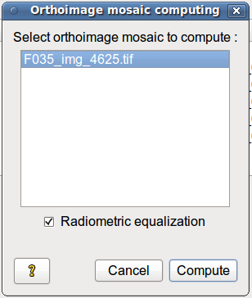
Select the orthoimages set to mosaic and click on . Only the orthoimages whose corresponding depth map was calculated with the "Compute orthoimages" option appear in the list.
Compute
To equalize radiometrically the orthoimages before the mosaic computation, check "Radiometric equalization".
The result is an image in tif format called Ortho-Eg-Test-Redr.tif or Ortho-NonEg-Test-Redr.tif and is put in the corresponding folder ORTHO*.

IV CONTACT
For bug reports, comments on the GUI, proposals for improvements or questions regarding data acquisition, use or application of the GUI, please write an email to isabelle.clery @ ign.fr

DATA ACQUISITION ANNEX

1 Camera setting
- The images can come from any type of camera. But the aesthetic quality of the pictures (and textured model) and the accuracy may depend on the quality of the camera (usually the precision mainly depends on the shoot).
- If possible do not set the auto-focus and set the focus once for each lens change (indeed, if the focus changes, the lens calibration is different and this should be indicated in GUI). Therefore ensure that the camera depth of the field is sufficient and that the whole scene is clear.
- Minimize specular highlights (metallic objects) and scenes with changing backgrounds too (trees, crowd). Avoid using flash and moving light sources (instead use fixed projectors). Shadows are not a problem and may even help the algorithm (except in case of saturation), but they should be static.
- A change in brightness does not affect the calculation of the 3D model while there are no saturation or expanded black areas, however, the different clouds that constitute the 3D model will have different radiometries. Indeed, it is recommended to equalize all the images that are used as a "reference image" in depth map computation just before the conversion to ply files).
- It is recommended not to use compressed jpg images. If this happens, adjust the size of the sensor on the GUI when creating initial calibrations.
- The algorithms only work on textured scenes (stone, colorful material, earth), so avoid monochrome plaster, uniform colors on smoothed surfaces. If the scene contains a wide non-textured area, it will appears as very noisy in the 3D model.
- The aerotriangulation of the images taken with the long focal length lenses is not robust and often diverges ; to avoid this take pictures of the same part of the scene with a short or medium focal length lens.
- In addition, if the images have very different scales (images that are taken with short and long focal lenses, or that have a very different distance from the scene), it may be useful to add images at an intermediate scale so that the algorithm finds enough tie-points between the two image blocks.

2 Shooting protocol
The shoot must obey two constraints :
- Calculating a depth map for every desired point of view (step MicMac)
- Referencing all the depth maps (thus all used images) in a single frame to merge all the point clouds (step Apero).
Various case studies are presented on the website of the MAP laboratory www.tapenade.gamsau.archi.fr (the website is still under construction).

a. Converging shoot

A Shooting protocol for one depth map

A depth map corresponds to all points in the scene seen by a "reference image", which means that each pixel of the image will be computed in 3D (it is the same principle as a laser scanner that is sited from the same point of view as the reference image and that has the same opening angle as the used lens).
The density and the resolution of the point cloud are directly related to the resolution of this reference image ; to get a very accurate point cloud just shoot closer to the scene or use a longer focal length, this technique is adaptable to a wide range of resolutions.
To obtain the missing 3D information from the 2D images, we use a set of images, taken with the principle of the stereoscope ; this means that any part of the scene to model must be seen in at least one image other than the reference image (it is not necessarily the same for the whole scene).
If a pixel (that is included in the mask) of the reference image is not seen on another image, it will be correlated with any similar pixel by the algorithm or relegated to the background by default ; at any rate, this will create a noisy 3D point (however if it is insulated it is usually recovered by the smoothing of the surface).
Experience shows that the configurations in cross (5 pictures) or T (4 images) can prevent the problem of hidden parts.
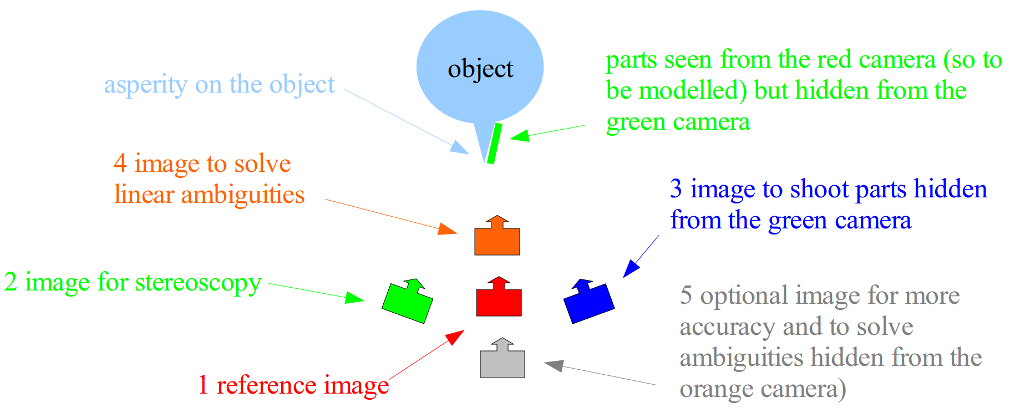
Example of converging shoot configuration for a depth map.
The cross (or T) may be on the horizontal plane (make sure you focus well) or on the vertical plane.
(The ambiguities are due to linear features that are parallel to the base line connecting two camera poses. They are removed by taking a picture outside this line)
Note that the greater the distance between the cameras, the more accurate the model will be.
However, the correspondence between the pixels of the reference image and those of other images is done by correlation, that is to say, by similarity of their neighborhood. If the object is too distorted from an image to another, there will be no matches. Models that require high accuracy should be inserted with intermediate images to distribute the deformations. A possible configuration is as follows

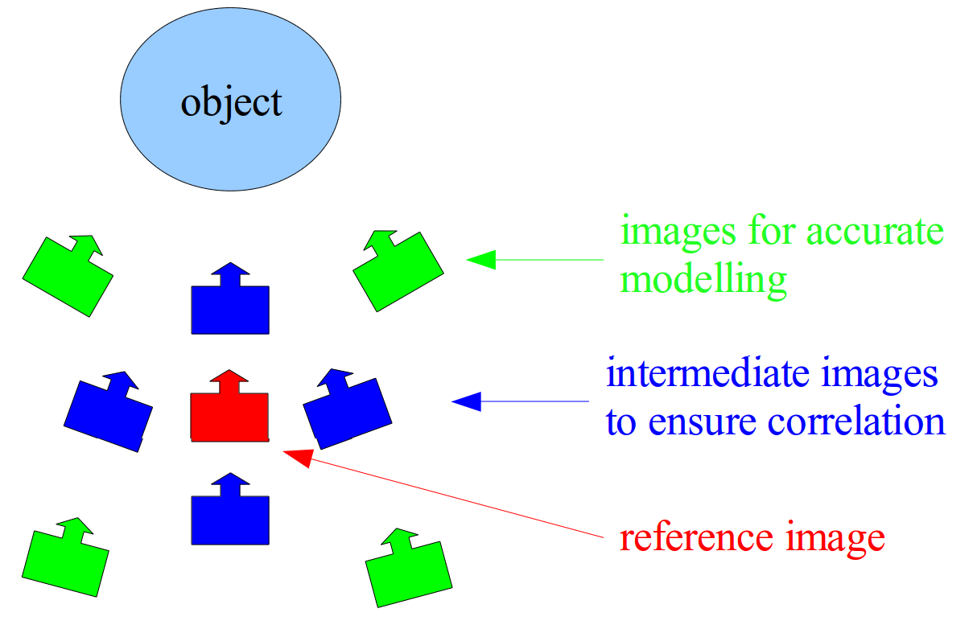
Example converging shoot configuration for a depth map with a high level of depth accuracy
Note that the more images there are and the more accurate the depth map will be, but the calculation will be much longer.

B Shooting protocol to link depth maps
To fully model an object, simply go around it and create as many depth maps as necessary to model every sides of the object (the number depends on the complexity of its shape). Otherwise, if the object is almost planar, divide it into blocks and create a depth map per block.
One method to ensure the completeness of the model is to take, before the final shoot, a picture for every future depth map and to check that the entire surface of the object is visible in these images.
To put every point cloud in the same frame, the pictures that are used to compute the depth maps must be linked with photos in between.
The images are linked to each other by tie-points - these are points of interest (areas of high gradient - spots, corners of objects) that are matched with a point of interest of another image using the likeness of their neighbor pixels. If the computed tie-points are correct, both points of the pair point represent the same spot of the scene.
To ensure the connection of an image to another, they must overlap enough (at least 60% of the image for parallel shoot, an overlap of 80% is usually for converging shoot). In addition, parts of the object are distorted from one image to another as they are seen from a different point of view. Finally, a rotation of 10 to 20 ° (depending on the curvature of the object and its shape complexity) between each point of view is sufficient. Note that it is better to take too many photos than not enough because it is rarely possible to complete the shoot in the same conditions some time later and it is easier to let the calculation run a little longer.
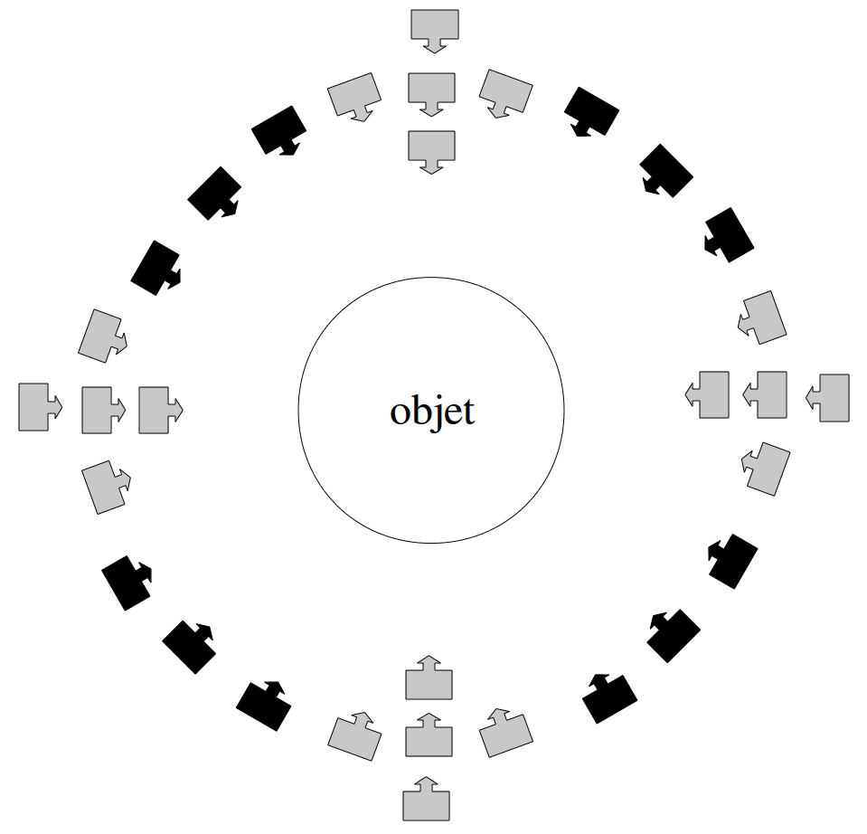
Example of a full converging shoot configuration to fully modelize an object
This parallel shoot configuration can also be used for fully modeled objects that are larger than the camera field. In this case, for every point of view when this problem happens just make a small pan shot instead of a single image. During processing, either the reference image is not split, then you will have to include all the images that are used for this point of view in the computation, or you can separate the point of view in several depth maps or compute a single depth map from a panoramic of the pictures (computation in the ground frame).

b. Parallel shoot
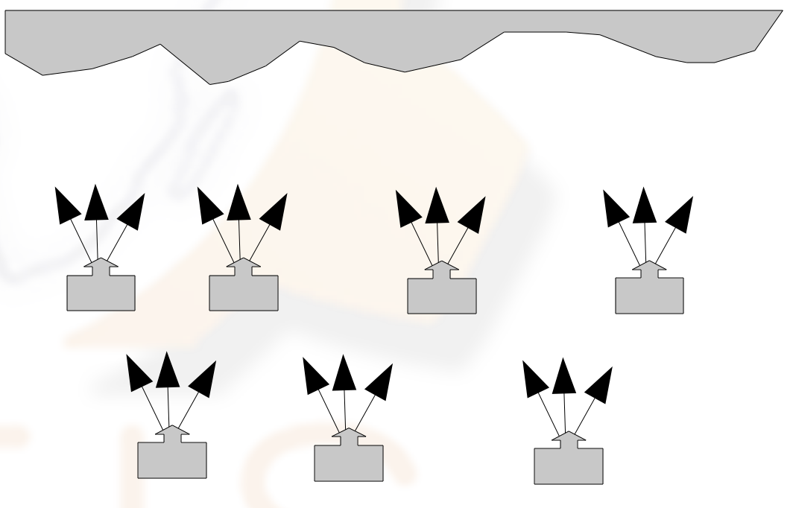
Example of a full parallel shoot configuration for a wide, almost planar scene
(a single picture can be taken from each point of view, it depends on the scene accessibility and on the number of possible points of view)

This type of shoot is mostly used in aerial photogrammetry or for building facades. Indeed, it is easier to use a converging shoot in terrestrial photogrammetry because the relief is usually more complex and therefore presents more hidden parts ; thus a converging shoot enables a greater redundancy and thus greater accuracy, but is easier to obtain in terrestrial photogrammetry than with a plane or a drone.
Parallel shoot is done by traditional strips, with an overlap of 80% between images and 20% inter-band.

c. Auto-calibration
If the calibration parameters of the used lenses are unknown, a specific shoot can ensure the convergence of the pose calculation.
Simply take some pictures (using a converging shoot as for a depth map) of a very textured scene that contains great differences in depth (wall corner etc.) to ensure the precision of the focal length estimation.

