Walnut PBMCs Flow Data

Walnut PBMC Project Tuesday 11.28.23

Code File: 001_FlowData_Reformatted.Rmd
002_FlowData_Exploratory.Rmd

The purpose of these scripts are to analyze the flow cytometry data generated by the UCHC flow Core (Evan Jellison and Nuoxi.) I want to make a code that is applicable for all batches so I can just run it on everything. I will need to manually process each batch excel file though.

Nuoxi has provided me with excel files that contain the number of cells for each cell type, before and after walnut for the 3 visits. Recall, for flow, we only did V2 (before) and V3 (after) because this is all we collected blood for.

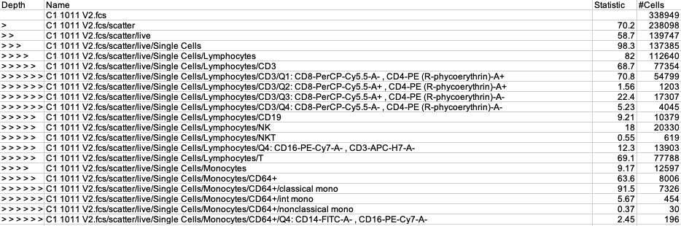

In column 1, you see depth (similar to microbiome data…you’re going further down each time, sub-setting the cells into different phenotypes.) You will notice that when depth has no value, the statistic column is empty. I inputted (100) for these values as place holders for R. Similarly, for depth, I will put 0.

“>” indicates total scatter
“>>” indicates live cells
“>>>” indicates single live cells
In column 2, you have the same name, as well as the phenotype. C1 refers to the physical plate well on the flow machine. The following number and V# indicate sample and visit information.

The phenotypes are also indicated by the depth. For example, Lymphocytes are broken down into CD3 then CD8-, CD4 +, etc.

Statistic (column 3) refers to the percentage of the cells that have this phenotype. #Cells is very self explanatory.

Metadata
Batch 2 samples:

Well Number | Sample ID | Visit Number
C1 | 1011 | V2
C2 | 1011 | V3
C3 | 1013 | V2
C4 | 1013 | V3
C5 | 1015 | V2
C6 | 1015 | V3
C7 | 1016 | V2
C8 | 1016 | V3
D1 | 1017 | V2
D2 | 1017 | V3
D3 | 1018 | V2
D4 | 1018 | V3
D5 | 1020 | V2
D6 | 1020 | V3
D7 | 1021 | V2
D8 | 1021 | V3

Batch 3 samples

Well Number | Sample ID | Visit Number
C1 | 1012 | V2
C2 | 1012 | V3
C3 | 1023 | V2
C4 | 1023 | V3
C5 | 1025 | V2
C6 | 1025 | V3
C7 | 1027 | V2
C8 | 1027 | V3
D1 | 1028 | V2
D2 | 1028 | V3
D3 | 1029 | V2
D4 | 1029 | V3
D5 | 1030 | V2
D6 | 1030 | V3
D7 | 1031 | V2
D8 | 1031 | V3

Unique cell types profiled:

Cell Type | Subgroup | Quadrant
Lymphocytes | Overall | NA
Lymphocytes | CD3 | Q1: CD8⁻, CD4⁺
Lymphocytes | CD3 | Q2: CD8⁺, CD4⁺
Lymphocytes | CD3 | Q3: CD8⁺, CD4⁻
Lymphocytes | CD3 | Q4: CD8⁻, CD4⁻
Lymphocytes | CD19 | NA
Lymphocytes | NK | NA
Lymphocytes | NKT | NA
T cells | NA | NA
Monocytes | Overall | NA
Monocytes | CD64⁺ | Classical Mono
Monocytes | CD64⁺ | Int Mono
Monocytes | CD64⁺ | Nonclassical Mono
Monocytes | CD64⁺ | Q4: CD14⁻, CD16⁻

Analysis Plan

Statistical Plan
Need to assess the distribution of the data. If the data is close to normal, a T-test would be appropriate.
Wilcoxon Signed-Rank test is non-parametric, meaning it makes fewer assumptions about the distribution of the data. It is less sensitive to outliers.
Both tests are appropriate for paired data (which we have.)

I will start with the Shapiro-Wilks test to assess normality, along with histograms of the number of cells. If the p-value is < 0.05, we reject the null hypothesis that the data is normal (i.e., data is not normally distributed.)

Scripts:
001_FlowData_Reformatted.Rmd

So, What I did was concatenate the batch 2 and batch 3 data frames. Then I isolated individual markers and saved them as csv files.

The file names are formatted as such: Merged_2.3 (meaning the concatenated batch 2 and 3 data) all_Lymphocytes.
This would include ALL lymphocytes.

002_FlowData_Exploratory.Rmd

Results
Shapriro-Wilks test for data normality
Significant p-values indicate data is non-normal, and downstream tests should be conducted with a non-parametric paired test such as Wilcoxon test.

Marker | Shapiro-Wilks W value | Shapiro-Wilks P value
CD3 lymphocytes | 0.97008 | 0.5017
CD4-, CD8- lymphocytes | 0.5757 | 1.88e-08
CD4+, CD8+ lymphocytes | 0.78506 | 2.162e-05
CD4+, CD8- lymphocytes | 0.97062 | 0.5166
CD4-, CD8+ lymphocytes | 0.83427 | 1.928e-04
CD16-, CD3- lymphocytes | 0.96976 | 0.4929
CD19 lymphocytes | 0.94563 | 0.1083
NK lymphocytes | 0.9157 | 0.01592
NKT lymphocytes | 0.88603 | 2.l782e-03
Overall lymphocytes | 0.97781 | 0.7338
T lymphocytes | 0.97069 | 0.5186
CD14-, CD16- monocytes | 0.78366 | 2.04e-05
CD64 monocytes | 0.8774 | 1.728e-03
Classical monocytes | 0.86697 | 9.895e-04
Int monocytes | 0.88181 | 2.2e-03
Nonclassical monocytes | 0.63626 | 1.1e-07
Overall monocytes | 0.91169 | 0.01245

Wilcox Test
A significant p value suggests that there is a significant difference between the paired samples. This could mean a difference in medians, but it doesn’t provide information about the direction of difference. This needs to be obtained visually.
Marker | Wilcox P value | Increased or decreased in V3
CD3 lymphocytes | 0.083 | Overall decrease
CD4-, CD8- lymphocytes | 0.044* | Overall decrease
CD4+, CD8+ lymphocytes | 0.11 | Overall decrease
CD4+, CD8- lymphocytes | 0.083 | Overall decrease
CD4-, CD8+ lymphocytes | 0.074 | Overall decrease
CD16-, CD3- lymphocytes | 0.039* | Overall decrease
CD19 lymphocytes | 0.039* | Overall decrease
NK lymphocytes | 0.058 | Overall decrease
NKT lymphocytes | 0.074 | Overall decrease
Overall lymphocytes | 0.065 | Overall decrease
T lymphocytes | 0.083 | Overall decrease
CD14-, CD16- monocytes | 0.14 | Overall decrease
CD64 monocytes | 0.21 | Slight increase
Classical monocytes | 0.21 | Slight increase
Int monocytes | 0.51 | Overall decrease
Nonclassical monocytes | 0.14 | Slight decrease
Overall monocytes | 0.3 | Slight increase

Walnut PBMC Project Wednesday 11.29.23

Code file: 003_Giardina_RNASeq_StratifiedBy_Uros.R
004_All_Flow_Batches_Exploratory.Rmd
005_AllBatches_Exploratory.Rmd

The purpose of this file is to compare the RNASeq data generated by Charlie Giardina and our urolithin stratifications for the on-going walnut NIH trial.

The Giardina RNASeq report is saved under the filename “Giardina_RNASeq_Report”

Giardina did RNASeq on 11 PBMC samples:

RNASeq Sample | Uros? | Flow?
1002 | Yes | In progress
1005 | Yes | In progress
1008 | Yes | In progress
1009 | Yes | In progress
1010 | Yes | In progress
1011 | Yes | Yes
1012 | Yes | Yes
1013 | Yes | Yes
1015 | Yes | Yes
1016 | Yes | Yes
1017 | Yes | Yes
1018 | Yes | Yes

From his technical report, I put the gene foldchange data into an excel sheet.
Previously, we had stratified the urolithin data by Kmeans clustering into 3 clusters, low, medium, and high.

Using these stratifications, I added this information into the list of the samples that Charlie did RNASeq on.

I input the data into R using 003_Giardina_RNASeq_StratifiedBy_Uros.R and Z-scaled the data by column.

In Code 004 and 005, I regenerate the merged file (including batch 1) (004) and iterate through and save the individual markers (005). Note that sample 1010 BEFORE was formatted differently, I had to manually go in and edit name entries for these samples so that everything downstream would work.

I need to collate a table of all the Shapiro-Wilks values as well as the p-vales for the Wilcox test into an excel sheet.
Might also be worthwhile to implement a seed into the code so that the p-values are the same if we re-run this.

