AI Tools & Reflective Journal
CNN Foundation — Deep Learning Workshop
April – May 2026
A. Tools Used
The following Generative AI and research tools were employed across the project lifecycle, from initial literature research through to simulator development and presentation preparation:

- Literature organisation, infographic generation, mind maps, slide decks, 10-question multiple-choice quiz, data tables, and video summaries. Custom prompts yielded step improvements in output quality.NotebookLM —
- Research of top CNN papers, consolidation of paper lists, live video-feed assistance for GitHub licence setup, concept explanation during paper review, study notes text building, image generation, and cross-evaluation of study notes.Google Gemini —
- Research of top CNN papers, quiz question context hints, UI layout improvement of the simulator, and cross-evaluation of study notes.Claude (Anthropic) —
- Initial research of CNN foundation papers.Perplexity AI —
- Conversion of quiz to Google Forms; layout enhancement of study notes (limited effectiveness noted).Manus AI —
- Drafting and iterating the CNN simulator; development of the walkthrough Jupyter Notebook for the worked example. Updated to use the MNIST dataset.Google Colab —
- Locating peer-reviewed links for each selected paper.Google Scholar —
- Drafting the final presentation slide deck.Presentations.AI —
- Interactive simulator UI framework (switched from Streamlit after Gemini consultation).Gravio / Streamlit —

B. Reference Prompts
The following prompts were used at key stages of the workflow. Actual prompt text is to be inserted manually in the spaces provided below.

Prompt 1 — Paper Research & Consolidation
Prompt 1: 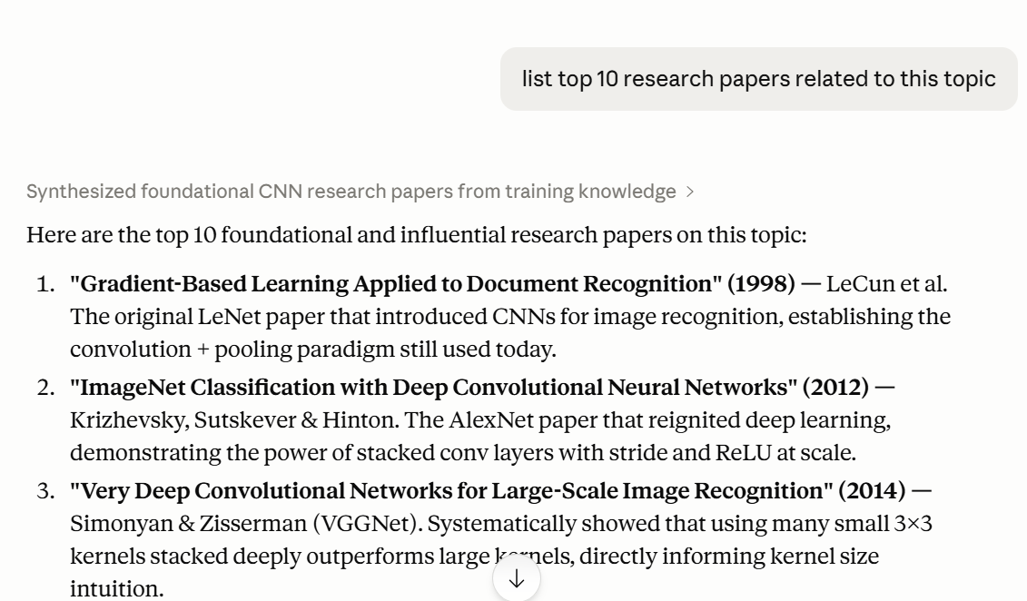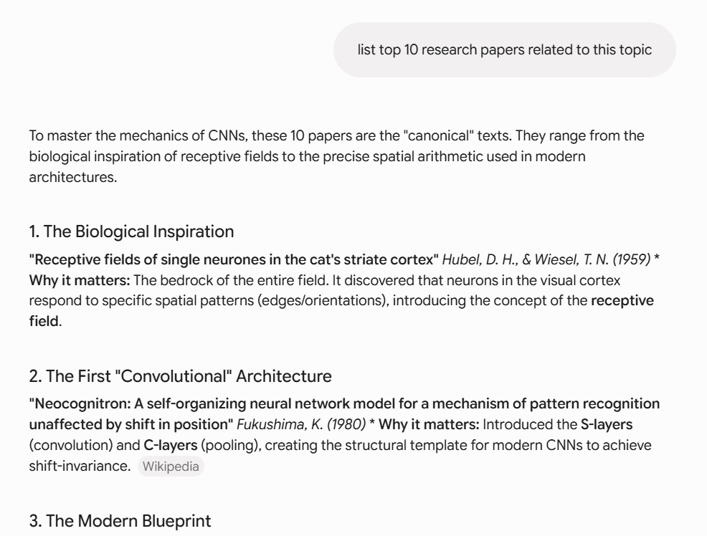

Prompt 2 — NotebookLM – understanding research papers / topic
Prompt 2: 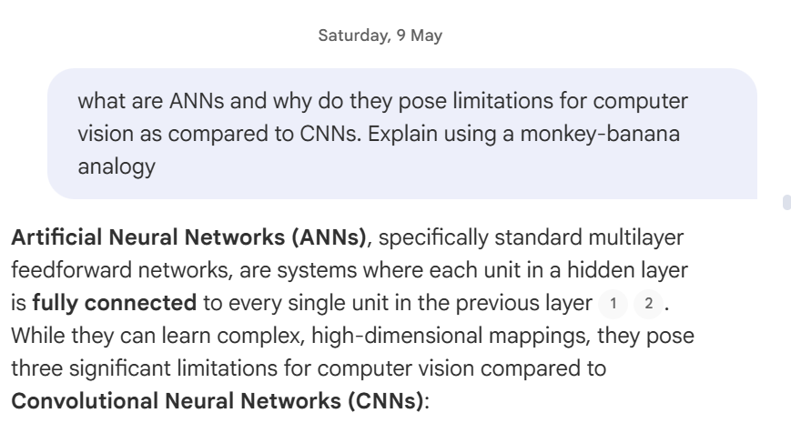

Prompt 3 — Simulator Development / UI Improvement
Prompt 3: 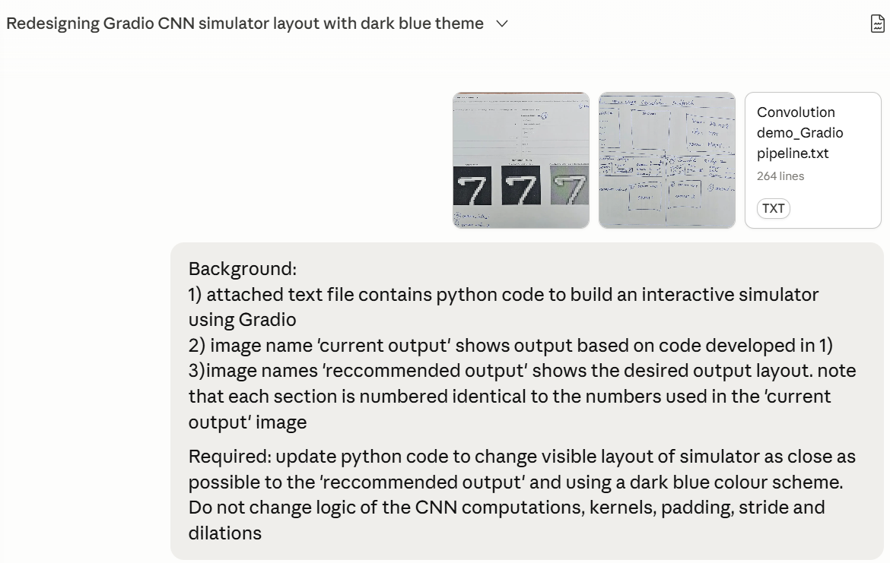

Prompt 4 — Study Notes Cross-Evaluation
Prompt 4: 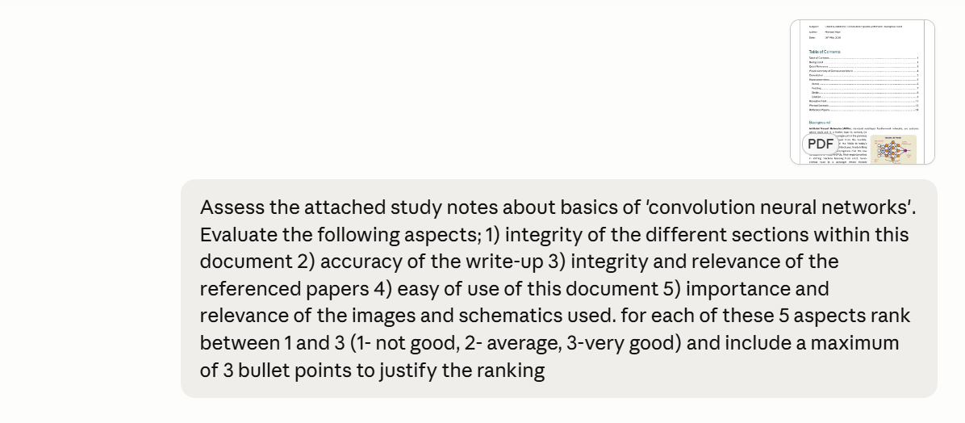
Prompt 5 — Quiz conversion from typed document to interactive Google forms
Prompt 5: 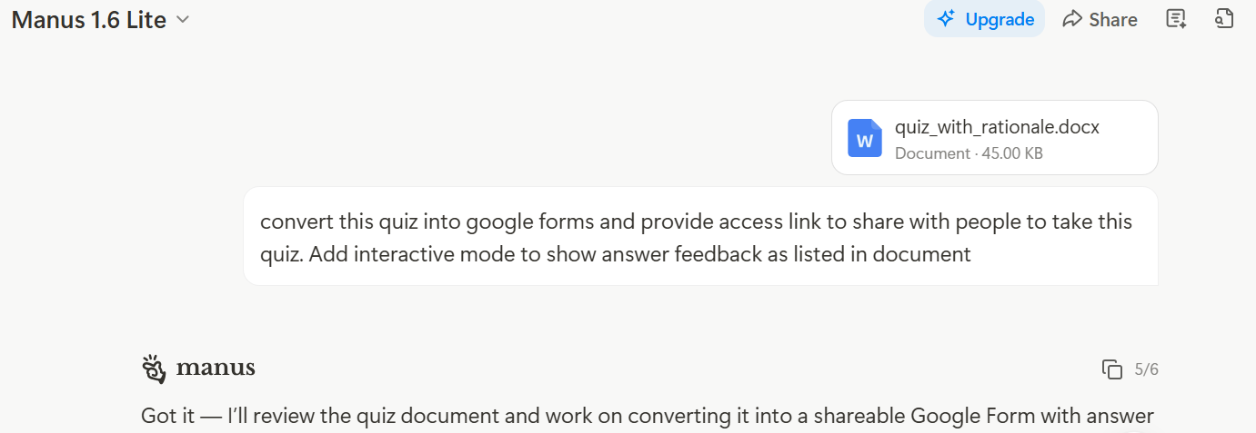

C. Reflective Questions
i) Which concepts did AI help explain?
Generative AI proved particularly useful in demystifying the theoretical underpinnings of Convolutional Neural Networks. Gemini was used interactively during the manual review of the top six selected papers to clarify concepts such as convolutional operations, feature map construction, pooling strategies, and the role of activation functions. NotebookLM further consolidated understanding by synthesising content across multiple papers into structured infographics, data tables, and mind maps. The LeCun 1998 paper, once correctly re-ingested, contributed meaningfully to explanations of gradient-based learning and the architecture of LeNet. Claude assisted in contextualising quiz questions, helping to frame CNN concepts at the appropriate depth for student assessment.

ii) Where did Gen AI return wrong information?
A notable issue arose with NotebookLM's initial handling of the LeCun 1998 paper: the tool failed to surface any content from it in its outputs. This was later identified as a text-decoding problem — the PDF had not been properly parsed, rendering the foundational paper invisible to the model. This represents a subtle but significant form of misinformation by omission. Additionally, early paper lists generated by AI tools (returning 40+ results) lacked the precision required for a focused literature review, suggesting that broad AI-generated searches should always be validated against authoritative academic sources such as Google Scholar and IEEE.

iii) When did Gen AI waste your time?
The attempt to use Manus to enhance the layout of the study notes and produce a cheat sheet was noted as ineffective, requiring manual correction and ultimately yielding unsatisfactory results. Similarly, the initial over-reliance on broad AI-generated paper searches (40+ papers from NotebookLM web search) required significant manual filtering before a workable shortlist could be established. The early exploration of Streamlit for the simulator UI, pursued with Gemini's guidance, was later abandoned in favour of Gravio, representing an iteration cycle that could have been shortened with more targeted tooling decisions upfront.

iv) When and where did Gen AI excel?
Gen AI delivered the most value during content synthesis and iterative refinement. NotebookLM, once supplied with correctly parsed papers and guided by custom prompts, produced a marked step improvement in output quality across infographics, slide decks, quizzes, and data tables. Gemini excelled in real-time concept clarification during paper review sessions and in generating supporting images for the study notes. Claude contributed effectively to UI layout refinements for the simulator and to cross-evaluation of study notes alongside Gemini. The use of Google Colab with AI assistance for MNIST dataset integration and the development of the walkthrough Jupyter Notebook represented a smooth and productive AI-augmented development cycle.

v) Do you see any gaps in the explanations of the CNN foundation subject?
Several potential gaps were observed across the AI-generated content. Backpropagation through convolutional layers — specifically the computation of gradients with respect to filter weights — was not addressed with sufficient rigour in any of the synthesised outputs. The distinction between valid and same padding, and its practical impact on feature map dimensions, was touched upon but not consistently explained across tools. Furthermore, the transition from classical CNNs (LeNet, AlexNet) to modern architectures (ResNet, attention mechanisms) was largely absent, which may leave learners without a sense of the field's evolution. The mathematical treatment of batch normalisation and regularisation techniques such as dropout also appeared superficial in AI-generated study materials, suggesting these are areas warranting additional manually curated content.

