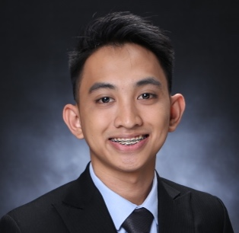JOHN MICHAEL ASPIRAS QUINTERO

5468 J P Orias St., Barangay Ipilan, Tayabas City, Quezon, Philippines

+63 995 844 3800 | [qmichael1234@gmail.com](mailto:qmichael1234@gmail.com)

**Career Objective**

Seeking an entry-level position in the field of information technology (IT) and secure a position in a creative and dynamic work environment where I can apply my skills and maximized.

**Technical Skills**

* Web Development and Web Design
* NodeJS Developer
* Java, C++, C#, VB, Visual Studio .Net Development
* HTML, JavaScript, CSS, PHP
* MS Windows / Mac OS X
* Microsoft Office Suite
* Git and Github

**Educational Attainment**

**Bachelor of Science in Computer Science major in Information Technology**

Arellano University – Legarda Campus

June 2015 – April 2019

Relevant Courses: Advance Web Design, Object Oriented Programming, Computer Programming, Computer Organization etc.

**Pre-Professional Experience**

**Web Developer**

SMS Global Technologies, Inc.

April 2018 – November 2018

Solution Database (Web Application)

**Personal Skills**

* High level of maturity and sense of responsibility
* Sound time management skills
* Highly resourceful, objective and reliable

**Training, Seminars Attend and Certificates**

**Front-Web Devs – PH (FEWDPH) and Vue.JS Philippines**

Microsoft Philippines, Makati, NCR

February 2019

**Tech Tutor 10 – The Digital Generation**

SM Megatrade Hall, Manila

September 2018

**6th PSITE-NCR Student Congress**

Adamson University, Manila

January 2018

**Development of Mobile App Using Animated CC 2018**

Arellano University – Legarda Campus

March 2018

**Tech Tutor 9 – Empowering Education in a Connected Word**

SM Megatrade Hall, Manila

September 2017

**Character References**

**Geraldine Rilles, MIT**

Program Chair

Arellano University

+63 915 657 7586

**Yves John Paul Cabaneros**

Software Developer

Bluewave Global Electronics and Testing Services, Inc.

+63 906 008 2920

**Amelita M. Delos Reyes, MIT**

Professor

Arellano University

+63 999 975 1905

**Co/Extra-Curricular Involvement**

**Organization and Affiliations**

**Treasurer**

SY. 2018-2019

Computer Science Society

Arellano University, Legarda Campus

**Auditor**

S.Y 2017-2018

Computer Science Society

Arellano University, Legarda Campus

**Contest Participation**

**Best Thesis**

CS Students Research Colloquium 2019

Arellano University, Main

February 27, 2019