BTP CAP Microservice Architecture application Hands-on

Exercises / Solutions

Speakers:   
한정우 (SAP SE)

Table of ContentS

1. 실습 개요 3

1.1 Microservice Application 생성 3

1.2 Unsubscribe && Undeploy application 9

1.3 Wrap-up & Assignment 9

3. References 10

# 실습 개요

SAP BTP CAP 를 활용해, Microservice applications들을 생성하여, MSA가 주는 다양한 장점들을 활용합니다.

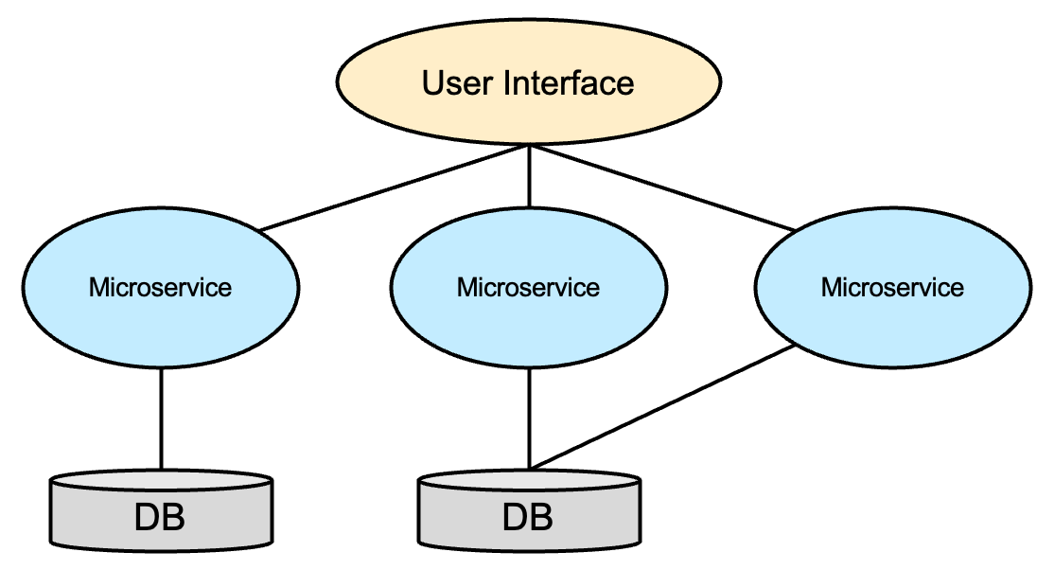

<https://gruuuuu.github.io/cloud/architecture-microservice/>

<https://medium.com/@Dopedev/microservice-architecture%EB%9E%80-ca9825087050>

**장점**

* 전체프로그램을 다시 배포하지 않고도 업데이트가 가능
* 독립적으로 개발가능
* 서비스 하나가 다운되더라도 전체 서비스에 영향을 끼치지 않음
* 서비스를 독립적으로 확장가능, 리소스의 유연한 운용 가능

**단점**

* 서비스간 통신방법이 필요하고 복잡함
* 서비스끼리의 테스트가 어려움
* 복잡하고 독립된 구조로 인해 통합적인 유지관리가 어려워질 수 있음

BTP의 CAP은 Applications들간의 messaging 교환을 위해, Event-mesh 서비스를 활용하기도 하고, CAP에 내장된 messaging 기술도 활용합니다.

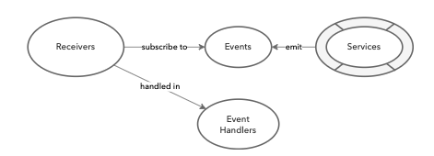

## Microservice Application 생성

Provider 테넌트에 예제 프로그램을 생성하기 위해 BAS에 추가적인 component를 인스톨 합니다.

| Explanation | Screenshot |
| --- | --- |
| 1. Extension 컴포넌트 설치 |  |
| 1. SAP Partner Engineering BAS Installer 설치 |  |
| 1. Click on BAS install SAP HANA Academy yeoman generators   View >> Command Palette  >> BAS: Install SAP HANA Academy yeoman generators. |  |
| 1. SAP HANA Academy CAP 선택   View / Find Command  Input : wizard |  |
| 1. SaaS API 를 사용하는 예제를 포함. |  |
|  |  |
|  |  |
|  |  |
|  |  |
|  |  |
|  |  |
| 1. Cds watch |  |
| 1. Data modeling 2. Service modeling 3. Event handling 4. CDS UI annotation |  |
| 1. $>mbt build | user: msaapp02 $ mbt build  [2023-03-30 05:05:04] INFO Cloud MTA Build Tool version 1.2.18  [2023-03-30 05:05:04] INFO generating the "Makefile_20230330050504.mta" file...  [2023-03-30 05:05:04] INFO done  [2023-03-30 05:05:04] INFO executing the "make -f Makefile_20230330050504.mta p=cf mtar= strict=true mode=" command...  [2023-03-30 05:05:04] INFO validating the MTA project  [2023-03-30 05:05:04] INFO running the "before-all" build...  [2023-03-30 05:05:04] INFO executing the "npm install --production" command...  npm WARN config production Use `--omit=dev` instead. |
| 1. $>cf deploy | user: msaapp02 $ cf deploy "/home/user/projects/msaapp02/mta_archives/msaapp02_0.0.1.mtar"  Deploying multi-target app archive /home/user/projects/msaapp02/mta_archives/msaapp02_0.0.1.mtar in org btpkrmta-producer / space dev as jungwoo.han@sap.com...  Uploading 1 files...  /home/user/projects/msaapp02/mta_archives/msaapp02_0.0.1.mtar  OK  Operation ID: c9890dfc-ceb8-11ed-ae26-eeee0a900bd5  Deploying in org "btpkrmta-producer" and space "dev"  Detected MTA schema version: "3"  No deployed MTA detected - this is initial deployment of MTA with ID "msaapp02"  Detected new MTA version: "0.0.1"  Processing service "msaapp02-db"... |
|  |  |

## Unsubscribe && Undeploy application

반드시, Consumer tenant에서 Unsubscribe작업 수행 후, Provider application을 삭제 해야 함.

| Explanation | Screenshot |
| --- | --- |
| 1. Unsubscribe | Unsubscribe at the consumer tenant |
| 1. Undeploy application | Undeploy Provider application  $>cf undeploy msaapp02 --delete-services --delete-service-keys -f |

## Wrap-up & Assignment

아래 블러그에 포함된 “sample guestbook”을 본인의 trial에 deploy.

[Cloud-Native Lab #4 – Multi-tenant Web Apps in SAP BTP](https://blogs.sap.com/2021/04/22/cloud-native-lab-4-multi-tenant-apps-in-sap-btp/)

## References

[Developing Multitenant Applications in the Cloud Foundry Environment](https://help.sap.com/viewer/65de2977205c403bbc107264b8eccf4b/Cloud/en-US/5e8a2b74e4f2442b8257c850ed912f48.html)

[Cloud-Native Lab #4 – Multi-tenant Web Apps in SAP BTP](https://blogs.sap.com/2021/04/22/cloud-native-lab-4-multi-tenant-apps-in-sap-btp/)

[Multitenancy Architecture on SAP Cloud Platform, Cloud Foundry environment](https://blogs.sap.com/2018/09/26/multitenancy-architecture-on-sap-cloud-platform-cloud-foundry-environment/)

[Developing Multitenant Applications on SAP Cloud Platform, Cloud Foundry environment](https://blogs.sap.com/2018/09/17/developing-multitenant-applications-on-sap-cloud-platform-cloud-foundry-environment/)

[Using SaaS Provisioning Service to develop Multitenant application on SAP Cloud Platform, Cloud Foundry Environment](https://blogs.sap.com/2018/10/25/using-saas-registry-to-develop-multitenant-application-on-sap-cloud-platform-cloud-foundry-environment/)