**Dojo Admin App**

**Overview**

1. What is a database and why would we use one?

You can find databases everywhere the most popular website in the world is? Google and google is just a big database. Database store information – normally lots of it to be worthwhile and then make it possible to find using queries. New information has to be added and existing info updated or deleted.

Google use a lot of hashing algorithms or indexes to make the queries you run against the database as quick and as relevant as possible. If you have a google account you can sign into it and run a query on something – you’ll find that you get results tailored based on your browsing history as opposed to the same query if you sign out.

We had been talking about building a dojo app for this class and to do that we are going to need a database to store data – what sort of data do you think we’ll need to store?

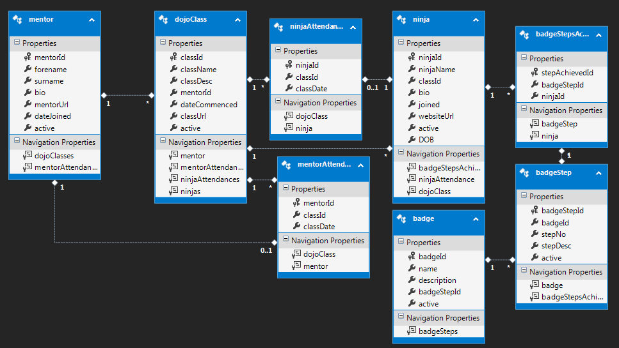

**Technology**

There are lots of different types of databases that exist – lots of them are free to use locally like MySQL, MongoDB, Hadoop and even SQL Server but normally where the companies make money is if you either need support on your DB – they charge huge money thousands per day sometimes for consultancy or also licenses and they tend to be charged per CPU or CPU Core. A big thing you would have heard of lately is cloud computing and some of the big players in this would be Amazon with its AWS system – and Azure from Microsoft. In both of these you don’t need to have a physical server yourself – you pay the companies to manage the servers and infrastructure and you can hook into a cloud DB – normally they’ll charge you based on your usage. Can anyone think of any advantages of this model?

One big thing is that if you guys have an amazing idea for a new business and you need to up and running cheap – you don’t have to find thousands and thousands for new hardware just to start you can use these services relatively cheap – a lot of them have free student accounts – also if your business gets really big – these guys can scale with you massively – they have literally football pitches worth of datacentres whirring away all the time. * Ireland is popular for these cloud datacentres because of our cool but not crazy climate – its much cheaper to run on electricity so you see Microsoft and Amazon both building big warehouses here.

Ok so let’s create a Database – go into visual studio community and on the left hand side click into SQL Server Object Explorer

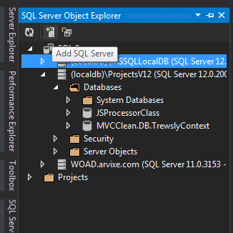

If you can see a SQL server expand it and then expand the database folder otherwise click the add SQL Server button and pick a new server name from the drop down in this box with “windows authentication” and click connect.

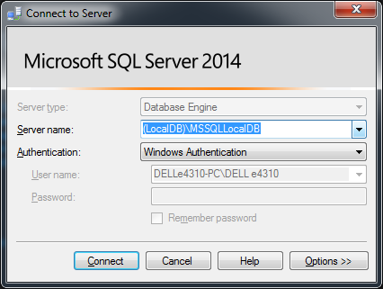

**Database**

1. **Creating a database** -> right click on the databases folder and select add new database

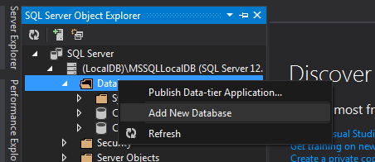

Give it whatever name you like – but avoid spaces or funny characters – these can cause trouble down the line when you’re trying to connect to it

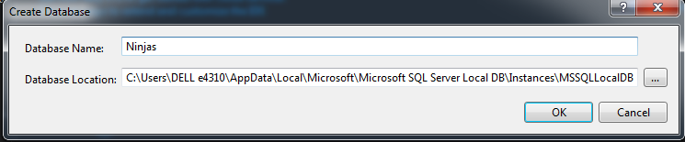

1. **Creating a table.** If you expand out your new database and have a look at the folders that come pre-packed you can see there’s quite a few – probably the ones you’ll care about the most initially would be tables + programmability. The “Tables” folder as you’d imagine contains all your own tables which you’ve created! The “Programmability” folder contains any “stored procedures” that we might be using – these are basically queries that we’ve written and saved off to the database.

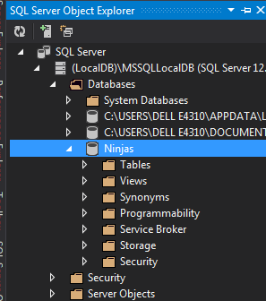

To create a new table right click on the “Tables” folder and click add new table:

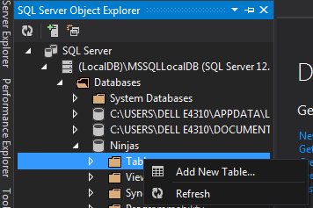

1. Insert a record into it
2. Select the record back
3. Delete the record from the database
4. Update the record

**Access**

**[Ninja screen]**

* We need to be able to see all the ninjas
  + We need to be able to search
  + We need to be able to filter by class
* They need to be able to see what badges they have achieved
* They need to be able to drill into what steps they have achieved
* They can be reassigned to a different classes

**[Badges Screen]**

* We need to be able to see all the badges
  + We need to be able to search
* We need to be able Create new badges
* We need to be able to create steps link them
  + We need to be able to edit the steps
  + We need to delete steps

**[Dojo Classes]**

* We need to be able to show all the classes
  + Need to search all the classes
* Creating classes – entry screen and editing

**[Ninja Attendance]**

* We need to be able to sign-in for a session
  + We need to be able to do it for a class / ninja / time
* We need to be able to show attendance for a session
* We need to be able to search for sessions
* We need to be able to search for ninjas
* We need to be able to search for classes

**[Ninja Attendance]**

* We need to be able to sign-in for a session
  + We need to be able to do it for a class / ninja / time
* We need to be able to show attendance for a session
* We need to be able to search for sessions
* We need to be able to search for ninjas
* We need to be able to search for classes

**[Mentor screen]**

* We need to be able to see all the ninjas
  + We need to be able to search
  + We need to be able to filter by class
* They need to be able to see what badges they have achieved
* They need to be able to drill into what steps they have achieved
* They can be reassigned to a different classes

**Ninjas Screen Design**

The scaffolded code gives us this for our ninja screen

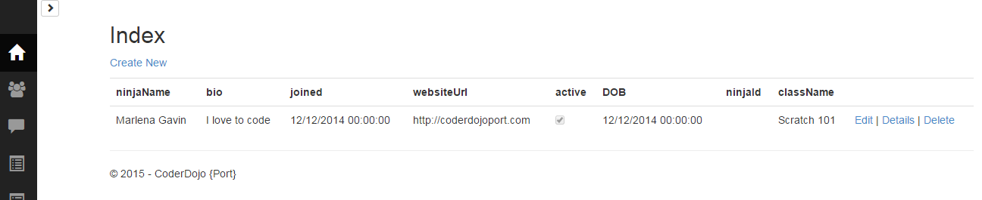

Maybe get closer to

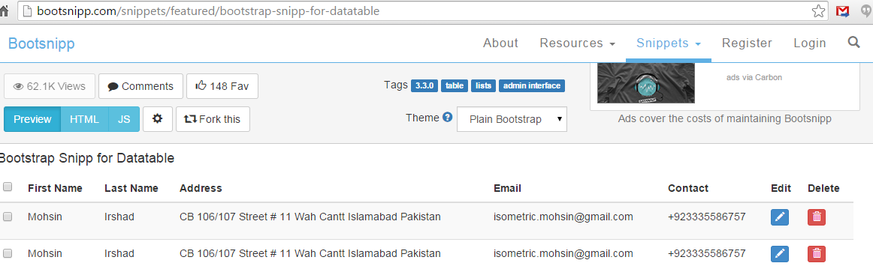

With a pop up for the ninja of:

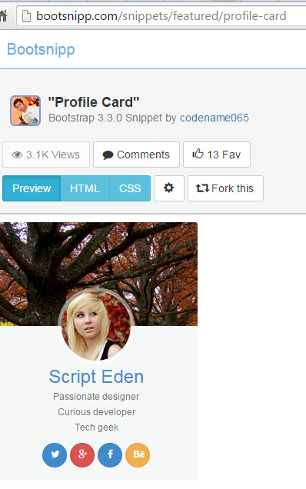

Or

<http://glyphicons.bootstrapcheatsheets.com/> handy cheat for cool icons

Filter by Class:

Show list of ninja pic + name + badges – click through

Display all the ninjas by class

Show their name, bio, url, badges

Phone Gap

<http://phonegap.com/blog/2015/03/02/phonegap-app-desktop-0-1-2/> using the new desktop app for installing phonegap…

- node.js installed <https://nodejs.org/download/>

- git installed <http://git-scm.com/download/win>

- ant installed <http://ant.apache.org/bindownload.cgi>

- android studio installed <https://developer.android.com/sdk/index.html>

<http://docs.phonegap.com/en/edge/plugin_ref_plugman.md.html#Using%20Plugman%20to%20Manage%20Plugins>

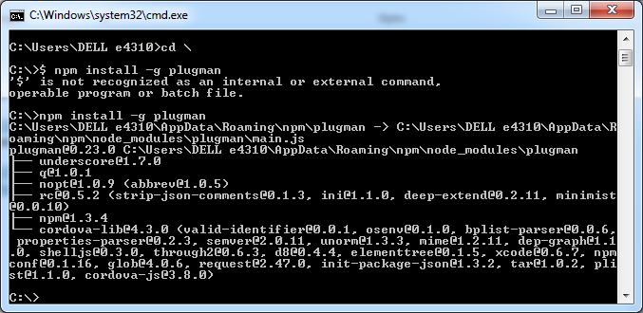

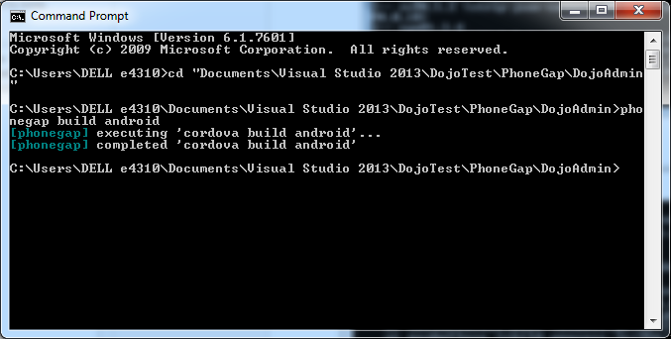

PhoneGap commands using cordova

C:\DojoTest\cordova\dojoTest>npm install -g cordova

C:\DojoTest\cordova\dojoTest>mkdir Cordova

C:\DojoTest\cordova\dojoTest>cd cordova`

C:\DojoTest\cordova\dojoTest>cordova create dojoTest com.dojo.dojoTest DojoTest

C:\DojoTest\cordova\dojoTest>cordova platform add android

C:\DojoTest\cordova\dojoTest>cordova platforms ls

C:\DojoTest\cordova\dojoTest>cordova build

C:\DojoTest\cordova\dojoTest>cordova run android

C:\DojoTest\cordova\dojoTest>cordova plugin add com.phonegap.plugins.barcodescanner

C:\DojoTest\cordova\dojoTest>cordova plugin ls

C:\DojoTest\cordova\dojoTest>cordova run android