Microsoft Innovation Center

Functional Specification
Chat
Code
Version | 1
Last modified | 19-Jul-13
Number of pages | 6

Document History
Data | Description | Author(s)
2013-Jul-18 | Version 1.0: Creating the initial version of Chat Fspec. | Aram  Vardan M.  Vardan G.
2013-Jul-08 | Version 1.0: Update the initial version of Chat Fspec. | Aram  Vardan M.  Vardan G.
2013-Jul-10 |  | Aram  Vardan M.  Vardan G.
2013-Jul-12 |  | Aram  Vardan M.  Vardan G.
2013-Jul-15 |  | Aram  Vardan M.  Vardan G.

Table of Contents
1. Introduction 4
1.1. Document identifier 4
1.2. Scope 4
1.3. Definitions of Terms and Acronyms 4
1.4. References 4
2. Problem Statement 4
3. Platform requirements 4
4. Overview of Solution 4
5. Black-box Description 4
6. Use Cases Coverage 5
7. Questions and Answers 7
8. Dependencies, Assumptions, Risks 7
9. Schedule and Effort Estimations 7
9.1. Level 2 subtitle 7
10. Appendix 7

Introduction

Document identifier
This is a functional specification document for the Chat project.

Scope
The “Problem Statements” section describes the problem statements for the project.
The “Platform Requirements” section describes the platform requirements for the project.
The “Overview of Solution” section describes the overview of the solutions for the project.
The “Black-box Description” section describes the black-boxes description for the project.
The “Use Cases Coverage” section describes the coverage of use cases for the project.
The “Questions and Answers” section is for the questions and their answers founded during the project implementation process.
The “Dependencies, Assumptions, Risks” section describes the dependencies, assumptions and risks about the deadlines for the project completion.
The “Schedule and Effort Estimations” section describes the deadlines and efforts of the estimations for the project implementation.

Definitions of Terms and Acronyms
QT - is a cross-platform application and UI framework for writing web-enabled applications for desktop, mobile, and embedded operating systems.
POSIX (Portable Operating System Interface for Unix) - is the name of a family of related standards specified by the IEEE to define the application programming interface (API), along with shell and utilities interfaces, for software compatible with variants of the Unix operating system, although the standard can apply to any operating system.

References
QT Library - http://doc.qt.nokia.com/latest/classes.html
Posix Libraries - https://computing.llnl.gov/tutorials/pthreads/ http://cplus.kompf.de/posixlist.html

Problem Statement
The project will provide text messaging. It will also provide multi chat sessions. It used for communication between 2 users without dependencies with each other. It will provide registered users contact list.

Platform requirements
Cross-platform – The project will support Widows OS (especially windows 7/8, x64_32)

Overview of Solution
The GUI of the project will be provided with QT tool. The text messaging will be provided with POSIX socket/thread library.

Black-box Description
First time user must be registered with pressing “Registration” button. The user must enter his/her username and press “OK” button for the registration. It also allows to log in system. After registration user can enter his/her username in the “Login” window and press “Sign in” button to log-in system. Then user can choose the other user with whom he/she want to communicate. User can selected contact from contact list, write a message and send the by pressing enter.

Use Cases Coverage
Below is defined the steps to execute the Chat program.
- Opened login window
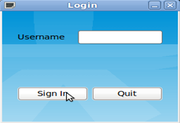
- Enter username

- Press “Sign in” button.

- Opened “Chat” window of the program.
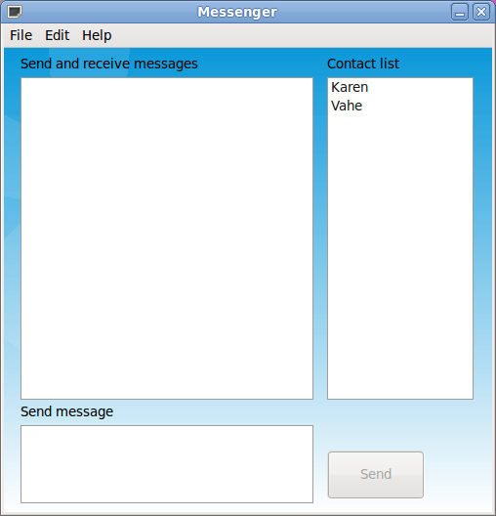
- Select the user with whom you want to communicate.
- Write message for the selected user and press “Enter” from keyboard.
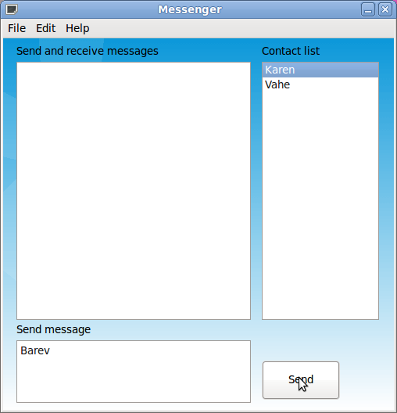
- Here you can see the sent version of the message

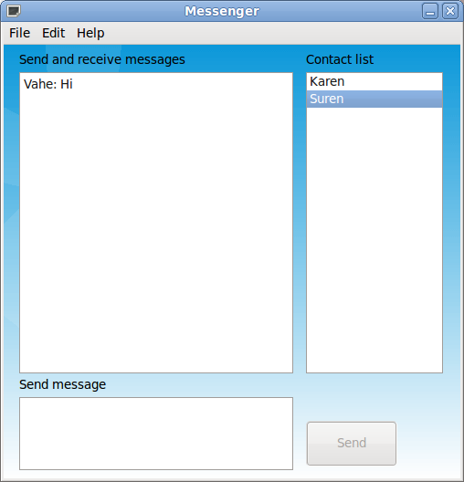

Questions and Answers
None

Dependencies, Assumptions, Risks
The project sources implementations depends on managements review and confirmation of the documentations on time.
Depending on deadlines the following optional requirements can be skipped.
-
-
-

Schedule and Effort Estimations
Aug 4 - FSpec documentation
Aug 5 - Writing Development plan, Fspec and initial GUI version of development, DevSpec
Aug 8 – Implementation(GUI functionality, Engine functionality), writing Test plan
Aug 9 – Implementation(GUI functionality, Engine functionality)
Aug 10 – Implementation(Engine functionality, connecting GUI with Engine)
Aug 11 – Writing ReadMe, Bug fixing
Aug 12 – Stabilization
Aug 15 - Release

Appendix
None.

