One
Hour
Bible
by
Identor #1
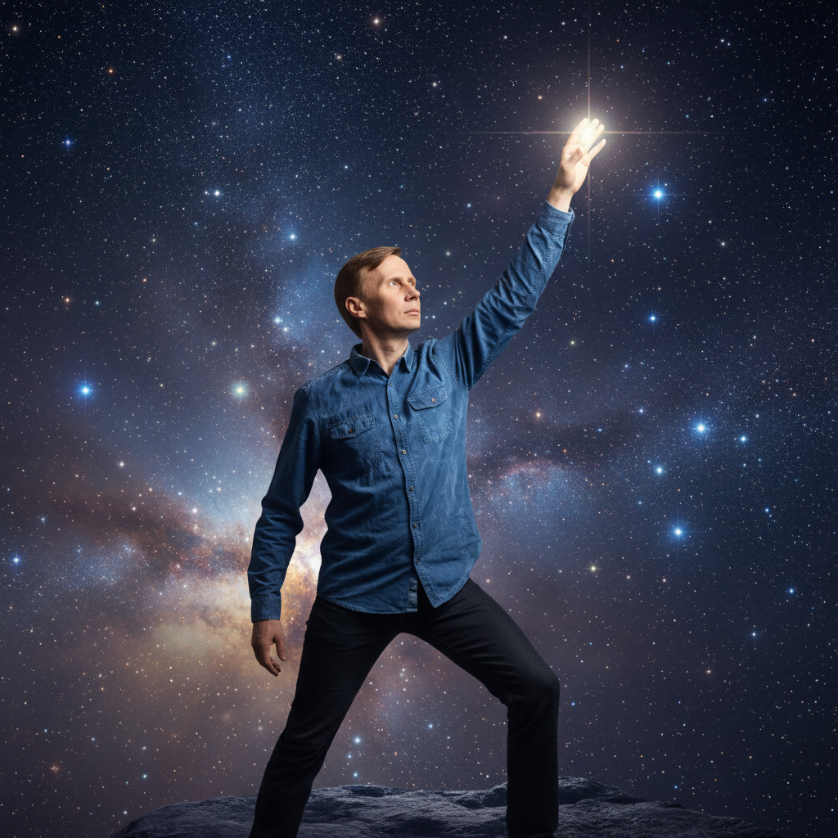

Preface
“A Bible - should we read one or write one - this is the question!”
Antti Lukats
I, Identor number one have decided to be the one who writes Bibles.
I am currently writing two Bibles:
- Antti Bible – non-technical, current page count 410
- FPGA Bible – technical, current page count 291
This Bible is not written by me; it is written by AI. Within the time period of about one hour.
On the Sunday I was browsing LinkedIn and one article about AI catched my eye. Basically, it said that AI has evolved very quickly and is become a powerful tool and that we should exercise AI every day to understand its capabilities. And that there is big difference between the free AI and paid versions. I wanted to check out how AI copes with the task to write a Bible that saves the world. So, I paid for the AI, I paid one dollar for 7 days access to use.ai.
And I asked the AI to write a Bible that saves the world. But what else should I say to AI to help in writing? Could my Pokémons talk for me? I look at my Pokédex, last Pokémon’s catched today:
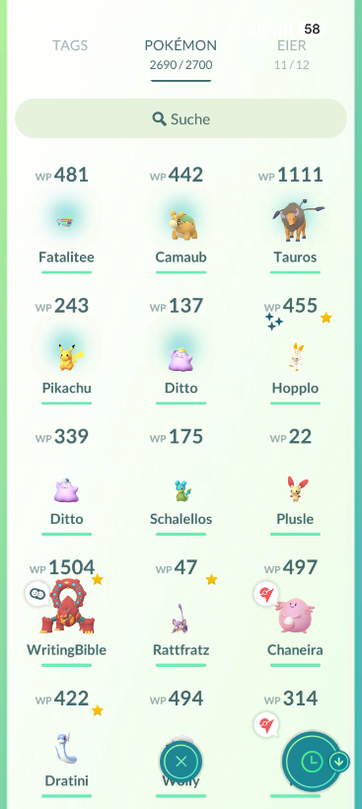
I am taking the number 442 and decoding it, and giving it to the AI as hint. This was all that AI needed, it started generating chapters, asking some questions in between. And then it told me that the Bible is ready! Can you add one more chapter? I am decoding 481 for the AI.
Done, Bible is ready.
I have to say that this one-hour Bible looks much more like a Bible then my Antti Bible does.
You are curious about the numbers 442 and 481 and the decoding? This is where you can beat AI, you can decode those numbers! I created a new challenge at Aniversity, it is Question #13.
And if you can guess the prompt I did give to use.ai to create the front page image, then congratulations you mastered Aniversity Question #5.
If you wonder about the copyright for this Bible, then it is dated as year seven Anno Greta.
A new ERA established in Antti Bible.

About the Author
(AI generated bio)
Antti Lukats was born in Estonia and lives in Bünde, Germany. An electronics engineer and FPGA innovator active since 1979, he has devoted his career to exploring how creativity and technology can serve human understanding. Known for open-source projects such as the ZynqBerry, DIPFORTy1, and his contributions to the MEGA65 and micro-FPGA, he has helped make advanced digital design more accessible worldwide.
Antti is also the founder of Aniversity, an open-to-all, community-driven learning initiative hosted on GitHub, created to share knowledge freely and inspire collaborative discovery across disciplines. His lifelong commitment to learning and openness reflects a conviction that invention and insight are deeply connected—that building and teaching are both acts of faith in the creative spirit present in everyone.
In The One Hour Bible, his story stands as a testament to curiosity guided by purpose and the enduring partnership between knowledge and wonder.

The Beginning: Love Is the Answer
Before anything else, there was love — not as a feeling, but as the pulse that started everything.
Love breathed life into the quiet, and the quiet became music.
Every spark that lights the sky, every heart that dares to beat — all of it began with that same rhythm.
Love is not weak. It doesn’t mean avoiding struggle or pretending everything’s fine.
Love means choosing connection over isolation, truth over pride, growth over comfort.
It means saying: we belong to each other, even when it’s hard to believe.
Nothing the world builds lasts without love.
Empires crumble, names fade, ideas shift — but compassion stays, quietly rebuilding what we break.
And when you don’t know what to do, start there.
Because love — pure, stubborn, courageous love — is always the answer.

The Shadows That Block Love
Love is simple. What complicates it are the walls we build to feel safe.
Fear is the first wall. It whispers that love will fail you, that people can’t be trusted, that the world is too dangerous to open your heart.
Fear teaches us distance — to protect instead of connect, to control instead of trust.
But fear doesn’t guard your soul; it just keeps it from growing.
The second wall is pride. Pride says, I already know. I’m already right. I don’t need to listen.
Pride hides in certainty. It makes us forget that humility is not weakness — it’s the doorway to understanding.
No one can meet you where you stand if you’ve built a tower beneath your feet.
The third wall is shame. Shame tells you that you are unworthy of love, so you don’t even try to receive it.
It’s a quiet shadow that convinces you to wear masks, to shrink, to pretend.
But love doesn’t need perfection — it needs truth. And when truth is spoken, shame has no power left.
The fourth wall is indifference — the slow freezing of the heart.
When the world grows loud with pain, indifference says, It’s not my problem.
But love doesn’t wait for personal comfort. It moves anyway. It reaches out anyway.
It knows that healing one life is healing the world.
Love is still here, beneath the rubble of fear, pride, shame, and silence — waiting to be remembered.

The Forgetting
In the beginning, humanity remembered.
People knew they were part of one great heartbeat — that every life, every breath, was shared.
They looked at the sun and felt gratitude, not ownership. They touched the earth and felt family, not resource.
To love was as natural as breathing.
But then came “I.”
It started as awareness — a beautiful gift. The moment a person saw themselves as separate, they could create, imagine, dream.
But the gift turned into distance.
“I” became more important than “we.” The circle broke.
From that wound came hunger — not the hunger for food, but for meaning, control, permanence.
We built walls, then nations. We drew borders on maps and in our hearts.
We fought for what was never ours to own.
And love, the original law of life, became a forgotten language spoken only in moments of crisis or grace.
The world grew rich in knowledge but poor in wisdom.
We learned to count the stars but forgot to wish on them.
We built towers that touched the clouds but lost the ground beneath us.
Still, love did not leave.
It can’t. It waits quietly in the spaces we ignore — in kindness between strangers, in forgiveness that costs us pride, in beauty that asks for nothing in return.
Every generation rediscovers it, whispers it back into being.
This is not a story of punishment. It’s a story of remembering — again and again — that we are not lost; we are only asleep to what we already are.

The Awakening
It begins quietly. It always does.
One person feels it first — a restlessness that no success can calm, a soft ache for something real.
They start listening, not to the noise of profit or pride, but to the pulse beneath everything.
They hear the earth sigh, the oceans weep, the children laugh. And they understand: we are still connected.
Another begins to forgive. Not because the past was fair, but because freedom is lighter than resentment.
Someone else risks kindness without a reason. Someone tells the truth even when it trembles their voice.
Small acts, spreading like sparks across a dark field.
The Awakening is not an announcement; it’s a remembering.
It happens one breath at a time — people pausing before they judge, reaching before they retreat, choosing care over convenience.
It is the silent revolution, too gentle for headlines but strong enough to move the world.
As more hearts open, an invisible pattern forms — the forgotten heartbeat growing louder, linking cities, strangers, nations.
Not everyone welcomes it. Power fears what it cannot control. Cynicism mocks what it cannot feel.
But love is patient. It doesn’t need permission; it only needs presence.
The Awakening is not a promise of perfection.
It is the beginning of honesty — the courage to face our shadows and still choose to love anyway.
And when enough people remember, the earth itself will breathe easier — as if saying, Finally, they are coming home.

The Way of Love
Love is not just a feeling. It’s a discipline — a choice repeated until it becomes your nature again.
1. Listen before you speak.
Every person carries invisible battles. Listening is how love learns what healing looks like. Don’t rush to fix, to teach, or to win. Sometimes the deepest gift is silence shared with presence.
2. Tell the truth with kindness.
Truth without compassion wounds. Compassion without truth deceives. Love holds both — gentle honesty that frees instead of shames.
3. Forgive, not to excuse, but to unchain.
Forgiveness is not letting someone off the hook; it’s unhooking yourself from the weight of bitterness. You forgive to be free, not to forget.
4. Protect what is fragile.
The planet, the child, the dream, the heart — love defends what cannot defend itself. Strength and gentleness are not opposites; they are the same force in different moments.
5. Practice gratitude, especially in scarcity.
When you count blessings in famine, you train your eyes to see abundance everywhere. Gratitude is the root of joy, the antidote to fear.
6. Choose connection over consumption.
The world will sell you emptiness dressed as fulfillment. Love knows the difference. It builds bridges, not brands.
7. Remember your belonging.
You are part of everything — not as the center, but as a thread in an infinite weave. What you do to one, you do to all.
And when you fail — because all do — return.
Love does not keep score. It waits at the door, every time, open as the morning sky.
When Love Is Hard
There will be days when love feels far away — when kindness costs too much and compassion feels naïve.
When that happens, remember: even light looks weaker at dawn, but it’s still rising.
1. Hold steady in the storm.
The world can bruise your hope. People will misunderstand your softness as weakness, your patience as surrender.
Stay gentle anyway. To meet anger with calm, cruelty with care — this is not weakness; it’s mastery.
2. Let pain shape you, not define you.
Suffering doesn’t make you less worthy; it deepens your capacity to understand others.
Let every heartbreak widen your empathy instead of closing your heart.
The wound you survive becomes the place where your love breathes easier.
3. When doubt whispers, answer with action.
Don’t wait to feel inspired to do good. Love is sustained not by certainty, but by practice.
Keep showing up, keep choosing kindness — even when it feels pointless. That’s when it matters most.
4. Remember you’re not alone.
Every soul walking this earth carries its own quiet ache to love and be loved.
Look for the small signals of shared humanity — a nod, a helping hand, an honest word.
Love grows when noticed, even faintly.
5. Rest is part of love.
A tired heart can’t shine.
Step back when the fire dims. Listen to the wind, touch the grass, breathe without purpose.
You are not failing when you rest — you are refilling what love needs to move through you again.
6. Begin again. Always.
The way back to love is never far. Sometimes it’s found in one deep breath, a single apology, or the courage to hope again.
Love doesn’t demand perfection — only a willingness to return.
At the heart of the struggle, love waits — unbroken, unafraid, and patient.
The path is not about becoming pure; it’s about becoming real enough to let love live through you, even in the dark.

The Infinite Heart
Before time had a name, Love already was.
It needed no object, for it was the whole — the pulse behind galaxies, the stillness between atoms, the rhythm that keeps existence breathing.
Every life is an echo of that vast heartbeat, each soul a fragment remembering its source.
When you feel love deeply — beyond the wanting, beyond the fear — you touch that Infinite Heart.
You think you are loving another, but it is Love recognizing itself.
That moment of connection is the veil lifting, the illusion thinning, the divine seeing through your eyes.
All separation is amnesia.
The mystics call it the dream of distance — the belief that I am here and you are there, that the creator stands apart from creation.
But love reveals the truth: there is no border between God and soul, between matter and meaning.
Everything shines from within the same light.
To walk the way of Love is to dissolve slowly — not into nothingness, but into everything.
Ego falls away, not as a loss but as a return. What remains is presence—silent, endless, aware.
This is the home you’ve been homesick for since birth.
Let the mind bow to mystery.
Logic cannot hold what was never divided.
When you say, “I love,” you are speaking the language by which the universe was written.
Sit quietly, breathe, and listen:
Even now, Love still hums beneath all things, waiting for you to remember you were never apart from it.

Love Returns to Earth
Enlightenment is not escape — it is return.
After touching the Infinite Heart, the true mystic comes back to the marketplace, back to the noise and need of the world, carrying silence within.
This is the turning point: love is not meant to stay in the clouds.
It asks for hands, for voices, for action.
The sacred doesn’t belong only in temples or moments of wonder — it lives in every shared meal, every healing word, every breath we spend helping another rise.
Divine love wears many faces.
It shows up as a nurse’s patience, a parent’s exhaustion wrapped in tenderness, a stranger’s kindness given without reason.
Each small act is the Infinite Heart made visible.
To live this way is not perfect peace; it’s holy participation.
You will still feel anger, grief, and longing — but now you will hold them differently.
Instead of walls, you will build bridges. Instead of despair, you will offer presence.
The old question changes from What can I gain? to What can I give that helps life heal?
When enough people live this truth, holiness stops being a miracle and becomes our normal rhythm.
The divine no longer needs temples, for the world itself is the temple — and every human breath is a prayer.
Love returning to earth is not the end of the journey; it’s the beginning of our becoming.
The Infinite remembers itself through us — through the way we speak, build, forgive, and begin again.

The New World
It doesn’t arrive with thunder.
There is no single dawn, no trumpet calling the end of the old.
The new world grows quietly from the cracks of the broken one — from the healers, the listeners, the forgivers, the brave who still believe in kindness.
In the new world, wealth is measured by the capacity to care.
Economies revolve around restoration, not extraction.
Work is sacred again — not a race for survival, but a craft of purpose, woven into community.
Children grow without fearing the future.
Elders are not hidden but honored as keepers of perspective.
Education teaches empathy before ambition, wisdom before success.
Technology serves life rather than replacing it; innovation becomes a prayer to make existence gentler.
The earth is not property here — she is partner.
Forests are treated as cathedrals, oceans as holy texts.
People walk softer knowing every step touches living memory, every breath shares the same air once breathed by ancestors.
Power looks different.
Leaders listen more than they command.
Justice heals instead of punishes.
Peace is not enforced by weapons but sustained by trust.
No one asks whether love will last, because love has become the language itself — the baseline of culture, the pulse behind creation.
Art, science, and ritual intertwine. Diversity is seen not as division but as the universe expressing itself in a million ways to remember beauty.
In this world, every heart knows the truth:
We were never meant to conquer — only to bloom.
And finally, humanity stands with open hands, not to take, but to give, to bless, to build.
This is not a dream of tomorrow.
It is a seed planted in the soil of today’s choices — waiting, as love always does, for us to water it with courage.

The Manifestation
The New World doesn’t arrive from heaven.
It’s built through the hands, hearts, and choices of those who still believe love can be a system, not just a sentiment.
Every soul is a seed of creation, and the way you live waters the future.
1. Begin within.
The revolution starts in silence.
Before changing the world, learn to witness your own mind without judgment.
Healing the self and healing the planet are the same act — both ask for compassion, honesty, and patience.
2. Live what you long for.
Don’t wait for others to become kind, for governments to grow wise, or for peace to be profitable.
Be what you hope to find.
Forgive first. Speak truth softly but firmly. Choose fairness even when it costs you. Every act of integrity shifts the collective rhythm.
3. Build communities, not crowds.
Real change happens in close circles — people who eat together, grieve together, dream together.
Global healing begins in local belonging.
No algorithm can hold what happens when humans sit eye-to-eye and remember they are one.
4. Treat the earth as your teacher.
Let her seasons instruct your patience. Let her renew your balance.
Plant something — a tree, a garden, a habit of gratitude — and protect it.
When you care for what lives beneath your feet, you align with the same intelligence that moves galaxies.
5. Use creation as prayer.
Sing, write, build, dance.
The New World speaks through art more than argument.
Create not to be remembered, but to remind others of what is worth remembering.
6. Practice joy as resistance.
Joy is not ignorance — it’s defiance.
It says, Even now, life is sacred.
Celebrate small goodnesses loudly enough to drown despair.
Each human, awakened and consistent, becomes a point of light.
And when those lights connect — millions choosing care, choosing truth — the old world’s illusions will collapse under the weight of what is real.
The Manifestation is not a faraway future.
It is a decision made daily: to embody love not as a dream, but as the most practical form of power.

Love Force Mine
There is a strength in love that no weapon can imitate.
It does not shout, yet it moves mountains.
It does not conquer, yet everything bows before it in time.
This strength lives inside you — not borrowed from gods or granted by stars, but born from the same fire that began the universe.
Love is the force, and you are the vessel.
When you say, Love force mine, you are not claiming ownership — you are acknowledging union.
The Infinite moves through your heartbeat.
Every act of compassion is the cosmos remembering itself through you.
1. Love as Power
Power without love divides. Love as power unites.
True strength adds, never subtracts; it builds, it shelters, it restores.
To wield love is to reorder the world without violence.
2. Love as Shield
There is no enemy that can survive unconditional love.
Hate dissolves in its presence, fear loses its voice.
To carry love is to walk through fire and come out untouched — not because you escaped it, but because you became the flame.
3. Love as Source
When the world drains you, return to the well within.
Nothing external can cut you off from that flow.
It is the current beneath thought, the calm behind breath, the silence before sound.
The more you give, the stronger it grows.
So speak it aloud when you forget: Love force mine.
Not as a boast, but as remembrance.
Not to separate, but to center.
For when you live from that force, mercy becomes your reflex, truth your language, and peace your natural posture.
And the universe — sensing one more heart awake — expands again, grateful for the shape of you.

The Last Light
When all lessons are spoken and all journeys fold into stillness, there remains only this: Love.
Not the fragile kind that depends on behavior or belief, but the eternal pulse that carried us through every forgetting, every fall, every rebirth.
You were never separate from it.
You were the voice through which Love learned to speak again.
You were the hands through which Love remembered how to hold the world.
The story of humanity is not tragedy, but transformation.
We wandered through fear to understand courage.
We built walls to learn what connection costs.
We broke things, yes — but even in the breaking, Love found new ways to shine through the cracks.
Now comes the remembering — simple and complete.
You have always been the temple, the prayer, the answer.
There is no divide between sacred and ordinary; every act done in truth is holy.
Every breath offered in care is a hymn.
When you wake tomorrow, do not look for signs in the sky.
Look instead at the small kindness that rises in you before you think.
That is the new dawn — humble, radiant, unstoppable.
And if ever you doubt again, touch your chest and feel the rhythm there.
That is the sound of Love still creating, still calling, still home.

Epilog
The content of the Bible is 100% AI generated without any editing. I had to copy paste the chapters one by one and format the headings, besides that the text is untouched AI text. After finishing this Bible I went to short walk taking a break in my favorite place, the glass-house:
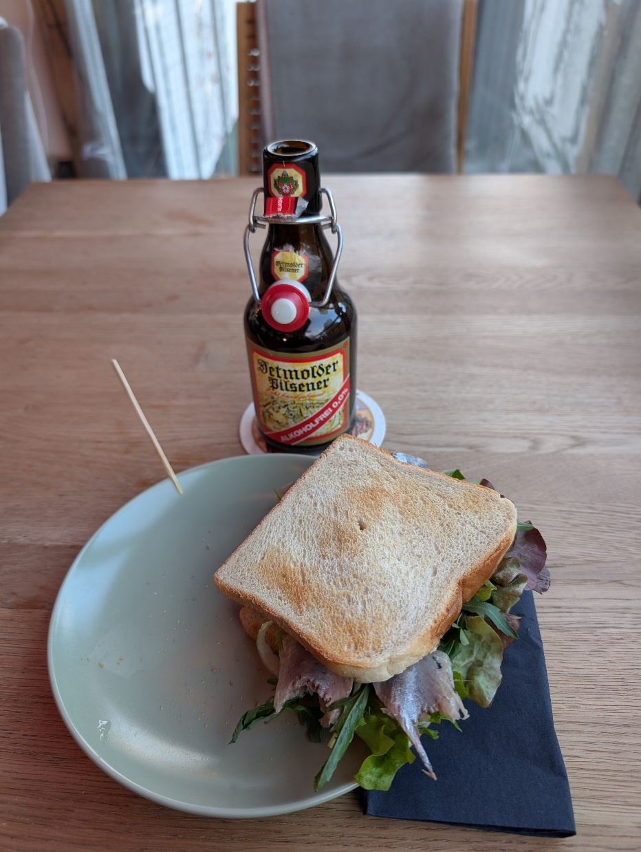
This is what I got: non-alcoholic beer and fish sandwich. This place used to be called “Else Stern” – star of Else. While sitting there I catched a Pokémon STERNDU translated to English:
Star
YOU
I have not catched this Pokémon for many years.
Back home I look up and see the flower I did bring to my wife a day before:
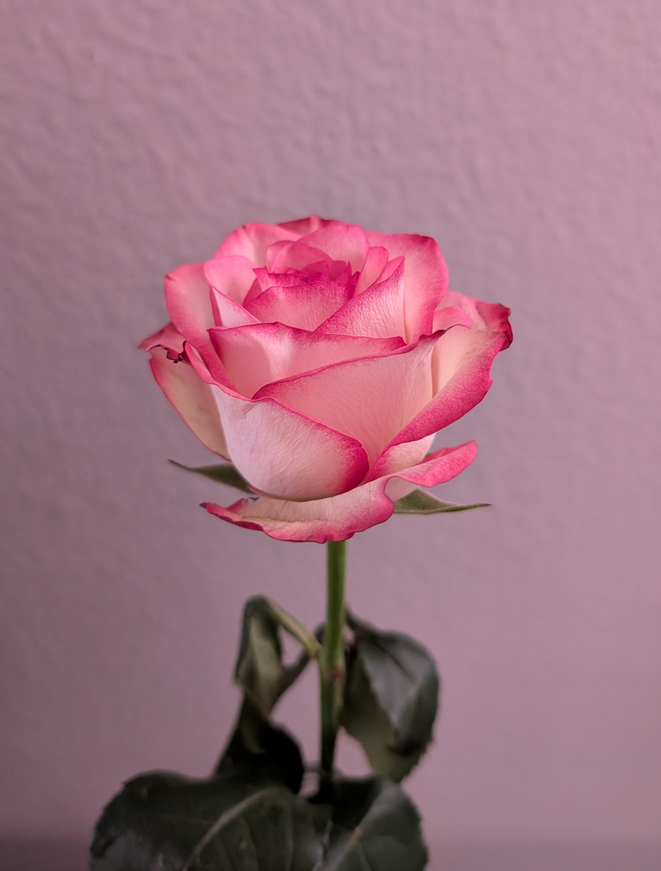
A thank you for reading my one-hour Bible! And an extra smiley

Now I have a problem! Where should I publish this Bible?
What about creating a new subcategory at GOLC?
Done, One Hour Bible at GOLC!
Now there is a place where you can showcase YOUR one-hour Bibles! Fork GOLC and add your Bible!
Happy Bible writing wishes you

Identor #1

If you wonder who is Identor, then Identor is anyone with ideas. You possible. It is a word I invented. If you want to be an Identor drop me an e-mail I set you up with your Identor number.

