Power and Distance micro-ROS Demo Box

This demo illustrates micro-ROS capabilities and showcases the integration of micro-ROS with ROS 2 tools. Besides, it enables the comparison of micro-ROS and ROS 2 outcomes.
The use-case consists in a ROS2-controlled Raspberry Pi 4 with a TFMini sensor that measures the distance to a target object and a micro-ROS-controlled Olimex STM32-E407 board with the same TFMini sensor, which measures the distance to the same object. The demo explores another micro-ROS-controlled Olimex STM32-E407 board, which measures the power consumption of both Raspberry Pi 4 and Olimex STM32-E407 board for distance measurements, using INA219 sensors. The last component, a tablet display, visualizes measurement results using standard ROS 2 tools (rqt).
Raspberry Pi 4 is running linux and a ROS 2 application, while Olimex STM32-E407 boards are running NuttX and micro-ROS applications. All of them are sending measured distance and power data to the display. The tablet is running linux, ROS 2 and a micro-ROS agent.
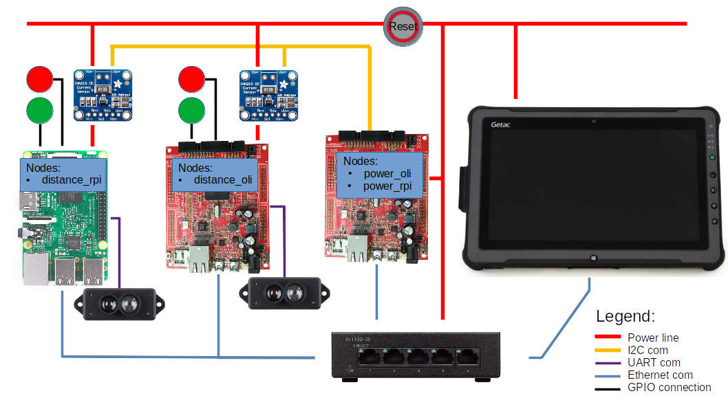

Topics
In this demo there are two different micro-ROS nodes and a ROS 2 node which publish the following topics:
- /distance_oli: distance measured by a sensor on the Olimex-E407 board.
- /power_oli: power consumtion of the distance Olimex board.
- /power_rpi: power consumtion of the Raspberry Pi.
- /distance_rpi: distance measured by a sensor on the Raspberry Pi.
From these topics subscribes a ROS 2 node on the tablet.

Hardware
The following is a list of the demo hardware:
- 1 x Raspberry Pi 4 + Power Supply + SD Card
- 2 x Olimex STM32-E407 + Power Supply + Ethernet cable
- 2 x TFMini - Micro LiDAR Module
- 2 x INA219 DC Current Sensor
- 1 x NETGEAR proSafe Gigabit Switch GS105 + Power Supply
- 1 x Getac 2 Tablet + Power Supply + Ethernet cable
and
- 1 x PC + ST-LINK/V2 for flashing firmware to Olimex boards

Sensor connection

TFMini Olimex STM-E407
red <-----> 5V
black <-----> GND
white <-----> Tx3
green <-----> Rx3

TFMini RPI / Pin Number
red <-----> 5V / 2
black <-----> GND/ 6
white <-----> Tx / 8
green <-----> Rx / 10

INA219 Olimex STM-E407
SCL <-----> I2C1_SCL (UEXT pin 5)
SDA <-----> I2C1_SDA (UEXT pin 6)
5V <-----> 5V
GND <-----> GND

Ethernet connection

IP addresses:
Tablet: 192.168.10.2
RPI: 192.168.10.4
Distance Olimex: 192.168.10.17
Power Olimex: 192.168.10.18

How to build the micro-ROS system on Olimex STM32-E407
Use a PC workstation with the Docker installation to prepare the environment for setting up Demo Box applications in a docker container:

- Download the micro-ROS base Foxy image from the Docker Hub https://hub.docker.com/, then run a docker container

sudo docker pull microros/base:foxy
sudo docker run -it --net=host --privileged -v /dev/bus/usb:/dev/bus/usb microros/base:foxy
- Create a ROS 2 workspace in the uros_ws folder of the docker container and build the package

source /opt/ros/$ROS_DISTRO/setup.bash
git clone -b $ROS_DISTRO https://github.com/micro-ROS/micro_ros_setup.git src/micro_ros_setup
apt update && rosdep update
rosdep install --from-path src --ignore-src -y
apt-get install python3-pip
apt-get -y install python3-pip
colcon build
source install/local_setup.bas
- Create the Nuttx firmware on Olimex-E407 with Demo Box sensor applications
ros2 run micro_ros_setup create_firmware_ws.sh nuttx olimex-stm32-e407
cd firmware/NuttX
git checkout -t origin/ucs_demo_f
cd ../apps
git checkout -t origin/ucs_demo_f
cd ..
Build an flash the firmware:
- Set the config profile variable to select the demo distance or demo power application t

CFG_PROFILE=demo_distance_romfs

or

CFG_PROFILE=demo_power_romfs

- Build the application
ros2 run micro_ros_setup configure_firmware.sh $CFG_PROFILE
cp firmware/NuttX/configs/olimex-stm32-e407/$CFG_PROFILE/rcS.template firmware/apps/nshlib/rcS.template
cd firmware/apps/nshlib/
../../NuttX/tools/mkromfsimg.sh -nofat ../../NuttX/
cd /uros_ws/
ros2 run micro_ros_setup build_firmware.sh
ros2 run micro_ros_setup flash_firmware.sh
- Connect ST-Link/V2 to Olimex STM32-E407 JTAG interface and flash the firmware
ros2 run micro_ros_setup flash_firmware.sh

How to build the ROS 2 system on a Tablet

Use a tablet with Ubuntu 20.04 LTS (Focal Fossa) installation:
- Install the ROS 2 Desktop system

sudo apt update && sudo apt install locales
sudo locale-gen en_US en_US.UTF-8
sudo update-locale LC_ALL=en_US.UTF-8 LANG=en_US.UTF-8
export LANG=en_US.UTF-8
sudo apt update && sudo apt install curl gnupg2 lsb-release
curl -s https://raw.githubusercontent.com/ros/rosdistro/master/ros.asc | sudo apt-key add -
sudo sh -c 'echo "deb [arch=$(dpkg --print-architecture)] http://packages.ros.org/ros2/ubuntu $(lsb_release -cs) main" > /etc/apt/sources.list.d/ros2-latest.list'
sudo apt update && sudo apt install ros-foxy-desktop
source /opt/ros/foxy/setup.bash
sudo apt install -y python3-pip
pip3 install -U argcomplete
sudo apt install python3-colcon-common-extensions

- Install a micro_ROS agent

mkdir ~/microros_ws && cd ~/microros_ws
git clone -b $ROS_DISTRO https://github.com/micro-ROS/micro_ros_setup.git src/micro_ros_setup
sudo apt update && rosdep update
rosdep install --from-path src --ignore-src -y
# Install pip
# sudo apt-get install python3-pip
colcon build
source install/local_setup.bash
ros2 run micro_ros_setup create_agent_ws.sh
ros2 run micro_ros_setup build_agent.sh

- Install ROS 2 Demo Box packeges

cd ~/
git clone ssh://git@10.0.9.18:6822/amalki/demo_suitcase.git
cd ~/demo_suitcase/
colcon build –symlink-install

- Configure static ethernet address

IPv4 address: 192.168.10.2
netmask 255.255.255.0

How to build the ROS 2 system on Raspberry Pi

- Install the Ubuntu Server 20.04. for arm64 architectures on Raspberry Pi 4 I

- Power on Raspberry Pi, obtain a console using ssh and install the ROS 2 Foxy system as following

sudo locale-gen en_US en_US.UTF-8
sudo update-locale LC_ALL=en_US.UTF-8 LANG=en_US.UTF-8
export LANG=en_US.UTF-8
sudo apt update && sudo apt install curl gnupg2 lsb-release
curl -s https://raw.githubusercontent.com/ros/rosdistro/master/ros.asc | sudo apt-key add -
sudo sh -c 'echo "deb [arch=$(dpkg --print-architecture)] http://packages.ros.org/ros2/ubuntu $(lsb_release -cs) main" > /etc/apt/sources.list.d/ros2-latest.list'
sudo apt update
sudo apt install ros-foxy-ros-base
sudo apt install python3-colcon-common-extensions
sudo apt install python3-argcomplete # optional

- Install ROS 2 Demo Box packeges

cd ~/
git clone ssh://git@10.0.9.18:6822/amalki/demo_suitcase.git
cd ~/demo_suitcase/
colcon build –symlink-install

- Configure static eth0 address assingment in the /etc/netplan/50-cloud-init.yaml file

network:
ethernets:
eth0:
dhcp4: no
dhcp6: no
addresses: [192.168.10.4/24]
gateway4: 192.168.10.1

version: 2

- Switch off serial console adjusting the /boot/firmware/cmdline.txt file
net.ifnames=0 dwc_otg.lpm_enable=0 root=LABEL=writable rootfstype=ext4 elevator=deadline rootwait fixrtc

Running the demo
- Connect the devices via ethernet LAN and power them on
- On the tablet run the command

~/startup.sh

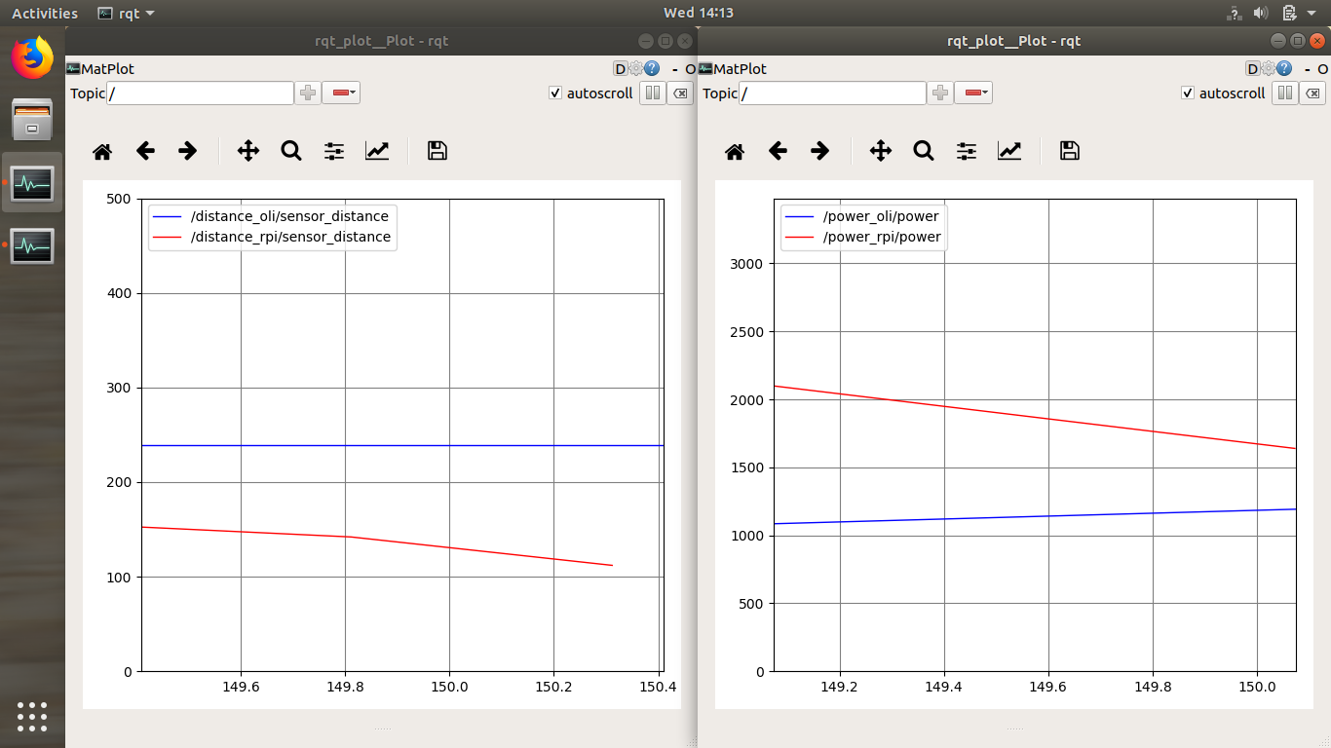
- After some time two rqt windows should appear

- It is possible to change figure parameters on a popup window which appears after clicking on the increase arrow

