# Autres_cereales - AB

## Covariate distribution before matching

|  |  | Autres_cereales - AB (N=46) / Mean | Autres_cereales - AB (N=46) / Std. Dev. | Autres_cereales - Conventionnel (N=182) / Mean | Autres_cereales - Conventionnel (N=182) / Std. Dev. | Diff. in Means | Std. Error |
| --- | --- | --- | --- | --- | --- | --- | --- |
| PBSTOT_COEF17 |  | 218648.3 | 213367.4 | 236411.4 | 188257.6 | 17763.1 | 34415.4 |
| AGE |  | 47.3 | 10.3 | 47.6 | 10.4 | 0.3 | 1.7 |
|  |  | N | Pct. | N | Pct. |  |  |
| SIEGE_REG | 11 | 1 | 2.2 | 3 | 1.6 |  |  |
|  | 24 | 2 | 4.3 | 42 | 23.1 |  |  |
|  | 27 | 4 | 8.7 | 17 | 9.3 |  |  |
|  | 28 | 5 | 10.9 | 1 | 0.5 |  |  |
|  | 32 | 4 | 8.7 | 3 | 1.6 |  |  |
|  | 44 | 6 | 13.0 | 20 | 11.0 |  |  |
|  | 52 | 4 | 8.7 | 4 | 2.2 |  |  |
|  | 53 | 3 | 6.5 | 5 | 2.7 |  |  |
|  | 75 | 3 | 6.5 | 19 | 10.4 |  |  |
|  | 76 | 6 | 13.0 | 29 | 15.9 |  |  |
|  | 84 | 8 | 17.4 | 35 | 19.2 |  |  |
|  | 93 | 0 | 0.0 | 4 | 2.2 |  |  |
| MNT | FALSE | 35 | 76.1 | 135 | 74.2 |  |  |
|  | TRUE | 11 | 23.9 | 47 | 25.8 |  |  |
| NivForm | 00 | 1 | 2.2 | 0 | 0.0 |  |  |
|  | 11 | 0 | 0.0 | 3 | 1.6 |  |  |
|  | 23 | 1 | 2.2 | 5 | 2.7 |  |  |
|  | 24 | 7 | 15.2 | 49 | 26.9 |  |  |
|  | 25 | 3 | 6.5 | 23 | 12.6 |  |  |
|  | 26 | 17 | 37.0 | 51 | 28.0 |  |  |
|  | 27 | 13 | 28.3 | 46 | 25.3 |  |  |
|  | 28 | 4 | 8.7 | 5 | 2.7 |  |  |

## Covariate distribution after matching

|  |  | Autres_cereales - AB (N=41) / Mean | Autres_cereales - AB (N=41) / Std. Dev. | Autres_cereales - Conventionnel (N=103) / Mean | Autres_cereales - Conventionnel (N=103) / Std. Dev. | Diff. in Means | Std. Error |
| --- | --- | --- | --- | --- | --- | --- | --- |
| PBSTOT_COEF17 |  | 218219.8 | 217376.9 | 219757.4 | 148905.4 | 1537.6 | 36983.4 |
| AGE |  | 47.0 | 10.5 | 45.8 | 10.5 | -1.2 | 1.9 |
|  |  | N | Pct. | N | Pct. |  |  |
| SIEGE_REG | 11 | 1 | 2.4 | 3 | 2.9 |  |  |
|  | 24 | 2 | 4.9 | 6 | 5.8 |  |  |
|  | 27 | 4 | 9.8 | 12 | 11.7 |  |  |
|  | 28 | 1 | 2.4 | 1 | 1.0 |  |  |
|  | 32 | 3 | 7.3 | 3 | 2.9 |  |  |
|  | 44 | 6 | 14.6 | 18 | 17.5 |  |  |
|  | 52 | 4 | 9.8 | 4 | 3.9 |  |  |
|  | 53 | 3 | 7.3 | 5 | 4.9 |  |  |
|  | 75 | 3 | 7.3 | 9 | 8.7 |  |  |
|  | 76 | 6 | 14.6 | 18 | 17.5 |  |  |
|  | 84 | 8 | 19.5 | 24 | 23.3 |  |  |
| MNT | FALSE | 30 | 73.2 | 71 | 68.9 |  |  |
|  | TRUE | 11 | 26.8 | 32 | 31.1 |  |  |
| NivForm | 00 | 1 | 2.4 | 0 | 0.0 |  |  |
|  | 11 | 0 | 0.0 | 1 | 1.0 |  |  |
|  | 23 | 1 | 2.4 | 2 | 1.9 |  |  |
|  | 24 | 6 | 14.6 | 19 | 18.4 |  |  |
|  | 25 | 2 | 4.9 | 16 | 15.5 |  |  |
|  | 26 | 15 | 36.6 | 35 | 34.0 |  |  |
|  | 27 | 12 | 29.3 | 28 | 27.2 |  |  |
|  | 28 | 4 | 9.8 | 2 | 1.9 |  |  |

## Matching model coefficients

| . | Estimate | Std. Error | t value | Pr(&gt;|t|) |
| --- | --- | --- | --- | --- |
| (Intercept) | 20.1353121627942 | 3955.43761556299 | 0.00509053968733324 | 0.995943280776628 |
| SIEGE_REG24 | -2.6963278190519 | 1.60853707835363 | -1.67626090522678 | 0.095204056228171 |
| SIEGE_REG27 | -0.231838117652677 | 1.37790108108699 | -0.168254543693214 | 0.866548109520699 |
| SIEGE_REG28 | 3.02034049755542 | 1.67629372775847 | 1.80179669442192 | 0.0730394922209494 |
| SIEGE_REG32 | 1.5493777175902 | 1.44816630952893 | 1.06988935414068 | 0.285921106017428 |
| SIEGE_REG44 | 0.238691006066204 | 1.35725673312878 | 0.175862827009867 | 0.860574463937573 |
| SIEGE_REG52 | 2.63039476822286 | 1.59364596669153 | 1.65055151721286 | 0.10035395513245 |
| SIEGE_REG53 | 1.01841916573501 | 1.52089641816378 | 0.669617702804882 | 0.503851369081516 |
| SIEGE_REG75 | -0.661523456227138 | 1.37165458242238 | -0.482281373681463 | 0.630118117353263 |
| SIEGE_REG76 | -0.65258549205163 | 1.40087578682554 | -0.465841081835259 | 0.641821413487168 |
| SIEGE_REG84 | -0.44113085893318 | 1.39156723802358 | -0.317002906420613 | 0.751562433602369 |
| SIEGE_REG93 | -17.7459639307754 | 1842.69277678213 | -0.0096304517792515 | 0.992325449954257 |
| MNTTRUE | 0.507789668718124 | 0.67387975526129 | 0.753531568137454 | 0.451990919079154 |
| PBSTOT_COEF17 | -1.92307132356022e-06 | 1.2713114979485e-06 | -1.5126672941002 | 0.131896811175221 |
| AGE | 0.00450215833643196 | 0.0214643108732834 | 0.209750891282319 | 0.834069398078594 |
| NivForm11 | -38.4850421992476 | 4482.03103797906 | -0.0085865184495912 | 0.993157343295162 |
| NivForm23 | -21.1132847964937 | 3955.43722166397 | -0.00533778786346451 | 0.995746247232019 |
| NivForm24 | -22.1084062484127 | 3955.43707121049 | -0.00558937125035511 | 0.995545759200411 |
| NivForm25 | -22.2772785802515 | 3955.43713283908 | -0.00563206488488964 | 0.995511736461985 |
| NivForm26 | -21.0778937943135 | 3955.43707405308 | -0.00532884063118598 | 0.995753377330243 |
| NivForm27 | -20.8358825598741 | 3955.43708470682 | -0.00526765616888038 | 0.995802135571241 |
| NivForm28 | -19.2698403451302 | 3955.4371236426 | -0.00487173471421143 | 0.996117647971532 |

## Propensity score distribution

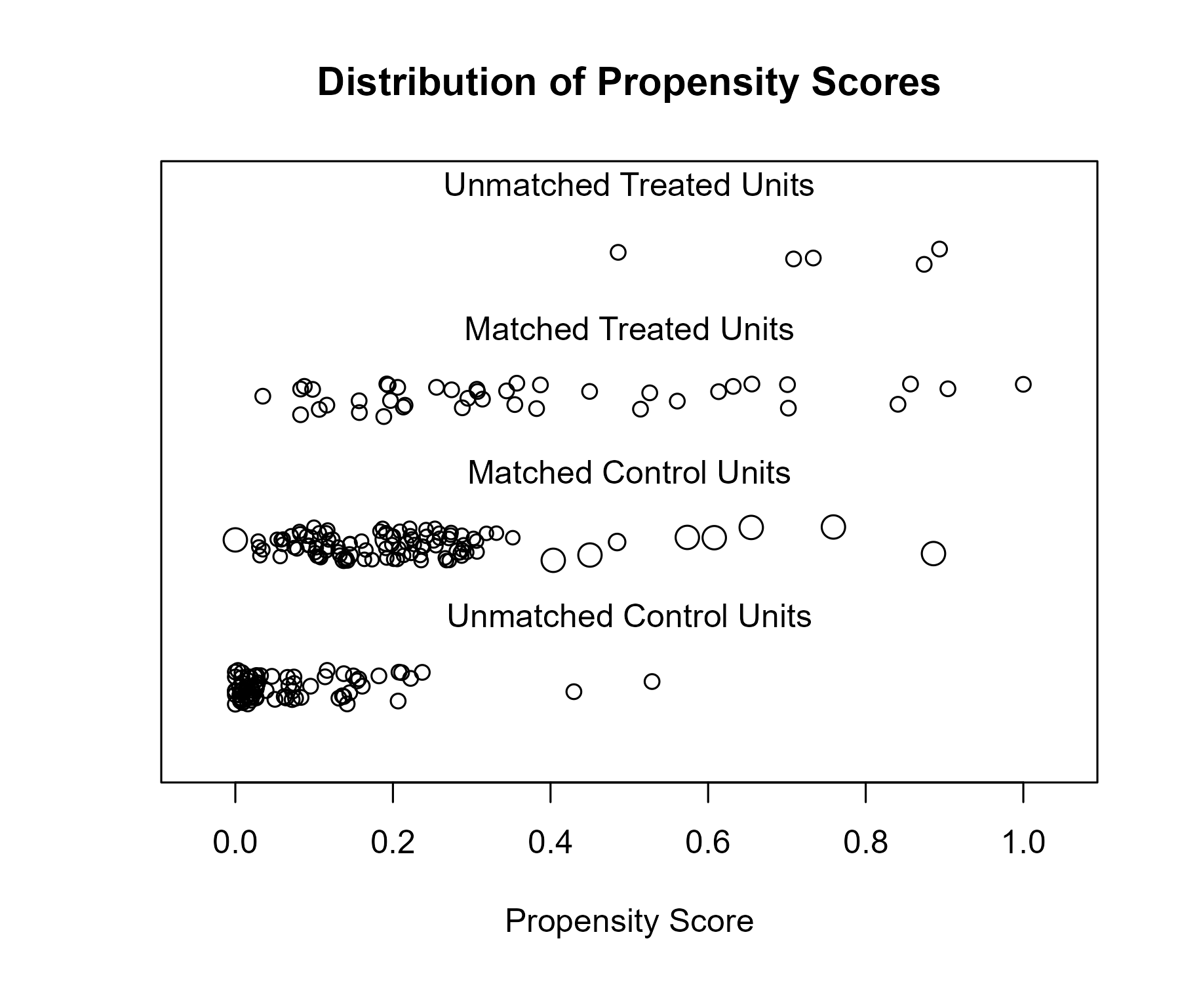

## Covariate balance

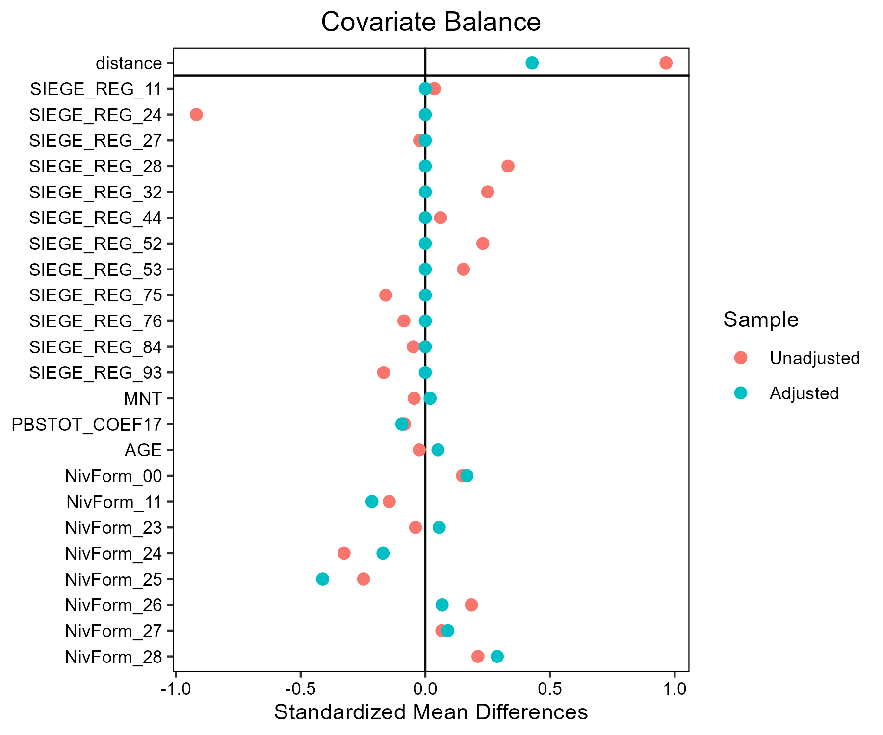

# Ble_tendre - LR

## Covariate distribution before matching

|  |  | Ble_tendre - Conventionnel (N=3136) / Mean | Ble_tendre - Conventionnel (N=3136) / Std. Dev. | Ble_tendre - LR (N=100) / Mean | Ble_tendre - LR (N=100) / Std. Dev. | Diff. in Means | Std. Error |
| --- | --- | --- | --- | --- | --- | --- | --- |
| PBSTOT_COEF17 |  | 302458.5 | 359401.5 | 322075.3 | 225190.3 | 19616.7 | 23415.7 |
| AGE |  | 49.3 | 10.2 | 48.6 | 10.3 | -0.6 | 1.0 |
|  |  | N | Pct. | N | Pct. |  |  |
| SIEGE_REG | 11 | 114 | 3.6 | 15 | 15.0 |  |  |
|  | 24 | 237 | 7.6 | 9 | 9.0 |  |  |
|  | 27 | 239 | 7.6 | 12 | 12.0 |  |  |
|  | 28 | 226 | 7.2 | 2 | 2.0 |  |  |
|  | 32 | 470 | 15.0 | 9 | 9.0 |  |  |
|  | 44 | 504 | 16.1 | 0 | 0.0 |  |  |
|  | 52 | 209 | 6.7 | 20 | 20.0 |  |  |
|  | 53 | 249 | 7.9 | 0 | 0.0 |  |  |
|  | 75 | 336 | 10.7 | 13 | 13.0 |  |  |
|  | 76 | 225 | 7.2 | 5 | 5.0 |  |  |
|  | 84 | 310 | 9.9 | 15 | 15.0 |  |  |
|  | 93 | 17 | 0.5 | 0 | 0.0 |  |  |
| MNT | FALSE | 2926 | 93.3 | 97 | 97.0 |  |  |
|  | TRUE | 210 | 6.7 | 3 | 3.0 |  |  |
| NivForm | 00 | 15 | 0.5 | 0 | 0.0 |  |  |
|  | 10 | 21 | 0.7 | 0 | 0.0 |  |  |
|  | 11 | 72 | 2.3 | 6 | 6.0 |  |  |
|  | 23 | 114 | 3.6 | 2 | 2.0 |  |  |
|  | 24 | 886 | 28.3 | 26 | 26.0 |  |  |
|  | 25 | 351 | 11.2 | 16 | 16.0 |  |  |
|  | 26 | 764 | 24.4 | 19 | 19.0 |  |  |
|  | 27 | 767 | 24.5 | 26 | 26.0 |  |  |
|  | 28 | 146 | 4.7 | 5 | 5.0 |  |  |

## Covariate distribution after matching

|  |  | Ble_tendre - Conventionnel (N=300) / Mean | Ble_tendre - Conventionnel (N=300) / Std. Dev. | Ble_tendre - LR (N=100) / Mean | Ble_tendre - LR (N=100) / Std. Dev. | Diff. in Means | Std. Error |
| --- | --- | --- | --- | --- | --- | --- | --- |
| PBSTOT_COEF17 |  | 337219.4 | 371618.8 | 322075.3 | 225190.3 | -15144.2 | 31103.7 |
| AGE |  | 47.8 | 10.0 | 48.6 | 10.3 | 0.8 | 1.2 |
|  |  | N | Pct. | N | Pct. |  |  |
| SIEGE_REG | 11 | 45 | 15.0 | 15 | 15.0 |  |  |
|  | 24 | 27 | 9.0 | 9 | 9.0 |  |  |
|  | 27 | 36 | 12.0 | 12 | 12.0 |  |  |
|  | 28 | 6 | 2.0 | 2 | 2.0 |  |  |
|  | 32 | 27 | 9.0 | 9 | 9.0 |  |  |
|  | 52 | 60 | 20.0 | 20 | 20.0 |  |  |
|  | 75 | 39 | 13.0 | 13 | 13.0 |  |  |
|  | 76 | 15 | 5.0 | 5 | 5.0 |  |  |
|  | 84 | 45 | 15.0 | 15 | 15.0 |  |  |
| MNT | FALSE | 290 | 96.7 | 97 | 97.0 |  |  |
|  | TRUE | 10 | 3.3 | 3 | 3.0 |  |  |
| NivForm | 11 | 14 | 4.7 | 6 | 6.0 |  |  |
|  | 23 | 1 | 0.3 | 2 | 2.0 |  |  |
|  | 24 | 79 | 26.3 | 26 | 26.0 |  |  |
|  | 25 | 47 | 15.7 | 16 | 16.0 |  |  |
|  | 26 | 62 | 20.7 | 19 | 19.0 |  |  |
|  | 27 | 82 | 27.3 | 26 | 26.0 |  |  |
|  | 28 | 15 | 5.0 | 5 | 5.0 |  |  |

## Matching model coefficients

| . | Estimate | Std. Error | t value | Pr(&gt;|t|) |
| --- | --- | --- | --- | --- |
| (Intercept) | -19.0774419554205 | 3702.94218607324 | -0.0051519686229968 | 0.995889661801691 |
| SIEGE_REG24 | -1.31852556423804 | 0.383723844269739 | -3.43613143652125 | 0.000597572215313342 |
| SIEGE_REG27 | -1.04734147151421 | 0.359378046781159 | -2.91431677837567 | 0.00358930619286703 |
| SIEGE_REG28 | -2.87715589712267 | 0.677303214953758 | -4.24795842334678 | 2.21850727084669e-05 |
| SIEGE_REG32 | -1.96493738806591 | 0.379727205610711 | -5.17460260690493 | 2.42415429820853e-07 |
| SIEGE_REG44 | -18.6094021510281 | 677.662147889723 | -0.0274611798946995 | 0.978093607553182 |
| SIEGE_REG52 | -0.40330515247048 | 0.324931078698273 | -1.24120214688661 | 0.214621691849323 |
| SIEGE_REG53 | -18.6596943251102 | 968.094967938144 | -0.0192746527387202 | 0.984623201151091 |
| SIEGE_REG75 | -1.31047124867996 | 0.351932612809303 | -3.72364254116467 | 0.000199739831244259 |
| SIEGE_REG76 | -1.70647218420254 | 0.465939175956524 | -3.66243551145777 | 0.000253856972339813 |
| SIEGE_REG84 | -0.785222779029403 | 0.353578254975262 | -2.22078922552616 | 0.0264347231150087 |
| SIEGE_REG93 | -17.7244633734889 | 3604.50667592785 | -0.00491730629654789 | 0.996076878307179 |
| MNTTRUE | -1.20255844991973 | 0.547826948175126 | -2.19514292592868 | 0.0282246384899191 |
| PBSTOT_COEF17 | 2.18421618361664e-07 | 2.02278319245164e-07 | 1.07980736233493 | 0.280309020565153 |
| AGE | -0.00456613260711213 | 0.00964702894824311 | -0.473320089699088 | 0.636016986439054 |
| NivForm10 | -0.0667138002692859 | 4834.98064888379 | -1.37981524878879e-05 | 0.999988991523753 |
| NivForm11 | 18.4802909716647 | 3702.94216965546 | 0.00499070472207352 | 0.996018320112061 |
| NivForm23 | 16.8991797399743 | 3702.94220123713 | 0.00456371685583654 | 0.99635897673972 |
| NivForm24 | 17.2536786470134 | 3702.94215259293 | 0.00465945130547928 | 0.996282598456061 |
| NivForm25 | 17.5765757627883 | 3702.94215525797 | 0.00474665145331276 | 0.996213028987458 |
| NivForm26 | 17.0536089891559 | 3702.94215358088 | 0.0046054213870623 | 0.996325704276939 |
| NivForm27 | 17.3117085023611 | 3702.94215234342 | 0.00467512258904863 | 0.996270095689949 |
| NivForm28 | 17.1882171396112 | 3702.94217057516 | 0.0046417730409604 | 0.996296702420344 |

## Propensity score distribution

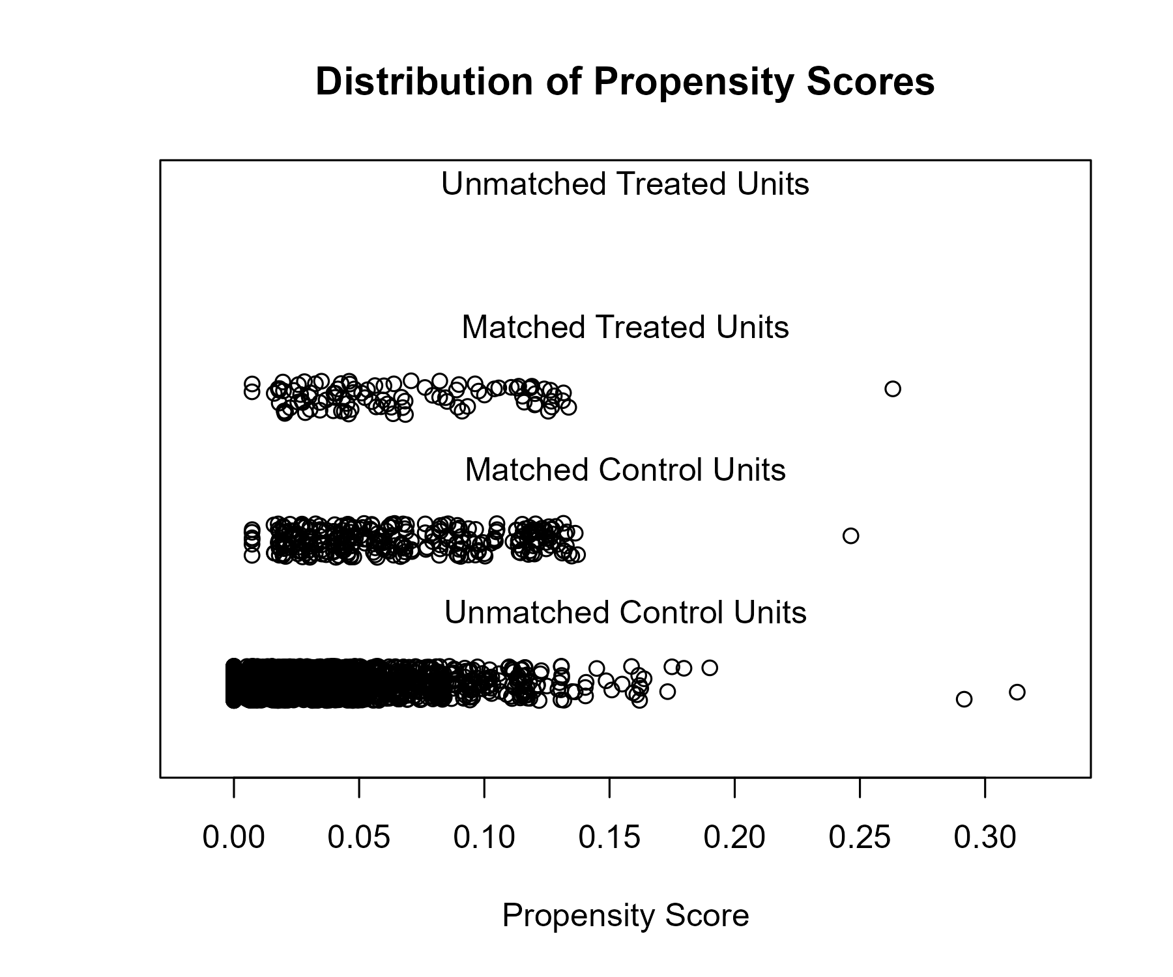

## Covariate balance

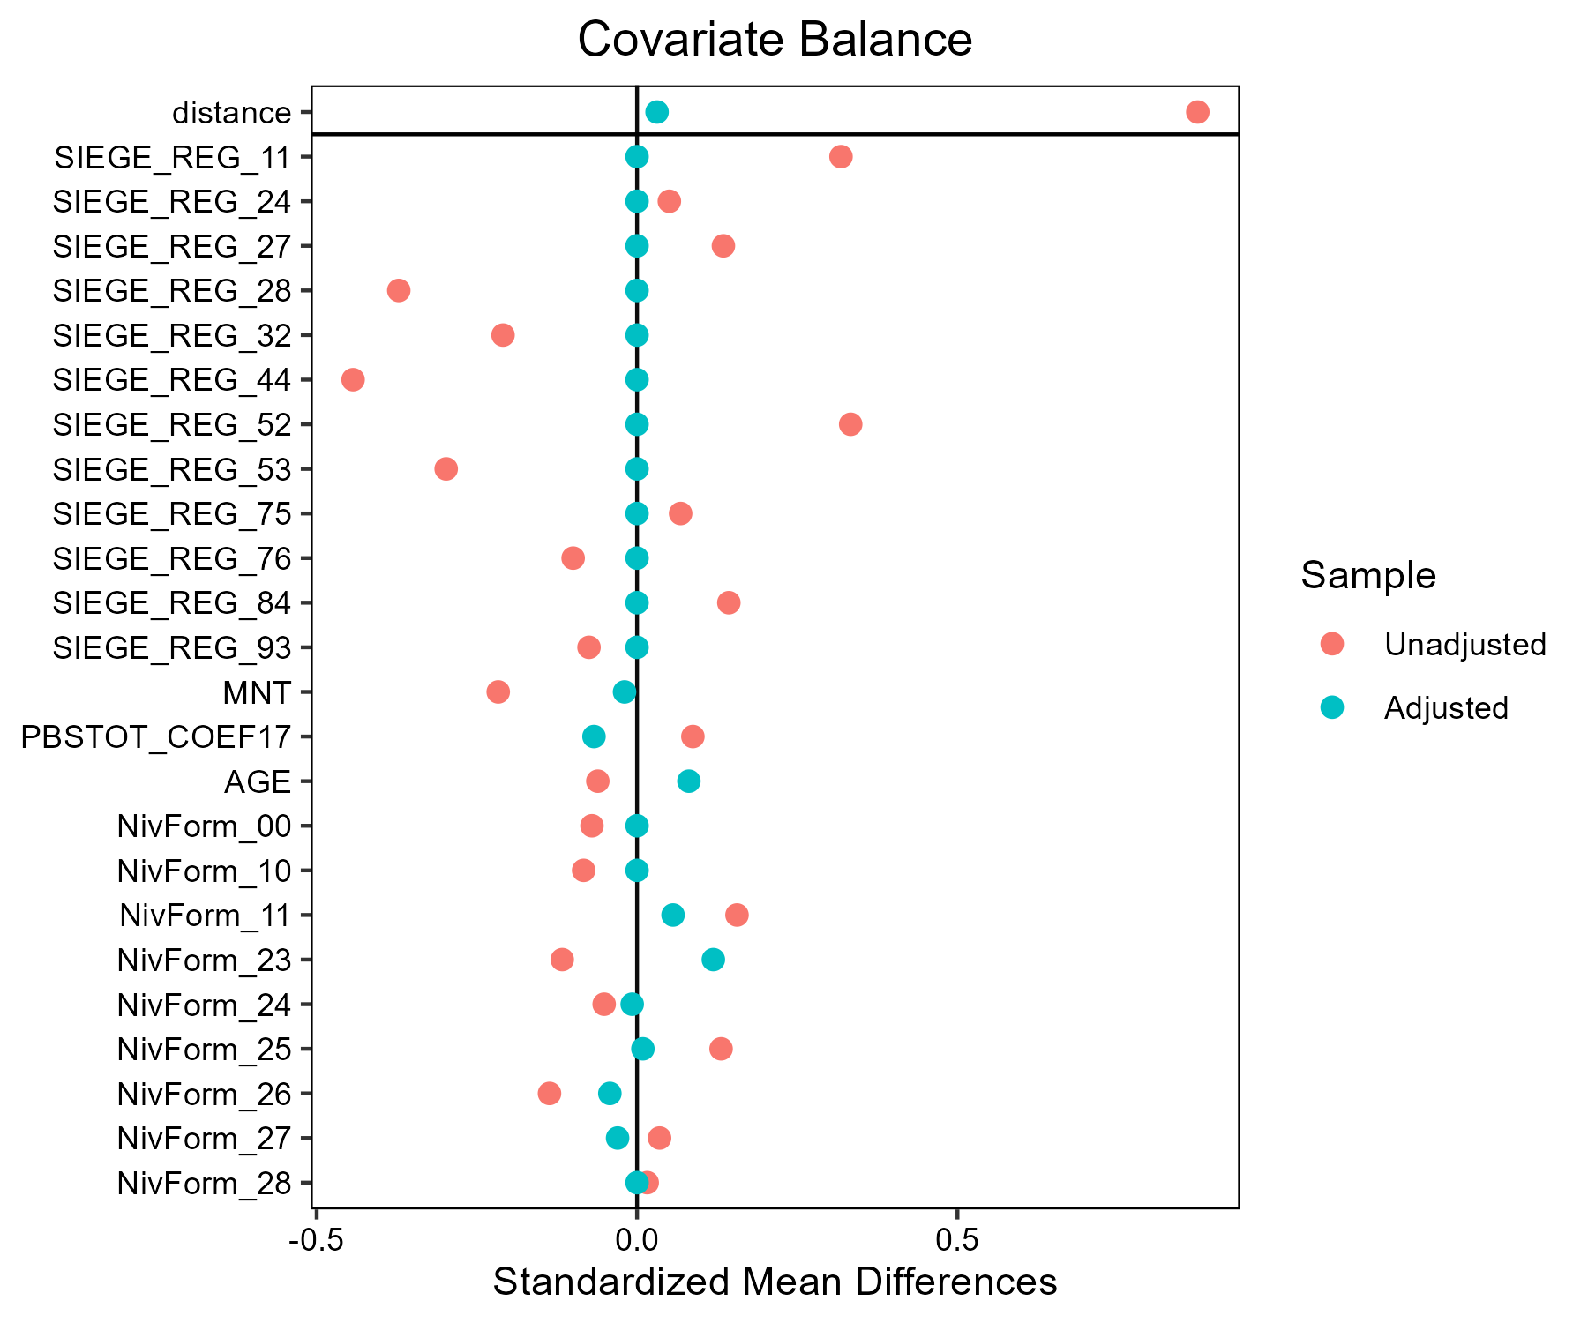

# Ble_tendre - AB

## Covariate distribution before matching

|  |  | Ble_tendre - AB (N=93) / Mean | Ble_tendre - AB (N=93) / Std. Dev. | Ble_tendre - Conventionnel (N=3136) / Mean | Ble_tendre - Conventionnel (N=3136) / Std. Dev. | Diff. in Means | Std. Error |
| --- | --- | --- | --- | --- | --- | --- | --- |
| PBSTOT_COEF17 |  | 236493.7 | 309228.9 | 302458.5 | 359401.5 | 65964.8 | 32701.5 |
| AGE |  | 48.5 | 9.5 | 49.3 | 10.2 | 0.8 | 1.0 |
|  |  | N | Pct. | N | Pct. |  |  |
| SIEGE_REG | 11 | 10 | 10.8 | 114 | 3.6 |  |  |
|  | 24 | 2 | 2.2 | 237 | 7.6 |  |  |
|  | 27 | 7 | 7.5 | 239 | 7.6 |  |  |
|  | 28 | 6 | 6.5 | 226 | 7.2 |  |  |
|  | 32 | 9 | 9.7 | 470 | 15.0 |  |  |
|  | 44 | 17 | 18.3 | 504 | 16.1 |  |  |
|  | 52 | 7 | 7.5 | 209 | 6.7 |  |  |
|  | 53 | 5 | 5.4 | 249 | 7.9 |  |  |
|  | 75 | 8 | 8.6 | 336 | 10.7 |  |  |
|  | 76 | 12 | 12.9 | 225 | 7.2 |  |  |
|  | 84 | 9 | 9.7 | 310 | 9.9 |  |  |
|  | 93 | 1 | 1.1 | 17 | 0.5 |  |  |
| MNT | FALSE | 84 | 90.3 | 2926 | 93.3 |  |  |
|  | TRUE | 9 | 9.7 | 210 | 6.7 |  |  |
| NivForm | 00 | 0 | 0.0 | 15 | 0.5 |  |  |
|  | 10 | 0 | 0.0 | 21 | 0.7 |  |  |
|  | 11 | 0 | 0.0 | 72 | 2.3 |  |  |
|  | 23 | 2 | 2.2 | 114 | 3.6 |  |  |
|  | 24 | 15 | 16.1 | 886 | 28.3 |  |  |
|  | 25 | 5 | 5.4 | 351 | 11.2 |  |  |
|  | 26 | 27 | 29.0 | 764 | 24.4 |  |  |
|  | 27 | 27 | 29.0 | 767 | 24.5 |  |  |
|  | 28 | 17 | 18.3 | 146 | 4.7 |  |  |

## Covariate distribution after matching

|  |  | Ble_tendre - AB (N=93) / Mean | Ble_tendre - AB (N=93) / Std. Dev. | Ble_tendre - Conventionnel (N=279) / Mean | Ble_tendre - Conventionnel (N=279) / Std. Dev. | Diff. in Means | Std. Error |
| --- | --- | --- | --- | --- | --- | --- | --- |
| PBSTOT_COEF17 |  | 236493.7 | 309228.9 | 235295.5 | 201358.0 | -1198.2 | 34256.7 |
| AGE |  | 48.5 | 9.5 | 48.7 | 10.2 | 0.1 | 1.2 |
|  |  | N | Pct. | N | Pct. |  |  |
| SIEGE_REG | 11 | 10 | 10.8 | 30 | 10.8 |  |  |
|  | 24 | 2 | 2.2 | 6 | 2.2 |  |  |
|  | 27 | 7 | 7.5 | 21 | 7.5 |  |  |
|  | 28 | 6 | 6.5 | 18 | 6.5 |  |  |
|  | 32 | 9 | 9.7 | 27 | 9.7 |  |  |
|  | 44 | 17 | 18.3 | 51 | 18.3 |  |  |
|  | 52 | 7 | 7.5 | 21 | 7.5 |  |  |
|  | 53 | 5 | 5.4 | 15 | 5.4 |  |  |
|  | 75 | 8 | 8.6 | 24 | 8.6 |  |  |
|  | 76 | 12 | 12.9 | 36 | 12.9 |  |  |
|  | 84 | 9 | 9.7 | 27 | 9.7 |  |  |
|  | 93 | 1 | 1.1 | 3 | 1.1 |  |  |
| MNT | FALSE | 84 | 90.3 | 251 | 90.0 |  |  |
|  | TRUE | 9 | 9.7 | 28 | 10.0 |  |  |
| NivForm | 23 | 2 | 2.2 | 9 | 3.2 |  |  |
|  | 24 | 15 | 16.1 | 46 | 16.5 |  |  |
|  | 25 | 5 | 5.4 | 14 | 5.0 |  |  |
|  | 26 | 27 | 29.0 | 82 | 29.4 |  |  |
|  | 27 | 27 | 29.0 | 80 | 28.7 |  |  |
|  | 28 | 17 | 18.3 | 48 | 17.2 |  |  |

## Matching model coefficients

| . | Estimate | Std. Error | t value | Pr(&gt;|t|) |
| --- | --- | --- | --- | --- |
| (Intercept) | -18.1867206360001 | 1620.47237960234 | -0.0112230981934188 | 0.991046149506503 |
| SIEGE_REG24 | -1.96341793991476 | 0.781252722623523 | -2.51316620481195 | 0.0120139635604103 |
| SIEGE_REG27 | -0.577248688566839 | 0.518998927831593 | -1.11223483828496 | 0.266120585650532 |
| SIEGE_REG28 | -0.663127878390497 | 0.539680755495501 | -1.2287410133453 | 0.219259107951198 |
| SIEGE_REG32 | -1.18213299465615 | 0.47869536588286 | -2.46948911334443 | 0.0135823437566152 |
| SIEGE_REG44 | -0.497417231962537 | 0.42505313345157 | -1.17024718280123 | 0.241988492709089 |
| SIEGE_REG52 | -0.347311904904211 | 0.524768054352224 | -0.661838886768622 | 0.508122047253036 |
| SIEGE_REG53 | -0.785031974186831 | 0.580291541981948 | -1.3528233954705 | 0.17620745094619 |
| SIEGE_REG75 | -0.756672940977645 | 0.500054572711793 | -1.51318072520408 | 0.130332326479078 |
| SIEGE_REG76 | -0.152554211505819 | 0.469460047630302 | -0.324956750368573 | 0.745235007625014 |
| SIEGE_REG84 | -0.746661586696625 | 0.533189917628188 | -1.40036703998086 | 0.161500203835439 |
| SIEGE_REG93 | -0.277033641837568 | 1.13658454027728 | -0.243742222439505 | 0.807446065850697 |
| MNTTRUE | 0.347460988320735 | 0.435624239655991 | 0.797616286447058 | 0.425152267180419 |
| PBSTOT_COEF17 | -1.50954497559721e-06 | 6.15506362021824e-07 | -2.45252538192885 | 0.0142386705529126 |
| AGE | 0.0117217220072809 | 0.0112437355233891 | 1.04251135958307 | 0.297253266146246 |
| NivForm10 | -0.500825700858455 | 2135.54426993221 | -0.000234518997292598 | 0.999812895505312 |
| NivForm11 | -0.216909679683889 | 1783.61209659752 | -0.000121612586109768 | 0.999902974761589 |
| NivForm23 | 14.4407739073131 | 1620.47237867492 | 0.00891145945919885 | 0.992890332646281 |
| NivForm24 | 14.4102674024813 | 1620.4722451206 | 0.00889263450569554 | 0.992905351019559 |
| NivForm25 | 14.4150888384954 | 1620.47228821601 | 0.00889560959685714 | 0.992902977519261 |
| NivForm26 | 15.2769327825483 | 1620.47223725578 | 0.00942745727530594 | 0.992478675374727 |
| NivForm27 | 15.4370825019478 | 1620.47223942669 | 0.00952628630491646 | 0.992399830908324 |
| NivForm28 | 16.5571009242415 | 1620.47224991358 | 0.0102174541558021 | 0.991848428640776 |

## Propensity score distribution

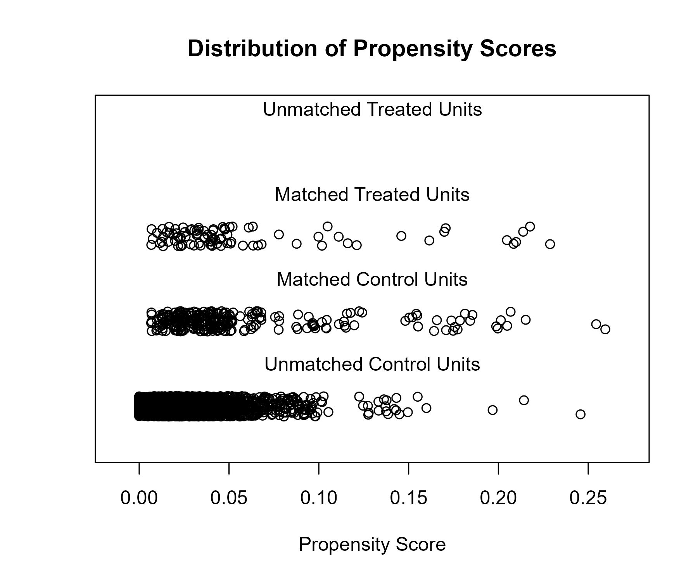

## Covariate balance

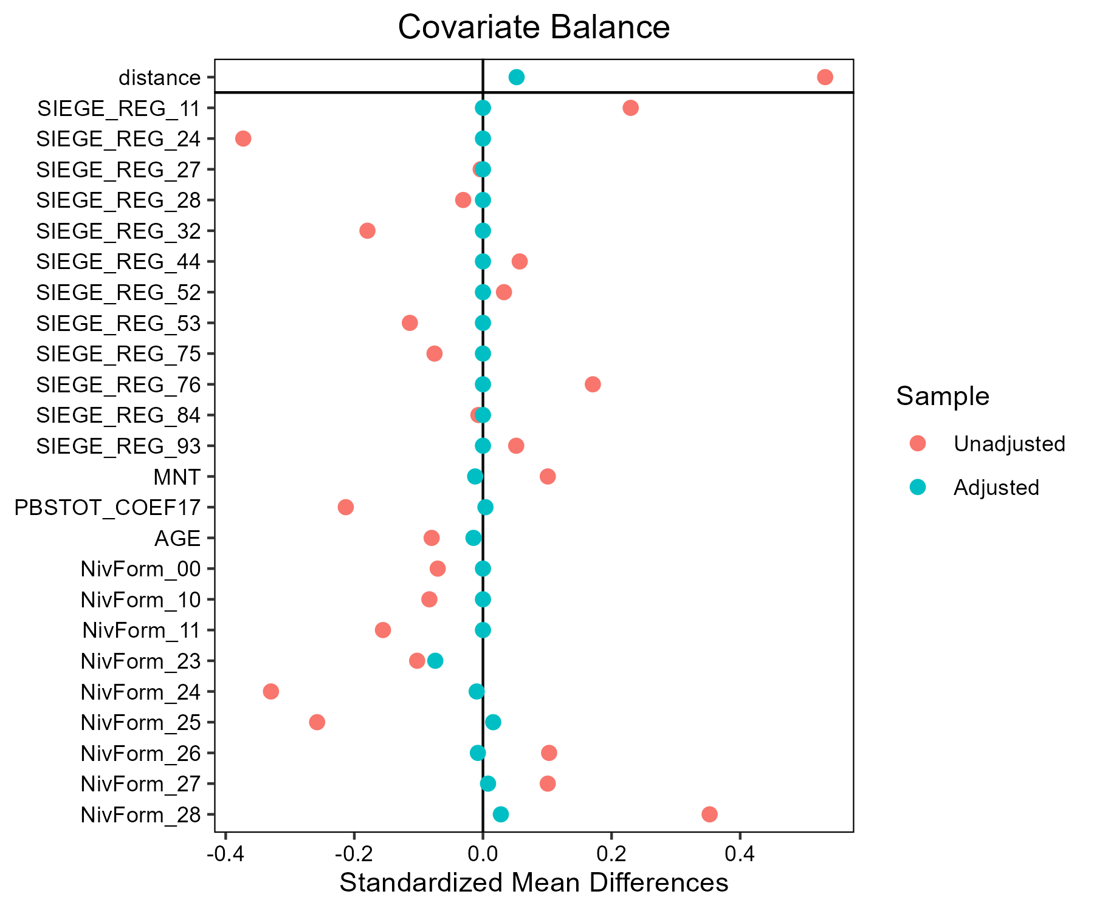

# Lait - AB

## Covariate distribution before matching

|  |  | Lait - AB (N=88) / Mean | Lait - AB (N=88) / Std. Dev. | Lait - Conventionnel (N=882) / Mean | Lait - Conventionnel (N=882) / Std. Dev. | Diff. in Means | Std. Error |
| --- | --- | --- | --- | --- | --- | --- | --- |
| PBSTOT_COEF17 |  | 218276.5 | 113442.2 | 298723.1 | 173676.7 | 80446.6 | 13432.8 |
| AGE |  | 46.9 | 9.5 | 48.4 | 9.4 | 1.5 | 1.1 |
|  |  | N | Pct. | N | Pct. |  |  |
| SIEGE_REG | 11 | 0 | 0.0 | 2 | 0.2 |  |  |
|  | 24 | 0 | 0.0 | 27 | 3.1 |  |  |
|  | 27 | 8 | 9.1 | 71 | 8.0 |  |  |
|  | 28 | 14 | 15.9 | 106 | 12.0 |  |  |
|  | 32 | 8 | 9.1 | 155 | 17.6 |  |  |
|  | 44 | 13 | 14.8 | 125 | 14.2 |  |  |
|  | 52 | 11 | 12.5 | 87 | 9.9 |  |  |
|  | 53 | 9 | 10.2 | 116 | 13.2 |  |  |
|  | 75 | 1 | 1.1 | 44 | 5.0 |  |  |
|  | 76 | 4 | 4.5 | 39 | 4.4 |  |  |
|  | 84 | 19 | 21.6 | 105 | 11.9 |  |  |
|  | 93 | 1 | 1.1 | 5 | 0.6 |  |  |
| MNT | FALSE | 64 | 72.7 | 745 | 84.5 |  |  |
|  | TRUE | 24 | 27.3 | 137 | 15.5 |  |  |
| NivForm | 00 | 1 | 1.1 | 3 | 0.3 |  |  |
|  | 10 | 0 | 0.0 | 2 | 0.2 |  |  |
|  | 11 | 0 | 0.0 | 18 | 2.0 |  |  |
|  | 23 | 2 | 2.3 | 37 | 4.2 |  |  |
|  | 24 | 18 | 20.5 | 256 | 29.0 |  |  |
|  | 25 | 9 | 10.2 | 107 | 12.1 |  |  |
|  | 26 | 28 | 31.8 | 240 | 27.2 |  |  |
|  | 27 | 25 | 28.4 | 200 | 22.7 |  |  |
|  | 28 | 5 | 5.7 | 19 | 2.2 |  |  |

## Covariate distribution after matching

|  |  | Lait - AB (N=88) / Mean | Lait - AB (N=88) / Std. Dev. | Lait - Conventionnel (N=264) / Mean | Lait - Conventionnel (N=264) / Std. Dev. | Diff. in Means | Std. Error |
| --- | --- | --- | --- | --- | --- | --- | --- |
| PBSTOT_COEF17 |  | 218276.5 | 113442.2 | 232829.2 | 119769.8 | 14552.7 | 14162.5 |
| AGE |  | 46.9 | 9.5 | 47.4 | 9.5 | 0.6 | 1.2 |
|  |  | N | Pct. | N | Pct. |  |  |
| SIEGE_REG | 27 | 8 | 9.1 | 24 | 9.1 |  |  |
|  | 28 | 14 | 15.9 | 42 | 15.9 |  |  |
|  | 32 | 8 | 9.1 | 24 | 9.1 |  |  |
|  | 44 | 13 | 14.8 | 39 | 14.8 |  |  |
|  | 52 | 11 | 12.5 | 33 | 12.5 |  |  |
|  | 53 | 9 | 10.2 | 27 | 10.2 |  |  |
|  | 75 | 1 | 1.1 | 3 | 1.1 |  |  |
|  | 76 | 4 | 4.5 | 12 | 4.5 |  |  |
|  | 84 | 19 | 21.6 | 57 | 21.6 |  |  |
|  | 93 | 1 | 1.1 | 3 | 1.1 |  |  |
| MNT | FALSE | 64 | 72.7 | 203 | 76.9 |  |  |
|  | TRUE | 24 | 27.3 | 61 | 23.1 |  |  |
| NivForm | 00 | 1 | 1.1 | 2 | 0.8 |  |  |
|  | 23 | 2 | 2.3 | 9 | 3.4 |  |  |
|  | 24 | 18 | 20.5 | 64 | 24.2 |  |  |
|  | 25 | 9 | 10.2 | 28 | 10.6 |  |  |
|  | 26 | 28 | 31.8 | 75 | 28.4 |  |  |
|  | 27 | 25 | 28.4 | 75 | 28.4 |  |  |
|  | 28 | 5 | 5.7 | 11 | 4.2 |  |  |

## Matching model coefficients

| . | Estimate | Std. Error | t value | Pr(&gt;|t|) |
| --- | --- | --- | --- | --- |
| (Intercept) | -15.3837593184296 | 2829.53118024885 | -0.00543685802998526 | 0.995663181346869 |
| SIEGE_REG24 | 0.782842292147149 | 2927.84922035867 | 0.000267377939650611 | 0.999786719584248 |
| SIEGE_REG27 | 15.9928958210036 | 2829.53084393484 | 0.00565213694534724 | 0.995491461605867 |
| SIEGE_REG28 | 16.3332607885278 | 2829.53083362404 | 0.00577242721458819 | 0.99539551075836 |
| SIEGE_REG32 | 15.171217891218 | 2829.53084160539 | 0.00536174325020267 | 0.995723097575957 |
| SIEGE_REG44 | 15.996832175274 | 2829.53083429497 | 0.0056535281331401 | 0.995490351909348 |
| SIEGE_REG52 | 16.109712350332 | 2829.53083806469 | 0.00569342172688617 | 0.995458530341379 |
| SIEGE_REG53 | 15.5651976298209 | 2829.53084132472 | 0.00550098178909887 | 0.995612032260134 |
| SIEGE_REG75 | 14.1118994361391 | 2829.53102335065 | 0.00498736338979178 | 0.996021726635415 |
| SIEGE_REG76 | 15.2757326839087 | 2829.53089464675 | 0.00539868029460613 | 0.995693634284591 |
| SIEGE_REG84 | 15.7641506933527 | 2829.53086521568 | 0.0055712948344711 | 0.995555946235636 |
| SIEGE_REG93 | 15.453834512944 | 2829.53110582339 | 0.00546162382917044 | 0.995643426607526 |
| MNTTRUE | 0.262737971982924 | 0.531351447494198 | 0.494471170111553 | 0.621088146156966 |
| PBSTOT_COEF17 | -5.28234839606945e-06 | 1.19522715258544e-06 | -4.4195351357631 | 1.10345754201814e-05 |
| AGE | -0.00800781766539782 | 0.0153678176434869 | -0.521077087922867 | 0.60243489257189 |
| NivForm10 | -16.6347695156406 | 2909.91196095917 | -0.00571658859059 | 0.995440051038655 |
| NivForm11 | -16.79488882636 | 947.415718139675 | -0.0177270531877369 | 0.985860332740631 |
| NivForm23 | -2.07390912320031 | 1.47199782916318 | -1.40890773213932 | 0.159190706171108 |
| NivForm24 | -1.4940708572239 | 1.27796481297625 | -1.16910171708434 | 0.242656839541338 |
| NivForm25 | -1.12487334699815 | 1.32049221071837 | -0.85185913091165 | 0.394507648253602 |
| NivForm26 | -0.839530085663532 | 1.27720212585123 | -0.657319674522152 | 0.511135110504789 |
| NivForm27 | -0.572741440841186 | 1.28524397997094 | -0.445628573069946 | 0.655967422267623 |
| NivForm28 | 0.139442208066358 | 1.37709011525509 | 0.101258593407686 | 0.919366619102328 |

## Propensity score distribution

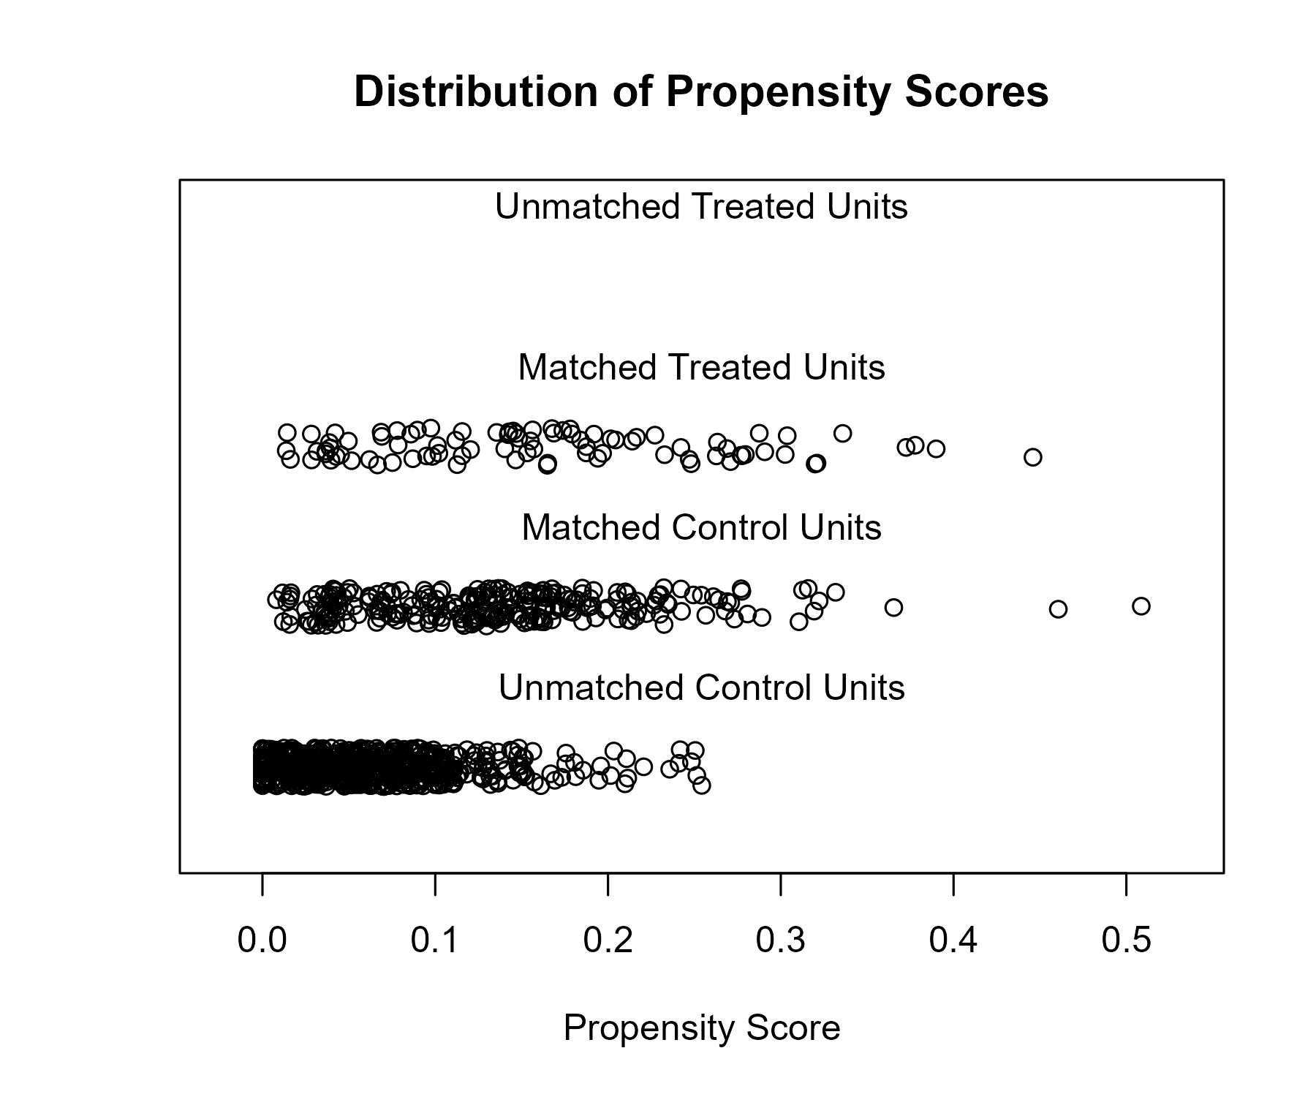

## Covariate balance

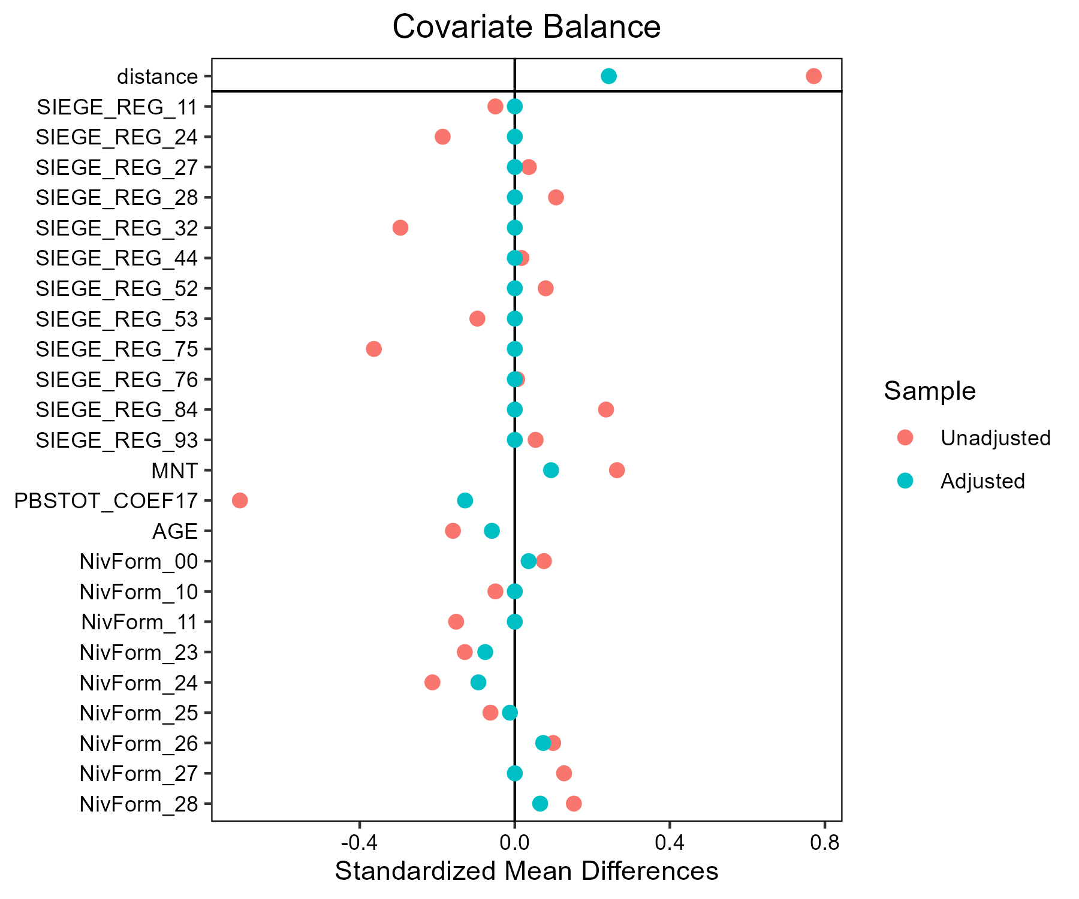

# Lait - Bleu d'Auvergne - Cantal

## Covariate distribution before matching

|  |  | Lait - Bleu d'Auvergne - Cantal (N=54) / Mean | Lait - Bleu d'Auvergne - Cantal (N=54) / Std. Dev. | Lait - Conventionnel (N=882) / Mean | Lait - Conventionnel (N=882) / Std. Dev. | Diff. in Means | Std. Error |
| --- | --- | --- | --- | --- | --- | --- | --- |
| PBSTOT_COEF17 |  | 164086.7 | 83927.4 | 298723.1 | 173676.7 | 134636.5 | 12831.2 |
| AGE |  | 46.3 | 10.7 | 48.4 | 9.4 | 2.1 | 1.5 |
|  |  | N | Pct. | N | Pct. |  |  |
| SIEGE_REG | 11 | 0 | 0.0 | 2 | 0.2 |  |  |
|  | 24 | 0 | 0.0 | 27 | 3.1 |  |  |
|  | 27 | 0 | 0.0 | 71 | 8.0 |  |  |
|  | 28 | 0 | 0.0 | 106 | 12.0 |  |  |
|  | 32 | 0 | 0.0 | 155 | 17.6 |  |  |
|  | 44 | 0 | 0.0 | 125 | 14.2 |  |  |
|  | 52 | 0 | 0.0 | 87 | 9.9 |  |  |
|  | 53 | 0 | 0.0 | 116 | 13.2 |  |  |
|  | 75 | 0 | 0.0 | 44 | 5.0 |  |  |
|  | 76 | 2 | 3.7 | 39 | 4.4 |  |  |
|  | 84 | 52 | 96.3 | 105 | 11.9 |  |  |
|  | 93 | 0 | 0.0 | 5 | 0.6 |  |  |
| MNT | FALSE | 0 | 0.0 | 745 | 84.5 |  |  |
|  | TRUE | 54 | 100.0 | 137 | 15.5 |  |  |
| NivForm | 00 | 0 | 0.0 | 3 | 0.3 |  |  |
|  | 10 | 0 | 0.0 | 2 | 0.2 |  |  |
|  | 11 | 1 | 1.9 | 18 | 2.0 |  |  |
|  | 23 | 0 | 0.0 | 37 | 4.2 |  |  |
|  | 24 | 25 | 46.3 | 256 | 29.0 |  |  |
|  | 25 | 9 | 16.7 | 107 | 12.1 |  |  |
|  | 26 | 16 | 29.6 | 240 | 27.2 |  |  |
|  | 27 | 3 | 5.6 | 200 | 22.7 |  |  |
|  | 28 | 0 | 0.0 | 19 | 2.2 |  |  |

## Covariate distribution after matching

|  |  | Lait - Bleu d'Auvergne - Cantal (N=54) / Mean | Lait - Bleu d'Auvergne - Cantal (N=54) / Std. Dev. | Lait - Conventionnel (N=111) / Mean | Lait - Conventionnel (N=111) / Std. Dev. | Diff. in Means | Std. Error |
| --- | --- | --- | --- | --- | --- | --- | --- |
| PBSTOT_COEF17 |  | 164086.7 | 83927.4 | 189246.6 | 117861.4 | 25159.9 | 15987.1 |
| AGE |  | 46.3 | 10.7 | 48.3 | 10.1 | 2.1 | 1.7 |
|  |  | N | Pct. | N | Pct. |  |  |
| SIEGE_REG | 76 | 2 | 3.7 | 6 | 5.4 |  |  |
|  | 84 | 52 | 96.3 | 105 | 94.6 |  |  |
| MNT | FALSE | 0 | 0.0 | 20 | 18.0 |  |  |
|  | TRUE | 54 | 100.0 | 91 | 82.0 |  |  |
| NivForm | 11 | 1 | 1.9 | 3 | 2.7 |  |  |
|  | 23 | 0 | 0.0 | 6 | 5.4 |  |  |
|  | 24 | 25 | 46.3 | 39 | 35.1 |  |  |
|  | 25 | 9 | 16.7 | 9 | 8.1 |  |  |
|  | 26 | 16 | 29.6 | 29 | 26.1 |  |  |
|  | 27 | 3 | 5.6 | 22 | 19.8 |  |  |
|  | 28 | 0 | 0.0 | 3 | 2.7 |  |  |

## Matching model coefficients

| . | Estimate | Std. Error | t value | Pr(&gt;|t|) |
| --- | --- | --- | --- | --- |
| (Intercept) | -19.399529923295 | 17897.5413156825 | -0.00108392150525706 | 0.999135392716719 |
| SIEGE_REG24 | 0.220712929724133 | 14427.7840194403 | 1.52977705673123e-05 | 0.99998779748683 |
| SIEGE_REG27 | -17.285242047626 | 14150.1148293853 | -0.00122156196299765 | 0.999025601661057 |
| SIEGE_REG28 | -0.0481592448702093 | 14102.7680027285 | -3.41487889901413e-06 | 0.999997276066826 |
| SIEGE_REG32 | 0.0501657323296409 | 14067.8360274178 | 3.56598784858377e-06 | 0.999997155532337 |
| SIEGE_REG44 | -14.740598222867 | 14092.0021446058 | -0.0010460258288074 | 0.99916562079645 |
| SIEGE_REG52 | -0.280977588319804 | 14132.3392782282 | -1.98818881140696e-05 | 0.999984140891611 |
| SIEGE_REG53 | 0.0820256136107372 | 14094.0762004 | 5.81986449089932e-06 | 0.999995357691319 |
| SIEGE_REG75 | -18.1774188034863 | 14253.1708882684 | -0.00127532455381195 | 0.998982717097735 |
| SIEGE_REG76 | 0.623862989722192 | 14021.4426865151 | 4.44934949755336e-05 | 0.999964509046867 |
| SIEGE_REG84 | 2.62400242205573 | 14021.4426837018 | 0.000187142113778763 | 0.99985072307859 |
| SIEGE_REG93 | -19.6739245452484 | 16578.3457180465 | -0.00118672422929582 | 0.999053390520479 |
| MNTTRUE | 19.1795921154341 | 1037.48163786146 | 0.0184866810317421 | 0.985254641832128 |
| PBSTOT_COEF17 | -1.30265669558453e-06 | 9.07051850134093e-07 | -1.43614358472666 | 0.151304025432042 |
| AGE | -0.0477428757655375 | 0.00936620648855275 | -5.09735460390374 | 4.18697742325044e-07 |
| NivForm10 | 17.1510461887653 | 18121.9658508513 | 0.000946423049790682 | 0.999245070518427 |
| NivForm11 | 0.0898277532642095 | 11171.2800709432 | 8.04095436635356e-06 | 0.999993586003194 |
| NivForm23 | -19.9931144748774 | 11463.372265078 | -0.00174408664506033 | 0.998608801892985 |
| NivForm24 | 0.102682604754311 | 11171.2800573616 | 9.19165970480227e-06 | 0.999992668124541 |
| NivForm25 | 0.510015852153822 | 11171.2800582941 | 4.56541998313935e-05 | 0.999963583191938 |
| NivForm26 | -0.603647309630873 | 11171.2800578652 | -5.40356437672399e-05 | 0.99995689759815 |
| NivForm27 | -1.98434543326611 | 11171.2800605636 | -0.000177629190433706 | 0.999858311215042 |
| NivForm28 | -20.6050559019133 | 11729.0519759188 | -0.00175675373800185 | 0.998598697797705 |

## Propensity score distribution

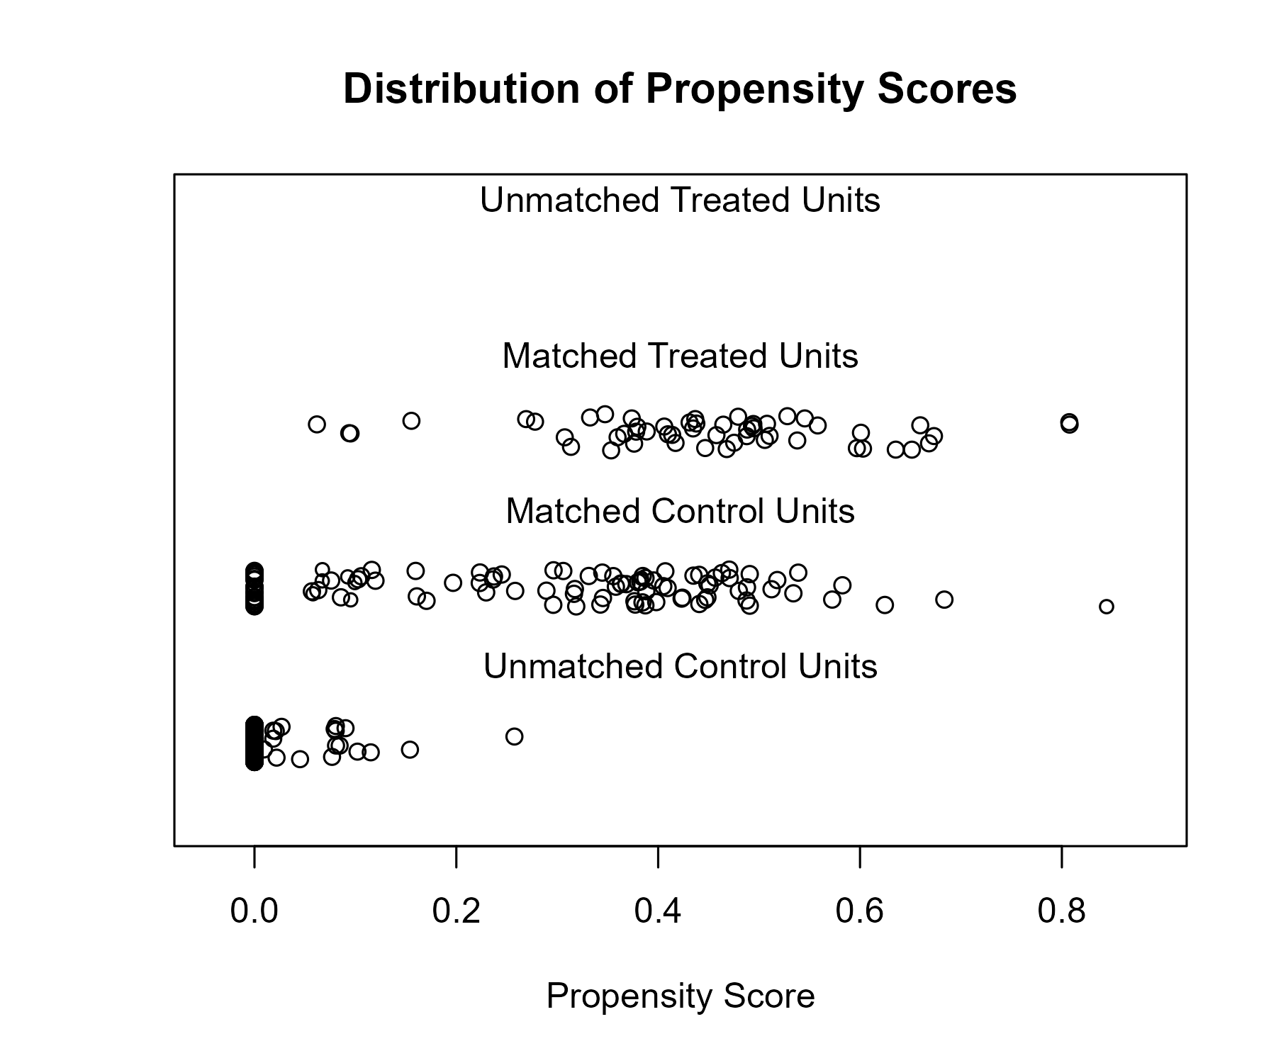

## Covariate balance

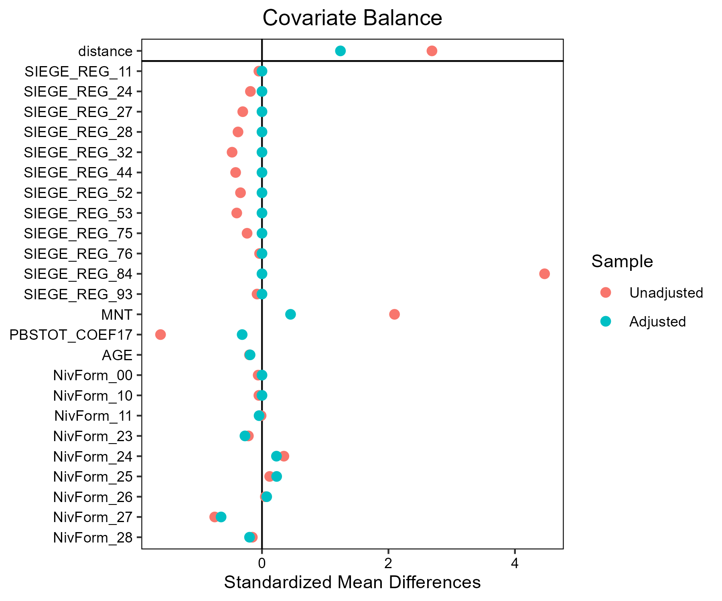

# Lait - Beurre de Charentes-Poitou

## Covariate distribution before matching

|  |  | Lait - Beurre de Charentes-Poitou (N=59) / Mean | Lait - Beurre de Charentes-Poitou (N=59) / Std. Dev. | Lait - Conventionnel (N=882) / Mean | Lait - Conventionnel (N=882) / Std. Dev. | Diff. in Means | Std. Error |
| --- | --- | --- | --- | --- | --- | --- | --- |
| PBSTOT_COEF17 |  | 317864.8 | 161015.4 | 298723.1 | 173676.7 | -19141.7 | 21762.9 |
| AGE |  | 47.3 | 10.6 | 48.4 | 9.4 | 1.1 | 1.4 |
|  |  | N | Pct. | N | Pct. |  |  |
| SIEGE_REG | 11 | 0 | 0.0 | 2 | 0.2 |  |  |
|  | 24 | 3 | 5.1 | 27 | 3.1 |  |  |
|  | 27 | 0 | 0.0 | 71 | 8.0 |  |  |
|  | 28 | 0 | 0.0 | 106 | 12.0 |  |  |
|  | 32 | 0 | 0.0 | 155 | 17.6 |  |  |
|  | 44 | 0 | 0.0 | 125 | 14.2 |  |  |
|  | 52 | 17 | 28.8 | 87 | 9.9 |  |  |
|  | 53 | 0 | 0.0 | 116 | 13.2 |  |  |
|  | 75 | 39 | 66.1 | 44 | 5.0 |  |  |
|  | 76 | 0 | 0.0 | 39 | 4.4 |  |  |
|  | 84 | 0 | 0.0 | 105 | 11.9 |  |  |
|  | 93 | 0 | 0.0 | 5 | 0.6 |  |  |
| MNT | FALSE | 59 | 100.0 | 745 | 84.5 |  |  |
|  | TRUE | 0 | 0.0 | 137 | 15.5 |  |  |
| NivForm | 00 | 1 | 1.7 | 3 | 0.3 |  |  |
|  | 10 | 1 | 1.7 | 2 | 0.2 |  |  |
|  | 11 | 1 | 1.7 | 18 | 2.0 |  |  |
|  | 23 | 1 | 1.7 | 37 | 4.2 |  |  |
|  | 24 | 17 | 28.8 | 256 | 29.0 |  |  |
|  | 25 | 10 | 16.9 | 107 | 12.1 |  |  |
|  | 26 | 17 | 28.8 | 240 | 27.2 |  |  |
|  | 27 | 9 | 15.3 | 200 | 22.7 |  |  |
|  | 28 | 2 | 3.4 | 19 | 2.2 |  |  |

## Covariate distribution after matching

|  |  | Lait - Beurre de Charentes-Poitou (N=59) / Mean | Lait - Beurre de Charentes-Poitou (N=59) / Std. Dev. | Lait - Conventionnel (N=104) / Mean | Lait - Conventionnel (N=104) / Std. Dev. | Diff. in Means | Std. Error |
| --- | --- | --- | --- | --- | --- | --- | --- |
| PBSTOT_COEF17 |  | 317864.8 | 161015.4 | 305264.7 | 185169.3 | -12600.1 | 27732.9 |
| AGE |  | 47.3 | 10.6 | 48.5 | 8.8 | 1.2 | 1.6 |
|  |  | N | Pct. | N | Pct. |  |  |
| SIEGE_REG | 24 | 3 | 5.1 | 9 | 8.7 |  |  |
|  | 52 | 17 | 28.8 | 51 | 49.0 |  |  |
|  | 75 | 39 | 66.1 | 44 | 42.3 |  |  |
| MNT | FALSE | 59 | 100.0 | 92 | 88.5 |  |  |
|  | TRUE | 0 | 0.0 | 12 | 11.5 |  |  |
| NivForm | 00 | 1 | 1.7 | 0 | 0.0 |  |  |
|  | 10 | 1 | 1.7 | 0 | 0.0 |  |  |
|  | 11 | 1 | 1.7 | 2 | 1.9 |  |  |
|  | 23 | 1 | 1.7 | 3 | 2.9 |  |  |
|  | 24 | 17 | 28.8 | 33 | 31.7 |  |  |
|  | 25 | 10 | 16.9 | 17 | 16.3 |  |  |
|  | 26 | 17 | 28.8 | 29 | 27.9 |  |  |
|  | 27 | 9 | 15.3 | 20 | 19.2 |  |  |
|  | 28 | 2 | 3.4 | 0 | 0.0 |  |  |

## Matching model coefficients

| . | Estimate | Std. Error | t value | Pr(&gt;|t|) |
| --- | --- | --- | --- | --- |
| (Intercept) | -1.94095869361477 | 16138.9911922039 | -0.000120265180797197 | 0.999904068397988 |
| SIEGE_REG24 | 20.7580656063743 | 16024.211046241 | 0.00129541888499052 | 0.998966687002876 |
| SIEGE_REG27 | -14.5433322113031 | 16231.4876250485 | -0.000895995028136535 | 0.999285294159386 |
| SIEGE_REG28 | -12.6330729046639 | 16140.8938019006 | -0.000782674928644677 | 0.999375685865443 |
| SIEGE_REG32 | -15.2743592355427 | 16113.0174506328 | -0.000947951510779432 | 0.999243850189714 |
| SIEGE_REG44 | -15.1997456304018 | 16127.1796228356 | -0.000942492486961541 | 0.999248204672564 |
| SIEGE_REG52 | 21.2652887558357 | 16024.2110441916 | 0.00132707243415544 | 0.998941438023458 |
| SIEGE_REG53 | -13.7910467524239 | 16141.3627062552 | -0.00085439172660927 | 0.999318479739927 |
| SIEGE_REG75 | 23.2907666674989 | 16024.2110443418 | 0.00145347353470627 | 0.998840612096277 |
| SIEGE_REG76 | -13.5690971366371 | 16262.5027280289 | -0.000834379391878615 | 0.999334442919274 |
| SIEGE_REG84 | 2.29971439858997 | 16133.6191334636 | 0.000142541755793653 | 0.999886299102675 |
| SIEGE_REG93 | 20.4971153538063 | 19089.0042298978 | 0.00107376556194079 | 0.999143492486416 |
| MNTTRUE | -19.9806358297428 | 1620.51162265733 | -0.0123298318570393 | 0.990165145755617 |
| PBSTOT_COEF17 | 1.05812482816453e-06 | 5.2361125015976e-07 | 2.02082141634979 | 0.0435881403583091 |
| AGE | -0.0547160089771332 | 0.0127407322186193 | -4.29457334462858 | 1.93664194732673e-05 |
| NivForm10 | 0.154503220762718 | 3191.08673881838 | 4.84171172419865e-05 | 0.999961379248753 |
| NivForm11 | -18.7659677837952 | 1921.37895230691 | -0.00976692690490015 | 0.992209365767713 |
| NivForm23 | -19.8866903175318 | 1921.37894269702 | -0.0103502176877286 | 0.991744117351483 |
| NivForm24 | -18.5207411604209 | 1921.37885700664 | -0.00963929684813683 | 0.992311167292967 |
| NivForm25 | -19.5798013707734 | 1921.37888891153 | -0.0101904946930407 | 0.991871516434987 |
| NivForm26 | -18.6777048076843 | 1921.37886541525 | -0.00972099003683359 | 0.992246006363953 |
| NivForm27 | -18.6893356320514 | 1921.3788779889 | -0.00972704334691837 | 0.992241178064959 |
| NivForm28 | -0.207593493556065 | 1940.49923337422 | -0.000106979425699176 | 0.999914666010338 |

## Propensity score distribution

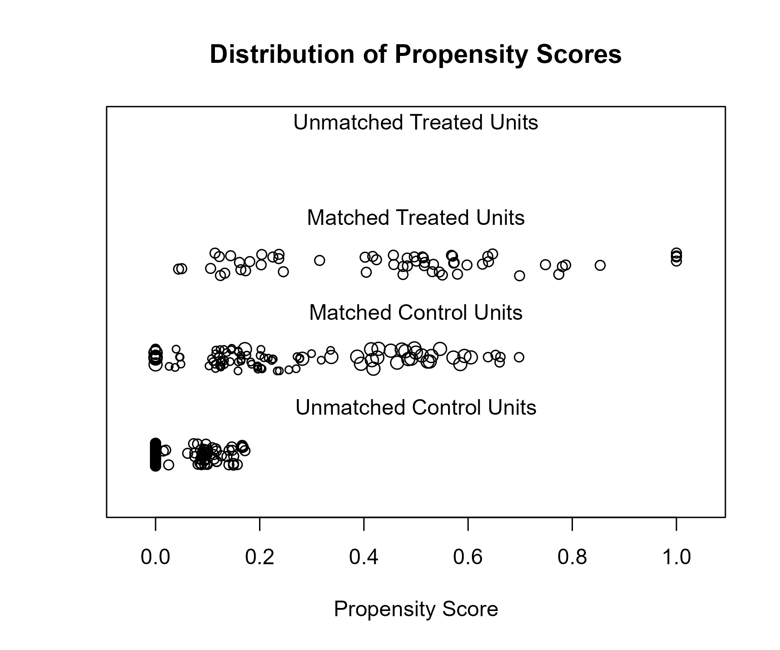

## Covariate balance

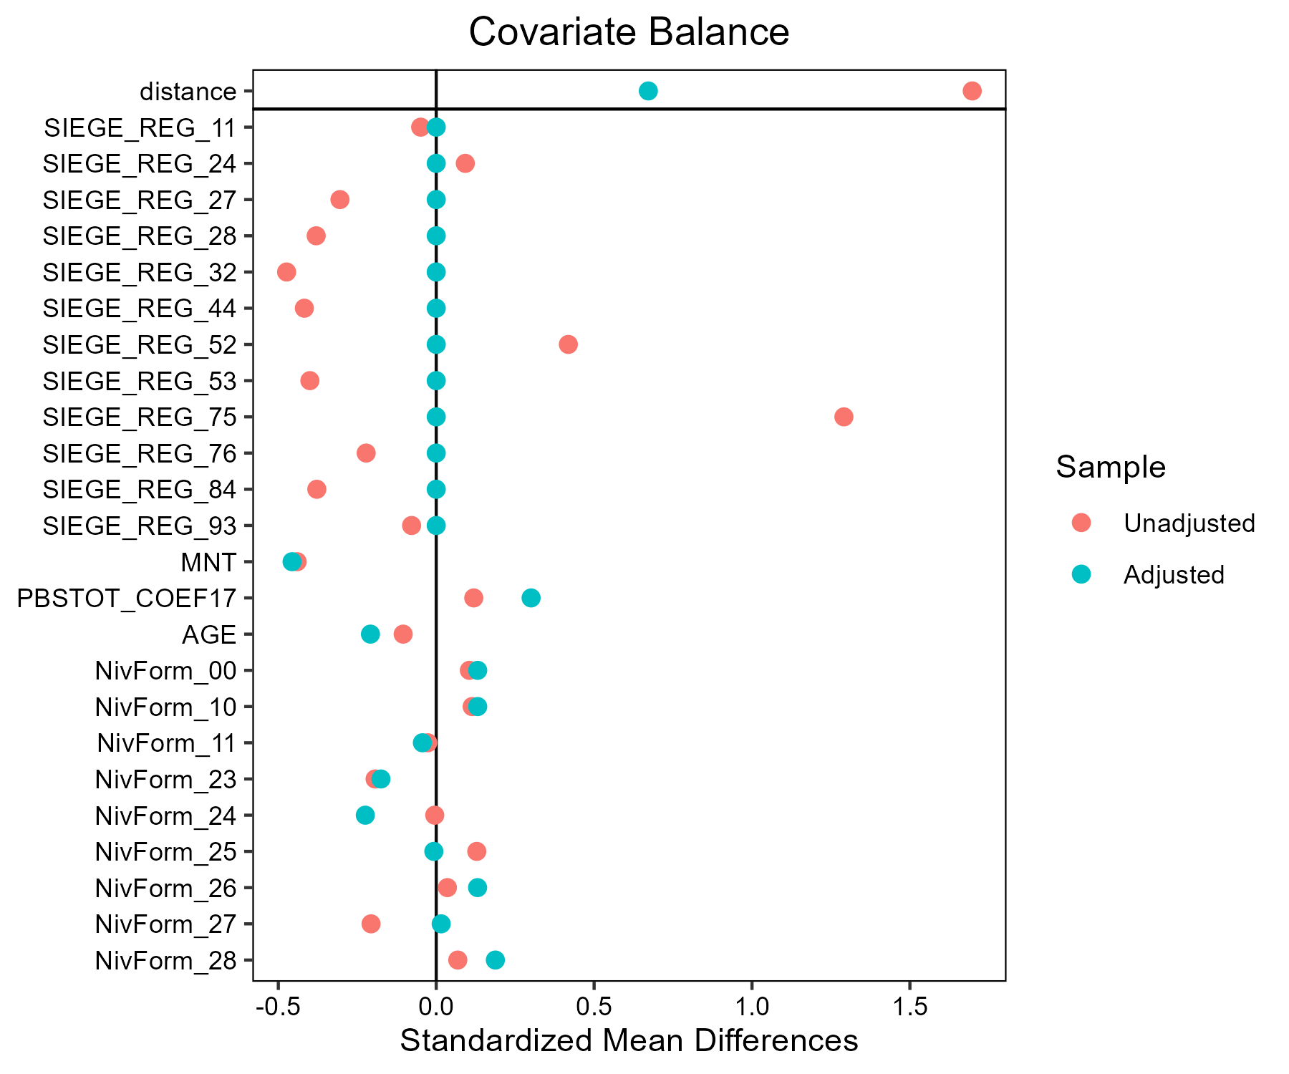

# Lait - Munster

## Covariate distribution before matching

|  |  | Lait - Conventionnel (N=882) / Mean | Lait - Conventionnel (N=882) / Std. Dev. | Lait - Munster (N=38) / Mean | Lait - Munster (N=38) / Std. Dev. | Diff. in Means | Std. Error |
| --- | --- | --- | --- | --- | --- | --- | --- |
| PBSTOT_COEF17 |  | 298723.1 | 173676.7 | 322218.0 | 153953.5 | 23494.8 | 25650.1 |
| AGE |  | 48.4 | 9.4 | 45.1 | 10.3 | -3.2 | 1.7 |
|  |  | N | Pct. | N | Pct. |  |  |
| SIEGE_REG | 11 | 2 | 0.2 | 0 | 0.0 |  |  |
|  | 24 | 27 | 3.1 | 0 | 0.0 |  |  |
|  | 27 | 71 | 8.0 | 4 | 10.5 |  |  |
|  | 28 | 106 | 12.0 | 0 | 0.0 |  |  |
|  | 32 | 155 | 17.6 | 0 | 0.0 |  |  |
|  | 44 | 125 | 14.2 | 34 | 89.5 |  |  |
|  | 52 | 87 | 9.9 | 0 | 0.0 |  |  |
|  | 53 | 116 | 13.2 | 0 | 0.0 |  |  |
|  | 75 | 44 | 5.0 | 0 | 0.0 |  |  |
|  | 76 | 39 | 4.4 | 0 | 0.0 |  |  |
|  | 84 | 105 | 11.9 | 0 | 0.0 |  |  |
|  | 93 | 5 | 0.6 | 0 | 0.0 |  |  |
| MNT | FALSE | 745 | 84.5 | 34 | 89.5 |  |  |
|  | TRUE | 137 | 15.5 | 4 | 10.5 |  |  |
| NivForm | 00 | 3 | 0.3 | 0 | 0.0 |  |  |
|  | 10 | 2 | 0.2 | 0 | 0.0 |  |  |
|  | 11 | 18 | 2.0 | 2 | 5.3 |  |  |
|  | 23 | 37 | 4.2 | 1 | 2.6 |  |  |
|  | 24 | 256 | 29.0 | 15 | 39.5 |  |  |
|  | 25 | 107 | 12.1 | 8 | 21.1 |  |  |
|  | 26 | 240 | 27.2 | 4 | 10.5 |  |  |
|  | 27 | 200 | 22.7 | 8 | 21.1 |  |  |
|  | 28 | 19 | 2.2 | 0 | 0.0 |  |  |

## Covariate distribution after matching

|  |  | Lait - Conventionnel (N=114) / Mean | Lait - Conventionnel (N=114) / Std. Dev. | Lait - Munster (N=38) / Mean | Lait - Munster (N=38) / Std. Dev. | Diff. in Means | Std. Error |
| --- | --- | --- | --- | --- | --- | --- | --- |
| PBSTOT_COEF17 |  | 306592.8 | 141576.4 | 322218.0 | 153953.5 | 15625.2 | 28276.3 |
| AGE |  | 46.5 | 11.2 | 45.1 | 10.3 | -1.4 | 2.0 |
|  |  | N | Pct. | N | Pct. |  |  |
| SIEGE_REG | 27 | 12 | 10.5 | 4 | 10.5 |  |  |
|  | 44 | 102 | 89.5 | 34 | 89.5 |  |  |
| MNT | FALSE | 109 | 95.6 | 34 | 89.5 |  |  |
|  | TRUE | 5 | 4.4 | 4 | 10.5 |  |  |
| NivForm | 11 | 5 | 4.4 | 2 | 5.3 |  |  |
|  | 23 | 5 | 4.4 | 1 | 2.6 |  |  |
|  | 24 | 45 | 39.5 | 15 | 39.5 |  |  |
|  | 25 | 15 | 13.2 | 8 | 21.1 |  |  |
|  | 26 | 17 | 14.9 | 4 | 10.5 |  |  |
|  | 27 | 27 | 23.7 | 8 | 21.1 |  |  |

## Matching model coefficients

| . | Estimate | Std. Error | t value | Pr(&gt;|t|) |
| --- | --- | --- | --- | --- |
| (Intercept) | -38.6102129365242 | 12914.6258216216 | -0.00298965014316428 | 0.997615272598206 |
| SIEGE_REG24 | 0.444104273124015 | 10936.6538259158 | 4.06069607937718e-05 | 0.999967609361678 |
| SIEGE_REG27 | 18.6180397823243 | 10567.1346053336 | 0.00176188157695343 | 0.998594614364946 |
| SIEGE_REG28 | 0.293051721903067 | 10662.5138046245 | 2.74842994131427e-05 | 0.999978076812828 |
| SIEGE_REG32 | 0.400314157861093 | 10632.0718008621 | 3.76515664452747e-05 | 0.999969966768081 |
| SIEGE_REG44 | 20.404382937204 | 10567.1346019669 | 0.00193092864866187 | 0.998459772133392 |
| SIEGE_REG52 | 0.335518848327597 | 10683.169296879 | 3.14063026620402e-05 | 0.999974948379027 |
| SIEGE_REG53 | 0.43391362667079 | 10654.5422304262 | 4.07256940079192e-05 | 0.999967514652679 |
| SIEGE_REG75 | -0.323177878258885 | 10790.1953164906 | -2.99510684264421e-05 | 0.999976109164392 |
| SIEGE_REG76 | -0.632337980913775 | 10816.9637357891 | -5.84579921278295e-05 | 0.999953370268484 |
| SIEGE_REG84 | -0.726954219329169 | 10662.1444486361 | -6.81808638807329e-05 | 0.999945614701071 |
| SIEGE_REG93 | -0.798040640100925 | 12410.1258054658 | -6.43056043597431e-05 | 0.999948705849162 |
| MNTTRUE | 1.19806868461347 | 0.358561429850455 | 3.34132057960932 | 0.000868254157842894 |
| PBSTOT_COEF17 | -9.54881117631564e-08 | 7.37380137753092e-07 | -0.129496452201877 | 0.89699386326403 |
| AGE | -0.0317491583974929 | 0.0117350767225517 | -2.70549218791893 | 0.00694969451969138 |
| NivForm10 | 0.285532507677573 | 12913.3241279328 | 2.21114644725705e-05 | 0.999982362520252 |
| NivForm11 | 19.1479908139715 | 7424.5017436493 | 0.00257902704788912 | 0.997942809852972 |
| NivForm23 | 18.2516981514123 | 7424.50175181424 | 0.00245830612767414 | 0.998039104063877 |
| NivForm24 | 18.813504433918 | 7424.50173285883 | 0.00253397535765323 | 0.997978745766472 |
| NivForm25 | 18.6716609391042 | 7424.50173907029 | 0.00251487057250556 | 0.997993984883117 |
| NivForm26 | 17.461948699824 | 7424.50173900435 | 0.00235193543131498 | 0.998123951703531 |
| NivForm27 | 18.0389858343462 | 7424.50173872816 | 0.00242965608590945 | 0.998061957051351 |
| NivForm28 | -0.218540513984932 | 7946.50647879813 | -2.75014579762836e-05 | 0.999978063126091 |

## Propensity score distribution

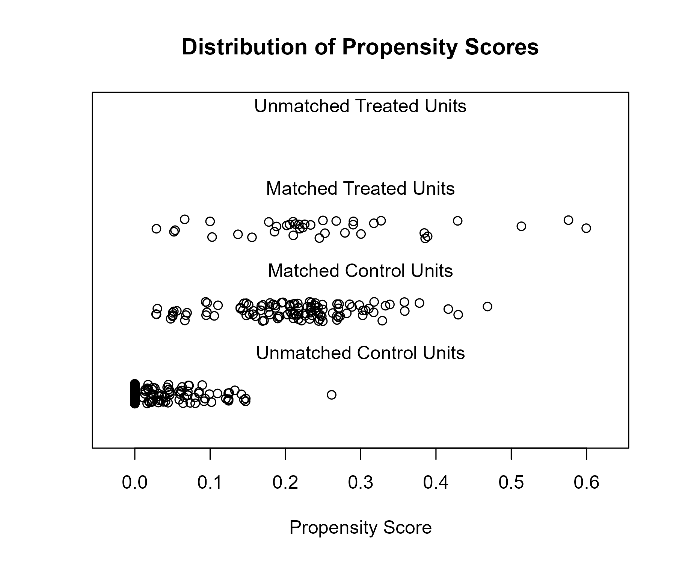

## Covariate balance

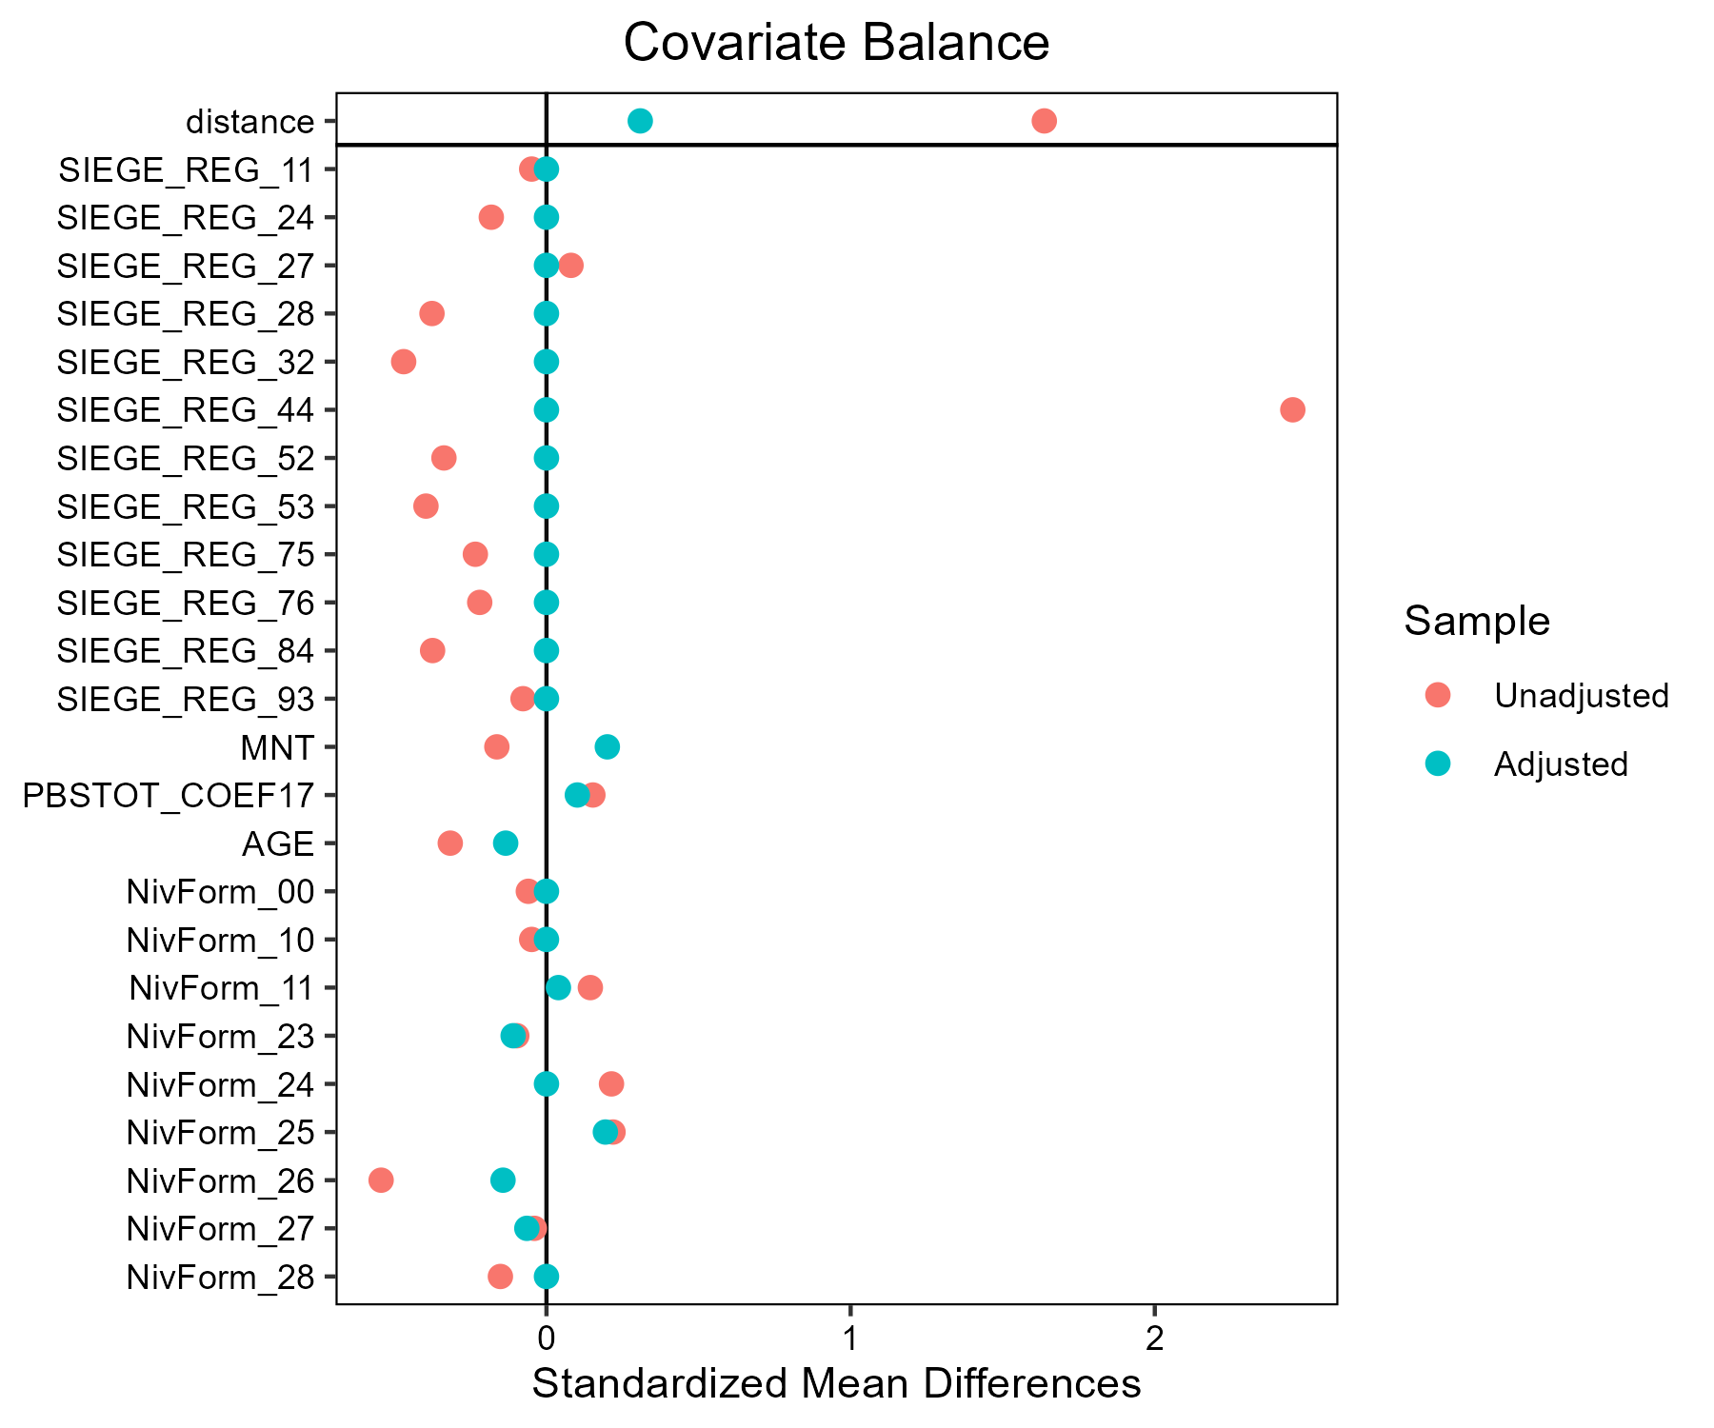

# Lait - Comte - Morbier

## Covariate distribution before matching

|  |  | Lait - Comte - Morbier (N=64) / Mean | Lait - Comte - Morbier (N=64) / Std. Dev. | Lait - Conventionnel (N=882) / Mean | Lait - Conventionnel (N=882) / Std. Dev. | Diff. in Means | Std. Error |
| --- | --- | --- | --- | --- | --- | --- | --- |
| PBSTOT_COEF17 |  | 250182.3 | 151211.2 | 298723.1 | 173676.7 | 48540.8 | 19785.4 |
| AGE |  | 46.0 | 9.7 | 48.4 | 9.4 | 2.3 | 1.2 |
|  |  | N | Pct. | N | Pct. |  |  |
| SIEGE_REG | 11 | 0 | 0.0 | 2 | 0.2 |  |  |
|  | 24 | 0 | 0.0 | 27 | 3.1 |  |  |
|  | 27 | 63 | 98.4 | 71 | 8.0 |  |  |
|  | 28 | 0 | 0.0 | 106 | 12.0 |  |  |
|  | 32 | 0 | 0.0 | 155 | 17.6 |  |  |
|  | 44 | 0 | 0.0 | 125 | 14.2 |  |  |
|  | 52 | 0 | 0.0 | 87 | 9.9 |  |  |
|  | 53 | 0 | 0.0 | 116 | 13.2 |  |  |
|  | 75 | 0 | 0.0 | 44 | 5.0 |  |  |
|  | 76 | 0 | 0.0 | 39 | 4.4 |  |  |
|  | 84 | 1 | 1.6 | 105 | 11.9 |  |  |
|  | 93 | 0 | 0.0 | 5 | 0.6 |  |  |
| MNT | FALSE | 36 | 56.2 | 745 | 84.5 |  |  |
|  | TRUE | 28 | 43.8 | 137 | 15.5 |  |  |
| NivForm | 00 | 0 | 0.0 | 3 | 0.3 |  |  |
|  | 10 | 0 | 0.0 | 2 | 0.2 |  |  |
|  | 11 | 0 | 0.0 | 18 | 2.0 |  |  |
|  | 23 | 3 | 4.7 | 37 | 4.2 |  |  |
|  | 24 | 14 | 21.9 | 256 | 29.0 |  |  |
|  | 25 | 9 | 14.1 | 107 | 12.1 |  |  |
|  | 26 | 21 | 32.8 | 240 | 27.2 |  |  |
|  | 27 | 14 | 21.9 | 200 | 22.7 |  |  |
|  | 28 | 3 | 4.7 | 19 | 2.2 |  |  |

## Covariate distribution after matching

|  |  | Lait - Comte - Morbier (N=64) / Mean | Lait - Comte - Morbier (N=64) / Std. Dev. | Lait - Conventionnel (N=74) / Mean | Lait - Conventionnel (N=74) / Std. Dev. | Diff. in Means | Std. Error |
| --- | --- | --- | --- | --- | --- | --- | --- |
| PBSTOT_COEF17 |  | 250182.3 | 151211.2 | 287653.6 | 129773.1 | 37471.3 | 24183.6 |
| AGE |  | 46.0 | 9.7 | 45.4 | 10.2 | -0.6 | 1.7 |
|  |  | N | Pct. | N | Pct. |  |  |
| SIEGE_REG | 27 | 63 | 98.4 | 71 | 95.9 |  |  |
|  | 84 | 1 | 1.6 | 3 | 4.1 |  |  |
| MNT | FALSE | 36 | 56.2 | 64 | 86.5 |  |  |
|  | TRUE | 28 | 43.8 | 10 | 13.5 |  |  |
| NivForm | 10 | 0 | 0.0 | 2 | 2.7 |  |  |
|  | 11 | 0 | 0.0 | 2 | 2.7 |  |  |
|  | 23 | 3 | 4.7 | 5 | 6.8 |  |  |
|  | 24 | 14 | 21.9 | 14 | 18.9 |  |  |
|  | 25 | 9 | 14.1 | 14 | 18.9 |  |  |
|  | 26 | 21 | 32.8 | 23 | 31.1 |  |  |
|  | 27 | 14 | 21.9 | 13 | 17.6 |  |  |
|  | 28 | 3 | 4.7 | 1 | 1.4 |  |  |

## Matching model coefficients

| . | Estimate | Std. Error | t value | Pr(&gt;|t|) |
| --- | --- | --- | --- | --- |
| (Intercept) | -22.0189162388739 | 12311.9259681349 | -0.00178842175431059 | 0.998573433101855 |
| SIEGE_REG24 | 0.0264804269369155 | 9863.91464472013 | 2.68457583937932e-06 | 0.999997858598475 |
| SIEGE_REG27 | 21.1061295143426 | 9522.98365695597 | 0.00221633579082391 | 0.998232100251118 |
| SIEGE_REG28 | 0.15571587014001 | 9609.47039096812 | 1.62044174969691e-05 | 0.999987074246953 |
| SIEGE_REG32 | -0.0340305726904883 | 9583.17610514829 | -3.55107454116452e-06 | 0.999997167419774 |
| SIEGE_REG44 | 0.00759441408756508 | 9595.57568080052 | 7.91449553439561e-07 | 0.999999368685639 |
| SIEGE_REG52 | 0.0517894522935822 | 9629.63005478605 | 5.37813519303809e-06 | 0.999995710031084 |
| SIEGE_REG53 | 0.016471580121735 | 9603.13523488676 | 1.71522942443799e-06 | 0.999998631815555 |
| SIEGE_REG75 | -0.815436135366133 | 9709.6876218813 | -8.39817064277644e-05 | 0.999933010440102 |
| SIEGE_REG76 | -1.5219414243241 | 9741.44979962064 | -0.000156233564369789 | 0.999875377410947 |
| SIEGE_REG84 | 15.0486401348111 | 9522.98367035634 | 0.00158024424442261 | 0.998739489503292 |
| SIEGE_REG93 | -2.22224748729139 | 11252.7249291262 | -0.000197485275903208 | 0.999842472221496 |
| MNTTRUE | 1.8417520485949 | 0.231396340959069 | 7.95929633528943 | 5.05762799424875e-15 |
| PBSTOT_COEF17 | -1.42386711128695e-06 | 7.13747510111284e-07 | -1.99491709759513 | 0.0463455813395752 |
| AGE | 0.0144013757804046 | 0.0101027407691337 | 1.42549196396331 | 0.154353120118707 |
| NivForm10 | -21.1991380481973 | 12311.1051405925 | -0.00172195248160938 | 0.998626453463701 |
| NivForm11 | -18.3596813222837 | 8213.33748460275 | -0.00223534968052901 | 0.998216933508261 |
| NivForm23 | -0.236456940850288 | 7803.60834694422 | -3.03009749256421e-05 | 0.999975829867442 |
| NivForm24 | -0.0741342033609291 | 7803.60834059491 | -9.49999027696942e-06 | 0.999992422157211 |
| NivForm25 | -0.272488161955758 | 7803.60834334393 | -3.49182262828677e-05 | 0.999972146831579 |
| NivForm26 | 0.398320620679658 | 7803.60834027129 | 5.10431332931056e-05 | 0.999959284501553 |
| NivForm27 | 0.251771860162406 | 7803.60834138894 | 3.2263518253095e-05 | 0.999974264408493 |
| NivForm28 | 1.38820392566192 | 7803.60835366715 | 0.000177892567482524 | 0.999858100707133 |

## Propensity score distribution

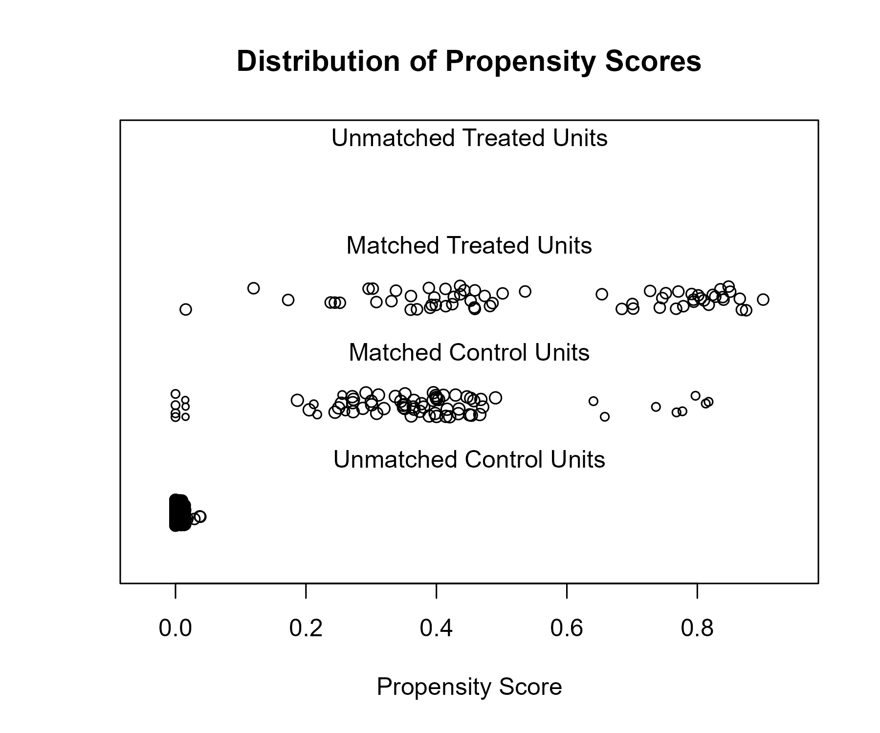

## Covariate balance

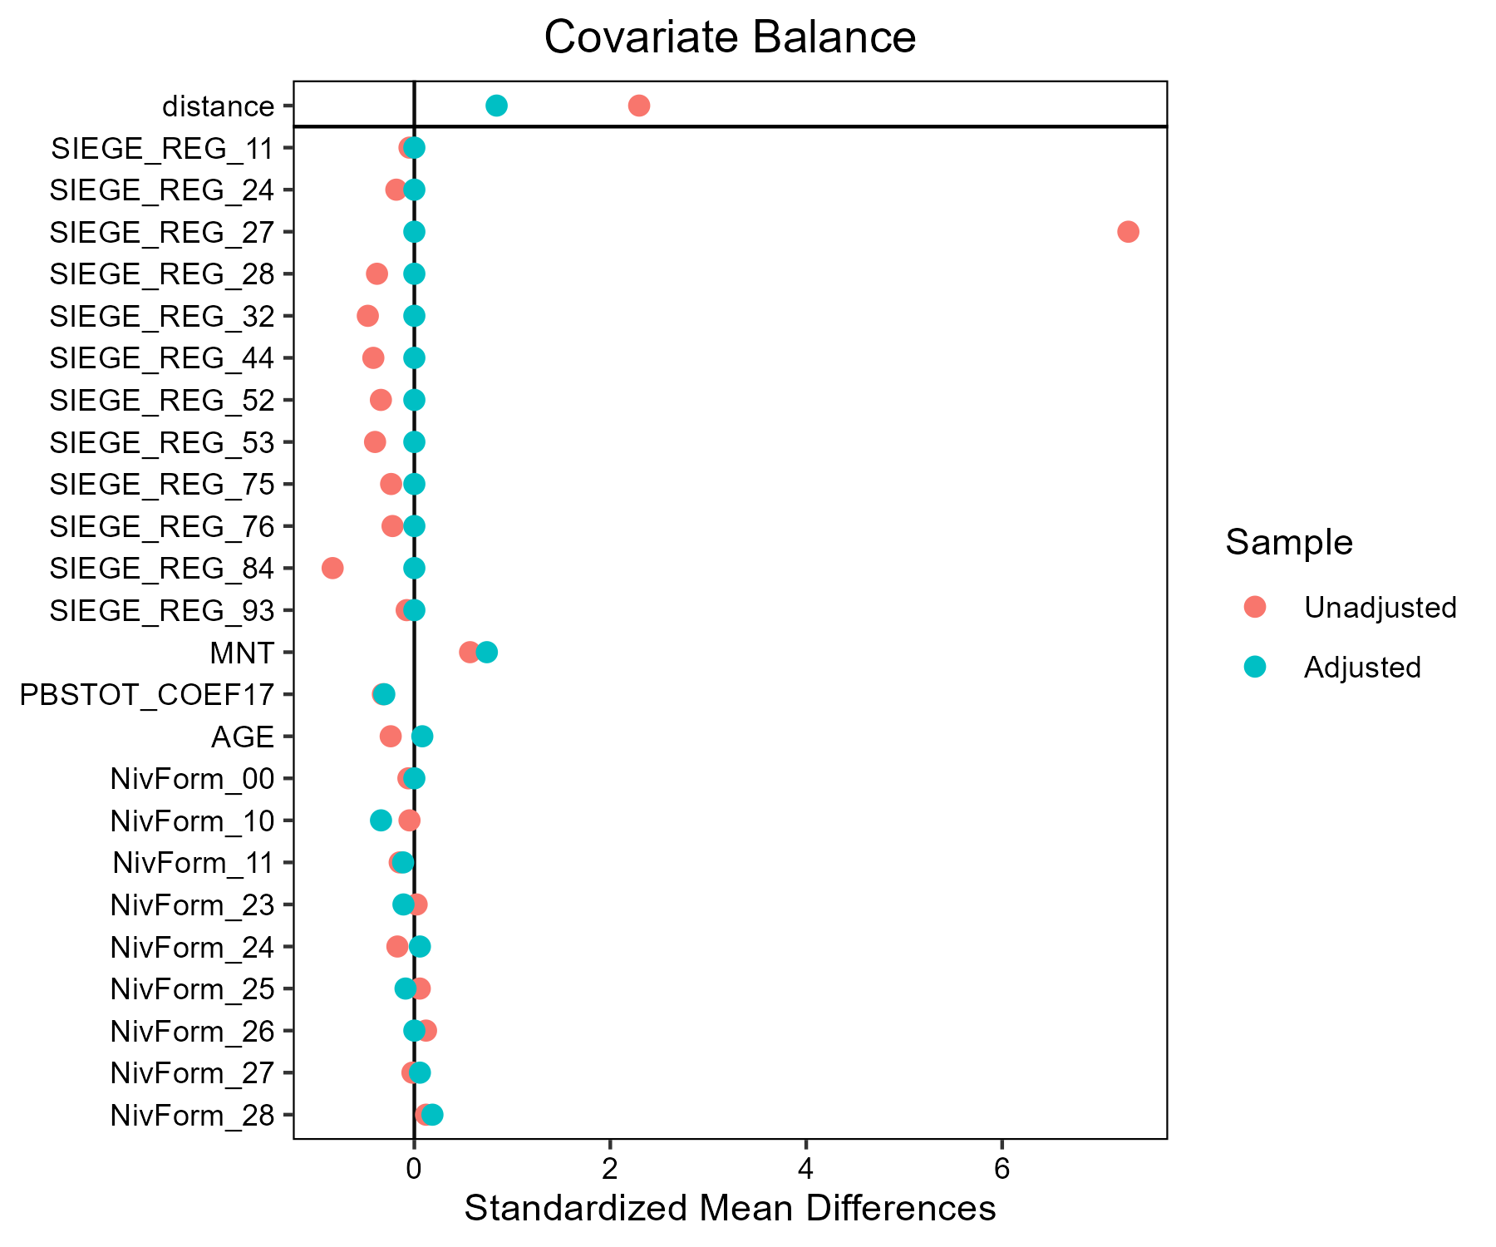

# Lait - Fromages de Savoie

## Covariate distribution before matching

|  |  | Lait - Conventionnel (N=882) / Mean | Lait - Conventionnel (N=882) / Std. Dev. | Lait - Fromages de Savoie (N=33) / Mean | Lait - Fromages de Savoie (N=33) / Std. Dev. | Diff. in Means | Std. Error |
| --- | --- | --- | --- | --- | --- | --- | --- |
| PBSTOT_COEF17 |  | 298723.1 | 173676.7 | 219212.4 | 128062.6 | -79510.7 | 23047.1 |
| AGE |  | 48.4 | 9.4 | 46.3 | 9.2 | -2.0 | 1.6 |
|  |  | N | Pct. | N | Pct. |  |  |
| SIEGE_REG | 11 | 2 | 0.2 | 0 | 0.0 |  |  |
|  | 24 | 27 | 3.1 | 0 | 0.0 |  |  |
|  | 27 | 71 | 8.0 | 0 | 0.0 |  |  |
|  | 28 | 106 | 12.0 | 0 | 0.0 |  |  |
|  | 32 | 155 | 17.6 | 0 | 0.0 |  |  |
|  | 44 | 125 | 14.2 | 0 | 0.0 |  |  |
|  | 52 | 87 | 9.9 | 0 | 0.0 |  |  |
|  | 53 | 116 | 13.2 | 0 | 0.0 |  |  |
|  | 75 | 44 | 5.0 | 0 | 0.0 |  |  |
|  | 76 | 39 | 4.4 | 0 | 0.0 |  |  |
|  | 84 | 105 | 11.9 | 33 | 100.0 |  |  |
|  | 93 | 5 | 0.6 | 0 | 0.0 |  |  |
| MNT | FALSE | 745 | 84.5 | 5 | 15.2 |  |  |
|  | TRUE | 137 | 15.5 | 28 | 84.8 |  |  |
| NivForm | 00 | 3 | 0.3 | 0 | 0.0 |  |  |
|  | 10 | 2 | 0.2 | 0 | 0.0 |  |  |
|  | 11 | 18 | 2.0 | 1 | 3.0 |  |  |
|  | 23 | 37 | 4.2 | 3 | 9.1 |  |  |
|  | 24 | 256 | 29.0 | 9 | 27.3 |  |  |
|  | 25 | 107 | 12.1 | 6 | 18.2 |  |  |
|  | 26 | 240 | 27.2 | 8 | 24.2 |  |  |
|  | 27 | 200 | 22.7 | 6 | 18.2 |  |  |
|  | 28 | 19 | 2.2 | 0 | 0.0 |  |  |

## Covariate distribution after matching

|  |  | Lait - Conventionnel (N=99) / Mean | Lait - Conventionnel (N=99) / Std. Dev. | Lait - Fromages de Savoie (N=33) / Mean | Lait - Fromages de Savoie (N=33) / Std. Dev. | Diff. in Means | Std. Error |
| --- | --- | --- | --- | --- | --- | --- | --- |
| PBSTOT_COEF17 |  | 196315.1 | 121981.0 | 219212.4 | 128062.6 | 22897.4 | 25441.4 |
| AGE |  | 48.1 | 10.3 | 46.3 | 9.2 | -1.8 | 1.9 |
|  |  | N | Pct. | N | Pct. |  |  |
|  | 84 | 99 | 100.0 | 33 | 100.0 |  |  |
| MNT | FALSE | 18 | 18.2 | 5 | 15.2 |  |  |
|  | TRUE | 81 | 81.8 | 28 | 84.8 |  |  |
| NivForm | 11 | 2 | 2.0 | 1 | 3.0 |  |  |
|  | 23 | 6 | 6.1 | 3 | 9.1 |  |  |
|  | 24 | 36 | 36.4 | 9 | 27.3 |  |  |
|  | 25 | 9 | 9.1 | 6 | 18.2 |  |  |
|  | 26 | 26 | 26.3 | 8 | 24.2 |  |  |
|  | 27 | 20 | 20.2 | 6 | 18.2 |  |  |

## Matching model coefficients

| . | Estimate | Std. Error | t value | Pr(&gt;|t|) |
| --- | --- | --- | --- | --- |
| (Intercept) | -20.5201367951754 | 10454.5678657873 | -0.00196279148584686 | 0.998434358846239 |
| SIEGE_REG24 | -0.51934523682476 | 8370.29428608531 | -6.20462338687559e-05 | 0.99995050814095 |
| SIEGE_REG27 | -0.653781718034122 | 8200.09427724588 | -7.97285611518243e-05 | 0.999936403638656 |
| SIEGE_REG28 | -0.534387454035891 | 8161.70837637995 | -6.54749507569288e-05 | 0.999947773187317 |
| SIEGE_REG32 | -0.30337652880462 | 8138.0998858948 | -3.72785457365105e-05 | 0.999970264359061 |
| SIEGE_REG44 | -0.500561130602502 | 8149.90642307804 | -6.14192488376389e-05 | 0.999951008262437 |
| SIEGE_REG52 | -0.542752304146795 | 8176.90446323075 | -6.6376256025419e-05 | 0.999947054251284 |
| SIEGE_REG53 | -0.56035816250023 | 8153.41913392121 | -6.87267701189228e-05 | 0.999945179337937 |
| SIEGE_REG75 | -0.511249583269329 | 8264.69168348343 | -6.18594864574363e-05 | 0.999950657102071 |
| SIEGE_REG76 | -0.447649450870778 | 8287.03863239065 | -5.40180238959064e-05 | 0.999956911930692 |
| SIEGE_REG84 | 19.7251175049274 | 8087.82881241809 | 0.00243886436797987 | 0.998054615013661 |
| SIEGE_REG93 | -0.39891203415416 | 9566.95663214966 | -4.16968582060486e-05 | 0.999966740043654 |
| MNTTRUE | 0.612335598232016 | 0.235597718806969 | 2.59907269617376 | 0.00950195888454441 |
| PBSTOT_COEF17 | 2.05389824123255e-06 | 7.39860342111285e-07 | 2.77606208135374 | 0.00561737339010648 |
| AGE | -0.019733165515041 | 0.00954472258836566 | -2.0674425403515 | 0.0389803938252584 |
| NivForm10 | 0.331767709627062 | 10544.4375910574 | 3.1463765303939e-05 | 0.999974902582457 |
| NivForm11 | 0.683774344765181 | 6624.57654740621 | 0.000103217819263166 | 0.999917667174329 |
| NivForm23 | 0.350828913406091 | 6624.57653590934 | 5.29586927563415e-05 | 0.999957756917795 |
| NivForm24 | -0.441359644565344 | 6624.57653204697 | -6.66245823306937e-05 | 0.999946856171083 |
| NivForm25 | 0.233745195829684 | 6624.57653475222 | 3.52845490732075e-05 | 0.999971854892372 |
| NivForm26 | -0.488457080481796 | 6624.57653271599 | -7.3734083691163e-05 | 0.999941185199347 |
| NivForm27 | -0.69607059988001 | 6624.57653432527 | -0.000105073976619233 | 0.999916186590061 |
| NivForm28 | -18.5900361240772 | 6958.53630530859 | -0.00267154403001319 | 0.997869016135777 |

## Propensity score distribution

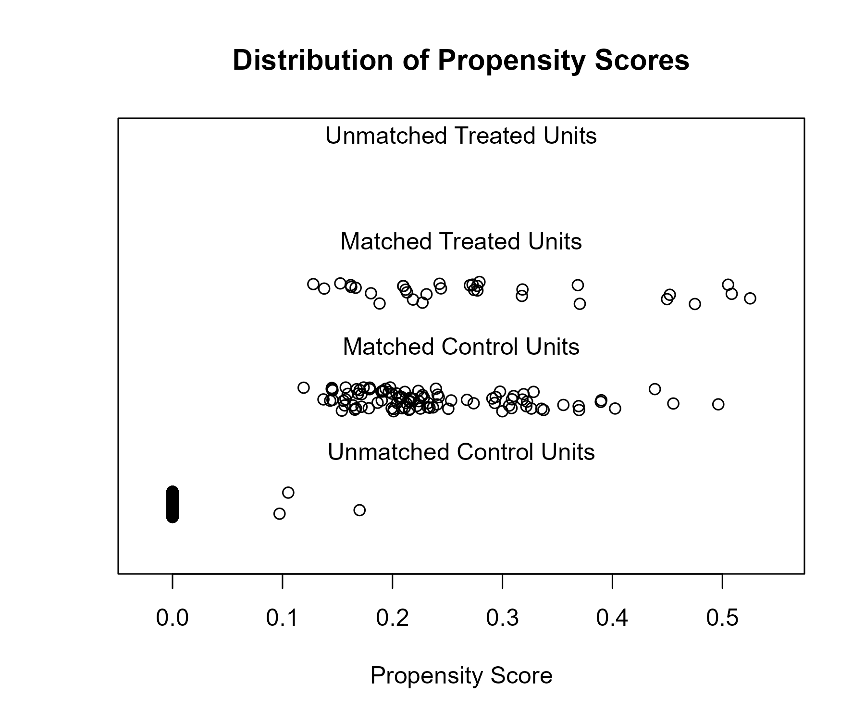

## Covariate balance

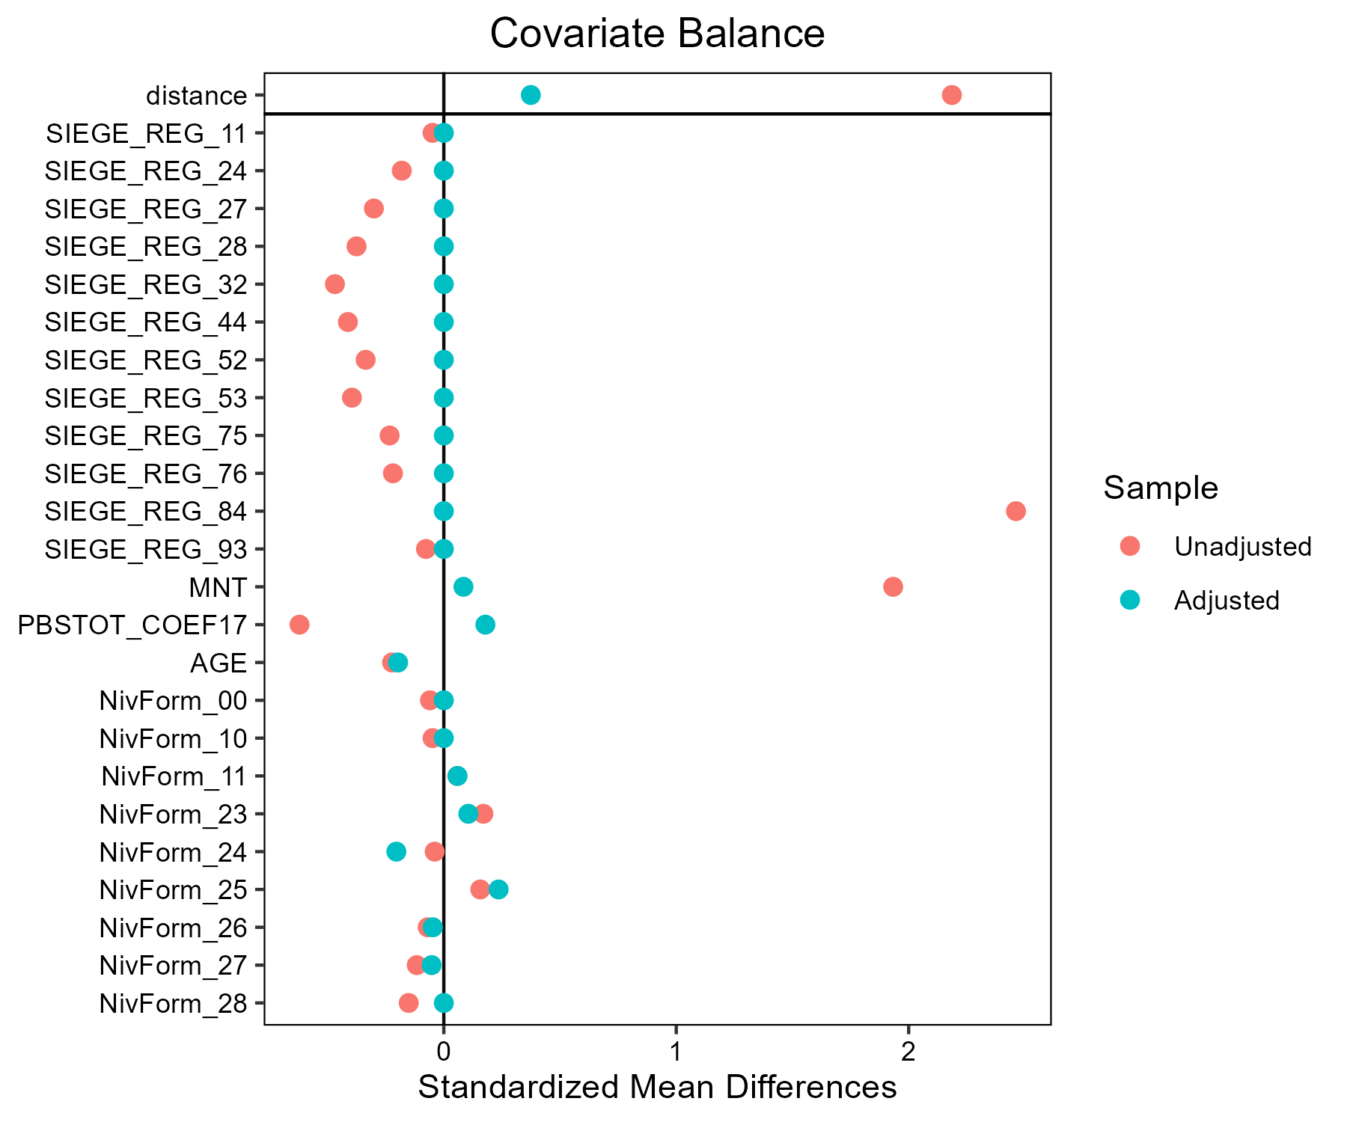

# Mais_fourrage - AB

## Covariate distribution before matching

|  |  | Mais_fourrage - AB (N=44) / Mean | Mais_fourrage - AB (N=44) / Std. Dev. | Mais_fourrage - Conventionnel (N=1806) / Mean | Mais_fourrage - Conventionnel (N=1806) / Std. Dev. | Diff. in Means | Std. Error |
| --- | --- | --- | --- | --- | --- | --- | --- |
| PBSTOT_COEF17 |  | 286124.5 | 215756.3 | 297542.8 | 254804.4 | 11418.3 | 33074.5 |
| AGE |  | 48.0 | 9.1 | 48.4 | 9.7 | 0.4 | 1.4 |
|  |  | N | Pct. | N | Pct. |  |  |
| SIEGE_REG | 11 | 0 | 0.0 | 5 | 0.3 |  |  |
|  | 24 | 0 | 0.0 | 57 | 3.2 |  |  |
|  | 27 | 1 | 2.3 | 137 | 7.6 |  |  |
|  | 28 | 4 | 9.1 | 188 | 10.4 |  |  |
|  | 32 | 4 | 9.1 | 247 | 13.7 |  |  |
|  | 44 | 4 | 9.1 | 239 | 13.2 |  |  |
|  | 52 | 8 | 18.2 | 209 | 11.6 |  |  |
|  | 53 | 10 | 22.7 | 193 | 10.7 |  |  |
|  | 75 | 3 | 6.8 | 246 | 13.6 |  |  |
|  | 76 | 3 | 6.8 | 63 | 3.5 |  |  |
|  | 84 | 7 | 15.9 | 219 | 12.1 |  |  |
|  | 93 | 0 | 0.0 | 3 | 0.2 |  |  |
| MNT | FALSE | 36 | 81.8 | 1565 | 86.7 |  |  |
|  | TRUE | 8 | 18.2 | 241 | 13.3 |  |  |
| NivForm | 00 | 0 | 0.0 | 8 | 0.4 |  |  |
|  | 10 | 0 | 0.0 | 8 | 0.4 |  |  |
|  | 11 | 0 | 0.0 | 38 | 2.1 |  |  |
|  | 23 | 0 | 0.0 | 68 | 3.8 |  |  |
|  | 24 | 10 | 22.7 | 546 | 30.2 |  |  |
|  | 25 | 4 | 9.1 | 225 | 12.5 |  |  |
|  | 26 | 15 | 34.1 | 470 | 26.0 |  |  |
|  | 27 | 12 | 27.3 | 397 | 22.0 |  |  |
|  | 28 | 3 | 6.8 | 46 | 2.5 |  |  |

## Covariate distribution after matching

|  |  | Mais_fourrage - AB (N=44) / Mean | Mais_fourrage - AB (N=44) / Std. Dev. | Mais_fourrage - Conventionnel (N=132) / Mean | Mais_fourrage - Conventionnel (N=132) / Std. Dev. | Diff. in Means | Std. Error |
| --- | --- | --- | --- | --- | --- | --- | --- |
| PBSTOT_COEF17 |  | 286124.5 | 215756.3 | 296323.1 | 209534.1 | 10198.6 | 37290.5 |
| AGE |  | 48.0 | 9.1 | 48.8 | 9.0 | 0.9 | 1.6 |
|  |  | N | Pct. | N | Pct. |  |  |
| SIEGE_REG | 27 | 1 | 2.3 | 3 | 2.3 |  |  |
|  | 28 | 4 | 9.1 | 12 | 9.1 |  |  |
|  | 32 | 4 | 9.1 | 12 | 9.1 |  |  |
|  | 44 | 4 | 9.1 | 12 | 9.1 |  |  |
|  | 52 | 8 | 18.2 | 24 | 18.2 |  |  |
|  | 53 | 10 | 22.7 | 30 | 22.7 |  |  |
|  | 75 | 3 | 6.8 | 9 | 6.8 |  |  |
|  | 76 | 3 | 6.8 | 9 | 6.8 |  |  |
|  | 84 | 7 | 15.9 | 21 | 15.9 |  |  |
| MNT | FALSE | 36 | 81.8 | 107 | 81.1 |  |  |
|  | TRUE | 8 | 18.2 | 25 | 18.9 |  |  |
| NivForm | 24 | 10 | 22.7 | 28 | 21.2 |  |  |
|  | 25 | 4 | 9.1 | 14 | 10.6 |  |  |
|  | 26 | 15 | 34.1 | 47 | 35.6 |  |  |
|  | 27 | 12 | 27.3 | 35 | 26.5 |  |  |
|  | 28 | 3 | 6.8 | 8 | 6.1 |  |  |

## Matching model coefficients

| . | Estimate | Std. Error | t value | Pr(&gt;|t|) |
| --- | --- | --- | --- | --- |
| (Intercept) | -35.649424154585 | 5617.99750857784 | -0.00634557493130847 | 0.994937690484877 |
| SIEGE_REG24 | -0.547482503439581 | 4568.78784314327 | -0.000119831019131525 | 0.999904401762366 |
| SIEGE_REG27 | 14.190585200859 | 4374.06712166633 | 0.00324425410176443 | 0.997411818465682 |
| SIEGE_REG28 | 15.3519947353995 | 4374.06704444489 | 0.00350977581719894 | 0.997199992985091 |
| SIEGE_REG32 | 14.8815825819536 | 4374.06704435502 | 0.00340223010553967 | 0.99728578979431 |
| SIEGE_REG44 | 15.0353789215255 | 4374.06704240892 | 0.00343739105408067 | 0.997257739419039 |
| SIEGE_REG52 | 15.8726938438575 | 4374.0670321017 | 0.00362881815193189 | 0.997105024545563 |
| SIEGE_REG53 | 16.1030003295123 | 4374.06703088012 | 0.00368147086357571 | 0.99706301978882 |
| SIEGE_REG75 | 14.6156044421014 | 4374.06705365999 | 0.00334142212791909 | 0.997334300626366 |
| SIEGE_REG76 | 15.8858517028924 | 4374.06706377616 | 0.0036318262777567 | 0.997102624752637 |
| SIEGE_REG84 | 15.3721360042655 | 4374.06705564889 | 0.00351438050873343 | 0.99719631949818 |
| SIEGE_REG93 | -0.599538891873176 | 7318.1127128941 | -8.19253426934546e-05 | 0.999934641977964 |
| MNTTRUE | 0.349041591851375 | 0.585712125005841 | 0.595926867397347 | 0.551297901189486 |
| PBSTOT_COEF17 | -8.21275800248825e-07 | 8.0233306111979e-07 | -1.02360957069698 | 0.306155234428757 |
| AGE | 0.00934277769399671 | 0.018646919170112 | 0.501035994673675 | 0.616406148453448 |
| NivForm10 | 0.618592237876149 | 4932.99136972565 | 0.000125399010765055 | 0.99989995975571 |
| NivForm11 | 0.353251477587005 | 3879.97077976392 | 9.10448809123503e-05 | 0.999927366634844 |
| NivForm23 | 0.516400546775373 | 3723.46732737667 | 0.000138688083276186 | 0.999889358060815 |
| NivForm24 | 15.9843915921221 | 3525.54009256067 | 0.00453388450349809 | 0.996382990926754 |
| NivForm25 | 16.0997699524475 | 3525.54012382019 | 0.00456661089847481 | 0.996356882884713 |
| NivForm26 | 16.5801017638212 | 3525.54009372638 | 0.00470285440614478 | 0.996248192335534 |
| NivForm27 | 16.6165058543648 | 3525.54010157539 | 0.00471318021512213 | 0.996239954750609 |
| NivForm28 | 17.4870999981008 | 3525.54013759219 | 0.00496011939039895 | 0.996042955060074 |

## Propensity score distribution

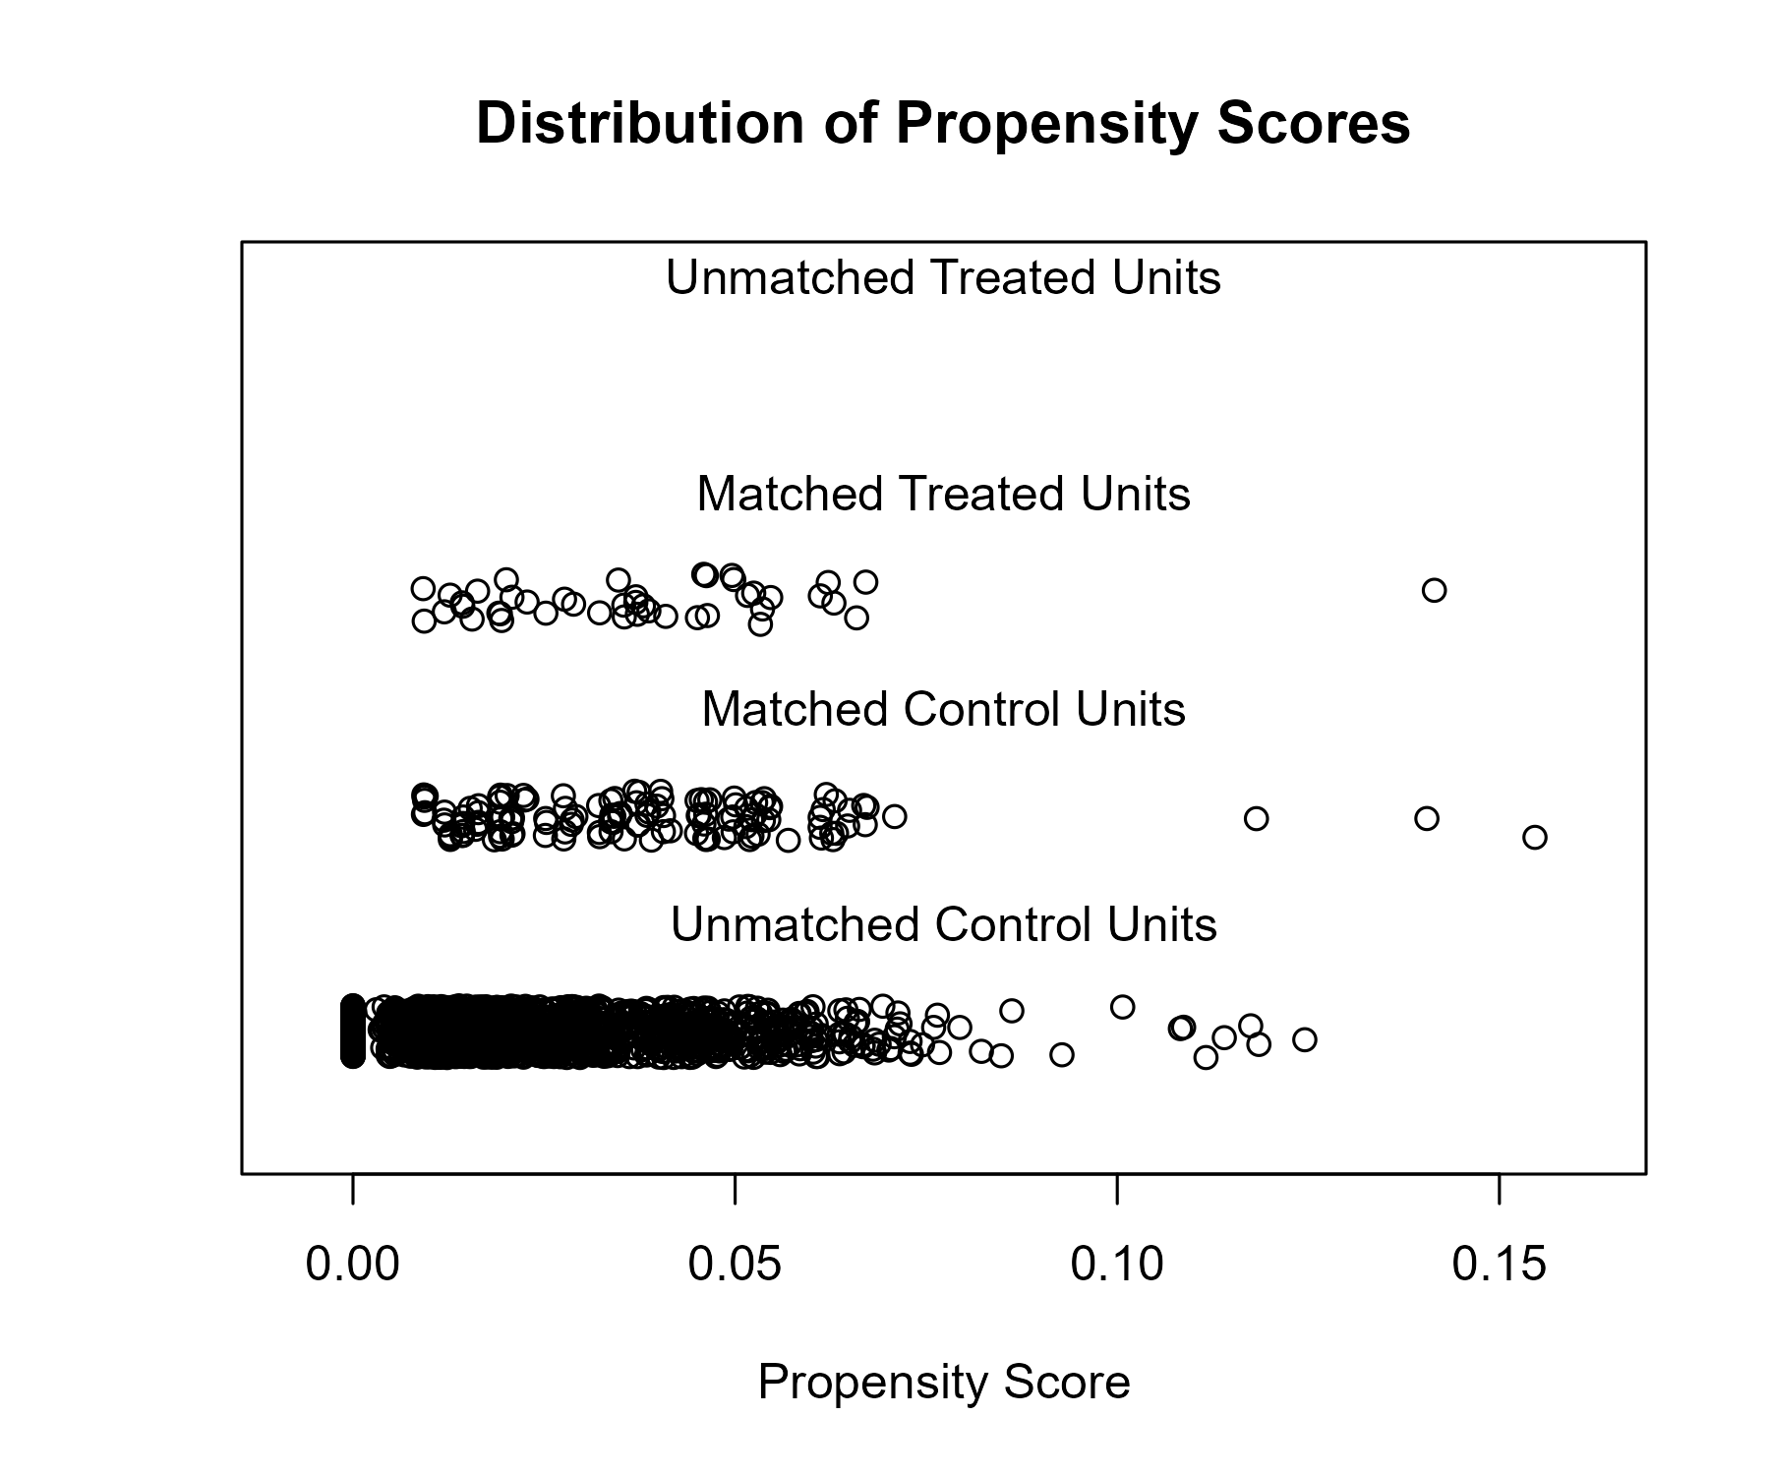

## Covariate balance

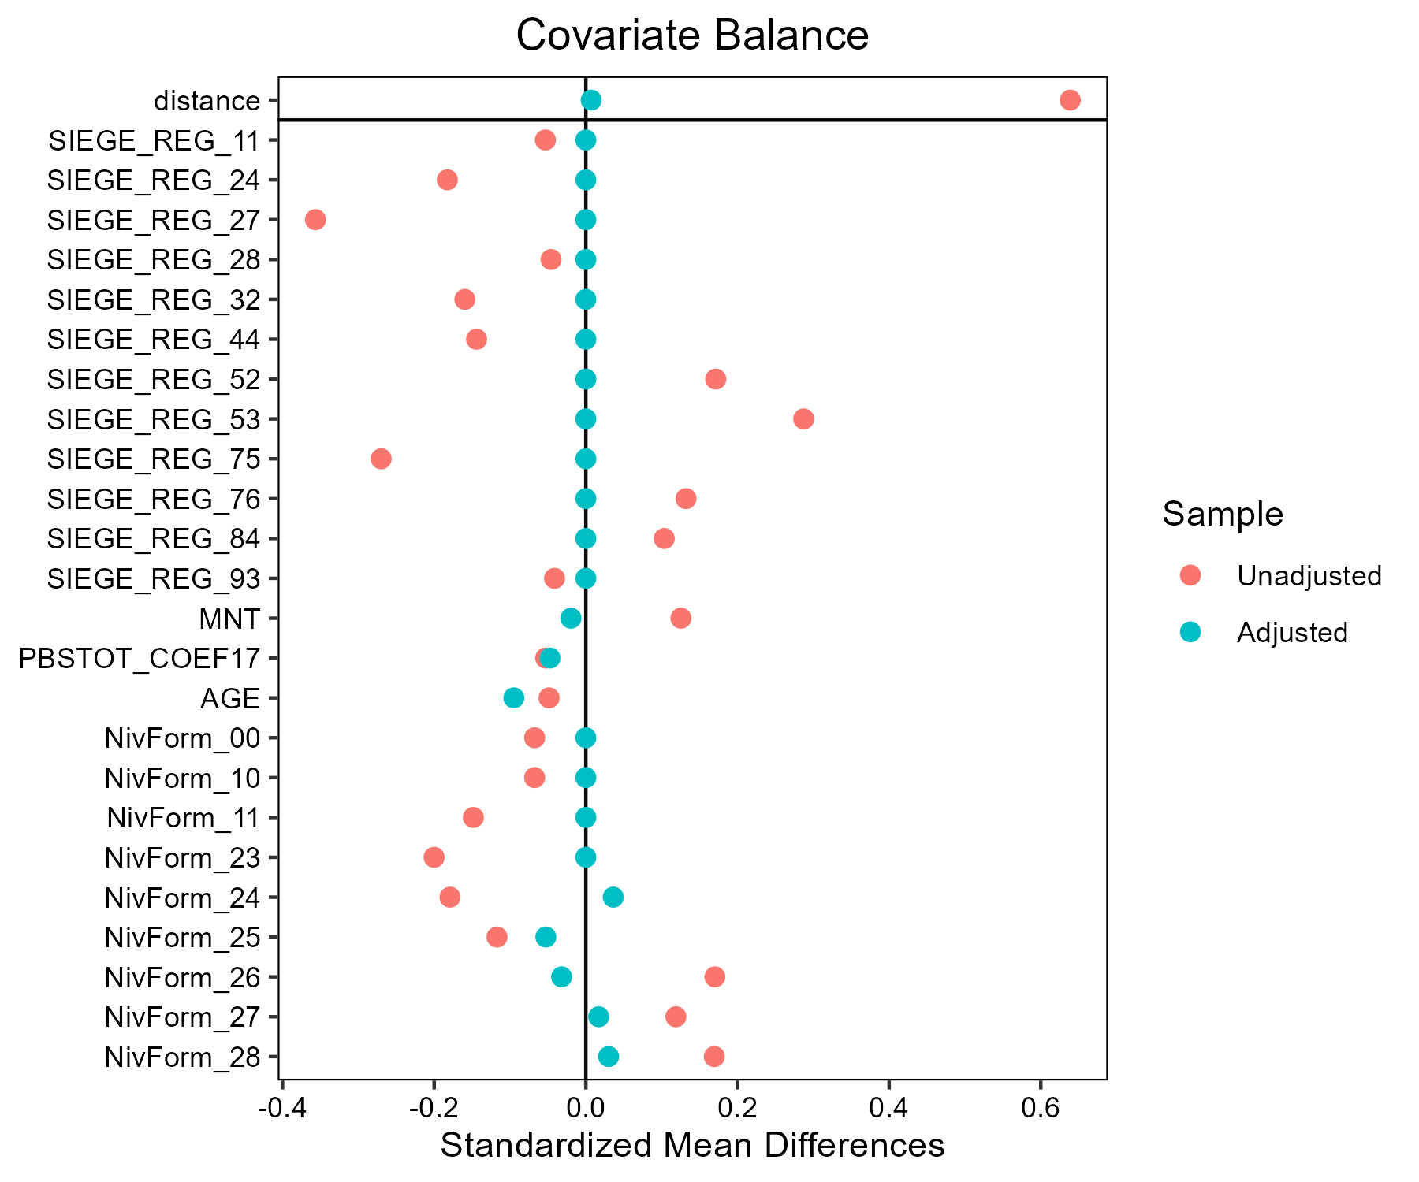

# Mais_grain - AB

## Covariate distribution before matching

|  |  | Mais_grain - AB (N=37) / Mean | Mais_grain - AB (N=37) / Std. Dev. | Mais_grain - Conventionnel (N=1656) / Mean | Mais_grain - Conventionnel (N=1656) / Std. Dev. | Diff. in Means | Std. Error |
| --- | --- | --- | --- | --- | --- | --- | --- |
| PBSTOT_COEF17 |  | 275796.8 | 249938.0 | 346855.5 | 467662.5 | 71058.7 | 42666.4 |
| AGE |  | 48.8 | 9.6 | 49.7 | 10.4 | 0.9 | 1.6 |
|  |  | N | Pct. | N | Pct. |  |  |
| SIEGE_REG | 11 | 5 | 13.5 | 61 | 3.7 |  |  |
|  | 24 | 1 | 2.7 | 106 | 6.4 |  |  |
|  | 27 | 1 | 2.7 | 100 | 6.0 |  |  |
|  | 28 | 2 | 5.4 | 71 | 4.3 |  |  |
|  | 32 | 0 | 0.0 | 138 | 8.3 |  |  |
|  | 44 | 5 | 13.5 | 173 | 10.4 |  |  |
|  | 52 | 4 | 10.8 | 121 | 7.3 |  |  |
|  | 53 | 3 | 8.1 | 195 | 11.8 |  |  |
|  | 75 | 9 | 24.3 | 394 | 23.8 |  |  |
|  | 76 | 5 | 13.5 | 120 | 7.2 |  |  |
|  | 84 | 2 | 5.4 | 173 | 10.4 |  |  |
|  | 93 | 0 | 0.0 | 3 | 0.2 |  |  |
|  | 94 | 0 | 0.0 | 1 | 0.1 |  |  |
| MNT | FALSE | 35 | 94.6 | 1600 | 96.6 |  |  |
|  | TRUE | 2 | 5.4 | 56 | 3.4 |  |  |
| NivForm | 00 | 0 | 0.0 | 8 | 0.5 |  |  |
|  | 10 | 0 | 0.0 | 10 | 0.6 |  |  |
|  | 11 | 0 | 0.0 | 45 | 2.7 |  |  |
|  | 23 | 1 | 2.7 | 65 | 3.9 |  |  |
|  | 24 | 5 | 13.5 | 468 | 28.3 |  |  |
|  | 25 | 2 | 5.4 | 187 | 11.3 |  |  |
|  | 26 | 14 | 37.8 | 391 | 23.6 |  |  |
|  | 27 | 12 | 32.4 | 399 | 24.1 |  |  |
|  | 28 | 3 | 8.1 | 83 | 5.0 |  |  |

## Covariate distribution after matching

|  |  | Mais_grain - AB (N=37) / Mean | Mais_grain - AB (N=37) / Std. Dev. | Mais_grain - Conventionnel (N=111) / Mean | Mais_grain - Conventionnel (N=111) / Std. Dev. | Diff. in Means | Std. Error |
| --- | --- | --- | --- | --- | --- | --- | --- |
| PBSTOT_COEF17 |  | 275796.8 | 249938.0 | 259369.5 | 175158.4 | -16427.3 | 44325.5 |
| AGE |  | 48.8 | 9.6 | 50.5 | 9.7 | 1.7 | 1.8 |
|  |  | N | Pct. | N | Pct. |  |  |
| SIEGE_REG | 11 | 5 | 13.5 | 15 | 13.5 |  |  |
|  | 24 | 1 | 2.7 | 3 | 2.7 |  |  |
|  | 27 | 1 | 2.7 | 3 | 2.7 |  |  |
|  | 28 | 2 | 5.4 | 6 | 5.4 |  |  |
|  | 44 | 5 | 13.5 | 15 | 13.5 |  |  |
|  | 52 | 4 | 10.8 | 12 | 10.8 |  |  |
|  | 53 | 3 | 8.1 | 9 | 8.1 |  |  |
|  | 75 | 9 | 24.3 | 27 | 24.3 |  |  |
|  | 76 | 5 | 13.5 | 15 | 13.5 |  |  |
|  | 84 | 2 | 5.4 | 6 | 5.4 |  |  |
| MNT | FALSE | 35 | 94.6 | 106 | 95.5 |  |  |
|  | TRUE | 2 | 5.4 | 5 | 4.5 |  |  |
| NivForm | 23 | 1 | 2.7 | 3 | 2.7 |  |  |
|  | 24 | 5 | 13.5 | 17 | 15.3 |  |  |
|  | 25 | 2 | 5.4 | 6 | 5.4 |  |  |
|  | 26 | 14 | 37.8 | 39 | 35.1 |  |  |
|  | 27 | 12 | 32.4 | 38 | 34.2 |  |  |
|  | 28 | 3 | 8.1 | 8 | 7.2 |  |  |

## Matching model coefficients

| . | Estimate | Std. Error | t value | Pr(&gt;|t|) |
| --- | --- | --- | --- | --- |
| (Intercept) | -18.1062020033321 | 3189.63544314268 | -0.00567657411829246 | 0.995471451875251 |
| SIEGE_REG24 | -2.04780088297816 | 1.00899452571303 | -2.02954607858851 | 0.0425610852560442 |
| SIEGE_REG27 | -1.83540254595087 | 1.00990749449377 | -1.81739669817075 | 0.0693356375986361 |
| SIEGE_REG28 | -0.967032540076183 | 0.780452774922414 | -1.23906605389713 | 0.215495254815125 |
| SIEGE_REG32 | -16.9110640967692 | 805.112661538973 | -0.0210045933999395 | 0.983244502218765 |
| SIEGE_REG44 | -0.894177679039789 | 0.608759248715131 | -1.46885272121462 | 0.142061188873487 |
| SIEGE_REG52 | -0.734209054974714 | 0.648591872022192 | -1.13200471150769 | 0.257795064890272 |
| SIEGE_REG53 | -1.41844843842504 | 0.707845025569734 | -2.00389688022932 | 0.045242458547947 |
| SIEGE_REG75 | -1.11410145526387 | 0.543736574258485 | -2.0489728078035 | 0.0406208472980666 |
| SIEGE_REG76 | -0.669703934065352 | 0.60873832663805 | -1.1001507622561 | 0.271425091213834 |
| SIEGE_REG84 | -2.00924396036282 | 0.807992139939053 | -2.48671225999102 | 0.0129900660905193 |
| SIEGE_REG93 | -17.6295191750194 | 5551.90934059379 | -0.00317539752425675 | 0.997466783081011 |
| SIEGE_REG94 | -18.4372951834841 | 9678.14722626013 | -0.00190504388417004 | 0.998480223481925 |
| MNTTRUE | 0.772370832415745 | 0.710990317308555 | 1.08633101409812 | 0.277489439837701 |
| PBSTOT_COEF17 | -9.70341080149635e-07 | 6.98234915083851e-07 | -1.3897057554521 | 0.164803585971274 |
| AGE | 0.00638681032131501 | 0.0160823440663672 | 0.397131804602518 | 0.691321045606872 |
| NivForm10 | -0.589503815055056 | 4384.17711491448 | -0.000134461678806185 | 0.999892731171816 |
| NivForm11 | -0.43707963452053 | 3487.31967424999 | -0.000125333974326438 | 0.999900012935415 |
| NivForm23 | 15.0303080651136 | 3189.63536838042 | 0.0047122339481536 | 0.996240758348776 |
| NivForm24 | 14.602782198045 | 3189.63526373537 | 0.00457819812944498 | 0.996347686286554 |
| NivForm25 | 14.7559679270804 | 3189.63530903582 | 0.00462622415963313 | 0.99630937320396 |
| NivForm26 | 15.8788592636305 | 3189.63524966978 | 0.00497826805283596 | 0.996028528130122 |
| NivForm27 | 15.8762460524002 | 3189.63525789825 | 0.00497744875784371 | 0.996029181726934 |
| NivForm28 | 15.6702363221451 | 3189.63529487503 | 0.00491286146329124 | 0.996080706583087 |

## Propensity score distribution

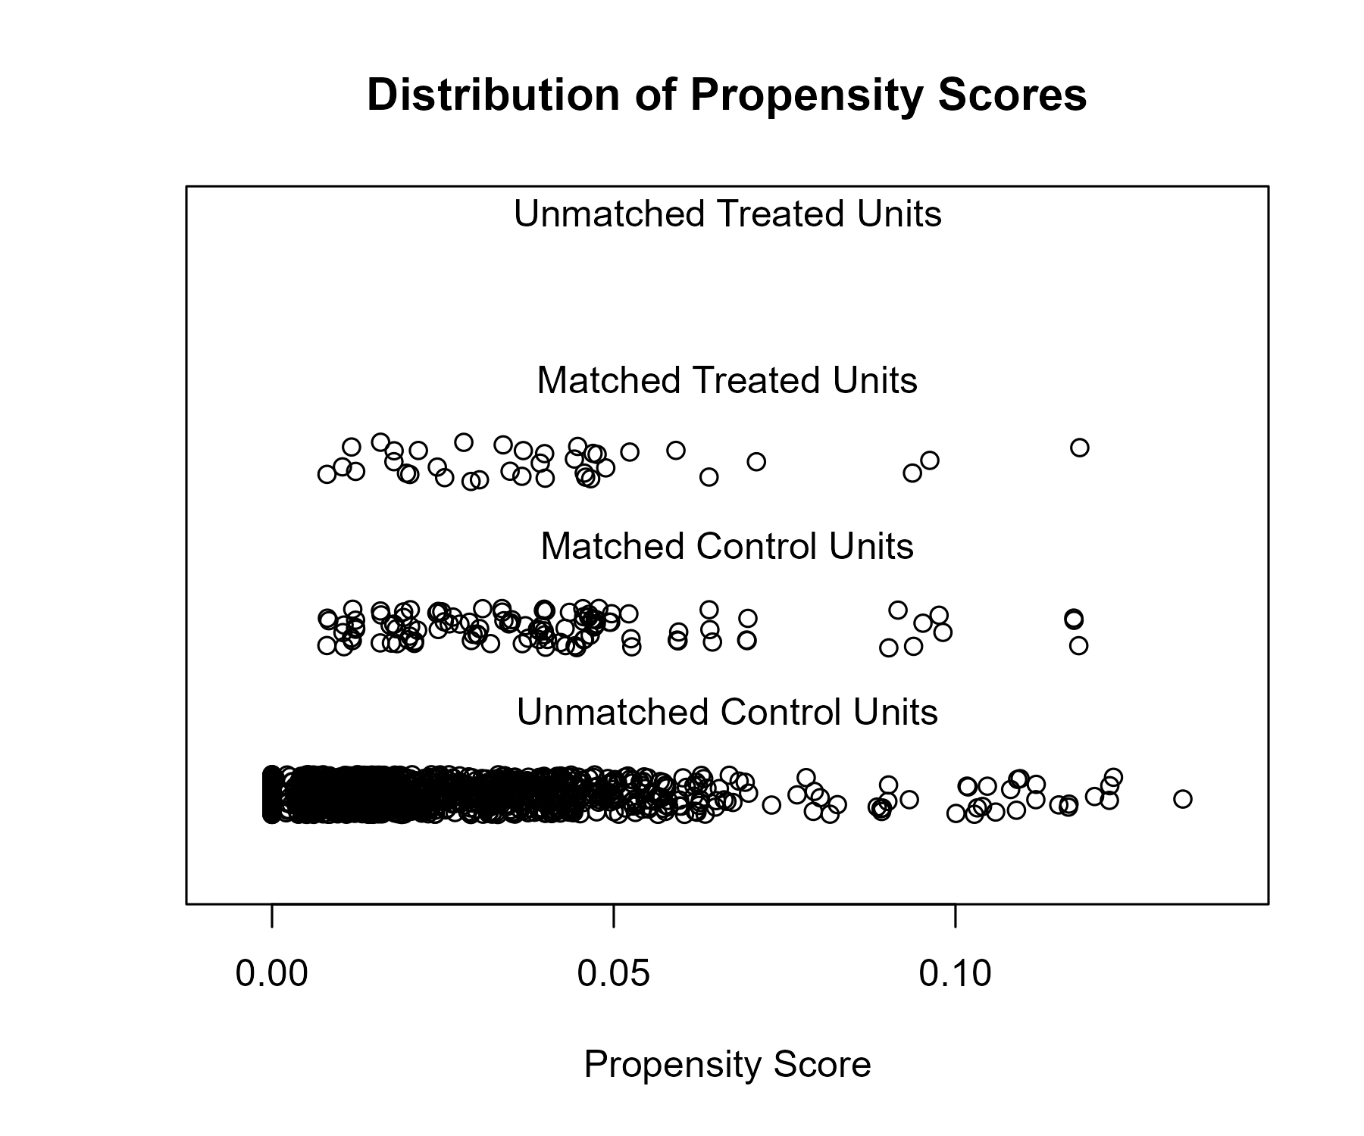

## Covariate balance

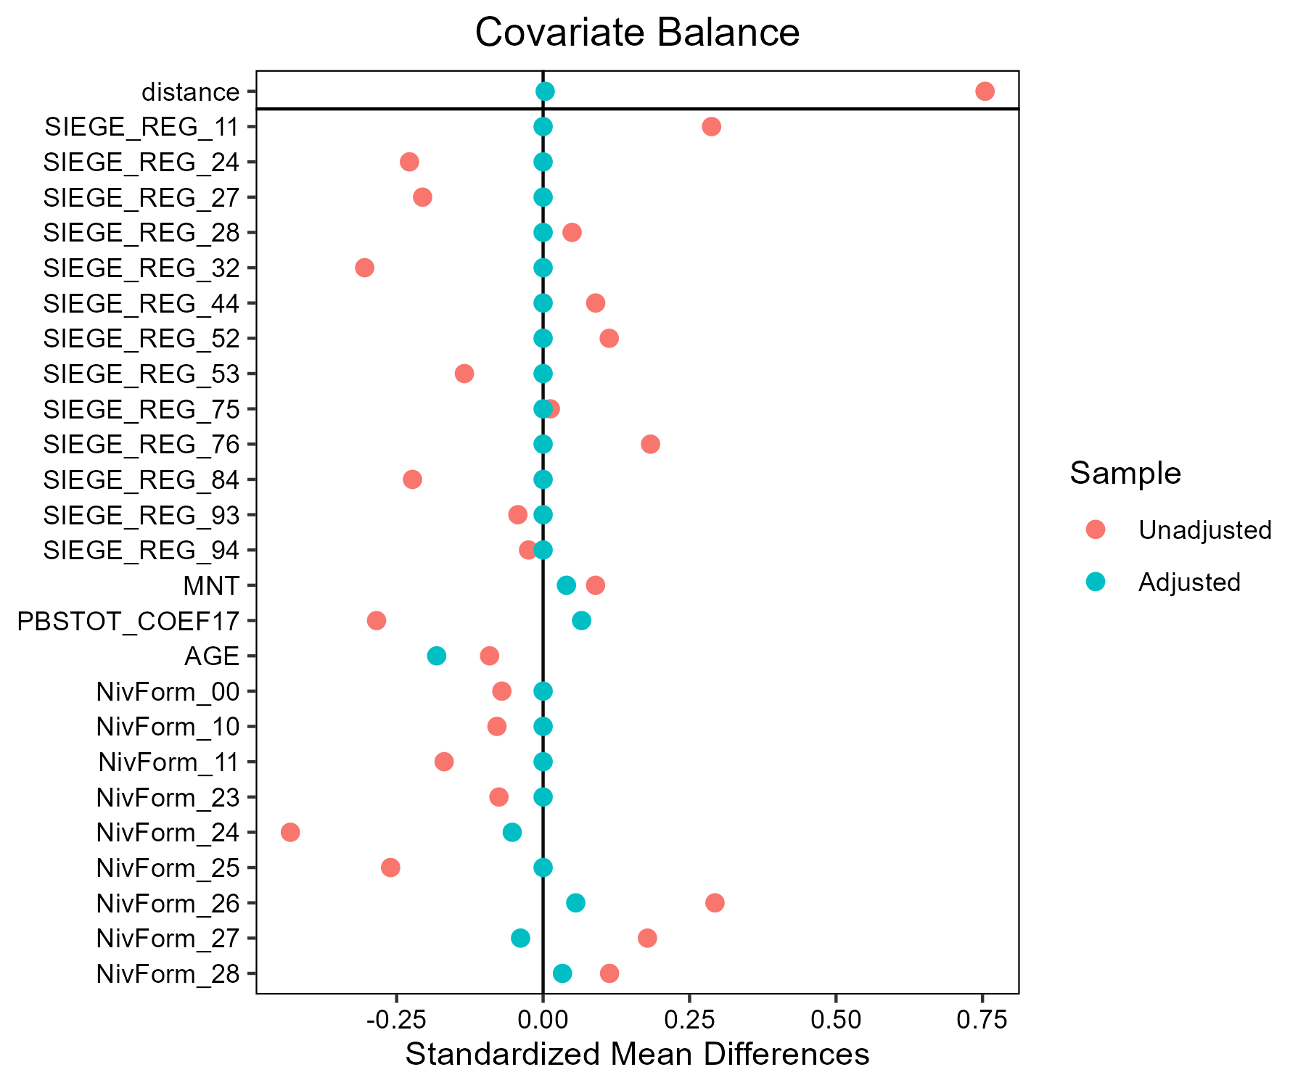

# Melange_cereales_d_ete - AB

## Covariate distribution before matching

|  |  | Melange_cereales_d_ete - AB (N=53) / Mean | Melange_cereales_d_ete - AB (N=53) / Std. Dev. | Melange_cereales_d_ete - Conventionnel (N=128) / Mean | Melange_cereales_d_ete - Conventionnel (N=128) / Std. Dev. | Diff. in Means | Std. Error |
| --- | --- | --- | --- | --- | --- | --- | --- |
| PBSTOT_COEF17 |  | 174613.0 | 119081.5 | 195446.7 | 128758.0 | 20833.7 | 19926.7 |
| AGE |  | 45.6 | 9.8 | 47.6 | 10.1 | 2.0 | 1.6 |
|  |  | N | Pct. | N | Pct. |  |  |
| SIEGE_REG | 11 | 1 | 1.9 | 1 | 0.8 |  |  |
|  | 24 | 0 | 0.0 | 3 | 2.3 |  |  |
|  | 27 | 2 | 3.8 | 5 | 3.9 |  |  |
|  | 28 | 7 | 13.2 | 6 | 4.7 |  |  |
|  | 32 | 2 | 3.8 | 1 | 0.8 |  |  |
|  | 44 | 6 | 11.3 | 4 | 3.1 |  |  |
|  | 52 | 7 | 13.2 | 7 | 5.5 |  |  |
|  | 53 | 5 | 9.4 | 4 | 3.1 |  |  |
|  | 75 | 6 | 11.3 | 40 | 31.2 |  |  |
|  | 76 | 12 | 22.6 | 29 | 22.7 |  |  |
|  | 84 | 5 | 9.4 | 26 | 20.3 |  |  |
|  | 93 | 0 | 0.0 | 2 | 1.6 |  |  |
| MNT | FALSE | 44 | 83.0 | 90 | 70.3 |  |  |
|  | TRUE | 9 | 17.0 | 38 | 29.7 |  |  |
| NivForm | 10 | 0 | 0.0 | 1 | 0.8 |  |  |
|  | 11 | 2 | 3.8 | 3 | 2.3 |  |  |
|  | 23 | 0 | 0.0 | 4 | 3.1 |  |  |
|  | 24 | 9 | 17.0 | 39 | 30.5 |  |  |
|  | 25 | 1 | 1.9 | 20 | 15.6 |  |  |
|  | 26 | 17 | 32.1 | 34 | 26.6 |  |  |
|  | 27 | 15 | 28.3 | 25 | 19.5 |  |  |
|  | 28 | 9 | 17.0 | 2 | 1.6 |  |  |

## Covariate distribution after matching

|  |  | Melange_cereales_d_ete - AB (N=48) / Mean | Melange_cereales_d_ete - AB (N=48) / Std. Dev. | Melange_cereales_d_ete - Conventionnel (N=90) / Mean | Melange_cereales_d_ete - Conventionnel (N=90) / Std. Dev. | Diff. in Means | Std. Error |
| --- | --- | --- | --- | --- | --- | --- | --- |
| PBSTOT_COEF17 |  | 158514.1 | 101715.6 | 207811.3 | 128070.1 | 49297.2 | 19944.6 |
| AGE |  | 44.7 | 9.8 | 46.0 | 9.9 | 1.3 | 1.8 |
|  |  | N | Pct. | N | Pct. |  |  |
| SIEGE_REG | 11 | 1 | 2.1 | 1 | 1.1 |  |  |
|  | 27 | 2 | 4.2 | 5 | 5.6 |  |  |
|  | 28 | 6 | 12.5 | 6 | 6.7 |  |  |
|  | 32 | 1 | 2.1 | 1 | 1.1 |  |  |
|  | 44 | 4 | 8.3 | 4 | 4.4 |  |  |
|  | 52 | 7 | 14.6 | 7 | 7.8 |  |  |
|  | 53 | 4 | 8.3 | 4 | 4.4 |  |  |
|  | 75 | 6 | 12.5 | 18 | 20.0 |  |  |
|  | 76 | 12 | 25.0 | 29 | 32.2 |  |  |
|  | 84 | 5 | 10.4 | 15 | 16.7 |  |  |
| MNT | FALSE | 39 | 81.2 | 65 | 72.2 |  |  |
|  | TRUE | 9 | 18.8 | 25 | 27.8 |  |  |
| NivForm | 11 | 2 | 4.2 | 3 | 3.3 |  |  |
|  | 24 | 7 | 14.6 | 21 | 23.3 |  |  |
|  | 25 | 1 | 2.1 | 11 | 12.2 |  |  |
|  | 26 | 16 | 33.3 | 29 | 32.2 |  |  |
|  | 27 | 13 | 27.1 | 24 | 26.7 |  |  |
|  | 28 | 9 | 18.8 | 2 | 2.2 |  |  |

## Matching model coefficients

| . | Estimate | Std. Error | t value | Pr(&gt;|t|) |
| --- | --- | --- | --- | --- |
| (Intercept) | -15.5622569709605 | 4658.87369288127 | -0.00334034747384106 | 0.997338980566661 |
| SIEGE_REG24 | -14.446002657915 | 2493.84864907983 | -0.0057926541224726 | 0.995385418010977 |
| SIEGE_REG27 | 1.13568670204289 | 2.66427739045615 | 0.426264437070664 | 0.67049168856587 |
| SIEGE_REG28 | 1.82736263131813 | 2.54245567628645 | 0.718739228519101 | 0.473356519569245 |
| SIEGE_REG32 | 2.52659256869986 | 2.8529795393235 | 0.885597857914875 | 0.377171640785899 |
| SIEGE_REG44 | 2.35121160260891 | 2.60941571855651 | 0.901049068528478 | 0.368925023151276 |
| SIEGE_REG52 | 2.03852524952997 | 2.56743009668792 | 0.793994450777741 | 0.428382066810277 |
| SIEGE_REG53 | 3.40565525703945 | 2.71086430074274 | 1.25629868529618 | 0.210850401926018 |
| SIEGE_REG75 | -0.586440006587138 | 2.4709882315736 | -0.237330149570836 | 0.812706197310197 |
| SIEGE_REG76 | 0.378852620051458 | 2.48709316902567 | 0.152327474004472 | 0.879121780040155 |
| SIEGE_REG84 | 0.24828326898064 | 2.52603169908754 | 0.0982898469050591 | 0.92182594076215 |
| SIEGE_REG93 | -15.45598971297 | 3135.21540077845 | -0.00492980154063174 | 0.996072783180746 |
| MNTTRUE | -0.174641187663102 | 0.691457350025314 | -0.252569717650277 | 0.800926951196343 |
| PBSTOT_COEF17 | -6.20020963531489e-06 | 2.82290307589738e-06 | -2.19639479947213 | 0.0295114144814812 |
| AGE | -0.0180506282496193 | 0.0297008213435988 | -0.607748453849058 | 0.544221376890599 |
| NivForm11 | 16.0942897995053 | 4658.8728379614 | 0.00345454584387148 | 0.997248007131127 |
| NivForm23 | -0.120639339461939 | 5138.75412657776 | -2.34763789997247e-05 | 0.999981297988269 |
| NivForm24 | 15.5162197559565 | 4658.8726901452 | 0.00333046657161882 | 0.99734685195581 |
| NivForm25 | 13.6891999763268 | 4658.87290390885 | 0.00293830723839694 | 0.997659256698917 |
| NivForm26 | 16.1636714091202 | 4658.87271579965 | 0.00346943829444069 | 0.997236143414593 |
| NivForm27 | 16.0574479835732 | 4658.87273956896 | 0.0034466380348176 | 0.997254306699375 |
| NivForm28 | 18.2120975810949 | 4658.87278328961 | 0.00390912103168342 | 0.996885880908949 |

## Propensity score distribution

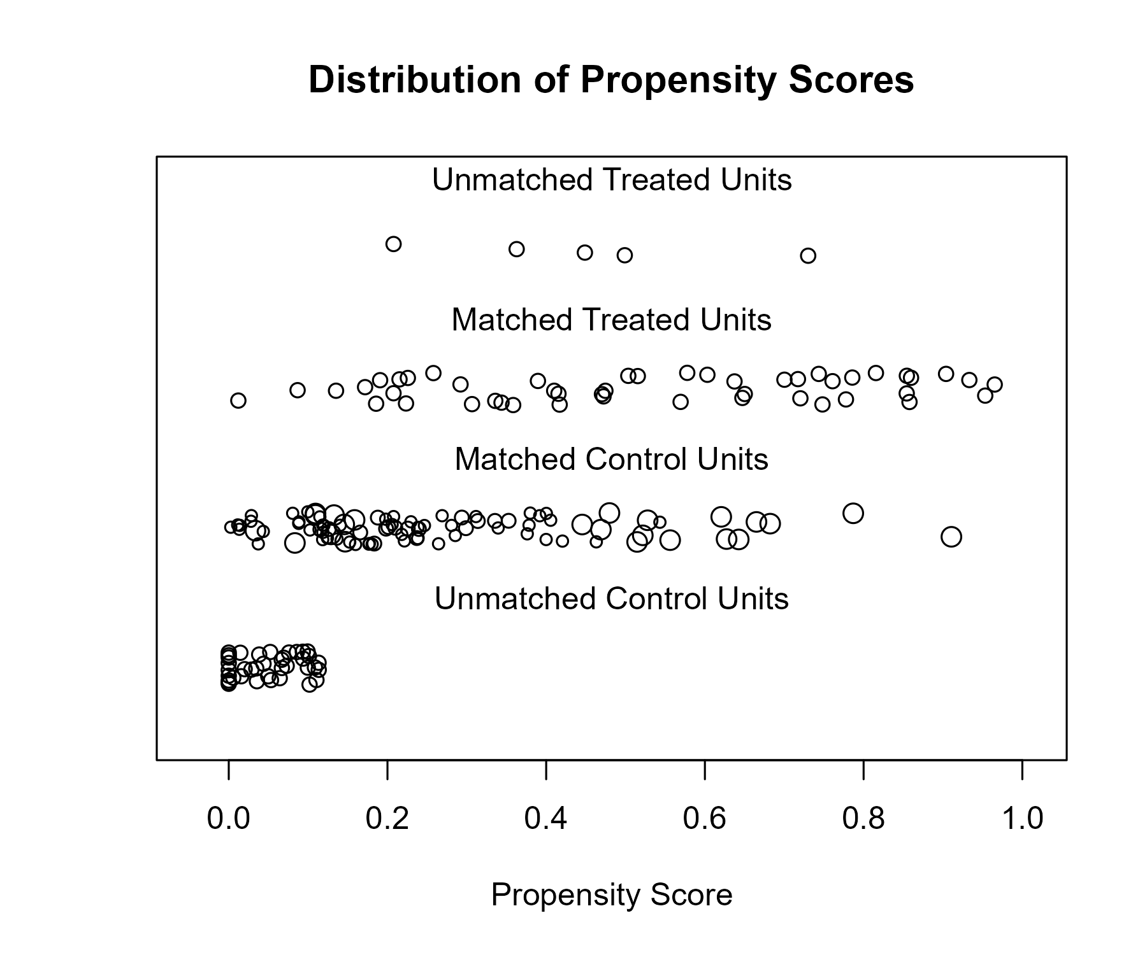

## Covariate balance

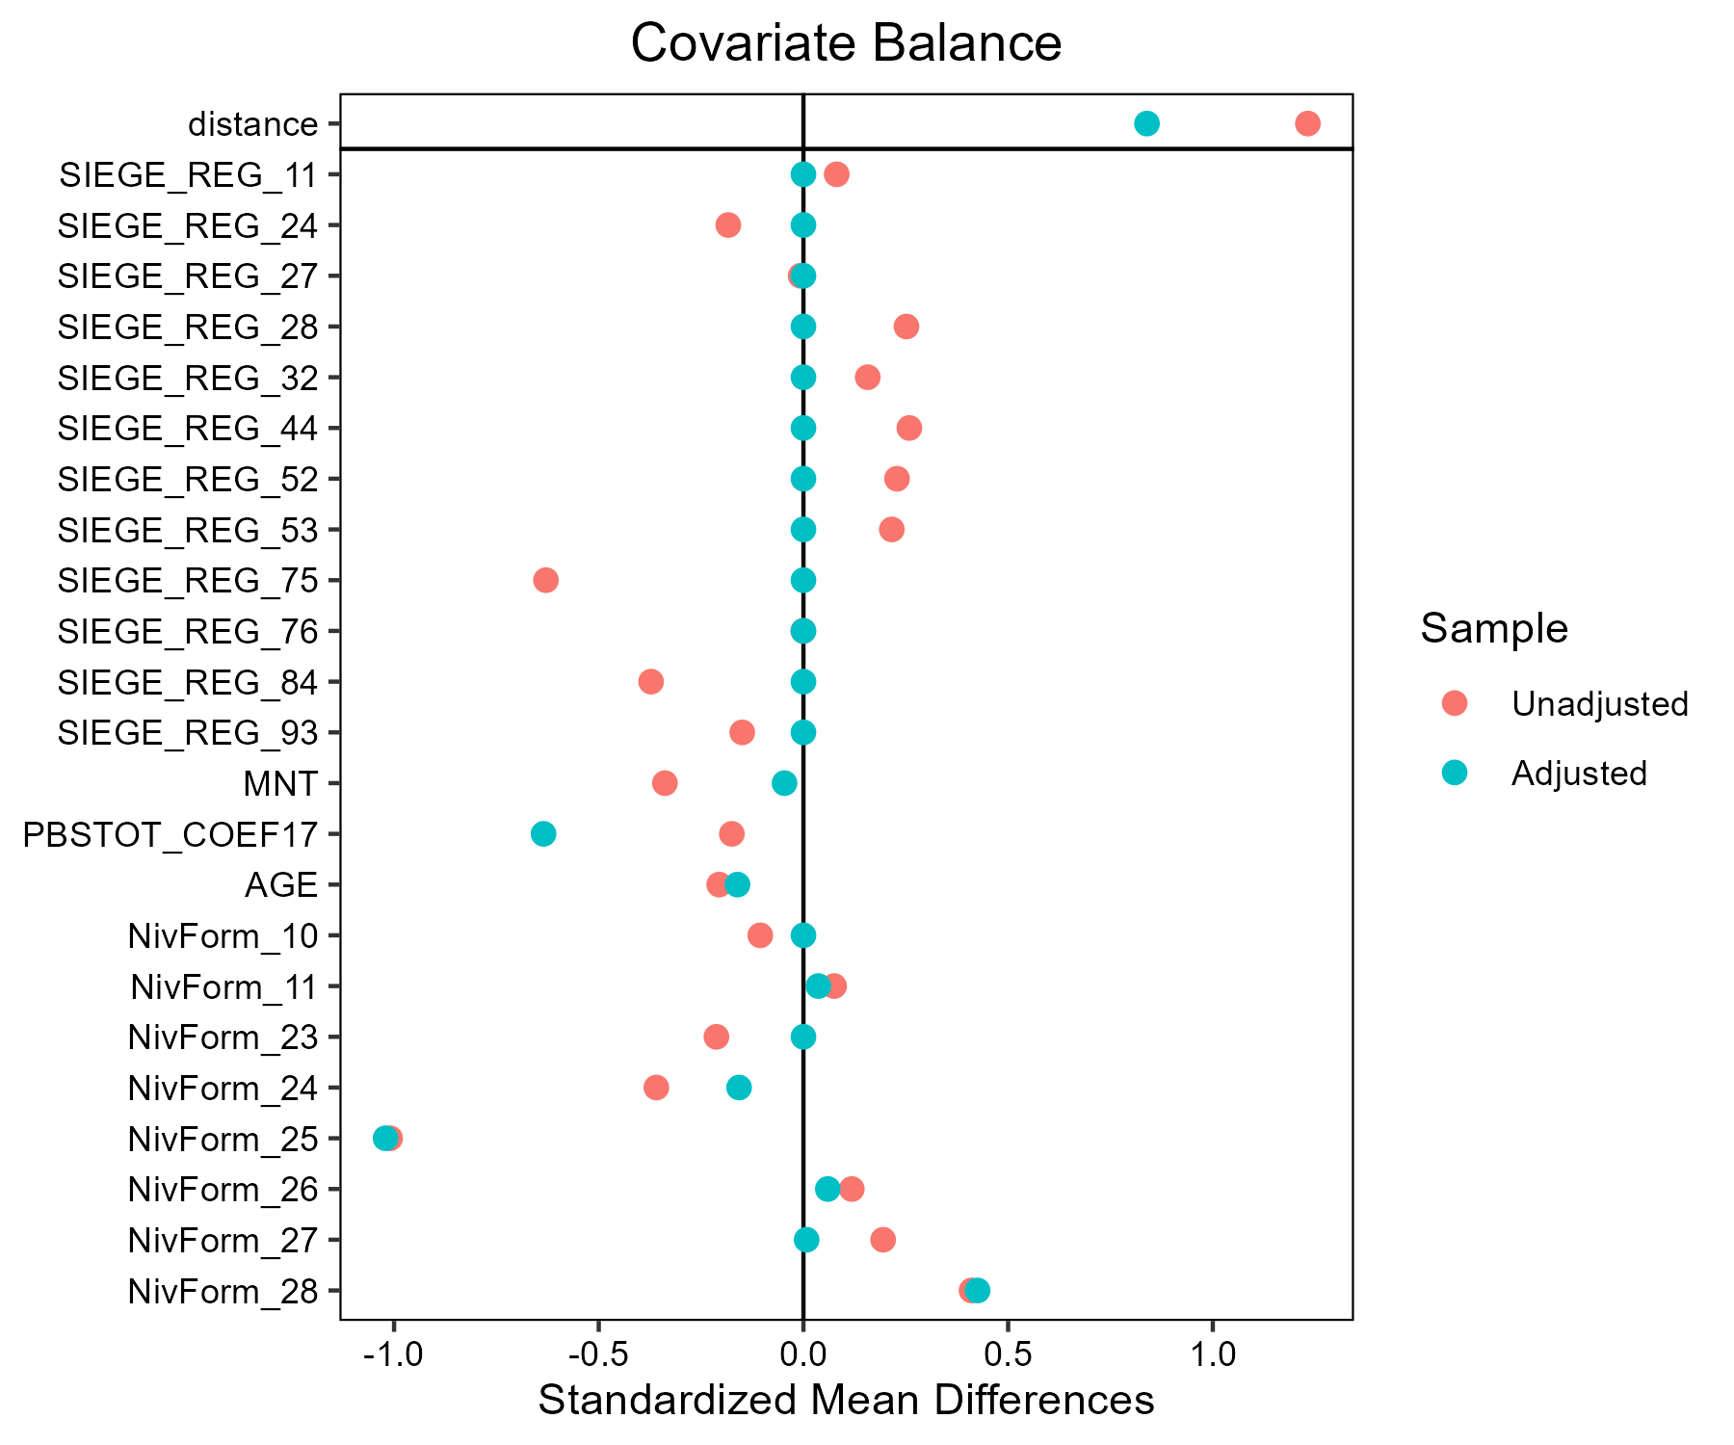

# Orge_d_hiver_et_escourgeon - AB

## Covariate distribution before matching

|  |  | Orge_d_hiver_et_escourgeon - AB (N=37) / Mean | Orge_d_hiver_et_escourgeon - AB (N=37) / Std. Dev. | Orge_d_hiver_et_escourgeon - Conventionnel (N=2088) / Mean | Orge_d_hiver_et_escourgeon - Conventionnel (N=2088) / Std. Dev. | Diff. in Means | Std. Error |
| --- | --- | --- | --- | --- | --- | --- | --- |
| PBSTOT_COEF17 |  | 252922.6 | 263951.7 | 297504.6 | 359931.7 | 44582.1 | 44102.5 |
| AGE |  | 47.4 | 10.7 | 49.0 | 10.3 | 1.6 | 1.8 |
|  |  | N | Pct. | N | Pct. |  |  |
| SIEGE_REG | 11 | 0 | 0.0 | 81 | 3.9 |  |  |
|  | 24 | 1 | 2.7 | 158 | 7.6 |  |  |
|  | 27 | 0 | 0.0 | 223 | 10.7 |  |  |
|  | 28 | 4 | 10.8 | 134 | 6.4 |  |  |
|  | 32 | 2 | 5.4 | 276 | 13.2 |  |  |
|  | 44 | 6 | 16.2 | 339 | 16.2 |  |  |
|  | 52 | 2 | 5.4 | 109 | 5.2 |  |  |
|  | 53 | 3 | 8.1 | 141 | 6.8 |  |  |
|  | 75 | 2 | 5.4 | 158 | 7.6 |  |  |
|  | 76 | 11 | 29.7 | 213 | 10.2 |  |  |
|  | 84 | 6 | 16.2 | 225 | 10.8 |  |  |
|  | 93 | 0 | 0.0 | 31 | 1.5 |  |  |
| MNT | FALSE | 28 | 75.7 | 1860 | 89.1 |  |  |
|  | TRUE | 9 | 24.3 | 228 | 10.9 |  |  |
| NivForm | 00 | 0 | 0.0 | 7 | 0.3 |  |  |
|  | 10 | 0 | 0.0 | 9 | 0.4 |  |  |
|  | 11 | 0 | 0.0 | 53 | 2.5 |  |  |
|  | 23 | 1 | 2.7 | 81 | 3.9 |  |  |
|  | 24 | 7 | 18.9 | 580 | 27.8 |  |  |
|  | 25 | 4 | 10.8 | 253 | 12.1 |  |  |
|  | 26 | 9 | 24.3 | 514 | 24.6 |  |  |
|  | 27 | 12 | 32.4 | 497 | 23.8 |  |  |
|  | 28 | 4 | 10.8 | 94 | 4.5 |  |  |

## Covariate distribution after matching

|  |  | Orge_d_hiver_et_escourgeon - AB (N=37) / Mean | Orge_d_hiver_et_escourgeon - AB (N=37) / Std. Dev. | Orge_d_hiver_et_escourgeon - Conventionnel (N=111) / Mean | Orge_d_hiver_et_escourgeon - Conventionnel (N=111) / Std. Dev. | Diff. in Means | Std. Error |
| --- | --- | --- | --- | --- | --- | --- | --- |
| PBSTOT_COEF17 |  | 252922.6 | 263951.7 | 242939.8 | 217120.9 | -9982.7 | 48038.4 |
| AGE |  | 47.4 | 10.7 | 47.9 | 10.0 | 0.4 | 2.0 |
|  |  | N | Pct. | N | Pct. |  |  |
| SIEGE_REG | 24 | 1 | 2.7 | 3 | 2.7 |  |  |
|  | 28 | 4 | 10.8 | 12 | 10.8 |  |  |
|  | 32 | 2 | 5.4 | 6 | 5.4 |  |  |
|  | 44 | 6 | 16.2 | 18 | 16.2 |  |  |
|  | 52 | 2 | 5.4 | 6 | 5.4 |  |  |
|  | 53 | 3 | 8.1 | 9 | 8.1 |  |  |
|  | 75 | 2 | 5.4 | 6 | 5.4 |  |  |
|  | 76 | 11 | 29.7 | 33 | 29.7 |  |  |
|  | 84 | 6 | 16.2 | 18 | 16.2 |  |  |
| MNT | FALSE | 28 | 75.7 | 90 | 81.1 |  |  |
|  | TRUE | 9 | 24.3 | 21 | 18.9 |  |  |
| NivForm | 23 | 1 | 2.7 | 2 | 1.8 |  |  |
|  | 24 | 7 | 18.9 | 24 | 21.6 |  |  |
|  | 25 | 4 | 10.8 | 7 | 6.3 |  |  |
|  | 26 | 9 | 24.3 | 29 | 26.1 |  |  |
|  | 27 | 12 | 32.4 | 38 | 34.2 |  |  |
|  | 28 | 4 | 10.8 | 11 | 9.9 |  |  |

## Matching model coefficients

| . | Estimate | Std. Error | t value | Pr(&gt;|t|) |
| --- | --- | --- | --- | --- |
| (Intercept) | -37.0437374404571 | 6280.64552538996 | -0.00589807803842856 | 0.995294601559096 |
| SIEGE_REG24 | 15.500648287992 | 1812.85806066288 | 0.00855039267791549 | 0.993178668198926 |
| SIEGE_REG27 | 0.210611986100276 | 2123.83213846609 | 9.91660227217339e-05 | 0.999920886371531 |
| SIEGE_REG28 | 17.2507088715288 | 1812.85787824828 | 0.00951575359464901 | 0.992408544696347 |
| SIEGE_REG32 | 15.7139139111626 | 1812.85793821231 | 0.00866803381552248 | 0.993084818794274 |
| SIEGE_REG44 | 16.6214599541134 | 1812.85785685235 | 0.00916865042192172 | 0.992685447931162 |
| SIEGE_REG52 | 16.7795287337701 | 1812.85794795283 | 0.00925584310271986 | 0.992615889464118 |
| SIEGE_REG53 | 17.0001452489882 | 1812.85791094193 | 0.00937753871739196 | 0.992518806175385 |
| SIEGE_REG75 | 16.3663408775984 | 1812.85794237013 | 0.0090279224284949 | 0.992797714621627 |
| SIEGE_REG76 | 17.4808697496697 | 1812.85785202471 | 0.0096427139779029 | 0.992307261663354 |
| SIEGE_REG84 | 16.867912376438 | 1812.85787943454 | 0.00930459721514378 | 0.992576995612483 |
| SIEGE_REG93 | -0.334557362433679 | 3456.78926176121 | -9.67826896867948e-05 | 0.999922787769999 |
| MNTTRUE | 0.489574186958973 | 0.47015952543808 | 1.04129377470934 | 0.297858974959584 |
| PBSTOT_COEF17 | -8.2490072587823e-07 | 8.17688491444075e-07 | -1.00882027142319 | 0.313176948767875 |
| AGE | 0.00345718074569957 | 0.0180809595822306 | 0.191205601117386 | 0.848382981691871 |
| NivForm10 | 1.00420937601702 | 7739.91483827068 | 0.000129744240989787 | 0.999896491385013 |
| NivForm11 | -0.340906474139709 | 6404.32968795978 | -5.3230625334704e-05 | 0.99995753315697 |
| NivForm23 | 16.0190901296695 | 6013.32306576538 | 0.00266393306238081 | 0.997874744234601 |
| NivForm24 | 15.926599273421 | 6013.32299962458 | 0.00264855210245904 | 0.997887014962241 |
| NivForm25 | 16.2307898035118 | 6013.32301503595 | 0.00269913819080194 | 0.997846658047824 |
| NivForm26 | 16.3329626144747 | 6013.32300268428 | 0.00271612926948775 | 0.997833102790469 |
| NivForm27 | 16.806557117582 | 6013.32300320276 | 0.0027948868052873 | 0.997770271080594 |
| NivForm28 | 17.466867566652 | 6013.32301754428 | 0.002904694711342 | 0.997682667823337 |

## Propensity score distribution

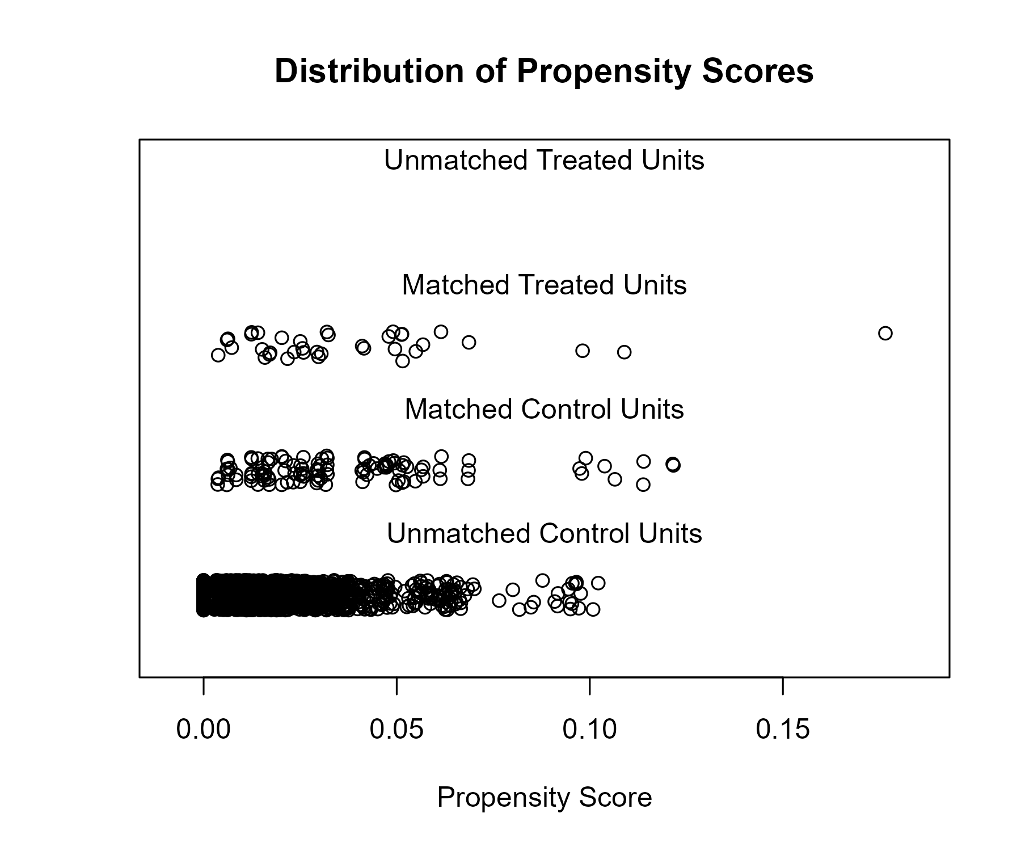

## Covariate balance

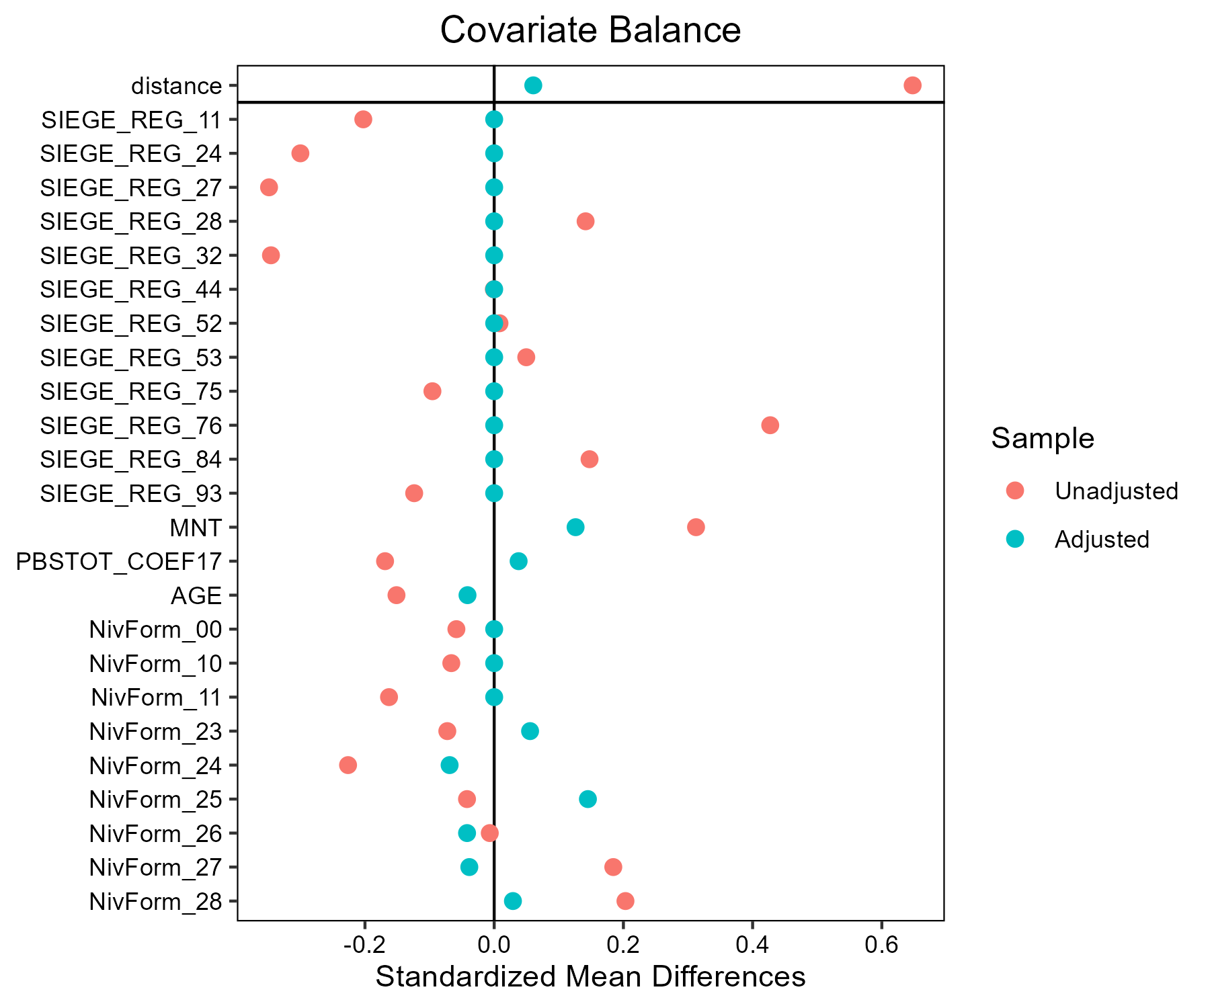

# Orge_de_printemps - AB

## Covariate distribution before matching

|  |  | Orge_de_printemps - AB (N=31) / Mean | Orge_de_printemps - AB (N=31) / Std. Dev. | Orge_de_printemps - Conventionnel (N=1052) / Mean | Orge_de_printemps - Conventionnel (N=1052) / Std. Dev. | Diff. in Means | Std. Error |
| --- | --- | --- | --- | --- | --- | --- | --- |
| PBSTOT_COEF17 |  | 295341.8 | 427519.9 | 276653.8 | 264108.6 | -18688.0 | 77215.4 |
| AGE |  | 52.5 | 8.4 | 50.3 | 10.2 | -2.2 | 1.5 |
|  |  | N | Pct. | N | Pct. |  |  |
| SIEGE_REG | 11 | 4 | 12.9 | 103 | 9.8 |  |  |
|  | 24 | 1 | 3.2 | 114 | 10.8 |  |  |
|  | 27 | 3 | 9.7 | 94 | 8.9 |  |  |
|  | 28 | 2 | 6.5 | 41 | 3.9 |  |  |
|  | 32 | 4 | 12.9 | 125 | 11.9 |  |  |
|  | 44 | 5 | 16.1 | 270 | 25.7 |  |  |
|  | 52 | 1 | 3.2 | 33 | 3.1 |  |  |
|  | 53 | 2 | 6.5 | 52 | 4.9 |  |  |
|  | 75 | 2 | 6.5 | 121 | 11.5 |  |  |
|  | 76 | 4 | 12.9 | 31 | 2.9 |  |  |
|  | 84 | 2 | 6.5 | 42 | 4.0 |  |  |
|  | 93 | 1 | 3.2 | 26 | 2.5 |  |  |
| MNT | FALSE | 29 | 93.5 | 999 | 95.0 |  |  |
|  | TRUE | 2 | 6.5 | 53 | 5.0 |  |  |
| NivForm | 00 | 0 | 0.0 | 10 | 1.0 |  |  |
|  | 10 | 0 | 0.0 | 11 | 1.0 |  |  |
|  | 11 | 1 | 3.2 | 31 | 2.9 |  |  |
|  | 23 | 1 | 3.2 | 32 | 3.0 |  |  |
|  | 24 | 6 | 19.4 | 290 | 27.6 |  |  |
|  | 25 | 2 | 6.5 | 93 | 8.8 |  |  |
|  | 26 | 11 | 35.5 | 239 | 22.7 |  |  |
|  | 27 | 5 | 16.1 | 277 | 26.3 |  |  |
|  | 28 | 5 | 16.1 | 69 | 6.6 |  |  |

## Covariate distribution after matching

|  |  | Orge_de_printemps - AB (N=31) / Mean | Orge_de_printemps - AB (N=31) / Std. Dev. | Orge_de_printemps - Conventionnel (N=93) / Mean | Orge_de_printemps - Conventionnel (N=93) / Std. Dev. | Diff. in Means | Std. Error |
| --- | --- | --- | --- | --- | --- | --- | --- |
| PBSTOT_COEF17 |  | 295341.8 | 427519.9 | 276756.6 | 212512.3 | -18585.2 | 79884.4 |
| AGE |  | 52.5 | 8.4 | 52.0 | 8.7 | -0.5 | 1.8 |
|  |  | N | Pct. | N | Pct. |  |  |
| SIEGE_REG | 11 | 4 | 12.9 | 12 | 12.9 |  |  |
|  | 24 | 1 | 3.2 | 3 | 3.2 |  |  |
|  | 27 | 3 | 9.7 | 9 | 9.7 |  |  |
|  | 28 | 2 | 6.5 | 6 | 6.5 |  |  |
|  | 32 | 4 | 12.9 | 12 | 12.9 |  |  |
|  | 44 | 5 | 16.1 | 15 | 16.1 |  |  |
|  | 52 | 1 | 3.2 | 3 | 3.2 |  |  |
|  | 53 | 2 | 6.5 | 6 | 6.5 |  |  |
|  | 75 | 2 | 6.5 | 6 | 6.5 |  |  |
|  | 76 | 4 | 12.9 | 12 | 12.9 |  |  |
|  | 84 | 2 | 6.5 | 6 | 6.5 |  |  |
|  | 93 | 1 | 3.2 | 3 | 3.2 |  |  |
| MNT | FALSE | 29 | 93.5 | 85 | 91.4 |  |  |
|  | TRUE | 2 | 6.5 | 8 | 8.6 |  |  |
| NivForm | 11 | 1 | 3.2 | 4 | 4.3 |  |  |
|  | 23 | 1 | 3.2 | 2 | 2.2 |  |  |
|  | 24 | 6 | 19.4 | 19 | 20.4 |  |  |
|  | 25 | 2 | 6.5 | 5 | 5.4 |  |  |
|  | 26 | 11 | 35.5 | 39 | 41.9 |  |  |
|  | 27 | 5 | 16.1 | 13 | 14.0 |  |  |
|  | 28 | 5 | 16.1 | 11 | 11.8 |  |  |

## Matching model coefficients

| . | Estimate | Std. Error | t value | Pr(&gt;|t|) |
| --- | --- | --- | --- | --- |
| (Intercept) | -19.2587762460786 | 1183.84338666295 | -0.0162680101633762 | 0.987023639717685 |
| SIEGE_REG24 | -1.35021286391317 | 1.12641415563489 | -1.198682435904 | 0.230919360391328 |
| SIEGE_REG27 | 0.058535142627636 | 0.79442007933565 | 0.0736828589184039 | 0.941276639813443 |
| SIEGE_REG28 | 0.450776187441231 | 0.901760935379656 | 0.499884359319077 | 0.617260256040077 |
| SIEGE_REG32 | -0.0950604830907126 | 0.725846748936938 | -0.130964949873973 | 0.895827885192393 |
| SIEGE_REG44 | -0.541445776712157 | 0.698355182617986 | -0.775315756492836 | 0.438326027226083 |
| SIEGE_REG52 | -0.174389734987677 | 1.14764224204998 | -0.15195478921739 | 0.879251510324597 |
| SIEGE_REG53 | 0.197300471859999 | 0.918646677595163 | 0.214772966225157 | 0.829985642188428 |
| SIEGE_REG75 | -0.570256989810835 | 0.897039766416059 | -0.635709821526844 | 0.525102791927702 |
| SIEGE_REG76 | 1.54870726709026 | 0.783233610543187 | 1.97732483162489 | 0.0482636769358976 |
| SIEGE_REG84 | 0.740388072888402 | 0.939717269543159 | 0.787883863460697 | 0.430940787077733 |
| SIEGE_REG93 | 0.335307506910379 | 1.33089133219498 | 0.251942062284958 | 0.801134685772979 |
| MNTTRUE | -0.435386037183529 | 0.936764642435899 | -0.46477633490882 | 0.642187089400452 |
| PBSTOT_COEF17 | 1.45410870995249e-08 | 6.12796202656134e-07 | 0.0237290750766687 | 0.981073180048299 |
| AGE | 0.0350020982435424 | 0.0209242624671621 | 1.67279961711786 | 0.0946618311595063 |
| NivForm10 | -0.410917110830915 | 1655.85721969207 | -0.000248159748282723 | 0.999802043863534 |
| NivForm11 | 13.7520707622473 | 1183.84288257838 | 0.0116164661414322 | 0.990733795344441 |
| NivForm23 | 14.1483041807401 | 1183.84287126352 | 0.011951167274116 | 0.990466824009895 |
| NivForm24 | 13.4320648404674 | 1183.84251065659 | 0.0113461585637921 | 0.990949404501358 |
| NivForm25 | 13.8012531148967 | 1183.8426814596 | 0.0116580127841655 | 0.990700655983139 |
| NivForm26 | 14.5007346799786 | 1183.84248131984 | 0.0122488717112196 | 0.990229363652604 |
| NivForm27 | 13.692120914633 | 1183.84255145368 | 0.011565829339231 | 0.990774185423448 |
| NivForm28 | 15.1522522928965 | 1183.84258388054 | 0.012799212073643 | 0.989790393591195 |

## Propensity score distribution

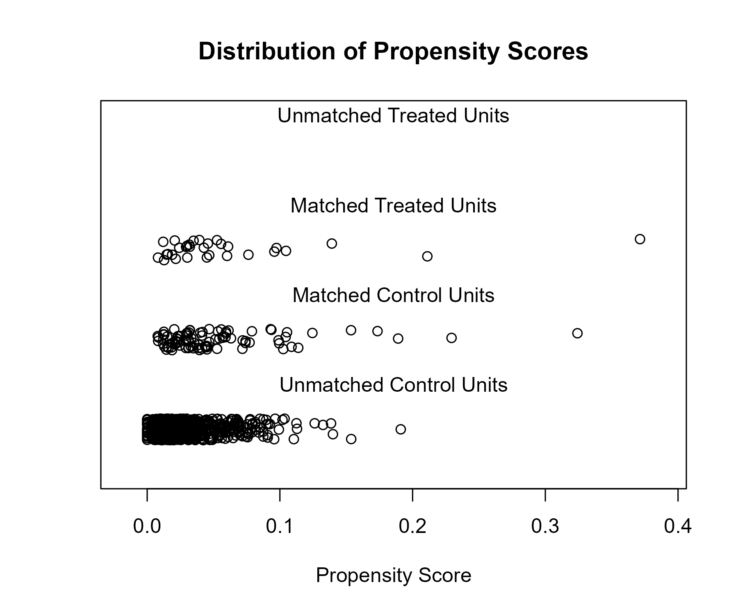

## Covariate balance

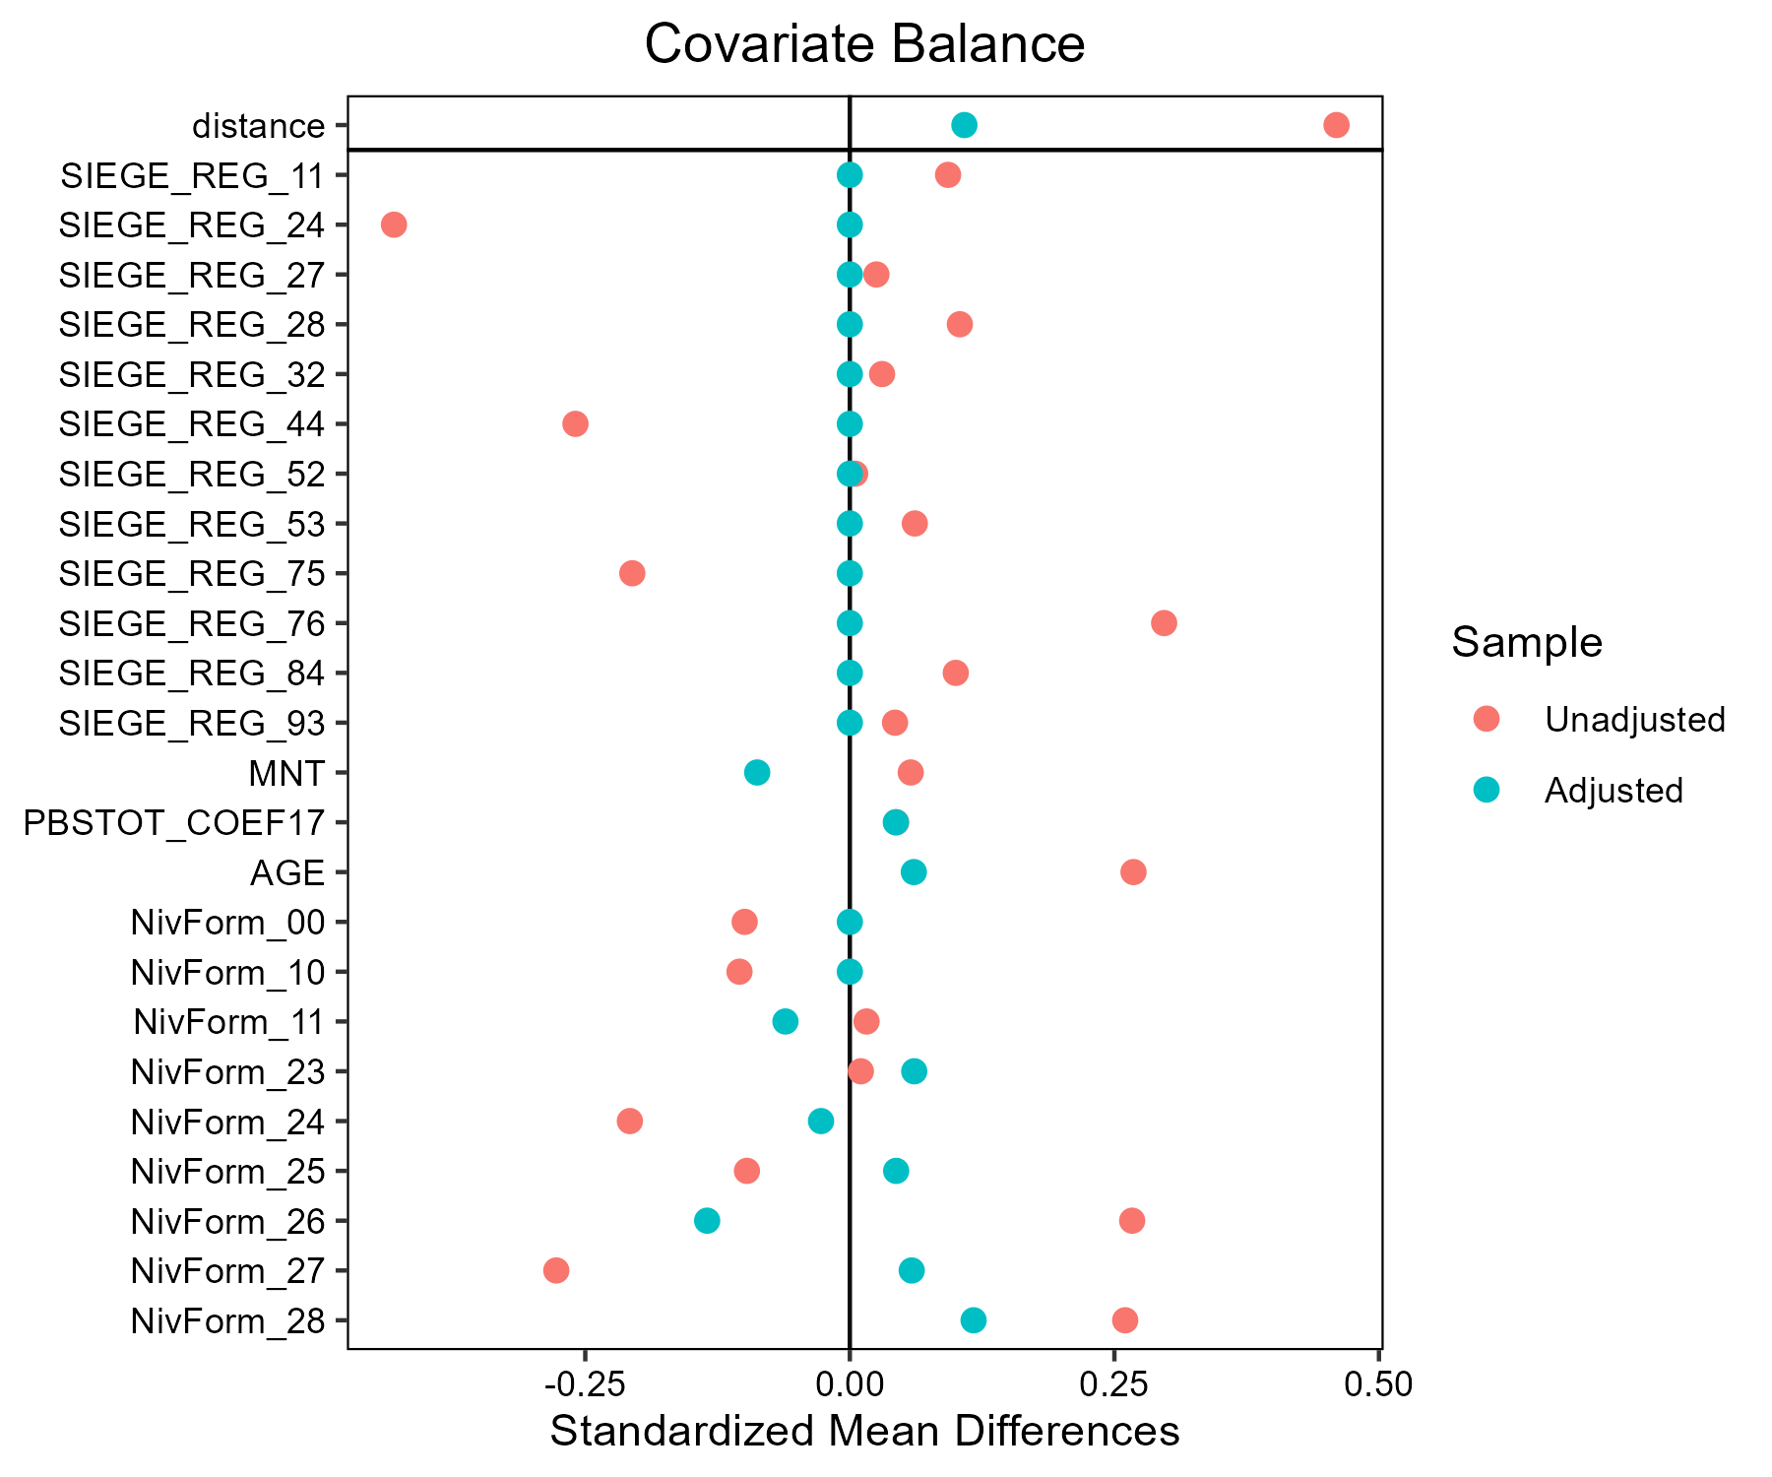

# Tournesol - AB

## Covariate distribution before matching

|  |  | Tournesol - AB (N=30) / Mean | Tournesol - AB (N=30) / Std. Dev. | Tournesol - Conventionnel (N=770) / Mean | Tournesol - Conventionnel (N=770) / Std. Dev. | Diff. in Means | Std. Error |
| --- | --- | --- | --- | --- | --- | --- | --- |
| PBSTOT_COEF17 |  | 172086.9 | 142485.6 | 272519.2 | 241726.9 | 100432.2 | 27434.0 |
| AGE |  | 46.4 | 10.9 | 49.9 | 10.6 | 3.5 | 2.0 |
|  |  | N | Pct. | N | Pct. |  |  |
| SIEGE_REG | 11 | 3 | 10.0 | 11 | 1.4 |  |  |
|  | 24 | 1 | 3.3 | 88 | 11.4 |  |  |
|  | 27 | 1 | 3.3 | 57 | 7.4 |  |  |
|  | 28 | 0 | 0.0 | 2 | 0.3 |  |  |
|  | 32 | 0 | 0.0 | 9 | 1.2 |  |  |
|  | 44 | 3 | 10.0 | 61 | 7.9 |  |  |
|  | 52 | 4 | 13.3 | 44 | 5.7 |  |  |
|  | 75 | 5 | 16.7 | 233 | 30.3 |  |  |
|  | 76 | 9 | 30.0 | 181 | 23.5 |  |  |
|  | 84 | 4 | 13.3 | 68 | 8.8 |  |  |
|  | 93 | 0 | 0.0 | 16 | 2.1 |  |  |
| MNT | FALSE | 28 | 93.3 | 752 | 97.7 |  |  |
|  | TRUE | 2 | 6.7 | 18 | 2.3 |  |  |
| NivForm | 00 | 0 | 0.0 | 5 | 0.6 |  |  |
|  | 10 | 0 | 0.0 | 1 | 0.1 |  |  |
|  | 11 | 0 | 0.0 | 27 | 3.5 |  |  |
|  | 23 | 0 | 0.0 | 26 | 3.4 |  |  |
|  | 24 | 5 | 16.7 | 236 | 30.6 |  |  |
|  | 25 | 3 | 10.0 | 87 | 11.3 |  |  |
|  | 26 | 6 | 20.0 | 158 | 20.5 |  |  |
|  | 27 | 12 | 40.0 | 192 | 24.9 |  |  |
|  | 28 | 4 | 13.3 | 38 | 4.9 |  |  |

## Covariate distribution after matching

|  |  | Tournesol - AB (N=30) / Mean | Tournesol - AB (N=30) / Std. Dev. | Tournesol - Conventionnel (N=90) / Mean | Tournesol - Conventionnel (N=90) / Std. Dev. | Diff. in Means | Std. Error |
| --- | --- | --- | --- | --- | --- | --- | --- |
| PBSTOT_COEF17 |  | 172086.9 | 142485.6 | 164010.7 | 119562.7 | -8076.3 | 28906.3 |
| AGE |  | 46.4 | 10.9 | 47.2 | 10.8 | 0.7 | 2.3 |
|  |  | N | Pct. | N | Pct. |  |  |
| SIEGE_REG | 11 | 3 | 10.0 | 9 | 10.0 |  |  |
|  | 24 | 1 | 3.3 | 3 | 3.3 |  |  |
|  | 27 | 1 | 3.3 | 3 | 3.3 |  |  |
|  | 44 | 3 | 10.0 | 9 | 10.0 |  |  |
|  | 52 | 4 | 13.3 | 12 | 13.3 |  |  |
|  | 75 | 5 | 16.7 | 15 | 16.7 |  |  |
|  | 76 | 9 | 30.0 | 27 | 30.0 |  |  |
|  | 84 | 4 | 13.3 | 12 | 13.3 |  |  |
| MNT | FALSE | 28 | 93.3 | 87 | 96.7 |  |  |
|  | TRUE | 2 | 6.7 | 3 | 3.3 |  |  |
| NivForm | 24 | 5 | 16.7 | 24 | 26.7 |  |  |
|  | 25 | 3 | 10.0 | 8 | 8.9 |  |  |
|  | 26 | 6 | 20.0 | 20 | 22.2 |  |  |
|  | 27 | 12 | 40.0 | 26 | 28.9 |  |  |
|  | 28 | 4 | 13.3 | 12 | 13.3 |  |  |

## Matching model coefficients

| . | Estimate | Std. Error | t value | Pr(&gt;|t|) |
| --- | --- | --- | --- | --- |
| (Intercept) | -17.0352200995128 | 4376.88983436138 | -0.00389208336151745 | 0.996895572353637 |
| SIEGE_REG24 | -3.0600118209744 | 1.21401882297125 | -2.52056373680036 | 0.0119156369090178 |
| SIEGE_REG27 | -2.58965760127366 | 1.20776061003712 | -2.14418120590476 | 0.0323276179138303 |
| SIEGE_REG28 | -18.1957526669485 | 7119.26442556521 | -0.00255584728692022 | 0.997961386319654 |
| SIEGE_REG32 | -17.9850185279174 | 3339.49330212695 | -0.00538555310665321 | 0.995704351694629 |
| SIEGE_REG44 | -1.60967885138504 | 0.901910272568103 | -1.78474389342704 | 0.0746924157821905 |
| SIEGE_REG52 | -0.361237184581404 | 0.909973734049474 | -0.396975397272031 | 0.691494475983776 |
| SIEGE_REG75 | -2.15308363037145 | 0.845042809842674 | -2.54789888191854 | 0.0110285975258604 |
| SIEGE_REG76 | -1.72691823381252 | 0.797628007524045 | -2.16506719613962 | 0.030685885178553 |
| SIEGE_REG84 | -1.69318698914056 | 0.923299887566359 | -1.83384294955724 | 0.0670591348091652 |
| SIEGE_REG93 | -18.6064083290703 | 2356.4172728536 | -0.00789605836938131 | 0.993701946606731 |
| MNTTRUE | 1.42183179124831 | 0.852778301208529 | 1.66729358525344 | 0.0958584878316933 |
| PBSTOT_COEF17 | -4.46016311168912e-06 | 1.55187834723437e-06 | -2.87404171830714 | 0.00416303105344513 |
| AGE | -0.0125967677657538 | 0.0198803486948059 | -0.633629115823555 | 0.526509122407046 |
| NivForm10 | 0.9290665457115 | 11176.6878346804 | 8.31253909435206e-05 | 0.999933696843091 |
| NivForm11 | 0.698460116931433 | 4745.05370747425 | 0.00014719751555841 | 0.999882591109217 |
| NivForm23 | 0.704064005117919 | 4780.07076010168 | 0.000147291544509049 | 0.999882516109074 |
| NivForm24 | 16.3993180085123 | 4376.88962470687 | 0.003746797249796 | 0.997011455808767 |
| NivForm25 | 17.0247487364432 | 4376.88965112572 | 0.00388969110337623 | 0.99689748047176 |
| NivForm26 | 17.094390185479 | 4376.88963127449 | 0.00390560229422585 | 0.996884789353569 |
| NivForm27 | 17.6391317869085 | 4376.8896268862 | 0.00403006090867714 | 0.99678551843392 |
| NivForm28 | 17.7158442979349 | 4376.88966394041 | 0.00404758759259782 | 0.996771538770521 |

## Propensity score distribution

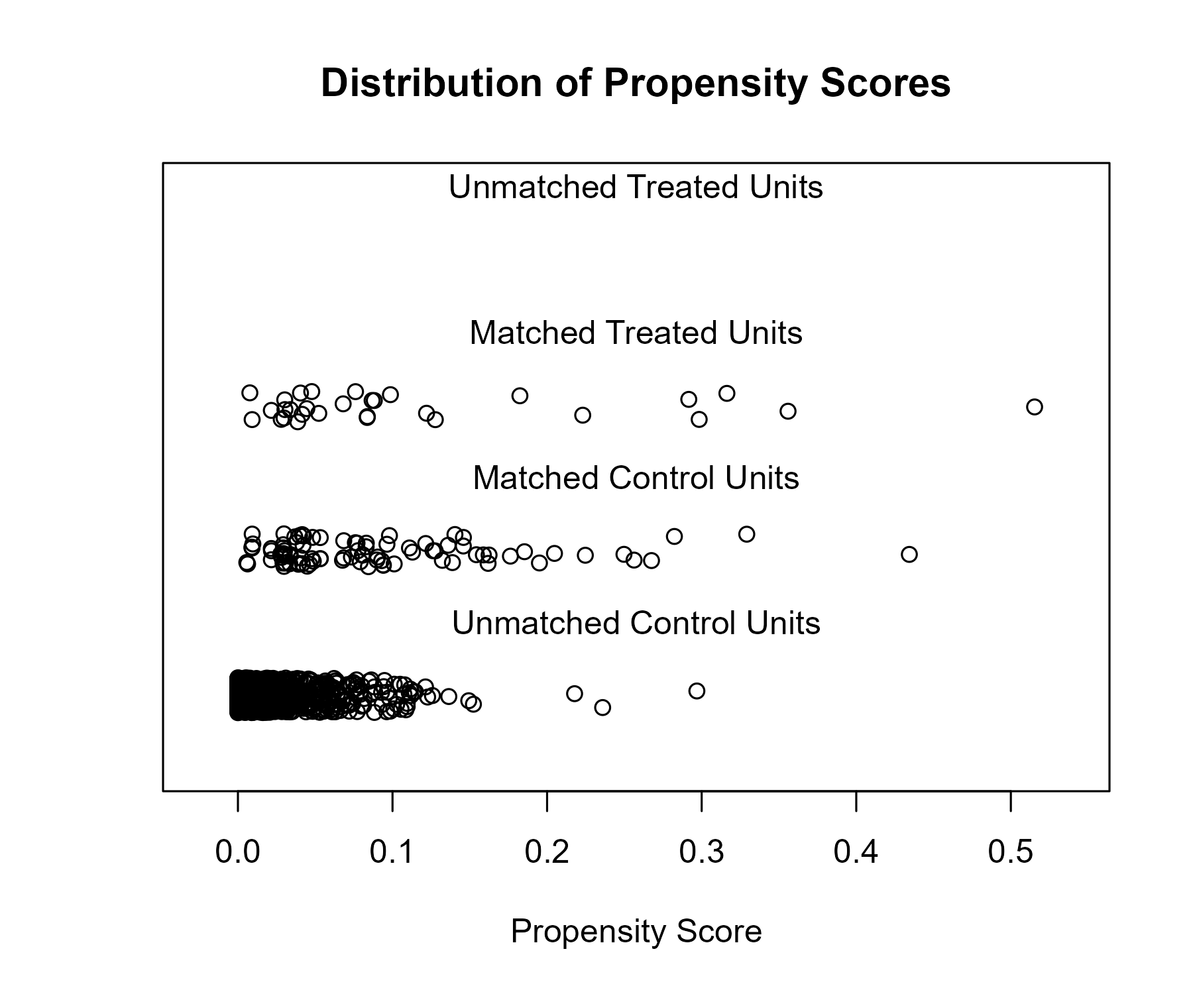

## Covariate balance

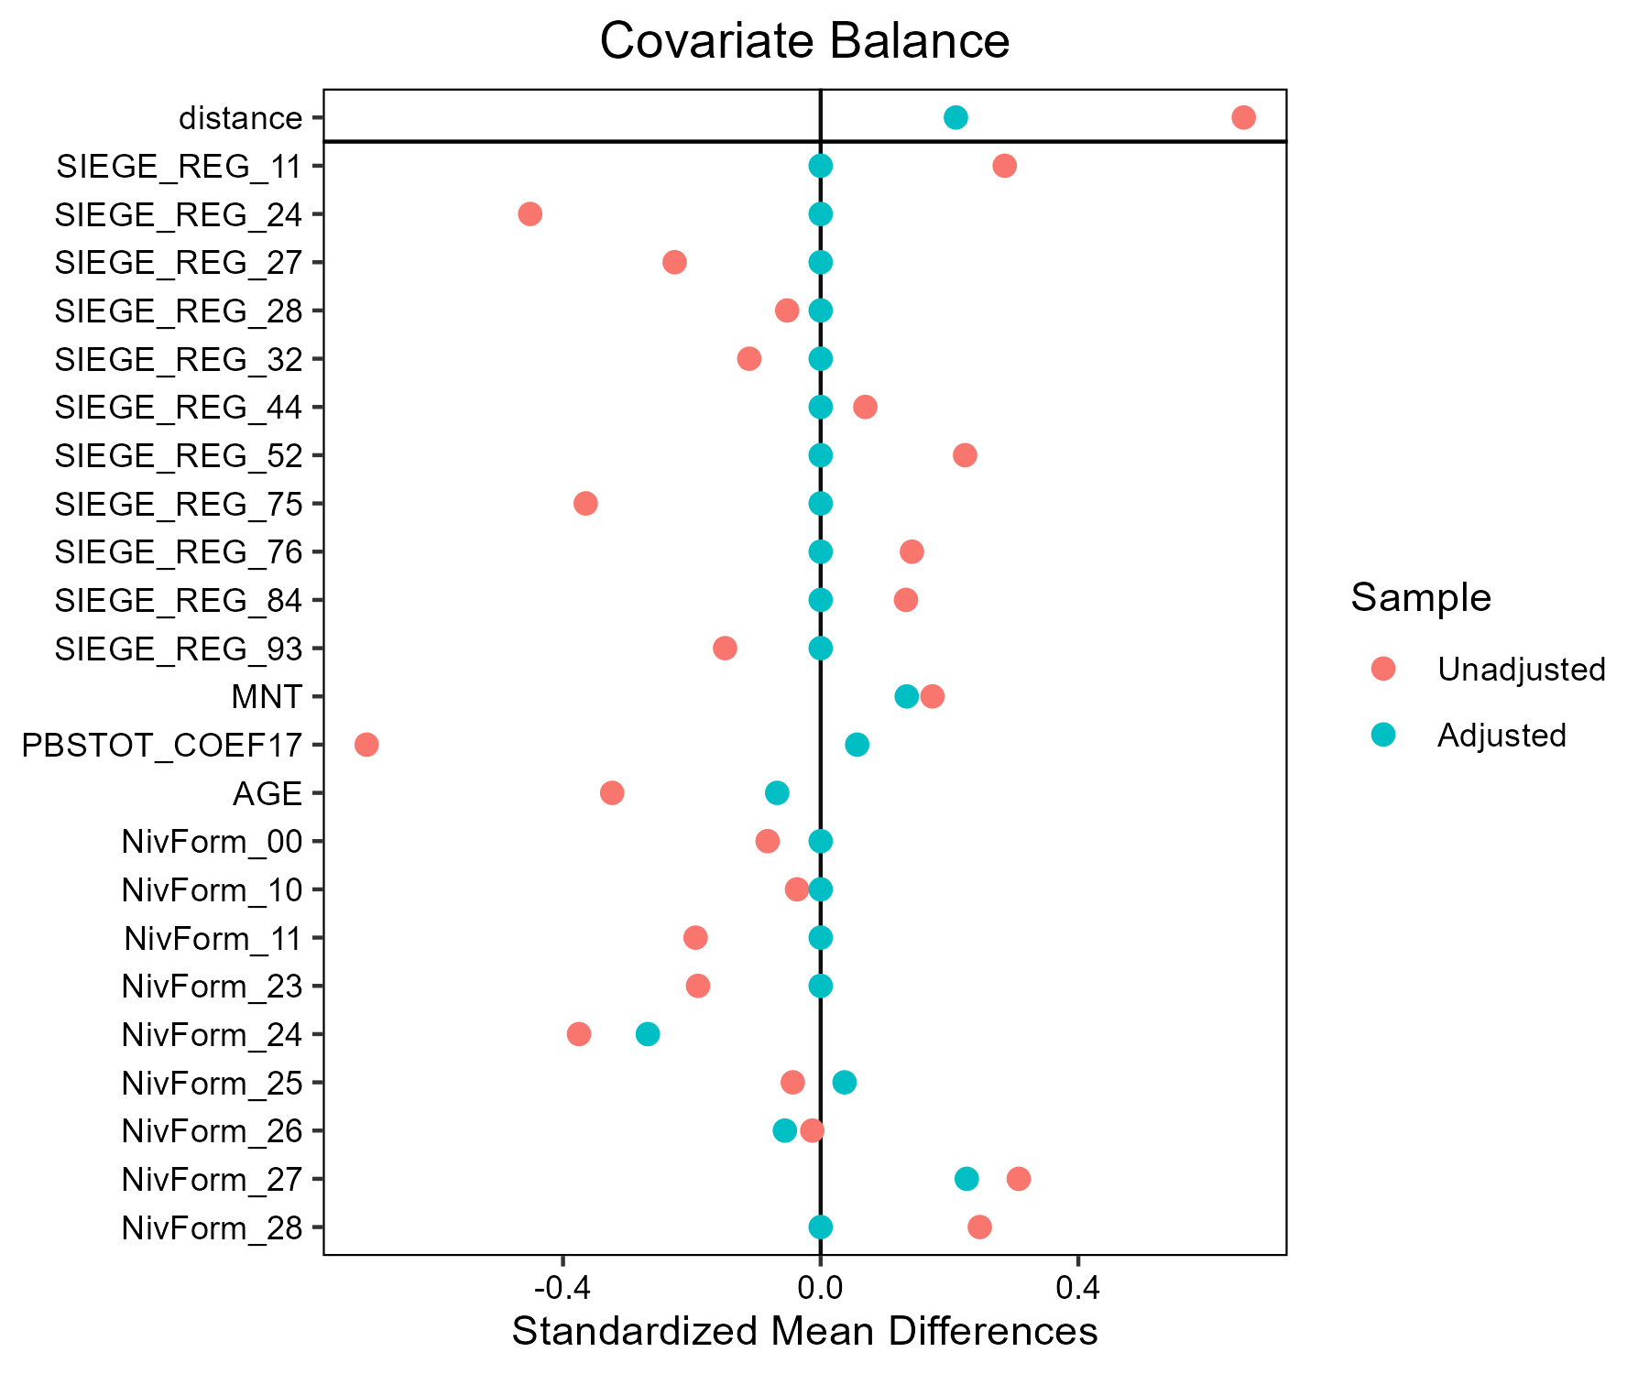

# Triticale - AB

## Covariate distribution before matching

|  |  | Triticale - AB (N=47) / Mean | Triticale - AB (N=47) / Std. Dev. | Triticale - Conventionnel (N=775) / Mean | Triticale - Conventionnel (N=775) / Std. Dev. | Diff. in Means | Std. Error |
| --- | --- | --- | --- | --- | --- | --- | --- |
| PBSTOT_COEF17 |  | 211745.7 | 118524.7 | 229715.0 | 206162.3 | 17969.3 | 18807.9 |
| AGE |  | 48.0 | 10.6 | 48.4 | 10.0 | 0.4 | 1.6 |
|  |  | N | Pct. | N | Pct. |  |  |
| SIEGE_REG | 11 | 6 | 12.8 | 2 | 0.3 |  |  |
|  | 24 | 1 | 2.1 | 55 | 7.1 |  |  |
|  | 27 | 6 | 12.8 | 95 | 12.3 |  |  |
|  | 28 | 1 | 2.1 | 16 | 2.1 |  |  |
|  | 32 | 3 | 6.4 | 6 | 0.8 |  |  |
|  | 44 | 10 | 21.3 | 63 | 8.1 |  |  |
|  | 52 | 2 | 4.3 | 55 | 7.1 |  |  |
|  | 53 | 2 | 4.3 | 35 | 4.5 |  |  |
|  | 75 | 5 | 10.6 | 177 | 22.8 |  |  |
|  | 76 | 3 | 6.4 | 88 | 11.4 |  |  |
|  | 84 | 8 | 17.0 | 162 | 20.9 |  |  |
|  | 93 | 0 | 0.0 | 21 | 2.7 |  |  |
| MNT | FALSE | 37 | 78.7 | 548 | 70.7 |  |  |
|  | TRUE | 10 | 21.3 | 227 | 29.3 |  |  |
| NivForm | 00 | 0 | 0.0 | 2 | 0.3 |  |  |
|  | 10 | 0 | 0.0 | 1 | 0.1 |  |  |
|  | 11 | 0 | 0.0 | 14 | 1.8 |  |  |
|  | 23 | 0 | 0.0 | 40 | 5.2 |  |  |
|  | 24 | 7 | 14.9 | 246 | 31.7 |  |  |
|  | 25 | 3 | 6.4 | 107 | 13.8 |  |  |
|  | 26 | 13 | 27.7 | 208 | 26.8 |  |  |
|  | 27 | 13 | 27.7 | 146 | 18.8 |  |  |
|  | 28 | 11 | 23.4 | 11 | 1.4 |  |  |

## Covariate distribution after matching

|  |  | Triticale - AB (N=43) / Mean | Triticale - AB (N=43) / Std. Dev. | Triticale - Conventionnel (N=122) / Mean | Triticale - Conventionnel (N=122) / Std. Dev. | Diff. in Means | Std. Error |
| --- | --- | --- | --- | --- | --- | --- | --- |
| PBSTOT_COEF17 |  | 209880.2 | 112776.5 | 224976.4 | 190619.1 | 15096.2 | 24364.2 |
| AGE |  | 48.2 | 10.6 | 47.3 | 9.6 | -0.8 | 1.8 |
|  |  | N | Pct. | N | Pct. |  |  |
| SIEGE_REG | 11 | 2 | 4.7 | 2 | 1.6 |  |  |
|  | 24 | 1 | 2.3 | 3 | 2.5 |  |  |
|  | 27 | 6 | 14.0 | 18 | 14.8 |  |  |
|  | 28 | 1 | 2.3 | 3 | 2.5 |  |  |
|  | 32 | 3 | 7.0 | 6 | 4.9 |  |  |
|  | 44 | 10 | 23.3 | 30 | 24.6 |  |  |
|  | 52 | 2 | 4.7 | 6 | 4.9 |  |  |
|  | 53 | 2 | 4.7 | 6 | 4.9 |  |  |
|  | 75 | 5 | 11.6 | 15 | 12.3 |  |  |
|  | 76 | 3 | 7.0 | 9 | 7.4 |  |  |
|  | 84 | 8 | 18.6 | 24 | 19.7 |  |  |
| MNT | FALSE | 33 | 76.7 | 90 | 73.8 |  |  |
|  | TRUE | 10 | 23.3 | 32 | 26.2 |  |  |
| NivForm | 24 | 7 | 16.3 | 26 | 21.3 |  |  |
|  | 25 | 2 | 4.7 | 6 | 4.9 |  |  |
|  | 26 | 13 | 30.2 | 44 | 36.1 |  |  |
|  | 27 | 13 | 30.2 | 42 | 34.4 |  |  |
|  | 28 | 8 | 18.6 | 4 | 3.3 |  |  |

## Matching model coefficients

| . | Estimate | Std. Error | t value | Pr(&gt;|t|) |
| --- | --- | --- | --- | --- |
| (Intercept) | -16.7724874786421 | 4444.70852175488 | -0.00377358546607684 | 0.996990063501975 |
| SIEGE_REG24 | -4.14012429951095 | 1.35891684213954 | -3.04663550493093 | 0.00239030205350551 |
| SIEGE_REG27 | -2.4312817326944 | 1.04201742441614 | -2.33324479584082 | 0.0198825628382644 |
| SIEGE_REG28 | -2.29695868353336 | 1.38591185378376 | -1.65736275165141 | 0.0978387130781949 |
| SIEGE_REG32 | 0.0380267859390024 | 1.20555722897504 | 0.0315429122940373 | 0.974844447493566 |
| SIEGE_REG44 | -1.65858822832394 | 1.00977213398557 | -1.64253713536092 | 0.100872202356678 |
| SIEGE_REG52 | -2.96519912397127 | 1.18004461386472 | -2.51278560923222 | 0.0121740600731441 |
| SIEGE_REG53 | -2.29059264474048 | 1.19516240293036 | -1.91655346513936 | 0.0556511395838997 |
| SIEGE_REG75 | -3.46286667221857 | 1.04656953092291 | -3.30877841357072 | 0.000978986626172575 |
| SIEGE_REG76 | -3.32808910675044 | 1.1793979436395 | -2.82185425597768 | 0.00489320589703068 |
| SIEGE_REG84 | -2.92931676284115 | 1.095607736316 | -2.67369119963595 | 0.007655315008677 |
| SIEGE_REG93 | -18.6159989607207 | 1340.34826524918 | -0.0138889268135545 | 0.988922063177126 |
| MNTTRUE | 0.220865070832172 | 0.560842653161482 | 0.393809332416411 | 0.693826884067612 |
| PBSTOT_COEF17 | -2.12662413933324e-06 | 1.15483721834572e-06 | -1.84149255457802 | 0.0659199154340097 |
| AGE | 0.0271679176717131 | 0.0200231232244913 | 1.35682717262023 | 0.175219331018167 |
| NivForm10 | -0.587748070036275 | 7710.0290551393 | -7.62316284196748e-05 | 0.999939194989018 |
| NivForm11 | -0.517952650145495 | 4728.5464491852 | -0.000109537392877836 | 0.999912629147401 |
| NivForm23 | 0.0126020446406082 | 4549.71308226882 | 2.76985480462954e-06 | 0.999997790667004 |
| NivForm24 | 14.8329573573197 | 4444.70820718862 | 0.00333721735283539 | 0.997338123754276 |
| NivForm25 | 15.0614873346622 | 4444.7082502286 | 0.00338863351354671 | 0.997297112659751 |
| NivForm26 | 15.8982529263946 | 4444.70820892755 | 0.00357689463044204 | 0.997146949925466 |
| NivForm27 | 16.2399609648861 | 4444.70822078878 | 0.00365377436676914 | 0.997085628362181 |
| NivForm28 | 18.2903145333684 | 4444.70823388454 | 0.00411507652941783 | 0.996717680417925 |

## Propensity score distribution

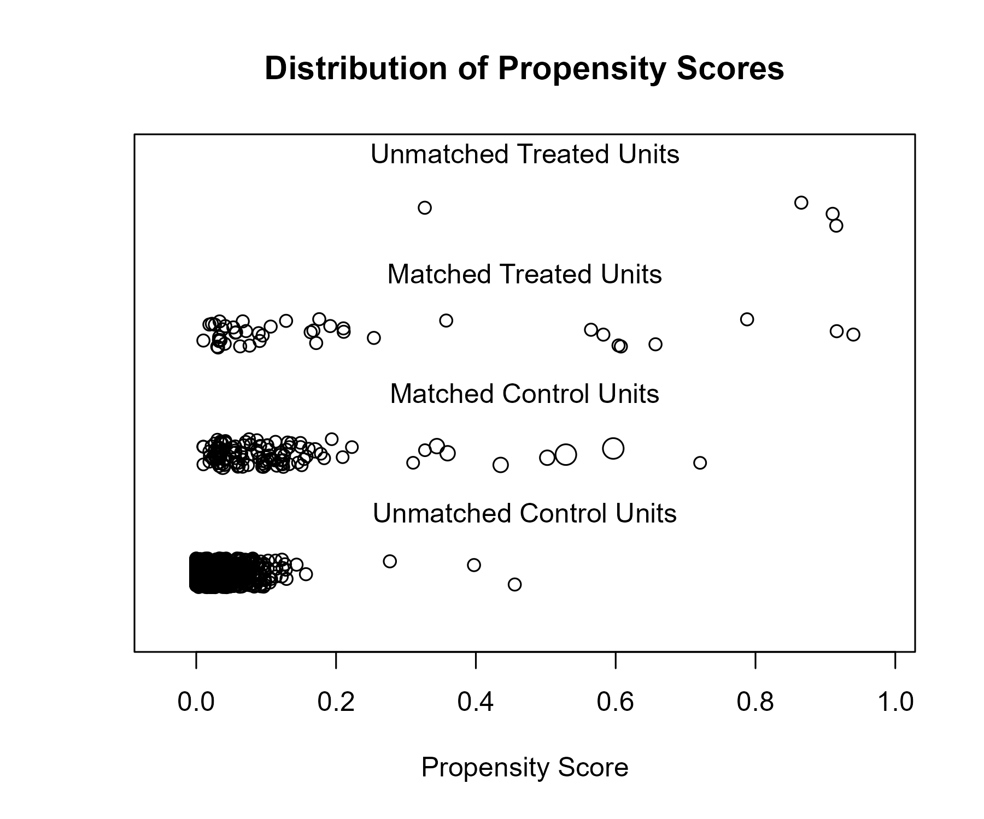

## Covariate balance

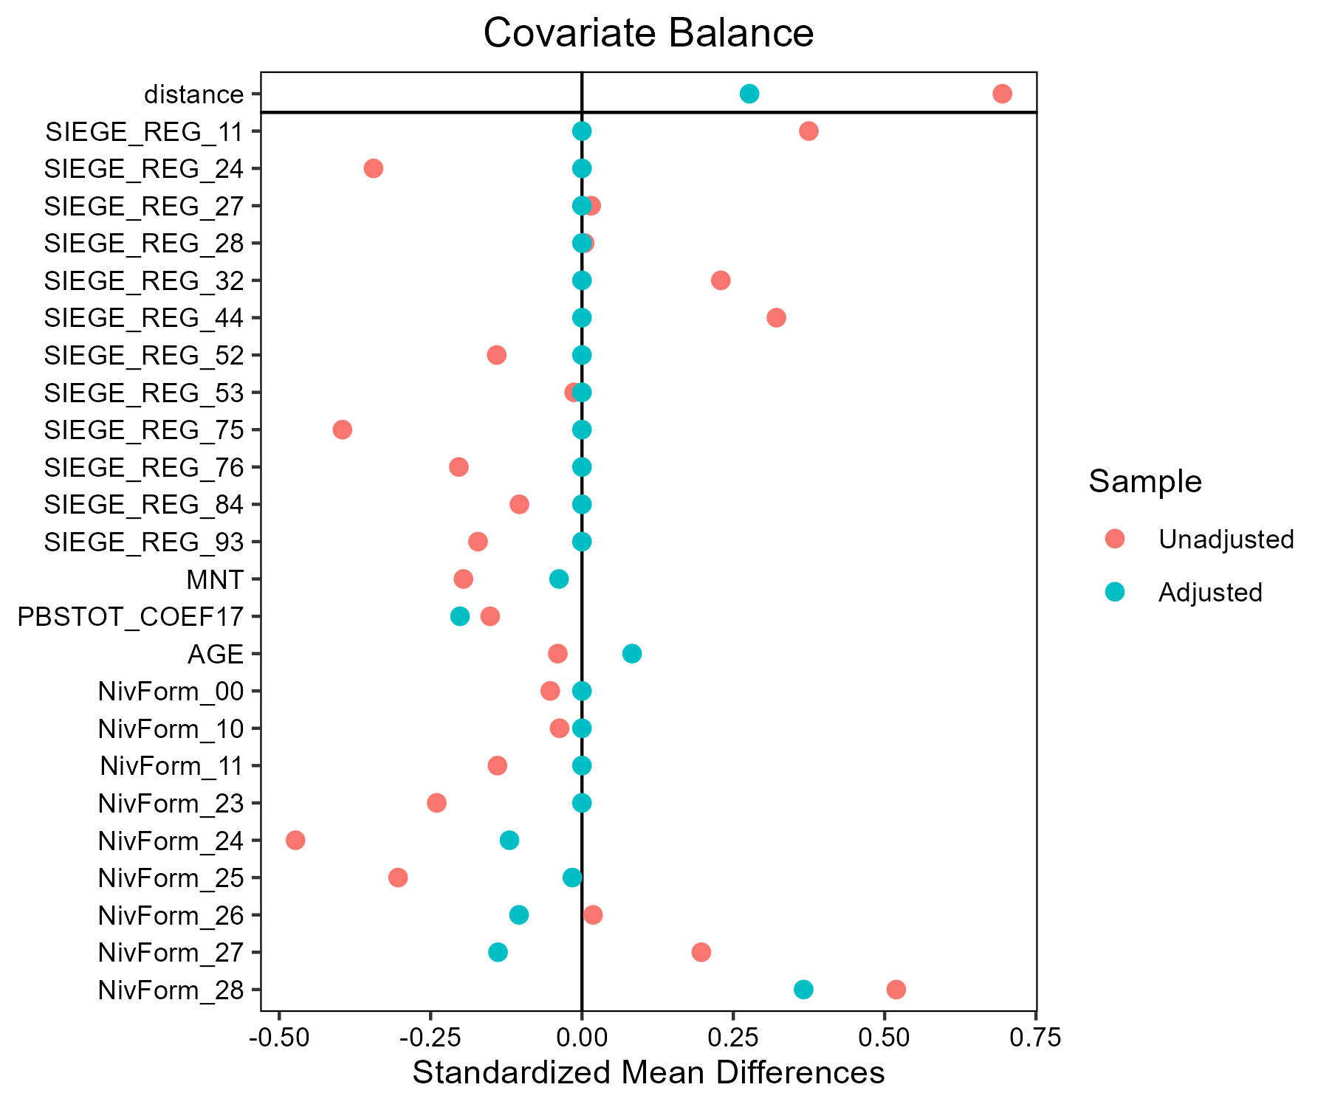

# Number of matches

| match | FQS | nobs |
| --- | --- | --- |
| Autres_cereales__AB | AB | 41 |
| Autres_cereales__AB | Conventionnel | 103 |
| Ble_tendre__AB | AB | 93 |
| Ble_tendre__AB | Conventionnel | 279 |
| Ble_tendre__LR | Conventionnel | 300 |
| Ble_tendre__LR | LR | 100 |
| Lait__AB | AB | 88 |
| Lait__AB | Conventionnel | 264 |
| Lait__Beurre de Charentes-Poitou | Beurre de Charentes-Poitou | 59 |
| Lait__Beurre de Charentes-Poitou | Conventionnel | 104 |
| Lait__Bleu d'Auvergne - Cantal | Bleu d'Auvergne - Cantal | 54 |
| Lait__Bleu d'Auvergne - Cantal | Conventionnel | 111 |
| Lait__Comte - Morbier | Comte - Morbier | 64 |
| Lait__Comte - Morbier | Conventionnel | 74 |
| Lait__Fromages de Savoie | Conventionnel | 99 |
| Lait__Fromages de Savoie | Fromages de Savoie | 33 |
| Lait__Munster | Conventionnel | 114 |
| Lait__Munster | Munster | 38 |
| Mais_fourrage__AB | AB | 44 |
| Mais_fourrage__AB | Conventionnel | 132 |
| Mais_grain__AB | AB | 37 |
| Mais_grain__AB | Conventionnel | 111 |
| Melange_cereales_d_ete__AB | AB | 48 |
| Melange_cereales_d_ete__AB | Conventionnel | 90 |
| Orge_d_hiver_et_escourgeon__AB | AB | 37 |
| Orge_d_hiver_et_escourgeon__AB | Conventionnel | 111 |
| Orge_de_printemps__AB | AB | 31 |
| Orge_de_printemps__AB | Conventionnel | 93 |
| Tournesol__AB | AB | 30 |
| Tournesol__AB | Conventionnel | 90 |
| Triticale__AB | AB | 43 |
| Triticale__AB | Conventionnel | 122 |