The MicroManage Manifesto
Open Source Microscopy Management Software

Nenad Amodaj, Nico Stuurman
Vale Lab, UCSF

Revisions:
- Draft, June 29, 2005
- Revision A, July 6, 2005

Abstract:

This document describes the motivation, goals and guidelines for the open source microscopy acquisition software environment referred to as MicroManage (MM). MM will provide a cross–platform, hardware-agnostic solution for controlling complex, automated microscopes and performing image acquisition tasks encountered in life science research. The core MM services and infrastructure can be used to control many different microscope configurations, regardless of the particular hardware (shutter, camera, filter wheels, stages, etc.). MM acts as an automated microscope hardware abstraction layer bridging the graphical user interface (GUI) on one side, and device drivers on the other. On the GUI side MM provides a uniform, device-independent programming interface. On the device driver side it provides a plug-in interface facilitating support of various hardware components with minimal programming effort. The flexibility of the MM software will make novel experimental approaches possible and will also reduce considerably the costs associated with image acquisition.
The MicroManage Manifesto

Introduction
Motivation
Objectives
Architecture requirements
Software Design Guidelines

Introduction

Microscopy and digital image acquisition have become fundamental research tools in the biological sciences. Most basic science and many clinical laboratories employ digital microscopy in some aspect of their studies. There is a clear, commonly expressed need for an open source, freely available, image acquisition software package. We intend to provide such software under the name ‘Micromanage’ (MM). The software will be easily adaptable to work with many different hardware configurations and will simplify and expand opportunities for microscopy novices and seasoned veterans alike. MM will make novel experimental approaches possible and will also reduce considerably the costs associated with image acquisition, which is currently provided by expensive commercial software packages that do not provide open access code.

The notion of an integrated or automated microscope is central to the MM project. We recognize the fact that all integrated microscopes, regardless of the actual hardware used, share common functionality. This functionality can be abstracted in the common, configurable layer, minimizing the amount of software that needs to be written in order to support each specific hardware component.

Motivation

Imaging cells, alive or fixed and stained, has become an essential technology in many laboratories working in the life sciences. The components needed for such image acquisition consist of a microscope, cameras, light sources, mirrors, filters mounted in motorized filter wheels, x-y-z stages, and shutters. In practice, many complicated successions of motorized operations are needed to achieve the imaging strategy desired by the researcher (e.g. acquiring images from multiple wavelengths). Thus, computer control of image acquisition is an integral part of contemporary microscopy.

From the user’s standpoint the whole setup (microscope equipped with the camera, stage, filter wheels, etc.) should ideally appear as an integrated, coherent system – an “appliance”. This appliance should allow for effective and comfortable interactive work, as well as unattended, completely automated operation.

There are several commercial programs on the market attempting to provide some, or all, of the functionality. However, not every software package supports every piece of hardware and the selection of hardware components is often directly dictated by the software package chosen. In practice, these choices can become quite debilitating; it is not uncommon to discover that a preferred piece of hardware (e.g. a particular camera) cannot be used simply because the current software package does not offer support. This limitation is even more extreme when one tries to equip all microscopes in a lab or department with the same software package. Moreover, slightly more complex or custom experimental set-ups are often not supported by a software package. The vendor is the only entity capable of adding such functionality, and more often than not, is uninterested in such extensions. It is also difficult to get two companies (e.g. software company and a hardware company) to communicate with one another to solve even simple problems. Lastly, commercial software packages are expensive ($4-20,000) and can be a major financial drain for research.

Objectives

We will nucleate development of a software package for image acquisition that will be freely available along with its source code. The software will have a graphical user interface to all commonly used experimental modes (such as acquiring single snapshots or multi-color, time-lapse, or 3-D images) and it will be extensible such that novel approaches or hardware can easily be incorporated. We envision that this software package will gain similar stature and community support for image acquisition as the software package ImageJ (written by Wayne Rasband at NIH, who also authored NIH image) has achieved for image analysis.

We have considered several possible platforms and decided to provide a graphical user interface (GUI) working within the freely available image analysis package ImageJ. ImageJ is written in Java, allowing it to be run on any modern operating systems (Windows, Mac, and Linux). ImageJ is supported by a large international community of users and developers, and it contains a plugin mechanism and a macro language that will facilitate development of an extensible system. Another advantage of building upon the ImageJ platform is that researchers can combine image acquisition with image analysis in one software environment. MM will contain a hardware abstraction layer to facilitate integration of novel hardware; for each piece of new hardware, all that will be required is the code that links the driver for the hardware to the hardware abstraction layer. Furthermore, the system will contain a well-documented application programmer’s interface (API), to be used to extend the system to more complex experimental set-ups.

Although the MM is not a commercial product and is available free of charge, we feel that it is very important that it has features which are normally expected from a commercial product: advanced user interfaces, easy installation and good documentation. The MM software provides full support for extending its functionality by adding to or modifying the original code, but the default MM software package should feel like a product designed for primarily for biologists - not computer scientists and programmers. Users without programming and system administration skills must be able to install configure and use the software.

Architecture requirements

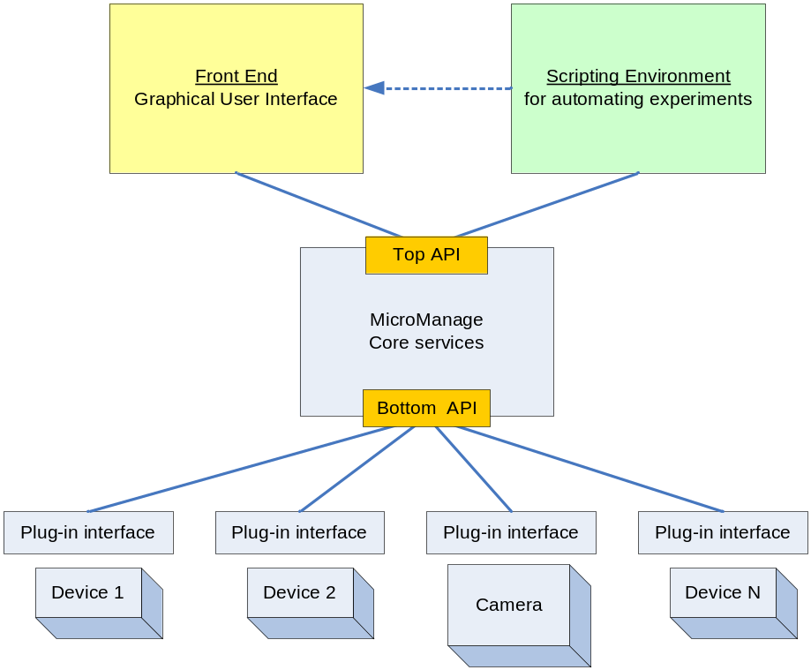

Figure 1, MicroManage software architecture block diagram

The MM Core module is a hardware abstraction layer providing services common to all automated microscopes. It also acts as insulation between intricacies of particular device drivers and the system GUI. It provides two programming interfaces “Top” API (from the GUI to the MM Core) and “Bottom” API (from device drivers to the MM Core).

The Top API gives the designer of the GUI the ability to implement user interfaces and entire applications that are essentially hardware independent. Although we will focus on providing a GUI running from within ImageJ, our approach will make it possible to construct alternative GUIs using the MM Core module. The Bottom API allows the programmer to support particular devices with a minimal amount of coding effort and minimal understanding of how the entire system works.

The basic MM system consists of the following components:
- ImageJ GUI front-end with plugins for interacting with the integrated microscope
- MM Core server
- Scripting environment for writing completely automated procedures and executing command-line control commands (in addition to the ImageJ macro capabilities)
- Set of device adapter modules for particular hardware devices

MM Core Services
MM Core provides the following device-independent services:
- Saving image files with automatic name generation and acquisition directory management
- Automatic metadata generation and image annotation
- Extensive and flexible hardware configuration facilities to support defining, naming and adding new devices
- Device synchronization
- High resolution timing
- Commonly used acquisition modes such as multiple channel, Z-stack and time-lapse.

ImageJ: the front-end to MM

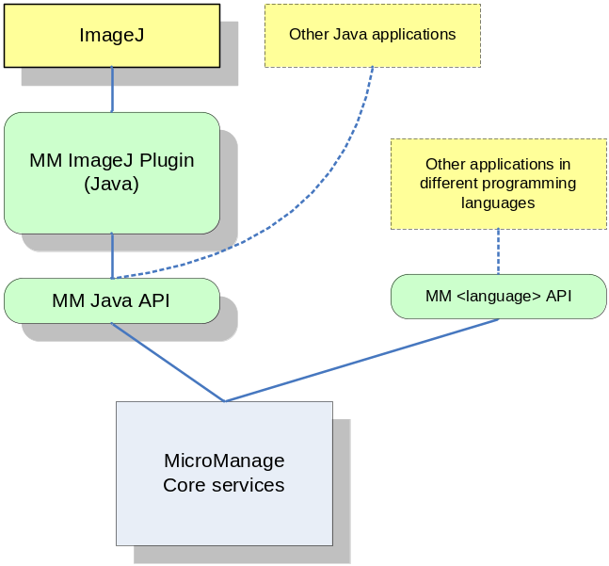
Figure 2, Integration of MM with ImageJ and other applications and programming environments

MM project contributors will strive to leverage the existing capabilities of ImageJ to the highest practical extent with respect to the requirements stated in this document. However, MM will not introduce any dependencies on ImageJ in its core functionality. In other words, it should be as easy to integrate MM will other environments: stand-alone applications, Matlab, S-Plus, R, scripting language interpreters, etc.

ImageJ is intended to serve as the default user interface and image analysis front-end to MM so that the combined software appears like a well-integrated, easy to use microscopy package. The MM software package will be seamlessly integrated by taking advantage of the ImageJ plugin architecture and its image processing and display components.

Multi-user and network access

Although multi-user access and network connectivity are not required to perform basic microscope control tasks, they are very important for automation and laboratory management procedures. For example, the status of the microscope setup can be monitored in real-time from a remote location. This is especially important during long, unattended experiments performed on live cells or during large-volume image acquisition from micro-well plates.

Also, transparent network access can dramatically simplify multi-platform setups. For example, the user who prefers to use Mac operating system can connect their ImageJ (or other) Mac client to the MM server host running Windows and have the same experience as if the microscope is controlled directly from his/hers Mac machine. This eliminates the need to provide or obtain Mac specific drivers for hardware devices used in the microscope setup.

Software Design Guidelines

Modularity
The MM software is highly modular to facilitate collaboration between different contributors and to make maintenance, testing and debugging as effective as possible.

Client-Server capabilities
The MM software and derived applications are designed around the client-server paradigm. In other words, the front-end GUI is strictly separated from the hardware control functionality by a well-defined, simple API. All commands, unless dictated otherwise by real-time performance constraints, should follow a simple request-response model, with the GUI sending requests and the MM core servicing them.

Rigorous client-server design enables easy and robust implementation of a distributed software system where multiple clients and servers communicate with each other over the network. The software should also allow for bypassing the network client/server middleware when operated on a single machine and under critical performance requirements.

Extensibility
One of the most important features is the support for extending the basic software to facilitate novel imaging techniques and building specialized imaging applications. The device level (Bottom) API is restricted by the programming environment used by most, if not all, hardware vendors (C/C++).

The application level API (Top), however, should provide relatively easy support for mainstream programming languages, such as Java and C++ as well as popular scripting environments such as Python. The MM software should not limit client-side programming to any single environment or programming language.

Portability
The MM implementation is not tied to any particular operating system. We will not use programming language features or system services heavily dependent on the operating systems. We recognize the fact that true platform neutrality is extremely difficult to achieve in practice and we will focus our efforts on supporting three operating systems commonly used in laboratories: Windows and Linux on the server side and Windows and Mac OS X on the client side.

Run-time configurability
The MM API allows design of the client software (GUI and automated operation scripts) with minimal a priori knowledge of the specific hardware. The API should support run-time discovery of the hardware configuration and capabilities to the maximum extent possible.

