MicroManage
Open Source Microscope Management Software

User’s Guide

Nenad Amodaj
Draft: March 31, 2006
Table of Contents:

Introduction 3
Credits, License and Copyright 3
Current status 4
Installation 5
Windows 5
Mac 5
Hardware configurations 5
ImageJ 5
Getting started 6
Acquiring a single image 6
Live mode 7
Brightness and contrast 8
Histogram 8
Line profile 8
Region of Interest (ROI) 9
Controlling devices 10
Configurations and device properties 10
Acquiring a 5D image 12
Scripting 14
Configuring the system 15

Introduction

Imaging cells has become an essential technology in many laboratories working in the life sciences. The components needed for such image acquisition consist of a microscope, cameras, light sources, mirrors, filters mounted in motorized filter wheels, x-y-z stages, and shutters. In practice, many complicated successions of motorized operations are needed to achieve the imaging strategy desired by the researcher (e.g. acquiring images from multiple wavelengths). Thus, computer control of image acquisition is an integral part of contemporary microscopy.

From the user’s standpoint the whole setup (microscope equipped with the camera, stage, filter wheels, etc.) should ideally appear as an integrated, coherent system – an “appliance”. This appliance should allow for effective and comfortable interactive work, as well as unattended, completely automated operation.

Available commercial packages more or less provide the needed functionality for controlling automated microscopes, but because they are proprietary and closed they are difficult to extend and customize. New devices can not be added to the system unless the software vendor chooses to provide appropriate drivers. Sometimes, the cost of configuring the system with all necessary software and drivers can be quite high.

In contrast to virtually all of the available commercial solutions, MicroManage supports multiple platforms (Windows, Mac and Linux) and provides open plug-in interfaces for adding new devices. In addition, MicroManage is integrated with the widely used image processing package ImageJ, also available in the public domain. Combined with ImageJ, MM provides a full featured microscope management and image processing package, comparable in capabilities to the commercial solutions. It is distributed free of charge and under an Open Source license. Its code base and functionality can be customized, extended and re-used practically without restrictions.

Credits, License and Copyright
MicroManage is an Open Source software package for controlling automated microscopes on multiple platforms (Windows, Mac and Linux). The software is developed entirely in the Vale Lab at UC San Francisco and funded by the Sandler Foundation, based on the original idea of Nico Stuurman and Ron Vale. The software is designed and developed by Nenad Amodaj. Nico Stuurman also develops MicroManage device drivers for the Mac OS X platform.

MicroManage is distributed under the BSD license for the user interface and the LGPL license for the MMCore (control module). All supplied device drivers for cameras and other devices are also covered by the BSD license.

MicroManage is built by extensively using other open source components and applications:
- ImageJ (http://rsb.info.nih.gov/ij/)
- Image5D component (http://rsb.info.nih.gov/ij/plugins/image5d.html)
- SWIG (http://www.swig.org/)
- Beanshell (http://www.beanshell.org/)
- ACE (http://www.cs.wustl.edu/~schmidt/ACE.html)

Current status
MicroManage is currently in the 1.0 Beta stage, available to interested parties upon request. The public 1.0 release is planned for the fall of 2006.

Installation

Windows
Run the installer (MicroManage_setup.exe) and follow the prompts. The package includes copies of both Java run time and ImageJ, and is completely self-contained. It is not required to install any other software in order to fully use MicroManage.

There are no particular hardware or software requirements. However, for practical use we recommend Windows XP, 1.7 GHz or better processor and at least 512 MB of RAM.

Mac
Double click on the file MM_ImageJ.dmg. This will open a drive called 'MM_ImageJ'. The drive is on the desktop and in every Finder Window. Open the drive (by double-clicking). In the drive there is a folder called MM_ImageJ. You can install the application by dragging this folder to your Applications folder, or you can launch the application by opening the folder and double clicking the 'MM_ImageJ' icon.

Hardware configurations
Installation includes a number of sample hardware configuration files (with extension *.cfg) provided only as an example, or the starting point - they need to be edited to in order to use the system with any particular hardware setup (see section Configuring the system).

By default, after the first installation MicroManage starts with the Demo configuration which loads software simulators for a number of commonly used devices. This configuration can be used to explore MicroManage features, train novice users and as a reference point for troubleshooting.

ImageJ
MicroManage is packaged as an ImageJ plug-in. Starting MicroManage will automatically start ImageJ as well. If you already use ImageJ and have it installed on your machine beforehand, the original installation will not be affected. MicroManage will also install and use its own copy of ImageJ.

However, if you have any existing ImageJ macros or plugins that you want to use with MicroManage, you will have to copy them manually to the appropriate sub-folders within the root MicroManage folder.

Getting started
On startup MicroManage displays the splash screen which allows you to choose the particular hardware configuration file. If you press OK without changing anything, the last successfully used configuration file will be loaded. Demo configuration (software simulator) will appear as default the first time you start the application. We recommend that you try it out for a while before attempting to control the real microscope setup. All examples in this guide refer to the Demo configuration.

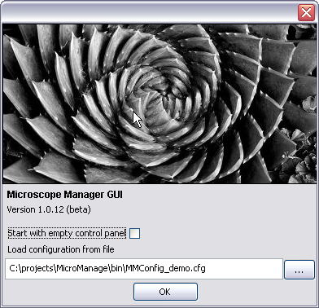
Figure 1. Startup screen: selection of the configuration file

You can also choose to skip loading the configuration file (Start with the empty control panel option) in which case the application starts without any devices attached. In that case devices can be loaded "manually" at any time using the MicroManage scripting features (see section Scripting).

Acquiring a single image
After the configuration file is loaded the main control panel displays current settings and shows the status of selected devices. To acquire a single image press the "Snap" button. The ImageJ window will automatically pop-up, displaying the acquired image. You can use any of the available ImageJ tools to analyze, save or edit the image. In addition, at the bottom of the window there are shortcut buttons for adjusting brightness/contrast and saving to image files.

Each time you press the Snap button the image in the window will be updated. The Demo camera driver generates a spatial sine wave which shifts each time you acquire a new image. You can also change any of the settings in the control panel and the changes will be immediate. The bottom part of the control panel displays the histogram of the acquired image.
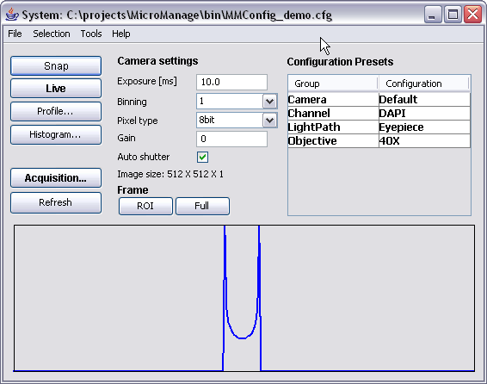
Figure 2. Main control panel displaying device controls and image histogram.

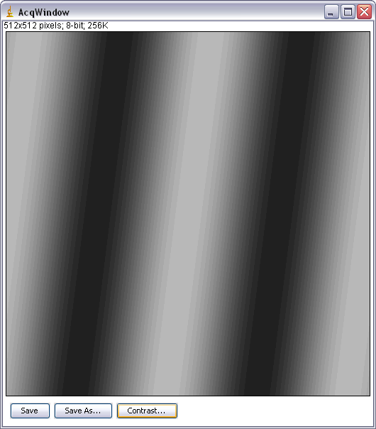
Figure 3. Acquisition image window.

Live mode
To continuously acquire images press the "Live" button. Pressing this button again, stops the live acquisition. Settings in the control panel can be changed during live acquisition and the effects on the acquired images will be immediate.

Brightness and contrast
The displayed brightness and contrast can be adjusted by pressing the "Contrast" button at the bottom of the image window. Any settings entered in the dialog will apply only to the image display - the actual pixel values will not be affected.

MicroManage brightness and contrast dialog is different from the standard ImageJ dialog in that it is connected to the live image, i.e. the current settings will be applied to each newly acquired image.

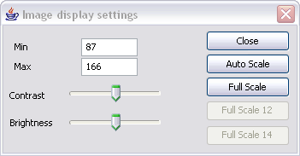
Figure 4. Brightness and contrast dialog.

Histogram
The "Histogram" button opens up a live histogram window. Unlike the regular ImageJ histogram this window will update each time a new image is acquired. The histogram is computed from the entire image or the currently active region of interest. To select a region of interest, use the standard rectangle tool from the ImageJ toolbar.

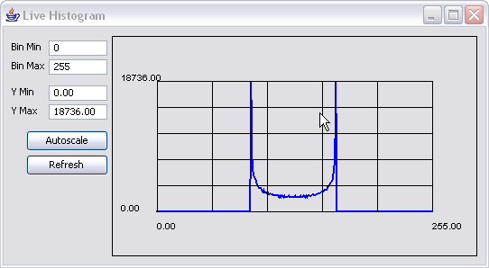
Figure 5. Histogram window.

Line profile
The "Profile" button opens up a live line profile window. Unlike the regular ImageJ profile this window will update each time a new image is acquired. The profile is computed from the currently active line drawn over the image. To draw a line profile a region, use standard line tool from the ImageJ toolbar.

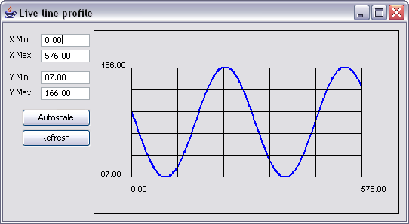
Figure 6. Line Profile window.

Region of Interest (ROI)
Most of the cameras used for microscopy can be configured to acquire from the Region of Interest (ROI) instead of the full frame. To select a ROI use the ImageJ rectangle tool on the image window. By pressing the "ROI" button while the selection is active, you will apply the current rectangle to the camera. Some cameras will internally adjust the rectangle dimensions slightly to fit within specific hardware constrains. To return to the full frame imaging, press the "Full" button.

Controlling devices
The main control panel provides basic settings for the camera and configuration presets. Available controls should be sufficient for the most common use cases. "Presets" are groups of simultaneous device commands configured to increase the ease of use. Placing the cursor over the current preset will display a tool-tip window and show which devices will be affected by the command. For example, choosing the "DAPI" channel preset command will move three filter wheels in the appropriate positions.

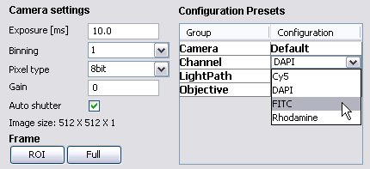
Figure 7. Detail of the main control window: configuration preset commands.

Configurations and device properties
The main control panel provides only a subset of the devices loaded in the system. To view and control all devices and all settings available in the currently loaded hardware, use "Property Editor" (menu command Tools | Property Editor). The Property Editor displays a list of all devices and associated "properties" (settings available for each device). Using the property editor you can inspect and change any setting on any device.

In practical situations we often need to execute groups of multiple commands over and over again. For example, to set the correct light path for imaging DAPI fluorescence channel we need to set three filters in proper positions:
// Set DAPI imaging path
core.setState("Emission", 1);
core.setState("Excitation", 2);
core.setState("Dichroic", 0);

To simplify instrument control, MicroManage provides a configuration feature in which we can define groups of commands and execute them as a single command. For example, each time we execute command "DAPI" in the Channel group, the three filters will be set to the defined positions. There is no limit in the number of devices or number of different properties you include in one configuration. We can set objectives, filters, stage positions, camera parameters in a single configuration command. Typically, predefined configurations are automatically defined at the initialization (when the program starts up) phase and used thereafter in the acquisition scripts or interactively.

To change existing and add new configuration presets use the right-most column titled "Active". By setting the check-box for the particular property you are including that setting in the current configuration preset.

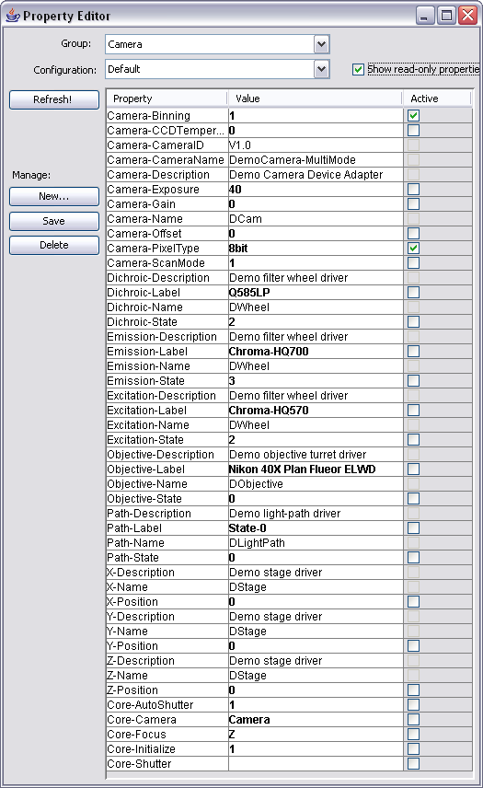
Figure 8. Property editor window.

Acquiring a 5D image
To acquire multi-image stacks, press the "Acquisition" button to open the Acquisition Control dialog. MicroManage allows you to create a stack as multi-channel (wavelength coordinate), multi-frame (time coordinate), multi-slice (Z coordinate), or any combination of the above. Such stacks will be referred to as "5D images".

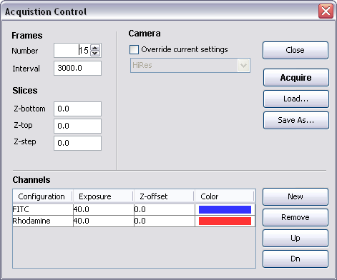
Figure 9. Acquisition control dialog.

After defining channels, slices and frames by using controls in the dialog, press the "Acquire" button. The acquisition starts immediately and the Image5D window will open displaying the progress. During and after acquisition you can use buttons at the bottom of the Image5D window to play-back the sequence, browse channels, slices or frames and save the entire image stack to disk.
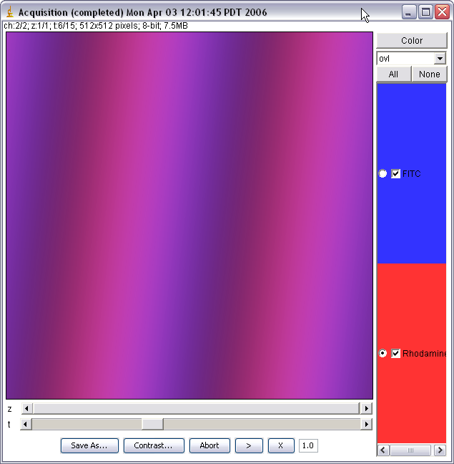
Figure 10. Acquisition data displayed in the 5D image window.

Scripting
MicroManage functionality can be easily extended and customized by using the built-in scripting engine and scripting editor (menu command Tools | Scripting Editor). The scripting language is Beanshell (http://www.beanshell.org/), which is essentially a type-relaxed variant of Java. See MicroManage Programmer's Manual for an in-depth tutorial on scripting and on how to program and extend the MicroManage application.

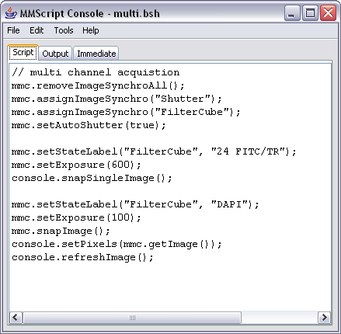
Figure 11. Scripting editor.

Configuring the system
In order to control a specific hardware setup, the MicroManage application needs to load and initialize appropriate drivers, define configuration presets, create labels for device positions, etc. Typically, on startup the MicroManage application loads the configuration file which contains commands for configuring all aspects of the system.

A configuration is defined in a text file (with default extension *.cfg) containing a list of simple commands to build the desired system state: devices, labels, equipment, properties, and configurations. The format is as follows:

- Each line consists of a number of string fields separated by "," (comma) characters. No extra spaces are allowed for formatting, i.e. space characters will treated as parts of the field.
- Lines beginning with "#" are ignored (can be used for comments).
- Each line in the file will be parsed by the system and as a result a corresponding command will be immediately executed.

The first field in the line always specifies the command from the following set of values:
- Device – loads device
- Label – attaches a label to the specified device position
- Equipment – defines various equipment attributes used for image annotation
- Property – sets a specific device property
- ConfigGroup – defines a single entry in the configuration group

Remaining fields in the line are used for specifying the corresponding command parameters. The number of parameters depends on the actual command used.

The following listing shows configuration file for the automated Zeiss microscope equipped with the Hamamatsu camera. Commands are shown in blue, device labels in orange and comments in green.

# Unload all devices
Property,Core,Initialize,0

# Load devices
Device,Baseport,ZeissMTB,Baseport
Device,CAM,Hamamatsu,Hamamatsu_DCAM
Device,DemoCAM,DemoCamera,DCam
Device,FilterCube,ZeissMTB,Reflector
Device,HalogenLamp,ZeissMTB,Halogen
Device,Objective,ZeissMTB,Objective
Device,Shutter,ZeissMTB,Shutter
Device,Sideport,ZeissMTB,Sideport
Device,Stand,ZeissMTB,Stand
Device,Z,ZeissMTB,Focus

# Initialize
Property,Core,Initialize,1

# Delays
Delay,HalogenLamp,2000

# Labels
Label,Baseport,0,BP
Label,Baseport,1,Vis
Label,Baseport,2,FP
Label,FilterCube,0,DAPI
Label,FilterCube,1,38 EGFP
Label,FilterCube,2,Texas Red
Label,FilterCube,3,47 CFP
Label,FilterCube,4,46 YFP
Label,Objective,0,A-Plan 10x/0.25 Ph1
Label,Objective,1,LD A-Plan 40x/0.50 Ph2
Label,Objective,2,< none >
Label,Objective,3,Plan Neofluar 40x/1.30 Oil DIC
Label,Objective,4,Plan Apochromat 63x/1.40 Oil (DIC III)
Label,Objective,5,Plan Neofluar 100x/1.30 Oil (DIC III)
Label,Sideport,0,100% BPS
Label,Sideport,1,50% SP left / 50% BPS
Label,Sideport,2,100% SP left

# Group configurations
ConfigGroup,Camera,HiRes,CAM,Binning,1
ConfigGroup,Camera,HiRes,CAM,PixelType,16bit
ConfigGroup,Camera,MedRes,CAM,Binning,2
ConfigGroup,Camera,MedRes,CAM,PixelType,8bit
ConfigGroup,Channel,DAPI,FilterCube,State,0
ConfigGroup,Channel,DAPI,Core,Shutter,Shutter
ConfigGroup,Channel,FITC,FilterCube,State,1
ConfigGroup,Channel,FITC,Core,Shutter,Shutter
ConfigGroup,Channel,Transmitted,FilterCube,State,1
ConfigGroup,Channel,Transmitted,Core,Shutter,HalogenLamp
ConfigGroup,Channel,TxR,FilterCube,State,2
ConfigGroup,Channel,TxR,Core,Shutter,Shutter
ConfigGroup,Lightpath,Camera,Sideport,State,1
ConfigGroup,Lightpath,Eyepiece,Sideport,State,0

# Roles
Property,Core,Camera,CAM
Property,Core,Shutter,Shutter

