Micro-Manager 1.1 (beta)
Version 1.1.34
Nenad Amodaj and Nico Stuurman, August 9, 2007

Overview of new features

Enhancements and major bug fixes
- Faster preset switching from the main panel. Preset detection and application logic was streamlined to reduce the number of device status queries.
- Closing Image5D does not prompt to save if the data is already saved.
- 19200 baud rate supported by the COM port adapter.
- Background color of the GUI can be set to dark gray to reduce screen glare in the dark room. Works only on Mac/Linux.
- Pixel size calibration. The system can be now calibrated to automatically sense the current resolution setting and annotate images with pixel size information

Device support
- Multiple bug fixes for Nikon TE2000 library of adapters
- Nikon TE2000 Analyzer device added
- Nikon TE2000 Perfect Focus device added
- ASIFW1000 controller library added with multiple devices
- ASI CRIF auto-focus device added
- Prior Lumen device added (shutter and wheel)
- Andor camera adapter update, new properties (temperature control, gains, frame transfer, etc) and streaming mode
- PVCAM adapter update, new properties exposed
- Processor and Signal generator virtual devices added to the plugin API to enable real-time processing and closed loop control (undocumented at this point)

Acquisition
- Multi threaded acquisition engine for smoother and more responsive processing
- Position list allows users to record stage positions and recall them at later time
- Multi-position acquisition mode allows running the same protocol on multiple stage positions recorded in the position list
- Optional order of slice/channel actions
- Burst acquisition mode added to provide asynchronous high-speed acquisition and streaming to disk (only with Andor cameras at this time)
- Hardware and image based auto-focus for focusing during multi-position acquisition
- Skipping of frames in specified channels to conserve disk space and reduce bleaching
- Acquisition now works even when no channels are defined. A default channel is automatically added.
- Pause-resume button added to the Image5D Acquisition window. Allows the user to stop acquisition at any time and continue from the same point, without the need to re-start.
- The option to display only the current frame during acquisition allows for virtually unlimited length of image sequences, because in that case images will not be accumulated in memory.

Detailed guide

Additions to the acquisition window
New entries in the acquisition window are: "Acquisition order" section, "Position XY" section, "Display only last frame" check box and "Skip Frame" column in the channel table.

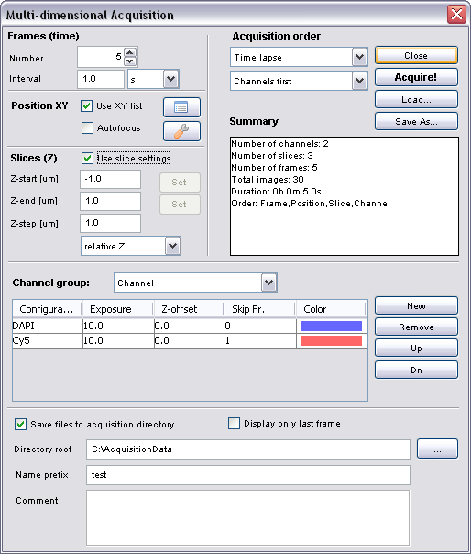

Multi-position acquisition
The most important extension to the acquisition protocol is the support for multiple positions. The position list dialog allows the user to record ("Mark") multiple stage positions and optionally save them in a file.

This list is then used in the acquisition protocol specification to execute multiple-position protocols.

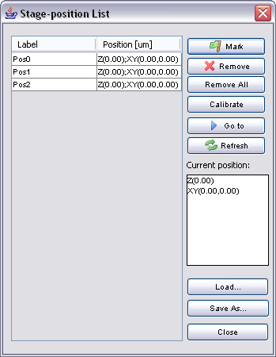

There are a number of ways of executing multi-position protocols, depending on the order of specific device movements. For example, if we select “Time lapse” option in the "Acquisition order" section, in each frame (time point) all positions will be visited and images acquired. Only after the entire protocol is executed at each location, the acquisition will be ready for the next frame (time point). The software will open a separate Image5D acquisition window for each position.

If we select "Multi Field" mode, the protocol will be executed in similar fashion to the micro-well plate scanning. All frames (time points) will be acquired at one position before moving on to the next one. If automatic data save option is selected, only one Image5D window remains open at all times, because positions are being scanned sequentially. In the current beta version "Multi-field" option is temporarily disabled.

Remaining ordering option "Channels First" or "Slices First" determine if all channels are acquired at one Z-position before moving to the next, or if the entire Z-stack is acquired in each channel before switching to the next, respectively. This ordering is in effect regardless of the whether we are operating in the multi-position mode or not.

Skipping frames
The new "Skip Fr." (Skip Frame) column in the channel list specifies if any channel images should be skipped during acquisition at regular time points. In some situations it may be desirable to acquire certain channels at lower sampling rates, to reduce photo-toxicity and to save disk space. The number in the "Skip Fr." column specifies how many consecutive frames (time points) are skipped before an acquisition takes place. For example "0" means regular sampling (no skipping) while "1" means that every second frame will be acquired.

Image5D display will automatically fill all gaps caused by missing frames by using the last acquired image in the respective channel.

Burst acquisition

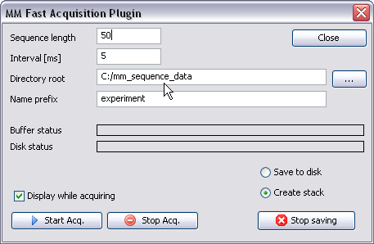

Burst acquisition (Tools menu) is a new feature to enable fast cameras to run at their full hardware speed. At this point only Andor camera adapter supports this mode of acquisition.

The software will capture a sequence of specified length and specified interval in milliseconds using current camera settings. However, for extremely short intervals, or inconsistent exposure settings, the camera may not be able to acquire at the requested speed in which case the actual frame interval will be displayed.

Data will be either saved to disk (parallel to the acquisition) or inserted into an ImageJ stack.

The acquisition is performed asynchronously at the specified hardware speed, using the internal circular buffer to smooth out display and disk streaming lags. If disk streaming gets too far behind the actual acquisition rate, the buffer may overflow. The size of the internal buffer can be specified in the Tools | Options menu. Default size is relatively modest (25 MB) and can be increased to almost all available RAM. However, allocating large chunks of the available memory to the buffer may impair overall performance and limit the size of the time lapse sequences in other acquisition modes.

Pixel Size settings
Micro-Manager supports automatic pixel size annotations in the metadata. If calibrated, the software will deduce pixel size from the current device settings, taking into account camera binning. In this beta version only square pixel setups are supported. Also, at this point we do not provide any user interface to calibrate the pixel size interactively. Essentially, all information must be supplied either through scripts or configuration files.

Calibration data are defined in two steps. First we have to declare which devices will affect the resolution, not counting the camera binning. Usually we will have to declare an objective only. If we have other optical devices affecting the magnification such as optovar, we will have to declare them as well. Once we define all distinct resolution situations, we then assign a specific pixel size in microns to each one. Actual pixel size numbers are usually obtained by direct measurement using the calibration slide.

Example below shows a portion of the configuration file defining pixel size as dependent only on the current objective.

# PixelSize settings
ConfigPixelSize,Res10X,Objective,State,1
ConfigPixelSize,Res20X,Objective,State,3
ConfigPixelSize,Res40X,Objective,State,0

PixelSize_um,Res10X,1.0
PixelSize_um,Res20X,0.5
PixelSize_um,Res40X,0.25

The same example calibration data can be alternatively entered through the Micro-Manager script:

mmc.definePixelSizeConfig("Res10X", "Objective", "State", "1");
mmc.definePixelSizeConfig("Res20X", "Objective", "State", "3");
mmc.definePixelSizeConfig("Res40X", "Objective", "State", "0");
mmc.setPixelSizeUm("Res10X", 1.0);
mmc.setPixelSizeUm("Res20X", 0.5);
mmc.setPixelSizeUm("Res40X", 0.25);

Autofocus

Hardware-continuous
Hardware-based, continuous (closed loop) auto-focus support is provided for Nikon Perfect Focus (PFS) and ASI CRIF devices. The only thing required for the proper operation of these two systems within Micro-Manager is to include respective devices in the system configuration. Once Micro-Manager becomes aware of the PFS or CRIF device, the process of focus control becomes automatic. Micro-manager will turn off the auto-focus device while acquiring Z-stack or switching channels and turn it on again before it moves to the next position, or while waiting between frames. There is no explicit interactive way within the GUI to control operation of these devices, i.e. they are completely automatic.

Image-based
The “auto-focus” check box in the Acquisition dialog refers to a different auto-focusing mechanism. Pakpoom Subsoontorn & Hernan Garcia (Caltech) contributed Java plugin module for auto-focusing based on the relative strength of gradients in the image (edge “sharpness”). This method is fully implemented in the top-level Java software layer and loosely coupled to Micro-Manager. It should work with any camera and Z-stage. However, this module is not extensively tested and may not work properly on all hardware set-ups.

