PlasmidFlow User Guide

## Step 1: Download Example CSV

Click the 'Download Example CSV' link to download a sample dataset showing the required format.

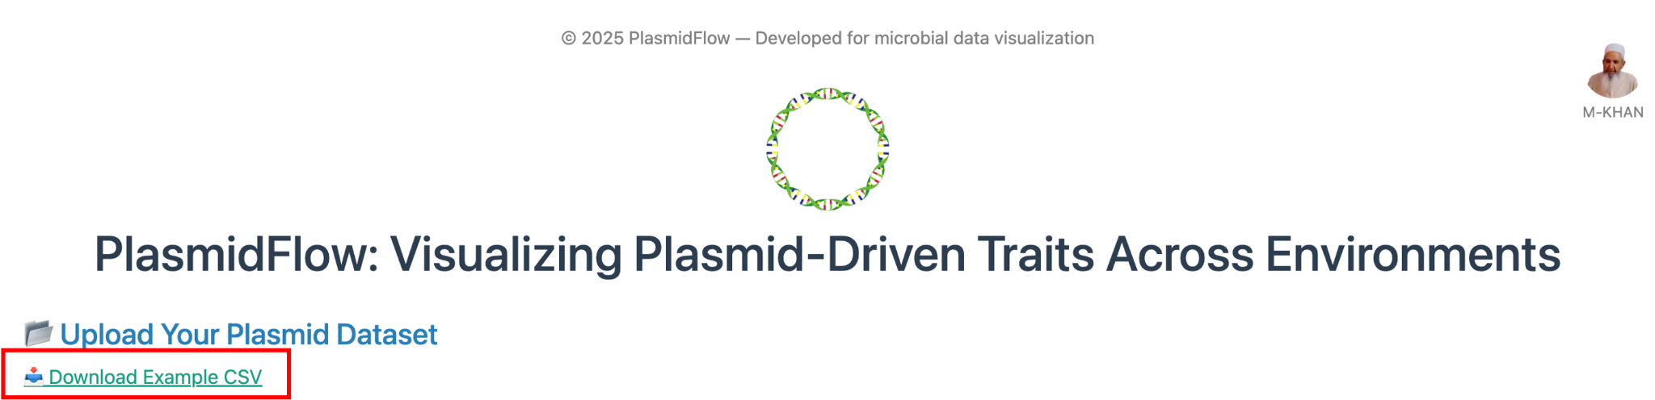

## Step 2: Upload Your Plasmid Dataset

Use the drag-and-drop area or select a CSV file from your computer to upload your plasmid-host-environment dataset.

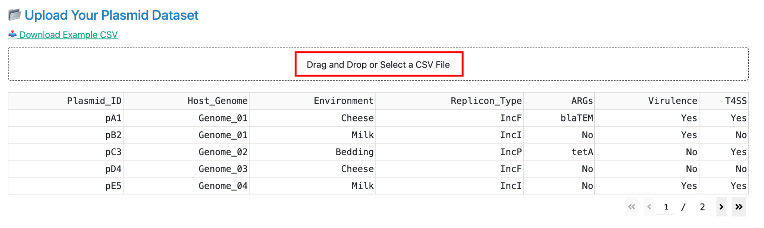

## Step 3: Filter by Environment and Traits

You can type an environment name (e.g., 'Milk', 'Soil') to filter, or leave it blank to include all. You can also select one or more plasmid traits like ARGs, Virulence, T4SS, or MGEs. If no traits are selected, all plasmids are shown.

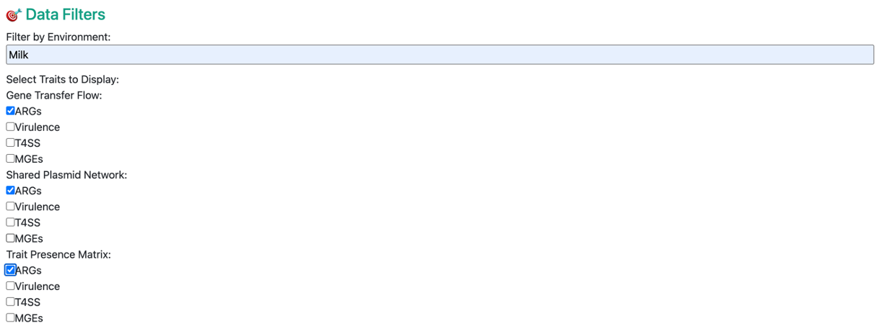

## Step 4: Explore Graph Visualizations

Use the tabs at the top to switch between Flow diagrams (gene flow across environments), Shared Plasmid Networks (environmental connections), and Heatmaps (trait presence overview).

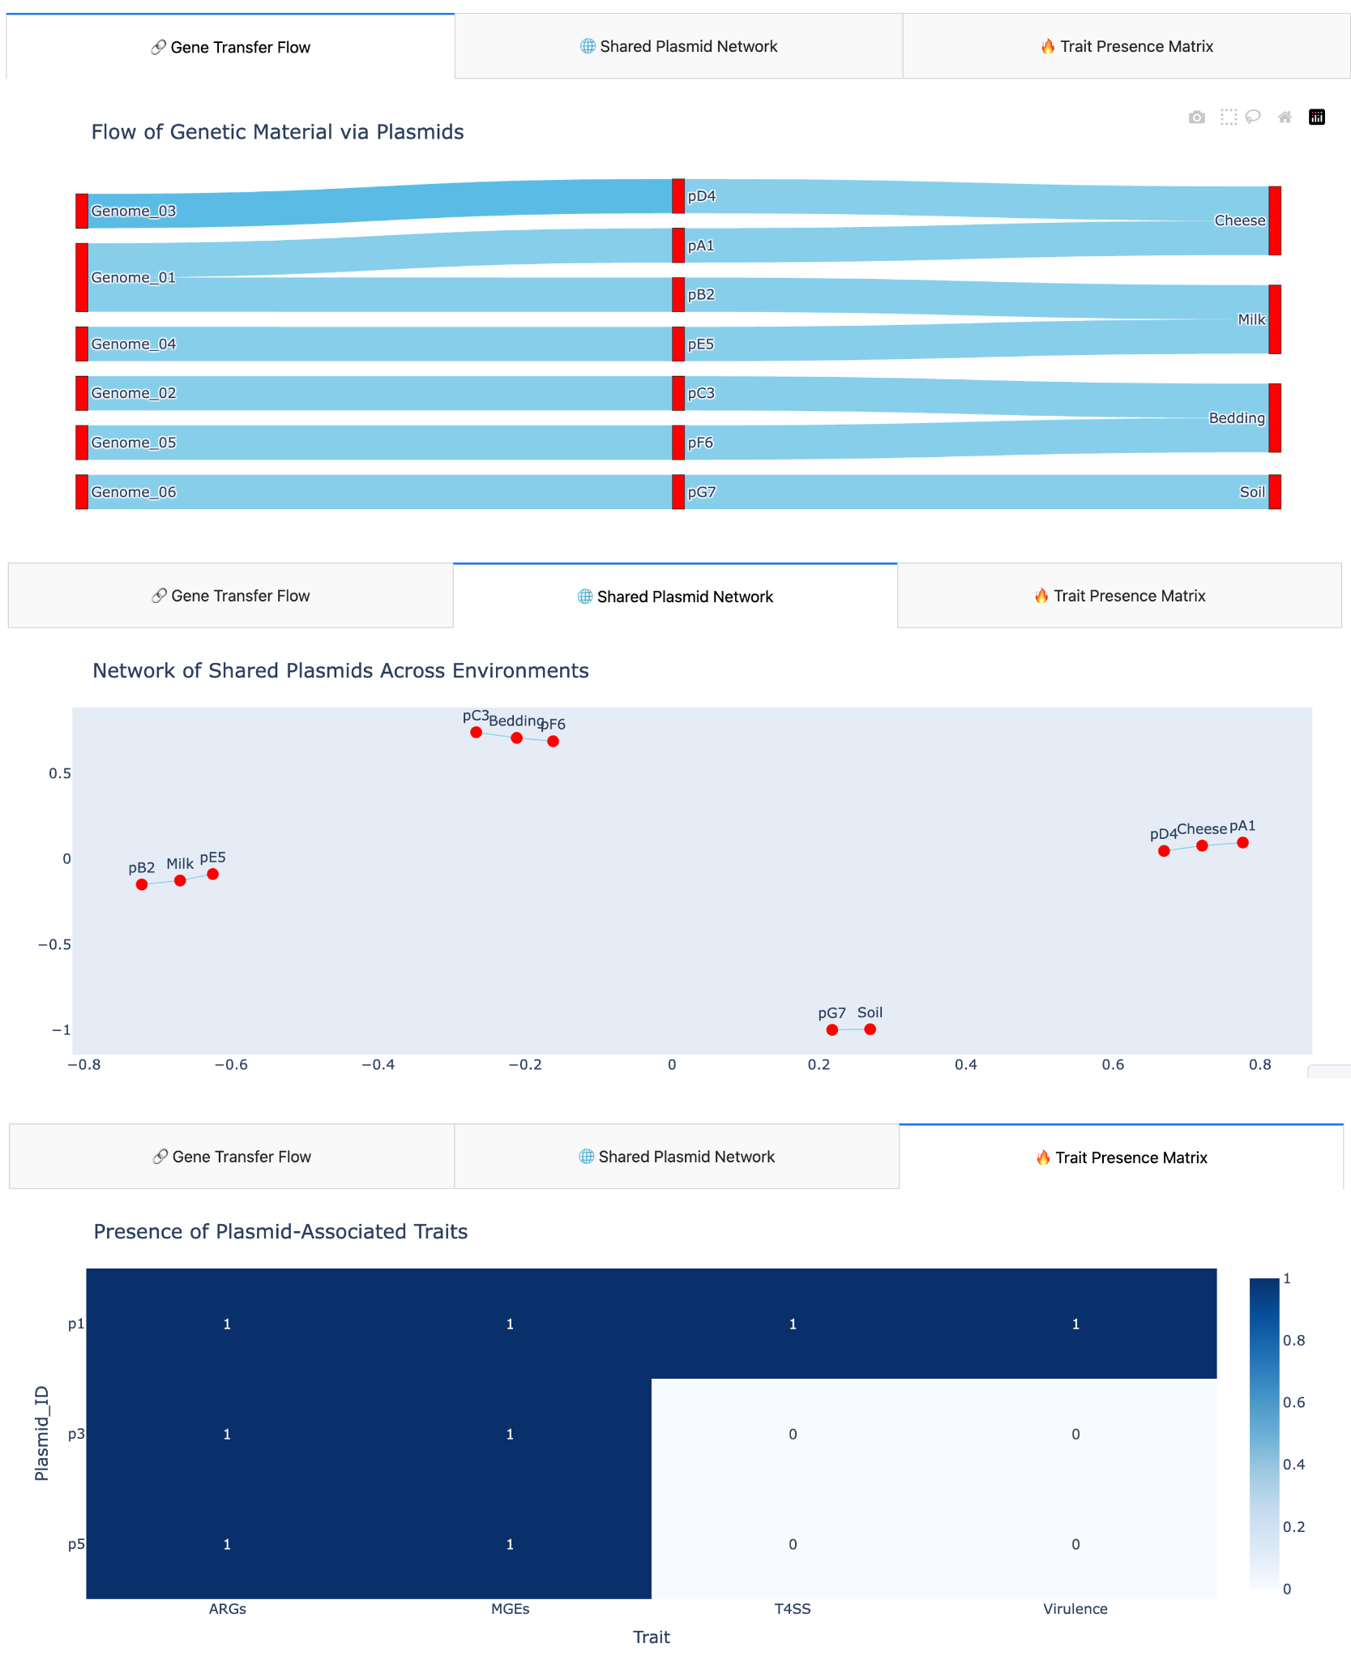

## Step 5: Customize Graph Appearance

Adjust node/edge color, node size, background color, and font size. You can also save and reload your preferred visual style settings using the provided buttons.

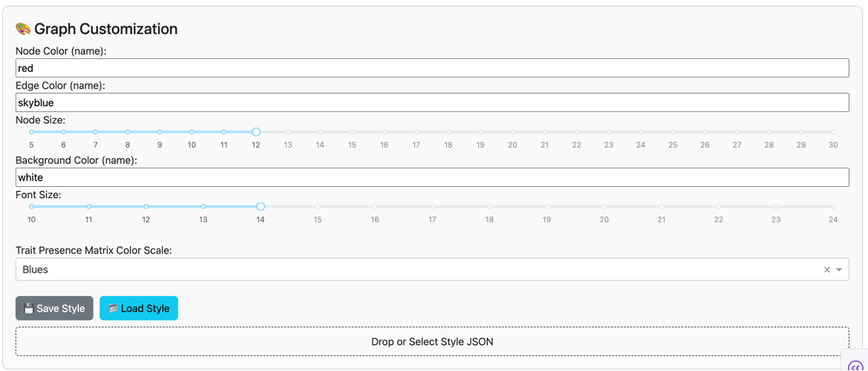

## Step 6: Download the Current Plot

Choose a format (SVG, PNG, or PDF) and click the button to download your visualization for sharing or publication.

