Summary:

1) Command:

df2 <- data_summary(bact_count_morpho_Nfix_data, varname="Average particle size (micrometer^2)", groupnames=c("Lake", "`Temp ( C )`"))

p<- ggplot(df2, aes(x= `Temp ( C )`, y=`Average particle size (micrometer^2)`, group= Lake, color=Lake)) + geom_line() + geom_pointrange(aes(ymin=`Average particle size (micrometer^2)`-sd, ymax=`Average particle size (micrometer^2)`+sd))

p + facet_grid(. ~ Lake)

cor.test(data=bact_count_morpho_Nfix_data, x=`Average particle size (micrometer^2)`, y=`Particle count (10^6 ml-1)` , method = "spearman")

Pearson's product-moment correlation

data: Average particle size (micrometer^2) and Temp ( C )

data: df2[, 2] and df2[, 3]
S = 2430, p-value = 0.006993
alternative hypothesis: true rho is not equal to 0
sample estimates:
rho
-0.5779221

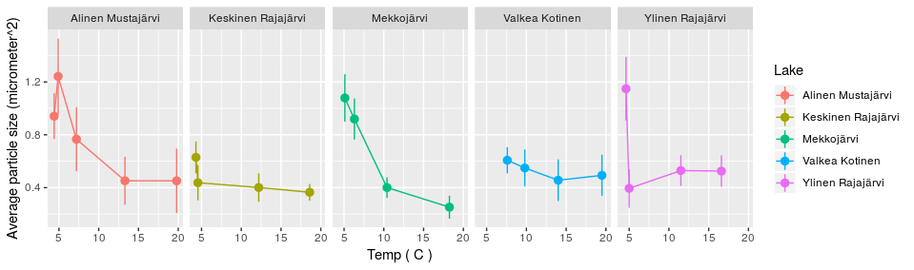

2)"Average particle size (micrometer^2)", groupnames=c("Lake", "`N2 uptake(umol L-1 d-1)`"))

Command:

df2 <- data_summary(bact_count_morpho_Nfix_data, varname="Average particle size (micrometer^2)", groupnames=c("Lake", "`N2 uptake(umol L-1 d-1)`"))

cor.test(df2[,2], df2[,3], method="spearman")

p<- ggplot(df2, aes(x= `N2 uptake(umol L-1 d-1)`, y=`Average particle size (micrometer^2)`, group= Lake, color=Lake)) + geom_line() + geom_pointrange(aes(ymin=`Average particle size (micrometer^2)`-sd, ymax=`Average particle size (micrometer^2)`+sd))
print(p)
p + facet_grid(Lake ~ .)

cor.test(df2[,2], df2[,3], method="spearman")

Spearman's rank correlation rho

data: df2[, 2] and df2[, 3]
S = 884, p-value = 0.01883
alternative hypothesis: true rho is not equal to 0
sample estimates:
rho
0.500847

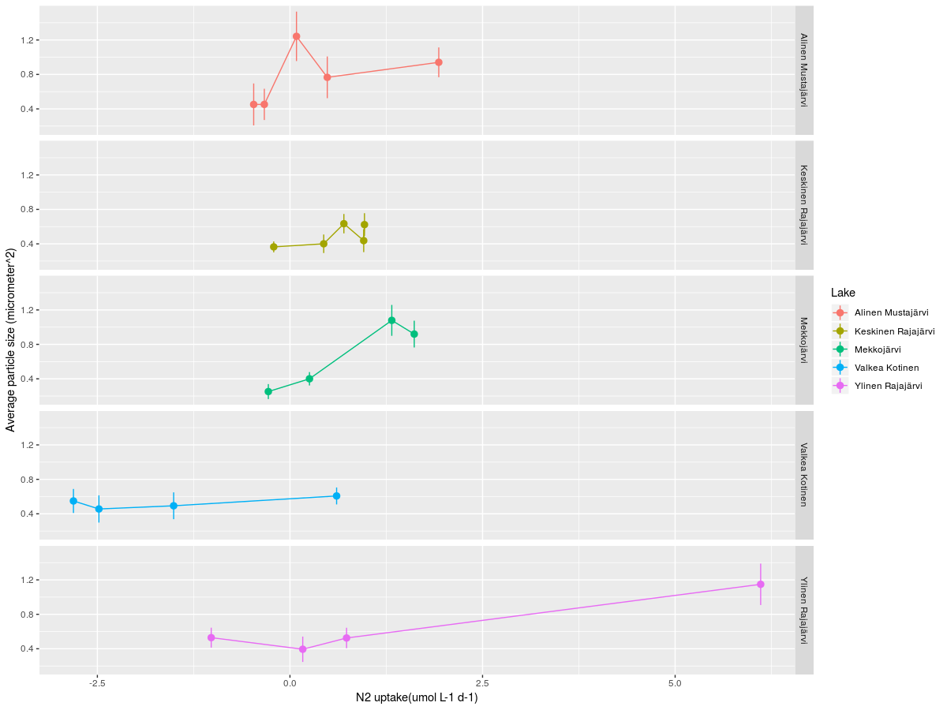

3) NOT MONOTONIC !!!!!!!!!!!!!

Spearman's rank correlation rho

data: Average particle size (micrometer^2) and Particle count (10^6 ml-1)
S = 6383400, p-value < 2.2e-16
alternative hypothesis: true rho is not equal to 0
sample estimates:
rho
0.5653616

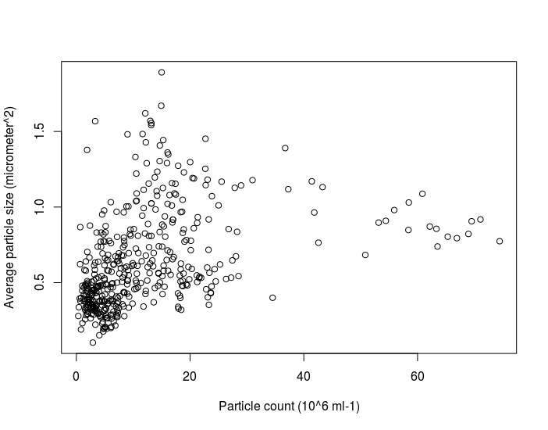

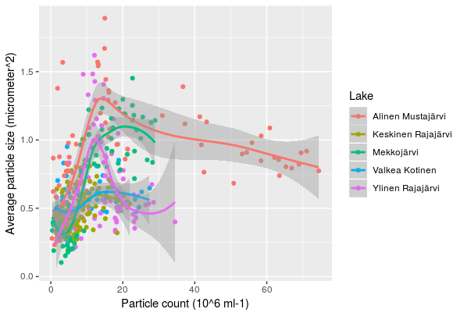

4) Particle count, depth and rates

> df2 <- data_summary(bact_count_morpho_Nfix_data, varname="Particle count (10^6 ml-1)", groupnames=c("Lake", "`Temp ( C )`"))
> cor.test(df2[,2], df2[,3], method="spearman")

Spearman's rank correlation rho

data: df2[, 2] and df2[, 3]
S = 2232, p-value = 0.0424
alternative hypothesis: true rho is not equal to 0
sample estimates:
rho
-0.4493506

> df2 <- data_summary(bact_count_morpho_Nfix_data, varname="Particle count (10^6 ml-1)", groupnames=c("Lake", "`N2 uptake(umol L-1 d-1)`"))
> p<- ggplot(df2, aes(x= `N2 uptake(umol L-1 d-1)`, y=`Particle count (10^6 ml-1)`, group= Lake, color=Lake)) + geom_line() + geom_pointrange(aes(ymin=`Particle count (10^6 ml-1)`-sd, ymax=`Particle count (10^6 ml-1)`+sd))
> p + facet_grid(. ~ Lake)
> cor.test(df2[,2], df2[,3], method="spearman")

Spearman's rank correlation rho

data: df2[, 2] and df2[, 3]
S = 902, p-value = 0.0217
alternative hypothesis: true rho is not equal to 0
sample estimates:
rho
0.4906832

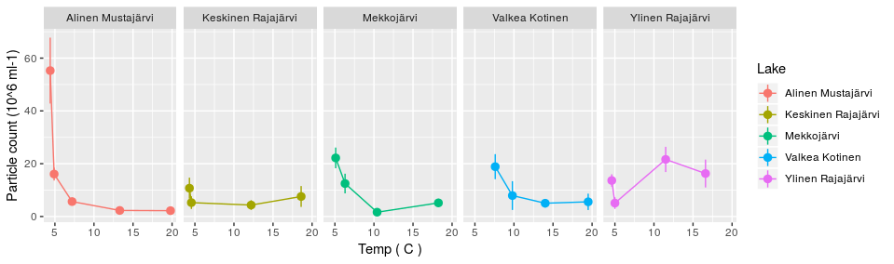
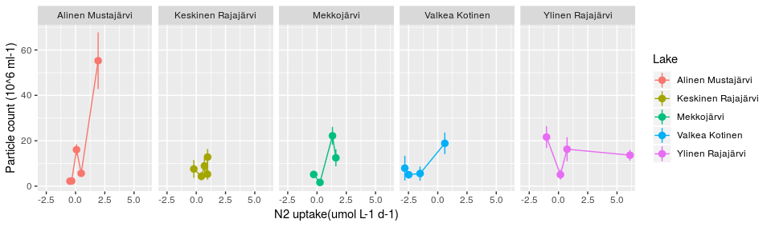

Complete table3:
Source | N2 uptake  (umol L-1 d-1) | Cell count (±SD) (10^6 ml-1) | Depth  (m) | References
Freswater:  Alinen Mustajärvi  Alinen Mustajärvi  Alinen Mustajärvi  Alinen Mustajärvi  Alinen Mustajärvi  Keskinen Rajajärvi  Keskinen Rajajärvi  Keskinen Rajajärvi  Keskinen Rajajärvi  Keskinen Rajajärvi  Mekkojärvi  Mekkojärvi  Mekkojärvi  Mekkojärvi  Valkea Kotinen  Valkea Kotinen  Valkea Kotinen  Valkea Kotinen  Ylinen Rajajärvi  Ylinen Rajajärvi  Ylinen Rajajärvi  Ylinen Rajajärvi | -0.47  -0.33  0.48  0.09  1.93  -0.21  0.44  0.96  0.70  0.97  -0.28  0.25  1.61  1.32  -1.51  -2.48  -2.81  0.61  0.73  -1.02  0.17  6.11 | 2.21 (± 1.17)  2.28 (±1.14)  5.65 (±1.43)  16.07 (±2.45)  55.27 (±12.50)  7.57 (±3.96)  4.33 (±1.82)  5.25 (±2.40)  8.91 (±3.51)  12.83 (±3.53)  5.15 (±1.54)  1.62 (±0.60)  12.48 (±3.73)  22.19 (±3.91)  5.55 (±3.10)  5.02 (±1.63)  7.92 (±5.45)  18.88 (±4.74)  16.27 (±5.28)  21.63 (±4.78)  5.07 (±2.21)  13.64 (±2.36) | 0.5  2.0  3.0  4.0  5.5  0.5  2.0  6.25  7.5  10  0.25  1  2  3  0.5  2.25  3.25  4.5  0.5  1.5  4  5

Boxplots:

Command

ggplot(metadata_new, aes(x = Fixation, y = `Depth`, fill=Fixation)) + geom_boxplot(outlier.colour="white", outlier.shape=16, outlier.size=.5, notch=FALSE) + theme_bw() + scale_x_discrete(name = "Activity") + scale_y_continuous(name = "Depth (m)") + geom_jitter() + theme(plot.title = element_text(size = 14, family = "Tahoma", face = "bold"),text = element_text(size = 12, family = "Tahoma"), axis.text.x=element_text(size = 11),legend.position = "none")

> ggplot(metadata_new, aes(x = Fixation, y = as.numeric(`NO3 µg l-1`), fill=Fixation)) + geom_boxplot(outlier.colour="white", outlier.shape=16, outlier.size=.5, notch=FALSE) + theme_bw() + scale_x_discrete(name = "Activity") + scale_y_continuous(name = "NO3 µg l-1") + geom_jitter() + theme(plot.title = element_text(size = 14, family = "Tahoma", face = "bold"),text = element_text(size = 12, family = "Tahoma"), axis.text.x=element_text(size = 11),legend.position = "none")
> wilcox.test(as.numeric(`NO3 µg l-1`) ~ Fixation , data=metadata_new)

Wilcoxon rank sum test

data: as.numeric(`NO3 µg l-1`) by Fixation
W = 53, p-value = 0.8676
alternative hypothesis: true location shift is not equal to 0

> wilcox.test(Depth ~ Fixation , data=metadata_new)

Wilcoxon rank sum test with continuity correction

data: Depth by Fixation
W = 95.5, p-value = 0.007496
alternative hypothesis: true location shift is not equal to 0

Warning message:
In wilcox.test.default(x = c(3, 4, 5.5, 1, 2, 3, 4.5, 0.5, 4, 5, :
cannot compute exact p-value with ties
> wilcox.test(Temperature ~ Fixation , data=metadata_new)
Error in eval(predvars, data, env) : object 'Temperature' not found
> wilcox.test(`Temp ( C )` ~ Fixation , data=metadata_new)

Wilcoxon rank sum test with continuity correction

data: Temp ( C ) by Fixation
W = 7, p-value = 0.0009291
alternative hypothesis: true location shift is not equal to 0

Warning message:
In wilcox.test.default(x = c(7.2, 4.9, 4.4, 10.4, 6.3, 5.1, 7.6, :
cannot compute exact p-value with ties
> wilcox.test(`PO4 µg/l` ~ Fixation , data=metadata_new)

Wilcoxon rank sum test with continuity correction

data: PO4 µg/l by Fixation
W = 99, p-value = 0.003475
alternative hypothesis: true location shift is not equal to 0

Warning message:
In wilcox.test.default(x = c(2L, 4L, 60L, 9L, 21L, 87L, 9L, 6L, :
cannot compute exact p-value with ties
> wilcox.test(`NH4 µg/l` ~ Fixation , data=metadata_new)

Wilcoxon rank sum test with continuity correction

data: NH4 µg/l by Fixation
W = 100, p-value = 0.002915
alternative hypothesis: true location shift is not equal to 0

Warning message:
In wilcox.test.default(x = c(6L, 74L, 657L, 11L, 28L, 140L, 81L, :
cannot compute exact p-value with ties

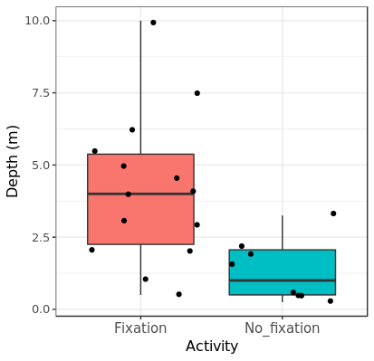
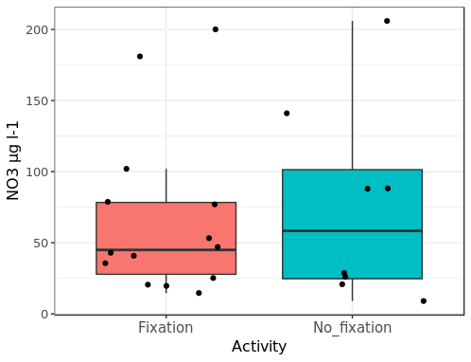

> ggplot(bact_count_morpho_Nfix_data, aes(x = Activity, y = `Particle count (10^6 ml-1)`, fill=Activity)) + geom_boxplot(outlier.colour="white", outlier.shape=16, outlier.size=.5, notch=FALSE) + theme_bw() + scale_x_discrete(name = "Activity") + scale_y_continuous(name = "Particle count (10^6 ml-1)") + geom_jitter() + theme(plot.title = element_text(size = 14, family = "Tahoma", face = "bold"),text = element_text(size = 12, family = "Tahoma"), axis.text.x=element_text(size = 11),legend.position = "none")

Wilcoxon rank sum test with continuity correction

data: Particle count (10^6 ml-1) by Activity
W = 31503, p-value = 1.037e-11
alternative hypothesis: true location shift is not equal to 0

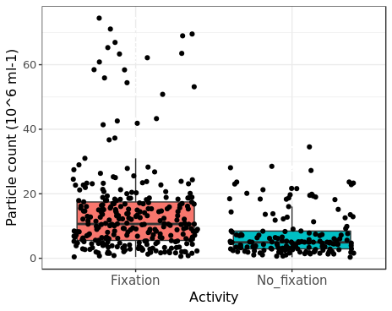

> ggplot(bact_count_morpho_Nfix_data, aes(x = Activity, y = `Average particle size (micrometer^2)`, fill=Activity)) + geom_boxplot(outlier.colour="white", outlier.shape=16, outlier.size=.5, notch=FALSE) + theme_bw() + scale_x_discrete(name = "Activity") + scale_y_continuous(name = "Average particle size (µm)2") + geom_jitter() + theme(plot.title = element_text(size = 14, family = "Tahoma", face = "bold"),text = element_text(size = 12, family = "Tahoma"), axis.text.x=element_text(size = 11),legend.position = "none")
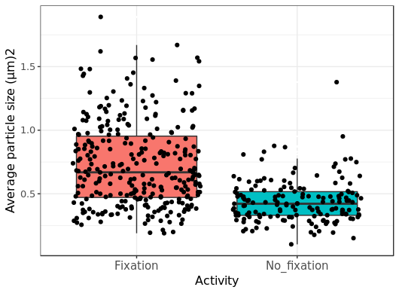

Wilcoxon rank sum test with continuity correction

data: Average particle size (micrometer^2) by Activity
W = 35315, p-value < 2.2e-16
alternative hypothesis: true location shift is not equal to 0

Comparison Average particle size against depth, ,O2, CO2, FeIII, FeII, Fe(tot), NO3- , SO4, NH4, PO4 and methane:
Command:
> df2 <- data_summary(bact_count_morpho_Nfix_data, varname="Average particle size (micrometer^2)", groupnames=c("Lake"," `CH4 (µM)`"))
> df2

> p<- ggplot(df2, aes(x= `CH4 (µM)`, y=`Average particle size (micrometer^2)`, group= Lake, color=Lake)) + geom_line() + geom_pointrange(aes(ymin=`Average particle size (micrometer^2)`-sd, ymax=`Average particle size (micrometer^2)`+sd))
> p
> p + facet_grid(. ~ Lake)
> cor.test(df2[,2], df2[,3], method="spearman")

Spearman's rank correlation rho

data: df2[, 2] and df2[, 3]
S = 550, p-value = 0.0005452
alternative hypothesis: true rho is not equal to 0
sample estimates:
rho
0.689441

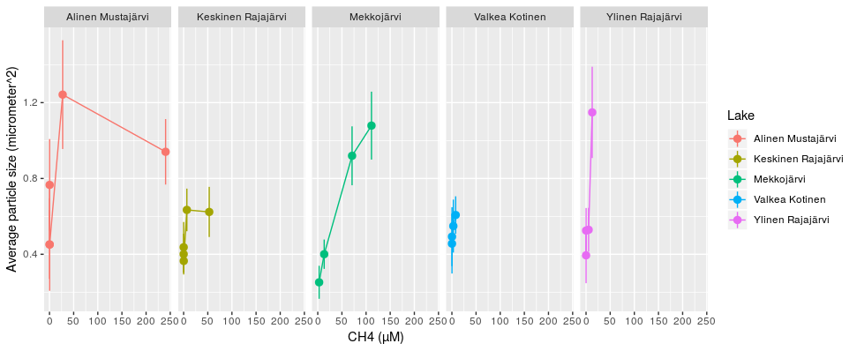

Comparison Average particle size and oxygen and depth:

df2 <- data_summary(bact_count_morpho_Nfix_data, varname="Average particle size (micrometer^2)", groupnames=c("Lake", "`O2 (mg L-1)`")
+ )
> p<- ggplot(df2, aes(x= `O2 (mg L-1)`, y=`Average particle size (micrometer^2)`, group= Lake, color=Lake)) + geom_line() + geom_pointrange(aes(ymin=`Average particle size (micrometer^2)`-sd, ymax=`Average particle size (micrometer^2)`+sd))
> p
> p + facet_grid(. ~ Lake)
> cor.test(df2[,2], df2[,3], method="spearman")

Spearman's rank correlation rho

data: df2[, 2] and df2[, 3]
S = 2090, p-value = 0.1125
alternative hypothesis: true rho is not equal to 0
sample estimates:
rho
-0.3571429

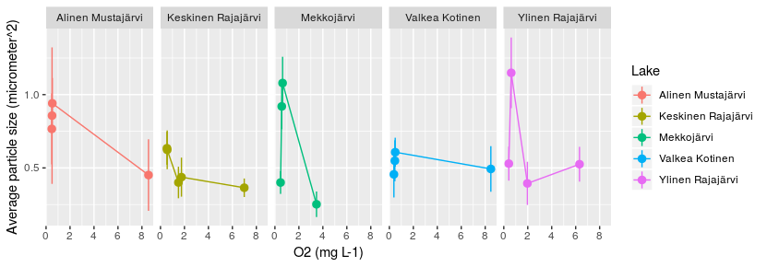

> df2 <- data_summary(bact_count_morpho_Nfix_data, varname="Average particle size (micrometer^2)", groupnames=c("Lake", "Depth"))
> cor.test(df2[,2], df2[,3], method="spearman")

Spearman's rank correlation rho

data: df2[, 2] and df2[, 3]
S = 811.66, p-value = 0.009217
alternative hypothesis: true rho is not equal to 0
sample estimates:
rho
0.5416959
> p<- ggplot(df2, aes(x= `Depth`, y=`Average particle size (micrometer^2)`, group= Lake, color=Lake)) + geom_line() + geom_pointrange(aes(ymin=`Average particle size (micrometer^2)`-sd, ymax=`Average particle size (micrometer^2)`+sd))
> p + facet_grid(. ~ Lake)

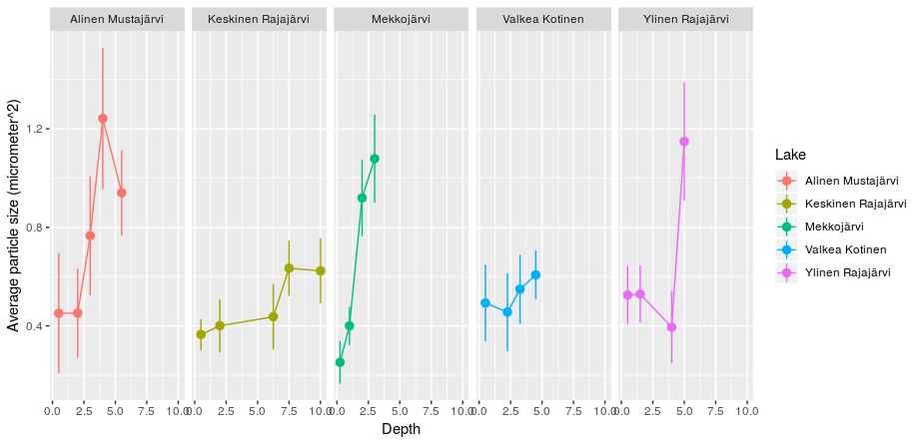

> df2 <- data_summary(bact_count_morpho_Nfix_data, varname="Average particle size (micrometer^2)", groupnames=c("Lake", "`CO2 (µM)`"))
> cor.test(df2[,2], df2[,3], method="spearman")

Spearman's rank correlation rho

data: df2[, 2] and df2[, 3]
S = 1554, p-value = 0.5856
alternative hypothesis: true rho is not equal to 0
sample estimates:
rho
0.1225296

> df2 <- data_summary(bact_count_morpho_Nfix_data, varname="Average particle size (micrometer^2)", groupnames=c("Lake", "`Fe (III) µM`"))
> cor.test(df2[,2], df2[,3], method="spearman")

Spearman's rank correlation rho

data: df2[, 2] and df2[, 3]
S = 2862, p-value = 0.002787
alternative hypothesis: true rho is not equal to 0
sample estimates:
rho
-0.6160361

> p<- ggplot(df2, aes(x= `Fe (III) µM`, y=`Average particle size (micrometer^2)`, group= Lake, color=Lake)) + geom_line() + geom_pointrange(aes(ymin=`Average particle size (micrometer^2)`-sd, ymax=`Average particle size (micrometer^2)`+sd))

> p + facet_grid(. ~ Lake)

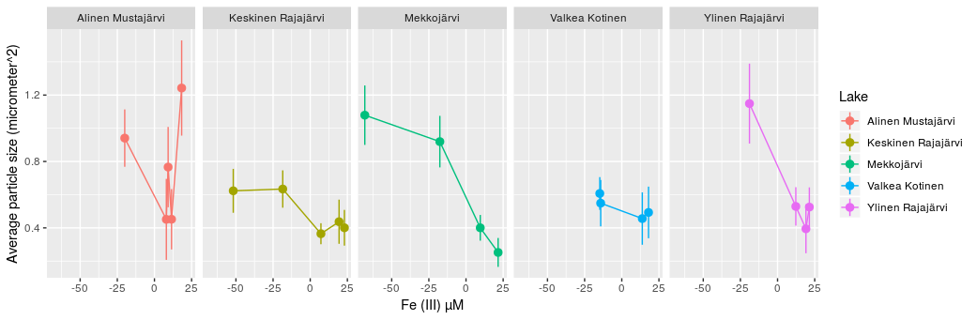
> df2 <- data_summary(bact_count_morpho_Nfix_data, varname="Average particle size (micrometer^2)", groupnames=c("Lake", "`Fe (II) µM`"))
> cor.test(df2[,2], df2[,3], method="spearman")

Spearman's rank correlation rho

data: df2[, 2] and df2[, 3]
S = 1092, p-value = 0.07908
alternative hypothesis: true rho is not equal to 0
sample estimates:
rho
0.3833992

> df2 <- data_summary(bact_count_morpho_Nfix_data, varname="Average particle size (micrometer^2)", groupnames=c("Lake", "`Fe (tot) µM`"))
> cor.test(df2[,2], df2[,3], method="spearman")

Spearman's rank correlation rho

data: df2[, 2] and df2[, 3]
S = 1120.8, p-value = 0.09281
alternative hypothesis: true rho is not equal to 0
sample estimates:
rho
0.3671279

Warning message:
In cor.test.default(df2[, 2], df2[, 3], method = "spearman") :
Cannot compute exact p-value with ties

> df2 <- data_summary(bact_count_morpho_Nfix_data, varname="Average particle size (micrometer^2)", groupnames=c("Lake", "`NO3 µg l-1`")
+ )
> cor.test(df2[,2], df2[,3], method="spearman")

Spearman's rank correlation rho

data: df2[, 2] and df2[, 3]
S = 1380, p-value = 0.3219
alternative hypothesis: true rho is not equal to 0
sample estimates:
rho
0.2207792

> df2 <- data_summary(bact_count_morpho_Nfix_data, varname="Average particle size (micrometer^2)", groupnames=c("Lake", "`SO4mg l-1`"))
> cor.test(df2[,2], df2[,3], method="spearman")

Spearman's rank correlation rho

data: df2[, 2] and df2[, 3]
S = 1716, p-value = 0.6207
alternative hypothesis: true rho is not equal to 0
sample estimates:
rho
-0.1142857
> df2 <- data_summary(bact_count_morpho_Nfix_data, varname="Average particle size (micrometer^2)", groupnames=c("Lake", "`PO4 µg/l`"))
> cor.test(df2[,2], df2[,3], method="spearman")

Spearman's rank correlation rho

data: df2[, 2] and df2[, 3]
S = 613.38, p-value = 0.04646
alternative hypothesis: true rho is not equal to 0
sample estimates:
rho
0.4619468
> df2 <- data_summary(bact_count_morpho_Nfix_data, varname="Average particle size (micrometer^2)", groupnames=c("Lake", "`NH4 µg/l`"))
> cor.test(df2[,2], df2[,3], method="spearman")

Spearman's rank correlation rho

data: df2[, 2] and df2[, 3]
S = 915.82, p-value = 0.02283
alternative hypothesis: true rho is not equal to 0
sample estimates:
rho
0.4828773

Warning message:
In cor.test.default(df2[, 2], df2[, 3], method = "spearman") :
Cannot compute exact p-value with ties

Comparison Particle count against temp, depth, ,O2, CO2, FeIII, FeII, Fe(tot), NO3- , SO4, NH4, PO4 and methane:

> df2 <- data_summary(bact_count_morpho_Nfix_data, varname="Particle count (10^6 ml-1)", groupnames=c("Lake", "Depth"))
> p<- ggplot(df2, aes(x= Depth, y=`Particle count (10^6 ml-1)`, group= Lake, color=Lake)) + geom_line() + geom_pointrange(aes(ymin=`Particle count (10^6 ml-1)`-sd, ymax=`Particle count (10^6 ml-1)`+sd))
> cor.test(df2[,2], df2[,3], method="spearman")

Spearman's rank correlation rho

data: df2[, 2] and df2[, 3]
S = 1105, p-value = 0.08454
alternative hypothesis: true rho is not equal to 0
sample estimates:
rho
0.3760674

Warning message:
In cor.test.default(df2[, 2], df2[, 3], method = "spearman") :
Cannot compute exact p-value with ties
> p
> p + facet_grid(. ~ Lake)

> df2 <- data_summary(bact_count_morpho_Nfix_data, varname="Particle count (10^6 ml-1)", groupnames=c("Lake", "`O2 (mg L-1)`"))

> cor.test(df2[,2], df2[,3], method="spearman")

Spearman's rank correlation rho

data: df2[, 2] and df2[, 3]
S = 1858, p-value = 0.3675
alternative hypothesis: true rho is not equal to 0
sample estimates:
rho
-0.2064935

> df2 <- data_summary(bact_count_morpho_Nfix_data, varname="Particle count (10^6 ml-1)", groupnames=c("Lake", "`Temp ( C )`"))
> cor.test(df2[,2], df2[,3], method="spearman")

Spearman's rank correlation rho

data: df2[, 2] and df2[, 3]
S = 2232, p-value = 0.0424
alternative hypothesis: true rho is not equal to 0
sample estimates:
rho
-0.4493506
> df2 <- data_summary(bact_count_morpho_Nfix_data, varname="Particle count (10^6 ml-1)", groupnames=c("Lake", "`CH4 (µM)`"))
> cor.test(df2[,2], df2[,3], method="spearman")

Spearman's rank correlation rho

data: df2[, 2] and df2[, 3]
S = 668, p-value = 0.002438
alternative hypothesis: true rho is not equal to 0
sample estimates:
rho
0.622812

> p<- ggplot(df2, aes(x= `CH4 (µM)`, y=`Particle count (10^6 ml-1)`, group= Lake, color=Lake)) + geom_line() + geom_pointrange(aes(ymin=`Particle count (10^6 ml-1)`-sd, ymax=`Particle count (10^6 ml-1)`+sd))
> p + facet_grid(. ~ Lake)

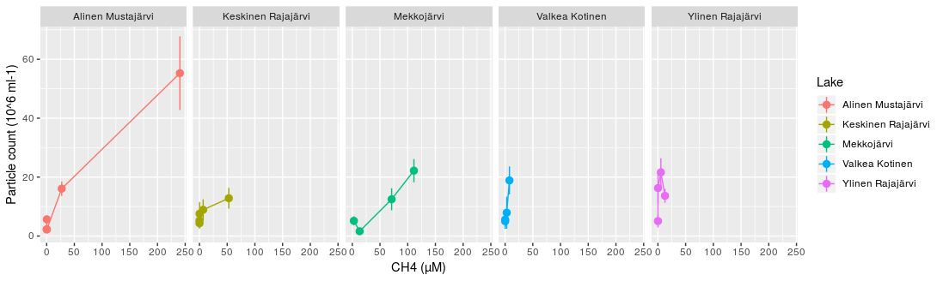

> df2 <- data_summary(bact_count_morpho_Nfix_data, varname="Particle count (10^6 ml-1)", groupnames=c("Lake", "`Fe (III) µM`")
+ )
> cor.test(df2[,2], df2[,3], method="spearman")

Spearman's rank correlation rho

data: df2[, 2] and df2[, 3]
S = 2626, p-value = 0.02416
alternative hypothesis: true rho is not equal to 0
sample estimates:
rho
-0.4827781

> df2 <- data_summary(bact_count_morpho_Nfix_data, varname="Particle count (10^6 ml-1)", groupnames=c("Lake", "`Fe (II) µM`")
+ )
> cor.test(df2[,2], df2[,3], method="spearman")

Spearman's rank correlation rho

data: df2[, 2] and df2[, 3]
S = 932, p-value = 0.02726
alternative hypothesis: true rho is not equal to 0
sample estimates:
rho
0.4737436

> df2 <- data_summary(bact_count_morpho_Nfix_data, varname="Particle count (10^6 ml-1)", groupnames=c("Lake", "`Fe (tot) µM`"))
> cor.test(df2[,2], df2[,3], method="spearman")

Spearman's rank correlation rho

data: df2[, 2] and df2[, 3]
S = 916.76, p-value = 0.023
alternative hypothesis: true rho is not equal to 0
sample estimates:
rho
0.4823496

Warning message:
In cor.test.default(df2[, 2], df2[, 3], method = "spearman") :
Cannot compute exact p-value with ties

> df2 <- data_summary(bact_count_morpho_Nfix_data, varname="Particle count (10^6 ml-1)", groupnames=c("Lake", "`NO3 µg l-1`")
+ )
> cor.test(df2[,2], df2[,3], method="spearman")

Spearman's rank correlation rho

data: df2[, 2] and df2[, 3]
S = 1826, p-value = 0.8919
alternative hypothesis: true rho is not equal to 0
sample estimates:
rho
-0.0310559

> df2 <- data_summary(bact_count_morpho_Nfix_data, varname="Particle count (10^6 ml-1)", groupnames=c("Lake", "`SO4mg l-1`"))
> cor.test(df2[,2], df2[,3], method="spearman")

Spearman's rank correlation rho

data: df2[, 2] and df2[, 3]
S = 1548, p-value = 0.9842
alternative hypothesis: true rho is not equal to 0
sample estimates:
rho
-0.005194805

> df2 <- data_summary(bact_count_morpho_Nfix_data, varname="Particle count (10^6 ml-1)", groupnames=c("Lake", "`PO4 µg/l`"))
> cor.test(df2[,2], df2[,3], method="spearman")

Spearman's rank correlation rho

data: df2[, 2] and df2[, 3]
S = 602.35, p-value = 0.0415
alternative hypothesis: true rho is not equal to 0
sample estimates:
rho
0.4716256

Warning message:
In cor.test.default(df2[, 2], df2[, 3], method = "spearman") :
Cannot compute exact p-value with ties

> cor.test(df2[,2], df2[,3], method="spearman")

Spearman's rank correlation rho

data: df2[, 2] and df2[, 3]
S = 756.42, p-value = 0.005324
alternative hypothesis: true rho is not equal to 0
sample estimates:
rho
0.5728861

Warning message:
In cor.test.default(df2[, 2], df2[, 3], method = "spearman") :
Cannot compute exact p-value with ties

> df2 <- data_summary(bact_count_morpho_Nfix_data, varname="Particle count (10^6 ml-1)", groupnames=c("Lake", "`NH4 µg/l`"))
> cor.test(df2[,2], df2[,3], method="spearman")

Spearman's rank correlation rho

data: df2[, 2] and df2[, 3]
S = 756.42, p-value = 0.005324
alternative hypothesis: true rho is not equal to 0
sample estimates:
rho
0.5728861

> p<- ggplot(df2, aes(x= `NH4 µg/l`, y=`Particle count (10^6 ml-1)`, group= Lake, color=Lake)) + geom_line() + geom_pointrange(aes(ymin=`Particle count (10^6 ml-1)`-sd, ymax=`Particle count (10^6 ml-1)`+sd))
> p + facet_grid(. ~ Lake)

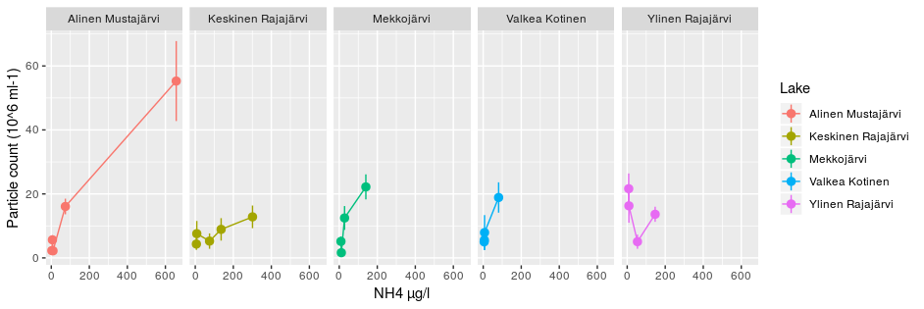

Main figures:

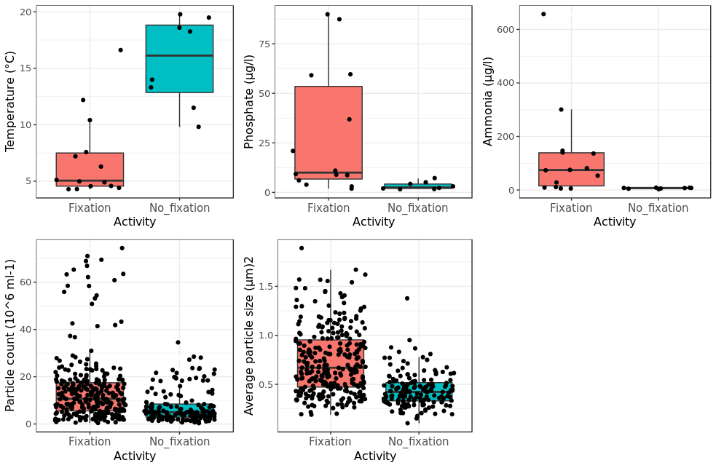

Command:
ibrary(readr)
> bact_count_morpho_Nfix_data <- read_csv("bact_count_morpho_Nfix_data.csv")
Parsed with column specification:
cols(
`Particle count (10^6 ml-1)` = col_double(),
`Average particle size (micrometer^2)` = col_double(),
Layer = col_character(),
Lake = col_character(),
Activity = col_character(),
Depth = col_double(),
`O2 (mg L-1)` = col_double(),
`Temp ( C )` = col_double(),
`CH4 (µM)` = col_double(),
`CO2 (µM)` = col_double(),
`Fe (II) µM` = col_double(),
`Fe (III) µM` = col_double(),
`Fe (tot) µM` = col_double(),
`NO3 µg l-1` = col_double(),
`SO4mg l-1` = col_double(),
`PO4 µg/l` = col_integer(),
`NH4 µg/l` = col_integer(),
`N2 uptake(umol L-1 d-1)` = col_double()
)
> View(bact_count_morpho_Nfix_data)
library(gridExtra)
> attach(metadata_new)
> p1 <- ggplot(metadata_new, aes(x = Fixation, y = `Temp ( C )`, fill=Fixation)) + geom_boxplot(outlier.colour="white", outlier.shape=16, outlier.size=.5, notch=FALSE) + theme_bw() + scale_x_discrete(name = "Activity") + scale_y_continuous(name = "Temperature (°C)") + geom_jitter() + theme(plot.title = element_text(size = 14, family = "Tahoma", face = "bold"),text = element_text(size = 12, family = "Tahoma"), axis.text.x=element_text(size = 11),legend.position = "none")
Error in ggplot(metadata_new, aes(x = Fixation, y = `Temp ( C )`, fill = Fixation)) :
could not find function "ggplot"
> library(ggplot)
Error in library(ggplot) : there is no package called ‘ggplot’
> library(ggplot2)
RStudio Community is a great place to get help: https://community.rstudio.com/c/tidyverse.
> p1 <- ggplot(metadata_new, aes(x = Fixation, y = `Temp ( C )`, fill=Fixation)) + geom_boxplot(outlier.colour="white", outlier.shape=16, outlier.size=.5, notch=FALSE) + theme_bw() + scale_x_discrete(name = "Activity") + scale_y_continuous(name = "Temperature (°C)") + geom_jitter() + theme(plot.title = element_text(size = 14, family = "Tahoma", face = "bold"),text = element_text(size = 12, family = "Tahoma"), axis.text.x=element_text(size = 11),legend.position = "none")
> p1
> p2 <- ggplot(metadata_new, aes(x = Fixation, y = `PO4 µg/l`, fill=Fixation)) + geom_boxplot(outlier.colour="white", outlier.shape=16, outlier.size=.5, notch=FALSE) + theme_bw() + scale_x_discrete(name = "Activity") + scale_y_continuous(name = "Phosphate (µg/l)") + geom_jitter() + theme(plot.title = element_text(size = 14, family = "Tahoma", face = "bold"),text = element_text(size = 12, family = "Tahoma"), axis.text.x=element_text(size = 11),legend.position = "none")
> p2
> p3 <- ggplot(metadata_new, aes(x = Fixation, y = `NH4 µg/l`, fill=Fixation)) + geom_boxplot(outlier.colour="white", outlier.shape=16, outlier.size=.5, notch=FALSE) + theme_bw() + scale_x_discrete(name = "Activity") + scale_y_continuous(name = "Ammonia (µg/l)") + geom_jitter() + theme(plot.title = element_text(size = 14, family = "Tahoma", face = "bold"),text = element_text(size = 12, family = "Tahoma"), axis.text.x=element_text(size = 11),legend.position = "none")
> attach("bact_count_morpho_Nfix_data")
Error in attach("bact_count_morpho_Nfix_data") :
file 'bact_count_morpho_Nfix_data' not found
> p4 <- ggplot(bact_count_morpho_Nfix_data, aes(x = Activity, y = `Particle count (10^6 ml-1)`, fill=Activity)) + geom_boxplot(outlier.colour="white", outlier.shape=16, outlier.size=.5, notch=FALSE) + theme_bw() + scale_x_discrete(name = "Activity") + scale_y_continuous(name = "Particle count (10^6 ml-1)") + geom_jitter() + theme(plot.title = element_text(size = 14, family = "Tahoma", face = "bold"),text = element_text(size = 12, family = "Tahoma"), axis.text.x=element_text(size = 11),legend.position = "none")
> p4
> p5 <- ggplot(bact_count_morpho_Nfix_data, aes(x = Activity, y = `Average particle size (micrometer^2)`, fill=Activity)) + geom_boxplot(outlier.colour="white", outlier.shape=16, outlier.size=.5, notch=FALSE) + theme_bw() + scale_x_discrete(name = "Activity") + scale_y_continuous(name = "Average particle size (µm)2") + geom_jitter() + theme(plot.title = element_text(size = 14, family = "Tahoma", face = "bold"),text = element_text(size = 12, family = "Tahoma"), axis.text.x=element_text(size = 11),legend.position = "none")
> grid.arrange(p1, p2, p3,p4, p5, nrow = 2)
>

