Gradus ad BBC micro:bit

Setting Up
Download “Mu” from http://codewith.mu/.
Plug your micro:bit into the computer with the microUSB cable.
Start the Mu editor. It should look like this:
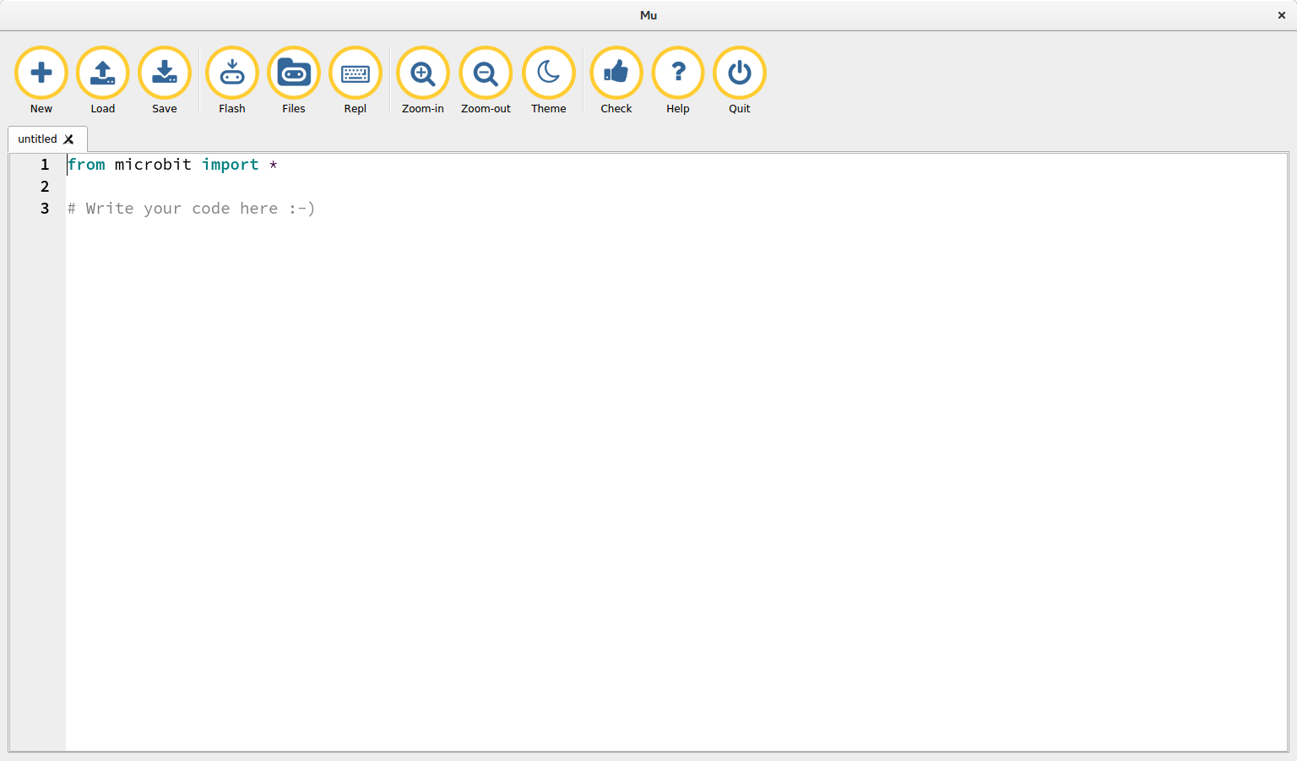
Click the “flash” button and the yellow LED on the back of the micro:bit should blink.
Well done! You’ve put Python onto your device.

Hello World
To scroll a message across the screen you should write the following code in Mu and click “flash”:

from microbit import display
display.scroll("Hello World!")

A friendly message will scroll across the display! Can you improve the message?

Pictures
The micro:bit knows lots of pictures. To find out what they are click on the “REPL” button in Mu and a new text area will appear at the bottom. In this new area type the following:

from microbit import Image
dir(Image)

A list of words will appear. Those words ALL_IN_UPPER_CASE are the names of pictures. The first picture on the list is “HEART”. To show a heart on the display, in the REPL area type the command:

display.show(Image.HEART)

Can you display the other pictures?
Click the “REPL” button again to get rid of the bottom text area.
You can create your own pictures!
Each light in the display (also called an LED) can be set from 0 (zero – no light) to 9 (the brightest amount of light). Type this code in the editor then press “flash”:

from microbit import display, Image
my_picture = Image(
'33333:'
'36663:'
'36963:'
'36663:'
'33333:')
display.show(my_picture)

Can you work out how to change the picture? HINT: each line of the display is five numbers followed by “:” - there are five lines of five numbers.

Buttons
You can do stuff with your micro:bit by pressing buttons. Here is the world’s worst cyber pet (type it into the editor, then press “Flash”):

from microbit import *
display.clear()
while True:
a = button_a.was_pressed()
b = button_b.was_pressed()
if a and b:
display.show(Image.ANGRY)
elif a:
display.show(Image.HAPPY)
elif b:
display.show(Image.SAD)
sleep(100)

If you press button A, button B or both buttons at the same time the micro:bit changes mood. How would you improve this rubbish cyber-pet? HINT: new images, scroll text.
The bit that says “while True:” is important. It puts the micro:bit into an infinite loop so it’ll always check for button presses for ever.
It’s also important that you indent the code underneath the “while True:” line by four spaces. It’s so Python knows what code to run for ever to check for button presses.
Ask a programmer to explain further! It’s interesting.

Sparkles
This code is similar to the rubbish cyber-pet but a lot more exciting to look at!

from microbit import *
import random
images = [Image.HAPPY, Image.GHOST, Image.SKULL,
Image.DUCK, Image.UMBRELLA,
Image.HEART, Image.STICKFIGURE]
while True:
sleep(20)
x = random.randint(0, 4)
y = random.randint(0, 4)
brightness = random.randint(0, 9)
display.set_pixel(x, y, brightness)
if button_a.was_pressed():
display.show(random.choice(images))
sleep(500)
if button_b.was_pressed():
display.scroll("Hello", delay=100)
if accelerometer.was_gesture('shake'):
display.show(Image.ANGRY)
sleep(1000)

There’s a lot of code to type but it’s worth it! Your micro:bit will SPARKLE! If you press the buttons pictures will appear or it’ll say “Hello”. Don’t shake it or you’ll make it angry!
Can you work out how the sparkles work? Ask a programmer! They’ll know.

Radio
It turns out that micro:bits can talk to each other by radio! For this to work you’ll need to buddy up with someone else with a micro:bit and make sure you both have the same code running on the device.

from microbit import display, button_a
import radio
radio.on()
while True:
message = radio.receive()
if message:
display.scroll(message, 80)
if button_a.was_pressed():
radio.send("Hello from Mary")

Change “Mary” to whatever your name is! You can actually send any message you like. We trust you’ll be sensible!
Can you improve this script. What about sending a different message if button B is pressed? Why not display a certain image if a pre-agreed message is received?
Perhaps Mary is a friend. If the message is “Hello from Mary” you can display a heart instead. Everything you need to make this happen has been explained in all the previous sections.
If in doubt, ask a programmer but NEVER LET THEM TYPE FOR YOU!

Music
So, micro:bits love making music. For this to work you should ask an adult to get you a speaker (supplies are limited, so you may need to wait). Once you’ve had the speaker connected to your micro:bit you’re ready to go!
There are already several tunes built into the micro:bit. To see what they are, click on the “REPL” button and type these commands into the text area at the bottom:

import music
dir(music)

A list with the names of tunes IN_UPPER_CASE is displayed. The first tune is called “DADADADUM”. To play the tune, type into the text area at the bottom:

music.play(music.DADADADUM)

Try changing the tune that’s played. Which one is your favourite? How could you improve the rubbish cyber-pet with music? Ask a programmer for help if you’re unsure!
Click the “REPL” button to remove the text area at the bottom. The following script turns the micro:bit into a musical instrument. Type it into the editor and click “Flash”.

from microbit import accelerometer
import music
while True:
music.pitch(accelerometer.get_x(), 20)

What happens if you change “accelerometer.get_x()” to “accelerometer.get_y()”?
Try it!
Can you play tunes with your micro:bit instrument? How would you improve your instrument? You can get a programmer to help you?

Speech
Did you know that micro:bits can talk?
Click the “New” button and then the “Flash” button to reset Python on your device. Once the device is ready, click the “REPL” button and in the text area at the bottom type the following commands:

import speech
speech.say("Hello Mary")

Obviously, replace “Mary” with your own name. Does the micro:bit get it right? How good is it at tongue twisters?
Click “REPL” to close the text area at the bottom. Use the editor to type in the following code and then click “Flash”.

from microbit import sleep
import speech
story = [
"Once upon a time there was a microbit called Mary.",
"She liked to help her owner learn to program.",
"One day she did a thing.",
"But then something annoying happened.",
"Luckily Mary was able to fix all the things.",
"The End",
]
for line in story:
speech.say(line)
sleep(500)

Your micro:bit will read you a bedtime story. Can you improve the story? Does the micro:bit always get it right? If not, how can you improve its pronunciation?

When you Get Home
The best editor to use for Python is “Mu”. The one on the BBC’s website is currently out of date (the BBC are very slow about this sort of thing). To get a version of Mu for your computer at home visit: http://codewith.mu/

To try some more in-depth tutorials and explore the programmer’s documentation visit:
http://microbit-micropython.rtfd.org/

To learn more about Python, micro:bit and the RaspberryPi check out: http://pyedu.io/
(This final site is currently being built – more content will appear very soon.)

A book about MicroPython on the BBC micro:bit will be available in the spring from: http://amzn.to/2cWZLVy

Remember that it’s ALWAYS OK to ask questions. If someone makes fun of you for asking them something, it’s probably not worth listening to their answer. Go find someone else more friendly!
Better still, try to find a friend who also likes programming. Work together on a project and help each other when you’re stuck. Getting a second opinion is always good.
Finally, programming computers is a lot of fun. If what you’re doing isn’t fun you’re either doing it wrong (try changing what you’re doing) or doing it for too long (go take a break).

That’s it..!

Go make something amazing..! Come back next year and show us. :-)

