dsPIC33/PIC24 RIPE File Documentation

# Enhanced ICSP Protocol

All dsPIC and PIC24 devices support the ICSP protocol for serial programming of flash memory. Select devices also support an additional protocol known as Enhanced ICSP, where a programming firmware runs from a special region in program memory, known as executive memory, to facilitate more efficient programming. This firmware is called the Programming Executive (PE).

Refer to the respective device’s programming specification to determine whether Enhanced ICSP is supported, as well as for details of ICSP and Enhanced ICSP (if applicable) protocols for that device.

# The Programming Executive File

The PE is stored in a .hex file format, with the naming convention:

RIPE_[Number][Letter (optional)]_[Revision number].hex.

The device’s executive memory must be programmed with the code in this hex file using ICSP before Enhanced ICSP can be used.

## Understanding Programming Executive Version

Each supported device has only one compatible PE, with version indicated in the hex file name.

The PE version consists of both the number and the letter, if a letter is present. The revision number at the end is separate from the PE version.

For example: **RIPE_23** is used for most dsPIC33C family devices, however, **RIPE_23a** and **RIPE_23s** are distinct PE versions, used for specific dsPIC33CK and dsPIC33CH devices respectively.

# Usage of the Programming Executive

The PE is used by Microchip development tools to implement the Enhanced ICSP protocol for supported devices, in a manner that is transparent to the user.

To implement the Enhanced ICSP protocol without use of a Microchip development tool, a user will need to obtain and use the correct PE for the respective device.

## Implementing the Enhanced ICSP Protocol

In order to use Enhanced ICSP with a particular device, the regular ICSP protocol must first be implemented according to the device’s flash programming specification. Once ICSP has been used to program the device’s PE into executive memory, Enhanced ICSP may be used for device programming.

Some memory locations, including executive memory, may be restricted to being programmed using ICSP only. Refer to the device’s programming specification for any device-specific details on ICSP and Enhanced ICSP protocols.

# Finding a Programming Executive

## From Microchip Bitbucket Repository (Recommended)

All latest PE files are available from a public Bitbucket repository. A spreadsheet containing the correspondence between device name, PE version, and the respective PE file is available at:

**<INSERT LINK HERE>**

The device name is in the left column, PE version number is in the middle column, and link to the PE hex file is in the right column.

For example, if your device was dsPIC33CK256MP508 you would click the link in the row indicated above to reach the following page:

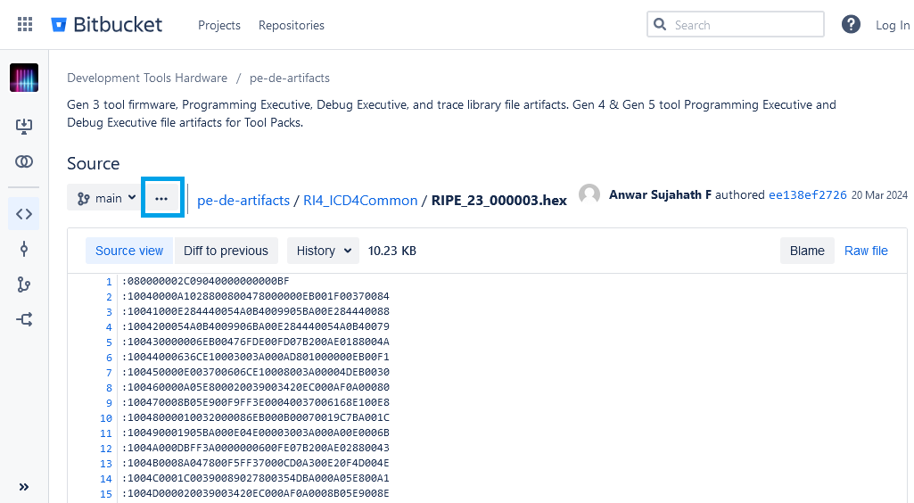

Click the three dots icon to open up a drop-down menu, giving the option to download the file.

## From a Tool Pack

Additionally, any tool pack contains the PEs for all supported devices in its firmware directory. Tool packs are found either in a local packs directory, or within an MPLAB X installation folder.

For example, the path to the firmware directory may resemble the following:

C:\Users\Microchip\.mchp_packs\Microchip\ICD5_TP\2.5.367\firmware

Or:

C:\Program Files\Microchip\MPLABX\v6.20\packs\Microchip\ICD5_TP\2.3.304\firmware

The pack directory would look like the following:

From there, open the firmware sub-directory, and the .hex files starting with “RIPE_” are the PEs, with filenames indicating the version numbers:

Continuing with the above example of dsPIC33CK256MP508 device, RIPE_23’s hex file is highlighted. As filename is RIPE_23_000003.hex, this is revision 3 of this PE.

The PE versions and revisions contained in a given tool pack will be the latest at the time the tool pack was made. To know which PE version to use for a particular device, you will want to consult the spreadsheet linked above.

## Device Families that Do Not Support Enhanced ICSP

If the device does not support Enhanced ICSP, a PE is not needed. In general, if the device-specific programming specification does not refer to Enhanced ICSP, it is not supported, however, you may also refer to the following list:

#### dsPIC30 Device Families

Enhanced ICSP is not supported for these devices.

#### PIC24F K Device Families

Enhanced ICSP is not supported for these devices.

#### Certain dsPIC33FJ Device Families

Some dsPIC33FJ devices do not support Enhanced ICSP.

Refer to the specific device’s Flash Programming Specification to determine whether Enhanced ICSP is supported.

#### dsPIC33CH PRAM-based Secondary Cores

PRAM-based secondary cores of dsPIC33CH devices, for example, dsPIC33CH128MP508S1, do not support Enhanced ICSP programming.

Note that because the PRAM program memory is volatile, and intended end usage is for the main core to load the secondary core’s PRAM, ICSP is generally only useful for these cores as part of specific development and debugging flows.

Flash-based dsPIC33CH main and secondary cores support Enhanced ICSP programming. Refer to the specific device datasheet to determine whether the secondary core uses flash or PRAM.

#### dsPIC33A Device Families

For dsPIC33A devices, the ICSP protocol has been enhanced significantly to improve its programming performance beyond that of Enhanced ICSP on previous devices. Therefore, Enhanced ICSP is not supported.