MCS AI Platform
User Guide

Version 1.0 · March 18, 2026

Table of Contents
- 1. Getting Started
- 2. Dashboard
- 3. Agent Detail & Chat
- 4. Agent Settings
- 5. Knowledge Bases
- 6. Workflows
- 7. Workflow Builder
- 8. Scheduled Jobs
- 9. Prompt Templates
- 10. Usage & Cost
- 11. Organizations
- 12. Billing & Subscription
- 13. API Keys
- 14. Marketplace
- 15. Integrations
- 16. Audit Logs
- 17. Admin Panel

1. Getting Started
Welcome to MCS AI Platform — a complete SaaS solution for building, deploying, and managing AI-powered agents. This guide walks you through every feature of the platform with step-by-step instructions.
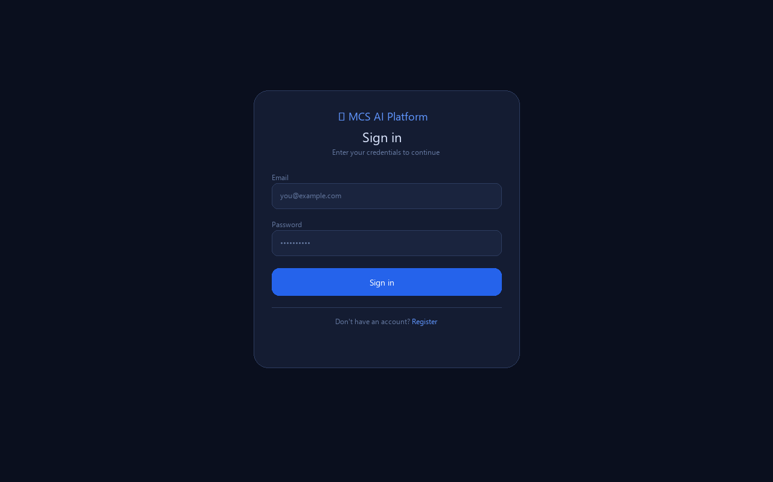
Figure 1 — Login page

1.1 Creating an Account
Navigate to the platform URL and click Register on the login page. Enter your full name, email address, and a secure password. Once registered, you are automatically logged in.

1.2 Logging In
Enter your email and password on the Sign in page and click the Sign in button. Your session token is stored locally and persists until you click Log out in the navigation bar.

2. Dashboard
The Dashboard is your home screen. It displays all your AI agents as cards with quick access to chat and settings. Disabled agents appear greyed out with a 'Disabled' badge.
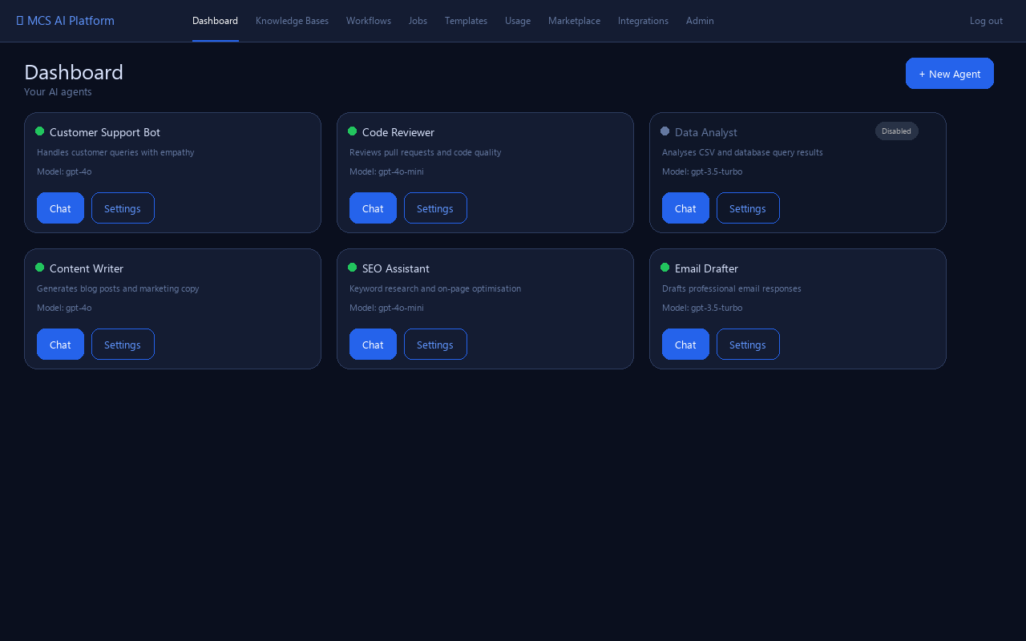
Figure 2 — Dashboard showing agent cards

2.1 Creating an Agent
Click the + New Agent button (top right). Enter a name and optionally a description. The agent is created with sensible defaults: gpt-3.5-turbo model, temperature 0.7, memory enabled.

2.2 Agent Status Indicators
A green dot next to the agent name indicates it is active and ready to chat. A grey dot and 'Disabled' badge mean the agent has been disabled via the Settings → Danger Zone section. Disabled agents cannot be used for chat.

3. Agent Detail & Chat
Click an agent card from the Dashboard to open its detail page. Here you can manage the agent's knowledge documents and start or review chat conversations.
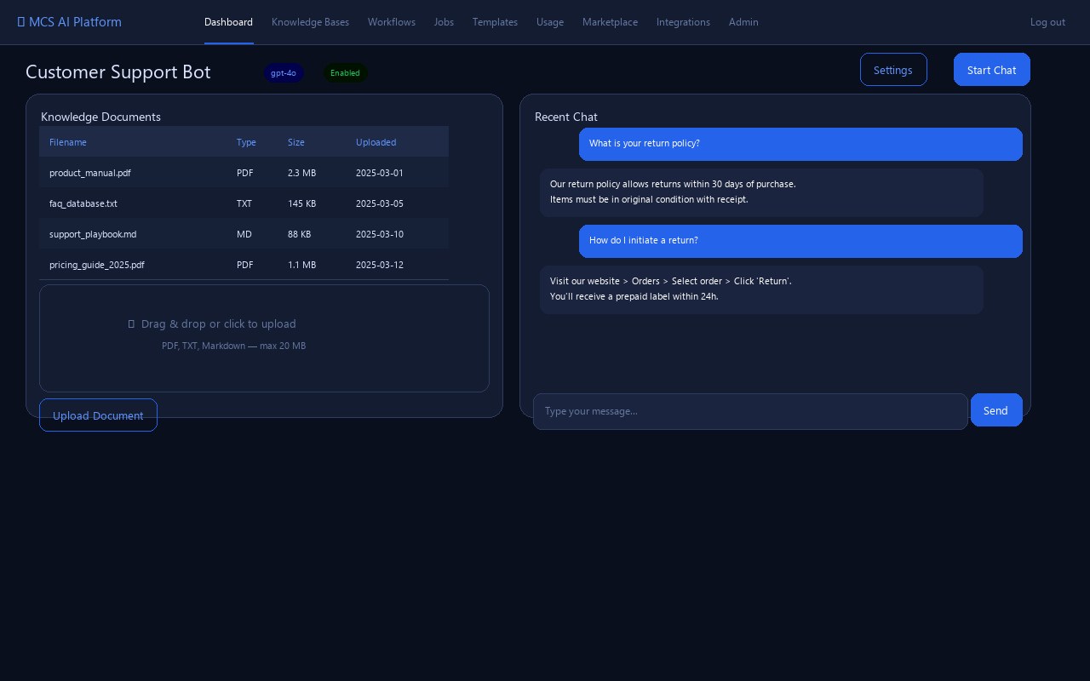
Figure 3 — Agent detail: documents on the left, chat preview on the right

3.1 Uploading Documents
The document upload follows a three-step process: (1) Click Upload Document to open the file picker, (2) select a PDF, TXT, or Markdown file (max 20 MB), (3) click Add to confirm. The document is parsed, split into chunks, and embedded using the text-embedding-3-small model for semantic search.

3.2 Downloading & Deleting Documents
Each document row in the table has Download (saves the original file to your computer) and Delete (removes the file, all chunks, and the database record) buttons. Deletion is permanent.

3.3 Chatting with an Agent
Click Start Chat (top right) to open a chat session. Type your message in the input bar and press Send. The agent responds using its configured LLM, system prompt, knowledge base, and enabled tools. The last 10 messages are kept as context; sessions exceeding 20 messages are automatically summarised.

4. Agent Settings
Click Settings on any agent card to open the full configuration page. All changes must be saved by clicking Save Changes.
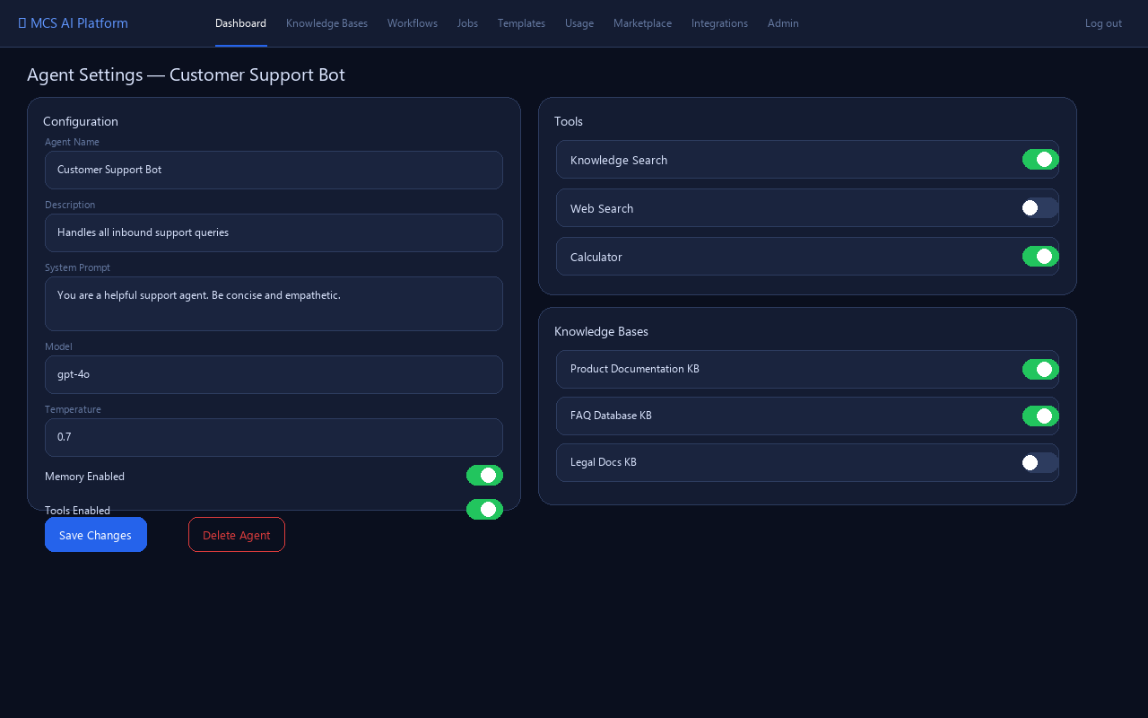
Figure 4 — Agent settings: model configuration, tools, and knowledge base bindings

4.1 Model Configuration
Agent Name and Description are used for display purposes. The System Prompt defines the agent's persona and behaviour. Model selects the LLM (e.g. gpt-4o, gpt-4o-mini, gpt-3.5-turbo). Temperature (0.0–2.0) controls response creativity — lower values are more deterministic.

4.2 Memory & Tools
Memory Enabled — when toggled on, the platform injects recent conversation history into each LLM call for contextual continuity. Tools Enabled — allows the agent to use registered tool executors (Knowledge Search, Web Search, Calculator). Individual tools can be toggled on or off per agent.

4.3 Knowledge Base Bindings
Link one or more Knowledge Bases to this agent. When the Knowledge Search tool runs, it searches across all linked KBs using cosine similarity on the embedded document chunks.

4.4 Danger Zone
Disable Agent — makes the agent unavailable for chat without deleting it. Delete Agent — permanently removes the agent and all associated data. Both actions require confirmation.

5. Knowledge Bases
Knowledge Bases are collections of documents that can be shared across multiple agents. Navigate to Knowledge Bases in the top navigation bar.
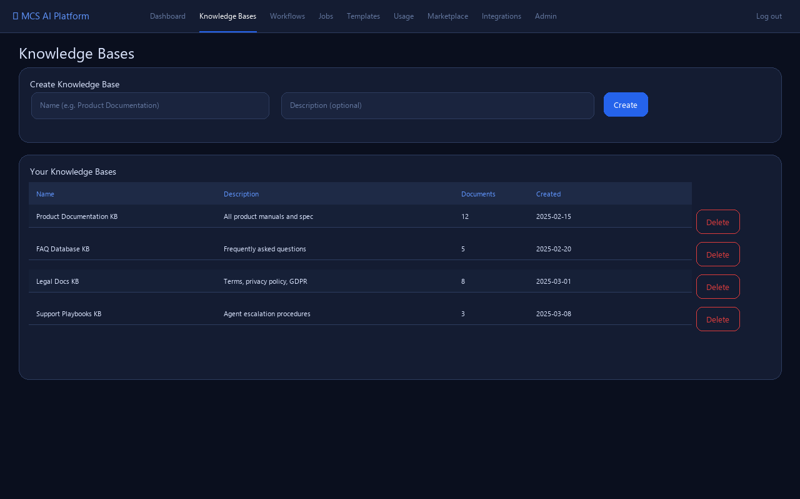
Figure 5 — Knowledge bases management

5.1 Creating a Knowledge Base
Enter a name (required) and optional description in the Create form at the top, then click Create. The KB starts empty — add documents by uploading them to an agent that has this KB linked.

5.2 Linking to Agents
Go to Agent Settings → Knowledge Bases section and toggle on the KBs you want the agent to search. An agent can be linked to multiple KBs simultaneously.

6. Workflows
Workflows let you chain multiple AI steps into an automated pipeline. Each step can call the LLM, search knowledge, fetch web results, summarise content, or make HTTP requests.
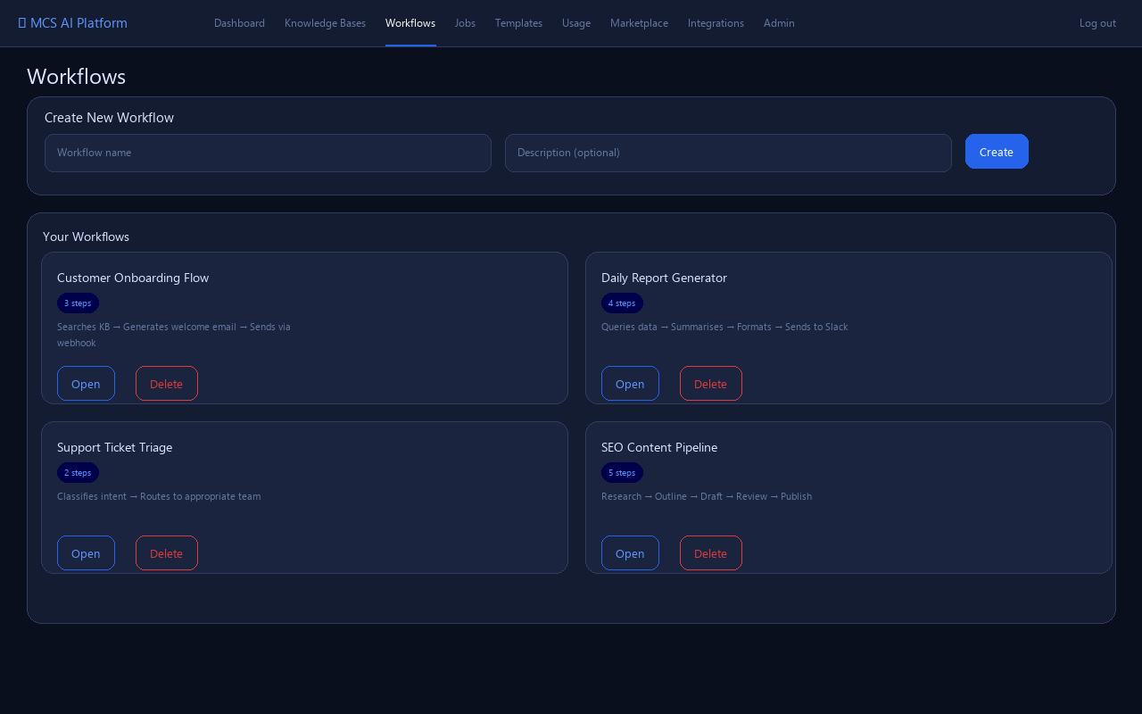
Figure 6 — Workflow list

6.1 Creating a Workflow
Click Create on the Workflows page. Enter a name and optional description. The workflow opens with zero steps — click + Add step to start building.

7. Workflow Builder
The Workflow Builder allows you to visually construct multi-step AI pipelines and execute them with a single click.
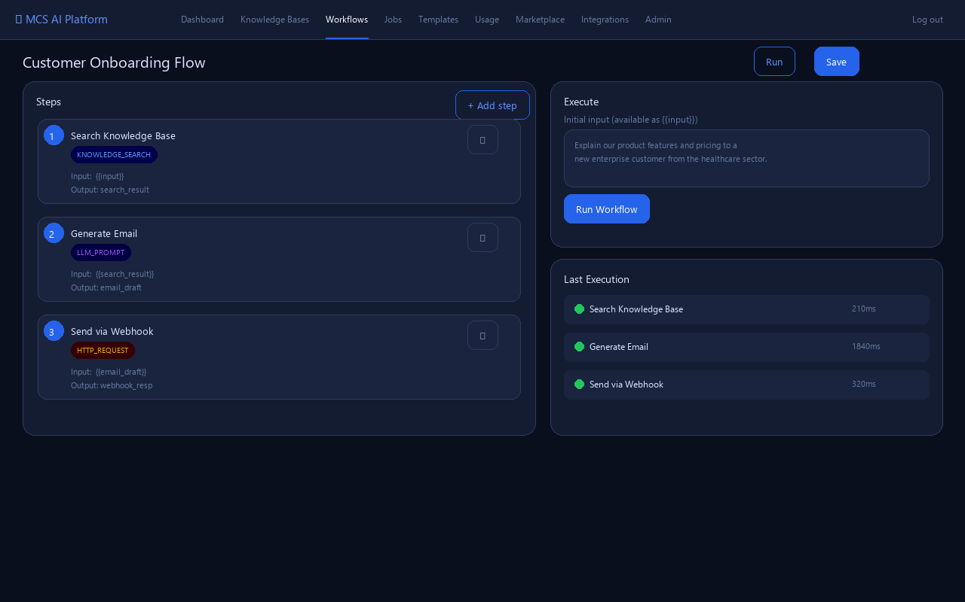
Figure 7 — Workflow builder with step editor and execution panel

7.1 Adding Steps
Click + Add step. For each step configure: Name (descriptive label), Type (KNOWLEDGE_SEARCH, WEB_SEARCH, LLM_PROMPT, SUMMARIZE, HTTP_REQUEST), Input Template (use {{variableName}} to reference previous step outputs or the initial {{input}}), Output Key (name under which this step's result is stored for downstream steps).

7.2 Executing a Workflow
Type your initial input in the Execute panel, then click Run Workflow. Execution is asynchronous — the status updates every 2 seconds automatically. The Execution History section shows step-by-step results, durations, and any errors, as well as the final output.

7.3 Step Variable Syntax
Use {{input}} to reference the workflow's initial input. Use {{outputKey}} to reference the output of a previous step, where outputKey is the Output Key configured on that step. Example: if step 1 has Output Key search_result, step 2 can use {{search_result}} in its Input Template.

8. Scheduled Jobs
Scheduled Jobs automatically trigger workflows on a recurring schedule. The scheduler checks for due jobs every 60 seconds.
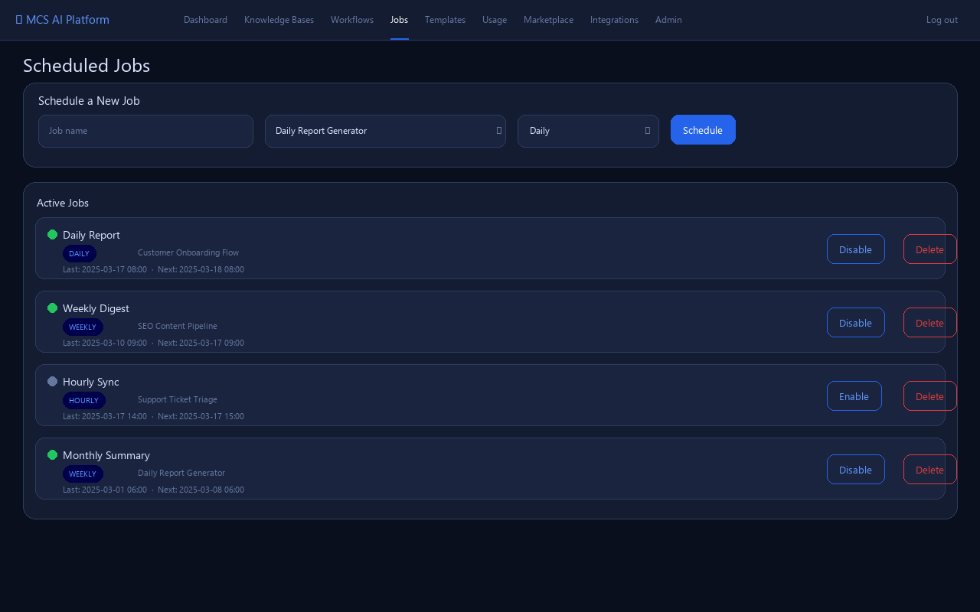
Figure 8 — Scheduled jobs with HOURLY/DAILY/WEEKLY options

8.1 Creating a Scheduled Job
Select the workflow to run, choose a schedule type (HOURLY, DAILY, WEEKLY), give the job a name, and click Schedule. The first run is queued immediately; subsequent runs are calculated from the last run time.

8.2 Managing Jobs
Each job card shows the last run time and next scheduled run. Click Disable to pause a job without deleting it. Click Enable to resume. Click Delete to permanently remove the job.

9. Prompt Templates
Prompt Templates let you define reusable prompt blueprints with dynamic placeholders. Use them in workflows or render them directly in the UI.
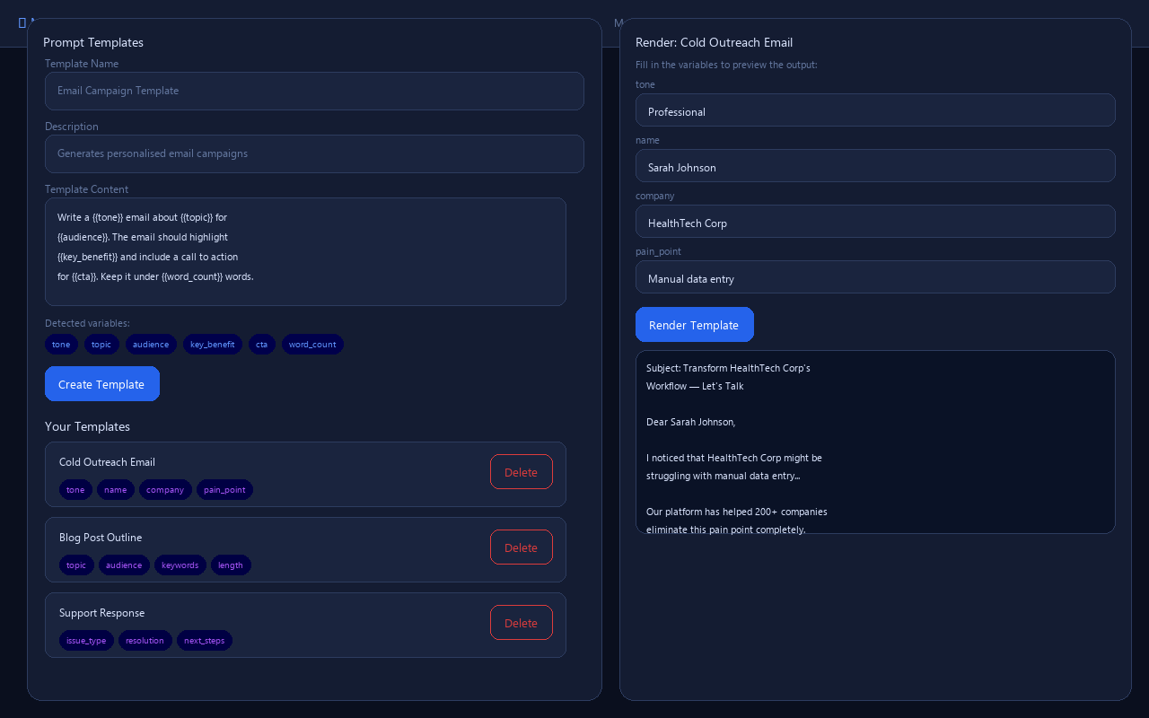
Figure 9 — Prompt template editor with variable detection and render panel

9.1 Creating a Template
Write your template content using {{variableName}} placeholders — for example: Write a {{tone}} email about {{topic}} for {{audience}}. The platform automatically detects and displays all variable names as badges. Click Create to save.

9.2 Rendering a Template
Click a template in the list to select it. The Render panel appears on the right with an input field for each variable. Fill in the values and click Render Template to see the final output immediately.

10. Usage & Cost
The Usage & Cost page gives you complete visibility into platform consumption and estimated spending across all agents and models.
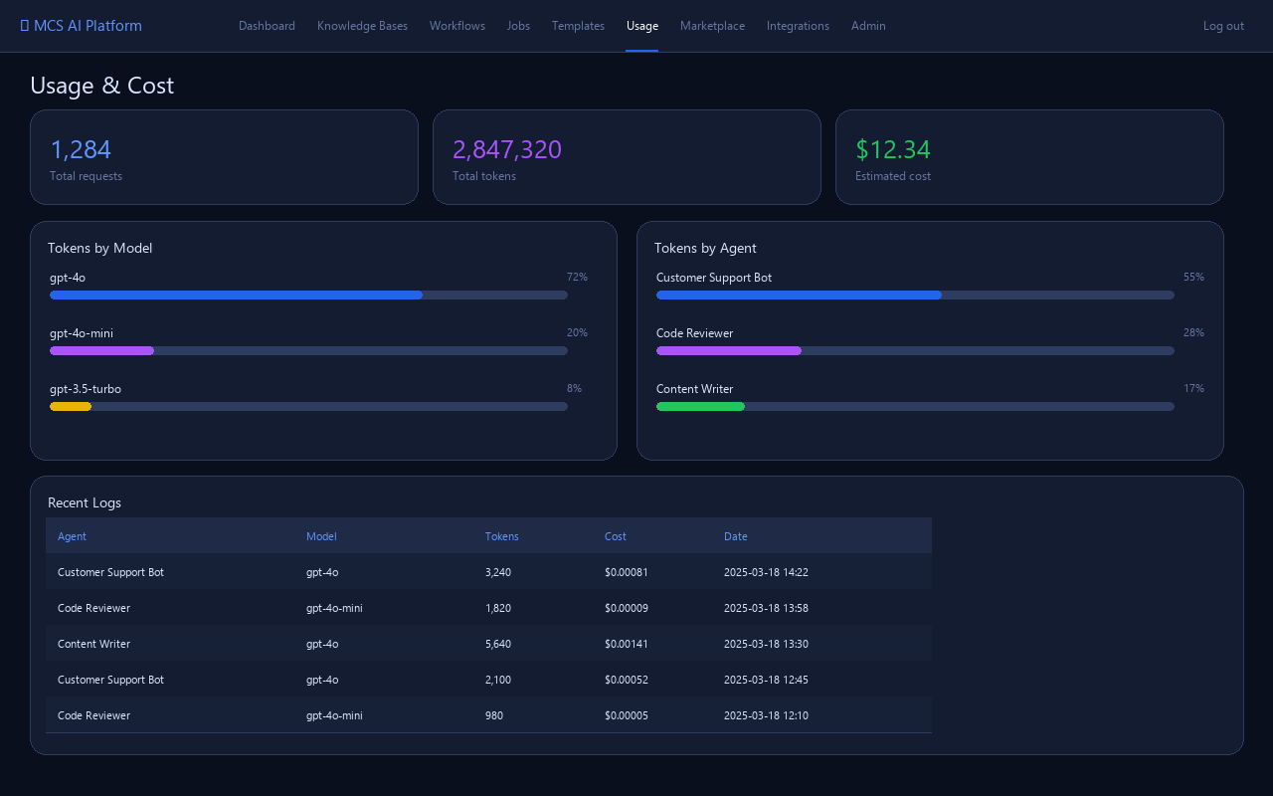
Figure 10 — Usage dashboard with stats, model charts, and log table

10.1 Summary Cards
The three stat cards at the top show total API requests made, total tokens consumed, and estimated cost in USD since account creation.

10.2 Breakdown Charts
Tokens by Model shows the proportional share of each LLM model's token usage with a progress bar. Tokens by Agent shows the same breakdown per agent. Both charts include cost figures.

10.3 Recent Logs
The log table shows the 50 most recent API calls with agent, model, token count, estimated cost, and timestamp. Use this for detailed cost attribution.

11. Organizations
Organizations enable team collaboration by grouping users under a shared workspace with role-based access control.
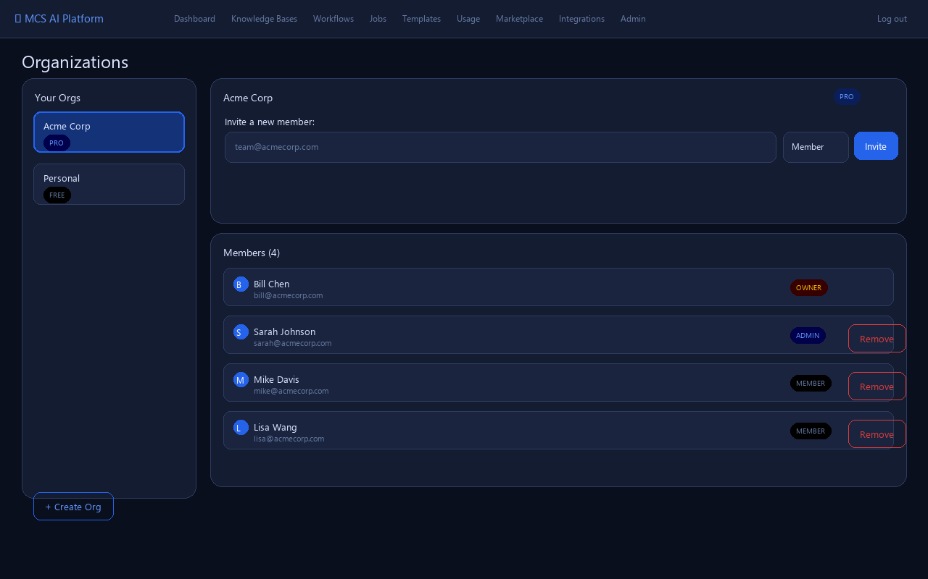
Figure 11 — Organization management with member roles

11.1 Creating an Organization
Click Create Organization, enter a name and optional description. You become the OWNER automatically and are the only member initially.

11.2 Inviting Members
Enter the email address of a registered platform user and select their role: MEMBER (read-only) or ADMIN (can invite/remove members). The user must already have an account on the platform.

11.3 Roles
OWNER — full control, cannot be removed. ADMIN — can invite and remove members, manage org settings. MEMBER — can access shared resources within the organisation.

12. Billing & Subscription
The Billing page shows your current subscription plan and allows you to upgrade to unlock higher limits.
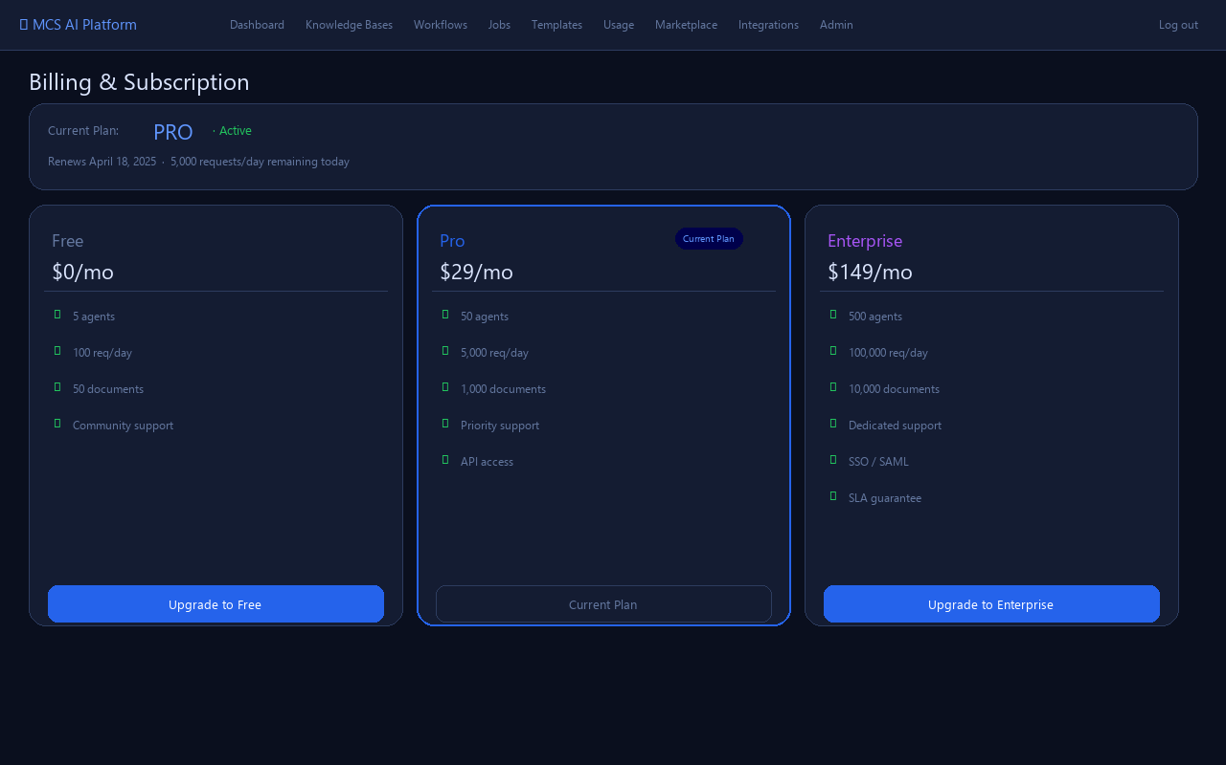
Figure 12 — Billing page with plan comparison cards

12.1 Plan Comparison
FREE ($0/mo): 5 agents, 100 requests/day, 50 documents. PRO ($29/mo): 50 agents, 5,000 requests/day, 1,000 documents, API access. ENTERPRISE ($149/mo): 500 agents, 100,000 requests/day, 10,000 documents, SSO/SAML, SLA guarantee.

12.2 Upgrading
Click the Upgrade button on any plan card and confirm when prompted. The plan change takes effect immediately. Billing integration with Stripe is configured by the platform administrator.

13. API Keys
API Keys let you authenticate programmatic access to the platform without using your password. Pass the key as the X-API-Key request header.
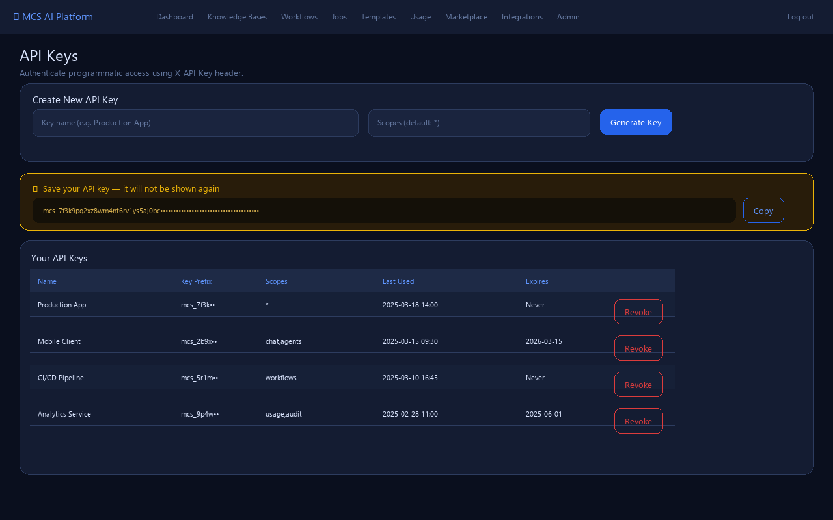
Figure 13 — API key management with one-time reveal panel

13.1 Generating an API Key
Enter a descriptive name and optional scope list (comma-separated, default *), then click Generate Key. The full key is displayed once in a yellow panel — copy it immediately as it cannot be retrieved again.

13.2 Using an API Key
Include the header X-API-Key: mcs_<your_key> in every request. API keys support the same endpoints as JWT authentication. The key's Last Used timestamp is updated on each use.

13.3 Revoking Keys
Click Revoke on any key to permanently delete it. Any application using that key will immediately lose access. Revocation cannot be undone.

14. Marketplace
The Marketplace is a public library of community-published agents, prompt templates, and workflows. Browse without logging in; publish and clone with an account.
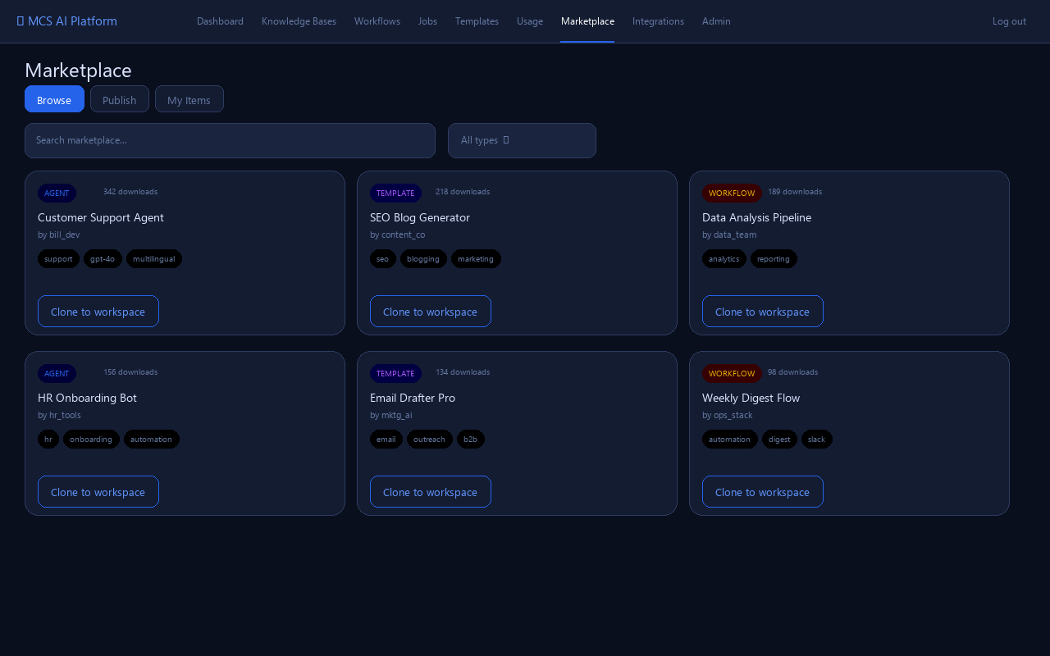
Figure 14 — Marketplace with agent, template, and workflow listings

14.1 Browsing & Cloning
Use the search box to find items by title or the type filter to narrow by AGENT, TEMPLATE, or WORKFLOW. Click Clone to workspace to copy an item's configuration into your account. The clone counter increments on each download.

14.2 Publishing
Switch to the Publish tab. Select the type, enter a title, description, category, and comma-separated tags, then click Publish. Your item appears in the public listing immediately.

14.3 Managing Your Items
The My Items tab lists everything you have published. Click Remove to unpublish an item — it disappears from the marketplace but is not deleted from your account.

15. Integrations
Integrations connect the platform to external services. Configured integrations are triggered automatically when workflows complete, sending output to Slack, webhooks, email, and more.
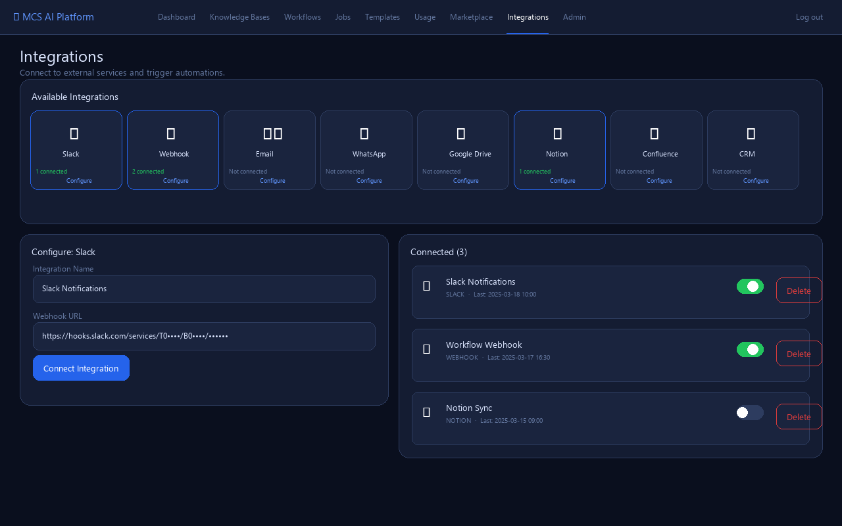
Figure 15 — Integrations page with tile grid and Slack configuration form

15.1 Available Integration Types
Slack — post messages via Incoming Webhooks. Webhook (generic) — POST JSON to any URL when a workflow completes. Email — send results via SMTP. WhatsApp — send via Meta Cloud API. Google Drive, Notion, Confluence — connect your document platforms. CRM — Salesforce, HubSpot via API key.

15.2 Adding an Integration
Click any integration tile to open its configuration form. Enter the integration name and fill in the required fields (webhook URL, API token, etc.). Click Connect to save. Sensitive fields are masked with password input styling.

15.3 Enabling & Disabling
Each connected integration has an Enable/Disable toggle. Disabled integrations are not triggered even when workflows complete. This is useful for temporarily pausing an integration without deleting it.

16. Audit Logs
Audit Logs provide a complete, tamper-visible record of every action taken in your account, including the IP address and timestamp of each event.
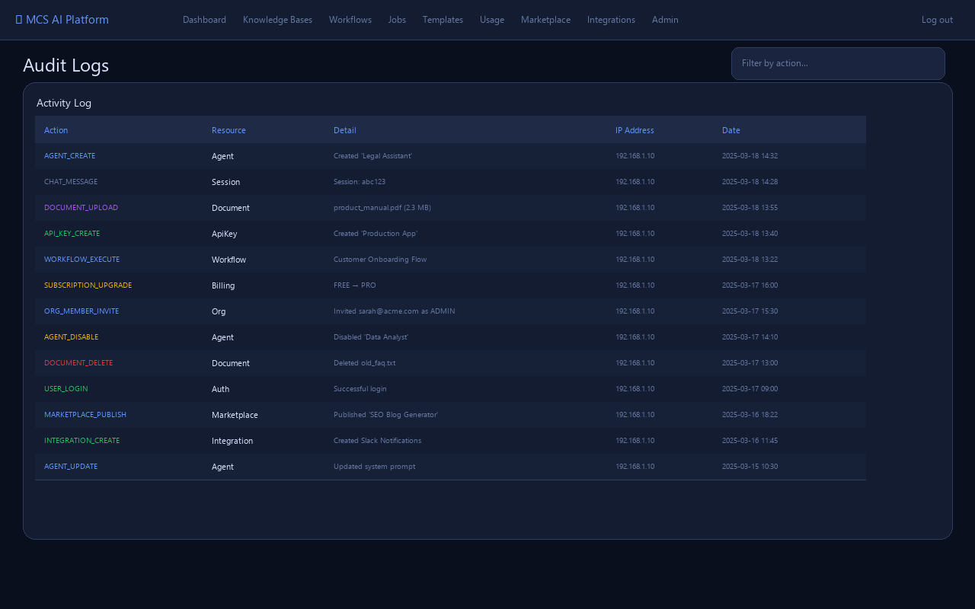
Figure 16 — Audit log table with colour-coded actions

16.1 Reading the Audit Log
Each row shows the action type (colour-coded by category), the resource it affected, a human-readable detail string, the originating IP address, and the exact date/time.

16.2 Filtering
Type in the Filter by action box (top right) to narrow the log to specific action types such as AGENT, DOCUMENT, or WORKFLOW.

17. Admin Panel
The Admin Panel is accessible to all authenticated users and provides platform-wide visibility across users, agents, and usage logs.
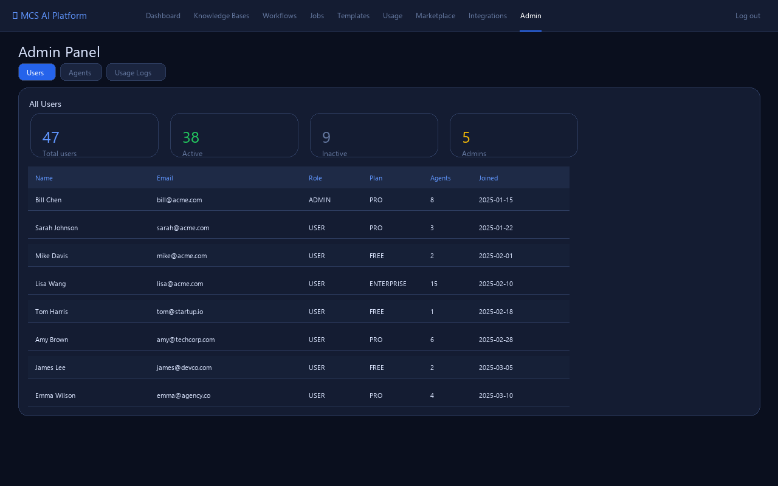
Figure 17 — Admin panel showing the Users tab

17.1 Users Tab
Lists all registered users with their email, role, subscription plan, number of agents, and registration date. Summary stats at the top show total, active, inactive, and admin user counts.

17.2 Agents Tab
Shows all agents across all users, useful for monitoring platform-wide agent usage and identifying inactive or misconfigured agents.

17.3 Usage Logs Tab
Displays all API calls across all users — valuable for cost allocation, quota monitoring, and identifying heavy consumers.

