rea Project
microfast 42
1337 Town
Switzerland

info@example.com
https://example.com

Invoice
Invoice No. | 1453234
Invoice Date | 22.07.2026
Due Date | 30.08.2026

Invoice No. 1453234

Dear Foobar

Thanks for being a customer of us. This is the invoice for June 2026, which is due on 30.08.2026.

Item | Qty | Price | VAT | Amount
Software Engineering  Project: INFNET | 10h | 160.00 | 7.7%  34.43 | 1600
Total CHF |  |  | 34.43 | 1600

Please find the Swiss QR-Code bill on the next page.

Best regards

Example GmbH

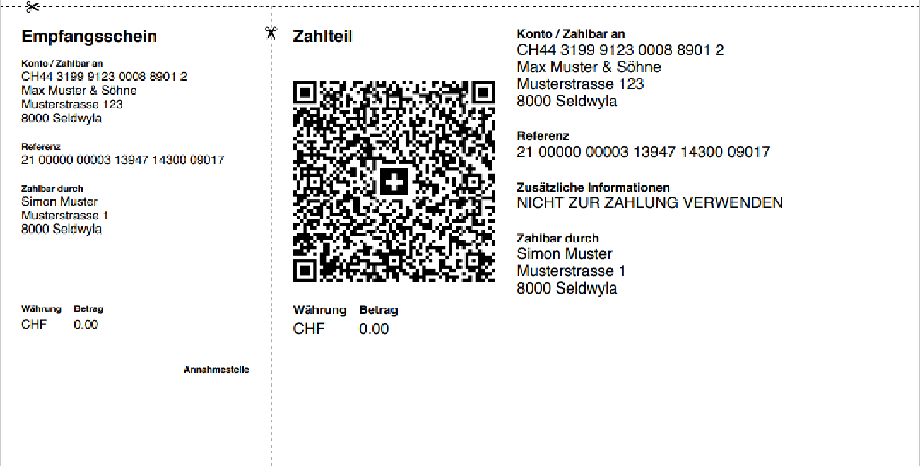
This is the QR-Code bill you can use for payment. As this invoice is a rea demonstration, it's a dummy code. A further version of rea will be able to generate QR-Code bills directly and include them into documents.

