Microfluidic pressure controller

*Authors of the manual:*

*Ivan A. Denisov Nikita A. Filatov Anton S. Bukatin Kirill A. Lukyanenko Vladimir V. Sorokin Anton S. Yakimov*

9 Jan 2022

**Abstract**

|  |  |  |
| --- | --- | --- |
|  | The manual includes instructions to assemble, setup  and develop the open-source microfluidic pressure con- troller. Additionally, the main stages of assembly of the device are indicated. The study of the microflu- idic pressure controller you can read in our paper in the magazine ... [insert when published] The develop- ment is distributed under the GNU GPLv3 license. |  |
| **Contents** |  |
|  | **1 Introduction** | **3** |
|  | 1.1 Transportation . . . . . . . . . . . . . . . . . . | 4 |
|  | 1.2 Storage . . . . . . . . . . . . . . . . . . . . . . . | 4 |
|  | **2 Software Installation and Description** | **5** |
|  | 2.1 PC Software installation . . . . . . . . . . . . . | 5 |
|  | 2.2 Software description . . . . . . . . . . . . . . . | 5 |
|  | **3 Hardware Adjustment** | **8** |
|  | 3.1 Calibration pressure sensors and adjustment ITV pressure rage . . . . . . . . . . . . . . . . . | 8 |

1. Manual control of the device 11
2. Instrument assembly 12
3. ATTENTIONS 19
4. **Introduction**

The controller has the following functions:

* 1. manual and program control 4 pressure outputs
  2. manual and program control 1 vacuum pump
  3. control 8 relays for manage output devices
  4. control 4 digital inputs and 4 ADC (analog-to-digital converters)
  5. write automatic work protocols

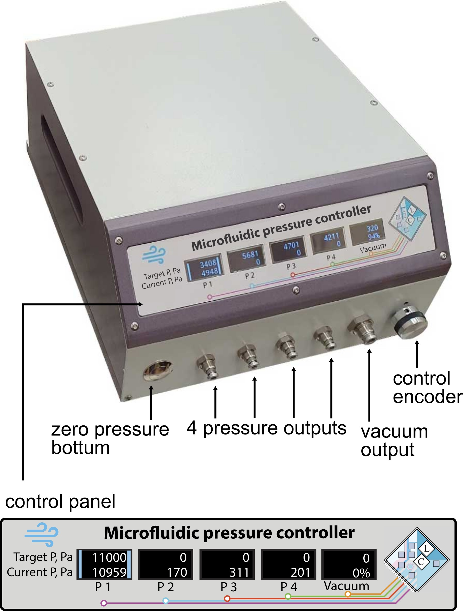

Figure 1 – The general view of the microfluidic controller with 5 displays, 4 positive pressure outputs and 1 vacuum pump output

## Transportation

The vacuum pump is attached to the body with silicone damp- ing elements. So, to avoid damage to them, the device must be transported in a normal (horizontally) position, not turned on its side or upside down. For transportation in luggage it is necessary to fix the vacuum pump by removing the top cover of the device 1

## Storage

The device must be stored under conditions that do not lead to metal corrosion. Place plugs in all pneumatic ports: 1 pressure inlet and 5 pressure outlets. The absence of plugs will lead to the accumulation of microparticles, which can get into the microfluidic chip after the device is started up and lead to its malfunction. There is a filter inside the housing at the air inlet of the instrument, however we recommend that you follow the above precautions and install a plug on the inlet during long-term storage of the instrument.

1 for this you need to use a special hex bit, using an unsuitable tool may damage the screws and it will be impossible to unscrew them

1. **Software Ins****tallation and Description**

## PC Software installation

[Link to download the software application.](https://github.com/microfluidic-pressure-controller/software/releases) If this link does not open:

[https://github.com/microfluidic-pressure-controller/software/](https://github.com/microfluidic-pressure-controller/software/releases) [releases](https://github.com/microfluidic-pressure-controller/software/releases)

## Software description

A USB 2.0 A / USB 2.0 B cable is required to connect the pressure controller to a computer.

General view of the menu panels is shown in the figure 2. The following are the functions of the buttons and other elements:

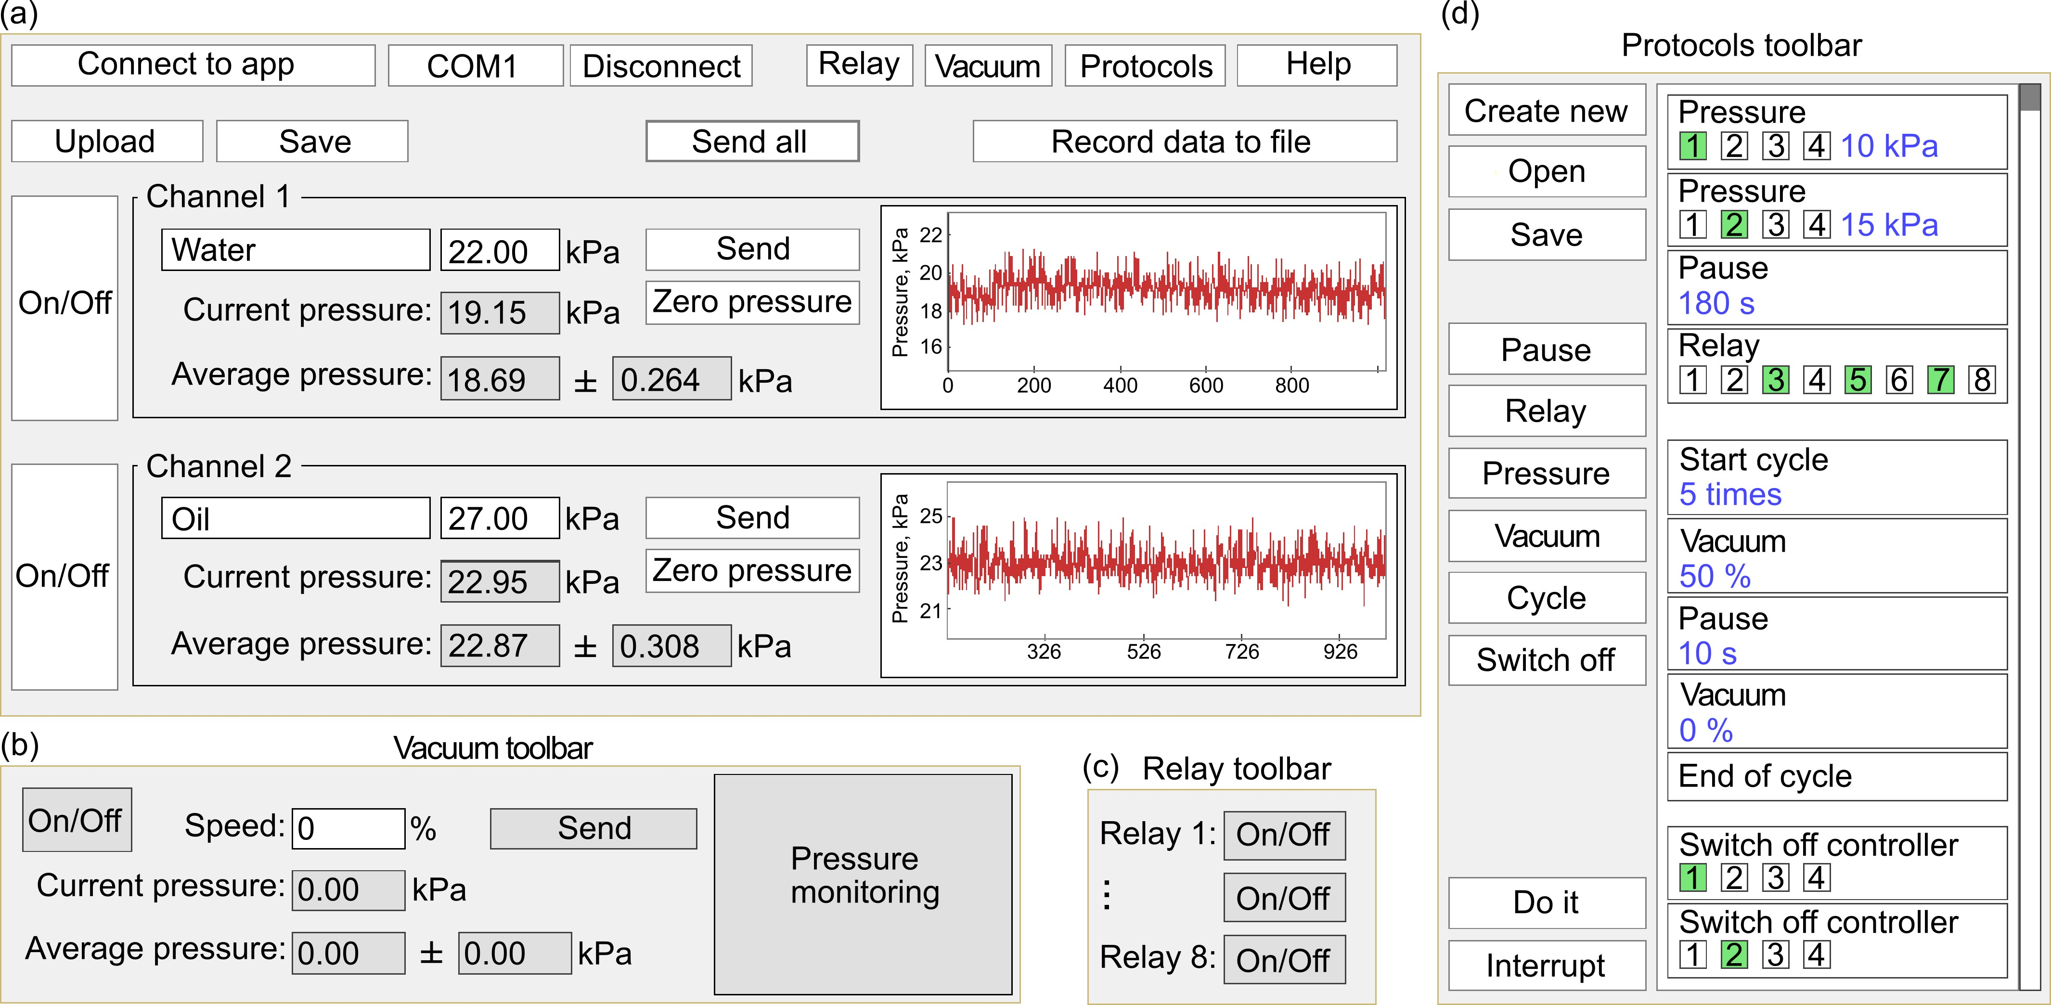

Figure 2 – The software interface of the microfluidics pressure controller. (a) Main window of the interface that allows to control and monitor pressures in each channel. (b) Toolbar for controlling the integrated vacuum pump. (c) Toolbar for controlling external devices via relay outputs. (d) Toolbar for writing sequences for experiment automation.

**Main menu** : figure 2 a

Connect to app:

Pressing the ”Connect to app” button establishes a connection to the pressure controller. Please note that disconnect occurs when you press the ”Disconnect/or Close” button.

Please note that when the application is launched, some of the buttons have a dark shade and cannot be pressed. This is a visual effect that the program has not estab- lished communication with the controller.

If the COM port is selected correctly, then after pressing the ”Connect to app”, such dark buttons will become

COM i:

Disconnect (or Close):

Relay: Vacuum: Protocols:

Help: Upload (or Load):

Save:

Send all: Record data to the file:

On/Off:

light and you can start controlling the controller.

If the COM port is incorrect, the connection will not be made and the dark buttons will not become active. However, it may happen that if the port is incorrect, and when you click on ”Connect to app”, the dark buttons will turn light - and you will not be able to control the controller - you need to click ”Disconnect/or Close”, enter the correct port and click on ”Connect to app” again (you may need to restart the program)

If the COM port is selected correctly, but you cannot manage the controller, most likely you need to check the com port and restart the program.

Enter the correct COM port to which the pressure con- troller is connected with a USB cable.

Pressing the button terminates communication with the controller.

Button to open the relay toolbar. Button to open the vacuum toolbar. Button to open the Protocols toolbar.

Help, Tips, Calibration, Debugging, Contacts.

Button for loading saved program settings from the save- file.

Button for saving all parameters of the program menu to a file: COM port number, signatures, pressures. The file will be saved in a folder with the Veterok.exe program.

Command for sending pressure values to all channels at once. Hot key - press ”Enter”.

Command for writing data from sensors to a file: pres- sure on all 4 channels, negative pressure from the vacuum pump, conditional time. The conditional time must be recalculated in real time, taking as a basis the time when the recording to the file began and the time when the recording was stopped. Recording stops when you press the button again, but a new recording starts immedi- ately. Also, the recording stops if you close the program or if you press ”Disconnect/or Close”.

The name of the recording file displays the date (year- month-day) and real time (hour:minute:second) of its creation. For example: data 2020-06-29 13-48-30.csv.

Enable / Disable ITV Pressure Controllers.

Channel 1,2,3,4:

Send Zero pressure

Graphic pressure sensor

Signatures to pressure channels. Below a caption there is a white field for entering the name of a channel, for example, ”disp.phase - water 1”.

Command to supply the set new pressure value. Command to supply zero pressure value (0 kPa).

It is a window where for each individual ITV controller

data channel a graph of pressures from a pressure sensor is displayed depending on a conditional time.

**Vacuum toolbar** : figure 2 b

On/Off Speed Send

Enable / Disable vacuum pump.

Text field for setting a pumping force in percent 0-100%. Command to supply the set new speed value.

**Relay toolbar** : figure 2 c

On/Off

Enable / Disable relay. A total of 8 relays can be con- trolled.

**Protocols toolbar** : figure 2 d

In the protocols menu, you can create an algorithm for the automatic operation of the microfluidic pressure con- troller yourself. Figure 2 d shows a sample code.

Create new

Open Save Pause Relay Pressure

Vacuum

Cycle Switch off

Do it Interrupt

Command to create a new protocol. Command to open saved protocol. Command to save protocol.

Pause operator.

Relay operator.

Pressure operator. You can select a channel or channels and set them a pressure value.

Negative pressure operator. You can set speed value of the vacuum pump.

Cycle operator. You can set the number of execution cycles. Required commands are placed inside the loop.

Command to power off one of pressure channels. Command to run the protocol.

Command to stop the protocol.

1. **Hardware****Adjustment**

## Calibration pressure sensors and adjustment ITV pressure rage

**Attention!** Further information for developers. Use it com- petently. Incorrect use can confuse instrument settings.

Calibration and adjustment an ITV pressure rage of the in- strument is performed in the Help menu of the application.

Please note that different ITV models (therefore different pressure ranges) can be built into a microfluidic pressure con- troller. For example, ITV0010 has 0.001 - 0.1 MPa output pressure range. ITV0030 has 0.001 - 0.5 MPa. Therefore, it must be observed that the range in the application (micro- controller firmware) matches the range of the installed ITV regulators.

Note that the instrument has a special DAC (digital to ana- logue converter) connection through a current limiting resistor, so the maximum value of a pressure range is never reached. Therefore, the ITV range must first be determined with an external measuring device.

Adjustment ITV pressure rage:

Note that DAC is powered by 5V, and operates in 5 volt range. In this case, the entire ITV pressure range can be used. But if you use the working range of DAC as 3.3V, then the accuracy of pressure regulation increases up to 2 times, but the pressure range is reduced and becomes about 66% of the total 2. For example, for 100 kPa, only up to 66 kPa can be used.

* + 1. Open the application **Veterok.exe**, press bottom ”Help” and find the button ”Calibration”.
    2. Set the maximum pressure value on the channel, which is allowed by the control panel of the controller and press the ”Send” button. This will supply the maximum volt- age value (maxP). Knowing this value of maxP in Pas- cals, calculate the coefficient using the formula maxP [Pa] / 4095 * 100.
    3. This coefficient must be specified for the corresponding channel through the calibration control panel: press the ”Calibration” button or go to this ”Calibration” window.

2 compare 12bit/5V with 12bit/3.3V

Calibration pressure

* + 1. Enter the coefficient in the appropriate field.
    2. Repeat instructions for other ITV regulators.

sensors: 1. Open the application **Veterok.exe**

* + - 1. Press bottom ”Help”
      2. Find and press the button ”Calibration”.
      3. Choose one of the pressure regulators.
      4. Connect the selected pressure output to the pneumatic input of the measuring device (water column, pressure gauge, vacuum gauge or other sensor).

ATTENTION! When calibrating using the height of the water column, be careful not to allow water to enter the pressure controller. Use an intermediate container of sufficient volume, where water will leak in case of an error, but not too large, so that the compressed air does not have a significant effect on the measured values. In the ”Calibration” menu, there is a handy calculator for working with the water column.

* + - 1. Open if closed the calibration control panel - press the button ”Calibration” in ”Help” menu.
      2. In the ”Calibration” control panel there is ”Configuring pressure sensors”, using the ”Request coefficients” but- ton, request the current coefficients that are saved in the device.

The coefficients sensA, sensB have the following mean- ing: p [Pa] = ADC x sensA + sensB

ADC can be an integer from 0 to 4095 - this is data from pressure sensors. The sensA and sensB coefficients are used to calculate the pressure in Pascals from the 12-bit ADC values.

Please note that for each analog pressure sensor in the documentation, some voltage conversion factors are in- dicated, which most often can be reduced to the form: y

= kx + b however, given that the device can use voltage dividers, it is not always possible to calculate specific factors sensA and sensB without experimental measure- ments.

* + - 1. If you are calibrating a new sensor:
         1. Set sensA = 1 [Pa/bit] and sensB = 0 [Pa], then the monitors will display just p = ADC, where ADC =

integer number from 0 to 4095. Take at least three different measurements (different pressure values) from the external sensor p [Pa] depending on ADC [0-4095]. Plot this graph and approximate it with a linear dependence (it is convenient to use OriginPro 8 or a later version). This will find the dependence p [Pa] = kx + b, or p [Pa] = ADC x sensA + sensB. In this way, the coefficients corresponding to the real ones sensA and sensB will be found. ATTENTION! To calibrate the coefficients more accurately, you can use measurements not by sensors, but by the readings of the water column in the capillary (note the warning above about water columns)

* + - * 1. Enter the found sensA and sensB in the menu ”Set- ting pressure sensors” in the fields corresponding to the output of the pneumatic interface (from top to bottom = 1 - 4 controller outputs, the 5th is the output of the vacuum pump). And click the ”Sub- mit” button below the fields and formulas. The pressure controller will show all values based on the new coefficient values.
        2. If you want to clarify the sensA and sensB coeffi- cients, then you should use the method of selection of values below:
      1. If the sensors have already been calibrated and you want to clarify the sensA and sensB coefficients, then you should use the method of selection of values below:
         1. Set the target pressure on the instrument control panel
         2. Calculate the difference between the pressure dis- played on the panel and the actual pressure that you measured with an external meter.
         3. The resulting difference must be added to the sensB coefficient, and then send it to the controller using the ”Send” button
         4. If the values start to coincide, then in this case save to the controller memory using the ”Flash” button.
         5. Steps 1-3 must be repeated several times for differ- ent pressures to ensure linearity over the operating range.

# Manual control of the device

The device can be controlled with the physical panel on the front part of the device box with or without a PC (personal computer) application.

**Control panel** : figure 1

Encoder:

Displays:

Zero pressure buttom:

Device has encoder to change settings. Simply twisting the encoder knob displaces the vertical band (a kind of indicator) from display to display.

If you leave a vertical band on the desired display and press the encoder, a second vertical band will appear on the left, which means that the display (device) is selected and values can be set. The values are set by rotating the encoder. To apply a value, you need to press the encoder and hold it for 3-5 seconds. To exit the selected screen, you just need to press the encoder 1 time.

Displays informing about target and current pressures. The current pressure is the pressure from the sensor. Also, a vertical band may appear on each display. If it is displayed on the right, it means that now the encoder pointer is on this display (device). If the vertical band is not displayed, then the encoder is pointing to another display (device). If vertical bands are displayed both on the left and on the right hands, then the display (device) is selected and you can operate it.

Pressure reset button to zero 0 kPa.

# Instrument assembly

If you wish, you can assemble such a pressure controller your- self.

All the designs, circuit diagrams, and software are pub- lished on [GitHub](https://github.com/microfluidic-pressure-controller) (https://github.com/microfluidic-pressure- controller).

In brief, the following is a description of the main subassem- blies.

The main components of the device is shown in the Table I. Table I.

|  |  |  |  |
| --- | --- | --- | --- |
| Description | Producer and country | | Qty |
| ITV 0010 / ITV 0030 | SMC Pneumatics, Japan | | 4 |
| IITV00-04 manifold | SMC Pneumatics, Japan | | 1 |
| SMC KQB2E04-00 fitting | SMC Pneumatics, Japan | | 5 |
| SMC KQB2E06-00 fitting | SMC Pneumatics, Japan | | 1 |
| Development board Diymore  STM32F4 | Fancy Module, China | | 1 |
| MCP4725 digital-to-analog con-  verter | Microchip  USA | Technology, | 4 |
| MPX5050GP / MPX5700GP pres-  sure sensors | Freescale  tor, USA | Semiconduc- | 4 |
| MPX2200DP vacuum sensor | Freescale  tor, USA | Semiconduc- | 1 |
| 0,96 inch OLED monochrome dis-  plays with SSD1306 driver | WinWin, China | | 5 |
| Vacuum pump Kamoer KVP8  PLUS-KJ-S 24V 9W | Kamoer, China | | 1 |
| Darlington transistor arrays Texas  Instruments ULN2803A | Texas Instruments, USA | | 1 |
| Step-down switching regulator  Texas Instruments LM2596T | Texas Instruments, USA | | 1 |
| Encoder PEC16-4220F-S0024 | Bourns, USA | | 1 |
| Power supply MEAN WELL DR-15-  24 15W 24V 630mA | Mean Well Enterprises  Co, Taiwan | | 2 |
| DC-DC step-down voltage regulator  LM2596 | Advanced Tech, China | | 1 |
| Linear regulator Texas Instruments  LM7805 | Texas Instruments, USA | | 2 |
| Modeling plastic Necuron 840 | NECUMER GmbH,  Germany | | 0.5 *m*2 |
| Laser cutting service | LaserPro, Krasnoyarsk,  Russia | | 1 |

The following are node diagrams.

The thumbnail image of the microcontroller trace layout is shown in the figure 3.

The initial data see the [link](https://github.com/microfluidic-pressure-controller) (https://github.com/microfluidic- pressure-controller).

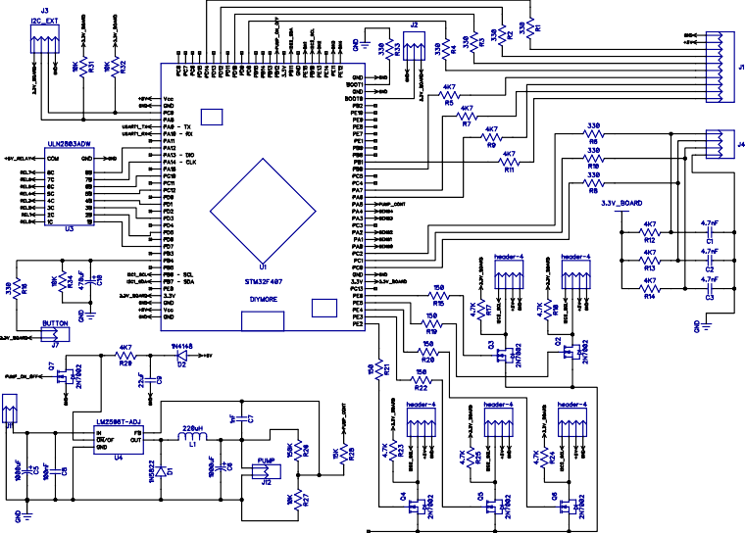

Figure 3 – Microcontroller trace layout.

The thumbnail image of power and control trace layout is shown in the figure 4.

The initial data see the [link](https://github.com/microfluidic-pressure-controller) (https://github.com/microfluidic- pressure-controller).

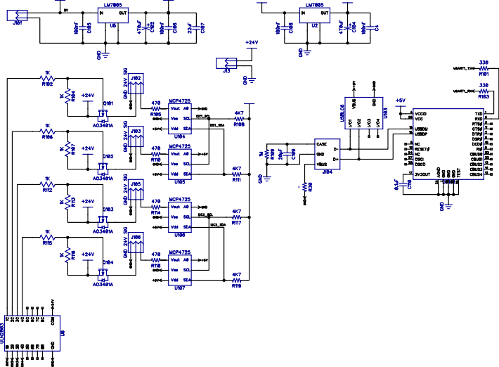

GND BODY GND BODY

Figure 4 – Power and control trace layout.

The thumbnail image of relay and sensors trace layout is shown in the figure 5.

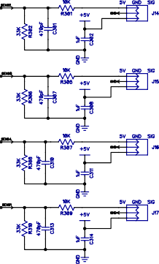The initial data see the [link](https://github.com/microfluidic-pressure-controller) (https://github.com/microfluidic- pressure-controller).



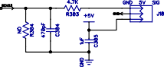Figure 5 – Relays and sensor trace layout.

For convenience, the 3D model of the controller PCB (printed circuit board) with elements is shown in the figure 6.

bootloader activation

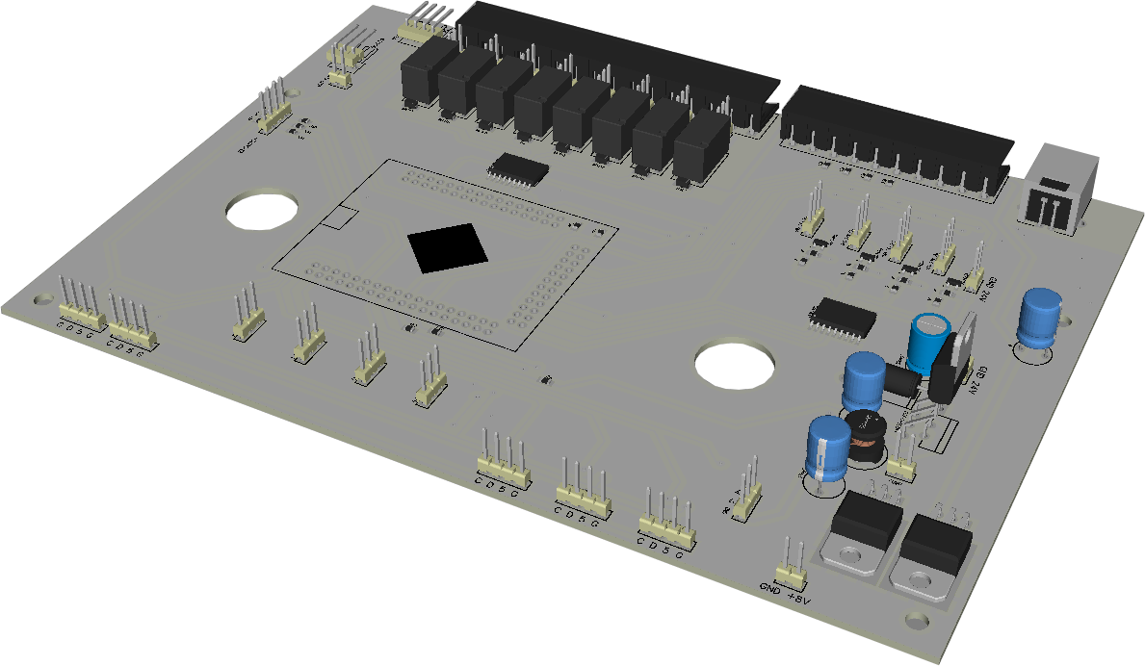

I2C bus

contacts

connectors for ITV controllers

button encoder

STM32F4

connect

for 8 relays

4 digital inputs

4 analog inputs

USB

connect 1-2 OLED displays

pressure

pump

sensors 1-4

connect 3-4

OLED displays

pressure sensor 5

Figure 6 – The 3D model of the controller PCB with elements.

The figure 7 shows a general diagram of the functioning of the microfluidic pressure controller.

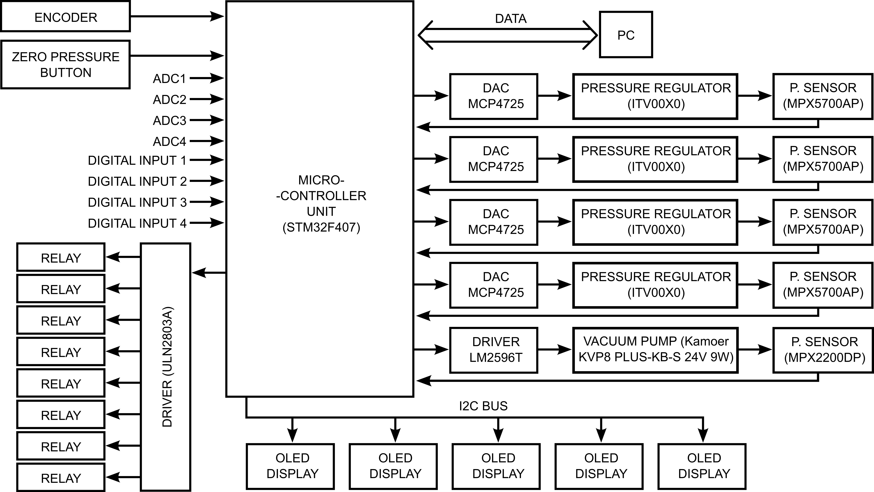

Figure 7 – The electric circuit diagram of the pressure controller.

Scheme for wiring diagram for pneumatic pipes, sensors, vac- uum pump, etc. is shown in the figure 8.

The initial data see the [link](https://github.com/microfluidic-pressure-controller) (https://github.com/microfluidic- pressure-controller).

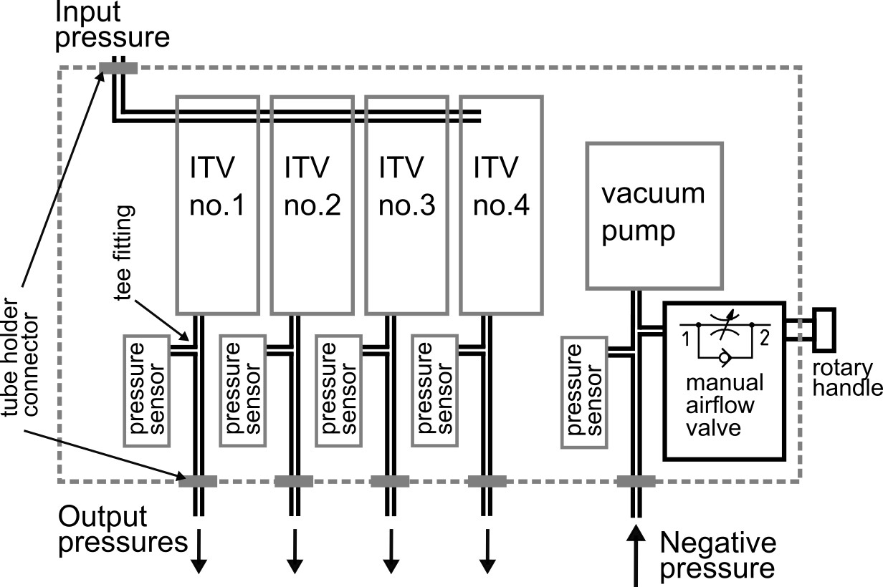

Figure 8 – Scheme for wiring diagram for pneumatic pipes, sensors, vacuum pump, etc.

The internal overview of the components of the microfluidic pressure controller is shown in figure 9, 10.

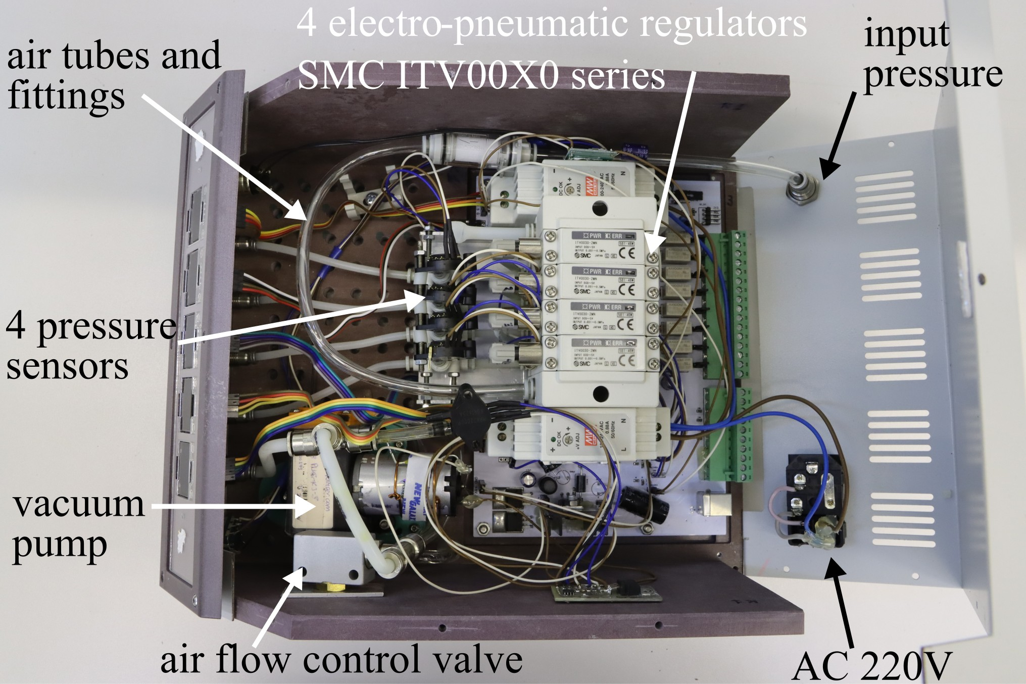

Figure 9 – The internal overview of the components of the microfluidic pressure controller: top view.

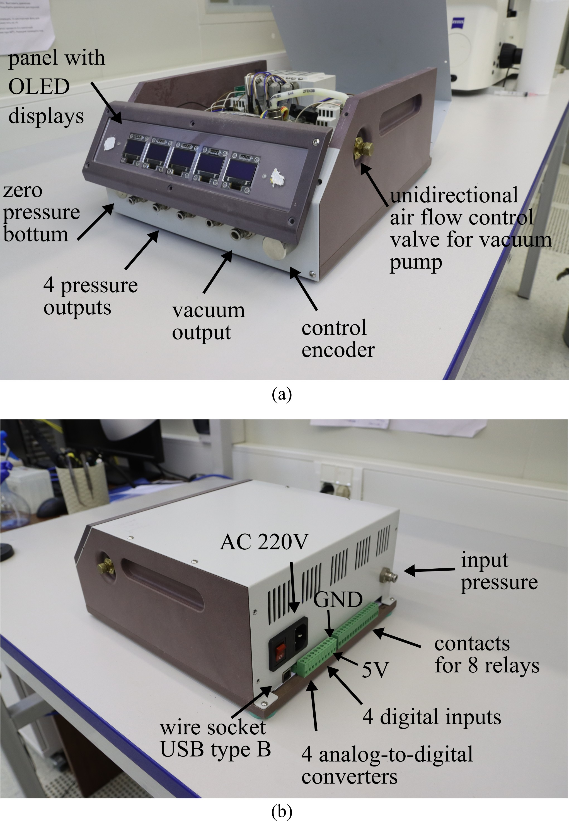

Figure 10 – The internal overview of the components of the microfluidic pressure controller: (a) side view; (b) back view.

The maket of panel around OLED displays is shown in figure 11.

The way to prepare the panel: 1) print, 2) check the dimen- sions, 3) adjust the dimensions if not suitable and print again,

4) cut out windows for displays, 5) laminate on both sides 6) glue to the body.

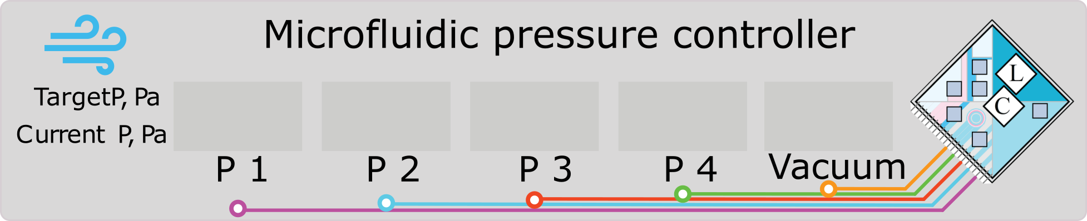

Figure 11 – The maket of panel around OLED displays.

The upper part of the case is made by bending a metal sheet.

The size information is at the [link](https://github.com/microfluidic-pressure-controller) (https://github.com/microfluidic- pressure-controller).

The figure 12 shows a 3D sketch of the result of metal pro- cessing.

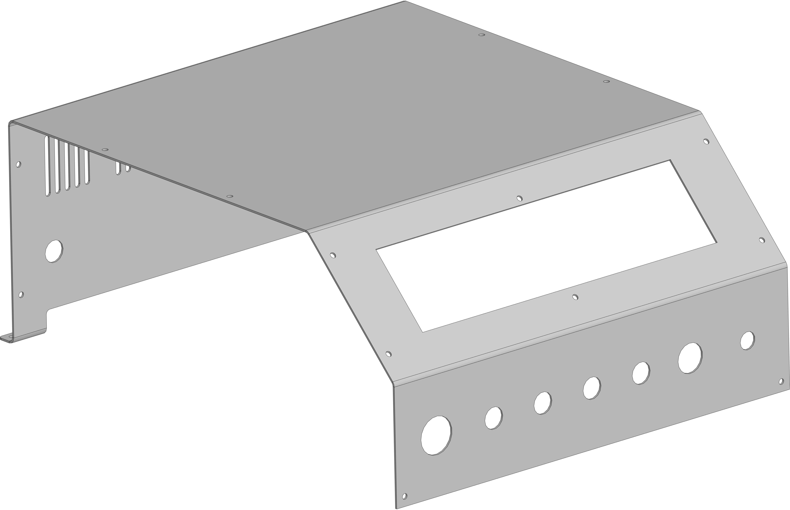

Figure 12 – The maket of panel around OLED displays.

# ATTENTIONS

Vacuum pump : If you set such a power that will stop the pump, it may overheat and fail. The device is equipped with protec- tion against fire (a thermal fuse is attached to the pump motor), however, system operation is irreversible with- out repairing the device (replacing the thermal fuse).