7: Isolation of an Antibiotic Producer from soil
Learning Objectives
To determine the variety of organisms that live in soil.
To identify an antibiotic producer in the above population.
To determine if the antibiotic made by the antibiotic producer kills bacteria.

Soil is the major reservoir of microorganisms that produce antibiotics.Considering that soil is densely packed with microorganisms, it is not a wonder that many bacterial and fungal species have evolved over the eons to develop ways of inhibiting their neighbors for the benefit of their own growth. An antibiotic made by a microbe can inhibit many other soil microbes. The bacterial genera Bacillus and Streptomyces along with the fungal genera Penicilium and Cephalosporium are commonly found in soil. The genus Streptomyces are the most prolific antibiotic producers and, although bacteria, are a unique subgroup of bacteria called the Actinomycetes. Although soil has historically been used to find new antibiotic producers, at present many of the ‘old’ antibiotics are now being manipulated in the lab and chemical modified to form new versions of older antibiotics.
In this experiment you will try to isolate an antibiotic producing bacterium or fungus from the soil. If you succeed at that you will then test that isolate to determine what organisms might be inhibited by the antibiotic that it makes. Because we want to isolate both bacterial and fungal antibiotic producers, two different kinds of media will be used. Glycerol yeast extract media is for isolation of Streptomyces, while Saboraud dextrose agar medium will be used for the isolation of the fungi. One-half of the groups will look for bacterial isolates and the one half will be looking for fungal isolates.
Note
You need to bring a soil sample for this class. An area around trees or bushes, or flowers. Dry, sun-baked soil is not the best sample. You need only a gram of specimen.

MATERIALS NEEDED
1st session
A bottle of 0.9% NaCl Balance/weigh boat/spatula
1ml and 10ml pipets, plus a pi-pump or propipet bulb Screw-cap test tubes and caps
4 Glycerol yeast agar plates or Saboraud yeast agar plates Glass or plastic spreaders for making spread plates
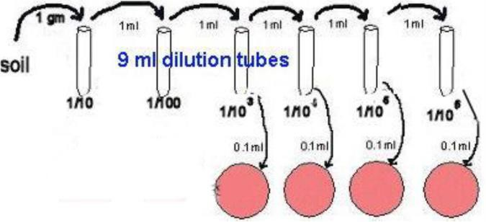
2nd Session
- TSA plates for pick/patch
- Toothpicks
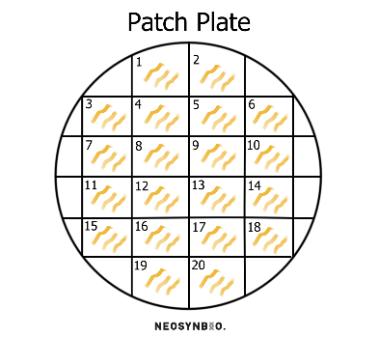
3rd session
2 liquefied TSA deeps Vortex mixer
1 ml pipets and bulb/pi-pump 45º-50ºC Water bath
Broth cultures of Staphylococcus epidermidis and E.coli

THE PROCEDURE
1st Session
- Bring a specimen of soil from any location.
- Weigh out 1 gram of soil.
- Obtain 4 plates of the appropriate agar medium (depending on whether your group is searching for bacteria or fungi). Label these plates 1/103 through 1/106.
- Set up a series of 1/10 dilutions:
  - Place 6 test tubes into a rack and fill each with 9ml of 0.9% NaCl solution.
  - Place the gram of soil into the first tube with saline and SHAKE WELL.
  - Let the soil particles settle after shaking and then transfer 1ml of the solution into tube 2. This is your 1/10 dilution.
  - Repeat the above step for tubes 2-6, changing 1 ml pipets between each transfer. Be sure TO SHAKE EACH TUBE WELL before transferring into the next tube. These tubes will be dilutions of 1/102, 1/103, 1/104, 1/105,and 1/106..
- Place 0.1ml of the 1/103 dilution onto the top of the appropriate agar. Place the spreader into the alcohol solution and then stick it into the flame to catch it on fire. DO NOT HOLD THE SPREADER IN THE FLAME. When the fire is out, you have a sterile spreader. Place the spreader on the agar with the 0.1ml sample and spread the sample all over the agar medium.
- Your plates will be made from the 1/103 through 1/106 dilutions.
- Incubate the plates at 30ºC until the next lab session. If you do not have sufficient colony numbers, re-incubate the plates and carry on the exercise at next period after.
2nd Session
Part A
- Calculate the CFUs/cell counts for 1 gram of soil (for your soil sample).
- Inoculate each of 2 liquified TSA deeps, one with with 1ml of Staph epidermidis broth culture and the other with 1ml of E.coli. broth culture.
- Mix each tube well (hand shake or use vortex mixer) and then pour the entire contents of each tube into a sterile petri dish. Slowly swirl the dish around to make sure the liquefied agar is evenly spread over the bottom of the petri dish.
- Let the media solidify in the dishes.
Part B- Create a Patch Plate
- Choose 20 well-isolated colonies from your soil plates. Circle these and number them on the base of the plate.
- Using an agar plate containing the appropriate media, divide the plate into patches, using a square grid (5 x 5). Label twenty of the squares with numbers 1 to 20. (see diagram above).
- Using a toothpick, pick up some growth from the colony of your first isolate of interest. Make sure you can see some cells on the tip, but you don’t need a lot (approx 1 mm3 = 1 µl).
- Transfer the growth onto the first patch on your agar plate, by scratching the tip across the surface of the agar a few times (e.g. make a set of three closely-spaced parallel lines – see diagram). Stay well clear of the borders of each square, we don’t want the isolates to touch each other when they grow up. Then discard the toothpick.
- Repeat steps 3 and 4 with the remaining (n) clones, being very careful to keep track of which colony and which patch you are up to (this is why labelling before you start is important!).
- Incubate the patch plate overnight at 37°C.
3rd Session
- From your primary pick/patch plates, choose a colony that looks like it might be Bacillus, Streptomyces, or a fungus. Circle the colony so you can find it again: you will use that organism against both Staph and E. coli.
- Using your sterile inoculating NEEDLE, pick up a SINGLE colony and inoculate the solidified Staph-seeded pour plate using the sectional streak plate technique. The reason for using the needle is that it is easier to pick mold hyphae/filaments than a loop.
- Repeat step 5 again with the E. coli-seeded plate, using the same colony as used in step 4.
- Incubate the plates at 30C until the next lab session.
4th Session
- Examine the 2 plates for evidence of inhibition of Staph epidermidis and E. coli. growth. IF you see inhibition, you have probably isolated an antibiotic producer.

QUESTIONS
- How does a colony of Streptomyces differ from a colony of Penicillium?
- How many different microorganisms did you see in your soil sample?

Contributors
Jackie Reynolds, Professor of Biology (Richland College)

7: Isolation of an Antibiotic Producer from soil is shared under a not declared license and was authored, remixed, and/or curated by LibreTexts.

