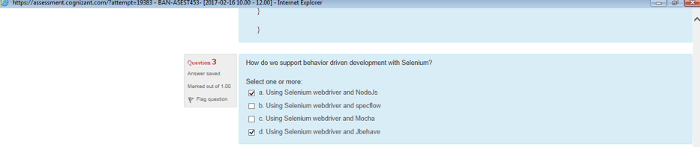

Ans: b and d

<https://www.packtpub.com/books/content/behavior-driven-development-selenium-webdriver>

* Using Cucumber-JVM and Selenium WebDriver in Java for BDD
* Using SpecFlow.NET and Selenium WebDriver in .NET for BDD
* Using JBehave and Selenium WebDriver in Java
* Using Capybara, Cucumber, and Selenium WebDriver in Ruby

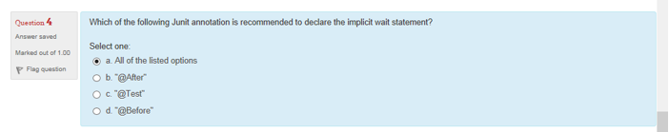

Ans: c

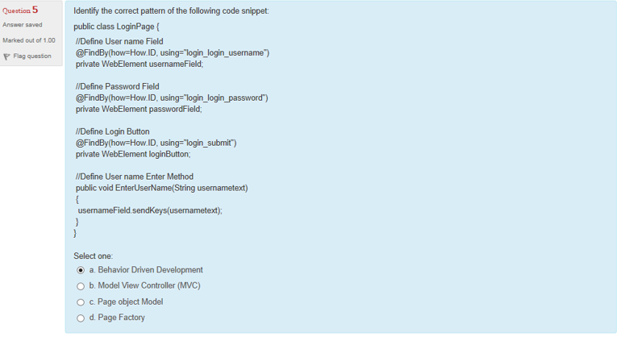

Ans: d

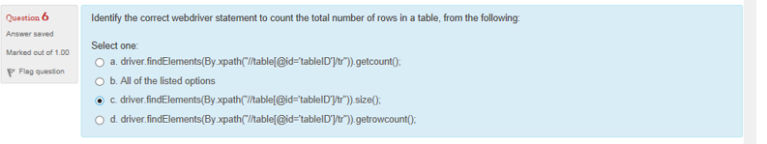

Ans : c

int rowCount=driver.findElements(By.xpath("//table[@id='DataTable']/tbody/tr")).size();

<http://stackoverflow.com/questions/14831041/how-to-count-no-of-rows-in-table-from-web-apllication-using-selenium-python-webd>

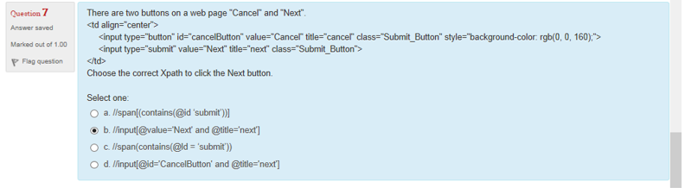

Ans: b

//input[@value='Next' and @title='next']

<http://stackoverflow.com/questions/8871654/how-to-press-click-the-button-using-selenium-if-the-button-does-not-have-the-id>

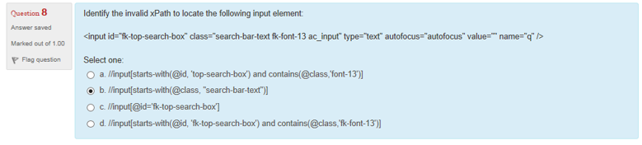

Ans: a

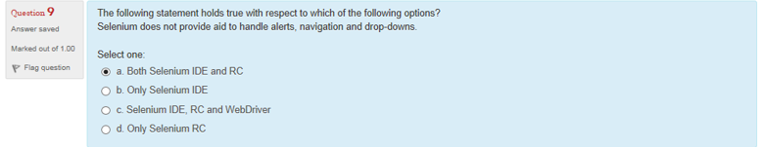

Ans: a

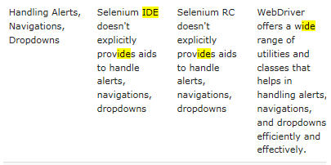

<http://www.softwaretestinghelp.com/selenium-interview-questions-answers/>

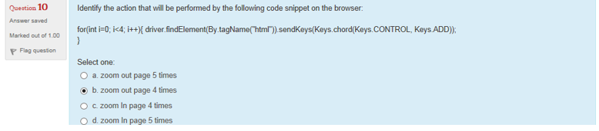

Ans: b

For(int i=0;i<4;i++) { driver.findElement(By.tagName(“html”)).sendKeys(Keys.chord(Keys.CONTROL,Keys.ADD)); }

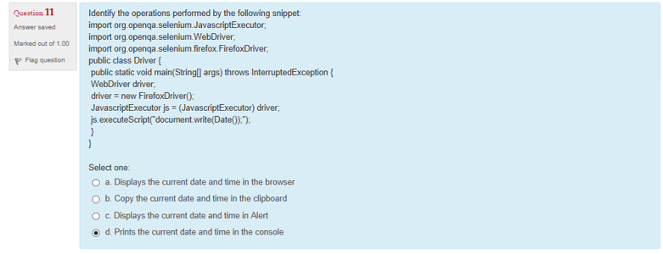

Ans: a

JavascriptExecutor js=(JavascriptExecutor)driver; js.executeScript(“document.write(Date()):”);

Java code is not displayed on the console. Displayed on browser

+++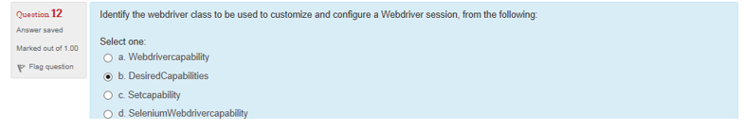

Ans: b

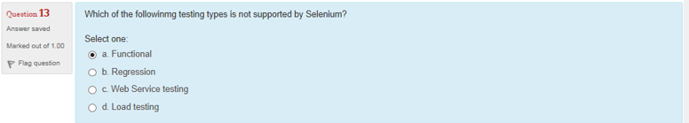

Ans: c

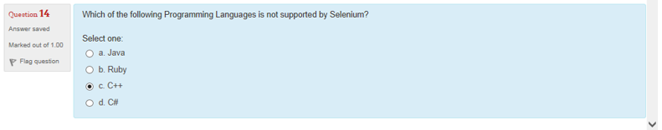

Ans: c

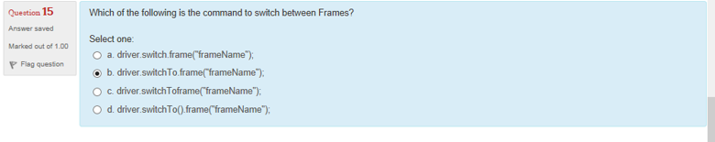

Ans: d

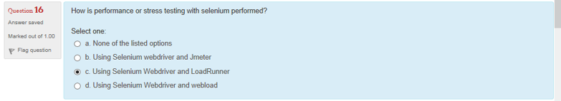

Ans: b

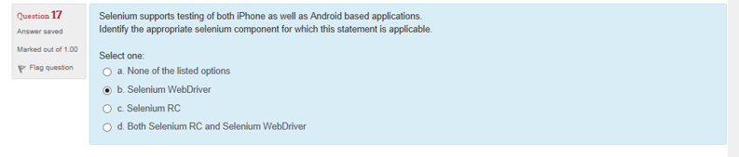

Ans: b

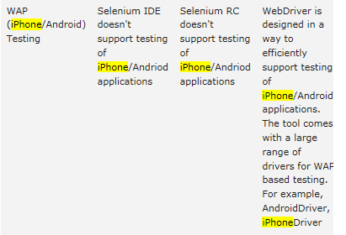

<http://www.softwaretestinghelp.com/selenium-interview-questions-answers/>