**Code:**

**Selenium basics:**

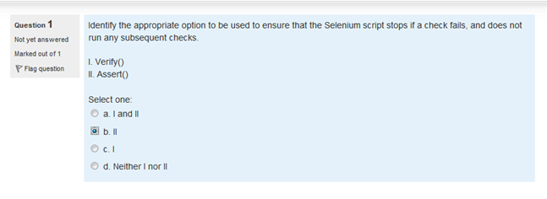**Ans: b.**

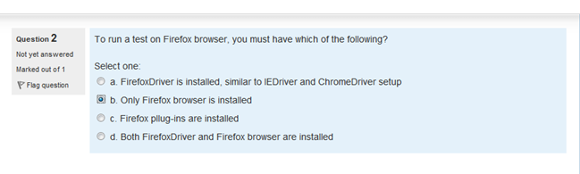**Ans: b.**

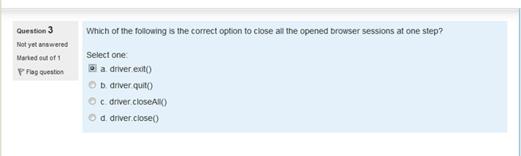**Ans: driver.quit()**

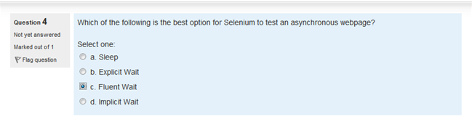**Ans: Explicit wait**

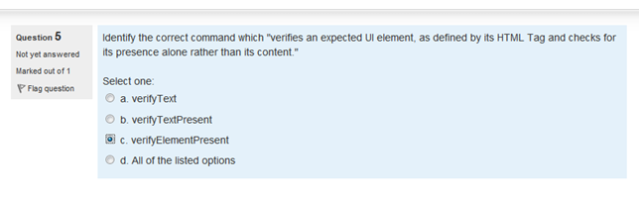**Ans: c.**

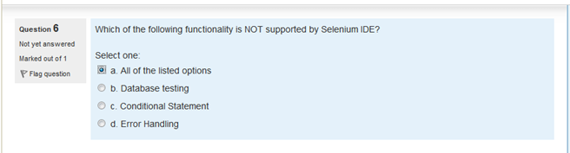**Ans: a.**

**+ iteration or looping, logging and reporting of test results, test case grouping, re-execution of failed tests, test case dependency, capture screenshots on test failures, results report generations**

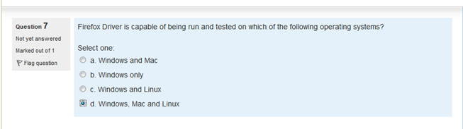**Ans: d.**

**Firefox Driver is capable of being run and is tested on Windows, Mac, Linux.**

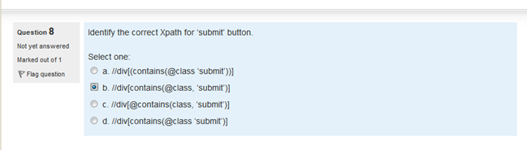**Ans: b.**

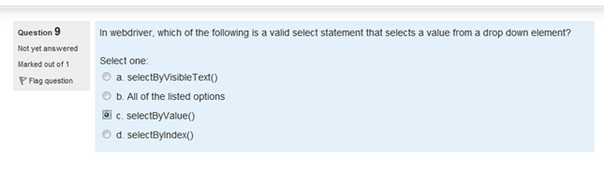**Ans: all of the listed (b)**

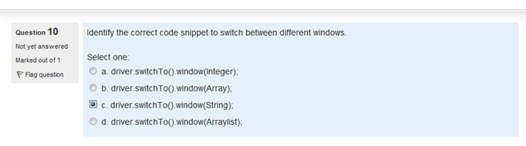**Ans: c.**

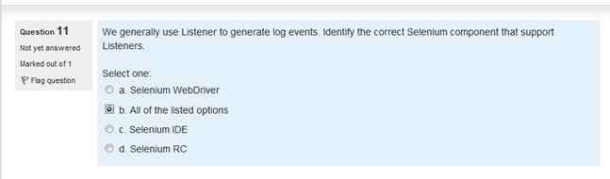**Ans: a.**

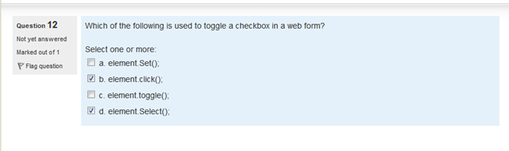**Ans: b**

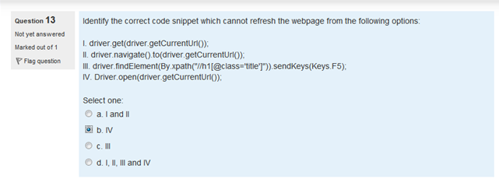**Ans: b.**

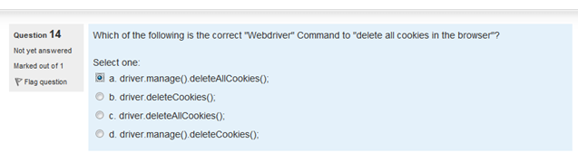**Ans: a.**

**------**

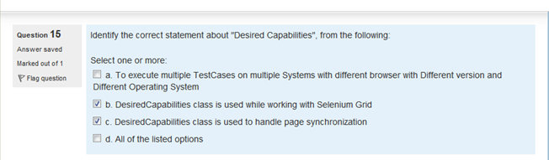**Ans: a & b.**

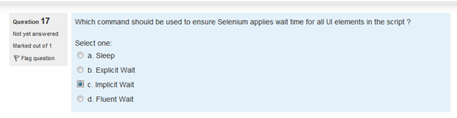**Ans: implicit**

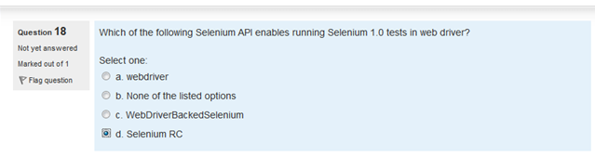**Ans: c**

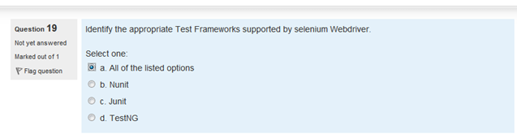**Ans: a)**

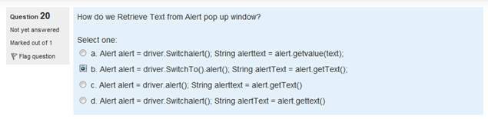**Ans: b.**

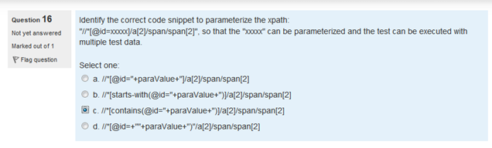**Ans: c**

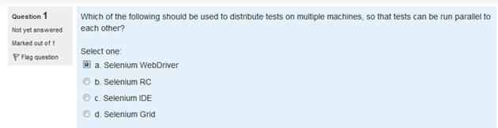**Ans: Selenium Grid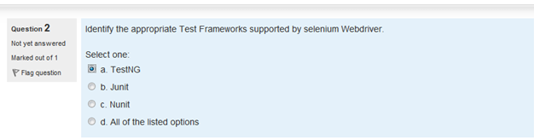 Ans: All options 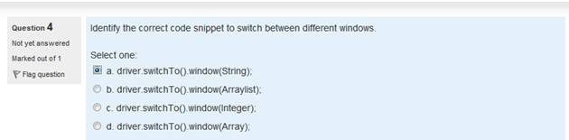Ans: a.**

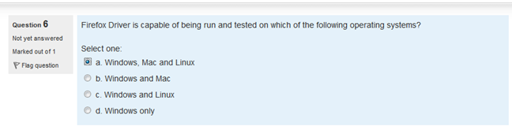**Ans: a.**

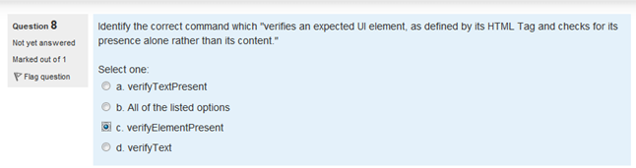**Ans: c.**

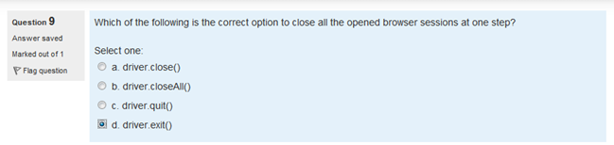**Ans: driver.quit()**

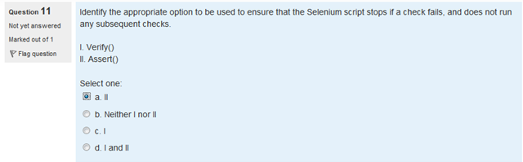**Ans: a. 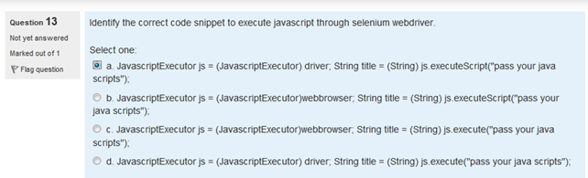Ans: a.**

**if (driver instanceof JavascriptExecutor) {**

**((JavascriptExecutor) driver)**

**.executeScript("alert('hello world');");**

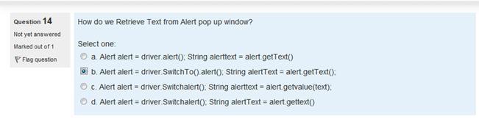**Ans: b.**

**// Get a handle to the open alert, prompt or confirmation  
Alert alert = driver.switchTo().alert();**

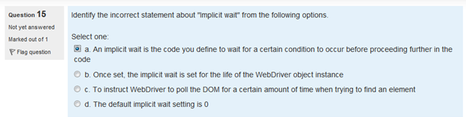**Ans: a.**

*An implicit wait is to tell WebDriver to poll the DOM for a certain amount of time when trying to find an element or elements if they are not immediately available. The default setting is 0. Once set, the implicit wait is set for the life of the WebDriver object instance.*

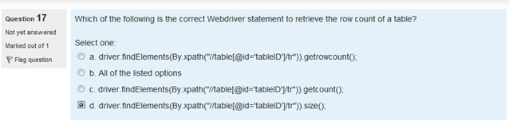**Ans: d.**

**int rowCount=driver.findElements(By.xpath("//table[@id='DataTable']/tbody/tr")).size();**

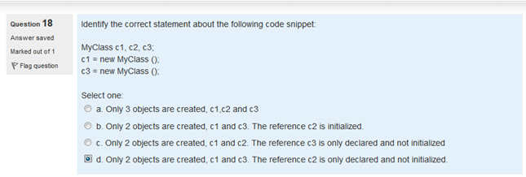**Ans: d.**

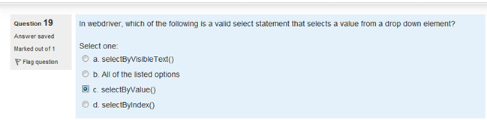**Ans: b**

**dropdown.selectByValue("prog");**

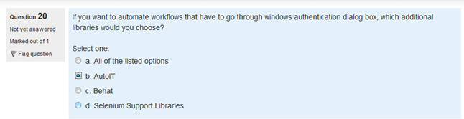**Ans: b.**

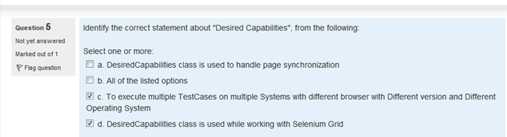**Ans: c. & d.**

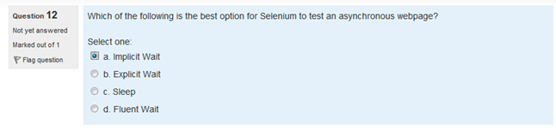**Ans: b**

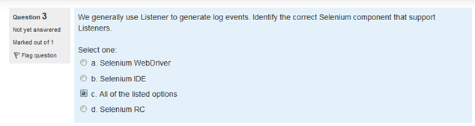**Ans: a 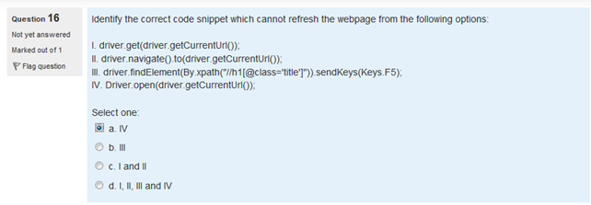Ans: a.**

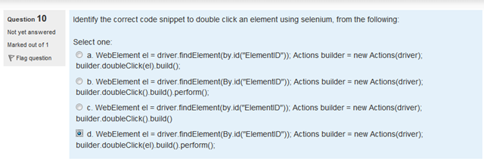**Ans: d.**

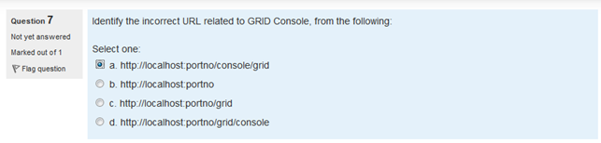**Ans: a**

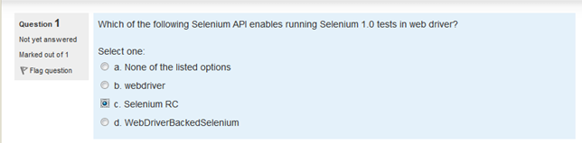**Ans: d**

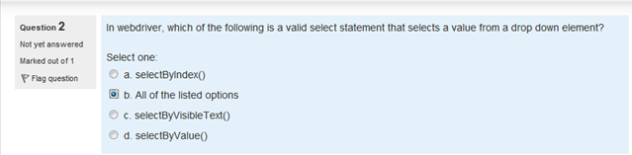**Ans: b**

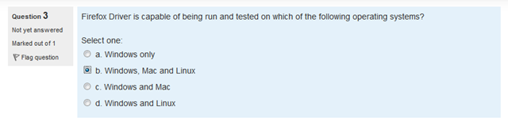**Ans:b.**

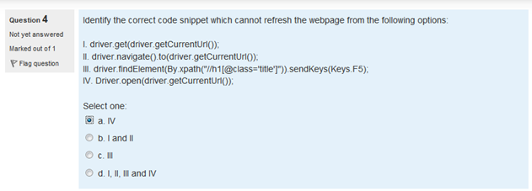**Ans: a.**

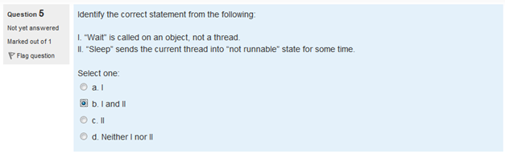**Ans: b. 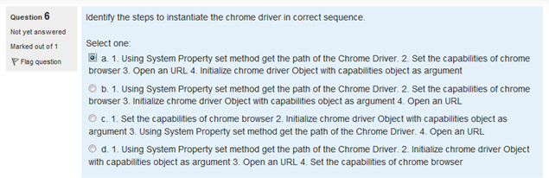Ans: b 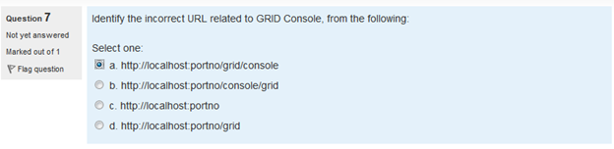Ans: b**

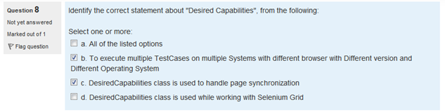**Ans: b & d**

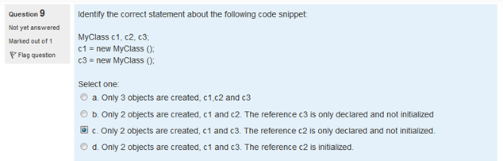**Ans: c. 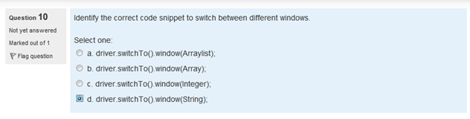Ans: d. 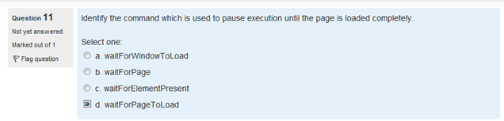Ans: d.**

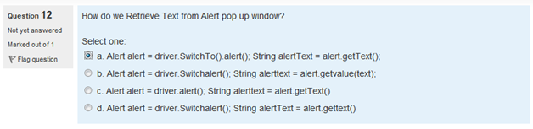**Ans: a.**

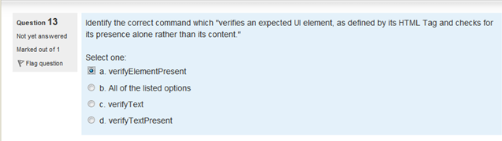**Ans: a, UI wait- implicit wait 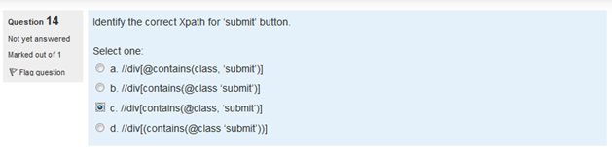Ans: c. 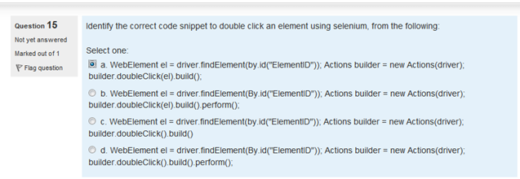Ans: d.**

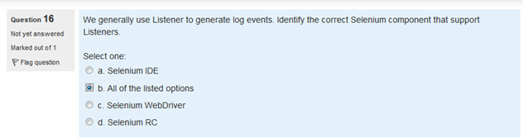**Ans: c.**

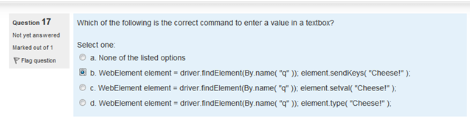**Ans: b.**

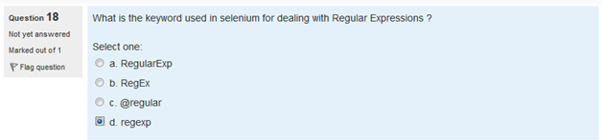**Ans: d. 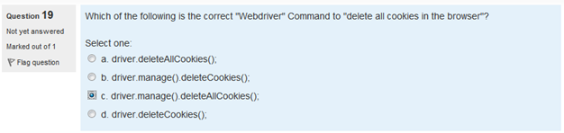Ans: c.**

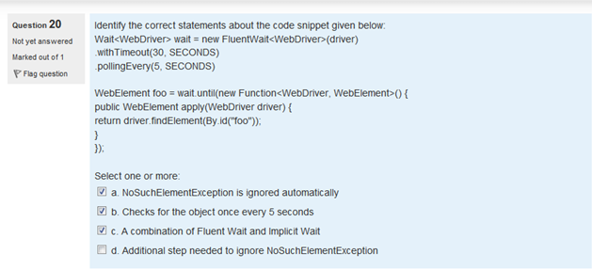**Ans: b and d**

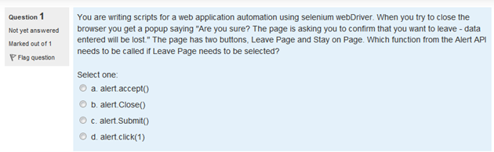

**Ans: a.**

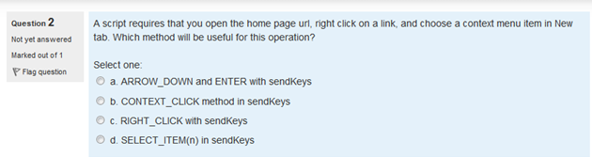

**Ans: unknown.b**

To select the item from the contextual menu:

action.contextClick(productLink).sendKeys(Keys.ARROW_DOWN).sendKeys(Keys.ARROW_DOWN).sendKeys(Keys.RETURN).build().perform()

**A script requires that you open the home page url, right click on a link and choose a context menu item in New tab.Which method will be useful for this operation?**

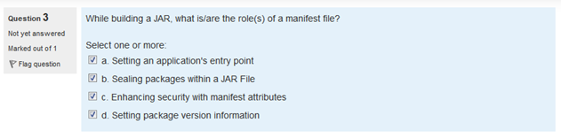**Ans: All of the above(Correct)**

**While building a JAR. What is/are the roles of the manifest file?**

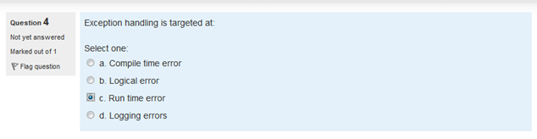**Ans: c.**

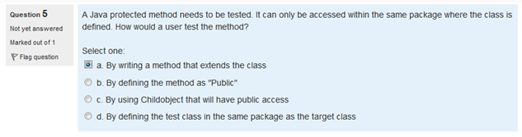**Ans: unknown(d)**

**A java protected method needs to be tested. It can only be accessed within the same package where the class is defined. How would a user test this method?**

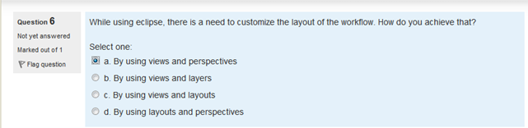**Ans: a. (not sure)(correct)**

**https://courses.cs.washington.edu/courses/cse143/15wi/eclipse_tutorial/customize_view.shtml**

**While using eclipse, there is need to customize the layout of the workflow. How do you achieve that?**

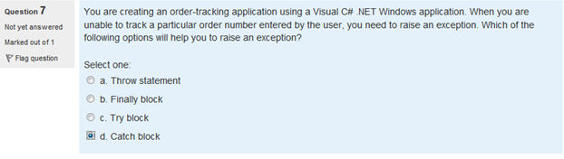**Ans: d. (not sure) (a) throw statement**

**http://www.pearsonitcertification.com/articles/article.aspx?p=98149&seqNum=5**

**You are creating an order-tracking application using a Visual C#.NET Windows application.When you are unable to track a particular order number entered by the user,you need to raise an exception.Which of the following options will help to raise an exception?**

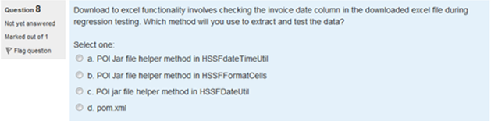**Ans: d. (not sure)** guess c

**Download to excel functionality involves checking the invoice date column in the downloaded excel file during regression testing.Which method will you use to extract and test the data?**

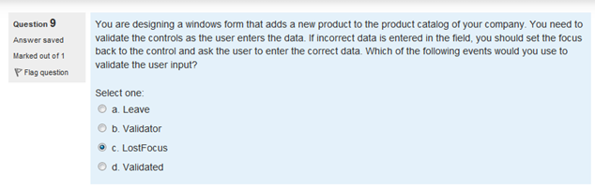

**Ans: unknown(b)**

**You are designing a windows form that adds a new product to the product catalog of your company.You need to validate the controls as the user enters the data. If incorrect data is entered in the filed,you should set the focus back to the cotrol and ask the user to enter the correct data.Which of the following events would you use to validate the user input?**

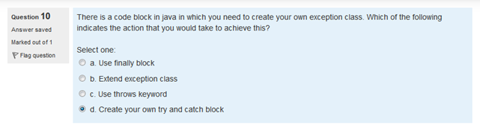**Ans: d. (not sure)(b) Extend exception class**

**http://www.java2novice.com/java_exception_handling_examples/create_custom_exception/**

**There is a code block in Java in which you need to create your own exceotion class.Which of the following indicates the action that you would take to achieve this?**

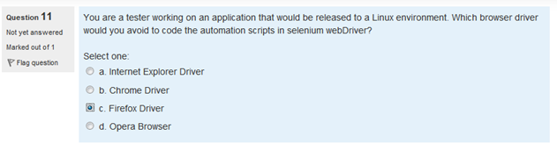**Ans: c. (not sure)**

**You are a tester working on an application that would released to a LINUX envinorment.Which browser driver would you avoid to co de the automation scripts in the selenium webdriver?**

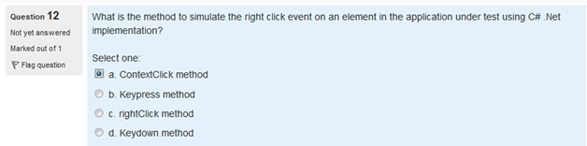**Ans: a. (not sure)** Correct

**What is the method to simulate the right click event on an element in the application under test using C#.Net implentation?**

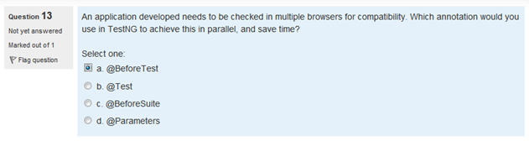**Ans: b. 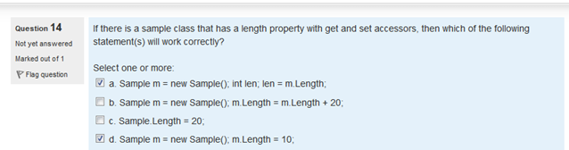Ans: a & d (not sure)(a,b,d)**

**http://www.indiaparinam.com/c-sharp-programming-language-question-answer-properties**

**If there is a sample class that has a length property with get and set accessors, then which of the following statement(s) will work correctly?**

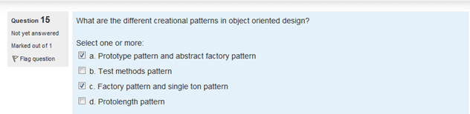

**Ans: unknown(a,d)**

**What are the different creational patterns in the object oriented design?**

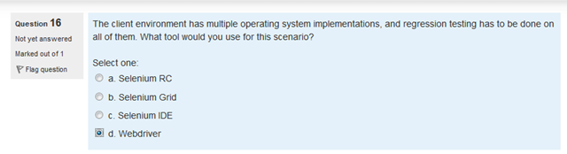

**Ans: unknown**

**The client environment has multiple operating system implementations and regression testing has to be done on all of them.What tool would you use for this scenario?**

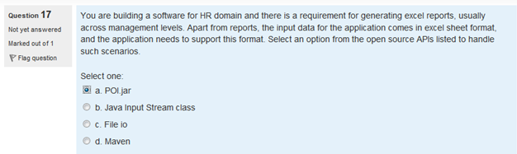 **Ans: unknown**

**You are building a software for HR domain and there is a requirement for generating excel reports,usully across managements levels.apart from reports,the input data for the appllication comes in excel sheet format and the application needs to support this format.Select an option from the open source APIs listed to handle such scenarios**.

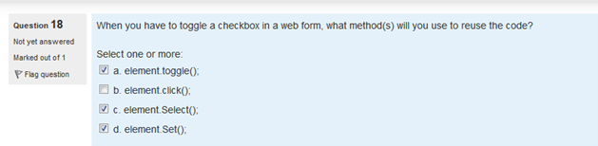 **Ans: unknown**

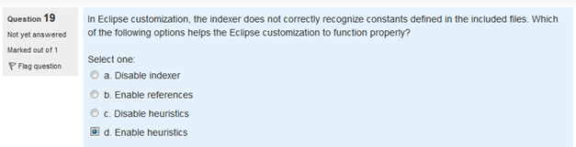 **Ans: unknown**

**In eclipse customizations,the indexer does not correctly recognize constants defined in the inckuded files.Which of the following options help the eclipse customizantions to function properly?**

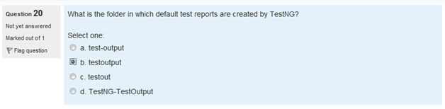 **Ans: a.**

