HDFS: Architecture

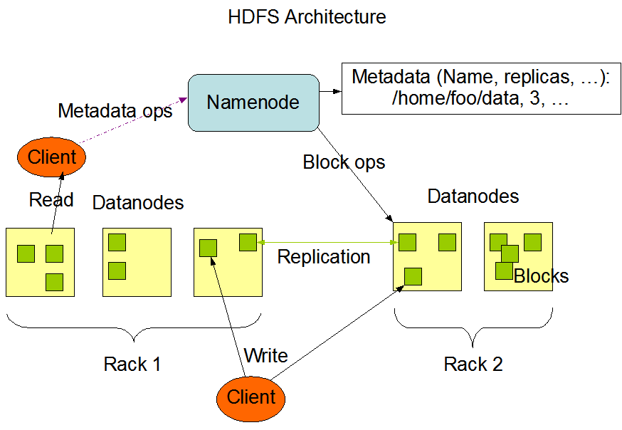

|  |  |  |
| --- | --- | --- |
| **Nodes:**   * NameNode * Stanby/ Secondary NameNode * Checkpoint Node * Backup Node * DataNode | Client protocol  Datanode protocol | HDFS clients:   * Java API * C Wrapper over Java API * REST API * Through Browser – to browse filesystem * FS Shell (targeted for applications that need a scripting language to interact with the stored data) * DFSAdmin (command set is used for administering an HDFS cluster) |
| Hadoop – has internal web server for heartbeat monitoring  SSL – password less login | HDFS Features:   * File Permissions introduced * Space quota * Rack awareness * NFS Gateway support for mounting HDFS as local file system   Append to file is allowed, modification is not allowed |
|  |  |  |

### [Try Hadoop Online with Cloudera Live - Cloudera VISION](https://vision.cloudera.com/cloudera-live/)

### [The fastest and easiest way to learn Hadoop - Cloudera](https://www.cloudera.com/get-started/cloudera-live.html)

|  |  |
| --- | --- |
| 6 down vote | If you want to learn about Hadoop and Bigdata, look into [bigdatauniversity.com](http://bigdatauniversity.com/). Its free and they give instructions on how to install Hadoop locally on a virtual machine and/or in Amazon's Web Services. BigDataUniversity provides labs and instructions to help guide your practice. I found it helpful so far. |

<https://www.quora.com/How-can-I-practice-Hadoop-programs-online-for-free-Is-there-any-free-cloud-service-that-provides-Hadoop-platform-along-with-sample-data-to-play-with-I-want-to-submit-map-reduce-code-there-and-get-the-results-Is-there-any-such-service-available>

# How can I practice Hadoop programs online for free? Is there any free cloud service that provides Hadoop platform along with sample data to play with? I want to submit map-reduce code there and get the results. Is there any such service available?

15 Answers

[Shubham Sinha](https://www.quora.com/profile/Shubham-Sinha-202)

[Shubham Sinha](https://www.quora.com/profile/Shubham-Sinha-202), Big Data and Hadoop Enthusiast

[Answered May 5](https://www.quora.com/How-can-I-practice-Hadoop-programs-online-for-free-Is-there-any-free-cloud-service-that-provides-Hadoop-platform-along-with-sample-data-to-play-with-I-want-to-submit-map-reduce-code-there-and-get-the-results-Is-there-any-such-service-available/answer/Shubham-Sinha-202)

First I would suggest you to setup your own VM with [***Hadoop single node cluster***](https://www.edureka.co/blog/install-hadoop-single-node-hadoop-cluster?utm_campaign=install-hadoop-single-node-hadoop-cluster-050517-ss&utm_medium=crosspost&utm_source=quora) or [***multi node cluster***](https://www.edureka.co/blog/setting-up-a-multi-node-cluster-in-hadoop-2.X?utm_campaign=setting-up-a-multi-node-cluster-in-hadoop-2.X-050517-ss&utm_medium=crosspost&utm_source=quora) based on your system resources. You can also go through this Hadoop installation video.

Now that you have installed Hadoop on your system. You can download data from various sources to start playing with your Hadoop VM:

* [Open Government Data (OGD) Platform India](https://data.gov.in/)
* [https://www.kaggle.com/datasets](https://kaggle.com/datasets)
* [http://www.assetmacro.com](http://www.assetmacro.com/)
* [http://usgovxml.com](http://usgovxml.com/)
* <http://aws.amazon.com/datasets>
* [http://databib.org](http://databib.org/)
* [http://datacite.org](http://datacite.org/)
* [http://figshare.com](http://figshare.com/)
* [http://linkeddata.org](http://linkeddata.org/)
* <http://reddit.com/r/datasets>
* [http://thewebminer.com](http://thewebminer.com/)/
* [http://thedatahub.org](http://thedatahub.org/) alias [http://ckan.net](http://ckan.net/)
* [http://quandl.com](http://quandl.com/)
* [Social Network Analysis Interactive Dataset Library](http://www.growmeme.com/overview) (Social Network Datasets)
* [Datasets for Data Mining](http://www.kdnuggets.com/datasets/index.html)
* [http://enigma.io](http://enigma.io/)
* [*http://www.ufindthem.com/*](http://www.ufindthem.com/)
* [http://NetworkRepository.com - The First Interactive Network Data Repository](https://www.quora.com/Data/www.networkrepository.com)
* [http://MLvis.com](http://www.mlvis.com/)
* [Open Data Inception - A Comprehensive List of 2500+ Open Data Portals in the World](http://opendatainception.io/)
* [http://data.opendatasoft.com](http://data.opendatasoft.com/page/home/)

There are multiple more sources from where you can download large data sets.

You can go through these MapReduce videos to understand how to write MapReduce program to analyse large datasets.

Go through these videos:

You can also various tools using which you can analyse data over HDFS.

**PIG**

PIG has two parts: **Pig Latin**, the language and **the pig runtime,** for the execution environment. You can better understand it as Java and [JVM.It](http://JVM.It) supports *pig latin* language, which has SQL like command structure.

As everyone does not belong from a programming background. So, Apache PIG relieves them. *You might be curious to know how?*

Well, I will tell you an interesting fact:

*10 line of pig latin = approx. 200 lines of Map-Reduce Java code*

But don’t be shocked when I say that at the back end of Pig job, a map-reduce job executes. The compiler internally converts pig latin to MapReduce. It produces a sequential set of MapReduce jobs, and that’s an abstraction (which works like black box). PIG was initially developed by Yahoo. It gives you a platform for building data flow for ETL (Extract, Transform and Load), processing and analyzing huge data sets.

In PIG, first the load command, loads the data. Then we perform various functions on it like grouping, filtering, joining, sorting, etc. At last, either you can dump the data on the screen or you can store the result back in HDFS.

You can go through this Pig Tutorial video:

**HIVE**

Facebook created HIVE for people who are fluent with SQL. Thus, HIVE makes them feel at home while working in a Hadoop Ecosystem. Basically, HIVE is a data warehousing component which performs reading, writing and managing large data sets in a distributed environment using SQL-like interface.

*HIVE + SQL = HQL*

The query language of Hive is called Hive Query Language(HQL), which is very similar like SQL. It has 2 basic components: Hive Command Line and JDBC/ODBC driver. TheHive Command line interface is used to execute HQL commands.

While, Java Database Connectivity (JDBC) and Object Database Connectivity (ODBC) is used to establish connection from data storage. Secondly, Hive is highly scalable. As, it can serve both the purposes, i.e. large data set processing (i.e. Batch query processing) and real time processing (i.e. Interactive query processing). It supports all primitive data types of SQL. You can use predefined functions, or write tailored user defined functions (UDF) also to accomplish your specific needs.

You can go through this Hive Tutorial video:

To learn more you can go through this [***Big Data & Hadoop tutorial videos playlist***](https://www.youtube.com/playlist?list=PL9ooVrP1hQOFrYxqxb0NJCdCABPZNo0pD) and [***Hadoop blog series***](https://www.edureka.co/blog/hadoop-tutorial/?utm_campaign=hadoop-tutorial-050517-ss&utm_medium=crosspost&utm_source=quora).

5.9k Views · [18 Upvotes](https://www.quora.com/api/mobile_expanded_voter_list?key=XNqeKtvYCqu&type=answer)

[Promoted by UpGrad.com](https://www.quora.com/red=https:/upgrad.com/data-science?utm_source=Quora&utm_medium=Paid_Social&utm_campaign=DA_June_2017_Topics&utm_term=DA_June_2017_Topics&utm_content=DA_June_2017_Topics" \t "_blank)

[Post graduate diploma in data science from IIIT Bangalore.](https://www.quora.com/red=https:/upgrad.com/data-science?utm_source=Quora&utm_medium=Paid_Social&utm_campaign=DA_June_2017_Topics&utm_term=DA_June_2017_Topics&utm_content=DA_June_2017_Topics" \t "_blank)

[Build your science career, choose your specialization, 3 month capstone project.](https://www.quora.com/red=https:/upgrad.com/data-science?utm_source=Quora&utm_medium=Paid_Social&utm_campaign=DA_June_2017_Topics&utm_term=DA_June_2017_Topics&utm_content=DA_June_2017_Topics" \t "_blank)

### Related Questions[More Answers Below](https://www.quora.com/How-can-I-practice-Hadoop-programs-online-for-free-Is-there-any-free-cloud-service-that-provides-Hadoop-platform-along-with-sample-data-to-play-with-I-want-to-submit-map-reduce-code-there-and-get-the-results-Is-there-any-such-service-available#MoreAnswers)

* [Can I find any sample Hadoop clusters online so that I can practice Hadoop development?](https://www.quora.com/Can-I-find-any-sample-Hadoop-clusters-online-so-that-I-can-practice-Hadoop-development)
* [How do I practice Hadoop programming with sample data and problems?](https://www.quora.com/How-do-I-practice-Hadoop-programming-with-sample-data-and-problems)
* [Where can I get free hands on courses on Hadoop development? Or free access to labs to practice? Or preconfigured virtual machines that would ...](https://www.quora.com/Where-can-I-get-free-hands-on-courses-on-Hadoop-development-Or-free-access-to-labs-to-practice-Or-preconfigured-virtual-machines-that-would-run-on-VMware-fusion-on-Mac)
* [How do I get practice in the Hadoop hive on an online terminal?](https://www.quora.com/How-do-I-get-practice-in-the-Hadoop-hive-on-an-online-terminal)
* [Which are the best online courses to learn C#?](https://www.quora.com/Which-are-the-best-online-courses-to-learn-C)

[Umesh Sharma](https://www.quora.com/profile/Umesh-Sharma-50)

[Umesh Sharma](https://www.quora.com/profile/Umesh-Sharma-50), Information gatherer

[Updated Jun 27](https://www.quora.com/How-can-I-practice-Hadoop-programs-online-for-free-Is-there-any-free-cloud-service-that-provides-Hadoop-platform-along-with-sample-data-to-play-with-I-want-to-submit-map-reduce-code-there-and-get-the-results-Is-there-any-such-service-available/answer/Umesh-Sharma-50)

Practice hadoop/hive/hbase/mysql/sqoop/flume for free.

* **Step 1:**

signup at <https://my.imdemocloud.com/>

and remember your username and password

just for explaining i ll use username as [**username@gmail.com**](mailto:username@gmail.com)

and password as **password**

[Demo Cloud | IBM Analytics Demo Cloud](https://my.imdemocloud.com/)

[IBM Analytics Demo Cloud](http://my.imdemocloud.com)

IBM Analytics Demo Cloud. Demo Cloud provides you with environments you can use to explore and experiment with new software capabilities. Log In Sign Up

* **Step 2:**  
  Download and install Putty <http://www.putty.org/>

[Download PuTTY - a free SSH and telnet client for Windows](http://www.putty.org/)

[a free SSH and telnet client for Windows](http://www.putty.org)

Download PuTTY. PuTTY is an SSH and telnet client, developed originally by Simon Tatham for the Windows platform.

PuTTY will be used for getting a shell for practicing all hadoop, mapreduce etc related commands.

* **Step 3:**  
  Download WinScp and install <https://winscp.net/eng/download.php>

WinScp is used to transfer files between your system and unix system hosted on cloud.

* **Step 4:**

login to the demo cloud website and click on this link as per image

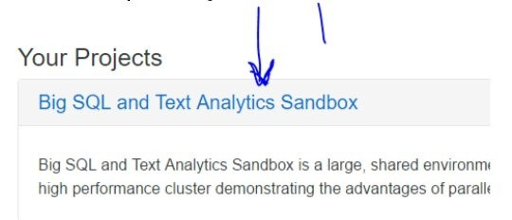

* **Step 5:**

open putty and put credentials as below :

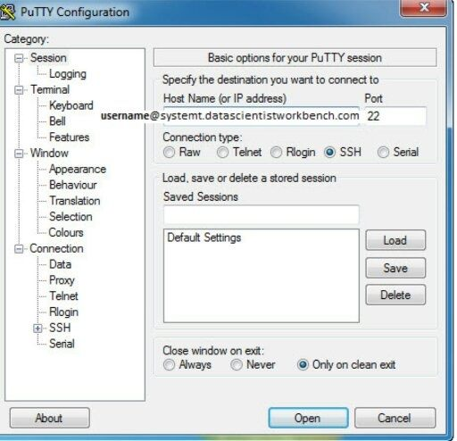

on login screen put **password**

Now after logging in to putty you will get a shell/prompt where you can practice hadoop commands.

for file transfer to the system use winscp

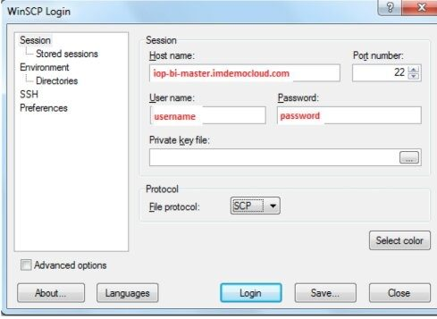

**Edit:** There are other ways too.

1. You can search for aws vms and get a vm for free for 1year. Note: credit card info is required.
2. Microsoft azure also offers same service free for 1year.
3. Google also offers vm with 300$ of free usage. (last time i checked it was 300 dollars)
4. [Home - Hadoop In Real World](http://www.hadoopinrealworld.com/) check this site its also good.

Will keep updating this answer if I find any other online platforms.

5.5k Views · [23 Upvotes](https://www.quora.com/api/mobile_expanded_voter_list?key=tAOcTAY1qx&type=answer)

[Krishna Kumar](https://www.quora.com/profile/Krishna-Kumar-100)

[Krishna Kumar](https://www.quora.com/profile/Krishna-Kumar-100), lived in Mumbai, Maharashtra, India

[Answered Feb 20, 2015](https://www.quora.com/How-can-I-practice-Hadoop-programs-online-for-free-Is-there-any-free-cloud-service-that-provides-Hadoop-platform-along-with-sample-data-to-play-with-I-want-to-submit-map-reduce-code-there-and-get-the-results-Is-there-any-such-service-available/answer/Krishna-Kumar-100)

I would suggest installing any of the virtual boxes provided by Cloudera or Hortonworks.   
  
For Hortonworks : [Download Hadoop](http://hortonworks.com/hdp/downloads/) and then practice the tutorials [Get Started with Hadoop](http://hortonworks.com/get-started/)   
For Cloudera: [QuickStart VM Download with CDH 5.3.x](http://www.cloudera.com/content/cloudera/en/downloads/quickstart_vms/cdh-5-3-x.html)   
  
Both of them should have pre installed Hadoop ecosystem components like Hive, Pig, Sqoop etc. You can play around using the sample data that they might have or download the datasets from any of the links mentioned here : [Where can I find large datasets open to the public?](https://www.quora.com/Where-can-I-find-large-datasets-open-to-the-public)  (I'm not sure which of those links work though).   
  
Hope it is of some help. Happy Learning !!

17.3k Views · [17 Upvotes](https://www.quora.com/api/mobile_expanded_voter_list?key=VeOOB5ok32u&type=answer)

[Promoted by Upwardly.in](https://www.quora.com/red=https:/www.upwardly.in?utm_source=quora&utm_campaign=10k_to_3.3Cr_Quora_Open" \t "_blank)

[Invest ₹10,000 per month & get more than 3.2 Crore on retirement.](https://www.quora.com/red=https:/www.upwardly.in?utm_source=quora&utm_campaign=10k_to_3.3Cr_Quora_Open" \t "_blank)

[Formulate the right mutual fund portfolio strategy for your long & short term financial goals.](https://www.quora.com/red=https:/www.upwardly.in?utm_source=quora&utm_campaign=10k_to_3.3Cr_Quora_Open" \t "_blank)

[Sandeep Giri](https://www.quora.com/profile/Sandeep-Giri-1)

[Sandeep Giri](https://www.quora.com/profile/Sandeep-Giri-1), Worked with Amazon, InMobi, D. E. Shaw, tBits Global in Engineering

[Answered Jun 13, 2016](https://www.quora.com/How-can-I-practice-Hadoop-programs-online-for-free-Is-there-any-free-cloud-service-that-provides-Hadoop-platform-along-with-sample-data-to-play-with-I-want-to-submit-map-reduce-code-there-and-get-the-results-Is-there-any-such-service-available/answer/Sandeep-Giri-1)

The free Hadoop environment is available from Cloudera Live but it is a read only. It is not possible to upload a jar of map-reduce to execute it.

I would suggest you to give a try to [CloudxLab](http://CloudxLab.com), though it is not free but it is quite affordable ($25 for a month). It provides complete environment to experiment with various tools such as HDFS, Map-Reduce, Hive, Pig, Kafka, Spark, Scala, Sqoop, Oozie, Mahout, MLLib, Zookeeper, R, Scala etc. Many of the popular trainers are using CloudxLab.

Disclaimer: I am one of the co-founder of CloudxLab.

7.7k Views · [8 Upvotes](https://www.quora.com/api/mobile_expanded_voter_list?key=bcMZR7w8GPF&type=answer)

[Swapnil Pote](https://www.quora.com/profile/Swapnil-Pote-1)

[Swapnil Pote](https://www.quora.com/profile/Swapnil-Pote-1), Data Miner, Science lover, Learner, Educator, Love to visit every city of WORLD

[Answered Sep 16, 2016](https://www.quora.com/How-can-I-practice-Hadoop-programs-online-for-free-Is-there-any-free-cloud-service-that-provides-Hadoop-platform-along-with-sample-data-to-play-with-I-want-to-submit-map-reduce-code-there-and-get-the-results-Is-there-any-such-service-available/answer/Swapnil-Pote-1)

Hi,

If u wants 2 just deploy hadoop cluster or vm on cloud. Check my this playlist it will help u to deploy on to microsoft azure cloud at free of cost.

Hortonworks Sandbox on Azure: [Hortonworks Sandbox on Azure](http://www.youtube.com/playlist?list=PL4vEMWWy1-t14pz9-r_lmhV9easKT7nAh)

I'll be uploading more videos on Pig, Hive, Mapreduce n Spark. So make sure subscribe to my youtube channel. Pls leave ur feedback for above playlist.

5.8k Views · [2 Upvotes](https://www.quora.com/api/mobile_expanded_voter_list?key=MykyxBRt1rZ&type=answer)

[Deepak G Rao](https://www.quora.com/profile/Deepak-G-Rao)

[Deepak G Rao](https://www.quora.com/profile/Deepak-G-Rao), Philosophy, Chess, Politics, Running, Python, Big data, ML & Data science nerd

[Answered Sep 8, 2016](https://www.quora.com/How-can-I-practice-Hadoop-programs-online-for-free-Is-there-any-free-cloud-service-that-provides-Hadoop-platform-along-with-sample-data-to-play-with-I-want-to-submit-map-reduce-code-there-and-get-the-results-Is-there-any-such-service-available/answer/Deepak-G-Rao)

All hadoop distributors (MapR, cloudera, hortonworks) provide free VM image (mostly single node) to download and get your hands on experience. Download one of them and play with it, if you really need to test cluster capability try google cloud, they even give you a $200 credit for first trial on google cloud.

6.5k Views · [2 Upvotes](https://www.quora.com/api/mobile_expanded_voter_list?key=dfUgayrY3Vq&type=answer)

[Malini Shukla](https://www.quora.com/profile/Malini-Shukla-1)

[Malini Shukla](https://www.quora.com/profile/Malini-Shukla-1)

[Answered Jun 28, 2016](https://www.quora.com/How-can-I-practice-Hadoop-programs-online-for-free-Is-there-any-free-cloud-service-that-provides-Hadoop-platform-along-with-sample-data-to-play-with-I-want-to-submit-map-reduce-code-there-and-get-the-results-Is-there-any-such-service-available/answer/Malini-Shukla-1)

There are a lot of resources from where you can learn Hadoop programs. To learn how to write Hadoop programs you should be aware with Mapreduce.MapReduce is the heart of hadoop. It is a programming model designed for processing large volumes of data in parallel by dividing the work into a set of independent tasks.

MapReduce has a simple model of data processing: inputs and outputs for the map and reduce functions are key-value pairs. The map and reduce functions in Hadoop MapReduce have the following general form:

**map: (K1, V1) → list(K2, V2)**

**reduce: (K2, list(V2)) → list(K3, V3)**

For more information [you can refer this blog](http://data-flair.training/blogs/hadoop-mapreduce-flow-how-data-flows-in-mapreduce/). If you want to know more about Hadoop [you can visit here.](http://data-flair.training/big-data-hadoop/)

6k Views · [2 Upvotes](https://www.quora.com/api/mobile_expanded_voter_list?key=8gzwr4e6jVj&type=answer)

[Shrikant Soni](https://www.quora.com/profile/Shrikant-Soni-7)

[Shrikant Soni](https://www.quora.com/profile/Shrikant-Soni-7)

[Answered Jun 17, 2015](https://www.quora.com/How-can-I-practice-Hadoop-programs-online-for-free-Is-there-any-free-cloud-service-that-provides-Hadoop-platform-along-with-sample-data-to-play-with-I-want-to-submit-map-reduce-code-there-and-get-the-results-Is-there-any-such-service-available/answer/Shrikant-Soni-7)

Cloudera launched a new platform online where you can play with Hadoop and its ecosystem as much as you want.Here you go - [Cloudera Live](http://cloudera.com/live)  
  
Hope this helps

9.3k Views · [12 Upvotes](https://www.quora.com/api/mobile_expanded_voter_list?key=qqYH6KLFWJ7&type=answer)

[Amit Choudhary](https://www.quora.com/profile/Amit-Choudhary-2)

[Amit Choudhary](https://www.quora.com/profile/Amit-Choudhary-2), Application Developer

[Answered Sep 14, 2016](https://www.quora.com/How-can-I-practice-Hadoop-programs-online-for-free-Is-there-any-free-cloud-service-that-provides-Hadoop-platform-along-with-sample-data-to-play-with-I-want-to-submit-map-reduce-code-there-and-get-the-results-Is-there-any-such-service-available/answer/Amit-Choudhary-2)

[The fastest and easiest way to learn Hadoop - Cloudera](http://www.cloudera.com/get-started/cloudera-live.html) : Visit this link.

Hope, It helps!

3.6k Views · [1 Upvote](https://www.quora.com/api/mobile_expanded_voter_list?key=Yu3N5JZZFPD&type=answer) · Answer requested by [Bharadwaj Pendyala](https://www.quora.com/profile/Bharadwaj-Pendyala)

[Sujeeth Sadafule](https://www.quora.com/profile/Sujeeth-Sadafule)

[Sujeeth Sadafule](https://www.quora.com/profile/Sujeeth-Sadafule), works at SRM University

[Answered Oct 3, 2016](https://www.quora.com/How-can-I-practice-Hadoop-programs-online-for-free-Is-there-any-free-cloud-service-that-provides-Hadoop-platform-along-with-sample-data-to-play-with-I-want-to-submit-map-reduce-code-there-and-get-the-results-Is-there-any-such-service-available/answer/Sujeeth-Sadafule)

Hi Ayesha, the perfect answer for your question has already been given by Krishna Kumar.You can refer his answer,but I would like add one point.

Hadoop is a big platform you cannot expect such big platform on a free cloud service but still you can play with data sets either by installing virtual boxes provided by Cloudera or Hortonworks.I’m not sure that these softwares are available open,if so please let me.

3k Views · Answer requested by [Ayesha Sarmathi](https://www.quora.com/profile/Ayesha-Sarmathi)

[Pranav Bhargava](https://www.quora.com/profile/Pranav-Bhargava-6)

[Pranav Bhargava](https://www.quora.com/profile/Pranav-Bhargava-6), Final year in cse btech. Trying to learn more.

[Answered Jun 22, 2016](https://www.quora.com/How-can-I-practice-Hadoop-programs-online-for-free-Is-there-any-free-cloud-service-that-provides-Hadoop-platform-along-with-sample-data-to-play-with-I-want-to-submit-map-reduce-code-there-and-get-the-results-Is-there-any-such-service-available/answer/Pranav-Bhargava-6)

If you know how to code in apache spark (part of hadoop framework)  then you can sign up on databricks community edition. Its a free 6 cluster account which allows you to use spark.

4.3k Views · [1 Upvote](https://www.quora.com/api/mobile_expanded_voter_list?key=VdWUZonbBKm&type=answer)

[Raj Sap](https://www.quora.com/profile/Raj-Sap-1)

[Raj Sap](https://www.quora.com/profile/Raj-Sap-1)

[Updated May 26](https://www.quora.com/How-can-I-practice-Hadoop-programs-online-for-free-Is-there-any-free-cloud-service-that-provides-Hadoop-platform-along-with-sample-data-to-play-with-I-want-to-submit-map-reduce-code-there-and-get-the-results-Is-there-any-such-service-available/answer/Raj-Sap-1)

Learn hadoop at todaycourses

100 Views

[Syed Hyder](https://www.quora.com/profile/Syed-Hyder-8)

[Syed Hyder](https://www.quora.com/profile/Syed-Hyder-8), Senior telecom engineer at Cyient

[Answered Sep 14, 2016](https://www.quora.com/How-can-I-practice-Hadoop-programs-online-for-free-Is-there-any-free-cloud-service-that-provides-Hadoop-platform-along-with-sample-data-to-play-with-I-want-to-submit-map-reduce-code-there-and-get-the-results-Is-there-any-such-service-available/answer/Syed-Hyder-8)

There are three modes in which you can get the experience of hadoop.

Standalone mode:

In this mode you need an ide like eclipse and the hadoop library files (which you can download from the apache website). You can create your mapreduce program and run it in your local machine. You will be able to check the logic of the code and you can check any syntax errors and this needs some sample data to perform these actions but you will not get the full experience of hadoop.

Psuedo-distributed mode:

In this mode you get all the daemons of hadoop running on a single machine and you can get a vm from cloudera or hortonworks which is just plug and play type of thing. It will have all the necessary tools installed and configured. In this mode you can scale up your data to check how your code performs and optimize accordingly to get the job done in the required time.

Fully-distributed mode:

In this mode you get all the daemons running on different machines. This is mostly used in the production stage of your project. When you have already verified your code you will get a chance to implement it in this mode.

Since you request an online service where you can practice your hadoop code. I suggest you install eclipse on you pc and download the libraries and start coding.[Running Hadoop MapReduce Application from Eclipse Kepler - DZone Big Data](https://dzone.com/articles/running-hadoop-mapreduce)

3.6k Views · Answer requested by [Bharadwaj Pendyala](https://www.quora.com/profile/Bharadwaj-Pendyala)

[Durga Viswanath Gadiraju](https://www.quora.com/profile/Durga-Viswanath-Gadiraju)

[Durga Viswanath Gadiraju](https://www.quora.com/profile/Durga-Viswanath-Gadiraju), Expert in Apache Hadoop

[Answered Sep 16, 2016](https://www.quora.com/How-can-I-practice-Hadoop-programs-online-for-free-Is-there-any-free-cloud-service-that-provides-Hadoop-platform-along-with-sample-data-to-play-with-I-want-to-submit-map-reduce-code-there-and-get-the-results-Is-there-any-such-service-available/answer/Durga-Viswanath-Gadiraju)

There is lot of content on our [website](http://www.itversity.com) and our [channel](http://www.YouTube.com/itversityin)

2.6k Views · [4 Upvotes](https://www.quora.com/api/mobile_expanded_voter_list?key=XBobUsl512Z&type=answer) · Answer requested by [Bharadwaj Pendyala](https://www.quora.com/profile/Bharadwaj-Pendyala)

[Nitin Sharma](https://www.quora.com/profile/Nitin-Sharma-174)

[Nitin Sharma](https://www.quora.com/profile/Nitin-Sharma-174), Sr. Software Engineer at Cybage Software

[Answered Feb 13, 2015](https://www.quora.com/How-can-I-practice-Hadoop-programs-online-for-free-Is-there-any-free-cloud-service-that-provides-Hadoop-platform-along-with-sample-data-to-play-with-I-want-to-submit-map-reduce-code-there-and-get-the-results-Is-there-any-such-service-available/answer/Nitin-Sharma-174)

Go for cbt or edureka tutorials

6.4k Views · [1 Upvote](https://www.quora.com/api/mobile_expanded_voter_list?key=ownI8ZKeqVy&type=answer)