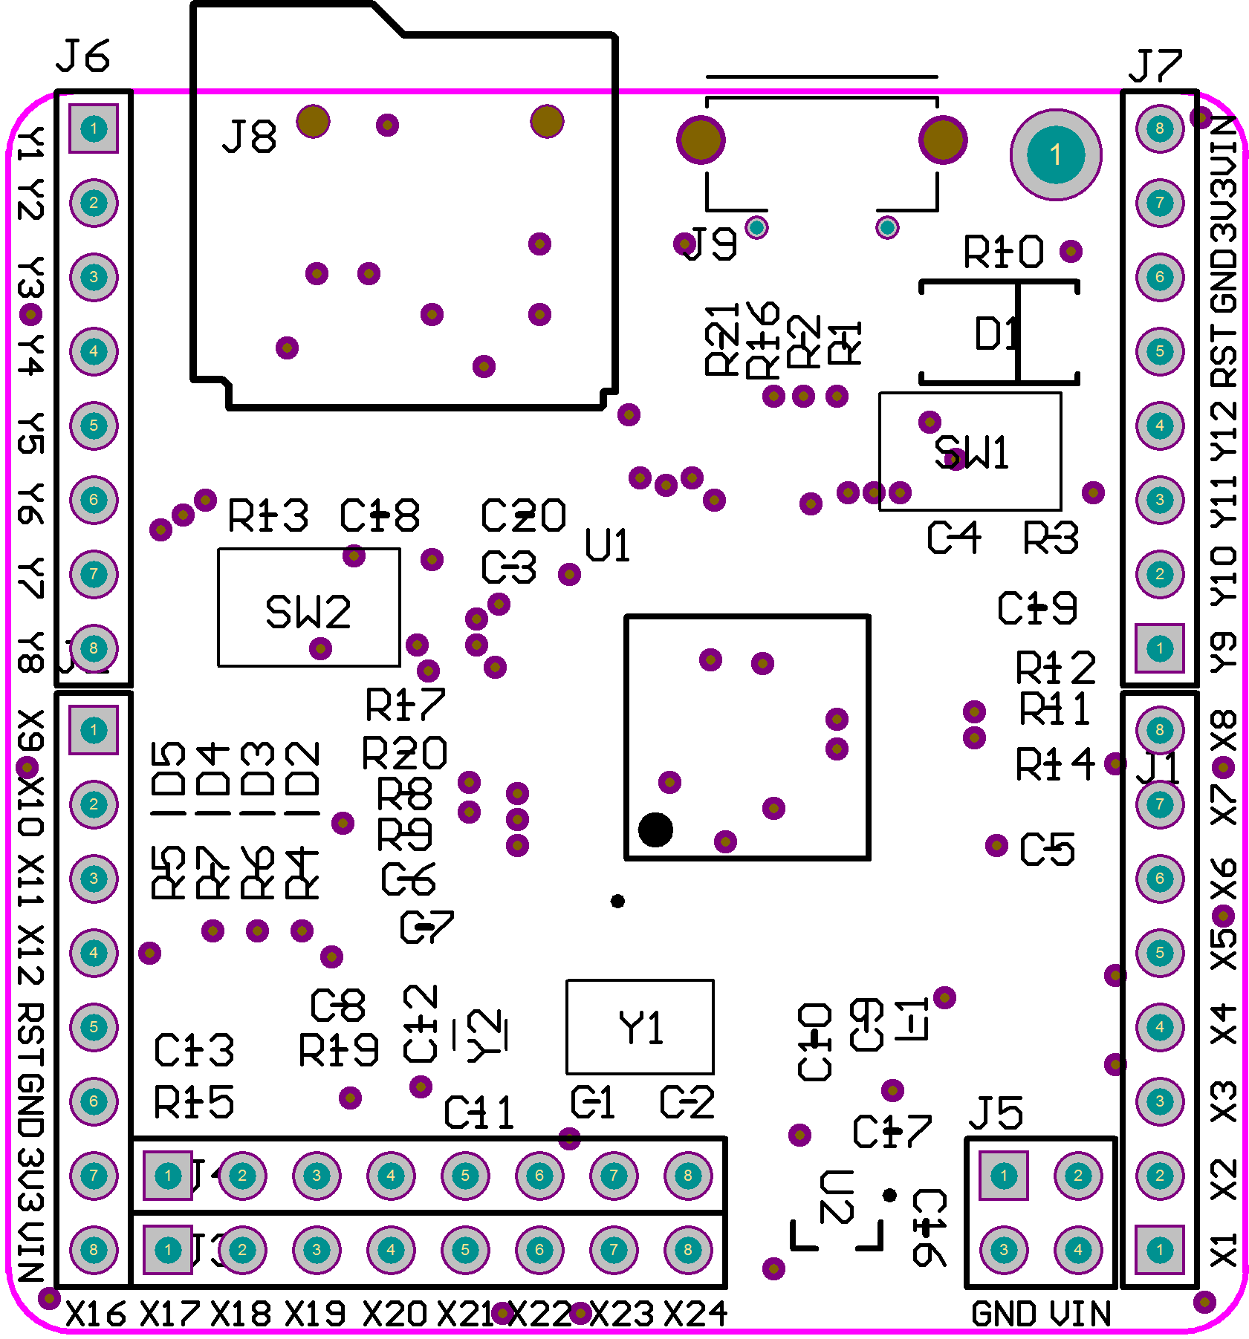

标号 | 参数 | 封装 | 数量
C1, C2 | 18p | SMD0603 | 2
C3, C4, C5, C6, C8, C9, C13 | 104 | SMD0603 | 7
C7, C10, C16, C17, C18, C19, C20 | 2u2 | SMD0805 | 7
C11, C12 | 2.2p | SMD0603 | 2
D1 | SS14/1N5819 |  | 1
D2 | LED RED 红 | LED0603 | 1
D3 | LED GREEN 绿 | LED0603 | 1
D4 | LED Yellow 黄 | LED0603 | 1
D5 | LED Blue 蓝 | LED0603 | 1
J9 | macro USB | MicroUSB | 1
J8 | microSD PUSH-PULL | microSD | 1
J1、J2、J3、J4、J6、J7 | 2.54mm 单排排针 | 2.54mm 单排排针 | 6
J5 | 2.54mm 单排排针 | HDR2X2 | 1
L1 | 33nH | SMD0603 | 1
R1, R2 | 22R | SMD0603 | 2
R3, R14, R8, R9, R11, R12, R17, R20 | 10k | SMD0603 | 8
R4, R5, R6, R7, R10, R16 | 560 | SMD0603 | 6
R13 | 10M | SMD0603 | 1
R15, R21 | 100k | SMD0603 | 2
R19 | 220 | SMD0603 | 1
SW1、SW2 |  | 3x6 轻触开关 | 2
U1 | STM32F405RGT6 | LQFP64_M | 1
U2 | XC6206P332MR | SOT-23_N | 1
Y1 | 8M | SMD5032 | 1
Y2 | 32K | TXC_9H03200019 | 1

