Test Execution Host startup/shutdown instruction:

STARTUP:

- Check that nothing looks broken, weird(?) or that no leaks appear (liquid on floor or around electronics). If there appear to be problems please do NOT start.

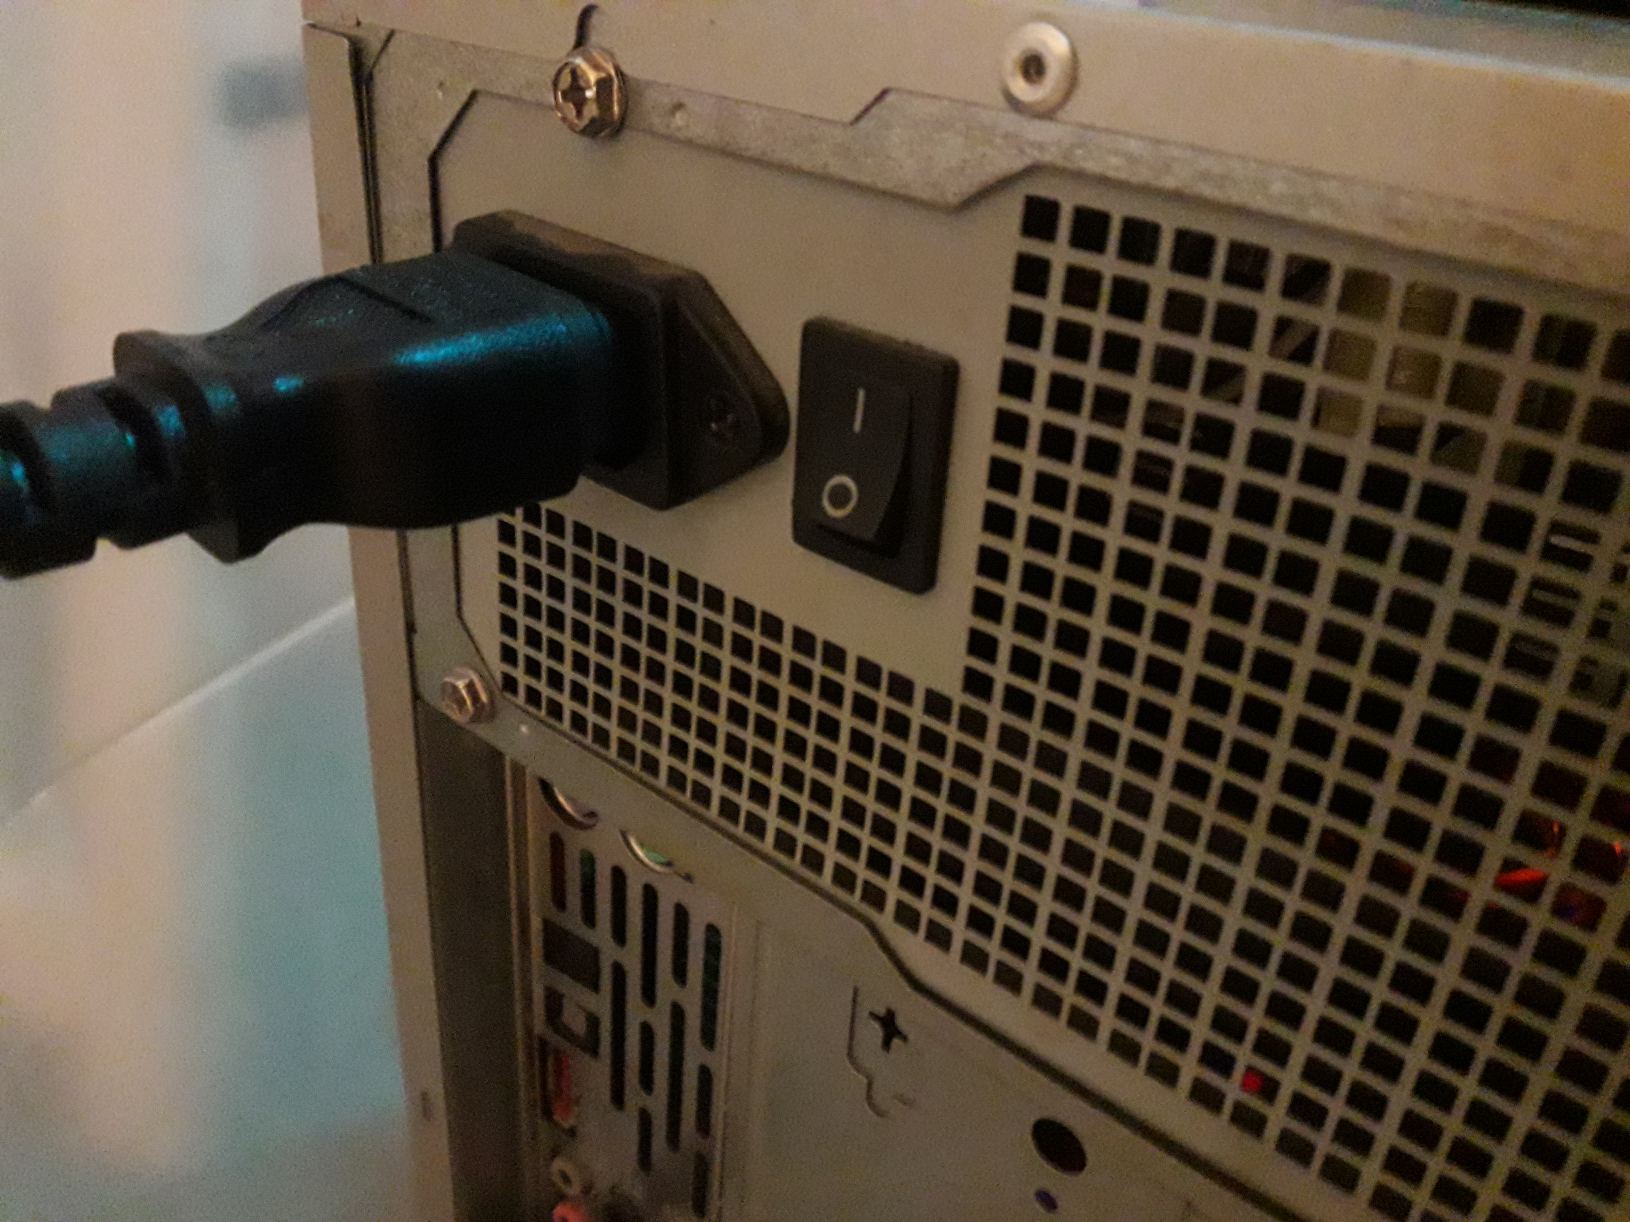
- Switch on the computer at the back (switch up):

- Turn on computer by pressing front button:

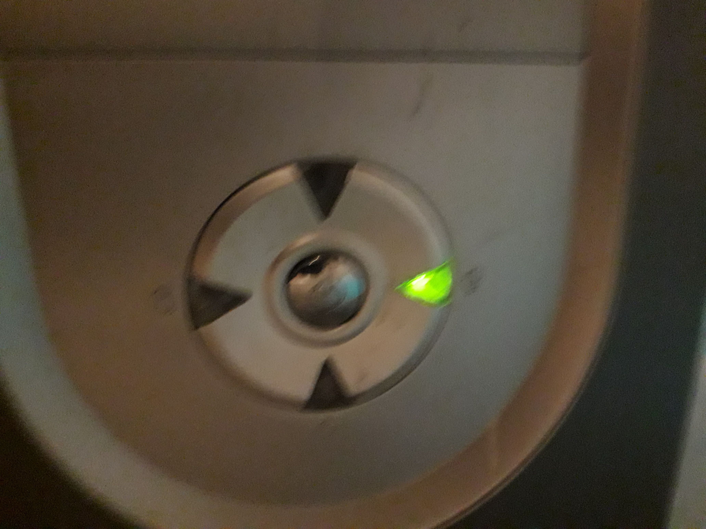

- The computer should start up and screen blink on.

- Switch on power supply at the back – red button - so it lights up:

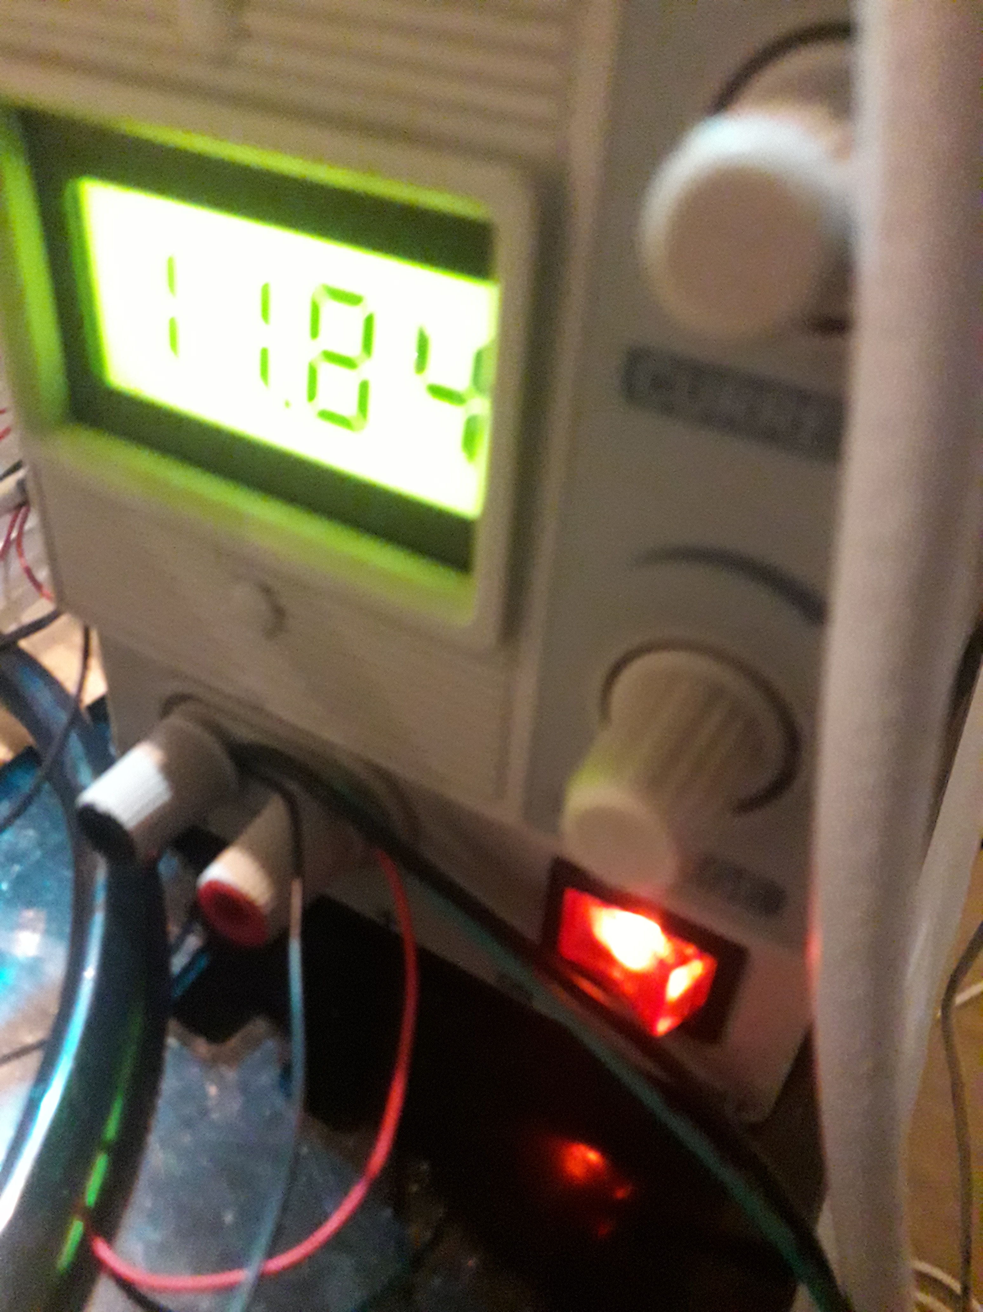

- Wait until the plastic head at the front which has the pipes and light on starts whirring and moving slowly left.

- Now plug in the plug with white masking tape LAST on it – into the power strip.

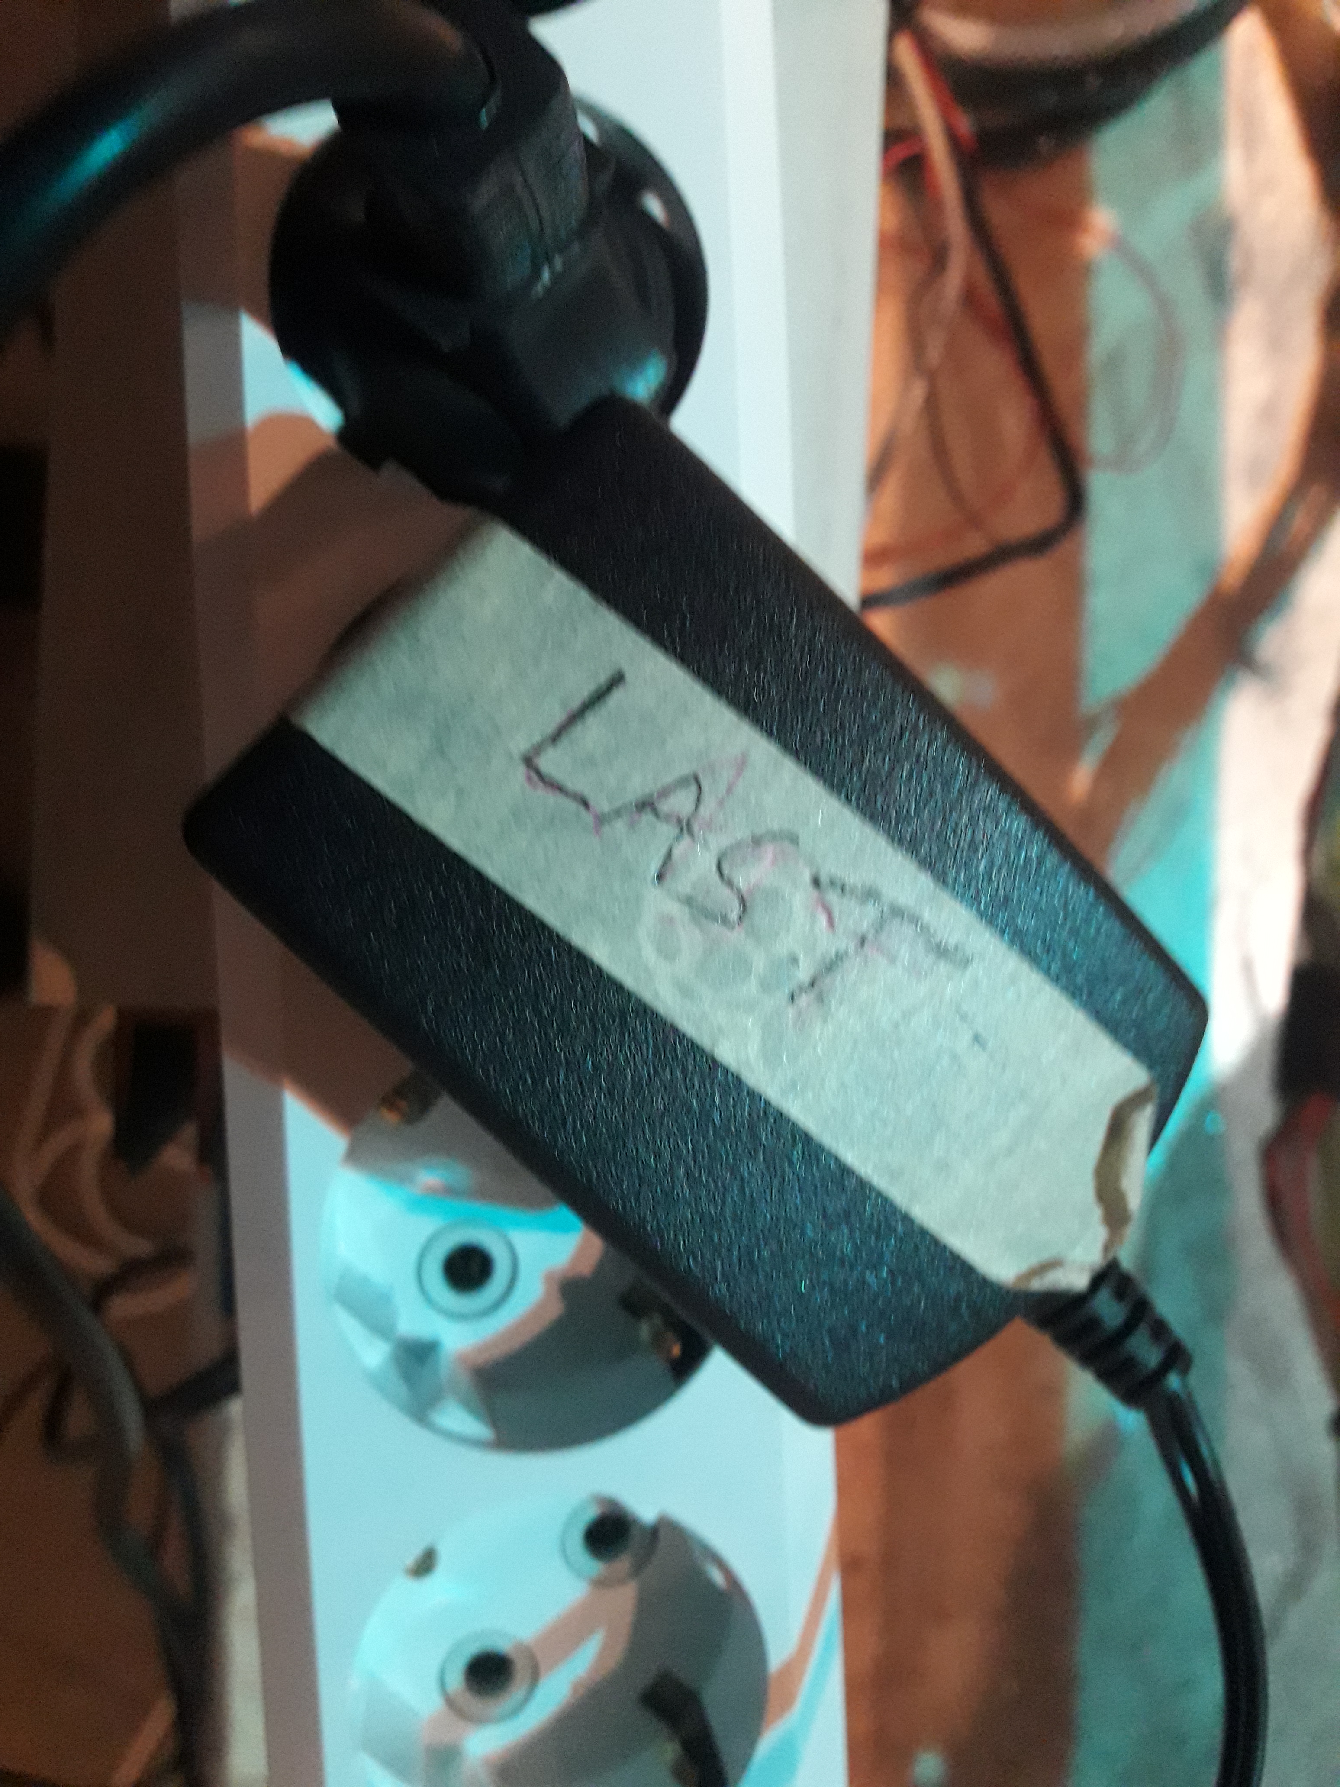

- After a while the thing should start to do its thing. If there are strange noises or leaks then please SHUTDOWN!

SHUTDOWN:

- Switch off the black switch on the back of the computer (down).

- Switch off the red switch of the power supply. It should be dark.

- Unplug the adapter/masking taped plug from the socket adapter thing (see last picture above). This is very important.

