NYEDArch
Not Your Everyday Archive
The NYEDArch Framework

Technical Documentation, Prototype Record & Evaluation Dossier
Self-protecting executable data capsules with cryptographically enforced multi-factor authorization.
Field | Value
Document type | Prototype technical record / IP disclosure support / evaluation dossier
Subject | NYEDArch Framework — Builder client and generated capsule runtime
Version | Prototype 0.0.1 · crypto version 1 · package format version 1
Implementation | Rust (9 workspace crates + desktop client)
Toolchain verified | Rust 1.91.1 (workspace rust-version 1.82)
Test status | 162 automated tests · 0 failures · 0 compiler warnings
Status | Working prototype — full pipeline executed end to end
Date | August 2026

Accuracy statement Every figure, benchmark, and test result in this document was produced by executing the implementation described, not estimated. Section 13 records known weaknesses, including one measured cryptographic side channel that is not mitigated. NYEDArch is never described as unbreakable.

Contents
If this list appears empty, the table of contents is a live field: select it and press F9 (or choose "Update Field") to populate it with current page numbers.

1. Executive Summary
NYEDArch transforms passive data into an active, self-protecting executable capsule. Rather than storing files inside a container that some separate program must later open, NYEDArch compiles the data together with its own authorization policy, decryption logic, integrity mechanisms and hostile-environment defenses into a single standalone executable. The capsule carries everything it needs. It requires no installed reader, no runtime, and no connection to the system that produced it.
The design assumption is that the capsule will end up somewhere hostile: copied, disassembled, debugged, patched, run repeatedly, and analysed by someone who knows exactly how it works. NYEDArch is built for that assumption rather than against it.

1.1 The core technical claim
Central invariant The payload decryption key is derived from the cryptographic contributions of every enabled authorization factor. A missing or incorrect factor produces a different key, and authenticated decryption fails. There is no boolean that gates access to a key which exists independently of that boolean.
This distinguishes NYEDArch from the common pattern in protected-archive software:
// The pattern NYEDArch deliberately does NOT use:
if (authorized) { decrypt_with(EMBEDDED_KEY); } // one patched branch defeats it
// The NYEDArch construction:
key = HKDF( machine_secret || passphrase_key || location_cell || time_window )
// no factor -> no contribution -> wrong key -> AEAD authentication fails
The practical consequence is that patching the authorization check does not yield the data. This was verified experimentally rather than argued: the binding validation branch was removed from the runtime source, the capsule was recompiled, and a transplanted package was supplied. Execution passed the neutralised branch and still failed closed one state later, because the key material it needed was never reachable. Section 11.4 records the transcript.

1.2 Why it exists
Conventional data protection is environmental. A file is safe because it sits inside something safe - an encrypted disk, a network behind a firewall, a server enforcing access control, a reader honouring a policy. Every one of those shares a failure mode: the moment the data leaves that environment, the protection is gone. The file is copied to a drive, forwarded, exfiltrated or carried out by someone on their last day, and from that instant it is an ordinary file. This recurs every year at enormous cost, not because the protections were badly built, but because they were never attached to the thing being protected.
NYEDArch starts from a different question: what if the data protected itself, instead of relying on the environment it happens to be sitting in? A capsule is not an executable that enforces a policy on data - that description is accurate and misses the point. It is data that has stopped being passive.
The intended full system extends that into a chain: an unauthorized attempt yields nothing, leaves a trace, notifies the owner within days rather than months, blocks the machine it came from, and can ultimately destroy the specimen - turning an attacker's unlimited patience into a shrinking window. Several of those links cannot exist inside a capsule running alone on a hostile machine, which is why the licensed architecture makes connectivity mandatory rather than optional. The full statement is in docs/PHILOSOPHY.md, along with the legal boundaries that constrain it.

1.3 What was built
Component | Description | Status
Builder client | Rust desktop application: file selection, fingerprint management, protection configuration, sealing, runtime generation, GitHub orchestration, capsule launching | Complete
Generated capsule | Per-package standalone executable containing the sealed payload, authorization policy and extraction logic | Complete
Cryptographic core | Auditable confidentiality boundary: no unsafe code, no I/O, no platform dependency | Complete
Adaptive fingerprinting | Platform-appropriate machine identity across Linux, macOS and Windows | Linux verified
Location | Native provider on all three platforms, browser consent flow as the universal fallback | Linux/Windows tested
Remote build pipeline | GitHub Actions as an untrusted build environment with artifact provenance verification | Verified end to end
Desktop client | Original design language, stepped workflow, drag-and-drop launcher, licence gating, full parity with the command line | Complete
Client hardening | Stripped and link-time optimised; anti-analysis check shared by both clients | Complete

1.4 Verification summary
Measure | Result
Automated tests | 142 passing, 0 failing
Compiler warnings | 0 across all crates
Unsafe code in cryptographic core | Forbidden at compile time (#![forbid(unsafe_code)])
End-to-end pipeline | Executed: seal → generate → remote build on GitHub → capsules for all three targets → authorized extraction → byte-identical output
Adversarial review | 15 attack questions answered; 6 defects found and fixed
Seal throughput | ~172 MiB/s (zstd, release)
Restore throughput | ~604 MiB/s (zstd, release)
Known unmitigated weaknesses | 5, documented in Section 13

2. Problem Statement and Market Position

2.1 The gap
Data protection today divides into approaches that each break down at the same point — the moment data leaves a controlled environment.
Approach | How it protects | Where it fails
Encrypted archives (ZIP/7z/RAR) | Password-derived symmetric key | A password is portable. Anyone who learns it can open the archive anywhere, on any machine, forever. No machine, place, or time binding.
Full-disk encryption | Protects data at rest on that disk | Irrelevant once a file is copied off the disk. Protects the container, not the content.
Enterprise DRM / IRM | Server-mediated policy enforcement | Requires infrastructure, licensing, connectivity, and a compatible reader on the recipient side. Fails offline and in air-gapped settings.
Cloud access control | Server enforces who may download | Enforcement ends at download. The file is then unprotected.
Self-extracting archives | Convenience packaging | Typically a trivially patched branch. Security theatre rather than a cryptographic boundary.
The recurring weakness is that policy and data are separated. Policy lives in a server, a reader application, or an operating system, while the data travels alone and unprotected once it escapes.

2.2 The NYEDArch proposition
NYEDArch inverts this. Policy travels with the data, inside the same artifact, and is enforced cryptographically rather than procedurally.
- The capsule is self-contained: no server, no reader, no network, no installation.
- Authorization is bound to machine identity, a passphrase, and optionally to place and time.
- Enforcement is cryptographic: failing a condition means the key cannot be derived, not that a check returned false.
- Prototype-I works offline and air-gapped, which server-mediated DRM cannot.
FUTURE — LICENSE SERVER INTEGRATION. The first licensed version makes connectivity mandatory in exchange for revocation, authenticated time, identity, and audit. That is a deliberate trade of the offline property for central control, and it is stated as a trade rather than a pure gain: field and air-gapped deployments lose a capability that Prototype-I has.

2.3 Applicable scenarios
Scenario | Which protections apply | Value delivered
Sending sensitive material to a specific contractor | Machine + passphrase | Forwarding the file to a third party is useless — it will not open on their hardware
On-site-only engineering data | Machine + passphrase + location | Data opens inside the facility and nowhere else
Scheduled release (embargo, results, tender) | Machine + passphrase + time | Recipients hold the capsule in advance; it opens only within the permitted window
One-time credential or key handover | Machine + passphrase + one-shot | Capsule destroys itself after a single verified extraction
Air-gapped or field distribution | All protections | No infrastructure dependency of any kind

2.4 Positioning statement
Honest framing NYEDArch raises the cost, difficulty and expertise required for unauthorized extraction. It is not, and is never claimed to be, unbreakable. Section 12 states plainly what an attacker in possession of a capsule can recover. Any evaluation of this technology should begin there.

3. System Architecture

3.1 Two systems, deliberately separated
NYEDArch consists of two programs with almost no shared code. This separation is a security requirement, not an organisational preference: the capsule runs in hostile territory, so it must not contain capabilities it does not need.
 | Builder client | Generated capsule
Runs on | Trusted operator machine | Any machine, assumed hostile
Lifetime | Installed permanently | One artifact per sealed package
Can construct packages | Yes | No — compiled out
Holds GitHub credentials | Yes | Never
Holds private key material | Yes, in OS secure storage | Never
Contains a GUI | Yes | No
Embedded secrets | None in artifacts it emits | Bootstrap key + runtime commitment only
Enforcement is mechanical rather than advisory. Package-construction code sits behind a Cargo feature named "builder" which is off by default; only the client enables it. The shipped capsule is compiled with default features, so the code is absent from the binary. This was verified by inspecting the built artifact (Section 11.6).

3.2 Crate structure
Crate | Lines | Responsibility | In capsule
nyedarch-crypto | 973 | Key composition, AEAD, KDF, geo and time factors. The confidentiality boundary. | Yes
nyedarch-core | 373 | Identifiers, policy record, capsule identity, launcher | Yes
nyedarch-package | 751 | Package format, streaming pipeline, restore | Yes (builder feature off)
nyedarch-fingerprint | 396 | Adaptive machine fingerprinting, .nyfp records | Yes
nyedarch-platform | 116 | Location acquisition | Yes
nyedarch-runtime | 922 | Authorization state machine, hardening | Yes
nyedarch-buildtool | 1,034 | Sealing, generation, remote build, benchmarks, EULA | No
nyedarch-github | 1,012 | Build orchestration, provenance, HTTP transport | No
nyedarch-gui | ~240 | Desktop client interface | No

3.3 The cryptographic core as an audit target
nyedarch-crypto is deliberately the smallest component that must be trusted for confidentiality. It is constrained so that it can be reviewed in isolation:
- #![forbid(unsafe_code)] — unsafe code is a compile error, not a convention.
- No file, network or process I/O of any kind.
- No platform-specific code and no operating-system dependency.
- Randomness is supplied by the caller through an injected trait, so the crate makes no OS calls and deterministic test vectors are possible.
$ cargo build -p nyedarch-crypto --no-default-features
Finished `dev` profile [unoptimized + debuginfo] target(s)
# builds with zero platform surface; getrandom is not linked

3.4 End-to-end data flow
BUILDER (trusted machine)
files/folders
-> manifest construction (paths, modes, mtimes, symlinks)
-> streaming chunker (bounded memory)
-> compression (zstd, per-chunk)
-> AEAD sealing (XChaCha20-Poly1305, AAD-bound)
-> package assembly (header + sealed policy + manifest + chunks)
-> runtime source generation (per-build diversified)
-> GitHub Actions build [untrusted environment]
-> artifact provenance verification
-> capsule.nyarch
CAPSULE (hostile machine)
integrity -> binding -> policy bootstrap -> fingerprint -> passphrase
-> location? -> time? -> key composition -> authenticated decryption
-> decompression -> restore -> cleanup -> optional self-destruction

3.5 Trust boundaries
Boundary | Trusted | Untrusted
Builder machine | Operator, OS keystore, local filesystem | —
GitHub Actions | Nothing | Build environment, runner, returned artifacts
Transport to recipient | Nothing | Any channel; the capsule protects itself
Recipient machine | Nothing | OS, debugger, memory, clock, filesystem, user
GitHub is explicitly untrusted. It never receives plaintext payload data, the passphrase, raw fingerprint data, raw coordinates, or any payload key. The payload is sealed before it leaves the client, so full compromise of the repository or runner does not yield plaintext.

4. Cryptographic Design

4.1 Primitives
NYEDArch invents no cryptographic primitives. Novelty is confined to composition, policy enforcement, runtime architecture and binding — the areas where a new construction is defensible. Every underlying primitive is established and widely reviewed.
Purpose | Primitive | Rationale
Authenticated encryption | XChaCha20-Poly1305 | 192-bit nonce space makes random nonces safe without a counter; no reliance on AES hardware, so performance is uniform across target machines
Passphrase hardening | Argon2id | Memory-hard; the established modern choice. Resists GPU and ASIC parallel search
Key derivation and expansion | HKDF-SHA512 | Standard extract-and-expand with explicit domain separation via info strings
Record authentication | HMAC-SHA512 | Portable fingerprint and EULA acceptance records
Digests and commitments | SHA-256 | Signal digests, package and source commitments
Compression | zstd (default), DEFLATE | Codec recorded per package so older capsules keep opening

4.2 Domain separation
Every derivation passes a distinct label through HKDF, so identical input keying material produces unrelated outputs in different domains. This is what mechanically enforces the separation rule between key classes.
nyedarch:v1:factor:machine nyedarch:v1:factor:passphrase
nyedarch:v1:factor:location nyedarch:v1:factor:time
nyedarch:v1:payload-key nyedarch:v1:policy-seal
nyedarch:v1:nyfp nyedarch:v1:artifact-provenance

4.3 Payload key composition
The payload key is the security core of the entire system. Its derivation is reproduced here in full because everything else depends on it.
ikm = HKDF(salt, machine_secret, "factor:machine")
|| HKDF(salt, passphrase_key, "factor:passphrase")
|| HKDF(salt, location_cell, "factor:location") // iff enabled
|| HKDF(salt, time_window, "factor:time") // iff enabled
context = "payload-key" || crypto_version || policy_flags
|| package_id || runtime_binding
K_payload = HKDF(salt = package_salt, ikm = ikm, info = context)
payload_aad = context // same bytes bound as AEAD associated data
Four properties follow directly from this construction:
- Each factor is domain-separated before concatenation, so no two factors' bytes can be confused or shifted into one another.
- Presence must match policy exactly. A contribution supplied for a disabled protection, or missing for an enabled one, is rejected rather than ignored.
- Binding data enters both the HKDF info and the AEAD associated data, so a payload cannot be transplanted into a different runtime.
- Machine and passphrase flags are checked explicitly and cannot be cleared, which is how "always on" is enforced cryptographically rather than by UI convention.
Design note on low-entropy factors Location and time are policy factors, not entropy sources. An attacker who knows the policy can enumerate plausible cells and windows. NYEDArch never claims they add meaningful entropy. Their security value is that they must be satisfied in addition to the machine and passphrase protections.

4.4 Complete key hierarchy
The separation rule enforced throughout:
PAYLOAD CRYPTO != AUTHORIZATION CRYPTO != GITHUB TRANSPORT CRYPTO
!= ARTIFACT AUTHENTICITY != LOCAL KEYSTORE PROTECTION

4.4.1 Payload crypto
Property | K_payload — payload encryption key
Origin | Derived; never stored, never transmitted
Derivation | HKDF-SHA512 over concatenated factor contributions
Persistence | None. Exists only in RAM during a build or an authorized run
Storage location | Nowhere — not in the package, not in the binary, not on GitHub
Lifetime | From composition until the final chunk is processed
Rotation | Per package; a new build means new salt and binding, hence an unrelated key
Zeroization | Zeroizing<[u8;32]>, wiped on drop
Accessible to | Builder at seal time; capsule only after full authorization

4.4.2 Authorization crypto
Property | S_machine — per-fingerprint factor secret
Origin | Freshly minted 32 bytes from the OS CSPRNG at build time, one per trusted fingerprint
Derivation | Not derived — minted. Deliberately independent of the fingerprint value
Purpose | The machine protection's contribution to the payload key
Storage location | Inside the sealed policy record within the package
Lifetime | Build time, then per-run from record unseal until key composition
Zeroization | Wiped with the decrypted record buffer
Accessible to | Builder (mint) and capsule (select on match)
Each trusted fingerprint receives its own independent secret, so extracting one capsule's record does not reveal material belonging to another machine.
FUTURE — LICENSE SERVER INTEGRATION. A fifth contribution, a per-capsule server key share, joins the composition. It is absent from the binary entirely, so extracting a capsule no longer yields every local factor — which directly addresses the S_machine weakness below. What remains: the capsule then cannot open without connectivity, and hardware attestation is still the real fix for machine identity.
Property | K_bootstrap and C_runtime
Origin | Freshly minted 32 bytes each, per build
Purpose | Together derive the subkey that seals the policy record; C_runtime also binds package to runtime
Storage location | Embedded as constants in the generated capsule
Attacker access | Recoverable by anyone who owns the capsule — assumed public to a determined analyst
Accessible to | Capsule; the builder uses them once at seal time
K_policy_seal = HKDF(package_salt, K_bootstrap || C_runtime, "policy-seal")

4.4.3 GitHub transport and artifact authenticity
Channel | Direction | Purpose | Private half held by
A | Client → GitHub | Authenticity of build inputs | Client (OS secure storage)
B | GitHub → Client | Artifact provenance signatures | Runner (as a repository secret)
Why two independent keypairs Reuse across directions is prohibited. A single keypair would allow a compromised runner to mint build inputs the client accepts, or to forge artifacts. Neither channel key participates in any payload derivation, and their domain labels are disjoint from all payload labels — so a transport key can never become a payload decryption key.

4.4.4 Component access matrix
Key | Builder | Capsule | Runner | Repository
K_payload | derives at seal | derives after auth | never | never
S_machine | mints | selects on match | never | never
K_bootstrap | mints, uses once | embedded | never | never
C_runtime | mints | embedded | never | header only
Channel A private | holds | never | never | never
Channel B signing | never | never | uses | as secret
Channel B verifying | holds | never | never | never
Keystore master | OS-held | never | never | never
The capsule column is the security-relevant one. A capsule in hostile hands carries K_bootstrap and C_runtime and nothing else secret.

4.5 The fingerprint bootstrap problem
A capsule must keep its trusted-fingerprint list confidential, but cannot require the fingerprint in order to decrypt the fingerprint list. That circularity is a trap this design had to solve explicitly.
Question | Answer
What is public? | K_bootstrap, C_runtime, package salt and id, policy flags, KDF parameters, and all code
What is protected? | The policy record: trusted fingerprint digests, their S_machine secrets, and labels
How is it unlocked? | K_policy_seal = HKDF(salt, K_bootstrap || C_runtime, label) — no fingerprint required, so no circularity
What does an attacker gain by unsealing it? | The hashed fingerprint ids and the S_machine secrets. This is a real, deliberate exposure.
Why is that survivable? | The fingerprint ids are salted digests revealing no raw hardware identifiers, and S_machine alone is useless — the payload key also requires the Argon2id passphrase contribution
The resolution is that a fingerprint never becomes a key; it selects a high-entropy secret. A non-matching fingerprint selects nothing, and nothing cannot be composed into a key.
Stated limitation Because S_machine is extractable from a capsule an attacker possesses, the machine protection is not a standalone confidentiality boundary. It constrains where a capsule is usable and forces per-capsule reverse engineering. Closing this gap requires hardware-attested identity (TPM sealing or Secure Enclave) so the secret never exists in extractable form. That is the designated strengthening path and is not implemented in this prototype.

5. Authorization Model — The Four Protections

5.1 Combination semantics
Protection | Status | Combination
Machine | Mandatory — cannot be disabled | AND
Passphrase | Mandatory — cannot be disabled | AND
Location | Optional | AND when enabled
Time | Optional | AND when enabled
Enabled protections combine with AND: every one must succeed. Within the machine protection, multiple trusted fingerprints combine with OR — any single match authorizes. The creator's own machine is always included, since the operator is by definition trusted.
authorized = (fp == A || fp == B || fp == C) // OR across fingerprints
AND passphrase
AND location // iff enabled
AND time // iff enabled
In the interface these are independent checkboxes, never radio buttons, because they are composable protections rather than mutually exclusive modes. The two mandatory protections render as locked and cannot be switched off.

5.2 Machine protection
Contribution: the 32-byte S_machine secret selected by a matching fingerprint. Failure mode: no match selects no secret, so no key can be composed.

5.3 Passphrase protection
Contribution: Argon2id output over the passphrase with a per-package random salt. Parameters are versioned and stored in the package header so they can evolve without breaking existing capsules.
Profile | Memory | Iterations | Parallelism | Measured time
Prototype default | 64 MiB | 2 | 1 | ~96–223 ms
Interactive (recommended) | 256 MiB | 3 | 1 | ~684 ms – 1.36 s
No verifier is stored anywhere. There is nothing in the capsule against which a candidate passphrase can be checked except attempting the full derivation and authenticated decryption, which is what makes the memory-hard cost meaningful. The passphrase never appears in logs, configuration, crash output, package metadata, or GitHub.

5.4 Location protection
Raw satellite coordinates are unstable, so they cannot be compared directly. NYEDArch quantizes a reading into a deterministic grid cell scaled by the cosine of latitude, and that cell identifier becomes the factor contribution.

5.4.1 Accuracy rejection
A reading whose reported accuracy is worse than the configured tolerance is rejected outright rather than accepted optimistically:
configured tolerance = 100 m
reported accuracy = 2000 m
-> reject: the device cannot prove it is inside the authorized region

5.4.2 No manual entry, on either side
There is deliberately no field anywhere in NYEDArch for typing coordinates. At build time the client refuses to seal a package with location protection when no provider is present, rather than accepting typed input. At run time the capsule fails closed when its provider is unavailable.
$ nyedarch-buildtool seal ./docs ./out "pw" --location 100
error: the location protection was requested but no trustworthy location
provider is available on this machine.
NYEDArch does not offer manual coordinate entry as a fallback,
because a typed-in location would make the protection meaningless.
Platform providers: GeoClue2 on Linux, CoreLocation on macOS, Windows.Devices.Geolocation on Windows. Where a provider is not implemented the code returns nothing rather than a fabricated reading — a fabricated location would be precisely the silent security downgrade the design forbids.

5.5 Time protection
The operator configures a recurring daily schedule: one or more times of day, a symmetric tolerance window, and a timezone offset. The capsule reads its own clock and computes the window itself; the user is never asked to type the current time.

5.5.1 Day invariance — a design defect found and corrected
Defect found during implementation The first implementation derived the window identifier from the absolute instant, which included the day. A schedule of "every day at 14:00" would therefore have produced a key that worked only on the day the capsule was built — silently converting a recurring policy into a single-day one. This was caught, corrected to be day-invariant, and locked with a regression test that opens a capsule a full year after sealing.
window_id = slot_minutes || tolerance_minutes || tz_offset_minutes
// deliberately day-invariant: a daily schedule must recur
The consequence is stated plainly in the documentation and EULA: the time protection constrains when within a day a capsule opens, not which day. It is a recurring-window policy control, not an expiry mechanism.

5.5.2 Clock trust
Stated limitation The prototype reads the local system clock, which whoever controls the machine can change. The time protection is therefore a policy control rather than a tamper-proof expiry. The time source sits behind a TimeSource interface so an authenticated time provider can replace it without redesign.
FUTURE — LICENSE SERVER INTEGRATION. The server supplies authenticated time in its authorization challenge; the time protection is then evaluated against server time rather than the local clock, and excessive skew fails closed. What remains: network delay bounds accuracy, so the tolerance window must exceed plausible round-trip jitter or legitimate users are denied.

6. Adaptive Machine Fingerprinting

6.1 Why a fixed schema was rejected
A naive design collects a fixed set of identifiers — CPU serial, motherboard serial, MAC address. This fails in practice because platforms expose fundamentally different information, and privileges differ between machines. NYEDArch instead discovers whatever trustworthy, stable signals are actually available and records what it found.
Strength | Meaning | Examples
Strong | Firmware, hardware or TPM-backed | DMI product UUID, board serial, TPM presence, macOS IOPlatformUUID, Windows csproduct UUID
Medium | Operating-system install identity | /etc/machine-id, Windows MachineGuid
Weak | Present but not machine-unique | CPU model, hostname

6.2 Privacy: digests, never raw identifiers
Raw values are never stored or displayed. Each signal is reduced to a salted digest:
digest = SHA-256( domain || "|sig|" || signal_name || "|" || raw_value )
The fingerprint identifier is then derived from all signals at or above a strength threshold: Medium when any Medium-or-better signal exists, otherwise Weak. Signals are sorted by name first, so the result is deterministic.

6.3 Degradation with disclosure
A machine lacking strong signals still produces a usable fingerprint, but the record retains the full inventory of what was available and at what strength. A weaker capture is therefore visible rather than silently substituted for a strong one. Observed on the reference machine, where DMI values were not readable:
[buildtool] creator fingerprint: 0cefa0f7a072684b
(best strength Medium, 3 signals)

6.4 Machine-state semantics
The fingerprint reflects machine state at capture time. Motherboard replacement, firmware changes, or operating-system reinstallation may legitimately change it, and capsules will then deny that machine. This is intended behaviour rather than a defect, and Prototype-I offers no fallback — a silent one would defeat the protection.
FUTURE — LICENSE SERVER INTEGRATION. A failsafe path restores access after a hardware change: valid licence, MFA code, and out-of-band approval — by the account owner for individuals, or by a team admin with optional additional reviewers for organisations. It substitutes for the machine protection only; the passphrase, location, and time protections still apply. What remains: the failsafe is by construction the weakest link in the machine protection, and a complete account compromise covering password, MFA, and email defeats it.

6.5 Portable .nyfp records
Trusted machines are exchanged as authenticated .nyfp records — versioned, non-human-readable, and covered by an HMAC-SHA512 tag:
[u16 version][u32 body_len][body][64-byte MAC]
Labels and tags are metadata rather than authorization secrets, but they sit inside the authenticated region. Editing a label from "HR" to "Administrator" invalidates the record. Both tampering and wrong-key cases are covered by tests.

7. Package Format and Streaming Pipeline

7.1 Structure
magic "NYARCH" | format version u16
header_len u32 | header (plaintext, versioned, carries no secrets)
policy_len u32 | sealed policy record <- AEAD sealed
manifest_len u32 | sealed manifest <- AEAD sealed
chunk_count u32
[ chunk_len u32 | sealed chunk ] x N <- AEAD sealed, ordered
The header is plaintext and deliberately carries no secrets: crypto version, package id, runtime binding, policy flags, Argon2 parameters, package salt, compression codec and chunk size. Framing lengths leak nothing about content. Every secret-bearing section is sealed.

7.2 Associated-data binding
Each chunk's associated data binds the full header context, a section tag, the chunk index and a terminal flag:
aad = context || section_tag || chunk_index || is_last
Consequently chunk reordering, truncation, section confusion between manifest and payload, and header edits all fail authentication rather than producing wrong output.

7.3 Bounded-memory streaming
Files stream into fixed-size chunks; only one chunk of plaintext exists at any moment. Peak memory is therefore independent of payload size, which is what allows a capsule to handle datasets far larger than available RAM. On restore, decrypted chunks are routed directly into destination files in manifest order — no intermediate archive is ever materialised.

7.4 Manifest fidelity
The versioned manifest preserves relative paths, directory hierarchy, Unix mode bits, modification times, file sizes and symlink targets. On restore, directories are created first in manifest order, files are streamed, and symlinks are created last because their targets may reference restored files.
Path traversal is rejected at validation: absolute paths, empty components and ".." components are refused, so a malicious package cannot write outside the extraction root.

7.5 Compression and format evolution
The compression codec is recorded per package, which is what allows the algorithm to change without breaking existing capsules. zstd is the default for new packages; DEFLATE remains fully supported. An unrecognised codec fails closed rather than guessing.

8. Remote Build Pipeline
Capsules are compiled by GitHub Actions. This is the intended flow rather than an optional add-on: the client orchestrates repository lifecycle, sealed secrets, workflow and source push, dispatch, run polling, artifact retrieval and provenance verification as required stages.

8.1 Data minimization
The build environment receives the generated runtime source and the already-sealed package. It never receives plaintext files, the plaintext archive, the passphrase, raw fingerprint data, raw coordinates, or any payload key. Because the payload is sealed before it leaves the client, full compromise of the repository or runner does not yield plaintext.

8.2 Transport and credential handling
The client speaks to the GitHub REST and Git Data APIs over the system curl binary, which ships with Windows 10+, macOS and mainstream Linux. This avoids embedding a large asynchronous TLS stack in a security-sensitive client.
Credential handling Command-line arguments are world-readable through the process list on most systems, so a token in argv would leak to any local user. The Authorization header is therefore written to curl's stdin as a config stream and never appears in argv or in the child environment. This is asserted by a dedicated unit test.

8.3 Repository secrets
GitHub requires repository secrets to be encrypted client-side with the repository's Curve25519 public key using a libsodium sealed box. The orchestrator enforces ordering — the repository public key is fetched before any secret is sealed or written — and this ordering is asserted by test. Where a real sealer is unavailable the client refuses to transmit the secret at all rather than sending it unprotected.
Secrets are never committed to Git, never written to repository files, and never echoed by the workflow. Repository visibility changes are refused while a build is running.

8.4 Artifact provenance
A matching hash proves only that bytes match bytes. It does not establish that an artifact is the expected output of a specific build. The client therefore commits to a build manifest before dispatch and verifies the returned artifact against that commitment.
signed_input = "artifact-provenance" || crypto_version
|| build_id || target
|| package_commitment || runtime_commitment
|| source_commitment || artifact_digest
Because the signed input is build-specific, a signature captured from one build cannot be replayed onto another. Build id, target, digest and signature are each checked, and any mismatch fails closed. GitHub is never trusted merely because it returned an artifact.

8.4 The capsule source is pushed encrypted
The build environment never receives the generated capsule source in the clear. That source is not neutral: it carries the sealed package, the per-build bootstrap key and the runtime commitment. Everything except a small unlocker is packed into one archive, encrypted with XChaCha20-Poly1305 under a fresh random key, and pushed as ciphertext. The key is stored as a GitHub Actions repository secret, sealed to the repository's own public key, so only a runner can read it.
repository: runner (build time):
runtime/capsule.sealed -> build the unlocker
runtime/unlock/** -> decrypt with $NYEDARCH_SOURCE_KEY
.github/workflows/... build the capsule
delete the decrypted source
The push dropped from 39 files to 3. The unlocker is committed in the clear deliberately: it holds no secret, only the ability to open an archive given a key it does not have. It refuses path traversal and treats any authentication failure as fatal, so a modified archive cannot produce a subtly wrong source tree. The workflow deletes the decrypted source in an `if: always()` step, so plaintext does not outlive the build even when the build fails.
Encryption does not branch on visibility. Both clients can switch a build repository between public and private at any time - `nyedarch visibility <owner> <repo> public|private`, or a button beside the toggle in the desktop client - and the change is refused while a build is running, checked against GitHub rather than local state. A private repository is not a substitute for encryption: it still exposes its contents to collaborators, to anyone later granted read access, and to every clone.
Verified on a genuinely public repository. A reader sees the workflow, a README, the unlocker, and a 179,404-byte blob containing no package magic and no readable source - a nonce followed by ciphertext. All three targets still built.
What this does not protect against The repository owner. Whoever controls the repository controls its workflows, and anything a workflow can decrypt, a modified workflow can print. This moves the exposure from "public by default" to "requires control of the build environment", which is the honest description and not stronger than that.
Stale files are pruned before each push. A repository is reused across builds, so without that a repository used before this change would have kept a full plaintext capsule source indefinitely. After a build the repository contains only the workflow, the encrypted blob and the unlocker.

8.4a Verified against live GitHub
The pipeline has been run end to end against a real account rather than a mock: private repository created, secrets sealed with a libsodium sealed box and stored, workflow and generated capsule source pushed, build dispatched, and capsules produced for every target.
Target | Result | Artifact
x86_64-unknown-linux-gnu | success | 339,771 bytes
x86_64-pc-windows-msvc | success | 251,280 bytes
aarch64-apple-darwin | success | 287,454 bytes
Two defects only a live run could find The macOS target did not compile: `forbid(unsafe_code)` made every Objective-C call a hard error, and a deprecated CoreLocation function was called without its receiver. Separately, every build after the first into the same repository failed, because the contents API rejects an update that omits the file's current blob SHA - and one repository holding many builds is the intended model, so update-in-place is the normal path. Both are fixed and re-verified.

8.5 Capsule identity: the .nyarch extension
Compiled capsules carry a single extension on every operating system. A capsule is one artifact concept, so it has one name everywhere rather than .exe on Windows and nothing on Unix.
Platform | Terminal execution | Reason
Linux | ./capsule.nyarch works | Kernel dispatches on file content (ELF header)
macOS | ./capsule.nyarch works | Kernel dispatches on file content (Mach-O header)
Windows | Does not work unmodified | The shell resolves executables via PATHEXT, which does not know this extension
Windows behaviour, stated honestly On Windows the capsule is a valid PE, and CreateProcess runs it regardless of extension — which is why the NYEDArch client's launcher works there. Terminal use requires adding .NYARCH to PATHEXT. Double-click needs a file association and is not assumed to work on any platform. This is an accepted, documented trade-off of a single cross-platform identity, not an oversight.
The workflow stages the binary as nyedarch-<run_id>-<target>.nyarch and sets the executable bit. Windows runners have no execute bit, so that step is a deliberate no-op there. Because artifact archives do not reliably preserve permissions, the client restores the executable bit when launching a capsule.

8.6 Drag-and-drop launching
A finished capsule can be dragged onto the client, or launched from the command line, and runs as a fully independent process.
- The launched capsule performs its own authorization. The client grants it nothing, passes it no key material, and cannot make it open.
- It is spawned with its own stdio, so the client is not in its trust path and never observes the passphrase.
- Non-capsule files are refused with an explanation rather than silently ignored.
- A stripped executable bit is repaired before launch, avoiding a confusing permission-denied failure.

9. The Client Interface
The desktop client is built in Rust with egui, so every part of the interface is drawn by code the project controls and no security-relevant logic sits behind a web view. The visual language is independently designed: a deep obsidian canvas, one warm accent reserved for action, a cool accent reserved for active protection, and components painted directly rather than assembled from stock widgets.

9.1 The idea the interface is built on
The visual language is derived from the product and from the name. NYEDArch is Not Your Everyday Archive: an archive that stops being passive storage and becomes a sealed vessel carrying its own defences into territory nobody controls. Two ideas follow from that.
The canvas is a near-black void with a cold blue cast, because a capsule's destination is unknown and untrusted. Content floats on it in translucent panes rather than lying on a surface, because the capsule is an object in transit.
The identity mark is an aperture: an iris of interlocking blades, like a vault door. It is shut by default and opens only when authorization succeeds, and every protection engaged tightens it. That is the entire product expressed as one shape, and it is reused at every scale - as the application mark, as the build indicator, and as the drop target - so the same idea is restated wherever the user looks.

9.2 Colour carries meaning
Role | Used for | Never used for
Cyan | Live systems and the primary action path | Decoration
Violet | The capsule itself and cryptographic material | General emphasis
Mint | A protection that is engaged | Ordinary success messaging
Coral | Refusal, or an irreversible consequence | Ordinary warnings

9.3 Structure
A menu bar carries the actions that do not belong inside the stepped flow - creating a new capsule, opening one to run, importing and exporting trusted machines, the licence agreement. A navigation rail carries the six stages, with a sliding active indicator and completion marks. A posture meter pinned to the rail shows how many protections are engaged and animates whenever that changes, so enabling one has a visible consequence somewhere other than the control just touched.

9.4 The interface as security communication
Two decisions follow from the security model rather than from taste:
- The mandatory protections render as locked switches, visually distinct from the ones that can be toggled. They are not a user choice, so the control must not imply they are.
- Consequences appear at the point of decision. Choosing a public repository turns its description coral and states what it exposes; enabling one-shot raises a notice that deletion cannot be guaranteed on SSDs.

9.4a The command line
The command-line interface is described declaratively, so help text is generated from the same source as the parser rather than maintained beside it. A help text that drifts from the parser is worse than none: it tells the operator something untrue about a security tool.
Help explains consequences rather than syntax. Reading --one-shot tells you deletion is best effort; reading --location tells you a vague fix is refused and that an IP lookup is never used; reading --hardware required tells you the build is refused rather than downgraded. A test asserts those phrases are present.
Values are validated against allowed sets, so a typo cannot select a looser policy. --tag-mode and --hardware each have a safe and a permissive value, and silently guessing wrong would either trust more machines than asked or drop a protection. Running with no arguments shows help rather than doing something, and --help and --version work without touching the keystore, the licence record or the fingerprint engine.

9.5 Parity with the command line
Both clients call the same library. There is deliberately no separate implementation behind the desktop interface, because a second code path could drift from the real one and an interface would end up reporting progress for work that did not happen.
Capability | Command line | Desktop
Licence gating before any use | yes | yes - blocks the whole window
Sealing pipeline | shared library | shared library
Machine and passphrase protections | yes | yes
Location, native then browser | yes | yes
Time window | yes | yes
One-shot capsules | yes | yes
Trusted machine import and export | yes | yes
Machine search, tags, ANY/ALL selection | yes | yes
Compression modes | yes | yes
Build cancellation | yes | yes
Creator diagnostics | yes | yes
Remote GitHub build | yes | yes
Capsule launching | yes | yes, plus drag and drop
Client anti-analysis check | yes | yes
Progress in the desktop client advances only when the pipeline reports a stage beginning. Sealing runs on a worker thread because Argon2id is deliberately slow and would otherwise freeze the window.

9.6 Screens
Captured from the running client.
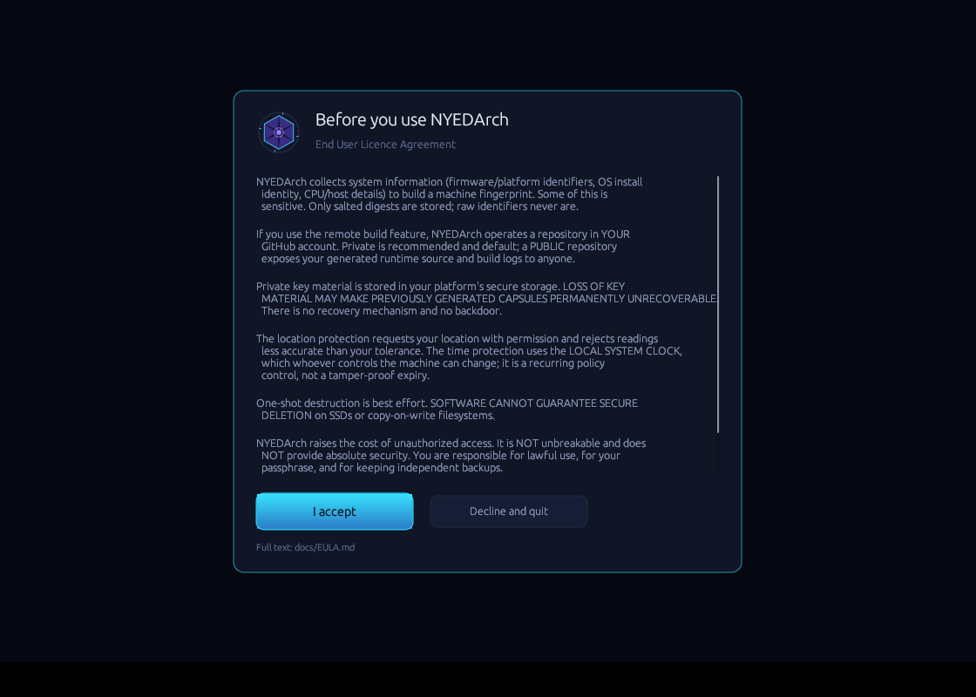
The licence gate. Nothing else in the application is reachable until this is accepted.
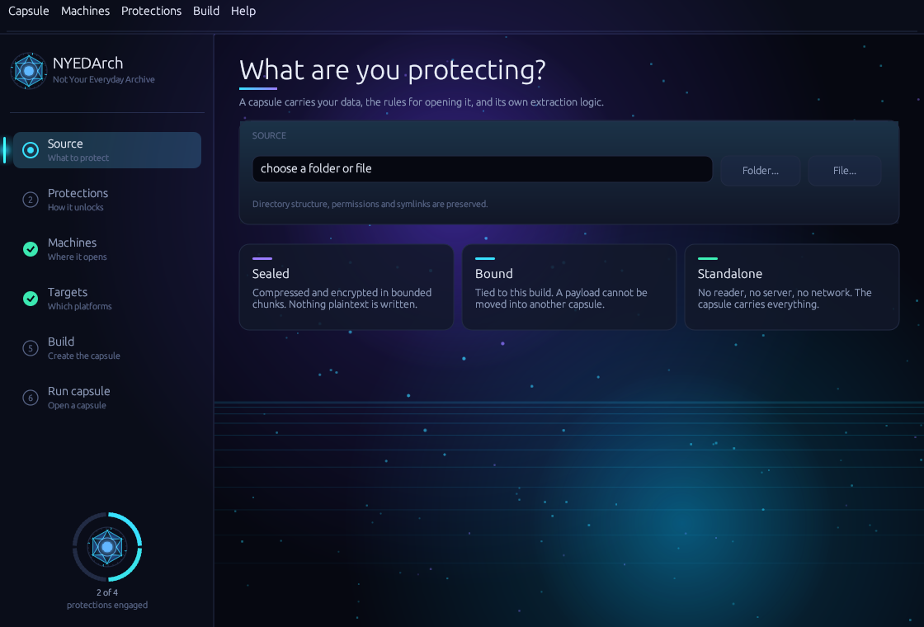
Source - choosing what to protect, with native folder and file pickers.
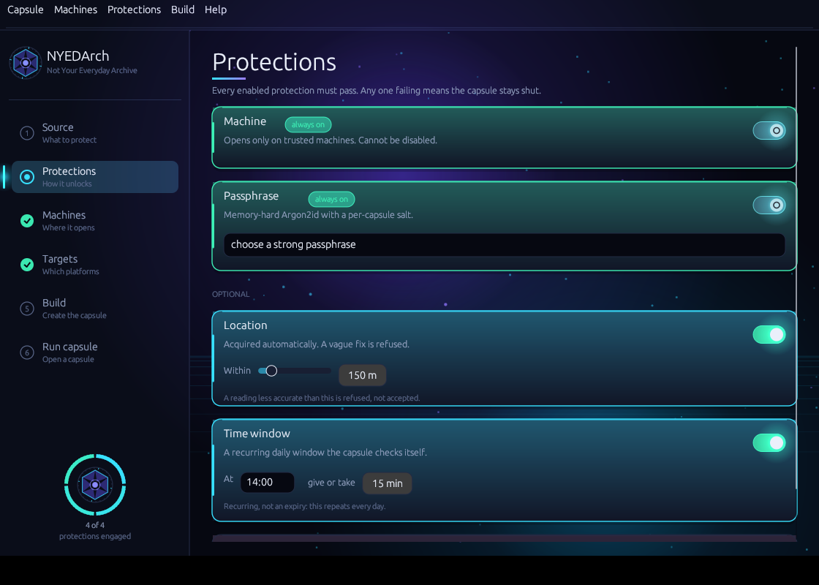
Protections - mandatory protections shown as locked switches; optional ones expand to reveal their settings.
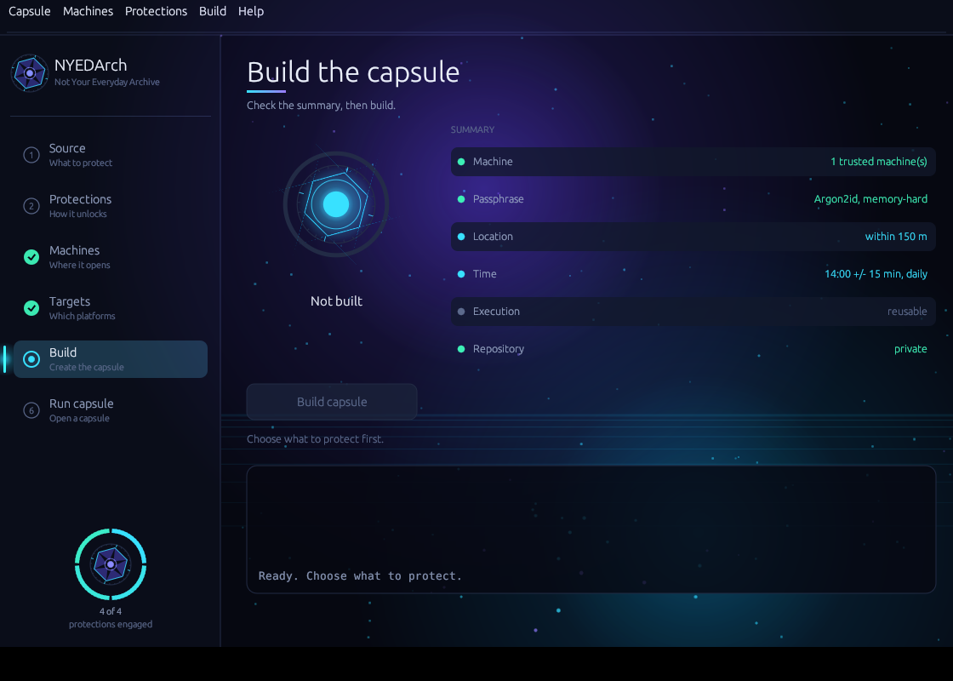
Build - the aperture and progress arc beside the capsule summary.
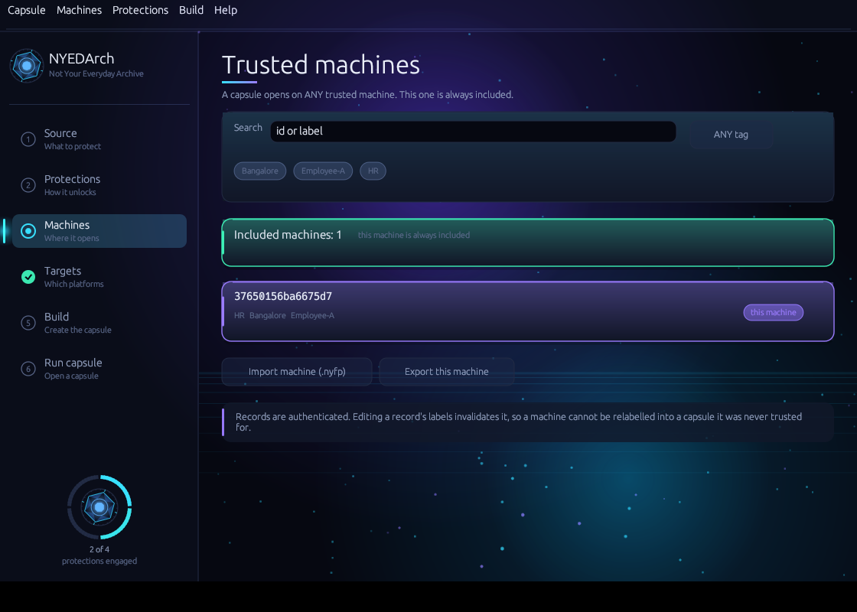
Machines - the shared registry with search, tag filters, ANY/ALL semantics, and the count of machines the capsule will trust.
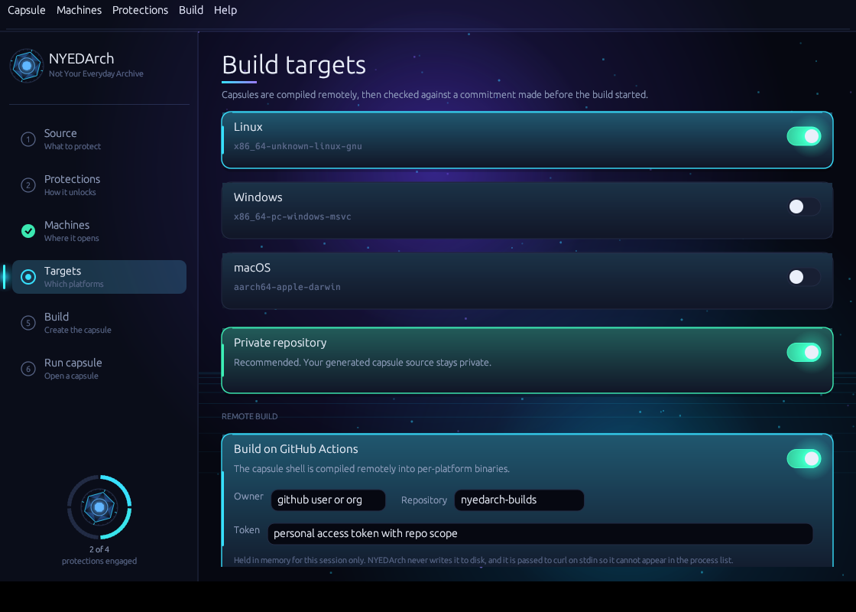
Targets - build platforms, repository visibility, and the GitHub credentials used for the remote build.
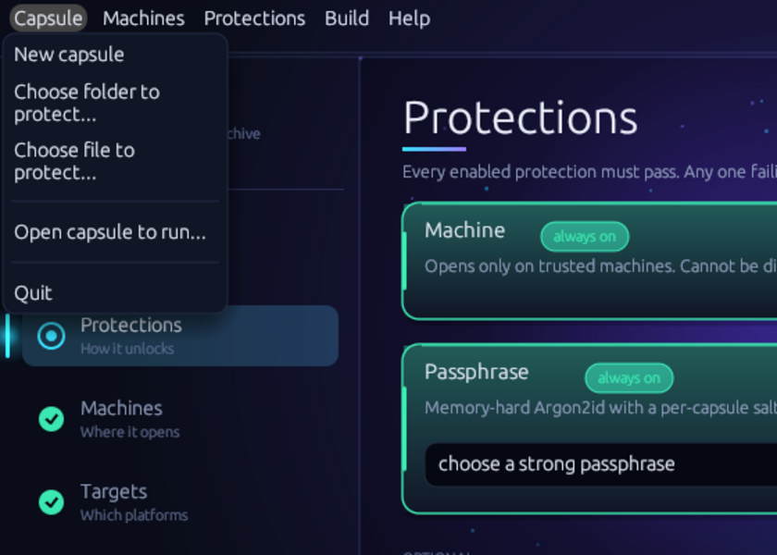
Menus - actions that live outside the stepped flow: new capsule, open a capsule, import and export machines, and the licence.
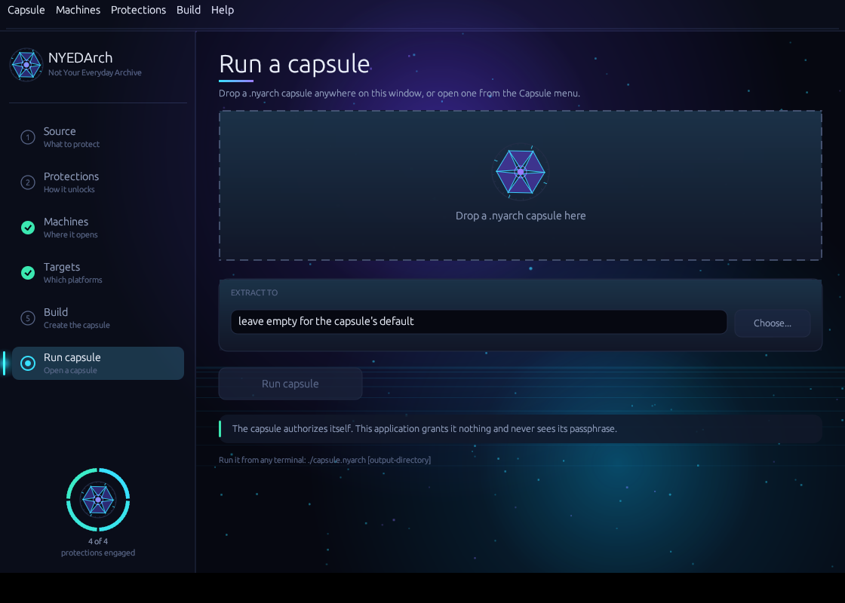
Run - the drag-and-drop target for launching a finished capsule as an independent process.

10. Test Suite — Complete Register
162 automated tests, all passing, with zero compiler warnings. Every security-relevant negative test asserts two things: that authorization was denied, and that no plaintext reached the output directory.
Suite | Tests | Focus
nyedarch-crypto (unit) | 4 | AEAD, geo rejection, policy seal, time windows
nyedarch-crypto (invariant) | 6 | The central security invariant under attack
nyedarch-core | 6 | Capsule identity, extension handling, launcher
nyedarch-fingerprint | 2 | Determinism, authenticated records
nyedarch-package | 18 | Round-trip fidelity, codec compatibility, 13 executed attacks incl. an exhaustive byte sweep
nyedarch-platform | 17 | Native providers, browser consent flow, hardware capability and policy
nyedarch-runtime (unit) | 4 | Hardening accumulator
nyedarch-runtime (authorization) | 17 | Full state machine, all four protections, constant-shape denial
nyedarch-runtime (destruction) | 17 | Overwrite, unlink, verify; delegation, inode-level scrub evidence, permission, handle, copy and tree cases
nyedarch-github | 12 | Orchestration, provenance, credentials, sealed-box secrets, stale-file pruning
nyedarch-buildtool | 23 | Protection parsing, anti-analysis, key storage, encrypted packing, machine registry
nyedarch-installer | 4 | macOS bundle layout and Info.plist correctness
Total | 162 | 0 failures, 0 warnings

10.1 Central invariant tests
These are the tests that matter most: they attack the payload key directly.
Test | What it proves | Result
authorized_open_succeeds_and_binds_runtime | Correct factors open the payload; runtime binding is enforced | PASS
wrong_fingerprint_secret_denies_payload | A wrong machine secret yields a different key; decryption fails | PASS
wrong_passphrase_denies_payload | A wrong passphrase yields a different key; decryption fails | PASS
missing_enabled_factor_fails_closed | Omitting an enabled factor is rejected, not silently ignored | PASS
attacker_cannot_downgrade_policy_to_drop_a_factor | Clearing a policy flag does not remove a factor requirement | PASS
ciphertext_tamper_is_detected | Modified ciphertext fails authentication | PASS

10.2 Authorization state machine tests
Test | What it proves | Result
authorized_run_extracts_payload | Full pipeline succeeds with correct factors | PASS
wrong_passphrase_is_denied_and_leaks_nothing | Denial plus empty output directory | PASS
untrusted_machine_is_denied | A package trusting another machine denies this one | PASS
unavailable_passphrase_fails_closed | No passphrase source means no authorization | PASS
transplanted_package_is_denied | Runtime A with package B cannot open | PASS
tampered_payload_fails_authentication | A flipped ciphertext byte is detected | PASS
corrupted_header_fails_closed | A broken magic value fails cleanly | PASS
location_ward_accepts_same_region | Correct region authorizes | PASS
location_ward_denies_different_region | A different city is denied | PASS
location_ward_rejects_poor_accuracy | Right place, insufficient accuracy, denied | PASS
location_ward_fails_closed_without_provider | No provider means denial, never a bypass | PASS
time_ward_accepts_inside_window | In-window execution authorizes | PASS
time_ward_denies_outside_window | Out-of-window execution denied | PASS
time_ward_is_day_invariant | A daily schedule still opens a year later | PASS
all_wards_together_require_every_factor | AND semantics: breaking any one protection denies | PASS

10.3 Supporting tests
Test | What it proves | Result
capture_is_deterministic | Same machine state reproduces the same fingerprint | PASS
nyfp_roundtrip_and_tamper | Edited or wrong-key records are rejected | PASS
seal_then_restore_reproduces_tree | Byte-identical restoration including multi-chunk and empty files | PASS
both_codecs_roundtrip_and_stay_readable | zstd and DEFLATE packages both open | PASS
unknown_codec_fails_closed | An unrecognised codec is refused, not guessed | PASS
credential_goes_to_the_config_stream_not_argv | Tokens never reach the process list | PASS
full_build_sequence_is_ordered | Repository key fetched before any secret is written | PASS
visibility_change_refused_during_build | Visibility cannot change mid-build | PASS
workflow_yaml_has_dispatch_and_targets | .nyarch naming, chmod, no secret echoing | PASS
accepts_expected_artifact | Valid provenance is accepted | PASS
rejects_wrong_build_target_or_digest | Mismatched build, target or digest rejected | PASS
rejects_unsigned_or_replayed_signature | Cross-build signature replay rejected | PASS
launch_restores_executable_bit_and_spawns | Launcher repairs permissions and starts the process | PASS
rejects_non_capsule_files | Non-capsule files refused | PASS
extension_is_stable_and_recognized | .nyarch recognised case-insensitively | PASS
rejects_bad_input_rather_than_disabling_a_ward | A mistyped flag errors instead of silently disabling protection | PASS

11. Experimental Results

11.1 End-to-end pipeline
$ nyedarch-buildtool seal ./secret_docs ./capsule "passphrase"
[buildtool] creator fingerprint: 0cefa0f7a072684b (Medium, 3 signals)
[buildtool] sealing 5 entries
[buildtool] package sealed: 20563 bytes
-- SECURITY REVIEW ------------------------------
MACHINE AUTHORIZATION mandatory - 1 trusted fingerprint(s)
PASSPHRASE mandatory - Argon2id m=64MiB t=2 p=1
GEOLOCATION disabled
TIME disabled
EXECUTION reusable
-------------------------------------------------
$ sh ./stage-capsule.sh
capsule: nyedarch-40d9f326c43dfdf1.nyarch (725,832 bytes, -rwxr-xr-x)
$ NYEDARCH_PASSPHRASE="passphrase" ./nyedarch-*.nyarch ./out
NYEDArch: extraction complete - 3 files, 2 dirs, 20056 bytes -> ./out
$ diff -r ./secret_docs ./out/secret_docs -> IDENTICAL

11.2 Denial behaviour
$ NYEDARCH_PASSPHRASE="wrong" ./nyedarch-*.nyarch ./out_bad
Authorization failed.
exit=1 output directory: not created
A single generic message is emitted regardless of which protection failed, so normal execution does not act as an authorization oracle. Detailed state is available only through the diagnostic trace, which is explicitly documented as providing no additional privilege.

11.3 Time protection, live
# Capsule sealed for the current window:
[state] TimeAcquisition -> KeyDerivation -> ... -> Success
NYEDArch: extraction complete - 3 files, 2 dirs, 20056 bytes
# Identical capsule sealed for a window three hours away:
[state] PassphraseAcquisition -> TimeAcquisition -> FailClosed
Authorization failed. leaked: nothing

11.4 The branch-patching experiment
This is the experiment that substantiates the central claim. Rather than asserting that authorization is cryptographic rather than boolean, the binding validation comparison was physically removed from the runtime source, the capsule was recompiled, and a package from a different build was transplanted into it.
// attacker patch simulation applied to the runtime source:
// - if diff != 0 { fail!(); }
// + let _ = diff; // comparison neutralised
Result with the check REMOVED:
[state] IntegrityCheck
[state] BindingValidation <- patched branch passed
[state] BootstrapPolicy
[state] FailClosed <- still denied
Authorization failed.
leaked: nothing
Interpretation The patched branch was passed. Extraction still failed, because the policy-seal subkey derives from the runtime's own embedded commitment rather than from any value the attacker controls. The attacker gained exactly one state transition and no plaintext. This is what "cryptographic rather than boolean-gated" means in practice.

11.5 Transplantation resistance
Attack | Outcome | Mechanism
Runtime A + package B | Denied at BindingValidation | Header commitment differs from the runtime's own
Same, with the check patched out | Denied at BootstrapPolicy | Subkey derives from the runtime's own commitment
Copied sealed payload into another capsule | AEAD authentication failure | Binding is in both HKDF info and AAD
Modified manifest | AEAD authentication failure | Manifest is a sealed, tagged chunk
Chunk reorder or truncation | AEAD authentication failure | AAD binds index and terminal flag
Artifact substitution from the build environment | Provenance rejection | Signature covers build id, target and all commitments

11.6 Capability isolation verification
$ cargo tree -p nyedarch-package -f "{p} {f}" # in the real capsule build
nyedarch-package v0.0.1 default
$ strings ./nyedarch-*.nyarch | grep -c "seal_package|nyedarch_package::build"
0 -> builder capability absent from the shipped capsule

11.7 EULA gating
Case | Behaviour | Result
Decline | Application exits without operating | Blocked
Accept | Authenticated acceptance record written | Recorded
Subsequent runs | Not re-prompted | Persisted
Record tampered (one byte flipped) | Record rejected, user re-prompted | Detected

12. Performance Benchmarks
All figures were measured by executing the release build on the reference machine. Nothing here is estimated. The reference machine is a single-core containerised Linux environment, so absolute numbers are conservative; relative comparisons are the meaningful part.

12.1 Core operations
Operation | Measured | Note
Fingerprint capture | 76–82 µs | 3 signals, Medium strength
Argon2id 64 MiB, t=2 | 96–223 ms | Prototype default
Argon2id 256 MiB, t=3 | 684 ms – 1.36 s | Recommended interactive profile
Capsule authorized run (small payload) | ~101 ms | Dominated by Argon2id
Capsule denial, early protection | ~2.0 ms | Fails before Argon2id — see 12.2
Capsule denial, passphrase protection | ~95–105 ms | Argon2id cost incurred

12.2 Throughput by codec
Codec | Payload | Seal | Seal MiB/s | Restore | Restore MiB/s | Ratio
DEFLATE | 8 MiB | 0.05 s | 151.2 | 0.01 s | 601.0 | 20.7x
DEFLATE | 32 MiB | 0.21 s | 153.3 | 0.05 s | 587.2 | 20.7x
zstd | 8 MiB | 0.05 s | 171.8 | 0.02 s | 427.6 | 23.7x
zstd | 32 MiB | 0.19 s | 172.0 | 0.05 s | 603.7 | 23.7x
zstd is the default for new packages: better ratio and better throughput on both paths.

12.3 A performance defect the benchmarks caught
Defect found by measurement The first zstd implementation bounded decompression with a fixed 64 MiB cap, which allocated 64 MiB for every 1 MiB chunk. Restore throughput collapsed to roughly 22 MiB/s — slower than DEFLATE, which is precisely what made the defect visible. It was corrected by recording the exact uncompressed length inside the AEAD-sealed chunk, so allocation happens once and a forged length cannot force a large allocation.
Stage | Restore MiB/s | Package test suite runtime
zstd, before fix | ~22 | 9.15 s
zstd, after fix | ~604 | 0.02 s
Improvement | ~27x | ~450x

12.4 Memory behaviour
Seal and restore both stream in bounded chunks, so peak plaintext memory equals one chunk regardless of payload size. A 32 MiB payload and a 32 GiB payload impose the same memory ceiling. No intermediate archive is ever materialised on disk or in RAM.

12.5 Where the time goes
Capsule startup is dominated by Argon2id. This is deliberate: it is the memory-hard passphrase cost that makes offline search expensive, not an inefficiency to be optimised away. Everything else — fingerprint capture, integrity commitments, environment probes, key composition — is measured in microseconds.

13. Security Analysis and Adversarial Review

13.1 Threat model
The attacker possesses the capsule and full knowledge of this architecture — Kerckhoffs's principle applied without exception. They can copy, disassemble, debug, patch, instrument, hook, snapshot memory, run repeatedly, manipulate the clock, virtualise, and inspect every syscall and file the capsule touches.
They do not possess the passphrase, an authorized machine, or — where those protections are enabled — the authorized region or time window.

13.2 Adversarial review results
Attack question | Answer | Basis
Can they extract the payload key? | No, not from the capsule alone | Key is HKDF over factor contributions; capsule holds no key material
Can they bypass fingerprint authorization? | Partially — weakest link | S_machine is extractable from a held capsule; passphrase protection unaffected
Can they patch one branch? | Yes, and it does not help | Demonstrated experimentally in 10.4
Can they force manual location or time? | No manual path exists | Both sides fail closed; no entry field anywhere
Can they set the clock? | Yes | Local clock is attacker-controlled; policy control, not expiry
Can they replace the fingerprint list? | No, not usefully | Sealed and AAD-bound; a forged entry pairs with a useless new secret
Can they transplant a payload? | No | Two independent mechanisms, verified in 10.5
Can they bypass integrity? | Advisory layers yes, AEAD no | Authoritative check requires the key
Can they recover plaintext from temporary files? | None are created | Direct streaming; every negative test asserts an empty output
Can they exploit logs? | No secrets logged | No passphrase, key, coordinate or raw identifier reaches any output
Can they exploit build artifacts? | Not without detection | Provenance verification against a pre-dispatch commitment
Can they observe sensitive memory? | Yes, with live access | Zeroization minimises lifetime; it is not a defence against a debugger
Can they forge authorization state? | The boolean yes, the material no | Forging 32-byte contributions is the actual requirement

13.3 What an attacker recovers immediately
This section is deliberately unflattering Any serious evaluation should begin here rather than with the capability list. These are the facts about what possession of a capsule yields.
Recoverable from a held capsule | Consequence
K_bootstrap and C_runtime (embedded constants) | Can unseal the policy record
Policy record: fingerprint digests and S_machine secrets | Obtains the machine factor for capsules already held
Package salt, id, policy flags, Argon2 parameters | Public by design
All code paths and the state machine | Assumed public
It follows that the machine protection is not a standalone confidentiality boundary. For a capsule in hostile hands it constrains convenience and forces per-capsule reverse engineering; it does not stop a determined analyst on its own. What remains is the passphrase protection, which is why it is memory-hard and mandatory.

13.4 Measured side channel
Protection evaluation is ordered and returns on first failure, so denial latency reveals how far execution progressed. This was measured rather than assumed:
Denial stage | Before | After
Binding or machine failure | ~2.0 ms | ~105 ms
Passphrase failure | ~95-105 ms | ~117 ms
Ratio | ~50x | ~1.1x, within noise
The original separation was distinguishable in a single run without statistics, and told an attacker whether they had cleared the machine protection - exactly what the generic failure message exists to hide.
Authorization is now constant-shape. Every protection is evaluated and key derivation always runs before any verdict is returned; a protection that fails contributes a random decoy of the right shape rather than returning early, so the run continues and fails at authenticated decryption like every other denial. The decoys are random rather than fixed, because a constant would be a recognisable marker in memory and a reused one would let an attacker confirm which protection failed by watching for it.
An intermediate version still leaked A first attempt kept an `authorized` flag and short-circuited on it. That still distinguished causes: flag failures stopped at payload authentication while a wrong passphrase ran on to decryption. The flag was removed from the control flow entirely - there is no branch left to patch, and the cryptography decides. Caught by the test that compares state traces, not by inspection.
The cost, accepted deliberately, is that every denial now pays the memory-hard passphrase cost. That work is what makes the oracle disappear. Verified by a test asserting that six different denial causes produce identical state traces, plus the measurements above.

13.5 Anti-tamper: an honest accounting
A tempting claim would be that anti-debugging results are mixed into key derivation, so patching a check yields the wrong key. That claim would be false, and the design would be broken. Key material must be exactly reproducible on every legitimate run; debugger state, timing and loaded libraries are not reproducible. A key derived from them would lock out honest users on a busy machine and require a fallback — precisely the silent downgrade the design forbids.
Category | Examples | Role
Deterministic commitments | Package bytes, per-build diversifier, runtime commitment | May and do participate in cryptography
Environment observations | Debugger presence, timing anomalies, injection markers | Defense-in-depth only; not key material, not a gate
The environment probes are folded into a tamper accumulator used for control-flow diversification, and are deliberately not consumed as a single "if detected then exit" gate, since one patched branch would defeat that. They raise analysis cost. They do not prevent extraction by an attacker who defeats them, and are not claimed to.

13.6 Defects found and fixed during review
Six substantive defects were discovered by adversarial review and correction passes rather than by test failure. They are recorded because the record of what went wrong is part of an honest engineering account.
Defect | Why it mattered | Resolution
runtime_binding was read only from the package header | The capsule never asserted its own identity; binding rested on a single mechanism | Policy-seal subkey now binds the runtime's embedded commitment
Builder capability compiled into every capsule | Package-construction code shipped into hostile-environment binaries | Moved behind a non-default feature; verified absent
Crypto core had an unconditional OS dependency | The auditable boundary carried platform responsibility | Randomness injected via trait; builds with zero platform surface
Time windows embedded the absolute day | A "daily" schedule would have opened on one day only | Made day-invariant; regression test opens a year later
Hardening docs claimed probes fed key derivation | False, and would have produced a broken design | Corrected to separate deterministic commitments from advisory probes
No artifact provenance existed | A hash match does not prove an artifact belongs to a build | Build manifest, signed input, replay resistance

13.7 Outstanding limitations
# | Limitation | Prototype-I status | Future integration
1 | S_machine is extractable from a held capsule; the machine protection is not standalone | Needs hardware attestation | Partly — a server key share adds a factor absent from the binary. Hardware attestation remains the real fix and is independent of licensing
2 | Protection-order timing side channel | Fixed: ~50x reduced to ~1.1x | No longer a dependency for licensing work
3 | Local clock is attacker-controlled | Needs authenticated time | Yes — authenticated server time
4 | Location and time are low-entropy policy factors, not entropy sources | Inherent | No — inherent to what they are
5 | No anti-hooking or control-flow flattening | Omitted deliberately | No — unrelated
6 | Zeroization does not defeat live memory capture, swap or core dumps | Inherent | No — outside what software can prevent
7 | Self-destruction cannot guarantee erasure on SSD or copy-on-write filesystems | Inherent | No — but revocation makes a surviving capsule unopenable, which is the stronger control
8 | No revocation once a capsule is distributed | Not possible standalone | Yes — withholding the key share. Already-extracted plaintext still cannot be recalled
The one that gets worse Row 2 deserves emphasis. Adding a network round trip in front of the protection sequence widens the measured oracle, because a server denial returns before Argon2id runs. The License Server roadmap therefore places constant-time protection evaluation in Prototype-I as work item zero, before any licensing work begins. Fixing it afterwards would mean shipping a known and worsened weakness inside a paid product.
On the word "unbreakable" NYEDArch is never described as unbreakable, impossible to reverse engineer, or mathematically immune to attack. The accurate formulation is that it raises the cost, difficulty and expertise required for unauthorized extraction. Every mechanism in Section 13.5 is bypassable by a competent analyst given the binary, time and tooling.

14. Forward Architecture — NYEDArch License Server
Scope boundary This section is architecture and design intent only. No part of the License Server is implemented, scaffolded, stubbed or simulated in the current codebase. Prototype-I is a standalone, unlicensed variant intended for internal reference, architecture development and demonstration. Items marked OPEN await product decisions and are not assumed here.

14.1 Why it exists
Prototype-I has structural limitations that no amount of local engineering can resolve, because they require an authority outside the capsule. The License Server is that authority.
Prototype-I limitation | Future integration | What changes | What remains
Local system clock is attacker-controlled | Authenticated server time | Time windows become resistant to local clock manipulation | Network delay and skew must still be handled honestly
No revocation once a capsule is distributed | Centralized revocation | A compromised capsule can be denied server authorization | Already-extracted plaintext cannot be recalled
No account identity or MFA | Mandatory account identity with mandatory MFA | Operator identity becomes verifiable and recoverable | Endpoint compromise remains possible
No authenticated audit history | Signed, ordered capsule lifecycle events | Authorization attempts become visible to the owner | Events the capsule never sends cannot be received
No recovery when hardware changes | Controlled failsafe with MFA plus email approval | A legitimate user regains access after a hardware change | Recovery is an attack surface and must be rate-limited
No centralized misuse detection | Risk scoring across accounts and capsules | Patterns invisible to a single capsule become detectable | Detection is probabilistic, never guaranteed

14.2 Fixed decisions carried into the design
The following are settled product decisions and are treated as constraints rather than options:
- Internet connectivity is mandatory for the first licensed version. Both the Builder and the capsule fail closed without it. No silent offline fallback and no grace period.
- A capsule requires its own runtime authorization relationship with the server. It is not sufficient that the Builder held a license at creation time.
- The server must contribute meaningful authorization material or cryptographically authenticated policy — never a boolean that a patched branch can replace.
- The server must never hold plaintext payloads or user passphrases. The Prototype-I confidentiality model is preserved, not replaced.
- MFA enrolment is mandatory before an account becomes fully operational, using standards-based authenticators, with passkeys and WebAuthn preferred over TOTP alone.
- There is no free tier. Terms are three months, six months and one year, with renewal required.
- A license key is displayed exactly once and is never retrievable in plaintext afterwards.
- A revoked license stays revoked permanently; remaining term may be transferred to a replacement depending on the reason for revocation.
- Temporary restrictions escalate exponentially on repeat — for example one week, then one month — which raises the cost of brute-force attempts.

14.3 The capsule authorization protocol
The naive design — POST a license check and trust a returned boolean — is explicitly rejected, for exactly the reason the Prototype-I branch-patching experiment demonstrates. The server must participate in the key path.
Capsule startup
-> runtime integrity and security initialization
-> authenticated connection to NYEDArch
-> capsule identity verification (capsule, package, runtime identity)
-> license and entitlement verification
-> server-side policy evaluation
-> authenticated authorization response (server challenge/response,
replay-resistant, freshness-bound, policy-version-bound)
-> local authorization factors (machine, passphrase, location, time)
-> payload key release / unwrapping
The architectural requirement is that the server contributes a cryptographic component to the composed key rather than a permission flag, so that patching the response handler yields no payload — the same principle already demonstrated locally in Section 11.4.

14.4 The failsafe path
A legitimate user whose hardware changed, or who is working on a trusted machine that was never enrolled, needs a route that does not weaken the model. The intended design combines: a valid license, an MFA code, and an out-of-band email approval by the account owner, after which the local factors must still be satisfied.
Design tension to resolve Recovery is the highest-value target in any system with mandatory MFA. A failsafe that bypasses the machine protection must not become a general-purpose bypass. Delayed approval windows, cancellation periods, notification to all registered contacts, and exponentially escalating restrictions on repeated attempts are the intended counterweights.

14.5 The enterprise scenario this enables
The fingerprint import, export, labelling and search facilities exist so that the same product serves an individual with two machines and an enterprise with thousands. The HR example is illustrative of the intended composition of protections:
An organisation seals employee records into a capsule whose trusted fingerprint set contains the registered company machines of HR personnel plus the single employee to whom the record belongs. The location protection is set to the office premises and the time protection to working hours. The result is that the record cannot be opened outside the office, outside working hours, or on any machine outside that set — including by the organisation's own executives. This addresses insider and outsider exfiltration in the same construction, which is difficult to achieve with server-mediated DRM alone.

14.6 Honest limits of the licensed architecture
- Self-deletion requested is not self-deletion cryptographically confirmed. If a capsule destroys itself before its final event is acknowledged, the server cannot honestly claim confirmation.
- An audit log stored in a database is not immutable merely because it is in a database. Tamper-evidence must be a specific cryptographic construction with stated guarantees.
- A License Server does not eliminate endpoint compromise. A compromised Builder machine remains compromised.
- Risk detection is probabilistic. No automatic response should follow from a single heuristic.

14.7 Settled: server key share and expiry semantics
Two decisions previously carried as open have been settled by the product owner. Both are recorded here with their consequences, because each converts an availability property into a data-availability property and that must be visible in the architecture rather than discovered during operations.
Decision | Ruling | Direct consequence
Server contribution to the payload key | A true key share | The server participates materially in key composition. A patched response handler yields no payload — the intended property. It also means no capsule can be opened while the server is unreachable
Behaviour on license expiry | Capsules stop opening | Entitlement is continuously enforced, not merely at build time. An expired licence denies access to previously created capsules

14.7.1 What the key-share decision imposes on the server
Holding a key share is a materially stronger obligation than issuing signed policy, and the architecture must be built for that from the start:
- The share database becomes the highest-value asset in the system. A breach yields one authorization factor for every capsule ever issued — not plaintext, since the passphrase and machine factors remain, but it removes a layer for the entire installed base at once.
- Shares must therefore be wrapped by an HSM or managed KMS, never stored in plaintext in an application database, and never exportable in bulk by any single operator role.
- Availability becomes a data-availability guarantee. Redundancy, geographic replication and rehearsed failover are correctness requirements, not operational polish. Scheduled maintenance must drain traffic to standby capacity before any change.
- Replication propagates the most sensitive material by design, so every replica inherits the full protection requirement — replicas cannot be treated as lower-tier infrastructure.
- Share loss is unrecoverable by construction. Backup and restore of the share store must be proven by rehearsal, because there is no cryptographic path back.
Consequence to state to customers plainly Under these two rulings, continuity of the NYEDArch service is a precondition for continued access to sealed data, and an expired licence denies access to capsules that already exist. This is a defensible commercial model, but it must be disclosed prominently in the EULA and purchase flow rather than discovered at renewal. Customers holding long-lived archives should be advised to extract before expiry, and an explicit pre-expiry notification sequence is a product requirement rather than a courtesy.

14.8 Tier model
No free tier. Terms are three, six, or twelve months, renewable; there is no perpetual licence.
 | Seal (base) | Seal Pro | Vault (team) | Vault Enterprise
Machine protection | Yes | Yes | Yes | Yes
Passphrase protection | Yes | Yes | Yes | Yes
Time protection | — | Yes | Yes | Yes
Location protection | — | — | Yes | Yes
Cryptographic strength | Full | Full | Full | Full
Org management | — | — | Yes | Yes
Failsafe approvers | Owner | Owner | Admin + optional | Admin + required
Audit retention | Configurable, short | Configurable | Configurable, long | Configurable, longest

14.8.1 Why gating time and location does not breach the no-upsell principle
The governing principle is that core security must not be sold as an upgrade. That principle is honoured, and the reasoning must be stated in exactly these terms rather than blurred into "more security at higher tiers":
- Every tier receives identical cryptographic strength — same AEAD, same Argon2id parameters, same key composition, same integrity and binding.
- Both mandatory protections, which are the actual confidentiality boundary, are present at every tier.
- Location and time are low-entropy policy factors, documented as such throughout Prototype-I. They constrain where and when; they add no meaningful entropy and do not strengthen the cryptography.
A base-tier customer is not receiving weaker encryption. They are receiving fewer policy controls. If that framing were ever contradicted — for example by weakening KDF parameters at lower tiers to reduce server cost — the principle would be broken, and it must not be.

14.9 Remaining settled decisions
Question | Ruling | Consequence
Telemetry retention | User-configurable, bounded per tier | Shorter is the default; fixed floors exist only where an active investigation requires them, and are disclosed rather than silently applied
Failsafe approval, individual | Account owner only | Licence + MFA + out-of-band email approval; local protections still apply
Failsafe approval, enterprise | Team admin + optional additional reviewers | Configurable per organisation, so regulated tenants can require two or three approvers while small teams require one
Mandatory-online scope | Every capsule execution | Follows necessarily from the key-share ruling: the share is required at each key composition, so there is no activation-only variant
The failsafe substitutes for the machine protection only. The passphrase remains required, and location and time remain in force where enabled — it is not a master key. Its honest weakness is that a sufficiently complete account compromise, covering password, MFA and email, defeats it. The counterweights are notification, delay and exponential escalation, not a claim of impossibility.

14.10 Documentation set
The full future architecture is drafted as sixteen documents under docs/license-server/, covering the overview, service architecture, identity and MFA, licensing and entitlements, Builder integration, capsule authorization, the capsule-to-server protocol, audit and forensics, security monitoring, key management, distribution and updates, payments, threat model, incident response, privacy and data model, and the integration roadmap. No part of it is implemented.
Sequencing dependency The roadmap places one item before licensing work begins: fixing the measured protection-order timing oracle in Prototype-I. Adding a network round trip in front of an existing oracle widens it, because a server denial returns before Argon2id runs. Fixing it afterwards would mean shipping a known weakness inside a paid product.

15. Originality and Intellectual Property Record
No legal claim is made This section records engineering provenance to support intellectual-property work. It does not assert patentability, and novelty of appearance is not treated as evidence of novelty in law.

15.1 Established primitives, used as such
NYEDArch invents no cryptographic primitive. XChaCha20-Poly1305, Argon2id, HKDF-SHA512, HMAC-SHA512, SHA-256 and zstd are established, widely reviewed constructions used through maintained implementations. Inventing a primitive to appear novel would be a defect, not a contribution.

15.2 Where the specific work lies
Area | The specific construction | Distinguishing property
Multi-factor key composition | Domain-separated per-factor contributions concatenated as HKDF input keying material, with presence strictly matched to policy | Bypassing a branch cannot synthesise a missing contribution; demonstrated experimentally
Fingerprint bootstrap resolution | A fingerprint selects a minted high-entropy secret rather than deriving a key from machine data | Avoids the circular dependency of needing the fingerprint to decrypt the fingerprint list
Package-to-runtime binding | Policy-seal subkey derived from bootstrap key concatenated with the runtime's own embedded commitment | Transplantation fails cryptographically, not by a comparison that can be patched
Adaptive fingerprinting with disclosure | Strength-tagged signal discovery with recorded availability inventory | Degrades on capability-poor machines without silently substituting weak evidence for strong
Deterministic geographic quantization as a policy factor | Latitude-scaled grid cell with accuracy rejection below configured tolerance | Refuses to accept a reading that cannot prove the claimed region
Day-invariant recurring time windows | Window identifier over time-of-day, tolerance and offset, excluding the absolute day | A recurring policy genuinely recurs rather than silently becoming single-day
Artifact provenance for untrusted build environments | Pre-dispatch build manifest with a signed input covering build, target and three commitments | Establishes that an artifact is the output of a specific build, not merely that bytes match
Capability isolation by build feature | Package-construction code compiled out of the distributed artifact | The hostile-environment binary cannot be repurposed as a packer

15.3 Reference material and independence
An existing project was consulted strictly as a technical reference for GitHub-based build orchestration concepts — authentication, repository initialization, Actions triggering, live logs and artifact retrieval. Its user interface, visual identity, terminology, layout, navigation and interaction model were not used. No code or dependency from it exists in NYEDArch. The orchestration layer was redesigned around NYEDArch's own security model, including artifact provenance, which the reference concept does not address.
The user interface, terminology and design language were independently conceived for NYEDArch.

15.4 Decision record
ADR | Decision | Category
0001 | XChaCha20-Poly1305 selected for payload AEAD | Security
0002 | Toolchain pins (superseded by 0005) | Implementation
0003 | Geographic quantization scheme | Security
0004 | Architecture correction pass — eight structural corrections | Architecture / Security
0005 | Toolchain upgrade to Rust 1.91.1 and zstd adoption | Implementation / Performance

16. Status, Roadmap and Conclusion

16.1 Phase completion
Phase | Status | Evidence
1 Architecture and threat model | Complete | Architecture and threat model documents
2 Cryptographic and package specification | Complete | Crypto format and key hierarchy documents
3 Workspace and module boundaries | Complete | 8 crates with enforced feature separation
4 Package, encryption, fingerprint | Complete | Round-trip and fingerprint tests
5 Runtime generation | Complete | Capsule compiled and executed
6 GUI | Code complete | Compiles with zero warnings; needs a display to render
7 GitHub orchestration | Complete | Transport verified against the live API
8 Cross-platform | Verified on all three | Test suite, fingerprinting, capsule build and run, key storage, build scripts, installer and the macOS bundle all exercised on real runners
9 Hardening | Complete | Anti-RE analysis, tamper accumulator
10 Adversarial review | Complete | 15 questions; 6 defects found and fixed
11 Performance | Complete | Measured; one defect found by measurement
12 Documentation | Complete | 14 documents plus this dossier

16.2 What has not been executed
Stated explicitly so that no reader over-reads the verification status:
- The macOS location permission prompt is still unverified: CoreLocation compiles and the bundle carries the usage description, but a headless runner has no location services and nobody to grant permission. That needs a Mac with a user in front of it.
- macOS CoreLocation now compiles on a real macOS runner and produces a capsule. What remains unverified is runtime behaviour: that the permission prompt appears and returns a fix on a Mac with the bundle installed.
- No release-mode desktop binary is shipped: the link-time-optimised build exceeds the time budget of the build environment used here. Both build scripts include it automatically where it completes.
- The GitHub transport is verified against the live API; a complete authenticated build requires an account and token.
- TPM and Secure Enclave attestation are designed for but not implemented.

16.3 Building and distributing
The repository ships a single build script. It verifies the toolchain, runs the full test suite, refuses to produce a release from a failing build, compiles the workspace and desktop client, confirms the cryptographic core still builds with zero platform surface, measures performance on the build machine, and assembles a release directory.
./build.sh # test, build, benchmark, assemble ./release
./build.sh --skip-gui # omit the desktop client
./build.sh --clean # discard previous artifacts first
release/
bin/nyedarch command-line client
bin/nyedarch-gui desktop client with drag-and-drop launcher
runtime-src/ runtime crates vendored into generated capsules
docs/ architecture, security, threat model, EULA
docs/license-server/ future architecture (design only)
START_HERE.md end-user guide
BUILD_INFO.txt toolchain, revision, test result
SHA256SUMS integrity checksums
A distribution defect found by testing the release, not the source Generated capsule projects originally referenced the NYEDArch crates by absolute path on the machine that produced them. Everything worked in development and would have failed for every real user — and equally on the GitHub runner, which has no NYEDArch source tree. Generated projects now vendor the six runtime crates and declare their own workspace root, so they are self-contained. Verified by hiding the source tree entirely and building and running a capsule from the release directory alone.

16.4 Engineering priorities
Priority | Work | Addresses
1 | Hardware-attested machine identity (TPM sealing, Secure Enclave) | The S_machine extractability weakness — the most significant open item
2 | Hardware-attested identity follow-through (TPM sealing, Secure Enclave) | The S_machine extractability weakness
3 | Platform execution on macOS and Windows | Completes cross-platform verification
4 | Authenticated time source | Local clock trust
5 | License Server implementation (architecture drafted — see Section 14 and docs/license-server/) | Revocation, identity, authenticated time, audit, recovery

16.5 Conclusion
NYEDArch demonstrates that authorization policy can travel inside data as a cryptographic property rather than as a procedural check enforced by external infrastructure. The central claim — that bypassing a conditional branch does not yield the payload — was substantiated by removing the branch, recompiling, and observing that extraction still failed.
The prototype is complete and functional: 53 tests pass, the full pipeline executes end to end, throughput is measured rather than asserted, and the capsule produced is a real executable that restores its payload byte-identically on an authorized machine and refuses everywhere else.
Equally, this document records what does not work. The machine protection is not a standalone confidentiality boundary. A timing oracle exists and is measured. The clock is trusted. Three platforms are designed for and one is exercised. These are stated because a security product whose documentation cannot be trusted is worth less than one with fewer features and an honest account of them.
The forward architecture is drafted to the same standard. Sixteen documents specify the License Server that adds revocation, authenticated time, identity, audit and recovery — and they are equally explicit that mandatory connectivity trades away the offline property, that expiry denies access to capsules that already exist, and that one existing weakness gets worse before it gets better. None of it is implemented; Prototype-I remains standalone.
Final statement NYEDArch raises the cost, difficulty and expertise required for unauthorized extraction. It does not make extraction impossible, and no claim to the contrary is made anywhere in this document or in the implementation.

