Mr. Phuc – 23521203@gm.uit.edu.vn
Mr. Toan – 23521601@gm.uit.edu.vn
Mr. Tri – 23521641@gm.uit.edu.vn

Prepared for
Driver's License Training and Testing System Project
Version 1.0
SOFTWARE REQUIREMENTS SPECIFICATION
Driver's License Training and Testing System

Revision and Sign Off Sheet
Change Record
Author | Version | Change reference | Date
Huynh Nhat Toan | 0.1 | Initialize document | 01/03/2026
Huynh Nhat Toan | 0.2 | Add some use case description | 15/03/2026
Nguyen Dang Phuc | 0.3 | Update use case diagram and introduction | 29/04/2026
Huynh Nhat Toan | 0.4 | Update business rules and message list | 13/05/2026
Nguyen Dang Phuc | 0.5 | Review and updates | 20/05/2026
Ngo Minh Tri | 1.0 | Review | 25/05/2026
Reviewers
Name | Version | Position | Date
Huynh Nhat Toan | 0.1 | Application Owner | 01/03/2026
Huynh Nhat Toan | 0.2 | Application Owner | 09/04/2026
Huynh Nhat Toan | 0.3 | Application Owner | 20/04/2026
Nguyen Dang Phuc | 0.4 | Application Owner | 01/05/2026
Nguyen Dang Phuc | 0.5 | Application Owner | 20/05/2026
Ngo Minh Tri | 1.0 | Application Owner | 25/05/2026

Table of Contents

1. Introduction 6
1.1. Purpose 6
1.2. Scope 6
1.3. Intended Audiences and Document Organization 6
2. Functional Requirements 8
2.1. Use Case Description 8
UC1: Login 8
Activities Flow 8
Business Rules 8
UC2: Forgot Password 9
Activities Flow 10
Business Rules 10
UC3: Create User Account 11
Activities Flow 12
Business Rules 12
UC4: Update User Account 13
Activities Flow 14
Business Rules 14
UC5: Lock User Account 15
Activities Flow 16
Business Rules 16
UC6: Assign License Categories To Students 17
Activities Flow 17
Business Rules 18
UC7: View Detailed Course List 18
Activities Flow 19
Business Rules 19
UC8: Create Course 20
Activities Flow 20
Business Rules 21
UC9: Update Course 21
Activities Flow 22
Business Rules 22
UC10: Delete Course 23
Activities Flow 24
Business Rules 24
UC11: Take Theory Exam 25
Activities Flow 26
Business Rules 26
UC12: Manage Exam Session 27
Activities Flow 28
Business Rules 28
UC13: Submit Exam 29
Activities Flow 29
Business Rules 30
UC14: Grade Exam 30
Activities Flow 31
Business Rules 31
UC15: View Exam Results 32
Activities Flow 33
Business Rules 33
UC16: Review Exams 34
Activities Flow 34
Business Rules 34
UC17: Search Question Bank 35
Activities Flow 36
Business Rules 36
UC18: Create Question 37
Activities Flow 37
Business Rules 37
UC19: Update Question 38
Activities Flow 39
Business Rules 39
UC20: Delete Question 40
Activities Flow 40
Business Rules 40
UC21: Create Exam Template 41
Activities Flow 42
Business Rules 42
UC22: Update Exam Template 43
Activities Flow 43
Business Rules 43
UC23: Delete Exam Template 44
Activities Flow 45
Business Rules 45
UC24: Auto-generate Exam Papers 46
Activities Flow 46
Business Rules 46
UC25: View Student List 47
Activities Flow 48
Business Rules 48
UC26: Track Learning Progress 49
Activities Flow 49
Business Rules 49
UC27: View Exam History 50
Activities Flow 51
Business Rules 51
UC28: Reset Learning Progress 52
Activities Flow 52
Business Rules 52
UC29: Send Academic Warnings 53
Activities Flow 54
Business Rules 54
UC30: View Maneuver Checkpoint Details 55
Activities Flow 55
Business Rules 56
UC31: View General Maneuver Errors 56
Activities Flow 57
Business Rules 57
UC32: Review Frequently Missed Questions 58
Activities Flow 59
Business Rules 59
UC33: Logout 60
Activities Flow 61
Business Rules 61
UC34: View my learning progress 62
Activities Flow 63
Business Rules 63
UC35: 2D Driving Practice 64
Activities Flow 65
Business Rules 65
UC36: Error Feedback Within Session 66
Activities Flow 67
Business Rules 67
2.2. List Description 68
2.3. View Description 68
3. Non-functional Requirements 68
3.1. User Access and Security 68
3.2. Performance Requirements 70
3.3. Implementation Requirements 71
4. Appendixes 72
Glossary 72
Messages 72

Introduction

Purpose
This document is the comprehensive Software Requirements Specification (SRS) and Design Document for the Driver's License Training and Testing System. It captures detailed functional and non-functional requirements, design constraints, and architecture guidance that will direct the system's implementation. The document is a key reference for developers, system architects, test engineers, and operations staff, providing a roadmap for application behavior, exam delivery, data handling, and deployment.
The primary purpose of this document is to specify the software requirements for the Driver's License Training and Testing System and to establish a clear design framework that supports reliable exam delivery, student management, instructor and center operations, and regulatory reporting. By detailing features, interfaces, and quality attributes, the document ensures a shared understanding of project goals among stakeholders.

Scope
The SRS covers both functional and non-functional requirements for the Driver's License Training and Testing System. It defines how the system components (web/mobile client, exam engine, user management, question bank, reporting, and admin consoles) will operate and interact. The scope includes user interactions (students, instructors, center managers, admins), exam delivery and recording, license category assignment, performance and availability requirements, data retention, security controls (authentication, RBAC), and deployment considerations for production exam hosting.

Intended Audiences and Document Organization
This document describes responsibilities and expectations for teams involved in designing, building, testing, and operating the Driver's License Training and Testing System. It also guides external stakeholders such as regulatory auditors and training center managers.
This document is intended for:
- Development team: Implement features, APIs, and integration according to the SRS; perform unit and integration testing.
- Documentation team: Produce user guides, admin manuals, and operational runbooks for instructors, center managers, and system administrators.
- UAT and QA teams: Validate the system against acceptance criteria, simulate exam delivery, and confirm conformance to regulatory requirements.
- Instructors and Center Managers: Use the system for student enrollment, license category assignment, scheduling, and monitoring exam sessions.
- System administrators and DevOps: Deploy, monitor, and maintain the production environment, backups, and disaster recovery.

Below are main sections of the document:
- 1. Introduction: This section describes the general introduction of this document.
- 2. Functional Requirements: This section describes the functional requirements in detail.
- 3. Non-functional Requirements: This section describes the non-functional requirements of this application such as user access and security, interfaces, screens and performance.
- 4. Appendixes: This section describes other requirements for this application and other supporting information for this document.

Functional Requirements

Use Case Description

UC1: Login
Name | Login
Description | This use case describes the process by which a user logs into the system.
Actor | All users
Trigger | When the user clicks the "Login" button.
Pre-condition | The user is not logged in to the system. The login page is available.
Post-condition | The user is logged in to the system. The user is redirected to the home page.

Activities Flow
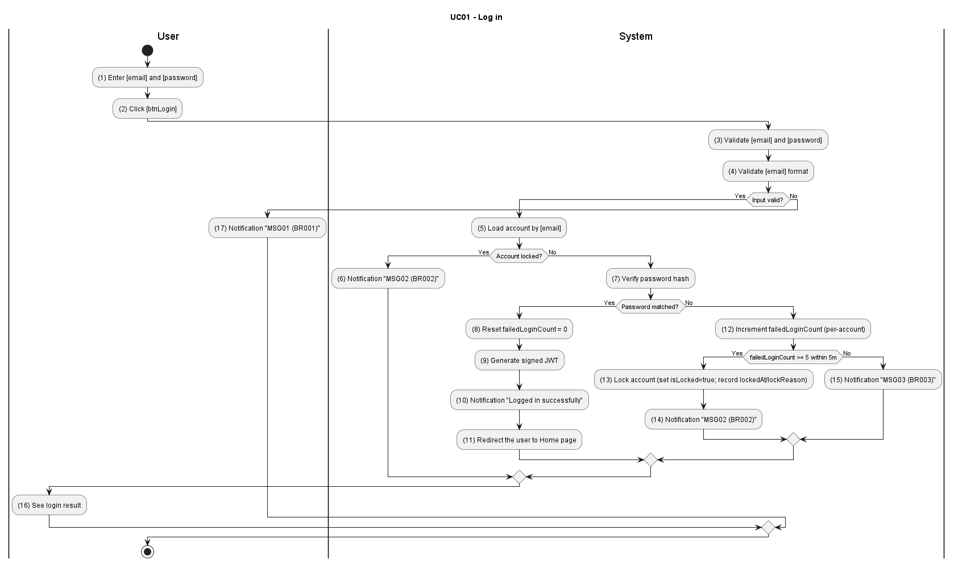

Business Rules
Activity | BR Code | Description
(3) | BR001 | Validate Rules:  - The system checks the items [email] and [password].  - If any of them is null or blank, or [email] format is invalid, the system will show an error message MSG01.
(5) | BR002 | Message Rules:  - The system loads the account by [email] and checks [isLocked].  - If the account is locked, the system will show an error message MSG02.
(7) | BR003 | Message Rules:  - The system verifies hash([password]) against the stored credential and updates failed-attempt counters.  - If invalid credentials are provided, the system will show an error message MSG03.
(12) | BR004 | Brute-force / Account Lock:  - When 5 or more failed login attempts occur for the same account within a 5-minute window, set [isLocked=true], record lock metadata, and return MSG02. Failed attempts are tracked per-account.  - Account lock is primary (Keycloak). WAF/IP rate-limiting is recommended as complementary.
(11) | BR005 | Redirect Rules:  - Keycloak issues a JWT access token and refresh token with role claims. The identity-service returns the auth payload to the client. The system redirects the user to the home page.

UC2: Forgot Password
Name | Forgot Password
Description | This use case describes the process of a user requesting a password reset via a single-use reset link containing a UUID token sent via email.
Actor | All users
Trigger | When the user submits a forgot-password request from the Login screen.
Pre-condition | The user is not logged in and provides a registered email address.
Post-condition | A valid reset token is consumed and the account password is updated securely.

Activities Flow
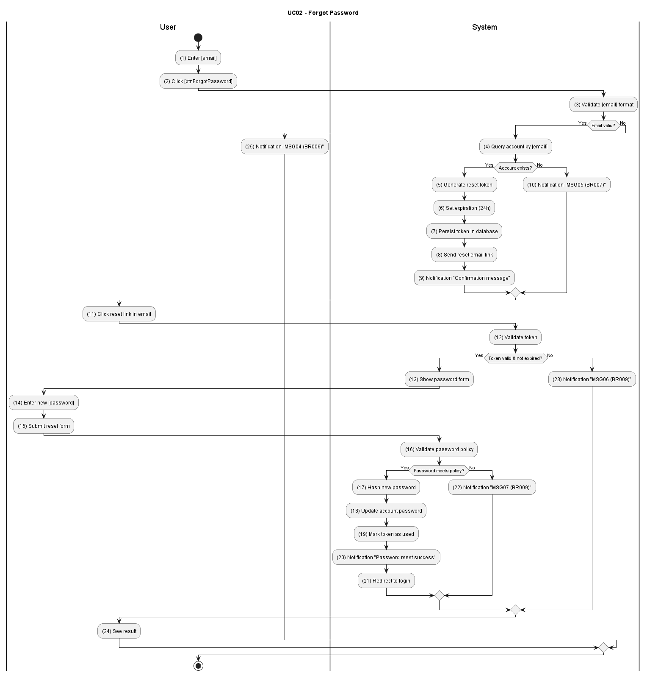

Business Rules
Activity | BR Code | Description
(3) | BR006 | Validate Rules:  - The system validates the [email] format.  - If the email is null, blank, or invalid the system returns MSG04.
(4) | BR007 | Message Rules:  - The system queries the account by [email].  - If the account does not exist the system returns MSG05.
(5) | BR008 | Generate Link Rules:  - Keycloak's built-in Forgot Password flow generates a single-use reset token (UUID) with TTL = 15 minutes and dispatches it via the configured email provider. Token lifecycle is managed entirely within Keycloak — no external token store is used.
(12) | BR009 | Validate Rules:  - The system validates the reset token state (exists, unused, not expired) and enforces password policy for the new password.  - If invalid token or policy fails the system returns MSG06 or MSG07.
(20) | BR010 | Success Response:  - The system hashes and updates the password, marks the token as used, and returns confirmation (MSG).

UC3: Create User Account
Name | Create User Account
Description | This use case describes the process of admins or center managers creating a new user account in the system
Actor | Admin, Center Manager
Trigger | When the actor submits the create-account form on User Management.
Pre-condition | The actor is authenticated with account-management permission.
Post-condition | A new active account is created and visible in the user list.

Activities Flow
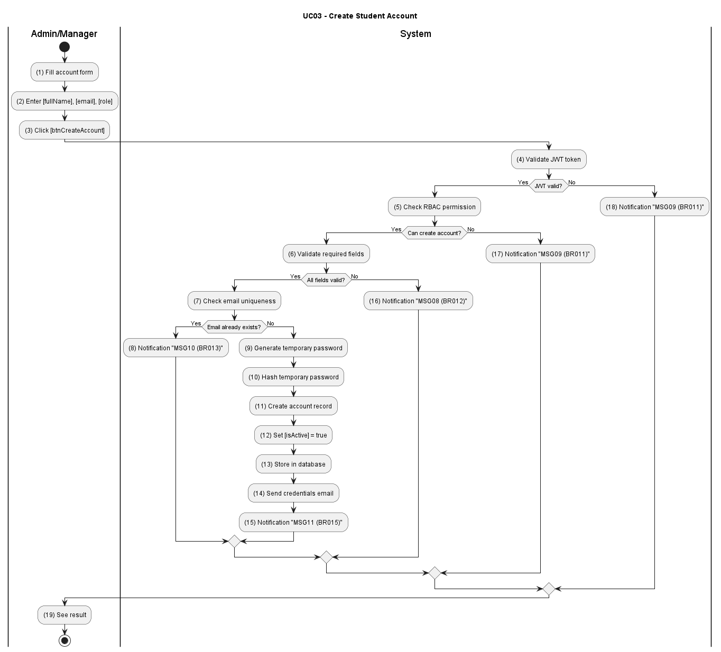

Business Rules
Activity | BR Code | Description
(5) | BR011 | RBAC Rules:  - The system checks actor permission to create the target role.  - If unauthorized, the system returns MSG09.
(6) | BR012 | Validation Rules:  - The system validates required fields [fullName], [email], [role], and [temporaryPassword\].  - If invalid, the system returns MSG08.
(7) | BR013 | Uniqueness Rules:  - The system checks duplicate [email] in the user repository.  - If duplicated, the system returns MSG10.
(11) | BR014 | Account Creation:  - The system hashes the temporary password, creates the account record, sets active status, and persists the record.
(15) | BR015 | Success Response:  - The system sends credential notification and returns creation payload (MSG11).

UC4: Update User Account
Name | Update User Account
Description | This use case describes the process of admins or center managers updating an existing user account in the system.
Actor | Admin, Center Manager
Trigger | When the actor submits the update-account form on User Management.
Pre-condition | The actor is authenticated and the user account exists.
Post-condition | The student account is updated and visible in the user list.

Activities Flow
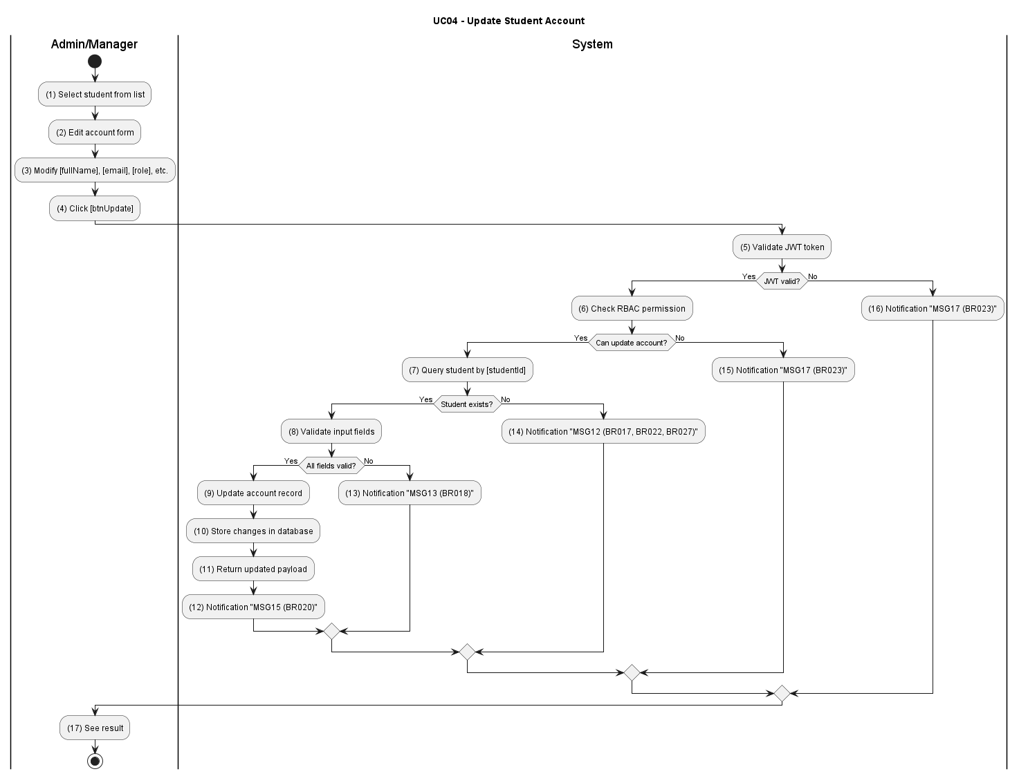

Business Rules
Activity | BR Code | Description
(5) | BR016 | JWT & RBAC:  - The system validates the JWT token and the caller's permission to update user accounts.  - If unauthorized the system returns MSG14.
(7) | BR017 | Existence Check:  - The system queries the user by [userId].  - If not found the system returns MSG12.
(8) | BR018 | Validation Rules:  - The system validates input fields [fullName], [email], [role] and other metadata.  - If invalid the system returns MSG13.
(9) | BR019 | Update Transaction:  - The system persists the updated account record and stores changes.
(12) | BR020 | Success Response:  - The system returns the updated payload and MSG15.

UC5: Lock User Account
Name | Lock User Account
Description | This use case describes the process of admins or center managers locking an inactive or invalid user account in the system.
Actor | Admin, Center Manager
Trigger | When the actor selects a user and clicks [btnLockAccount].
Pre-condition | The actor is authenticated and the target user account exists and is not already locked.
Post-condition | The user account status is set to locked and the user cannot log in.

Activities Flow
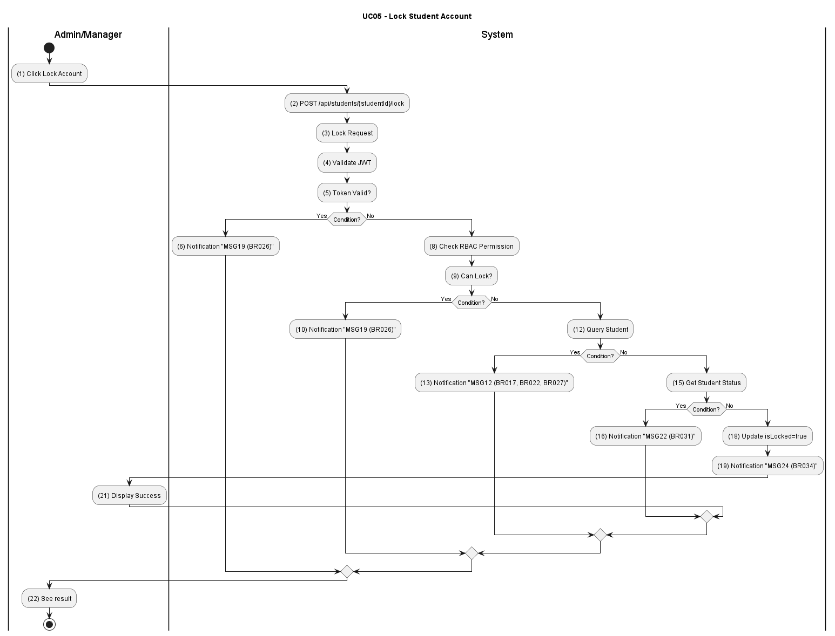

Business Rules
Activity | BR Code | Description
(4) | BR021 | JWT & RBAC:  - The system validates the JWT and checks permission to lock accounts.  - If unauthorized the system returns MSG16.
(12) | BR022 | Existence Check:  - The system queries the student record.  - If not found the system returns MSG12.
(15) | BR023 | Status Validation:  - The system checks current account status and if already locked or invalid returns MSG17.
(18) | BR024 | Lock Transaction:  - The system sets [isLocked=true] and records lock reason/metadata.
(19) | BR025 | Success Response:  - The system returns lock confirmation (MSG18).

UC6: Assign License Categories To Students
Name | Assign License Categories To Students
Description | This use case describes assigning or updating a student's license category for the appropriate training program.
Actor | Admin, Center Manager
Trigger | When the actor submits a new license category for a selected student.
Pre-condition | The actor is authenticated with assignment permission and the student account exists.
Post-condition | The student's license category is updated and audit information is recorded.

Activities Flow
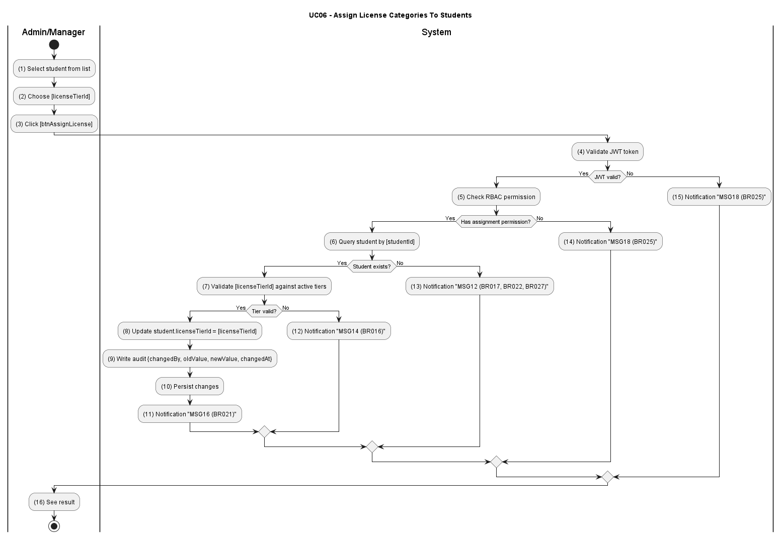

Business Rules
Activity | BR Code | Description
(4) | BR026 | JWT & RBAC:  - The system validates the JWT and checks permission to update student assignment data.  - If unauthorized the system returns MSG19.
(6) | BR027 | Existence Check:  - The system queries the student by [studentId].  - If not found the system returns MSG12.
(7) | BR028 | License Tier Validation:  - The system validates [licenseTierId] against active license tiers.  - If invalid the system returns MSG20.
(8) | BR029 | Assignment Update & Audit:  - The system updates [student.licenseTierId], writes audit metadata, and persists the change.
(11) | BR030 | Success Response:  - The system returns the updated student profile and MSG21.

UC7: View Detailed Course List
Name | View Detailed Course List
Description | This use case describes the process of a user viewing the detailed list of available courses in the system.
Actor | All users
Trigger | When the user navigates to the Course List page.
Pre-condition | The user is logged in.
Post-condition | The user receives paginated results and can navigate to a selected course detail.

Activities Flow
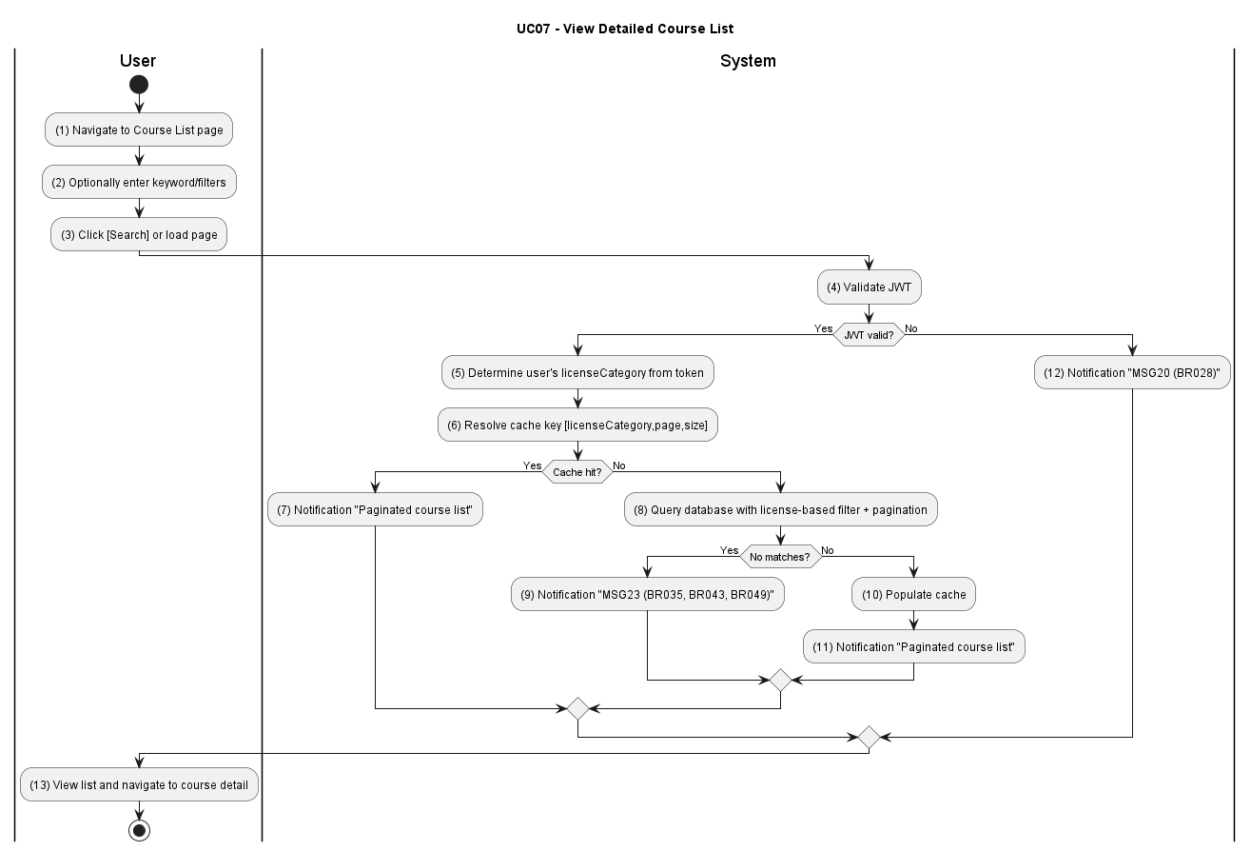

Business Rules
Activity | BR Code | Description
(4) | BR031 | JWT Validation:  - The system validates the JWT token.  - If invalid the system returns MSG22.
(5) | BR032 | License Filtering:  - The system determines the user's [licenseCategory] from the token to scope the course query.
(6) | BR033 | Cache-Aside Query:  - For course detail requests, the system resolves the cache key [licenseCategory, courseId] using NestJS in-memory CacheManager (TTL 5–10 min) and returns cached results on hit or falls back to the database on miss. Course list queries are served directly from the indexed database with cursor-based pagination.
(8) | BR034 | Search & Pagination:  - The system executes filtered queries and maintains pagination state.  - If no matches the system returns MSG24.
(13) | BR035 | Course Detail Response:  - The system queries course detail by [courseId] and returns the payload.  - If not found the system returns MSG23.

UC8: Create Course
Name | Create Course
Description | This use case describes the process of admins or center managers creating a new course in the system.
Actor | Admin, Center Manager
Trigger | When the actor clicks \[btnCreateCourse\] and submits the Course Create form.
Pre-condition | The actor is logged in with Admin or Center Manager role.
Post-condition | A new course is created and visible in the course list. A creation audit record is stored.

Activities Flow
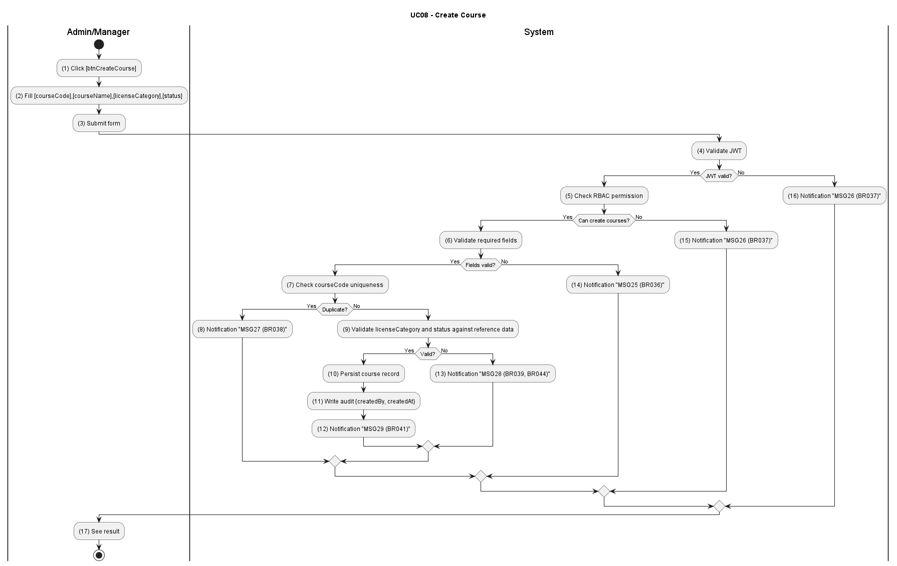

Business Rules
Activity | BR Code | Description
(6) | BR036 | Validation Rules:  - The system validates required fields [courseCode], [courseName], [licenseCategory], and [status].  - If any required field is missing or invalid the system returns MSG25.
(5) | BR037 | RBAC Permission:  - The system verifies actor permission to create courses.  - If unauthorized the system returns MSG26.
(7) | BR038 | Uniqueness Check:  - The system checks course code uniqueness.  - If duplicated the system returns MSG27.
(9) | BR039 | Data Integrity:  - The system validates [licenseCategory] and [status] against reference data.  - If invalid the system returns MSG28.
(10) | BR040 | Creation Transaction:  - The system persists the course record and writes audit metadata.
(12) | BR041 | Success Response:  - The system writes audit log and returns created payload with MSG29.

UC9: Update Course
Name | Update Course
Description | This use case describes the process of admins or center managers updating an existing course in the system.
Actor | Admin, Center Manager
Trigger | When the actor selects a course and clicks [btnUpdateCourse].
Pre-condition | The actor is logged in with Admin or Center Manager role. The course exists and is not deleted.
Post-condition | Course data is updated and reflected in list/detail pages. Update action is logged in audit trail.

Activities Flow
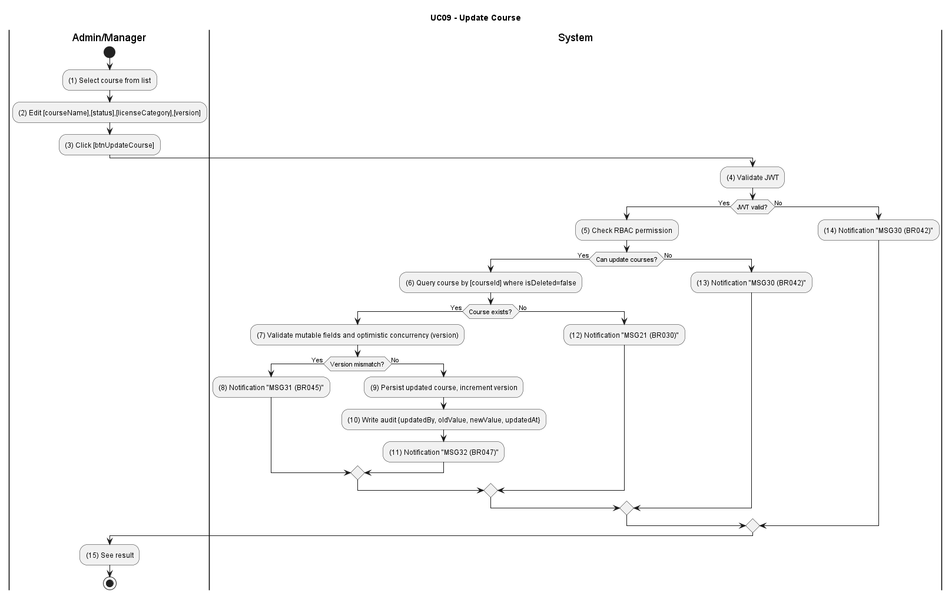

Business Rules
Activity | BR Code | Description
(4) | BR042 | JWT & RBAC:  - The system validates the token and caller permission for course update.  - If unauthorized the system returns MSG30.
(6) | BR043 | Existence Check:  - The system queries the course by [courseId] where [isDeleted=false].  - If not found the system returns MSG23.
(7) | BR044 | Payload Validation:  - The system validates mutable fields [courseName], [status], [roadmap], [licenseCategory].  - If invalid the system returns MSG28.
(7) | BR045 | Concurrency Check:  - The system compares client [version] with record version.  - If mismatch the system returns MSG31.
(9) | BR046 | Persist & Audit:  - The system persists the updated course, increments version, and writes audit log.
(11) | BR047 | Success Response:  - The system returns the updated payload and MSG32.

UC10: Delete Course
Name | Delete Course
Description | This use case describes the process of admins or center managers deleting an existing course from the system.
Actor | Admin, Center Manager
Trigger | When the actor clicks [btnDeleteCourse] and confirms the deletion dialog.
Pre-condition | The actor is logged in with Admin or Center Manager role. The target course exists and is not deleted.
Post-condition | The course is marked as deleted [isDeleted=true], excluded from active course lists, and deletion is logged for audit.

Activities Flow
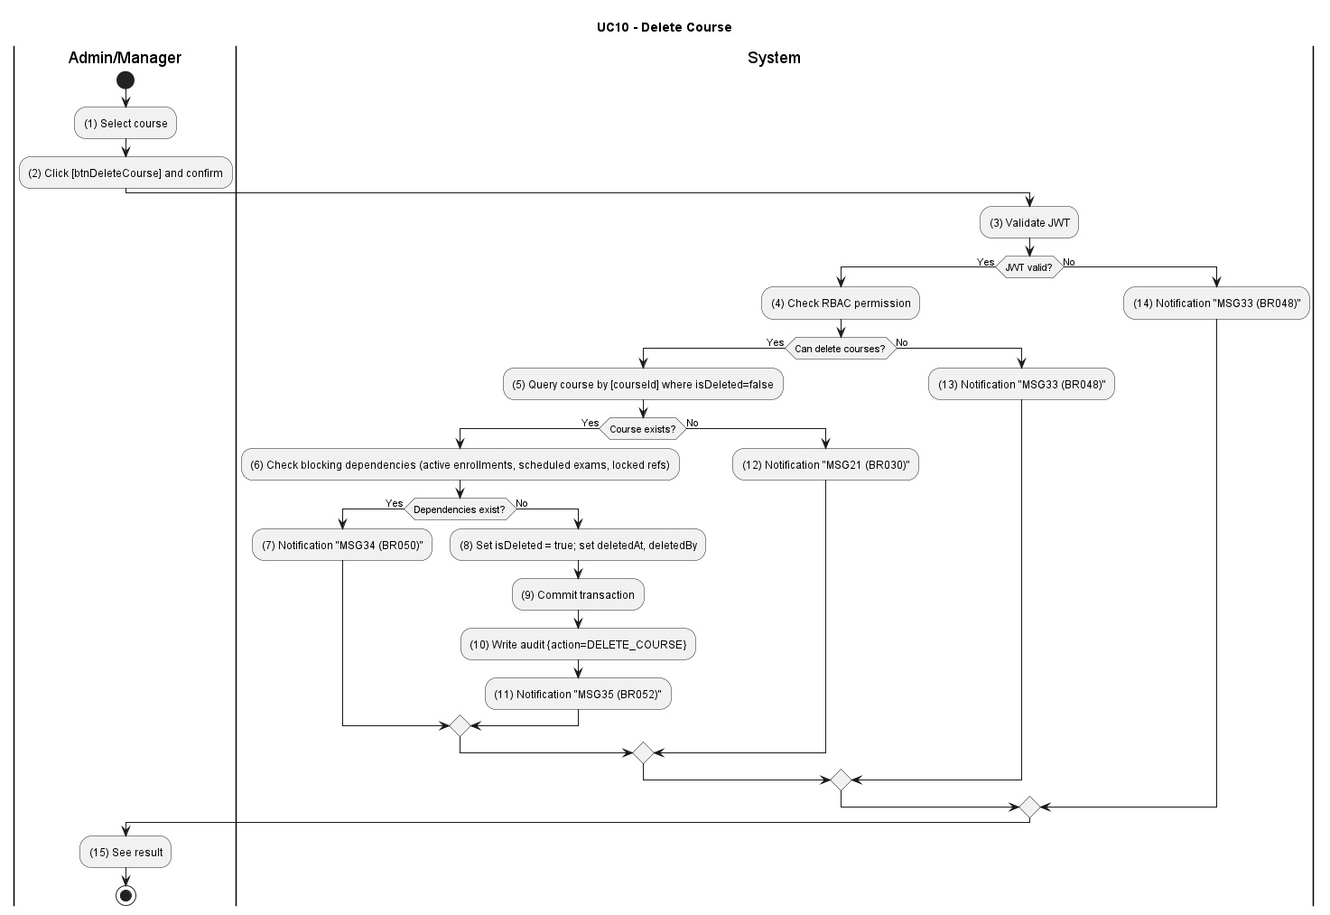

Business Rules
Activity | BR Code | Description
(3) | BR048 | JWT & RBAC:  - The system validates the JWT token and checks caller permission for course deletion.  - If unauthorized the system returns MSG33.
(5) | BR049 | Existence Check:  - The system queries the course by [courseId] where [isDeleted=false].  - If not found the system returns MSG23.
(6) | BR050 | Dependency Check:  - The system validates there are no blocking dependencies.  - If dependencies exist the system returns MSG34.
(8) | BR051 | Soft Delete Transaction:  - The system sets [isDeleted=true], records deletedAt and deletedBy in a transaction.
(11) | BR052 | Success Response:  - The system writes an audit log and returns success with MSG35.

UC11: Take Theory Exam
Name | Take Theory Exam
Description | This use case describes the process of a student taking a theoretical exam on the system.
Actor | Student
Trigger | When the student clicks [btnStartExam].
Pre-condition | The student is logged in and eligible for exam attempt creation.
Post-condition | A new exam attempt is created with randomized questions, timer settings, and initial session state.

Activities Flow
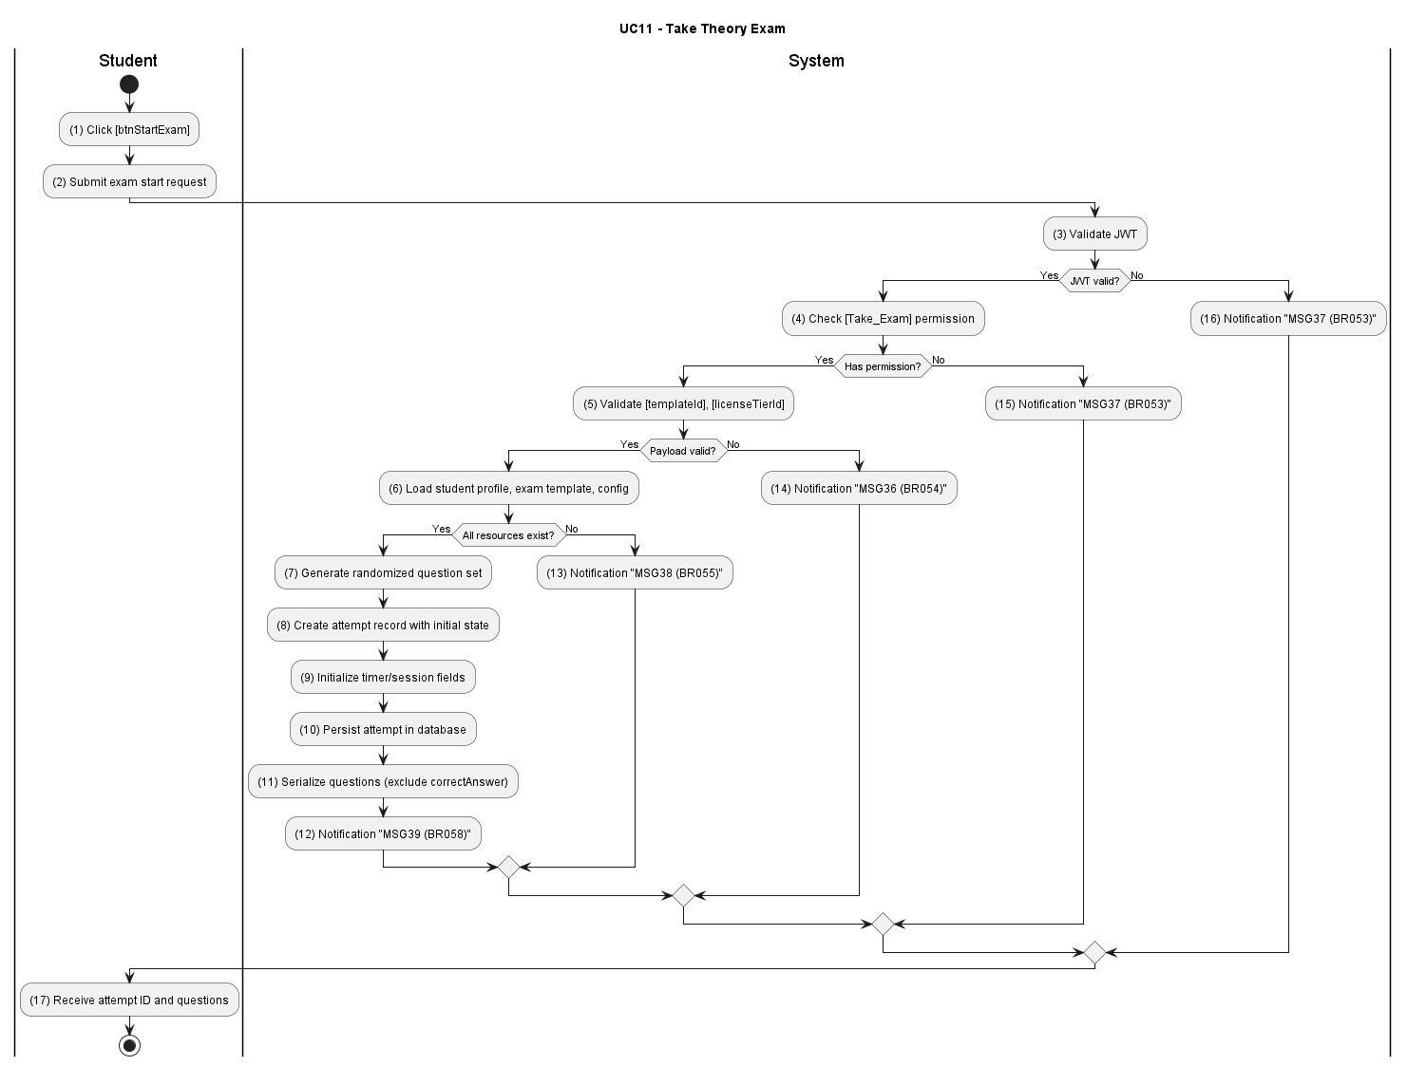

Business Rules
Activity | BR Code | Description
(3) | BR053 | JWT & RBAC:  - The system validates the JWT token and checks [Take_Exam] permission.  - If invalid the system returns MSG37.
(5) | BR054 | Payload Validation:  - The system validates [templateId] and [licenseTierId].  - If invalid the system returns MSG36.
(6) | BR055 | Resource Check:  - The system loads student profile, exam template, and configuration.  - If any resource is missing the system returns MSG38.
(10) | BR056 | Attempt Creation:  - The system generates the randomized question set, creates the attempt record, initializes timer/session fields, and persists the attempt.
(11) | BR057 | Answer Confidentiality:  - The system serializes questions using a restricted DTO that excludes [correctAnswer] and scoring metadata; the response contract must never include the answer key.
(12) | BR058 | Success Response:  - The system returns the attempt identifier and session bootstrap payload (MSG39).

UC12: Manage Exam Session
Name | Manage Exam Session
Description | This use case describes how the system supports in-exam features such as bookmarking questions, auto-saving answers, and displaying a countdown timer.
Actor | Student
Trigger | When the student performs session actions during an active attempt.
Pre-condition | The student has an active exam attempt.
Post-condition | Session state is updated and persisted for continuity and crash recovery.

Activities Flow
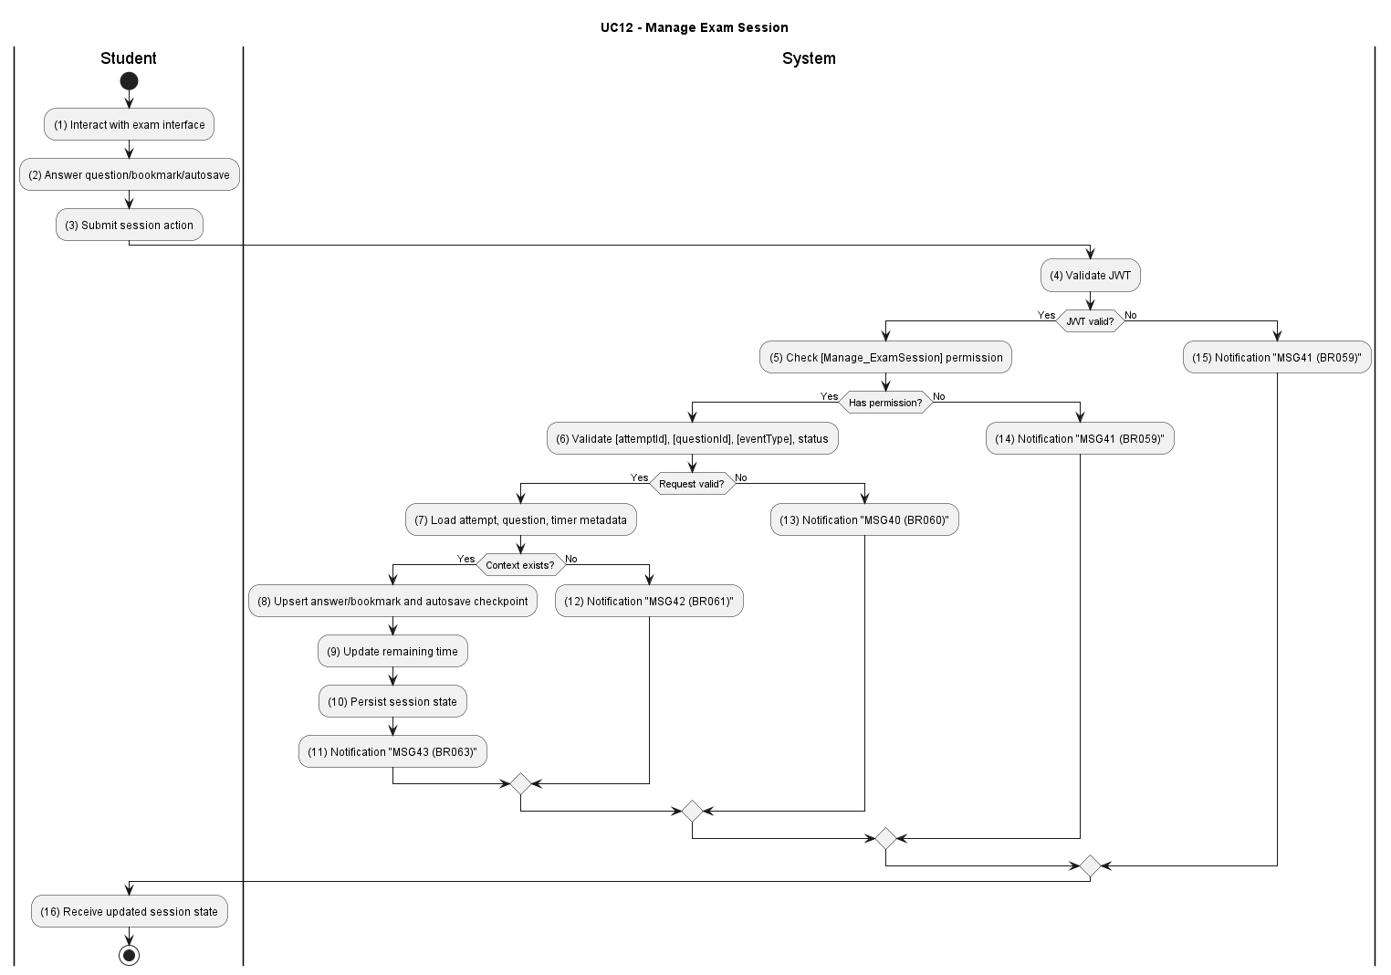

Business Rules
Activity | BR Code | Description
(4) | BR059 | JWT & RBAC:  - The system validates JWT and checks [Manage_ExamSession] permission.  - If invalid the system returns MSG41.
(6) | BR060 | Event Validation:  - The system validates [attemptId], [questionId], [eventType], and attempt status.  - If invalid the system returns MSG40.
(7) | BR061 | Context Check:  - The system loads attempt, question context, and timer metadata.  - If not found the system returns MSG42.
(10) | BR062 | Session Persistence:  - The system upserts answer/bookmark, updates remaining time, and persists session state.
(11) | BR063 | Success Response:  - The system returns the latest session state (MSG43).

UC13: Submit Exam
Name | Submit Exam
Description | This use case describes the process of a student completing and submitting the exam to the system.
Actor | Student
Trigger | When the student clicks [btnSubmitExam], or when the client countdown timer reaches zero and the client auto-submits the exam.
Pre-condition | The student has an active attempt and submission is still allowed.
Post-condition | Attempt is finalized, answers are locked, and grading executes synchronously within the same submission transaction.

Activities Flow
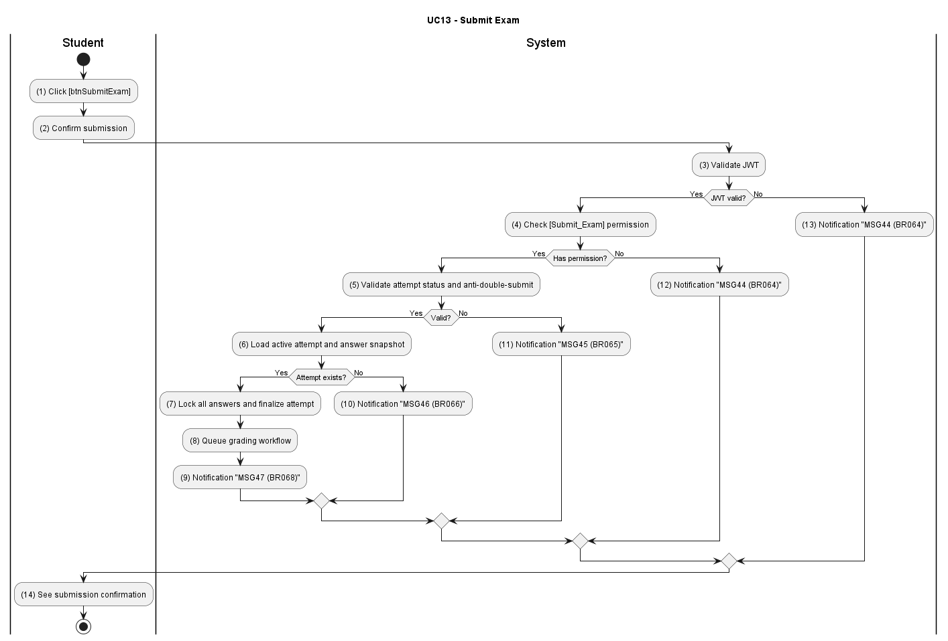

Business Rules
Activity | BR Code | Description
(3) | BR064 | JWT & RBAC:  - Validate JWT and [Submit_Exam] permission.  - Return MSG44 on failure.
(5) | BR065 | Submission State Validation:  - Validate attempt status and anti-double-submit policy.  - Return MSG45 on conflict.
(6) | BR066 | Attempt Existence Check:  - Load active attempt and answer snapshot.  - Return MSG46 if missing.
(7) | BR067 | Finalization Transaction:  - Validate the elapsed time against the server-recorded start time and discard any answers received after the deadline. Lock all answers (no further edits permitted), finalize attempt status to GRADING, and immediately invoke the grading workflow within the same database transaction.
(9) | BR068 | Success Response:  - Return submission confirmation (MSG47) when finalization commits.

UC14: Grade Exam
Name | Grade Exam
Description | This use case describes the system automatically grading the exam synchronously within the same database transaction as the submission. Grading evaluates fatal questions first, then computes the total score, and writes the immutable COMPLETED result — all as part of a single atomic unit with the submission.
Actor | System
Trigger | Invoked synchronously by the system upon answer lock and submission finalization. Not an independent API endpoint.
Pre-condition | Attempt is submitted and eligible for grading.
Post-condition | Grading result is persisted with score, pass/fail, and fatal-question evaluation.

Activities Flow
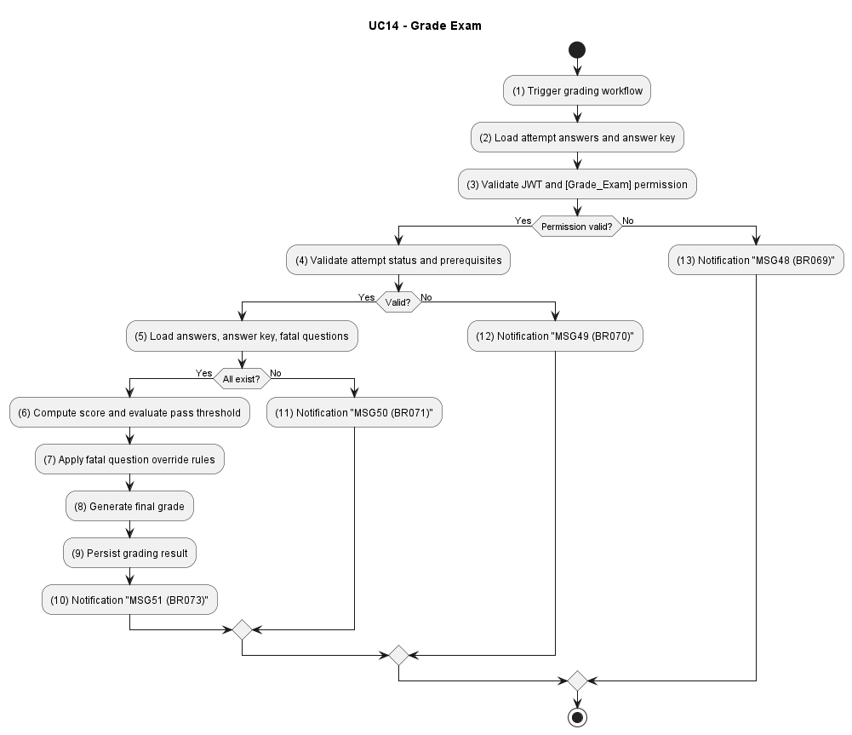

Business Rules
Activity | BR Code | Description
(3) | BR069 | Invocation Context Validation:  - The system validates that grading is being invoked as a synchronous internal step within the same atomic exam submission transaction.  - If invoked outside this context, grading is aborted immediately and logs MSG48 as a system error.
(4) | BR070 | Grading Input Validation:  - Validate attempt status and grading prerequisites  - Return MSG49 on failure.
(5) | BR071 | Resource Existence Check:  - Load attempt answers, answer key, and fatal-question definitions  - Return MSG50 if missing.
(6) | BR072 | Grading Logic Execution:  - Compute score, evaluate pass threshold, and apply fatal-question rules; persist final grade.
(10) | BR073 | Success Response:  - Return grading completion payload (MSG51) after persistence.

UC15: View Exam Results
Name | View Exam Results
Description | This use case describes the process of a student viewing their results after completing an exam.
Actor | Student
Trigger | When the student opens exam result detail.
Pre-condition | Exam attempt has been graded.
Post-condition | Student sees score, pass/fail status, and answer-level feedback.

Activities Flow
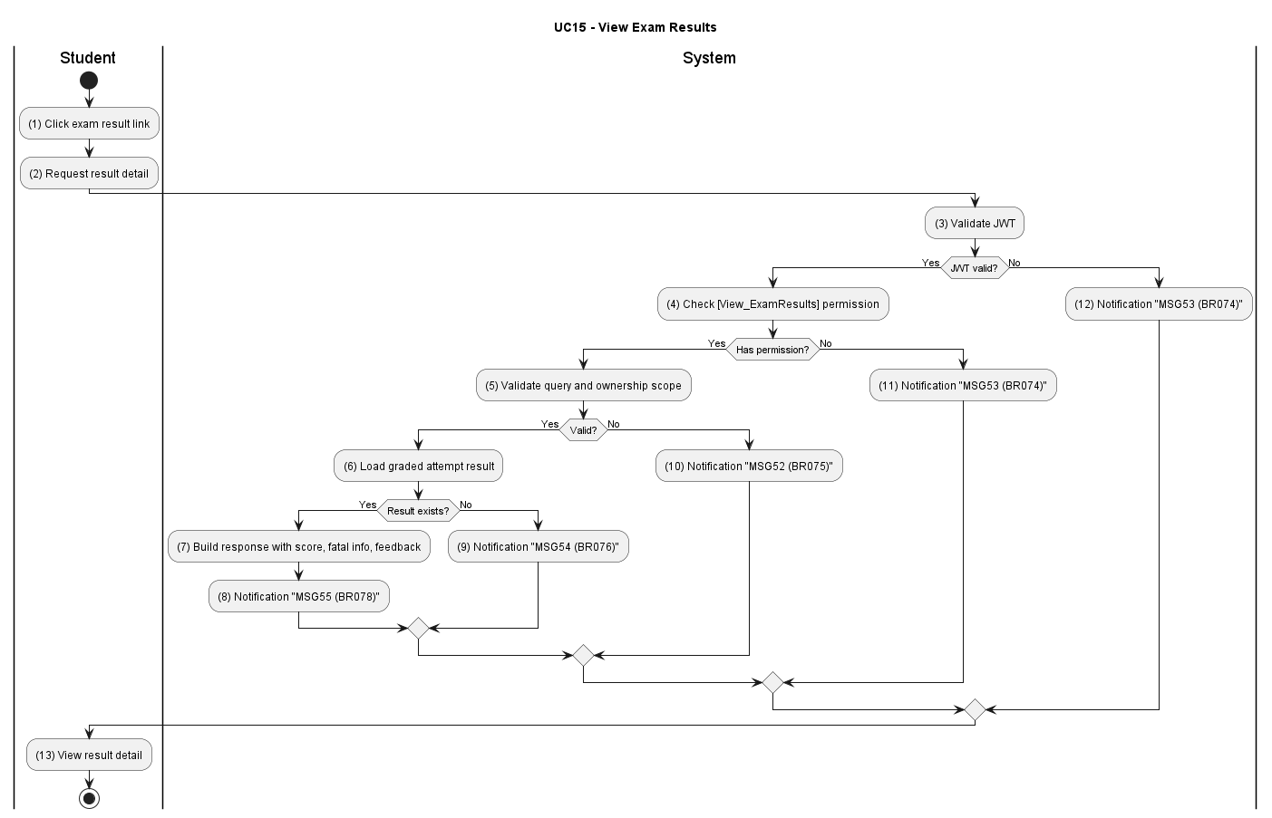

Business Rules
Activity | BR Code | Description
(3) | BR074 | JWT & RBAC:  - Validate JWT and [View_ExamResults] permission.  - Return MSG53 on failure.
(5) | BR075 | Query Validation:  - Validate ownership scope and query params.  - Return MSG52 on invalid.
(6) | BR076 | Result Existence Check:  - Load graded attempt result.  - Return MSG54 if not found.
(7) | BR077 | Result Projection:  - Build response with score, fatal-question info, and per-question feedback.
(8) | BR078 | Success Response:  - Return result detail to client (MSG55).

UC16: Review Exams
Name | Review Exams
Description | This use case describes the process of a student reviewing the exams they have previously taken.
Actor | Student
Trigger | When the student opens the exam review module.
Pre-condition | Student has at least one historical exam attempt.
Post-condition | Student receives a list of attempts and can drill down into selected review detail.

Activities Flow
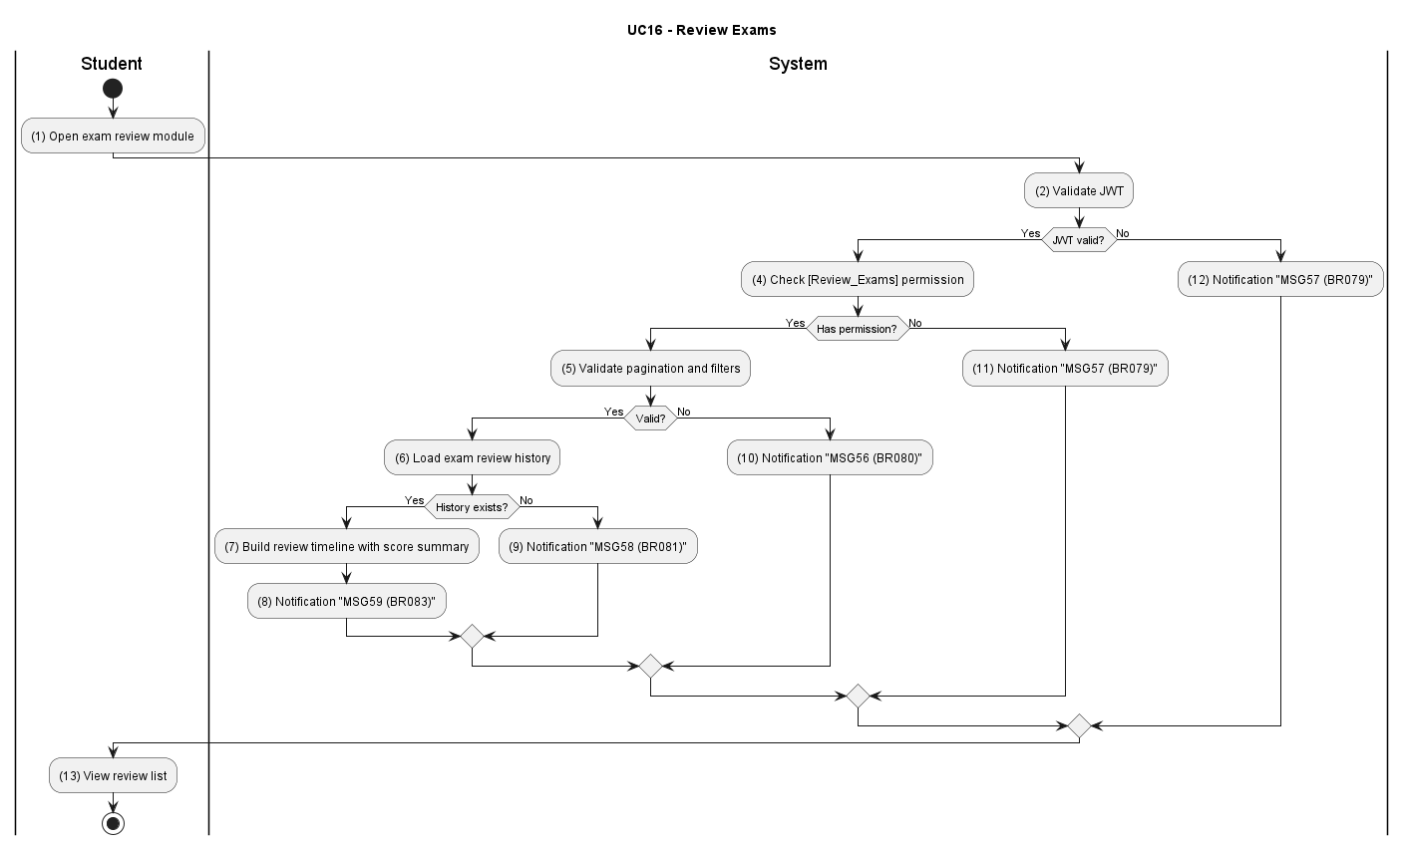

Business Rules
Activity | BR Code | Description
(2) | BR079 | JWT & RBAC:  - Validate JWT and [Review_Exams] permission.  - Return MSG57 on failure.
(5) | BR080 | Filter Validation:  - Validate pagination, sorting, and filter options.  - Return MSG56 if invalid.
(6) | BR081 | Review Data Check:  - Load exam review history and metadata.  - Return MSG58 if missing.
(7) | BR082 | Review Projection:  - Build review timeline with attempt status and score summary.
(8) | BR083 | Success Response:  - Return review listing payload (MSG59).

UC17: Search Question Bank
Name | Search Question Bank
Description | This use case describes the process of admins or center managers searching and filtering questions in the system.
Actor | Admin, Center Manager
Trigger | When actor enters keyword/filter on Question Bank page.
Pre-condition | Actor is logged in with question-bank access rights.
Post-condition | Filtered question list is returned with pagination.

Activities Flow
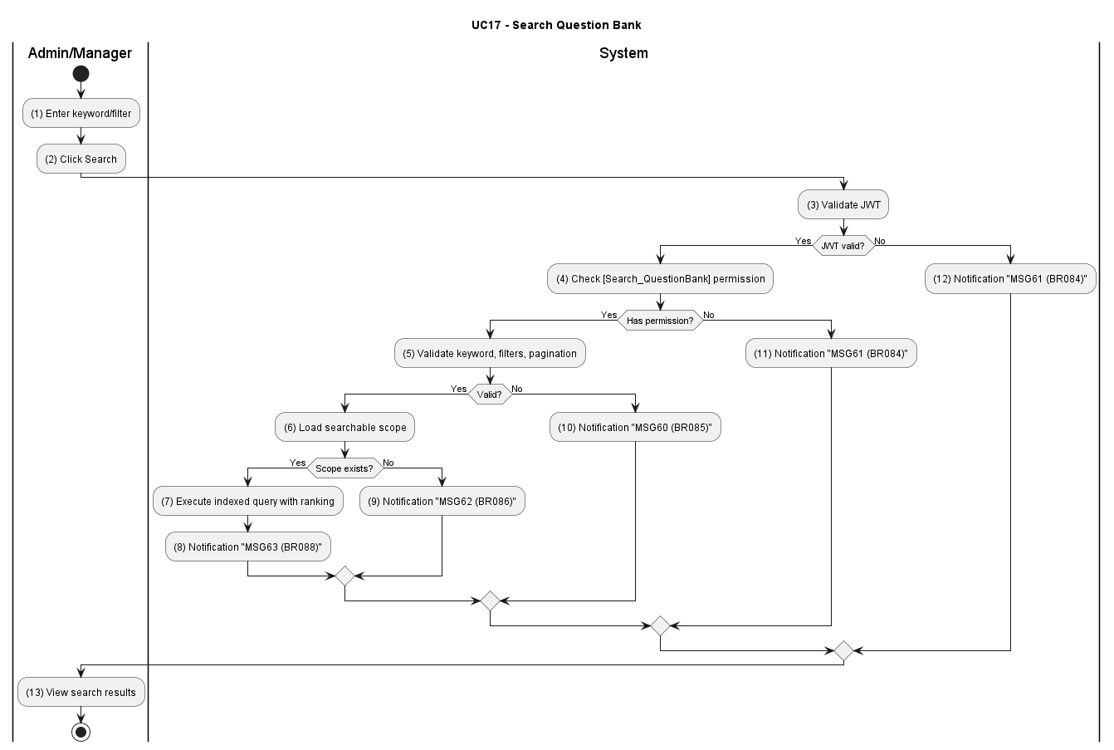

Business Rules
Activity | BR Code | Description
(3) | BR084 | JWT & RBAC:  - Validate JWT and [Search_QuestionBank] permission.  - Return MSG61 on failure.
(5) | BR085 | Query Validation:  - Validate [keyword], [licenseTierId], [status], [page], [size].  - Return MSG60 if invalid.
(6) | BR086 | Search Scope Check:  - Load searchable scope from question repository.  - Return MSG62 if missing.
(7) | BR087 | Indexed Search Execution:  - Execute indexed query with ranking and pagination.
(8) | BR088 | Success Response:  - Return paginated search results (MSG63).

UC18: Create Question
Name | Create Question
Description | This use case describes the process of admins or center managers creating a new question in the question bank.
Actor | Admin, Center Manager
Trigger | When actor submits [btnCreateQuestion] form.
Pre-condition | Actor is logged in with question creation permission.
Post-condition | New question is persisted and appears in the question list.

Activities Flow
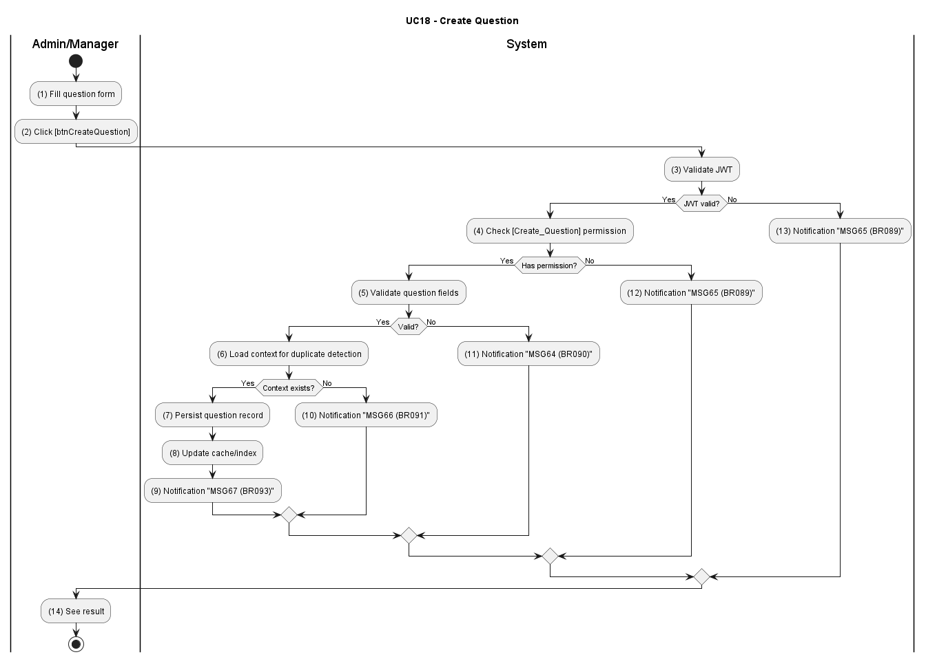

Business Rules
Activity | BR Code | Description
(3) | BR089 | JWT & RBAC:  - Validate JWT and [Create_Question] permission.  - Return MSG65 on failure.
(5) | BR090 | Payload Validation:  - Validate question text, options, correct answer, and metadata.  - Return MSG64 on invalid.
(6) | BR091 | Duplication Context Check:  - Load question signature context for duplicate detection.  - Return MSG66 if missing.
(7) | BR092 | Create Transaction:  - Persist new question and update related cache/index.
(9) | BR093 | Success Response:  - Return created question payload (MSG67).

UC19: Update Question
Name | Update Question
Description | This use case describes the process of admins or center managers updating an existing question in the question bank.
Actor | Admin, Center Manager
Trigger | When actor submits [btnUpdateQuestion] form.
Pre-condition | Actor is logged in and target question exists.
Post-condition | Question content is updated with audit/version history.

Activities Flow
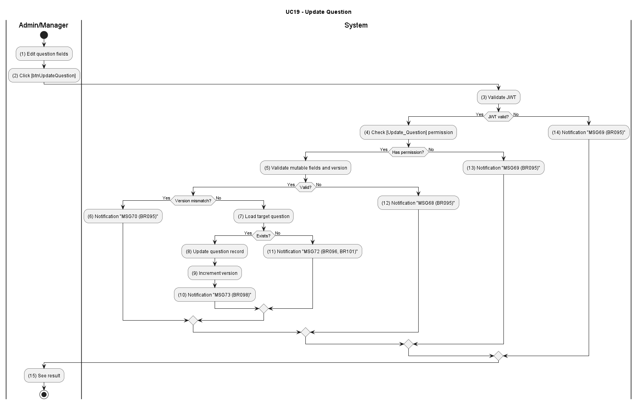

Business Rules
Activity | BR Code | Description
(3) | BR094 | JWT & RBAC:  - Validate JWT and [Update_Question] permission.  - Return MSG71 on failure.
(5) | BR095 | Payload & Version Validation:  - Validate mutable fields and optimistic concurrency.  - Return MSG68/MSG69/MSG70 as appropriate.
(7) | BR096 | Question Existence Check:  - Load target question and dependency context.  - Return MSG72 if missing.
(8) | BR097 | Update Transaction:  - Update question, keep version snapshot, and refresh index/cache.
(10) | BR098 | Success Response:  - Return updated question payload (MSG73).

UC20: Delete Question
Name | Delete Question
Description | This use case describes the process of admins or center managers deleting a question from the question bank.
Actor | Admin, Center Manager
Trigger | When actor confirms \[btnDeleteQuestion\].
Pre-condition | Actor is logged in and question delete policy is satisfied.
Post-condition | Question is soft-deleted and no longer shown in active lists.

Activities Flow
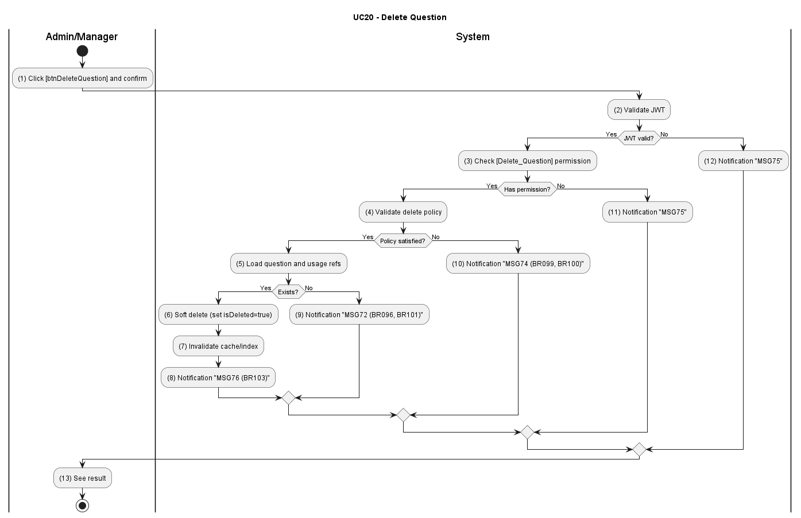

Business Rules
Activity | BR Code | Description
(2) | BR099 | JWT & RBAC:  - Validate JWT and [Delete_Question] permission  - Return MSG75 on failure.
(4) | BR100 | Delete Rule Validation:  - Validate safe-delete policy and conflict constraints.  - Return MSG74 on failure.
(5) | BR101 | Existence Check:  - Load target question and usage references.  - Return MSG72 if not found.
(6) | BR102 | Soft Delete Transaction:  - Mark [isDeleted=true], invalidate cache/index, and preserve history.
(8) | BR103 | Success Response:  - Return deletion result payload (MSG76).

UC21: Create Exam Template
Name | Create Exam Template
Description | This use case describes the process of an admin creating a new exam template with structure, number of questions, question types, and related rules.
Actor | Admin
Trigger | When actor submits \[btnCreateExamTemplate\].
Pre-condition | Actor is logged in with exam-config management permission.
Post-condition | New template is created and available for exam paper generation.

Activities Flow
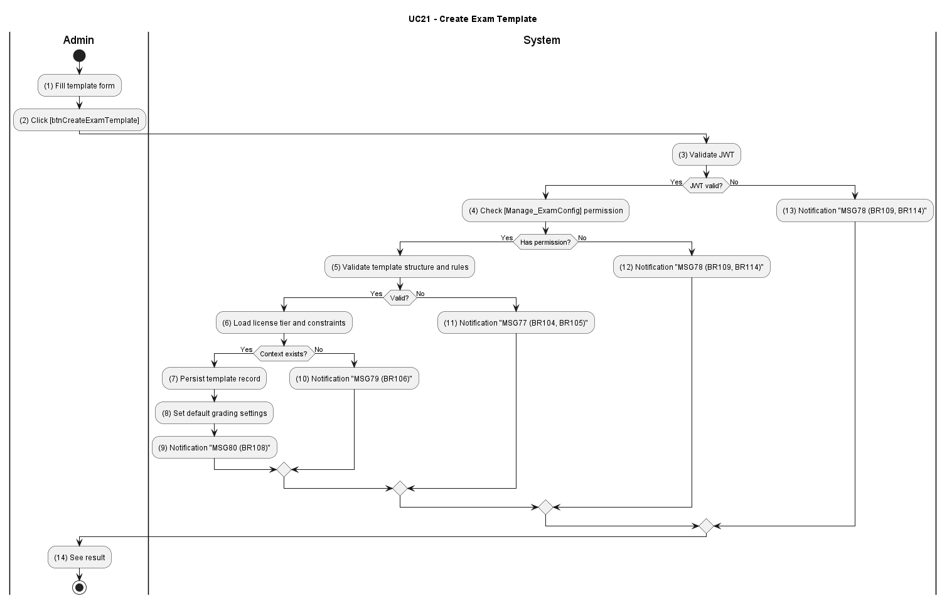

Business Rules
Activity | BR Code | Description
(3) | BR104 | JWT & RBAC:  - Validate JWT and [Manage_ExamConfig] permission.  - Return MSG78 on failure.
(5) | BR105 | Template Validation:  - Validate structure, section quotas, pass rules, and metadata.  - Return MSG77 on invalid.
(6) | BR106 | Context Existence Check:  - Load license tier and related constraints.  - Return MSG79 if missing.
(7) | BR107 | Create Transaction:  - Persist template and default grading settings in one transaction.
(9) | BR108 | Success Response:  - Return created template payload (MSG80).

UC22: Update Exam Template
Name | Update Exam Template
Description | This use case describes the process of an admin updating an existing exam template configuration.
Actor | Admin
Trigger | When actor submits \[btnUpdateExamTemplate\].
Pre-condition | Actor is logged in and template exists.
Post-condition | Template is updated and becomes active for subsequent generation flows.

Activities Flow
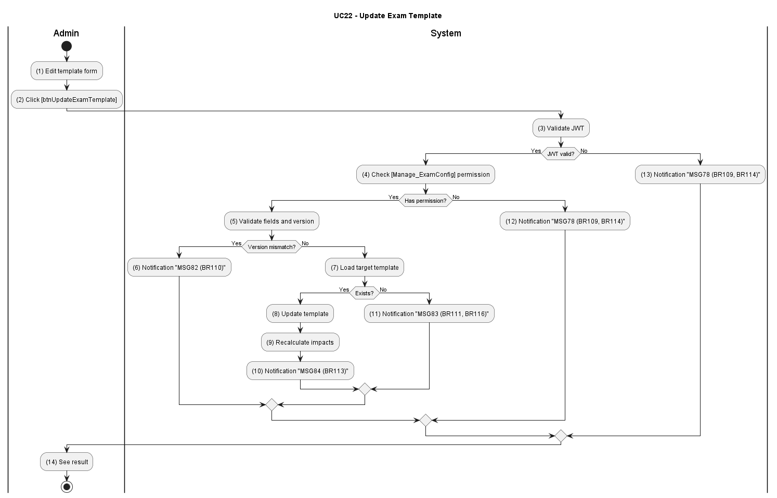

Business Rules
Activity | BR Code | Description
(3) | BR109 | JWT & RBAC:  - Validate JWT and [Manage_ExamConfig] permission; return MSG78 on failure.
(5) | BR110 | Update Validation:  - Validate mutable fields and optimistic concurrency.  - Return MSG81/MSG82 as appropriate.
(7) | BR111 | Template Existence Check:  - Load target template and lock state.  - Return MSG83 if not found.
(8) | BR112 | Update Transaction:  - Persist changes and recalculate constraint impacts.
(10) | BR113 | Success Response:  - Return updated payload (MSG84).

UC23: Delete Exam Template
Name | Delete Exam Template
Description | This use case describes the process of an admin deleting an unused exam template from the system.
Actor | Admin
Trigger | When actor confirms [btnDeleteExamTemplate].
Pre-condition | Actor is logged in, template exists, and template is not blocked by in-use constraints.
Post-condition | Template is soft-deleted and removed from active configuration views.

Activities Flow
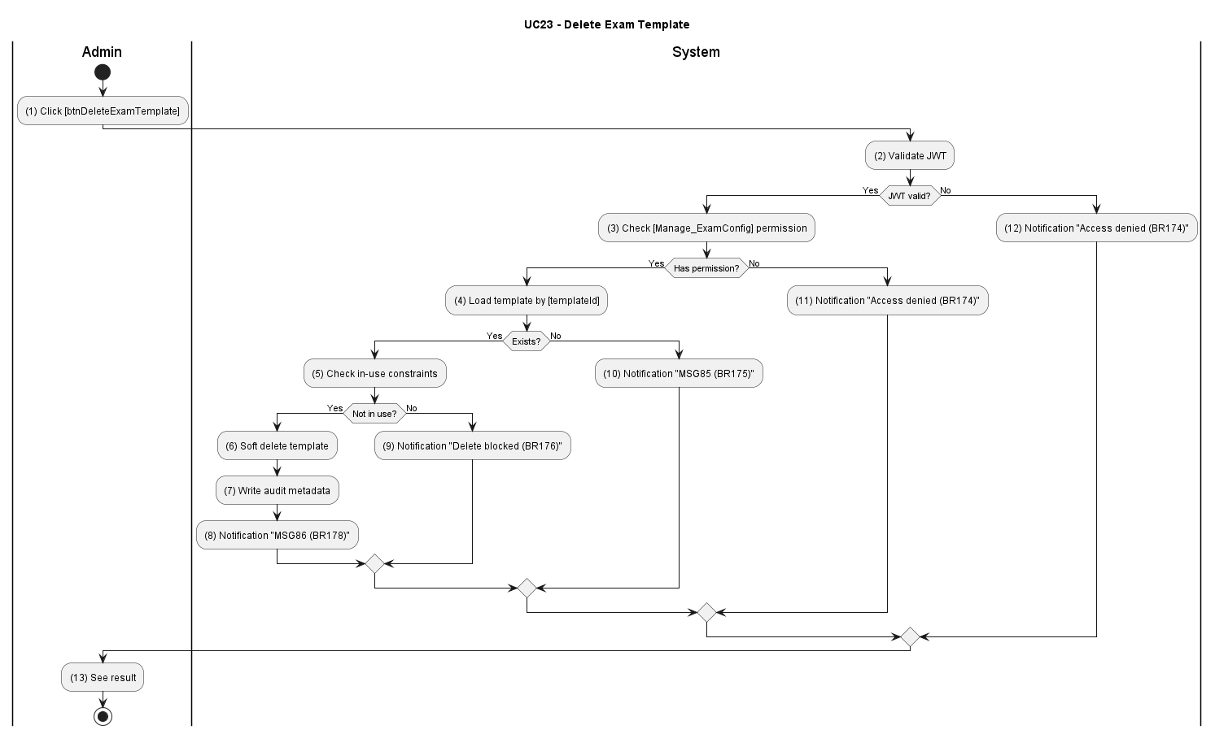

Business Rules
Activity | BR Code | Description
(2) | BR114 | JWT & RBAC:  - Validate JWT and [Manage_ExamConfig] permission.  - Return MSG78 if invalid.
(4) | BR115 | Template Existence Check:  - Load the exam template by [templateId].  - If not found, return MSG83.
(5) | BR116 | Usage Constraint Check:  - Verify the template is not referenced by active or scheduled exam generation jobs.  - If it is in use, stop the delete request.
(6) | BR117 | Soft Delete Transaction:  - Mark the template as deleted, persist the change, and write audit metadata in one transaction.
(8) | BR118 | Success Response:  - Return the delete confirmation payload (MSG86).

UC24: Auto-generate Exam Papers
Name | Auto-generate Exam Papers
Description | This use case describes the system automatically generating a randomized exam paper on demand when a student starts an exam (invoked from UC11). Questions are drawn per topic from the active ExamConfig using indexed queries against the question pool, and answer options are shuffled, so that each attempt is randomized, fair, and conforms to the standardized exam structure.
Actor | System
Trigger | When the System receives an exam-generation request as part of the exam-start flow (UC11 / BR056).
Pre-condition | Valid template and sufficient question pool are available.
Post-condition | A randomized exam paper is generated from the active ExamConfig and persisted as the student's exam attempt (with question snapshots), ready to be served for the current attempt.

Activities Flow
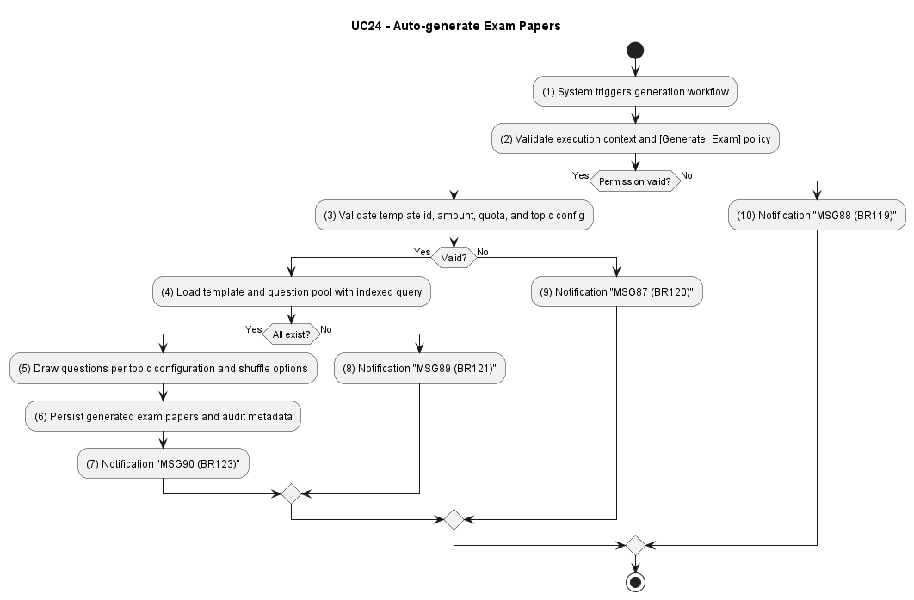

Business Rules
Activity | BR Code | Description
(2) | BR119 | Execution Authorization:  - Validate system execution context and [Generate_Exam] policy.  - Return an authorization error if invalid.
(4) | BR120 | Template & Input Validation:  - Validate [templateId], generation quantity, section quotas, and topic configuration before generation starts.
(5) | BR121 | Indexed Question Retrieval:  - Load the exam template and draw eligible questions per topic using indexed queries against the question pool.
(6) | BR122 | Paper Assembly Rules:  - Shuffle options, build each paper instance, and apply exam-paper constraints consistently.
(9) | BR123 | Persist & Success Response:  - Persist generated exam papers and return the generation result (MSG90).

UC25: View Student List
Name | View Student List
Description | This use case describes the process of an instructor, center manager, or admin viewing the list of students in the system.
Actor | Instructor, Admin, Center Manager
Trigger | When actor opens student roster module.
Pre-condition | Actor is logged in and has roster-view scope.
Post-condition | Student list is displayed with summary indicators and navigation to detail.

Activities Flow
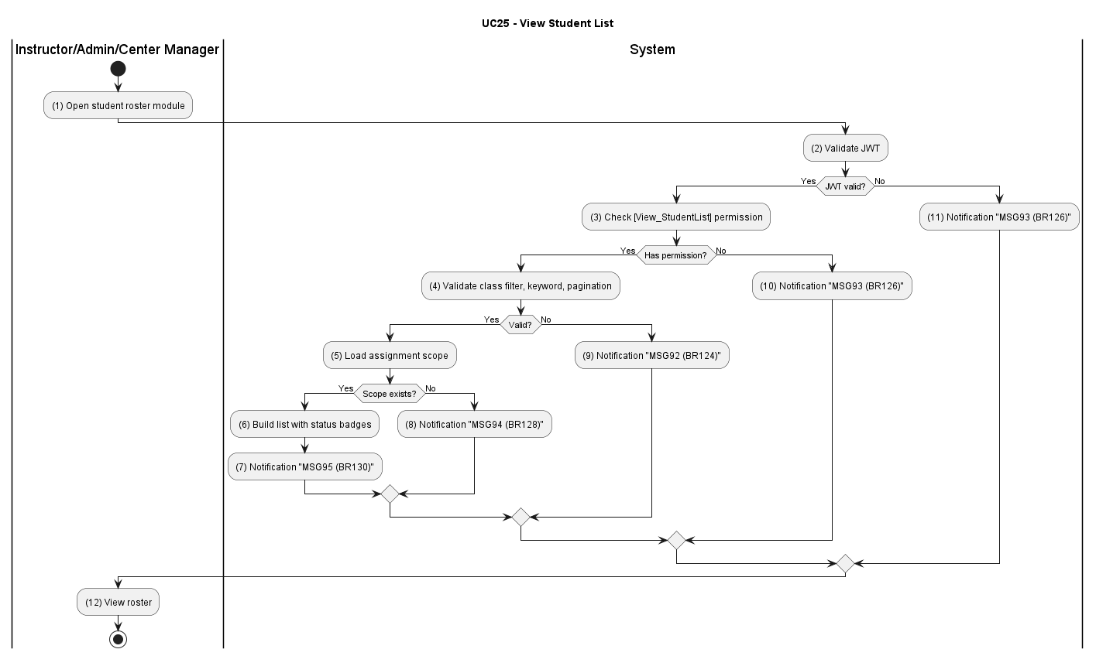

Business Rules
Activity | BR Code | Description
(2) | BR124 | JWT & RBAC:  - Validate JWT and [View_StudentList] permission; return MSG92 on failure.
(4) | BR125 | Query Validation:  - Validate class filter, keyword, and pagination.  - Return MSG91 if invalid.
(5) | BR126 | Scope Existence Check:  - Load assignment scope and roster.  - Return MSG93 if missing.
(6) | BR127 | Roster Projection:  - Build list with status badges and ordering.
(8) | BR128 | Success Response:  - Return roster response (MSG94).

UC26: Track Learning Progress

Name | Track Learning Progress
Description | This use case describes the process of an instructor or admin tracking the learning progress and exam results of students.
Actor | Instructor, Admin
Trigger | When actor opens progress dashboard for one or more students.
Pre-condition | Actor is logged in with learning-progress access rights.
Post-condition | Progress indicators are displayed to support instructional interventions.

Activities Flow
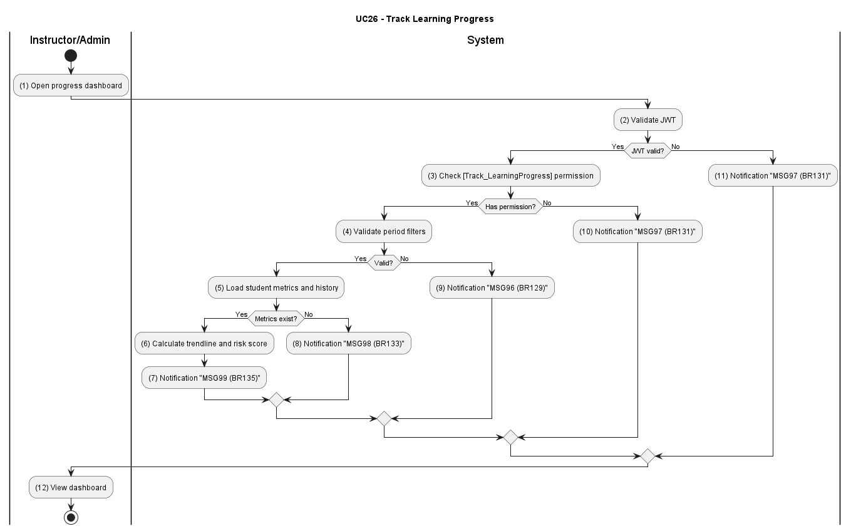

Business Rules
Activity | BR Code | Description
(2) | BR129 | JWT & RBAC:  - Validate JWT and [Track_LearningProgress] permission.  - Return MSG96 on failure.
(4) | BR130 | Scope Validation:  - Validate period filters and target scope.  - Return MSG95 if invalid.
(5) | BR131 | Metric Source Check:  - Load student metrics and recent attempt history.  - Return MSG97 if missing.
(6) | BR132 | Trend Computation:  - Calculate trendline, completion ratio, and risk score.
(8) | BR133 | Success Response:  - Return dashboard payload (MSG98).

UC27: View Exam History
Name | View Exam History
Description | This use case describes the process of an instructor or admin reviewing a student's exam history, including information such as exam time, exam type, score, and pass/fail result.
Actor | Instructor, Admin
Trigger | When actor opens exam history page for a student.
Pre-condition | Actor is logged in and student reference is valid.
Post-condition | Exam timeline is displayed and can be used for deeper review.

Activities Flow
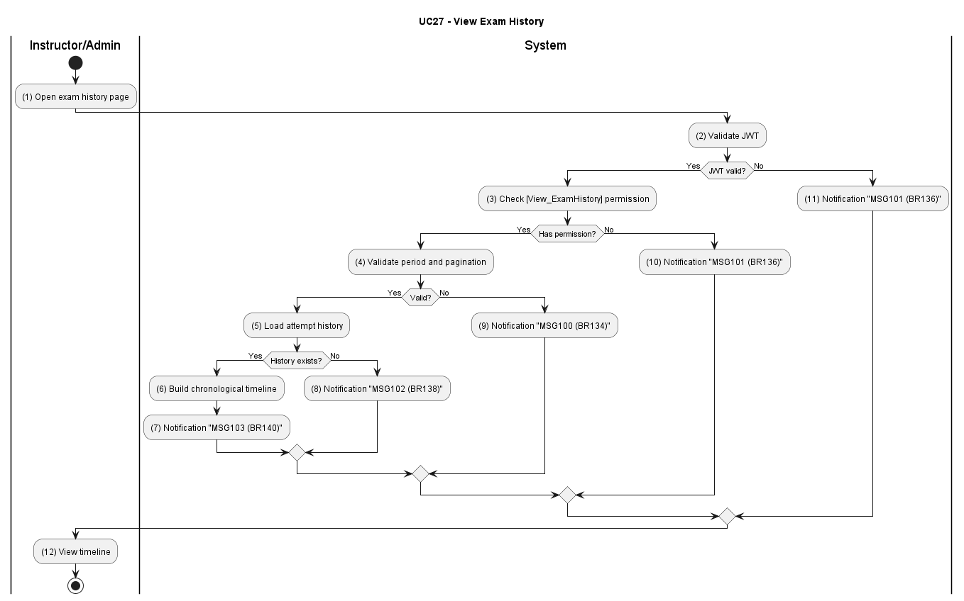

Business Rules
Activity | BR Code | Description
(2) | BR134 | JWT & RBAC:  - Validate JWT and [View_ExamHistory] permission.  - Return MSG100 on failure.
(4) | BR135 | Query Validation:  - Validate period, exam-type, and pagination.  - Return MSG99 if invalid.
(5) | BR136 | History Existence Check:  - Load attempt history source.  - Return MSG101 if not found.
(6) | BR137 | Timeline Projection:  - Build chronological exam history with score and pass/fail fields.
(8) | BR138 | Success Response:  - Return timeline payload (MSG102).

UC28: Reset Learning Progress
Name | Reset Learning Progress
Description | This use case describes the process by which an Administrator resets a student's learning progress on request or as a remediation action.
Actor | Admin
Trigger | When an Admin confirms a reset request for a specified student
Pre-condition | Admin is authenticated and has the [Reset_LearningProgress] permission; the target student exists and satisfies reset policy constraints.
Post-condition | The target student's progress markers are reset, the learning flow restarts from baseline for that student, and an immutable audit entry is recorded.

Activities Flow
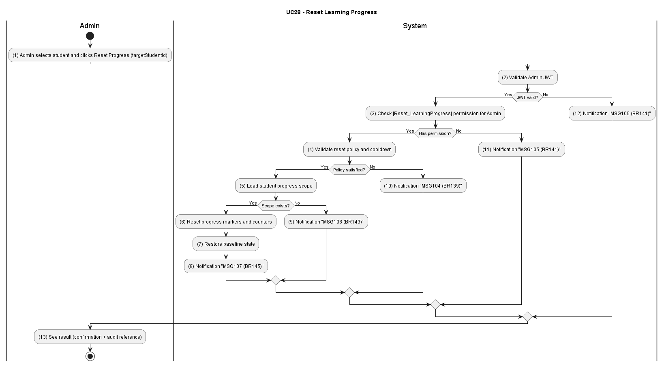

Business Rules
Activity | BR Code | Description
(2) | BR139 | JWT & RBAC:  - Validate JWT and [Reset_LearningProgress] permission.  - Return MSG104 on failure.
(4) | BR140 | Reset Policy Validation:  - Validate cooldown, frequency, and allowed scope.  - Return MSG103 on failure.
(5) | BR141 | Resource Existence Check:  - Load student progress scope to reset  - Return MSG105 if not found.
(6) | BR142 | Reset Transaction:  - Reset progress markers, review queues, and dependent counters by policy.
(9) | BR143 | Success Response:  - Return reset confirmation payload (MSG106).

UC29: Send Academic Warnings
Name | Send Academic Warnings
Description | This use case describes the process of an instructor or admin sending warnings to students when the system detects slow learning progress, low exam scores, or incomplete learning requirements.
Actor | Instructor, Admin
Trigger | When actor submits warning form for selected students.
Pre-condition | Actor is logged in with warning-dispatch permission.
Post-condition | Warning records are created and notifications are dispatched.

Activities Flow
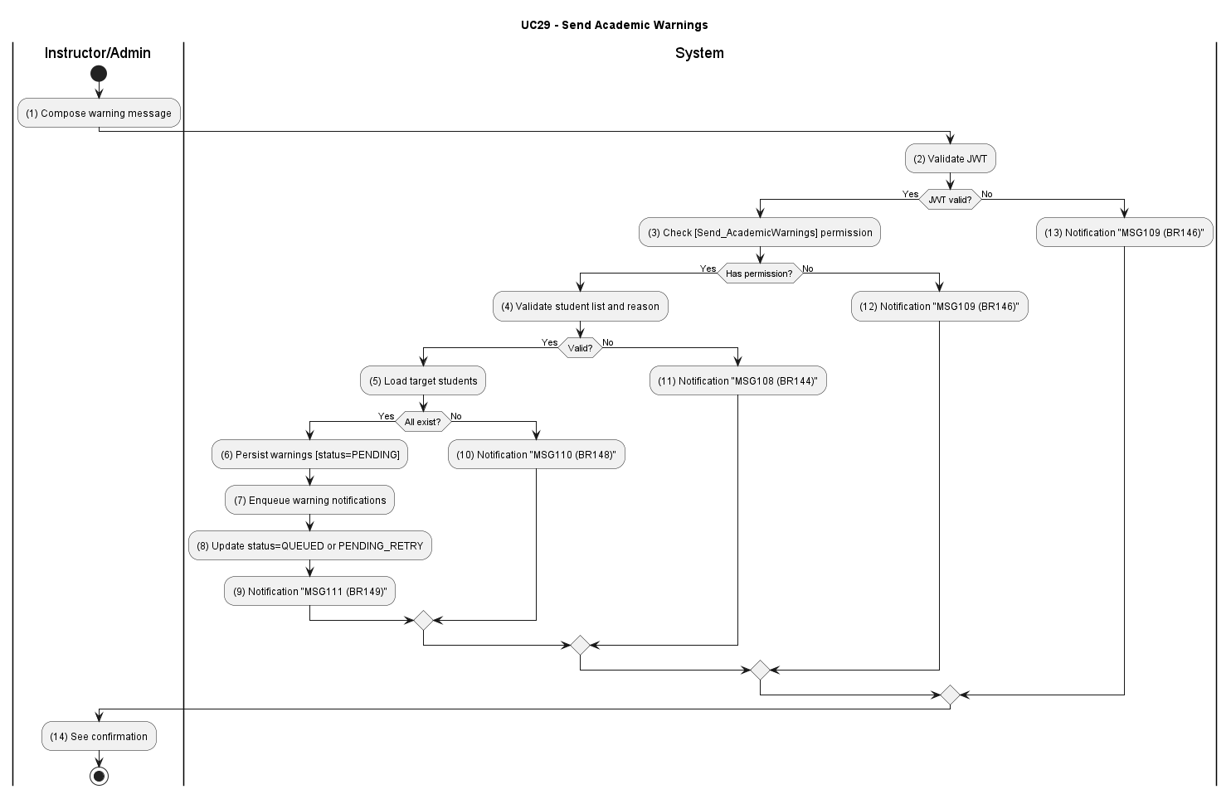

Business Rules
Activity | BR Code | Description
(2) | BR144 | JWT & RBAC:  - Validate JWT and [Send_AcademicWarnings] permission.  - Return MSG108 on failure.
(4) | BR145 | Warning Payload Validation:  - Validate recipients, reason codes, and delivery channel settings.  - Return MSG107 on invalid.
(5) | BR146 | Target Existence Check:  - Load target students and warning context.  - Return MSG109 if not found.
(6) | BR147 | Dispatch Transaction:  - Persist warning records and enqueue notification jobs.  - Ensure eventual consistency.
(9) | BR148 | Success Response:  - Return delivery summary payload (MSG110).

UC30: View Maneuver Checkpoint Details
Name | View Maneuver Checkpoint Details
Description | Allows a Student to navigate driving maneuvers via a hybrid Map/List view and drill down into step-by-step instructions and penalty criteria for a selected checkpoint.
Actor | Student
Trigger | Student clicks the "Sa hành chi tiết" button on the Training dashboard.
Pre-condition | Student is authenticated. The system has identified the specific license class.
Post-condition | Detailed maneuver screen is rendered with color-coded steps and error classifications.

Activities Flow
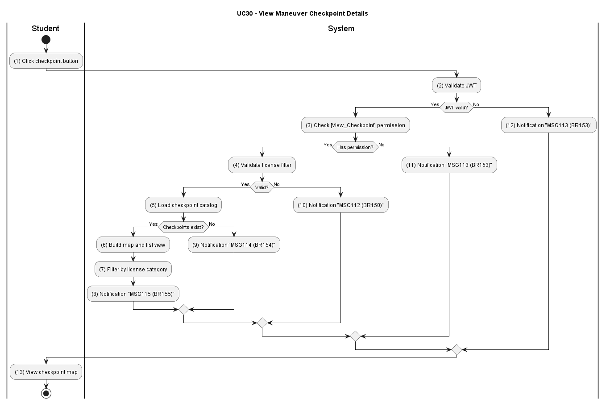

Business Rules
Activity | BR Code | Description
(2) | BR149 | JWT & RBAC:  - Validate JWT and query for active checkpoints.  - Return MSG111 on failure.
(7) | BR150 | License Class Context:  - Filter checkpoints by user's license category.  - Return MSG112 if none exist.
(6) | BR151 | Checkpoint List & Map:  - Build dual presentation (map pins + list) from checkpoint coordinates and names.
(5) | BR152 | Checkpoint Selection Query:  - Load detailed instructions and penalty rules for selected checkpointId.
(8) | BR153 | Categorized Penalty Display:  - Categorize and render penalties (Yellow/Red) with visual distinction (MSG113).

UC31: View General Maneuver Errors
Name | View General Maneuver Errors
Description | Provides a comprehensive list of universal driving errors applying to the entire exam, categorized by penalty severity.
Actor | Student
Trigger | Student clicks "Các Lỗi Sa Hình Chung" on the Training dashboard.
Pre-condition | System is operational. The student is on the main Training screen.
Post-condition | The categorized list of universal driving errors — Yellow (point deduction) and Red (fatal/elimination) — is displayed with visual distinction.

Activities Flow
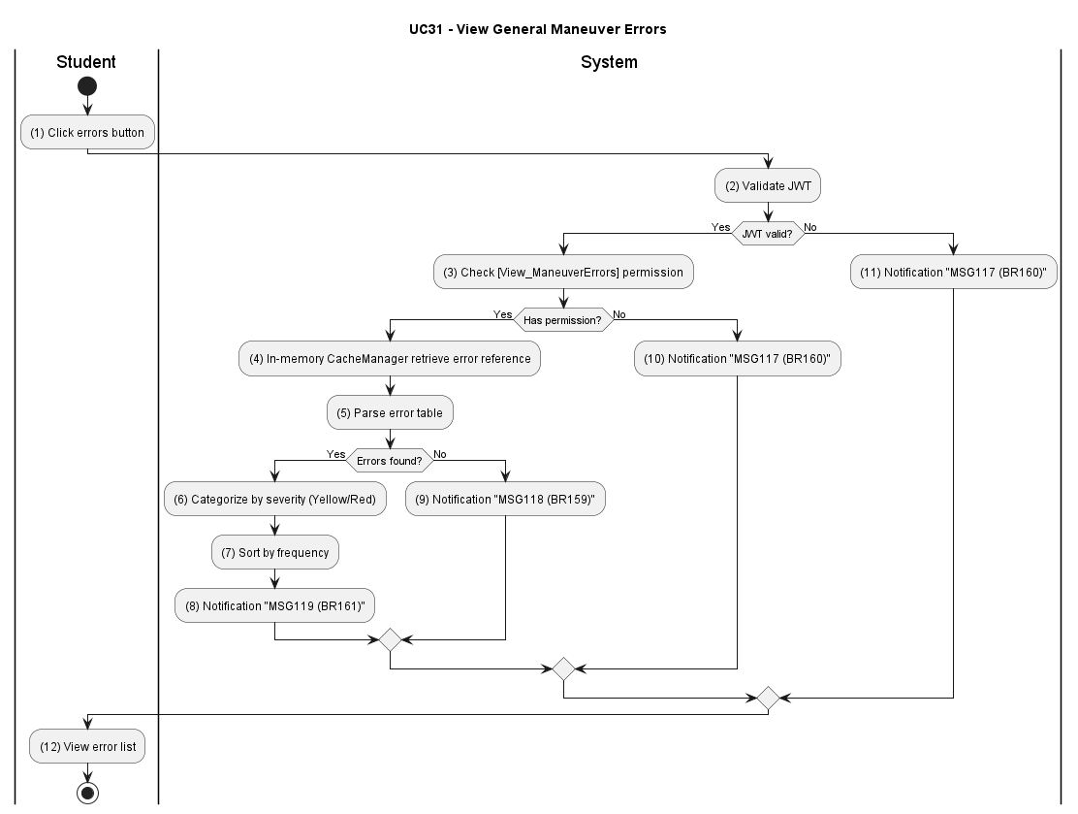

Business Rules
Activity | BR Code | Description
(2) | BR154 | JWT & RBAC:  - Validate JWT and [View_ManeuverErrors] permission.  - Return MSG114 on failure.
(4) | BR155 | Error Reference Query:  - Query ErrorReference for active universal driving errors.  - Return MSG115 if none found.
(5) | BR156 | In-memory CacheManager Retrieval:  - Check the application In-memory CacheManager.  - On miss fetch from database using an indexed query and optionally populate the CacheManager
(6) | BR157 | Error Categorization:  - Separate Yellow (Deduction) and Red (Fatal) categories and sort alphabetically.
(8) | BR158 | Success Response:  - Return categorized error list with visual metadata (MSG116).

UC32: Review Frequently Missed Questions
Name | Review Frequently Missed Questions
Description | This use case describes the process of a student taking review tests generated by the system based on questions or question types they frequently answered incorrectly in previous exams.
Actor | Student
Trigger | When student requests missed-question review session.
Pre-condition | Student is logged in and has exam history with wrong-answer records.
Post-condition | Personalized review set is generated and returned for study.

Activities Flow
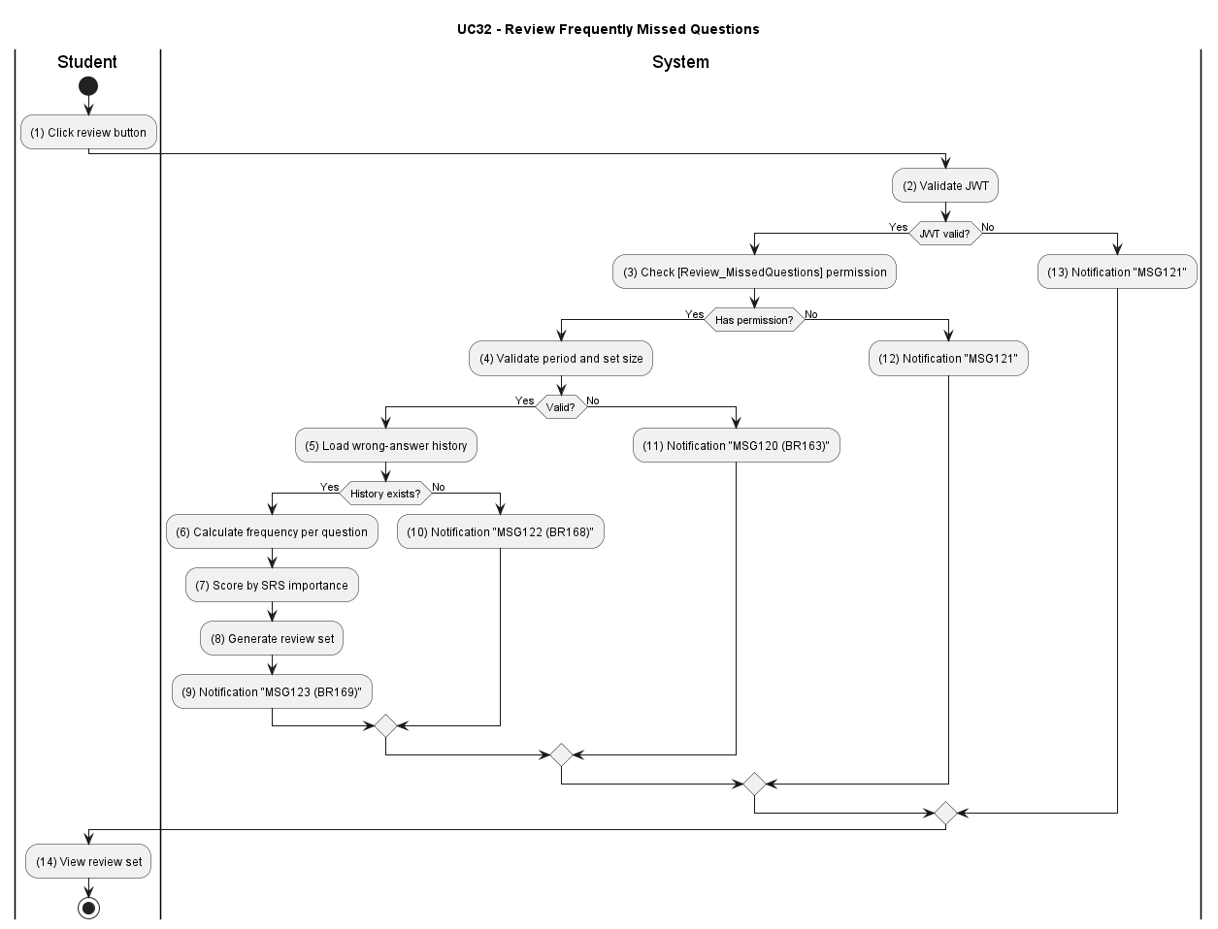

Business Rules
Activity | BR Code | Description
(2) | BR159 | JWT & RBAC:  - Validate JWT and [Review_MissedQuestions] permission.  - Return MSG118 on failure.
(4) | BR160 | Request Validation:  - Validate review period, size, and mode options  - Return MSG117 if invalid.
(5) | BR161 | Data Existence Check:  - Load wrong-answer history and SRS prioritization.  - Return MSG119 if missing.
(8) | BR162 | Review-Set Generation:  - Build prioritized question set based on frequency and SRS score.
(9) | BR163 | Success Response:  - Return personalized review payload (MSG120).

UC33: Logout
Name | Logout
Description | This use case describes the process of a user terminating their authenticated session, invalidating the server-side JWT, and clearing all client-side session state.
Actor | All users
Trigger | When the user clicks the [btnLogout] button or when a session-management event triggers a forced logout.
Pre-condition | The user is authenticated and holds a valid JWT.
Post-condition | The JWT is blacklisted server-side. The client-side token is cleared. Any subsequent API call using the invalidated token returns 401 Unauthorized.

Activities Flow
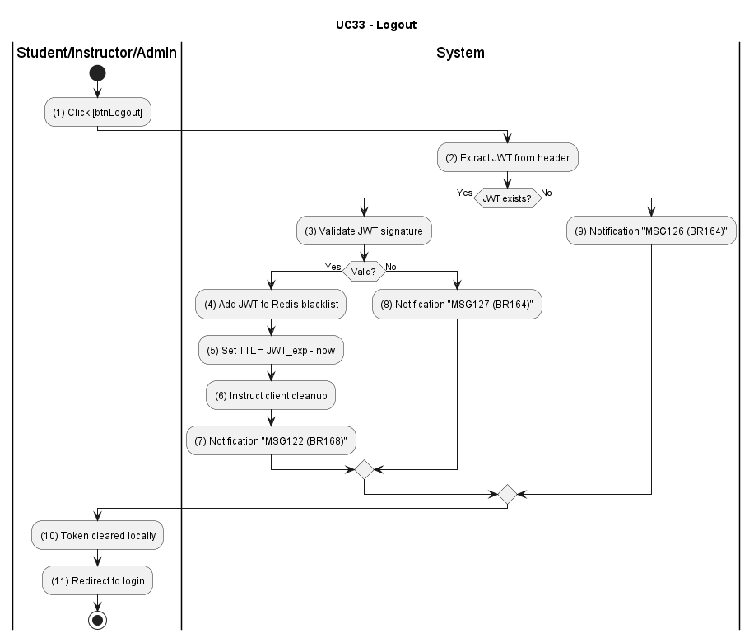

Business Rules
Activity | BR Code | Description
(2) | BR164 | JWT Validation:  - Extract and validate JWT from Authorization header or cookie.  - Return MSG126/MSG127 on failure.
(4) | BR165 | Token Blacklisting:  - Add current JWT to Redis blacklist with TTL equal to remaining lifespan.  - Operation must be atomic.
(6) | BR166 | Client Cleanup Instruction:  - Return response instructing client to delete token from storage.
(7) | BR167 | Post-Logout Verification:  - TokenBlacklistGuard registered globally across all NestJS services checks the JWT jti claim against the Redis blacklist on every authenticated request.  - Reject blacklisted tokens.
(7) | BR168 | Success Response:  - Return logout confirmation payload (MSG122).

UC34: View my learning progress
Name | View my learning progress
Description | This use case describes the process of a student viewing their own learning progress, including theory completion percentage, practice exam pass rate over time, and weak topic analysis. Data is retrieved directly from the database/aggregation source.
Actor | Student
Trigger | When the student navigates to the Learning Progress screen on the mobile app.
Pre-condition | The student is authenticated and has at least one recorded learning activity (exam attempt or topic studied).
Post-condition | The student receives their personalised progress dashboard data including completion statistics, pass-rate trend, and weak topic indicators.

Activities Flow
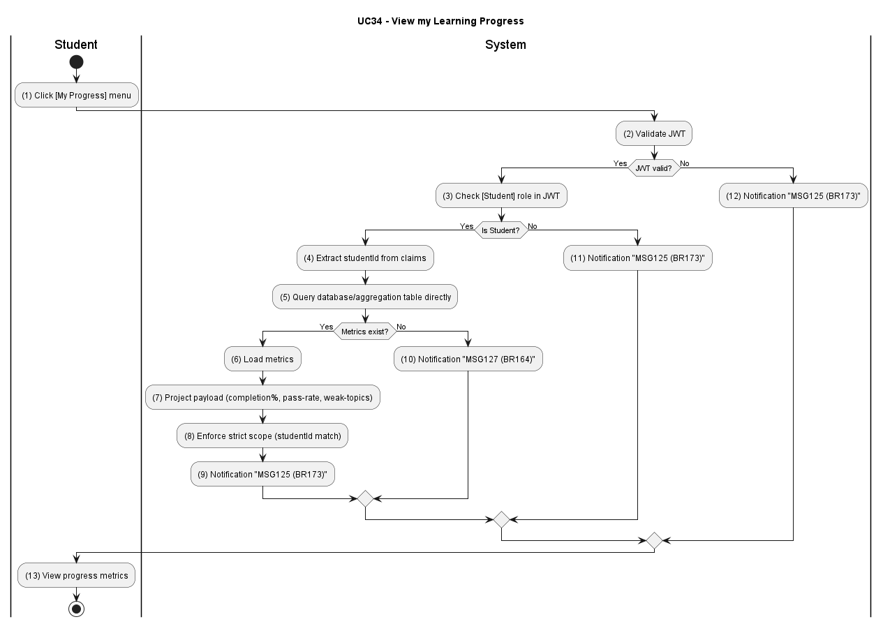

Business Rules
Activity | BR Code | Description
(2) | BR169 | JWT & RBAC:  - Validate JWT and [View_MyProgress] permission; confirm actor role is Student.  - Return MSG123 on failure.
(8) | BR170 | Strict Scope Enforcement:  - Extract [studentId] from JWT claims only.  - Return MSG124 on scope mismatch.
(5) | BR171 | Direct Data Resolution:  - Query Aggregation table with [studentId] and [licenseTierId]; return empty payload if no data.
(7) | BR172 | Progress Payload Projection:  - Build payload with completionPct, studiedCount, attemptCount, passRate, 30-day trend, and top 5 weak topics.
(9) | BR173 | Success Response:  - Return progress dashboard payload (MSG125).

UC35: 2D Driving Practice
Name | 2D Driving Practice
Description | This use case describes a student performing an interactive 2D driving practice session within the training environment. The session provides live telemetry, error detection, immediate feedback, and an optional persisted practice record for review.
Actor | Student
Trigger | When the student clicks the "Start 2D Practice" action on the Training dashboard.
Pre-condition | The student is authenticated. The client device supports the 2D practice UI (canvas/WebGL) and network connectivity for telemetry.
Post-condition | A practice session is created (optionally persisted), live feedback is provided, and a session summary is returned to the client.

Activities Flow
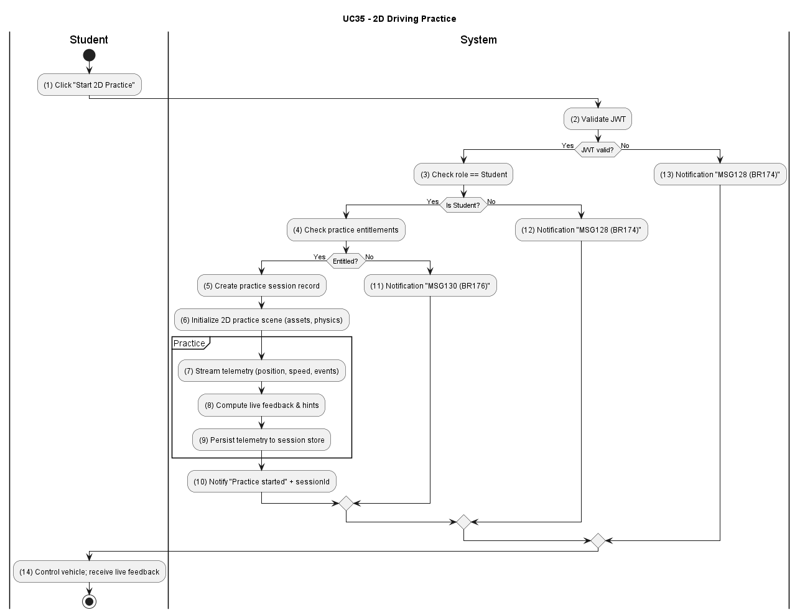

Business Rules
Activity | BR Code | Description
(2) | BR174 | JWT & RBAC:  - Validate JWT and [Practice_2D] permission  - Return MSG128 on failure.
(4) | BR175 | Session Creation:  - Validate request payload and create a `practice2d` session record (in-memory or persisted per user preference)  - Return MSG129 on invalid request.
(6) | BR176 | Resource & License Check:  - Verify student's licenseCategory and enabled practice features; return MSG130 if practice not permitted.
(8) | BR177 | Client Capability Validation:  - Verify client supports required rendering and input (canvas/WebGL, keyboard/touch).  - Return MSG131 if unsupported.
(11) | BR178 | Telemetry & Feedback:  - Continuously process telemetry, detect defined maneuver errors, compute scoring/penalties, and emit live feedback events to the client.
(14) | BR179 | Persistence & Audit:  - If persistence requested, persist telemetry snapshot, session summary, and audit metadata in a single transaction  - Return MSG133 on storage failure.
(17) | BR180 | Success Response:  - Return session summary and feedback payload when session ends or on explicit save (MSG134).

UC36: Error Feedback Within Session
Name | Error Feedback Within Session
Description | This use case describes the system detecting errors during an active practice or exam session and providing immediate, contextual feedback to the student while persisting the event for audit and review.
Actor | Student
Trigger | When telemetry or user action during an active session matches an error detection rule.
Pre-condition | The student has an active practice or exam session with telemetry streaming enabled.
Post-condition | Error feedback is emitted to the client, the event is recorded in session history, and scoring/penalty is updated as applicable.

Activities Flow
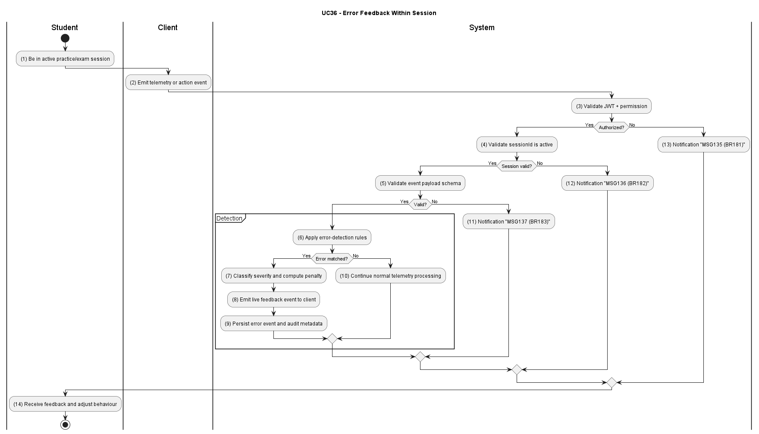

Business Rules
Activity | BR Code | Description
(2) | BR181 | JWT & RBAC:  - Validate JWT and [Session_ErrorFeedback] permission.  - Return MSG135 on failure.
(4) | BR182 | Sesion Validation:  - Confirm [sessionId] exists and is active  - Return MSG136 if not.
(6) | BR183 | Event Validation:  - Validate telemetry/event payload schema.  - Return MSG137 on invalid payload.
(8) | BR184 | Error Detection:  - Apply configured detection rules to incoming telemetry.  - When an error condition is matched, classify severity and penalty.
(11) | BR185 | Live Feedback Emission:  - Emit contextual feedback event to the client (visual + textual + hint) with severity and penalty data.
(14) | BR186 | Persistence & Audit:  - Persist the error event, penalties applied, and audit metadata in a single transaction.  - Return MSG138 on storage failure..
(17) | BR187 | Success Response:  - Acknowledge feedback emission and update session summary (MSG139 and MSG140).

List Description
List_Description.xlsx

View Description
View_Description.xlsx

Non-functional Requirements

User Access and Security
Function | Admin |  | Student | Instructor |  | Center Manager
Login | x |  | x | x |  | x
Forgot Password | x |  | x | x |  | x
Create Student Account | x |  |  |  |  | x
Update Student Account | x |  |  |  |  | x
Lock Student Account | x |  |  |  |  | x
Assign License Categories To Students | x |  |  |  |  | x
View Detailed Course List | x |  | x | x |  | x
Create Course | x |  |  |  |  | x
Update Course | x |  |  |  |  | x
Delete Course | x |  |  |  |  | x
Take Theory Exam |  |  | x
Manage Exam Session |  |  | x
Submit Exam |  |  | x
View Exam Results |  |  | x
Review Exams |  |  | x
Search Question Bank | x |  |  |  |  | x
Create Question | x |  |  |  |  | x
Update Question | x |  |  |  |  | x
Delete Question | x |  |  |  |  | x
Create Exam Template | x
Update Exam Template | x
Delete Exam Template | X
View Student List | x |  |  | x |  | x
Track Learning Progress | x |  |  | x
View Exam History | x |  |  | X
Reset Learning Progress | x
Send Academic Warnings | x |  |  | X
View Maneuver Checkpoint Details |  |  | x
View General Maneuver Errors |  |  | x
Review Frequently Missed Questions |  |  | x
Logout | x |  | x | x |  | x
View my learning progress |  |  | x
2D Driving Practice |  |  | x
Error Feedback Within Session |  |  | x
X: User has full permission to do the action.

3.2. Performance Requirements
Number of user
- Number of concurrent users (baseline, across all centers): 3,000 — primarily students taking practice tests or scheduled theory exams concurrently; design for up to 5,000 peak concurrent users during licensing/peak periods.
- Number of registered business users (instructors, center managers, admins): 600–700.
Data volume
- Number of documents/records: 6M–8M (includes student profiles, exam attempts and results, course materials, question bank entries, audit logs, and media assets).
- Data growth rate: ~5 MB/day (average net growth across the system; includes new exam attempts, logs, and uploaded training materials).
Level of availability
- Target availability: 99.9% (measured per standard SLA definitions). This corresponds to maximum allowable downtime of approximately 8.76 hours/year.
- Note: exam delivery and scheduled testing windows are business-critical; production exam-hosting SHOULD target 99.9% availability to match ADD/SAD. For peak exam periods consider a higher SLA of 99.95% (approximately 4.38 hours/year).
Usage frequency
- The system is used continuously during business hours; scheduled theory exams and batch uploads often generate hourly spikes in traffic.
- Deploy on servers (or cloud instances) sized to operate throughout business hours with capacity for peak concurrent exam sessions; schedule upgrades, maintenance, and backups outside peak testing hours.
- Ensure persistent storage and backup policies cover exam data, answer logs, and audit trails to meet compliance and reporting needs.

3.3. Implementation Requirements
Location
- Primary deployment region: Ho Chi Minh City (data center / cloud region serving testing centers in southern Vietnam).
Read-only Duration
- Read-only snapshot retention for audit and reporting: 1 day (daily snapshots of exam attempts and audit logs retained as immutable read-only copies for 24 hours).
Read-only Timeframe
- Daily read-only window: 00:00–00:30 (30-minute window for creating immutable daily snapshots and performing consistency checks). Adjust as needed to avoid overlapping scheduled exams.
Maintenance Window
- Weekly maintenance: every Sunday at 23:00 local time, duration 1–2 hours.
- Activities during window: software updates, database maintenance (index rebuilds, backups), non-critical migrations and patching. Schedule must avoid scheduled public exams; if conflicts arise, shift maintenance to a different off-peak window.
Overall conversion timeline
- Recurring data conversion / reconciliation schedule: 1st, 15th and 25th of every month (used for bulk imports, license tier reconciliations, and reporting snapshots).

Appendixes

Glossary
The list below contains all the necessary terms to interpret the document, including acronyms and abbreviations.
Term | Admin
JWT | JSON Web Token — a compact, URL-safe means of representing claims to be transferred between two parties for authentication and authorization.
RBAC | Role-Based Access Control — an authorization model that assigns permissions to roles rather than individual users.
DTO | Data Transfer Object — an object used to transfer data between processes or layers, often simplifying payloads.
TTL | Time To Live — the remaining lifetime of a resource (e.g., cache entry or token) expressed as a duration.
SRS | Software Requirements Specification — the primary requirements document that captures functional and non-functional requirements, use cases, business rules, and constraints for the system.

Messages
This section describes the details of messages used in business rules e.g. error messages, confirmation messages, etc.
MSG Code | Message Content
MSG01 | Please enter email and password.
MSG02 | Your account is locked. Please contact support.
MSG03 | Invalid email or password.
MSG04 | Please enter a valid email address.
MSG05 | No account found for this email.
MSG06 | Reset link is invalid or expired.
MSG07 | Password does not meet complexity requirements.
MSG08 | Please complete all required fields.
MSG09 | You do not have permission to create this account.
MSG10 | Email already exists.
MSG11 | User account created successfully.
MSG12 | User account not found.
MSG13 | Invalid user account data.
MSG14 | You do not have permission to update user accounts.
MSG15 | User account updated successfully.
MSG16 | You do not have permission to lock user accounts.
MSG17 | Invalid user account status for locking.
MSG18 | User account locked successfully.
MSG19 | You do not have permission to assign license categories.
MSG20 | Invalid license category.
MSG21 | License category assigned successfully.
MSG22 | Your session has expired. Please log in again.
MSG23 | Course not found.
MSG24 | No courses match your criteria.
MSG25 | Please complete all required course fields.
MSG26 | You do not have permission to create courses.
MSG27 | Course code already exists.
MSG28 | Invalid course data.
MSG29 | Course created successfully.
MSG30 | You do not have permission to update courses.
MSG31 | Course was modified by another user. Please reload and try again.
MSG32 | Course updated successfully.
MSG33 | You do not have permission to delete courses.
MSG34 | Course cannot be deleted because it is currently in use.
MSG35 | Course deleted successfully.
MSG36 | Invalid exam start request.
MSG37 | You are not authorized to start an exam.
MSG38 | Exam resource not found.
MSG39 | Exam attempt created successfully.
MSG40 | Invalid exam session request.
MSG41 | You are not authorized to manage exam session.
MSG42 | Exam session resource not found.
MSG43 | Exam session updated successfully.
MSG44 | You are not authorized to submit exam.
MSG45 | Invalid exam submission request.
MSG46 | Exam attempt not found.
MSG47 | Exam submitted successfully.
MSG48 | Grading could not proceed: invalid invocation context.
MSG49 | Invalid grading request.
MSG50 | Grading resource not found.
MSG51 | Exam graded successfully.
MSG52 | Invalid exam result query.
MSG53 | You are not authorized to view exam results.
MSG54 | Exam result not found.
MSG55 | Exam result loaded successfully.
MSG56 | Invalid exam review query.
MSG57 | You are not authorized to review exams.
MSG58 | Exam review resource not found.
MSG59 | Exam review data loaded successfully.
MSG60 | Invalid question search request.
MSG61 | You are not authorized to search question bank.
MSG62 | Question resource not found.
MSG63 | Question search completed successfully.
MSG64 | Invalid create-question request.
MSG65 | You are not authorized to create question.
MSG66 | Question context not found.
MSG67 | Question created successfully.
MSG68 | Invalid update-question request.
MSG69 | Version field is missing.
MSG70 | This question was modified by another user. Please reload and try again.
MSG71 | You are not authorized to update question.
MSG72 | Question not found.
MSG73 | Question updated successfully.
MSG74 | Invalid delete-question request.
MSG75 | You are not authorized to delete question.
MSG76 | Question deleted successfully.
MSG77 | Invalid create-template request.
MSG78 | You are not authorized to manage exam templates.
MSG79 | Exam template context not found.
MSG80 | Exam template created successfully.
MSG81 | Invalid update-template request.
MSG82 | This exam template was modified by another user. Please reload and try again.
MSG83 | Exam template not found.
MSG84 | Exam template updated successfully.
MSG85 | Invalid delete-template request.
MSG86 | Exam template deleted successfully.
MSG87 | Invalid exam-paper generation request.
MSG88 | You are not authorized to generate exam papers.
MSG89 | Generation resource not found.
MSG90 | Exam papers generated successfully.
MSG91 | Invalid student-list query.
MSG92 | You are not authorized to view student list.
MSG93 | Student list resource not found.
MSG94 | Student list loaded successfully.
MSG95 | Invalid learning-progress query.
MSG96 | You are not authorized to track learning progress.
MSG97 | Learning-progress resource not found.
MSG98 | Learning-progress data loaded successfully.
MSG99 | Invalid exam-history query.
MSG100 | You are not authorized to view exam history.
MSG101 | Exam-history resource not found.
MSG102 | Exam history loaded successfully.
MSG103 | Invalid reset-learning-progress request.
MSG104 | You are not authorized to reset learning progress.
MSG105 | Progress resource not found.
MSG106 | Learning progress reset successfully.
MSG107 | Invalid academic-warning request.
MSG108 | You are not authorized to send academic warnings.
MSG109 | Warning target not found.
MSG110 | Academic warnings sent successfully.
MSG111 | You are not authorized to view checkpoint details.
MSG112 | No checkpoints exist for this license category.
MSG113 | Checkpoint details loaded successfully.
MSG114 | You are not authorized to view maneuver errors.
MSG115 | No maneuver errors found.
MSG116 | Maneuver errors loaded successfully.
MSG117 | Invalid missed-question review request.
MSG118 | You are not authorized to review missed questions.
MSG119 | Missed-question resource not found.
MSG120 | Missed-question review set generated successfully.
MSG121 | Authentication token is missing or invalid.
MSG122 | You have been logged out successfully.
MSG123 | You are not authorized to view this progress data.
MSG124 | Access denied: you may only view your own progress.
MSG125 | Learning progress loaded successfully.
MSG126 | Authentication token is missing.
MSG127 | Authentication token signature is invalid.
MSG128 | You are not authorized to start 2D practice.
MSG129 | Invalid 2D practice start request.
MSG130 | Practice not permitted for your license.
MSG131 | Client does not support required 2D practice capabilities.
MSG132 | Telemetry persistence failed.
MSG133 | Practice session storage failed.
MSG134 | Practice session completed successfully.
MSG135 | You are not authorized to send session feedback.
MSG136 | Session not found or not active.
MSG137 | Invalid event payload.
MSG138 | Failed to persist error event.
MSG139 | Error event recorded with penalties applied.
MSG140 | Feedback emitted successfully.

