What are WebSockets? Need for them?

Following are some of the drawbacks of HTTP due to which they are unsuitable for certain scenarios-  
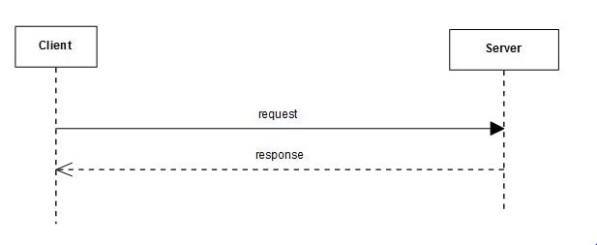

* **Traditional HTTP requests are unidirectional -**In traditional client server communication, the client always initiates the request.
* **Half Duplex -**User requests for a resource and the server then serves it to the client. The response is only sent after the request. So at a time only a single request occurs.
* **Multiple TCP connections -**For each request a new TCPsession is needed to be established and then closed after receiving the response. So without using WebSockets we will have multiple sessions.
* **Heavy -**Normal HTTP request and response require exchange of extra data between client and server.

WebSocket is a computer communications protocol, providing full-duplex communication channels over a single TCP connection.  
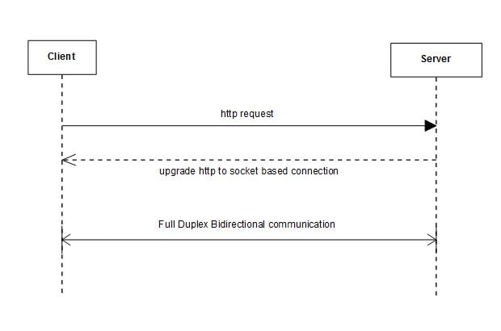

* **WebSocket are bi-directional -**Using WebSocket either client or server can initiate sending a message.
* **WebSocket are Full Duplex -**The client and server communication is independent of each other.
* **Single TCP connection -**The initial connection is using HTTP, then this connection gets upgraded to a socket based connection. This single connection is then used for all the future communication
* **Light -**The WebSocket message data exchange is much lighter compared to http.