Knowledge Representation and Expert Systems
2 big ideas to extract knowledge from people into some machine readable form:
- Knowledge representation
- Reasoning
- Knowledge representation
Knowledge: sth in out head and represents our understanding of the world. Can be obtained by active learning(integrate pieces of info into active model of world)
DIKW pyramid:
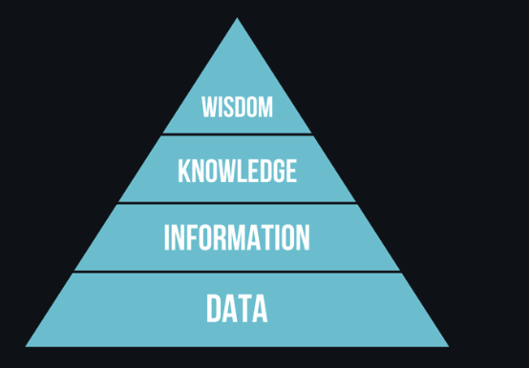
  - Data: represented in physical media (written text, spoken words,..). exists independently of human beings and can be passed between pp.
  - Information: how we interpret data in our head.
  - Knowledge: information intergrated into our world.
  - Wisdom: meta-knowledge. Hhow and when knowledge should be used. => higher knowledge.
- KR: find some effective way to represent knowledge
- Classifying computer knowledge representation
Network representations: reproduce same networks as graph inside computer => semantic network
- Object attribute value triplets (attribute value pairs): represent semantic network by a list of triplets, containing objects, attributes, and values.
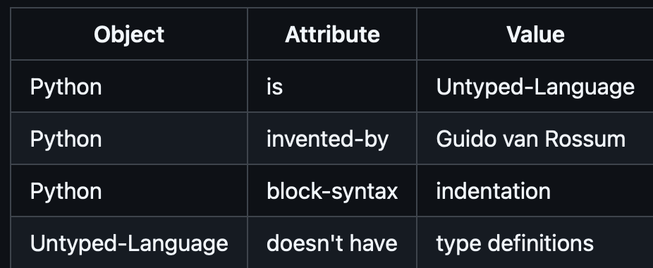
- Hierarchical representations:
Frame representation: representing each obj or class as a frame wich contains slot.
Slot: possible default values, value restriction, or stored procedures
Frames form a hierarchy similar to obj hierarchy in oop
Scenarios: special kind of frames => represent complex situations that can unfold in time
- Procedural representaions:list of actions that can be executed when a certain condition occurs
Production rules: if then statemetns -> allow us to draw conclusions
Algorithms: another form of procedural representation
- Logic: way to represent universal human knowledge
Predicate logic as math theoru is too rich to compute => some subset is normally used (horn clauses in prolog)
Descriptive logic: family of logical systems -> represent and reason about hierarchies of obj distributed knowledge representaions (semantic web)
- Expert systems
Comuter systems that were designed to act as an expert in some limited prob domain
based on: knowledge based and inference engine
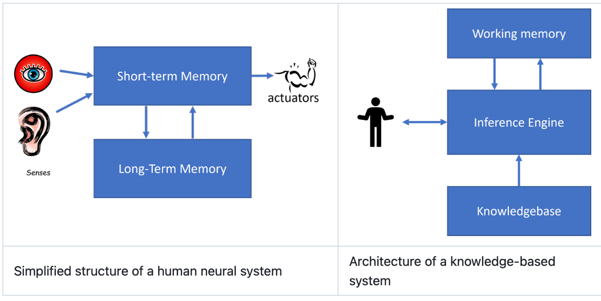
Built like human reasoning sys (longterm and shorterm):
  - Problem memory: currently solved problem’s knowledge. So called static knowledge – contains snapshot of what we know about problem (problem state)
  - Knowledge base: (long term knowledge) navigate from 1 prob state to another by extracting from human experts => dynamic knowledge
  - Inference engine: finding right rules to be applied to each state by searching in prob state, asking user when necessary
- Forward vs backward inference
Forward inference: executes reasoning loop from initial data about the avail prob in working memo
- If target attribute is present -> stop n give result
- Look for satisfied rules => obtaining conflict set of rules
- Perfom confict resolution : select 1 executed rule. Different strategies:
    - Select first applicable rule in knowledge base
    - Select random rule
    - Select more specific rule
- Apply selected rule and insert new piece of knowledge into prob state
- Repeat from step 1
Backward inference:
- Select all rules related to goal => conflict set
- Ask for value if require. If no => next step
- Use confict resolution strategy -> select 1 rule as hypothesis
- Repeat the process
- If any pt the process fails -> use another rule at step 3
5. Implementing expert systems
- directly programming from high level program lang. not best idea
- using expert systems shell
6. Ontology and semantic web
- Semantic web: use knowledge representation to annotate internet -> find res correspond to specific query. It relied on several concepts:
- description logics ~ frame knowledge representation: build hierarchy of obj with properties
- distributed knowledge representation: all concepts are represented by global URI identifier => possible to create knowledge hierarchies
- fam of XML-based lang for knowledge description: RDF, RDFS, OWL
Ontology: explicating specification of a prob domain using some formal knowledge representation
In semantic web, all representation are based on triplets. Each obj and relation are uniquely identified by URI

