
Basic RAIDDR Code Enablement

Date: 1/31/2025
Version: 1.0
Authors:
Majid Nemati SCHIE-CAASE-AMS (Majid.Nemati@microsoft.com)
Brett Dodds SCHIE-CAASE-AMS (Brett.Dodds@microsoft.com)
Terry Grunzke SPARC-LEAP (Terry.Grunzke@microsoft.com)

This document (“Basic RAIDDR Code Enablement”, version 1.0) licensed by the Microsoft Corporation under the OWFa 0.9 license.

© 2025 Microsoft. All rights reserved.

Table of Contents
Table of Figures 3
Revision History 4
1 Overview 5
2 Basic RAIDDR Code 6
2.1 An Example of Basic RAIDDR Implementation 7
3 Encoding 9
4 Decoding 10
4.1 Generate Error Mask and CRC Check 10
4.2 Trials 11
4.3 Some Example Cases 13
4.3.1 Case 1: Single Die Failure on Any Die 1-9 13
4.3.2 Case 2: Single Die Failure on Die 10 14
4.3.3 Case3: Multiple Die Failure 15
4.3.4 Probabilities for P_{SDC} and P_{UE} with Different Number of Metadata Bits 16
5 Selection of CRC Code Generator Polynomial 17
6 CRC Implementations to Avoid Latency 20
6.1 Parallel Implementation of CRC Encoder 20
6.2 Example of calculating CRC 23
6.3 Parallel Implementation of CRC Checker 23
7 Hardware Simplifications and Trade-Offs 24
7.1 Splitting the Codewords 24
7.2 Efficient Method to Perform Trials 25
8 Reliability Enhancement Against More Probable Errors in Multi-Codeword 26
8.1 Multi-Codeword Architecture with Improved Error Detection on Probable Error Patterns 27
9 Some Comparisons between Basic RAIDDR and RS based Methods 29
9.1 Silent Data Corruption (SDC) 29
9.2 Addition of Metadata 30

Table of Figures

Figure 1. One example of DDR4 memory 5
Figure 2. In a block of data, a large number of bits come from the same source 6
Figure 3. One example to demonstrate 64B cache line encoded to 640 bits in DDR5, with RS code of 16-bit symbols 7
Figure 4. Applying Basic RAIDDR code concept on DDR5 applications 7
Figure 5. One way to apply Basic RAIDDR concept for DDR5 8
Figure 6. One example of Basic RAIDDR choices with additional metadata 9
Figure 7. Encoding steps of Basic RAIDDR 10
Figure 8. Generation of error mask in decoding step 1 10
Figure 9. Demonstration of different trials 12
Figure 10. Demonstration of case 1, Die two is failed 13
Figure 11. Demonstration of case 2, die 10 failed 15
Figure 12. One example to demonstrate multiple die failure 16
Figure 13. CRC implementation by LFSR. r is the degree of the generator polynomial 20
Figure 14. A demonstration to calculate CRC 21
Figure 15. Shifting data bits to right or left results CRC be divided or multiplied by α, respectively 21
Figure 16. Corresponding to each bit location C_{i} in the data block, there is a coefficient derived from consecutive powers of α 22
Figure 17. CRC generator complete block diagram 22
Figure 18. The pre-calculated coefficients repeat with period d 23
Figure 19. Example of coefficients for CRC-3 on 20 bits information bits (codeword size is 23 bits) 23
Figure 20. CRC Checker 24
Figure 21. Splitting data into two codewords 25
Figure 22. Calculation of CRC parities for different trials 25
Figure 23. Equivalent method to calculate CRC parities 26
Figure 24. Using the CRC checker block to generate CRC(e_{i}) of error mask at different dies simultaneously 26
Figure 25. An example of multi-codeword implementation with 4 codewords and 4 metadata bits 27
Figure 26. An example of multi-codeword implementation with asymmetric CRC on 4 codewords and 4 metadata bits 28
Figure 27. Encoding Procedure for the architecture with enhanced reliability for more probable errors 28

Revision History
Version | Release date | Release Note
V 1.0 | 1/31/2025 | 1. Initial version

Overview
One of the standard methods to provide reliability in memory (such as DDR, LPDDR, etc.) is using Reed-Solomon correction codes. In such schemes 2 additional devices are needed to correct errors up to in any 1 device.
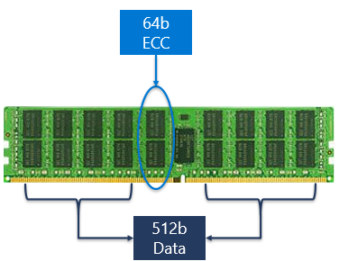
Figure 1. One example of DDR4 memory

In many applications metadata might be needed for Directory Mode, Poison, etc. Metadata might use bits from ECC parity; therefore, we lose the ability to correct some errors on a device. For example, DDR4 assigns 2 ECC DRAM per 16 Data DRAM. As such, the total error correction overhead (Baseline) will be 12.5%. Such a scheme has a correction capability between 100% and 99.9985% (depending on metadata usage) for a single device failure.
DDR5 changed DIMM architecture (Enable deeper transaction). It requires 2 additional devices for ECC bits. DDR5 DRAM also added on-die ECC in the form of SEC (single error correction). The modification was implemented due to vendors' concerns about single-bit errors. This adjustment led to a roughly 6% increase in DRAM die size.
Therefore, the total error correction overhead (Baseline) increased to 31% (2x ECC DRAM per 8x data DRAM + on-die ECC overhead). The single-device correction capability results between 100% and 99.999999978% (depending on metadata usage).
We propose “Basic RAIDDR” method to add metadata bits efficiently with minimum effect on reliability on standard DDR5 10x4 configuration (for simplicity and value proof). Basic RAIDDR also provides the capability to scale the number of metadata bits, without major change to the ECC scheme. No access to on-die ECC bits is needed to make Basic RAIDDR work.

Basic RAIDDR Code
Numerous Error Correction Codes (ECC) have been developed over many years. From more traditional ones such as convolutional and algebraic codes to more modern error correcting codes such as LDPC and polar codes. Some schemes are used mainly for correction, and others like CRC are mainly for error detection purposes. Each of these schemes have properties that may match better with specific circumstance. For example, when dealing with burst errors, often non-binary codes like RS codes are more efficient since every few errors will be in the same symbol and therefore, they can be corrected together.
One particular channel through which data is passed is the memory write/read channel. In such a channel, in addition to random errors that often appear in the form of single bits, there is a possibility that a die malfunctions, and therefore, the entire die data becomes erroneous. Figure 2 shows a block of data. For example, In DDR5 memory, a cache line is 64B, and each 64-bit segment is obtained from a different die with a particular failing probability. When a die fails, part or entire die data will not be reliable.

Figure 2. In a block of data, a large number of bits come from the same source

Non-binary codes such as Reed-Solomon (RS) are often used in such situations. However, the assigned number of bits per symbol in RS code is a parameter that is selected based on complexity and performance requirements. One example for DDR5 is shown in Figure 3. Note that the larger the symbol, the better reliability performance at the price of more complexity for the hardware. Though, theoretically the best reliability solution in this case is to put all the data from the same die into a single RS symbol.
In the example of DDR5, the number of bits from the same die is high (64 bits). Hence, the resulting RS code hardware will be excessively complicated if symbols of 64-bit are chosen.
Another challenge in employing RS code in these applications is the necessity of accommodating additional metadata, which is essential for modern applications like CXL. In many new applications, few metadata bits needed to be included in every cache line. This number varies based on specific application and can be 2, 3, 4 or much higher. The constrained space allocated for both data and parity in each cache line complicates the inclusion of metadata, maintaining reliability performance, and avoiding overly complex hardware solutions. In many RS based solutions, the symbol size is often chosen 8 or 16 bits, and various methods are utilized to add a few bits metadata. The most commonly employed techniques include extracting bits from parity symbols or introducing the virtual data symbols.
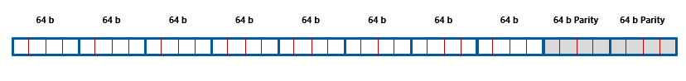
Figure 3. One example to demonstrate 64B cache line encoded to 640 bits in DDR5, with RS code of 16-bit symbols

One solution to address the above issues is to use Basic RAIDDR codes, which allows maintaining entire die data in a single virtual symbol, and adding as many metadata bits as needed without significantly altering the architecture or increasing complexity.
Developed in Microsoft for DDR applications, Basic RAIDDR code has the flexibility to match the virtual symbol size to the size of data from a single die in cache line. Basic RAIDDR is flexible enough to add various numbers of metadata bits. Basic RAIDDR is well adapted to the scenarios where only one device failure is anticipated, and additional single-bit errors are managed through other methods. For example, in DDR5, there is the on-die ECC mechanism that corrects any single bit error per die.
In one interpretation, we can consider that Basic RAIDDR separates the detection of error location (i.e., the erroneous symbol location) from its correction. Additional metadata can affect only detection probability. Basic RAIDDR results in a doubling of the probabilities for undecodable errors and mis-corrections with every additional use of metadata. Once the erroneous symbol's location is identified, full correction can be made. As an example, Figure 4 demonstrates the concept of Basic RAIDDR code in DDR5 applications.

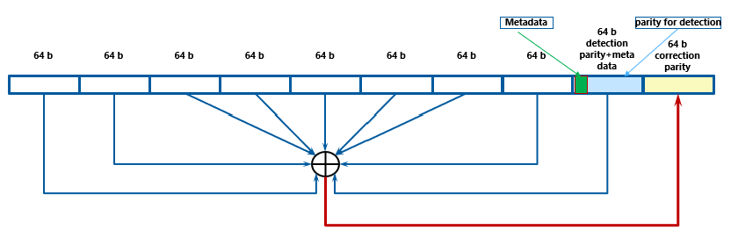
Figure 4. Applying Basic RAIDDR code concept on DDR5 applications

An Example of Basic RAIDDR Implementation
One implementation of Basic RAIDDR involves using CRC primarily for detection and XOR predominantly for correction. In such an implementation, changing the number of CRC parity bits allows for an easy accommodation of the needed metadata bits. The unused bits of the die for metadata will be used for CRC. as the main tool to detect any error. On a separate die, the bit-to-bit XOR of all previous dies will be written to be used mainly for correction. Figure 5 demonstrates such architecture.

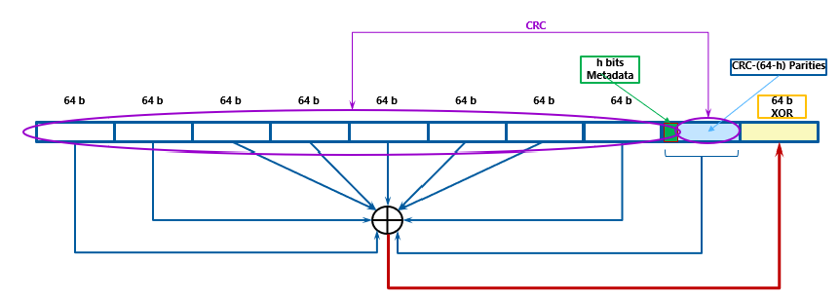
Figure 5. One way to apply Basic RAIDDR concept for DDR5

Hence, this implementation utilizes CRC in combination with XOR, pinpoints the exact location of the faulty die, as detailed in the following chapters. Then XOR will be used to correct the errors on the detected failed die. Each die's data is treated as a single symbol and will be corrected entirely when needed. Additionally, the change of number of metadata bits does not change the overall structure; it only utilizes a different CRC to accommodate for the changes in the number of metadata bits.
In many RS based designs, the size of the symbol primarily affects how granular the change in the number of metadata bits can be. While we might aim for smaller symbol sizes to support 3 or 4 metadata bits, larger symbol sizes generally are preferred to enhance the overall RS correction power. Therefore, separating detection from correction as described above greatly simplifies designing the codes and allows for easy adjustment of number of metadata bit quantities.
One practical example of Basic RAIDDR on 10x4 memory configuration is shown in Figure 6. Out of 10 dies, there are 8 data-bearing dies, and 2 “extra” dies for ECC and metadata. The combination of metadata and ECC can be different depending on the required number of metadata and reliability.

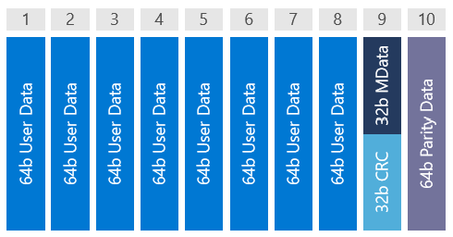
Figure 6. One example of Basic RAIDDR choices with additional metadata

Basic RAIDDR utilizes the two dies as follows:
- One die (#9) carries metadata and a CRC. The number of metadata bits and size of CRC are scalable. More metadata means smaller CRC (more ECC gaps/relatively less reliability).
- One die (#10) carries calculated bit-wise XOR parity data on corresponding bits of different dies (including metadata/CRC die).

Encoding
Figure 7 shows the encoding steps of Basic RAIDDR. In this example, host provides 8Χ64b of data and 32b of metadata. To fill the 32b CRC, get the 32-bit CRC remainder for the 512+32 (544) bits of host data. Note that the choice of polynomial may impact the mapping of the resulting ECC gaps.
32b CRC will be stored in Die 9 (figure on the left). Typically bit order for CRC calculation should include all bits from die1, then all bits from die 2, etc. Then with 512b of data and 32b of metadata from the host together with CRC parity bits generate the XOR parity bits. To do so, for each bit position per-die, generate the XOR parity bit and store in the corresponding die 10 position (figure on the right) and write the XOR parity data pattern to DRAM.

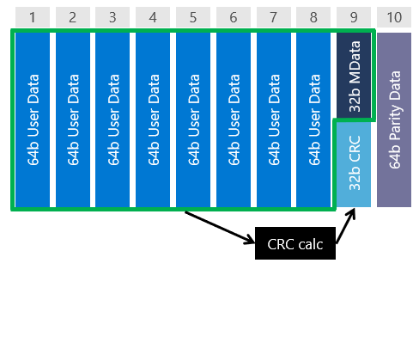
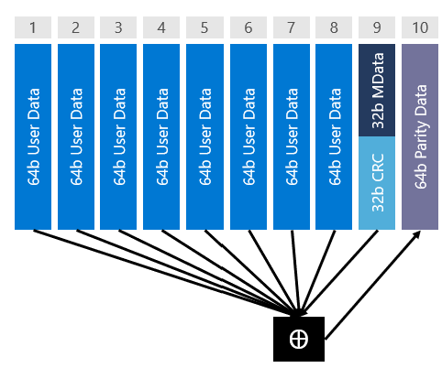

Figure 7. Encoding steps of Basic RAIDDR

Decoding
In decoding we notice that since on-die ECC is on, we expect all remaining errors originate from one die and therefore can be corrected. There are two main steps in decoding as discussed in the following sections.

Generate Error Mask and CRC Check
Generate the error mask:
As we saw, die 10 stored per-bit parity information for all dies. Therefore, we can generate the error mask by XORing all corresponding bits in all dies as shown in Figure 8.
- Single-device errors: The error mask result cannot be zero. The error mask shows the error pattern of the failing device.
- Multi-device errors: The result is a mix of multiple device error patterns and the error mask could be zero.
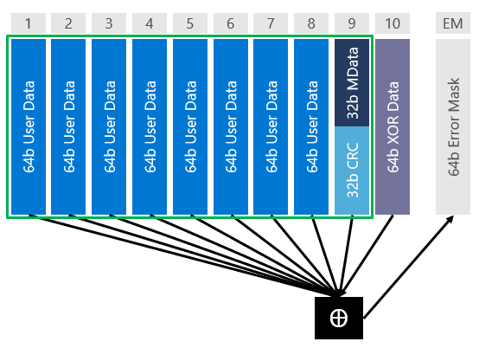
Figure 8. Generation of error mask in decoding step 1
Validate CRC (CRC Check):
- Calculate the CRC of the received data.
- A zero CRC (combined with zero error mask) means the data is detected as valid.
Table 1shows the next step based on error mask and CRC results.

Table 1. Next steps based on the results of error mask and CRC check
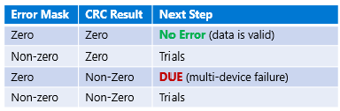

Trials
In trials, we “try” the Error Mask at each die position.
- XOR the failure mask with the die data
- Check for valid CRC
It will be shown in following sections that these steps can be done in parallel and can be optimized since only the CRC of the error mask at the die offsets needs to be calculated and compared to the CRC remainder of the first step. However, this is an optimization, not a requirement. Figure 9 demonstrates the concept of trials in decoding step 2.

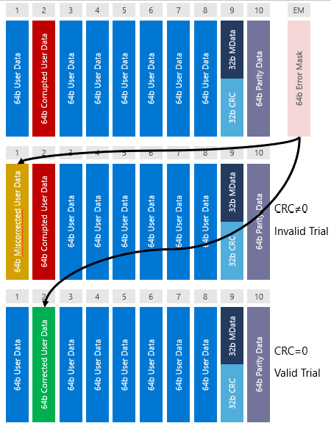

Figure 9. Demonstration of different trials

Table 2 shows the possible results and outcomes. We will expand on them in the following sections.

Table 2. Conclusions based on results of step 2
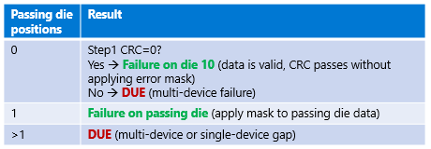

Some Example Cases

Case 1: Single Die Failure on Any Die 1-9

Consider one die failure case shown in Figure 10. As discussed before; after obtaining the error mask, we will try it in different die locations and check CRC.

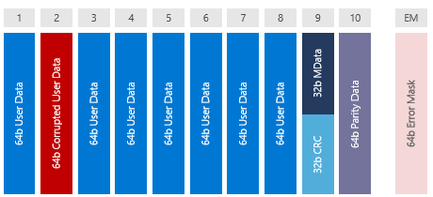
Figure 10. Demonstration of case 1, Die two is failed

Table 3 shows the possible outcomes of such trials. Note that except the case that all 9 trials pass, the possibility that in addition to the trial on failed trial, other trials also pass is zero. To prove this, consider S₀ to be the CRC syndrome on read data. Since the written data is a valid CRC codeword, the corresponding syndrome to the original data is zero. Therefore, S₀ is the syndrome corresponding to the error pattern at actual error location k₀, i.e., E₀.
$S\left(D_{r}\right)=S(D+E_{0})=S\left(D\right)+S\left(E_{0}\right)=S\left(E_{0}\right)=S_{0}$ (1)
The CRC syndrome of corrected data D_{c} after adding the error mask is D_{c}=D_{r}+E_{k}, where E_{k} is the error mask added to the data at die with location k (k=1-9).
$S\left(D_{c}\right)=S\left(D+E_{0}+E_{k}\right)=S\left(D\right)+S\left(E_{0}\right)+S\left(E_{k}\right)=S\left(E_{0}\right)+S\left(E_{k}\right)=S_{0}+S\left(E_{k}\right)$ (2)
Note that E_{k} is the shifted version of E₀ at location k. Therefore
$S\left(E_{k}\right)$=S$\left\{f_{k-k0}[E_{0}]\right\}$
Where f_{d}(A) represents shifting the pattern A location for d dies, i.e., 64d bits to the left, and k₀ is the actual die location of the errors that generates E₀. Therefore,
$S\left(E_{k}\right)= α^{64\left(k0-k\right)}S(E_{0})= α^{64\left(k0-k\right)}S_{0}$ (3)
Where α is the primitive element of GF(2^{m}) where the CRC-m code is built on it. For this purpose, α=2 is a valid choice. From equations (2) and (3) we have
$S\left(D_{c}\right)=S_{0}+α^{64\left(k0-k\right)}S_{0}=S_{0} \left(1+α^{64\left(k0-k\right)} \right)$ (4)
For D_{c} to be a valid CRC codeword and pass the CRC check, we must have S(D_{c}) = 0. This requires either S₀=0 or $1+α^{64\left(k0-k\right)}$=0
- S₀=0, therefore E₀ needs to be a valid CRC-m codeword. Based on CRC code cyclic property, any circular rotation of E₀ in original code space definition of (2^{m}-1) bits will also be a valid CW. However, E₀ elements are all zero except on the failed die. Therefore, shifting the nonzero elements from one die to another die is equivalent to cyclic shift on the code space. Therefore, all trials will pass the CRC check.
The probability of such an event is 2^{-m} for CRC-m.
- $1+α^{64\left(k0-k\right)}= 0$ à$1=α^{64\left(k0-k\right)}$
However, since α is the primitive element of the field, such equality is only valid if 64(k₀-k) = i(2^{m}-1), where i is any integer. For most choices of m, 2^{m}-1 is larger than the number of bits in CRC code. For choices of small m and large number of data bits in the code block, additional attention should be made to avoid die to die shifts be equal to i(2^{m}-1).
Table 3 shows the possible outcomes of trials for case 1.

Table 3. Possible outcomes for case 1 trials


Case 2: Single Die Failure on Die 10
This is the case that die 10 is the failed die. As such, the CRC check passes without any correction (or equivalently when the error mask correction is applied to die 10). Die 10 contains the XOR parity information and does not affect the CRC code.
In this case if the error mask is not a valid CW, trials on any die will fail the CRC. From (2) with E0 not belonging to CRC code, we have
$S\left(D_{c}\right)=S\left(D+E_{0}+E_{k}\right)=S\left(D\right)+S\left(E_{k}\right)=S\left(E_{k}\right)$ (5)

In (5), since there is no error on dies 1-9, S(E₀)=0. Also, S(D)=0, since it is the original data and a valid CRC codeword. Suppose S_{k1} is the CRC syndrome of zero CW when error mask is applied to die 1 (therefore, die 1 contains only the error mask and all other bits are zero). From (3) and (5), we get

${S\left(D_{c}\right)=α}^{64\left(k1-k\right)}S_{k1}$ (6)
where k is the die number that the error mask is applied to, in different trials.

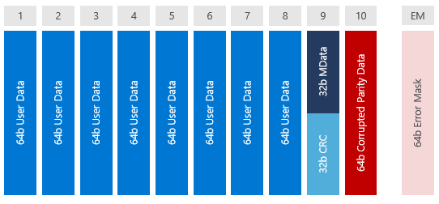
Figure 11. Demonstration of case 2, die 10 failed

The first term in (6) is powers of the GF primitive element and never is zero. Therefore, the only way to have S(D_{c})=0, is S_{k1}=0. The probability of such a random pattern becoming a valid CRC-m codeword is 2^{-m}. Note that in such a case, (6) shows that S(Dc) will be zero for all trials. Table 4 shows the results of trials in case 2.

Table 4. Possible outcomes for case 2 trials


Case3: Multiple Die Failure
When there is more than one failed die, considering random errors in each die, the error mask will also represent a random pattern. The probability that such a random mask is all zero is 2⁻⁶⁴ for memory architectures with 64 bits per die for cache line. For CRC-m, the probability that any random pattern be a valid codeword and passes CRC check is 2^{-m}. Such a probability repeats for each die for trials on 9 dies, and therefore, the overall probability will be 9x2^{-m}. Figure 12 shows one example of case 3 with multiple die failures. Table 5 shows possible outcomes and corresponding probabilities

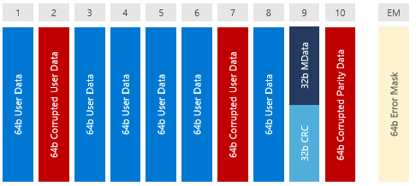
Figure 12. One example to demonstrate multiple die failure

Table 5. Possible outcomes for case 3 with multiple die failures and corresponding probabilities
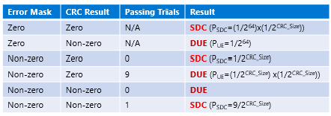

Probabilities for P_{SDC} and P_{UE} with Different Number of Metadata Bits
Depending on the number of supported metadata bits, the probabilities of uncorrectable errors (UE) and silent data corruption (SDC) are calculated in Table 6. These values have also been verified by simulations.

Table 6. PSDC and PUE values for different number of metadata bits
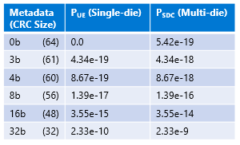
Notes:
- P_{SDC} for all single die failures is 0.0.
- For all multi-die failures, P_{UE} = 1-P_{SDC} of corresponding cases.

Selection of CRC Code Generator Polynomial
The CRC generator polynomial can be selected with different criteria. Although having primitive polynomial is not necessary (unless we are looking for specific property or application), often it is beneficial to have at least irreducible polynomials, meaning the polynomials shouldn’t be factored in smaller degree polynomials, except for having (x+1) factor when needed.
Selecting different polynomials with the same degree changes the error pattern mapping that cannot be detected by CRC (gaps mapping), although the probability of undetectable patterns mostly stays the same as long as the polynomial is not catastrophic.
If P(x) is the CRC generator polynomial and E(x) is the error polynomial, an error will go undetected iff P(x) divides E(x). In this way we can guarantee certain kinds of errors get caught by analyzing the divisors of P(x) and E(x). This can help us to design the codes that are more effective against specific errors that are more possible in memory.
Similarly, sometimes we can choose reducible polynomials to guarantee specific properties to make sure some patterns of interest are always detected. For example, when we have a primitive polynomial of degree m, we can detect all errors of weight 2, if their separation is less than 2^{m}-1. Therefore, if we choose a degree 8 (or larger) polynomial, two single errors can be apart up to 255 bits, meaning that all double errors in a single die can be detected.
While in this version of Basic RAIDDR we are not using any specific property of polynomials, it is safe to choose primitive polynomials for future modifications. Besides, as will be discussed in future sections, primitive polynomials allow for more hardware simplification methods.
Below we suggest a few primitive polynomials of degree 3 to 64. While using these polynomials are not strict requirement, they can be selected as viable choices for CRC.

Degree 3:
P(x) = x^3 + x^1 + 1

Degree 4:
P(x) = x^4 + x^1 + 1

Degree 5:
P(x) = x^5 + x^2 + 1
P(x) = x^5 + x^4 + x^3 + x^2 + 1
P(x) = x^5 + x^4 + x^2 + x^1 + 1

Degree 6:
P(x) = x^6 + x^1 + 1
P(x) = x^6 + x^5 + x^3 + x^2 + 1
P(x) = x^6 + x^5 + x^2 + x^1 + 1

Degree 7:
P(x) = x^7 + x^3 + 1
P(x) = x^7 + x^4 + x^3 + x^2 + 1
P(x) = x^7 + x^3 + x^2 + x^1 + 1

Degree 8:
P(x) = x^8 + x^6 + x^4 + x^3 + x^2 + x^1 + 1
P(x) = x^8 + x^4 + x^3 + x^2 + 1
P(x) = x^8 + x^6 + x^5 + x^1 + 1

Degree 9:
P(x) = x^9 + x^5 + x^3 + x^2 + 1
P(x) = x^9 + x^7 + x^6 + x^4 + x^3 + x^1 + 1
P(x) = x^9 + x^8 + x^7 + x^2 + 1

Degree 10:
P(x) = x^10 + x^4 + x^3 + x^1 + 1
P(x) = x^10 + x^8 + x^5 + x^1 + 1
P(x) = x^10 + x^6 + x^5 + x^3 + x^2 + x^1 + 1

Degree 11:
P(x) = x^11 + x^7 + x^3 + x^2 + 1
P(x) = x^11 + x^9 + x^8 + x^7 + x^4 + x^1 + 1
P(x) = x^11 + x^5 + x^3 + x^1 + 1

Degree 12:
P(x) = x^12 + x^6 + x^4 + x^1 + 1
P(x) = x^12 + x^9 + x^8 + x^3 + x^2 + x^1 + 1
P(x) = x^12 + x^11 + x^9 + x^7 + x^6 + x^5 + 1

Degree 13:
P(x) = x^13 + x^4 + x^3 + x^1 + 1
P(x) = x^13 + x^10 + x^9 + x^7 + x^5 + x^4 + 1
P(x) = x^13 + x^11 + x^8 + x^7 + x^4 + x^1 + 1

Degree 14:
P(x) = x^14 + x^8 + x^6 + x^1 + 1
P(x) = x^14 + x^11 + x^6 + x^1 + 1
P(x) = x^14 + x^13 + x^6 + x^5 + x^3 + x^1 + 1

Degree 15:
P(x) = x^15 + x^4 + 1
P(x) = x^15 + x^10 + x^5 + x^4 + 1
P(x) = x^15 + x^11 + x^7 + x^6 + x^2 + x^1 + 1

Degree 16:
P(x) = x^16 + x^12 + x^3 + x^1 + 1
P(x) = x^16 + x^14 + x^10 + x^8 + x^3 + x^1 + 1
P(x) = x^16 + x^15 + x^11 + x^10 + x^9 + x^6 + x^2 + x^1 + 1

Degree 23:
x^23 + x^5 + x^4 + x^1 + 1
x^23 + x^12 + x^5 + x^4 + 1
x^23 + x^17 + x^11 + x^9 + x^8 + x^5 + x^4 + x^1 + 1

Degree 24:
P(x) = x^24 + x^7 + x^2 + x^1 + 1
P(x) = x^24 + x^21 + x^19 + x^18 + x^17 + x^16 + x^15 + x^14 + x^13 + x^10 + x^9 + x^5 + x^4 + x^1 + 1
P(x) = x^24 + x^22 + x^20 + x^18 + x^16 + x^14 + x^11 + x^9 + x^8 + x^7 + x^5 + x^4 + 1

Degree 31:
P(x) = x^31 + x^3 + 1
P(x) = x^31 + x^13 + x^8 + x^3 + 1
P(x) = x^31 + x^21 + x^12 + x^3 + x^2 + x^1 + 1

Degree 32:
P(x) = x^32 + x^22 + x^2 + x^1 + 1
P(x) = x^32 + x^26 + x^23 + x^22 + x^16 + x^12 + x^11 + x^10 + x^8 + x^7 + x^5 + x^4 + x^2 + x^1 + 1
P(x) = x^32 + x^28 + x^19 + x^18 + x^16 + x^14 + x^11 + x^10 + x^9 + x^6 + x^5 + x^1 + 1

Degree 60:
P(x) = x^60 + x^1 + 1
P(x) = x^60 + x^34 + x^28 + x^27 + 1
P(x) = x^60 + x^48 + x^31 + x^19 + x^13 + x^12 + 1

Degree 61:
P(x) = x^61 + x^44 + x^19 + x^15 + 1
P(x) = x^61 + x^59 + x^52 + x^47 + x^38 + x^33 + 1

Degree 62:
P(x) = x^62 + x^57 + x^26 + x^3 + 1
P(x) = x^62 + x^48 + x^18 + x^16 + x^9 + x^2 + 1

Degree 63:
P(x) = x^63 + x^1 + 1
P(x) = x^63 + x^54 + x^44 + x^20 + 1
P(x) = x^63 + x^60 + x^22 + x^18 + x^8 + x^5 + 1

Degree 64:
P(x) = x^64 + x^61 + x^34 + x^9 + 1
P(x) = x^64 + x^61 + x^56 + x^31 + x^28 + x^23 + 1

CRC Implementations to Avoid Latency
CRC can be implemented in different ways. One standard method is through LFSRs as shown in Figure 13.

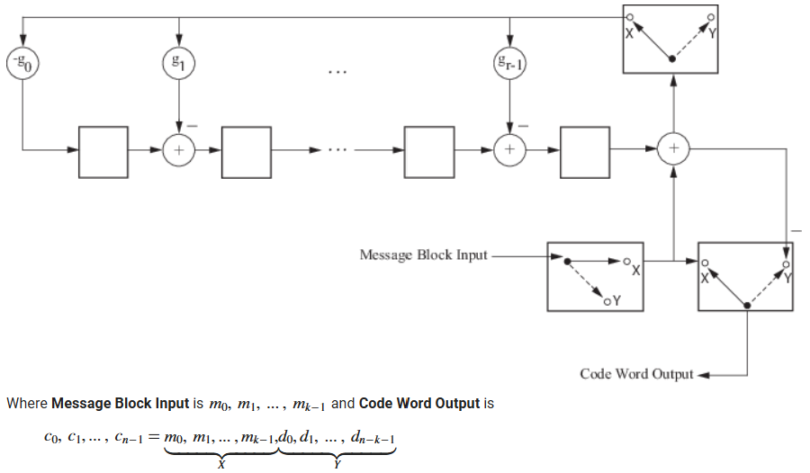
Figure 13. CRC implementation by LFSR. r is the degree of the generator polynomial

Implementation through LFSR is a serial implementation and adds considerable latency. Specifically, when the data block size is large, this implementation becomes a source of considerable added latency.
To avoid the latency, parallel implementation is preferred. In such an implementation the CRC will be calculated from the data bits as soon as they are available without going into a pipeline architecture.

Parallel Implementation of CRC Encoder
In this section we build the method to design and calculate the required coefficients for parallel implementation of CRC encoder and decoder.
It is known that the CRC parity bits in systematic encoder are in fact the remainder of data polynomial divided by generator polynomial. As an example, consider CRC-8 with generator polynomial P(x) = x⁸ + x⁴ + x³ + x² + 1, represented as 1 0 0 0 1 1 1 0 1 in binary. Figure 14 shows that if we have all zero data bits except the last data bit=1, the remainder of the block is the same as binary representation of generator polynomial, ignoring the most significant bit. We denote this part as R₀, i.e., in our example R₀ = 0 0 0 1 1 1 0 1= (29)_{d}=0x1D.

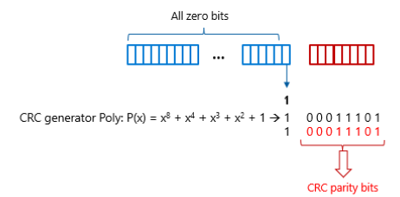
Figure 14. A demonstration to calculate CRC

Next, we know that with fixed codeword length and generator polynomial, shifting the data bits to right causes the resulting CRC to be divided by α, where α is the primitive element of GF(2^{m}) with primitive polynomial P(x). Shifting the data bits to the left on the other hand, results CRC be multiplied by α as shown in Figure 15. Therefore, the coefficients can be derived from consecutive powers of α. Note that division and multiplication are calculated in the defined GF. In this representation, α=2 is considered as primitive element of the field.

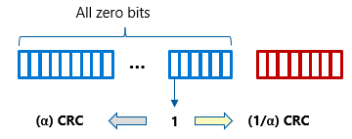
Figure 15. Shifting data bits to right or left results CRC be divided or multiplied by α, respectively

Therefore, the result of CRC corresponding to each position in the data set can be pre-calculated. These pre-calculated CRC values can be stored as coefficients for each bit location.
Figure 16 shows such a concept. C_{i}’s correspond to the information bits. Therefore, the switch is considered closed when the corresponding data bit is 1, and open when the corresponding data bit is 0.
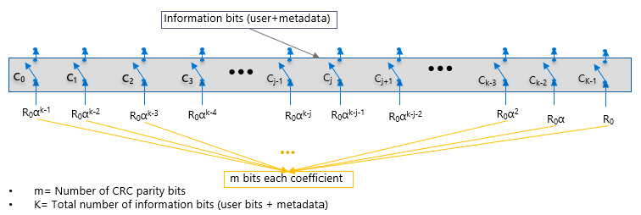
Figure 16. Corresponding to each bit location C_{i} in the data block, there is a coefficient derived from consecutive powers of α

Since CRC is a linear code, for a random data pattern we can calculate the overall CRC from the summation of corresponding CRC for each bit position. Figure 17 shows the complete block diagram of the CRC generator.

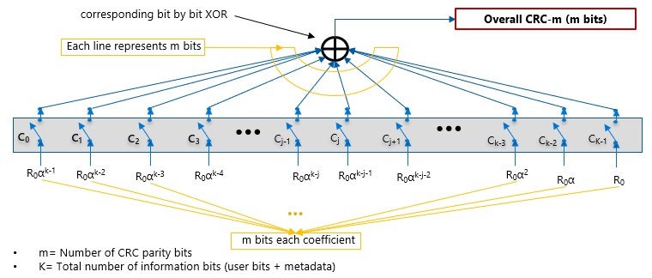
Figure 17. CRC generator complete block diagram

As mentioned before, α=2 is the primitive element of the GF(2^{m}). For the choice of primitive polynomial, consecutive powers of α (and their inverse) generate all the non-zero elements of the field. If a non-primitive, irreducible or reducible polynomial is chosen, the definition of GF will not be complete. There is no primitive element in the field, and therefore, powers of α=2 (hence their inverse) will not generate all the elements in the defined field. Therefore, the consecutive powers of α cycle back with shorter period. Hence, the coefficients will be repeated quicker. One consequence, for example, is that closer double errors can align with equal coefficients and generate CRC=0, i.e., missing the error patterns and leading to UE situation. Figure 18 shows the repeat period of the precalculated coefficients. For primitive polynomials, d=2^{m}-1 bits, and for non-primitive polynomials, d<2^{m}-1 bits, where m is the degree of the polynomial.

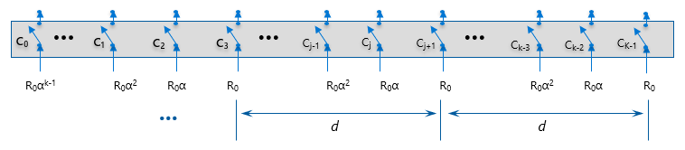
Figure 18. The pre-calculated coefficients repeat with period d

Example of calculating CRC
As an example to demonstrate the coefficient calculation, consider a CRC-3 on a block of 20 data bits CRC-3(23,20). Consider P(x) = x^3 + x + 1 = 1011 = (11)_{d}, as the (primitive) generator polynomial. R₀ = 011 = (3)_{d}. Other coefficients are calculated by multiplying R0 to the consecutive powers of α, as shown in Figure 19.

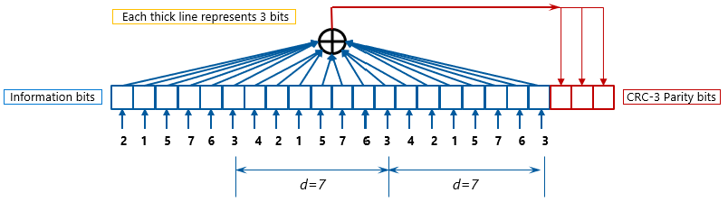
Figure 19. Example of coefficients for CRC-3 on 20 bits information bits (codeword size is 23 bits)

Parallel Implementation of CRC Checker
Checking CRC will be done through CRC decoder architecture that is very similar to CRC encoder. The CRC will be generated as before from the data part of the codeword. The calculated CRC parities should be equal to the CRC parities in the codeword. Therefore, the block diagram at Figure 20 can be used for CRC checker.

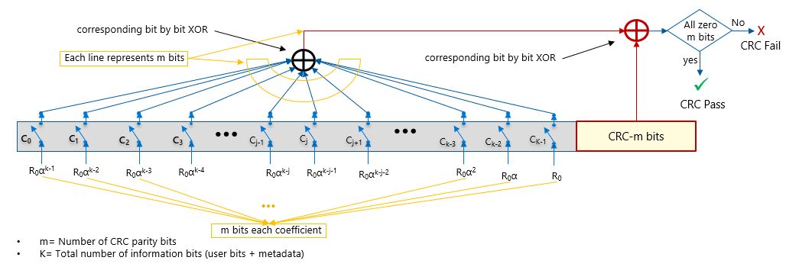
Figure 20. CRC Checker

Hardware Simplifications and Trade-Offs

Splitting the Codewords
When a small number of metadata is required, the implementation of CRC with large number of parities might add to the hardware complexities. Besides, the CRC code will work on a large block size which adds to the complexity of computations and/or possible additional latencies.
To simplify hardware implementation, data from a memory transaction can be split into two or more codewords. Basic RAIDDR procedures with parity, CRC, and trials remain the same, except that different CRC value for each codeword is generated and validated. CRC pass requires that all codewords have CRC = 0. Note that with such a modification, each CRC will be generated independently and in parallel with other ones. The number of XOR inputs will also be reduced since the data block included in each codeword is smaller.
For example, with 2 codewords, a trial on die 3 is considered valid only when upper and lower CRC = 0 (Figure 21). Note that metadata also split between the codewords. The split can be done for a larger number of CWs.

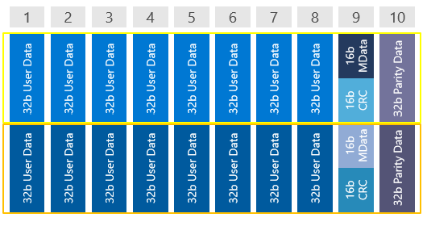
Figure 21. Splitting data into two codewords

P_{UE} remains 1/2^{Combined_CRC_SIZE} for single-die failures (equivalent to 1/2^{Codeword_CRC_Size} * 1/2^{Codeword_CRC_Size}), i.e., the probability of error masks on both codewords resulting in CRC=0 on every trial. Also, P_{SDC} remains roughly 10/2^{Combined_CRC_SIZE} for multi-die failures
The trade-off: Such a modification changes in the ECC gap pattern mappings, many of which will include bits only in one codeword. These error pattern types in some cases may align with more common faults. Codeword organization can be used in conjunction with fault-bounding to limit the impact of these cases.

Efficient Method to Perform Trials
Theoretically, the trials are done by applying the error mask to the proper position of read data and calculating the CRC parities for each assumed error location, as shown on Figure 22.

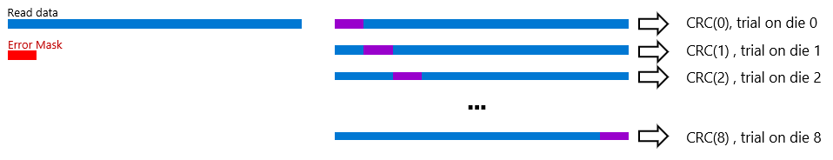
Figure 22. Calculation of CRC parities for different trials

However, using the linearity property of CRC codes, we can calculate CRC checksum of read data and error mask in assumed error locations/dies separately. Then we add the results, to calculate the corresponding CRC trial, as shown in Figure 19.

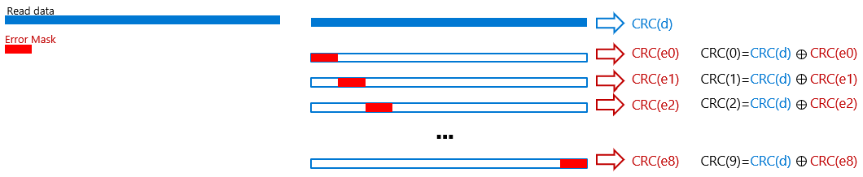
Figure 23. Equivalent method to calculate CRC parities

Hence, with an architecture as shown in Figure 24, we can calculate all CRC(e_{i})s at one decoding time. In this architecture, the input to all die data will be set to error mask simultaneously and all CRC(e_{i})s will be generated at the same time.

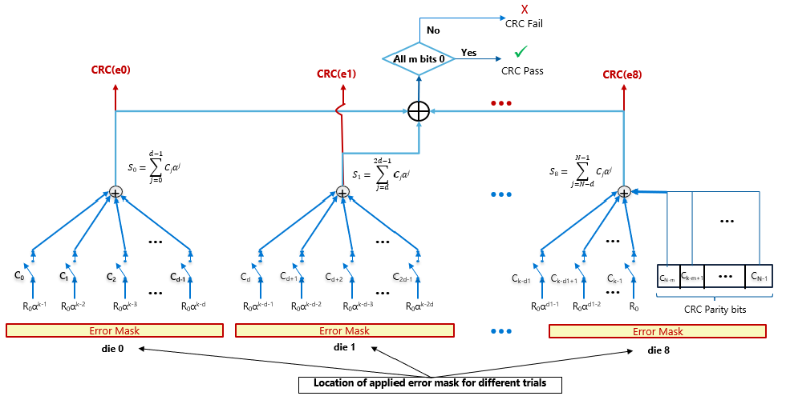
Figure 24. Using the CRC checker block to generate CRC(e_{i}) of error mask at different dies simultaneously

Reliability Enhancement Against More Probable Errors in Multi-Codeword
As discussed in the trade-offs in section 7.1, splitting codewords simplifies the hardware, but makes it more susceptible to more probable errors. These errors may affect a small part of memory, such as Sub-Wordline Arm (SWA), etc. In other words, multi-codeword architecture changes the ECC gap patterns, many of which will containing error bits within just one codeword. Such error patterns in some cases may align with more common memory faults.
If a large part of die is error free (e.g., in SWLA failure), some CRC CWs won’t have any error and if the errors on the only affected CW satisfies CRC check, UE will be claimed. To limit the impact of these cases, codeword re-organization can be used in conjunction with fault-bounding.
Consider the multi-codeword implementation shown on Figure 25 with 4 metadata bits on 10x4 memory configuration. 4 CWs, each with CRC-15 are used. Such codeword split simplifies the CRC implementation compared to CRC-60. Also, each CRC codeword works on a smaller data block size.
One disadvantage of this modification is that if the error on a die affects only one codeword (e.g., SWLA errors), the conditional probability of uncorrectable error (UE) for this case will be effectively 2⁻¹⁵=3.1e-5 instead of originally 2⁻⁶⁰=8.7e-19. To avoid such negative impact, particularly when the number of CRC parity bits in each codeword is not large enough to provide required reliability, we propose the following modification.
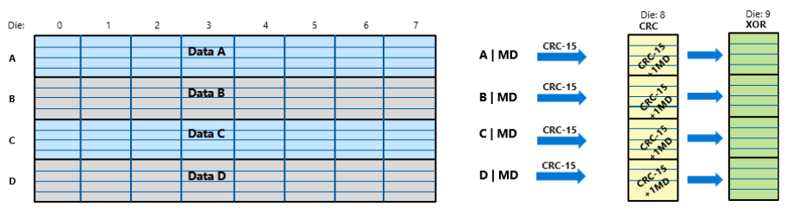
Figure 25. An example of multi-codeword implementation with 4 codewords and 4 metadata bits

Multi-Codeword Architecture with Improved Error Detection on Probable Error Patterns
Figure 26 shows another implementation of multi-codeword with 4 metadata bits on 10x4 memory configuration. In this implementation, instead of 4 CWs each with CRC-15, we use 3 CWs with CEC-16 and one CW with CRC-12. As such, although the overall probability of having UE does not theoretically change for the overall die failure, but based on memory architecture, this implementation is more susceptible to the errors affecting only the codeword with CRC-12.
In Figure 26, when we use primitive code generator polynomial, codewords A, B, and C can detect any error up to burst length 16. Therefore, any possible error will be detected in these codewords. However, if an error occurs only in the codeword D, the error might satisfy the corresponding CRC-12 check, and hence, causes UE.

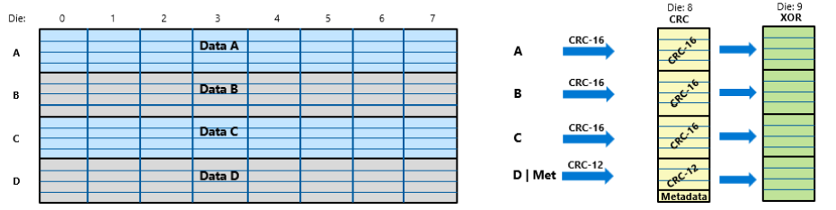
Figure 26. An example of multi-codeword implementation with asymmetric CRC on 4 codewords and 4 metadata bits

One method to minimize such effect is to adjust CW layouts so that the more probable errors are within minimum error burst length on the CW. Alternatively, we can map more probable memory fault patterns to other patterns that are more possible to detect by CRC, as proposed in the following modifications.
Figure 27 shows the encoding and decoding procedure of such a proposal. As before, host data will be written directly onto the designated chips (64B). However, to generate CRC, we XOR one section (section D in the figure) with the other sections to generate the data part of the CRC CWs. The resulting CRC parities for the combined data will be XORed, as shown in the figure, before being written to the assigned chip. Then the XOR will be generated from the die data, i.e., the original data (dies 0-7) and XORed version of CRC data written on die 8. Note that metadata will be encoded in the last CW as shown in the figure.

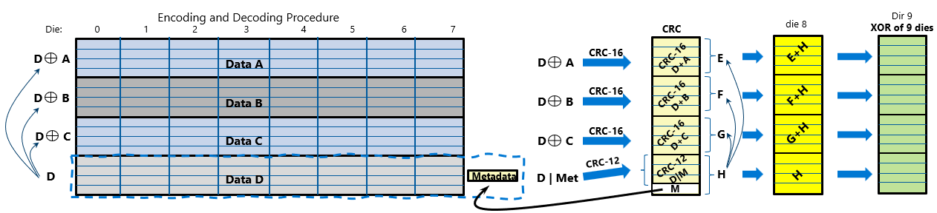
Figure 27. Encoding Procedure for the architecture with enhanced reliability for more probable errors

In this scheme, CRC-16 detects any error pattern with burst length of less than or equal to 16 bits. Therefore, any error pattern in a die that affects only A, B or C section will be detected by CRC. When the error is on D section, based on XOR, errors might be appeared on DꚚA, DꚚB, or DꚚC, and therefore, they will be detected. The exception is that the error patterns on A, B, C and D are the same, and therefore the error pattern on DꚚA, DꚚB, and DꚚC are all zero. The probability of such an event is:
P₁(XORed error patterns in A, B and C are all zero) = (any pattern in D) x P(C=D) x P(B=D) x P(A=D) = 1 x 2⁻¹⁶ x 2⁻¹⁶ x 2⁻¹⁶ = 2⁻⁴⁸
In such events, while DꚚA, DꚚB, and DꚚC are zero and the corresponding CRC cannot detect them, error pattern on [ D | Metadata] is not zero (we have all equal non-zero patterns in A, B, C, and D). Therefore, CRC-12 can detect them with P₂=2⁻¹². The overall undecodable error (UE) will be
P(UE) = P₁ . P₂ = 2⁻⁶⁰ = 8.7e-19
Note that the errors in UE patterns in this scheme must be distributed all over the chip and must cancel each other in different sections A, B, C and D. These are not among the most likely error patterns that practically happen in memory.
In this scheme, the error mask will be added to each die raw data, then the codewords are built in the horizontal XOR operation. Equivalently, we can build codewords separately by horizontal XOR operation, also build corresponding CW error pattern by horizontal XOR of error mask and use the same simplified hardware structure discussed in 7.2.

Some Comparisons between Basic RAIDDR and RS based Methods

Silent Data Corruption (SDC)
When there is no metadata, RS based methods and Basic RAIDDR perform closely. They correct all errors in a single die, regardless of the error patterns. However, when there are errors in more than one die, the SDC probability becomes different in these methods.
For RS based methods, the best performance is obtained if the entire cache line utilizes one big codeword. Thus, with an RS code that features 8-bit symbols, such as RS(80, 64, 8), the probability of mis-correction (leading to SDC probability) is 6e-10. Such a mis-correction probability for 16-bit symbols code RS(40,32,16) is 2.8e-15. This probability for Basic RAIDDR method is 2⁻⁶⁴=5.4e-20. Therefore, the SDC probability for the Basic RAIDDR method is orders of magnitude lower than RS based methods. We indicate that with additional approaches the SDC probability in RS based methods can also be further reduced.
Note that the above probabilities are obtained with a large RS code. In practice, often the cache line is broken into few codewords which makes the mis-correction probability worse. For example, if we use 4 codewords RS(20, 16, 8), with 8-bit symbols the mis-correction probability of one codeword will be 0.0021. When we use four codewords of 16-bit symbols RS(10,8,16), the mis-correction probability of one codeword will be 1.2e-4. Note that while reliability enhancement as mentioned in section 8 is also possible for RS codes, often it is not used based on more complexity.

Addition of Metadata
Metadata is fundamental in recent applications like CXL and many others, and it needs to be included with every cache line. Adding metadata to the data can be done in different ways. Common methods for RS based schemes include stealing from RS parity bits or adding a virtual metadata symbol to the data. The former usually leads to hard to manage undecodable/undetectable error masks, since design of RS code is a more complicated process. Managing the error masks often is done through adjusting the codeword and symbol layouts.
On the other hand, incorporating a virtual metadata symbol to RS code makes the overall decoder architecture exponentially more complicated. Common methods include utilizing a separate decoder, each with a different assumption for metadata. Therefore, on average, a CW with 4 metadata needs to be decoded 16 times. Breaking the codewords into smaller codewords helps to some extent, but it makes the system much more susceptible to UE and SDC. We emphasize that in each scheme there might be specific methods to mitigate errors or/and hardware complexities.
In contrast, adding more metadata to Basic RAIDDR based methods does not change the complexity or the design fundamental significantly. The same architecture can be used for different numbers of metadata by changing the code generator polynomial accordingly. Such a change does not add to hardware complexity or latency. In addition, while an increased number of metadata bits in RS based methods might add to the probabilities of SDC and UE significantly (based on the specific design), in Basic RAIDDR addition of each metadata bit only doubles each of those probabilities.

