Microsoft Cloud Adoption Framework for Azure

# Getting started: Initial decisions

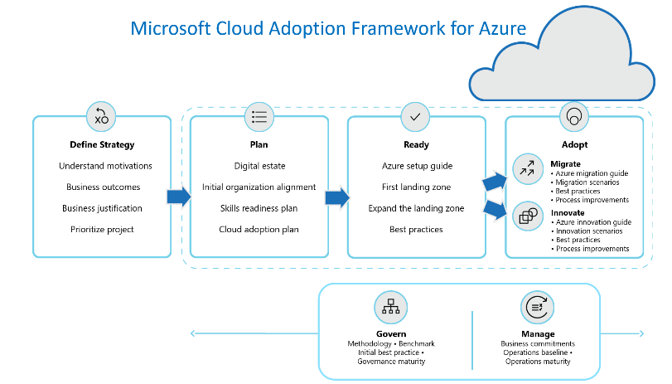The cloud adoption journey can unlock a number of business, technical, and organizational benefits through various journeys. Regardless of what you want to accomplish, if your journey involves the cloud there are a few fundamental decisions that should be understood by every team member involved in cloud adoption.

The initial decisions will improve consistency across any efforts which attempt to [accelerate adoption](https://docs.microsoft.com/en-us/azure/cloud-adoption-framework/get-started/blockers-overview), [build a well-managed operating model](https://docs.microsoft.com/en-us/azure/cloud-adoption-framework/get-started/operating-model-overview), or [build out teams](https://docs.microsoft.com/en-us/azure/cloud-adoption-framework/get-started/org-alignment) to support your cloud adoption lifecycle. These decisions will also inform activities within each methodology or phase of cloud adoption.

## Initial decision checklist

This checklist outlines those initial decisions and provides an easy way to record your decisions to ease future on-boarding and getting started efforts.

* Every member of the team should have a [basic understand of how azure works](https://docs.microsoft.com/en-us/azure/cloud-adoption-framework/get-started/cloud-concepts#step-1-gain-clarity-on-how-azure-works).
* Every technical team member should have a basic understanding of [fundamental Azure concepts](https://docs.microsoft.com/en-us/azure/cloud-adoption-framework/get-started/cloud-concepts#step-2-understand-initial-azure-concepts).
* The [portfolio of candidate workloads](https://docs.microsoft.com/en-us/azure/cloud-adoption-framework/get-started/cloud-concepts#step-3-review-the-portfolio) should be available to all team members to be used during strategic, release planning and completion of technical tasks within an iteration. (Record references on the next page.)
* The technical strategy should include clarity on which [levels of the hosting hierarchy](https://docs.microsoft.com/en-us/azure/cloud-adoption-framework/get-started/cloud-concepts#step-4-define-portfolio-hierarchy-depth-to-align-the-portfolio) will be used and what those terms mean in your business. (Record decisions on the next page.)
* A [naming and tagging standard](https://docs.microsoft.com/en-us/azure/cloud-adoption-framework/get-started/cloud-concepts#step-5-establish-a-naming-and-tagging-standard-across-the-portfolio) should be established, maintained, and enforced to guide implementation and resource organization.
* The hosting hierarchy should be reflected in a [resource organization design](https://docs.microsoft.com/en-us/azure/cloud-adoption-framework/get-started/cloud-concepts#step-6-create-a-resource-organization-design-to-implement-the-portfolio-hierarchy) (or subscription design). (Record the design requirements on the next page.)
* [Align cloud capabilities, teams, and RACI structure](https://docs.microsoft.com/en-us/azure/cloud-adoption-framework/get-started/cloud-concepts#step-7-map-capabilities-teams-and-raci-to-fundamental-concepts) to the fundamental concepts above. (Record assignments and RACI references on the next page.)

## Initial decisions

All decisions regarding cloud adoption start with an understanding of the portfolio of workloads that may be hosted in the cloud. That portfolio will influence the level of hosting and organizational hierarchies required. It will also create clarity around the types of support needed to operate, govern, and secure your cloud environment. This page captures those decisions that best fit your portfolio. See the prior page for links to guidance to help make these decisions.

### Hosting Hierarchy (Cloud Agnostic terms)

**IT Assets** will be deployed to the following clouds: Hybrid, Azure. All assets must be assigned to the workload that is most dependent on that IT asset.

Those assets will support multiple **workloads**, which will each have a defined workload name, business stakeholder, business unit, and operations lead.

When multiple solutions (or distinct combinations of assets) are required to support a workload, those will be labeled as **solutions**. If those solutions drive some level of business value on their own, they will also be labeled as **solutions**.

Each workload will be hosted in a **shared landing zone** grouping them by application category.

Each landing zone will be hosted in environments segmented using a **mixed model** to respect the boundaries drawn by **Production vs Non-Production, and Business Unit.**

### Organization Design in Azure

* Solutions will be represented by a tag.
* Workloads will be represented by a tag. All assets supporting a workload will be assigned to a resource group and inherit the same tags.
* Each landing zone will be in a dedicated subscription, hosting several similar workloads.
* Management group hierarchy aligns to the image to the right to preserve environment boundaries.

### Necessary references

|  |  |  |  |  |  |
| --- | --- | --- | --- | --- | --- |
|  | File or URL | Accountable team | Assigned person | Current status | Last updated |
| Portfolio | [Template](https://docs.microsoft.com/en-us/azure/cloud-adoption-framework/digital-estate/inventory) | Cloud Strategy Team | <Insert name here> | <Discovery> | <Insert data here> |
| Naming & Tagging standard | [Template](https://archcenter.blob.core.windows.net/cdn/fusion/readiness/CAF%20Readiness%20Naming%20and%20Tagging%20tracking%20template.xlsx) | Cloud Governance Team | <Insert name here> | <Discovery> | <Insert data here> |
| RACI assignments | [Template](https://archcenter.blob.core.windows.net/cdn/fusion/management/raci-template.xlsx) | Cloud Strategy Team | <Insert name here> | <Discovery> | <Insert data here> |