Getting started with sensitivity labels
In today’s fast paced world, data changes hands frequently both inside and side of the company. As an End User, how does one keep company secrets private but also sharing data with partners or vendors without ending up on the news? Let me introduce data labels or sensitivity labels to combat such events. One can think of labels as ‘tags’ on the data that help control who can and who cannot see the data, what one should do with the data, and xx what can be changed once the data leaves your organization.
The intent of this document is to provide step-by-step instructions along with images of screens for using labels with Office applications, emails, and document shares. If you have never used labels before, do not worry this documentation will get you started. <add label names here: Non-Business, Public, etc..> The label naming will be dependent upon your company’s needs though these instructions will familiarize one working on any platform or mobile device.

Assumptions
We assume you have worked with drop-down menus, toolbars and dialog boxes in your daily tasks. The information provided is straightforward with an easy-to-understand style for a visual learner allowing you to make you better at choosing labels with little to no effort, allowing you will get up to speed quickly.

Sensitive Information Types
To assist with the effort of identifying content with sensitive information, Office 365 has over 87 filters that search data for items like credit card numbers, social security numbers and such. <add custom SIT here> Depending on your company or industry some filters will or will not apply.

Mandatory Labeling
Just a quick note, your organization may label emails or documents by default, or you can pick a label, and lastly have a label assigned based off the criteria from one of the 87 filters or custom filters for your organization.

State, Local and Government Agencies
Presently, sensitivity labels are supported for Office 365 commercial tenants and are not yet available government organization tenants.

In this document, section include:
- Windows: Word, Excel and PowerPoint apps
- Mac: Word, Excel and PowerPoint apps
- Office for Android: Word, Excel and PowerPoint apps
- Office for iOS: Word, Excel and PowerPoint apps
- Using Labels in Outlook
- Creating Teams Channels
- SharePoint and OneDrive Settings
- Sharing files with external vendors, partners, or clients

Windows: Word, Excel and PowerPoint apps
Whether you are using Office installed locally on your desktop or via the web, one will choose a label to protect files. It all starts with clicking Sensitivity and choosing a data label. Your organization may apply labels automatically or recommend labels based off the content in your documents. A Policy Tip will appear if so and you should choose the correct label. See section below on when and how to use a Policy Tip.

Selecting labels in Office 365
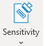
- On the Home tab, select Sensitivity dropdown.
- Choose a data label you wish to apply to your document or email.
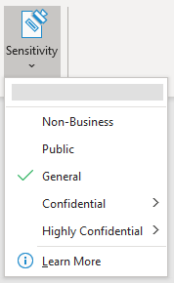

- Notice the default is General indicated by green check and both Confidential & Highly Confidential have sub labels.
- Click Learn More for <Munson's Pickles and Preserves Farm> overview of sensitivity labels.

Removing labels in Office 365
- To remove a sensitivity label that has already been applied to a file, unselect it from the Sensitivity menu.
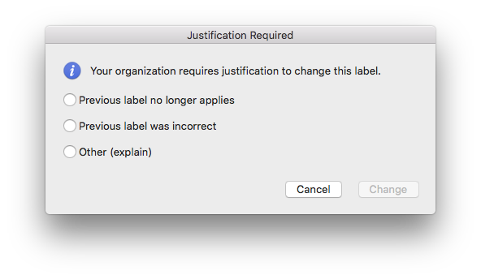
- You will need to provide justification before changing a sensitivity label from a higher sensitivity to a lower sensitivity.

Automatic Labels
- A Policy Tip with a message appears at the top of your document.

- Click OK to acknowledge a label was applied to the documents automatically.

Recommended Labels
- A Policy Tip with a message appears at the top of your document.

- Click Apply Sensitivity to then choose a label to apply to the document.

Mac: Word, Excel and PowerPoint apps
Using Office on Mac follows the same steps as outlined above including using Safari or a different browser. It all starts with clicking Sensitivity and choosing a data label.

Selecting labels in O365_Mac
- On the Home tab, select Sensitivity dropdown.

- Choose a data label you wish to apply to your document or email.
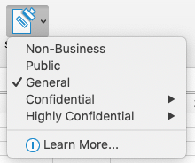

- Notice the default is General indicated by green check and both Confidential & Highly Confidential have sub labels.
- Click Learn More for <Munson's Pickles and Preserves Farm> overview of sensitivity labels.

Removing labels in O365_Mac
- To remove a sensitivity label that has already been applied to a file, unselect it from the Sensitivity menu.
- You will need to provide justification before changing a sensitivity label from a higher sensitivity to a lower sensitivity.

Office for Android: Word, Excel and PowerPoint apps
Using an Android device involves a few more steps but follows a similar flow to using Office on the desktop. Just make sure you do not miss the Edit icon.

Selecting labels in Office 365 for Mobile
- On your Android phone, start by going to the Home tab and selecting Sensitivity.
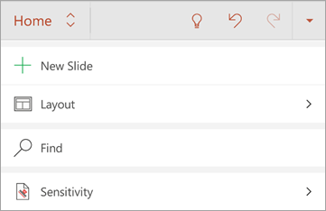
Select the Edit icon (A with pencil symbol) from the top of your screen to show the ribbon. On your Home tab, scroll down, then select Sensitivity.

- Choose a data label you wish to apply to your document.

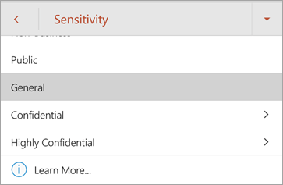

- Notice that both Confidential & Highly Confidential have sub labels.
- Click Learn More for <Munson's Pickles and Preserves Farm> overview of sensitivity labels.

Removing labels in Office 365 for Mobile
- To remove a sensitivity label that has already been applied to a file, unselect it from the Sensitivity menu.
- You will need to provide justification before changing a sensitivity label from a higher sensitivity to a lower sensitivity.

Office for iOS: Word, Excel and PowerPoint apps
Using an Apple device involves a few more steps but follows a similar flow to using Office on the desktop. Just make sure you do not miss the Edit icon.

Selecting labels in Office 365 for Mobile
- On your Apple device, select the Home tab and choose Sensitivity.

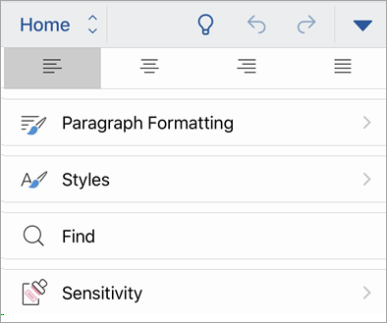
Select the Edit icon (A with pencil symbol) on the top of your screen to show the ribbon. On the Home tab, scroll down, then select Sensitivity.

- Choose a data label you wish to apply to your document.
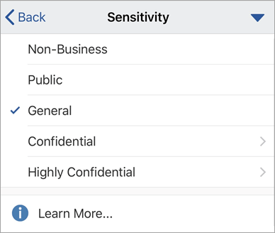

- Notice that both Confidential & Highly Confidential have sub labels.
- Click Learn More for <Munson's Pickles and Preserves Farm> overview of sensitivity labels.

Removing labels in Office 365 for Mobile
- To remove a sensitivity label that has already been applied to a file, unselect it from the Sensitivity menu.
- You will need to provide justification before changing a sensitivity label from a higher sensitivity to a lower sensitivity.

Using labels in Outlook
, Outlook app on both Android and Apple devices. The exact screens differ from device to device but the wording and application of using labels is the same.

Selecting labels in Outlook on web
- Start a new email and select Sensitivity
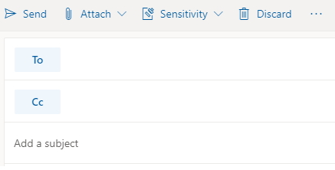

- Choose a data label you wish to apply to your email.
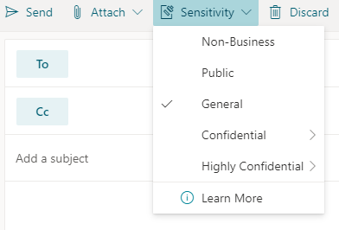

Removing labels in Outlook on web
- To remove a sensitivity label that has already been applied to a file, unselect it from the Sensitivity menu.
- You will need to provide justification before changing a sensitivity label from a higher sensitivity to a lower sensitivity.
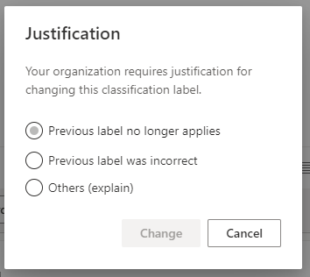

Automatic Label
- 1. A Policy Tip with a message appears at the top of your email.
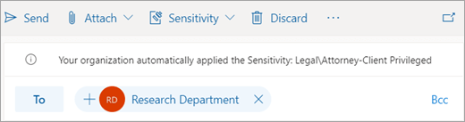

Recommended Label
- A Policy Tip with a message appears at the top of your email.
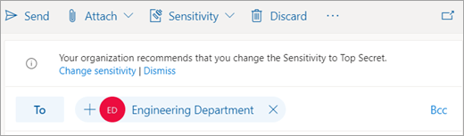

- Click Change Sensitivity to then choose the recommended label to apply to the email or select Dismiss to not apply the recommended label.

Selecting labels in Outlook on Android
- Starting a new email and select .
- Click Edit Sensitivity
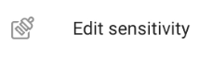

- Choose a data label you wish to apply to your email.
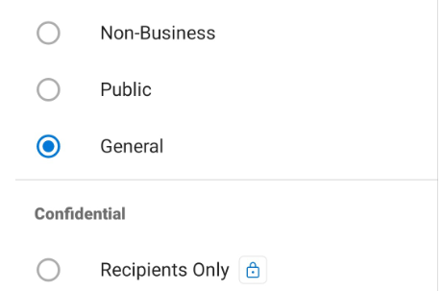
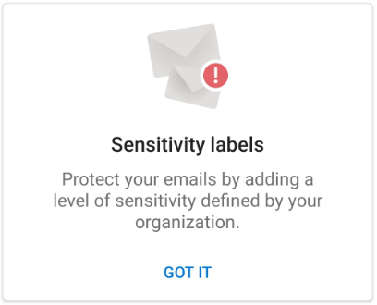

Removing a Labels Outlook on Android
- To remove a sensitivity label that has already been applied to a file, unselect it from the Sensitivity menu.
- You will need to provide justification before changing a sensitivity label from a higher sensitivity to a lower sensitivity.

Selecting labels in Outlook on iOS
- Starting a new email and select .
- Click Edit Sensitivity


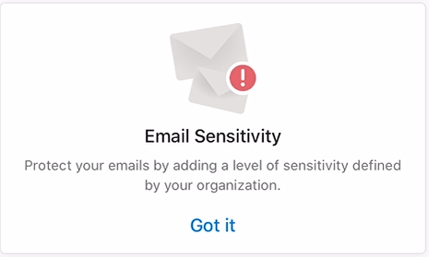
- Choose a label to apply to the email
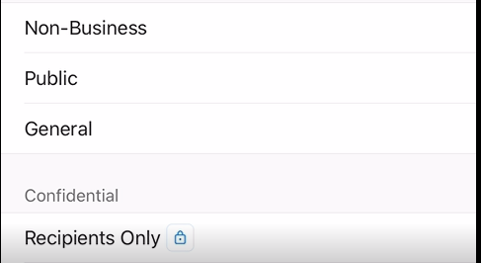

Removing a Labels on Outlook on iOS
- To remove a sensitivity label that has already been applied to a file, unselect it from the Sensitivity menu.
- You will need to provide justification before changing a sensitivity label from a higher sensitivity to a lower sensitivity.
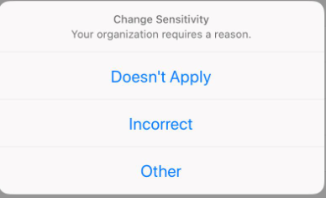

Creating Teams channels
You now can select labels as you work with Teams to create new channels for projects, departments and other events or situations as needed. Simply apply the correct label and you are ready to get started.

Selecting labels in Teams
- Click Join Or Create A Team in the lower left-hand corner.
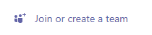
- Then click Create A Team.

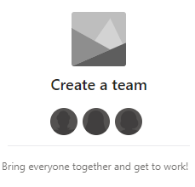

- Choose to Build A Team From Scratch or Create From…
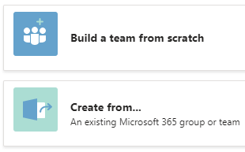

- Under Sensitivity, in the General section, select from the list of labels.
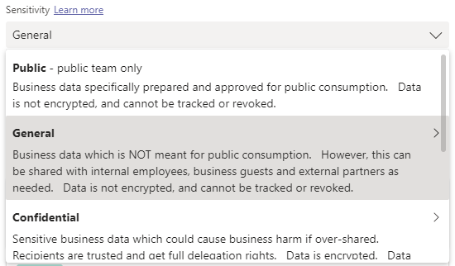

- Select the new Teams channel and notice the label applied.
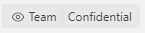

SharePoint and OneDrive settings
When working with documents that are stored in either SharePoint or OneDrive, just remember that labels are applied to the documents themselves, or the location (set by admin).

Applying labels in SharePoint
- Use steps in section ‘Word, Excel and PowerPoint apps’ to apply a label to a document that is saved or copied in a document library.

You may verify the label is applied in the lower corner of the documents, Word in this example.

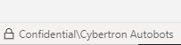
- Browse to your SharePoint library and view the Sensitivity column for your documents.
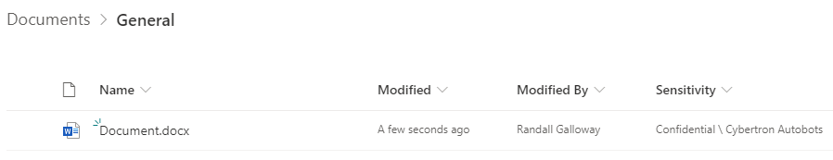

Changing labels in SharePoint
- Open document in library and use the Sensitivity drop-down to choose a different label.

- To change a sensitivity label that has already been applied to a file, unselect it from the Sensitivity menu.
- You will need to provide justification before changing a sensitivity label from a higher sensitivity to a lower sensitivity.

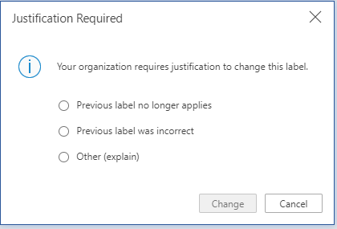

Removing labels in SharePoint
- To remove a sensitivity label that has already been applied to a file, unselect it from the Sensitivity menu.
- You will need to provide justification before changing a sensitivity label from a higher sensitivity to a lower sensitivity.

Selecting labels in OneDrive
- Follow the same steps outlined for working with documents as listed above with SharePoint except for the documents will be stored to OneDrive.

Why Markings and Encrypted data?
This section covers what you will see should labels with higher security be chosen for documents like Highly Confidential or Confidential. Headers, footers and watermarks are visual marking indicators to remind oneself of the type of data you are working with. The data may also be encrypted or made secret should the information in the document fall into the wrong hands.

Visual marking in Documents
- Below is an example of a document labeled as Highly Confidential with markings in the header, footer along with a watermark. Others outside of your organization will see this information
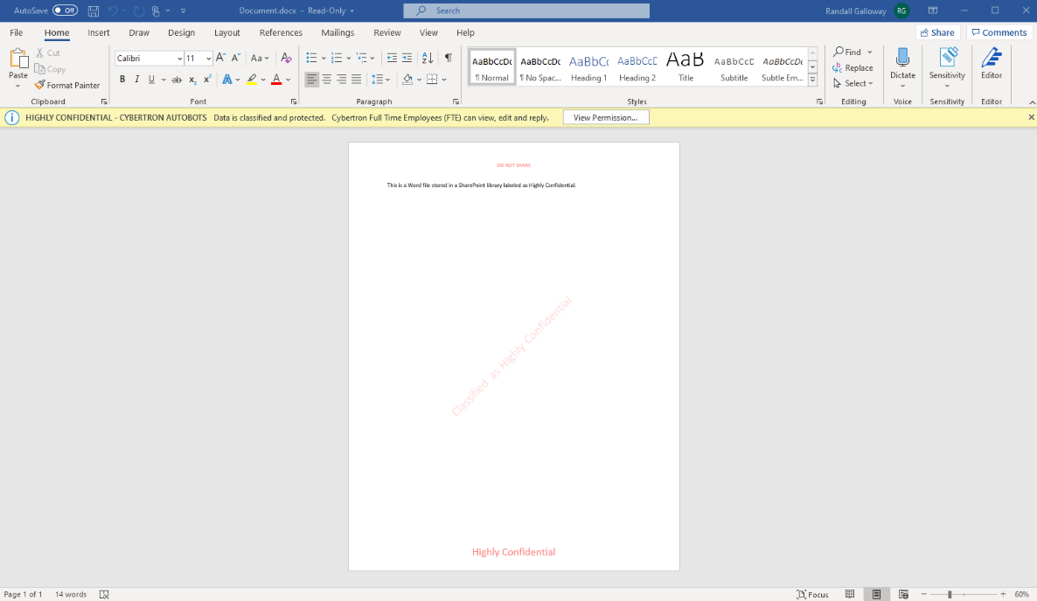

Scrambled or Garbled Data (Encryption)
- Below is an example of a Word document that is encrypted with the label of Confidential\Microsoft FTE.
The data contained is readable by you as your company has decrypted or unscrambled the data for you to view.
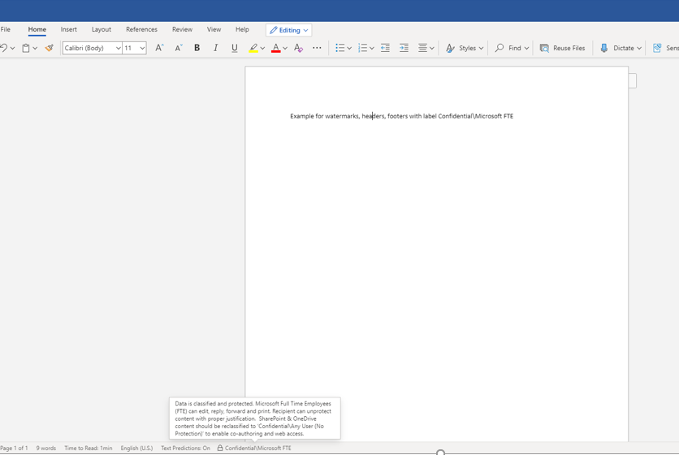

- The same document is opened without it being unscrambled or decrypted below.
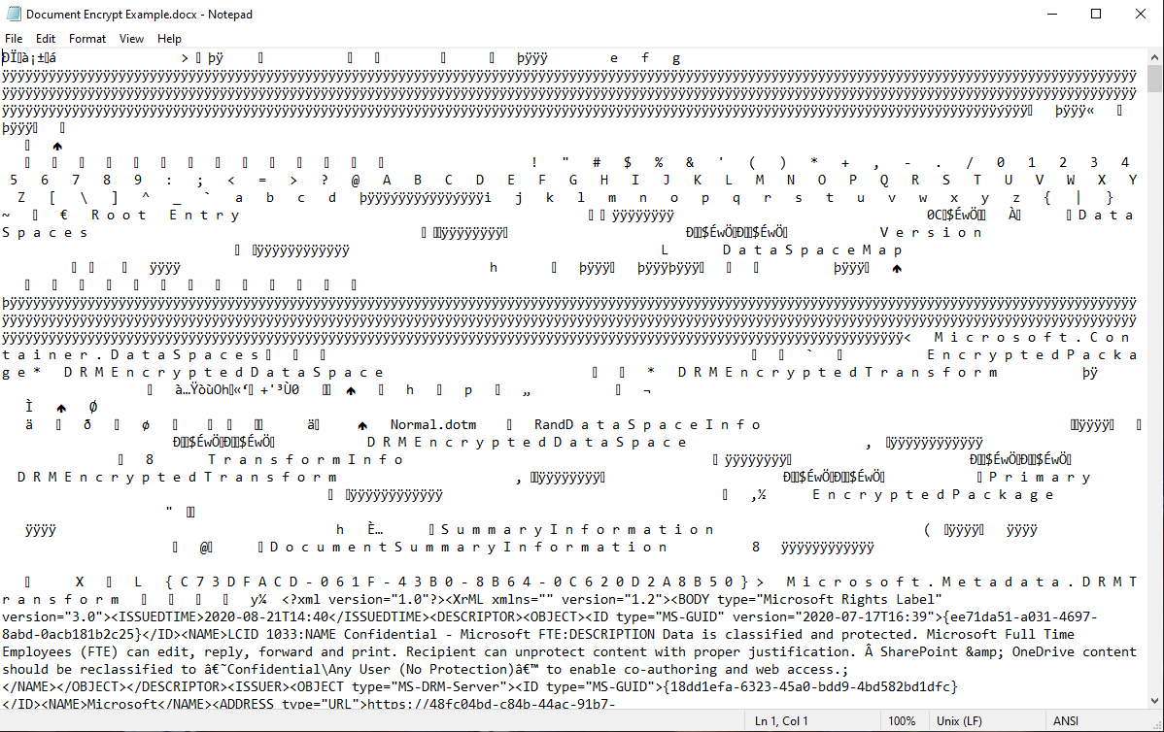

Sharing files and emails with external vendors, partners, or clients
Working with others outside your company will require one to share files or send emails that may or may not have sensitive information to your company. Understand labeling a file or email as Confidential or Highly Confidential may not allow you to share or send the data to vendors, partners or clients.

SharePoint, OneDrive and Teams
- Below is an example of trying to send a document labeled as Confidential or Highly Confidential outside or your organization. The same protection applies to sharing documents in SharePoint, OneDrive or Teams.
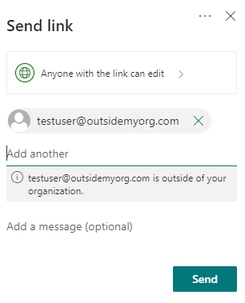

- Below is an example of sharing a document labeled as General with a vendor or party outside of your organization. The receiver would click Open to view the Word document. *Do note that the external vendor can change the label and you should check once receiving the file.
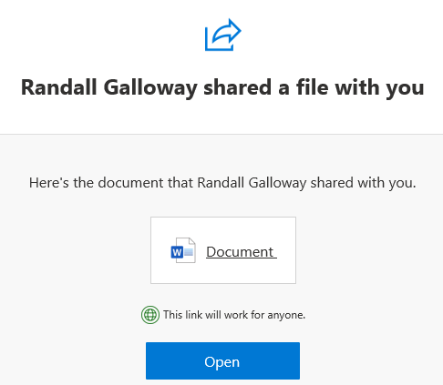

Email
- Below is an example of an external vendor being sent an email labeled as Confidential that your company encrypted or scrambled. The receiver would click Read The Message.

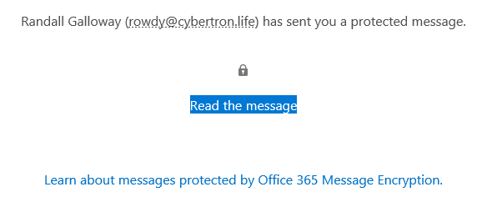

- The receiver would need to Sign In to view the message and use the One-Time Passcode to validate or prove who they are.
