
Getting started with retention labels
In today’s fast paced world, data changes frequently within a company. As an End User, how does one know how long to keep items deemed with historic significance, or retained for individuals to support your daily work, tasks, projects, and what version is latest version of a document? Let me introduce retention labels to help with those decisions. One can think of labels as ‘tags’ on the data that help manage risk and liability by only keeping what’s needed and deleting what’s not.
The intent of this document is to provide step-by-step instructions along with images of screens for using labels with Outlook, emails, OneDrive, SharePoint, and other content shares. If you have never used labels before, do not worry this documentation will get you started. <add label names here: Non-Business, Public, etc..> The label naming will be dependent upon your company’s needs though these instructions will familiarize one working on any platform.

Assumptions
We assume you have worked with drop-down menus, toolbars, and dialog boxes in your daily tasks. The information provided is straightforward with an easy-to-understand style for a visual learner allowing you to make you better at choosing labels with little to no effort, allowing you will get up to speed quickly.

Auto Applied Retention Policies
To assist with the effort of identifying content with sensitive information, Office 365 has over 87 filters that search data for items like credit card numbers, social security numbers and such. <add custom SIT here> Depending on your company or industry some filters will or will not apply.

Mandatory Labeling
Just a quick note, your organization may label emails or documents by default, or you can pick a label, and lastly have a label assigned based off the criteria from one of the built-in filters or custom filters for your organization.

In this document, section include:
- OneDrive and SharePoint
- Using Retention Labels in Outlook
- Retention Labels with Outlook on the Web
- SharePoint Site Settings
- Teams chat and channel

OneDrive and SharePoint
Whether you are using Office installed locally on your desktop or via the web, one will choose a label to apply to an item. Your organization may apply labels automatically or recommend labels based off the content in your documents. A Policy Tip will appear if so and you should choose the correct label. SharePoint and OneDrive store items, that one creates, collaborates, or stores. Classifying data is important as different types of data should keep or deleted along with a duration of each.

Selecting labels in SharePoint 
- Highlight an item in SharePoint and click the details pane ( ) to display the properties. In the Apply Retention Label section, select the drop down and choose the correct retention label.

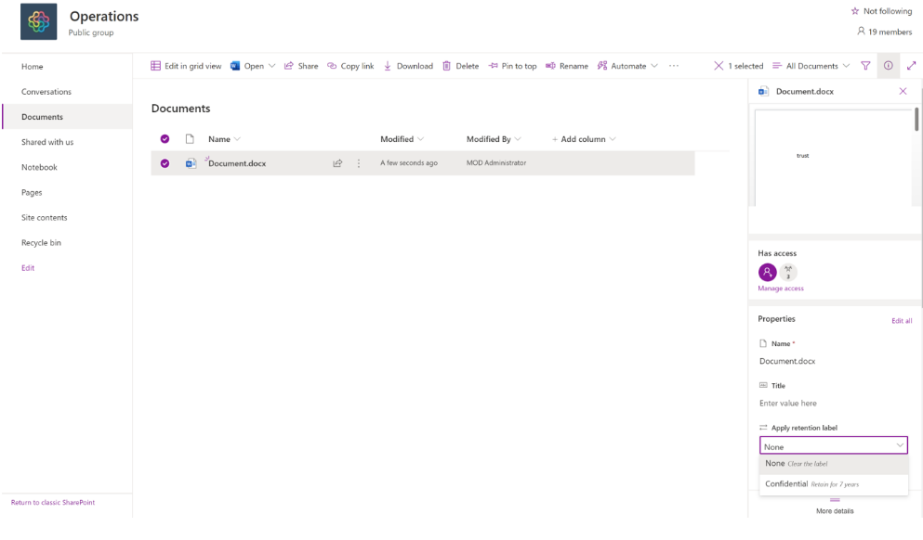
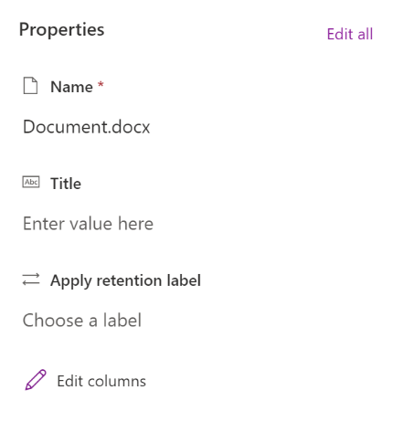

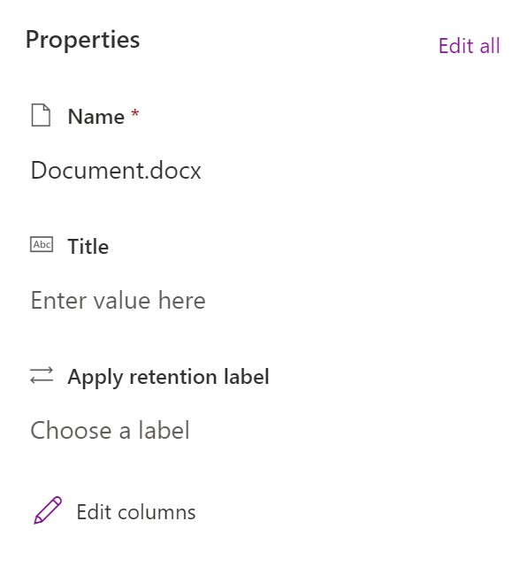

Selecting labels in OneDrive
- A Policy Tip is shown stating the item is blocked as is conflicts with the governance established in your organization. Clicking on View Policy Tip display additional information on the policy.
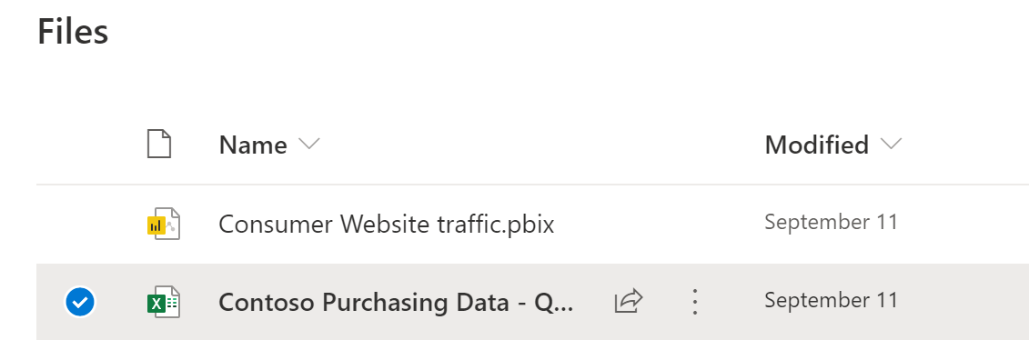

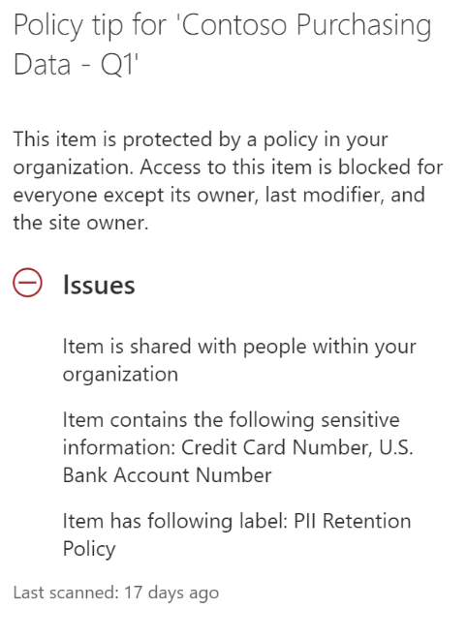
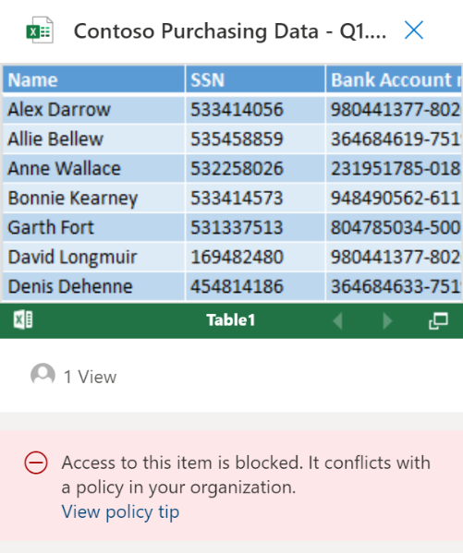

Using Retention Labels in Outlook
As you work with email each day you may have need to retain or delete the mail. Remember, the retention does apply to mail at rest and is applied once the mail is deleted.

Selecting labels in Outlook desktop 
- Click Assign Policy from the Outlook toolbar and select the appropriate label.
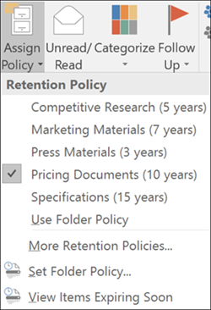

Using Email rules to apply a retention label
- In the Quick Steps section of the Outlook toolbar, click Create New. Give the rule a name and use the drop down to select Set Retention Policy in the Actions section. Choose a retention policy and then choose an action for the rule.

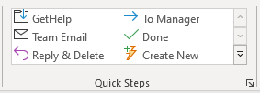
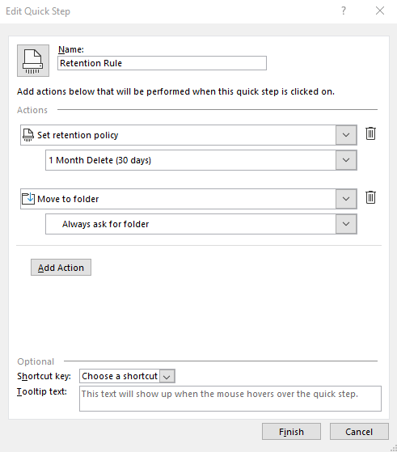

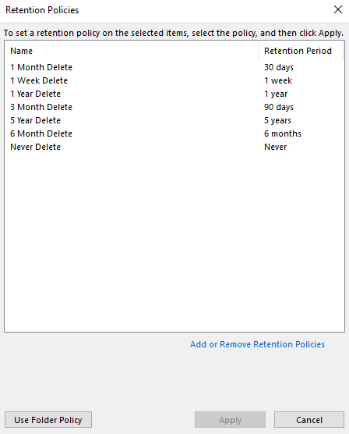

Retention Labels with Outlook on the Web

We are only covering using the Outlook app in this section which includes accessing your email by using Outlook on the web by logging in from the waffle internally.

Selecting labels
- Right the email item and select Assign Policy>then choose the appropriate retention label.

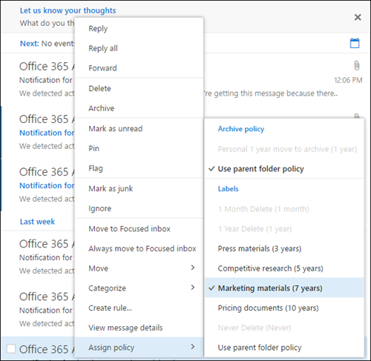

SharePoint Site Settings
In addition to selecting a label to be applied to a single item in SharePoint, one can set all content to be labeled in the library folder or document set. This allows all the documents to have a default label applied.

Selecting labels in SharePoint at the site level
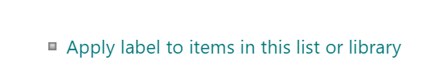
- Navigate to SharePoint and click the settings icon and select Library Settings. On the Documents>Settings page, click Apply Label To Items In This List or Library as shown below.

- On the Settings>Apply Label page, click the down drop and choose the appropriate retention label.
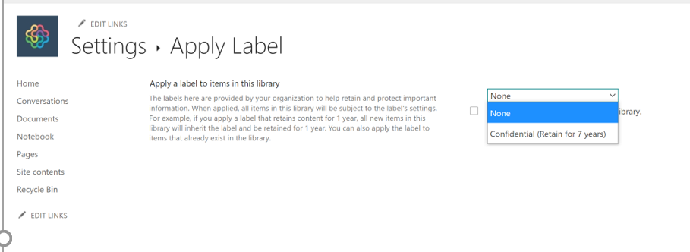

Teams chat and channel
Allow there is no end user action for retention labels and Teams settings, below are examples of what you could see in Teams should a retention label be applied.

Working with retention labels in Teams channel
- Below is an example of a previous post to a channel that Munson’s removes historic conversations after 1 month.

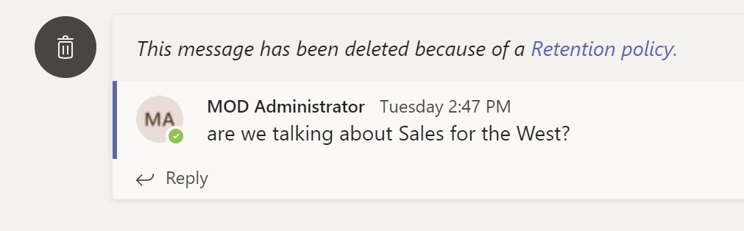
Teams

Working with retention labels in Teams chat
- Below is an example of a previous post to a chat that Munson’s removes historic conversations after 1 month.

